TRACE
Appendix: Implementation and Running Costs
What it costs a payment aggregator to deploy and operate Trace, with every assumption stated
Merchant Legitimacy Challenge
November 2026
All figures are planning estimates in Indian rupees (1 lakh = ₹1,00,000; 1 crore = ₹1,00,00,000), built from the assumptions in section 3. They are not vendor quotes. The model that produces every table is explained/financials/model.py in the Trace repository.

Contents
1 Summary 3
2 Scope and approach 4
2.1 Who implements Trace 4
2.2 What is included 4
2.3 Three sizes of payment aggregator 4
3 Key assumptions 5
3.1 General 5
3.2 Salaries 5
3.3 Workload 6
3.4 Cloud prices 6
4 Implementation cost (one-time) 7
4.1 Timeline 7
4.2 Team 7
4.3 Other one-time costs 8
4.4 Total implementation cost 8
5 Running cost (annual) 9
5.1 Overview 9
5.2 Cloud and data 9
5.3 Model and engineering team 10
5.4 Analyst desk 10
5.5 Audit, software and other 11
6 Costs at different scales 11
7 Sensitivity 12
8 Five-year cost of ownership 13
9 Value and break-even 14
9.1 Regulatory exposure 14
9.2 Analyst time 14
9.3 Honest merchants protected 14
9.4 Break-even 14
10 Ways to lower the cost 14
11 Limitations 15
12 Sources 15

1 Summary
For a mid-size payment aggregator (PA) with 20 lakh active merchants, Trace costs about ₹2.15 crore to implement over 9 months and about ₹1.88 crore a year to run. That is roughly ₹9.4 per merchant per year, or ₹939 for every case an analyst handles.
Measure (mid-size PA, base case) | Value
One-time implementation (9 months) | ₹2.15 crore
Annual running cost | ₹1.88 crore
Running cost per active merchant | ₹9.4 a year
Running cost per case handled | ₹939
Analysts needed | 7 analysts and 1 team lead
Annual cost with the build spread over 5 years | ₹2.31 crore
Five-year cost of ownership (build plus five years) | ₹13.99 crore
Break-even | One FIU-IND-scale penalty (₹5.49 crore) avoided every 2.4 years

What the numbers say
- People are most of the cost. The analyst desk and the model team are 76% of the running cost; cloud and data are 15%.
- The cost per merchant falls with scale: ₹28.1 a year for a small PA, ₹9.4 for a mid-size one and ₹5.2 for a large one.
- The biggest unknown is how many merchants reach a case each year. Halving or doubling it moves the running cost more than any other assumption (section 7).
- Trace pays for itself if it prevents one penalty of the size FIU-IND imposed on Paytm Payments Bank every 2.4 years, before counting about ₹33.0 lakh a year of analyst time saved or the honest merchants it keeps out of trouble (section 9).

2 Scope and approach

2.1 Who implements Trace
The buyer is a payment aggregator authorised by the Reserve Bank of India: the company that onboards merchants, collects their UPI payments and settles the money to their bank accounts. Under the RBI's Payment Aggregator directions and the Prevention of Money Laundering Act, it must know what its merchants really do, so monitoring is an obligation, not an option.
A PA already runs KYC at onboarding and has a compliance team. Every cost in this appendix is incremental: what Trace adds on top of what the PA already spends.

2.2 What is included
Included
- Building Trace into the PA's systems: data pipelines, the ten weekly signals, peer scoring, the network, change points, the learning loop, case management, the GST check and regulator reports
- A three-month shadow pilot in which Trace scores merchants without acting, so its flags can be checked first
- Running it: cloud, the team that maintains the models, and the analysts who work the cases Trace opens
- Security testing, a data-protection impact assessment, legal review of merchant notices and appeals, and training
Not included
- The PA's existing KYC, onboarding and compliance staff, which it pays for today with or without Trace
- Person-to-person UPI transfers, which never reach a PA; those are watched by banks and NPCI (for example, RBI's MuleHunter.AI)
- Revenue effects of offboarding merchants. Most small UPI merchants pay no merchant discount rate, so losing a front costs a PA little revenue
- Litigation, if a merchant takes a decision to court

2.3 Three sizes of payment aggregator
Costs are worked out for three sizes. The mid-size PA is the base case used throughout.
Scenario | Active merchants | Payments a year | History kept (5 years)
Small PA | 5,00,000 | 1.5 billion | 0.4 TB
Mid-size PA (base case) | 20,00,000 | 5.8 billion | 1.8 TB
Large PA | 1,00,00,000 | 29.2 billion | 8.8 TB

Payments a year assume 8 payments per merchant per day. History is stored compressed (about 60 bytes per payment) for 5 years, the PMLA record-keeping period.

3 Key assumptions
Every figure here follows from the assumptions below. Changing one and re-running the model (explained/financials/model.py) regenerates every table.

3.1 General
Assumption | Value | Basis
Exchange rate | ₹90 per US$ | USD/INR ranged from 88.6 to 89.7 in November 2025; rounded up for caution
Overhead on salaries | 20% | Office, laptops, recruiting and software seats on top of cost to company
Productive hours per analyst | 1,700 a year | About 220 working days of 7.7 hours
Contingency on implementation | 15% | Standard allowance for integration surprises
Build spread over | 5 years | Used only for the all-in annual cost and break-even
Growth in the five-year view | 10% merchants, 8% salaries a year | Planning assumption

3.2 Salaries
Annual cost to company in India. Market surveys put the average data scientist at roughly ₹7 to ₹14 lakh and mid-level at ₹8 to ₹20 lakh; fintech and senior roles pay more, so the figures below sit at the upper end. Anti-money-laundering analysts have a median of about ₹5 to ₹6 lakh.
Role | ₹ lakh a year
Product / project lead | 35.0
Senior data scientist | 24.0
Data scientist | 18.0
ML / data engineer | 22.0
Backend engineer | 18.0
DevOps / QA engineer | 16.0
Compliance and legal specialist | 30.0
Risk analyst | 6.5
Analyst team lead | 14.0

3.3 Workload
Assumption | Value | Basis
Merchants reaching a case each year | 1.0% | Share that reach Ask or above; the real rate is unknown, so section 7 tests 0.5% to 2%
Ask: neutral question, merchant replies | 60% of cases, 10 min | Reading the merchant's reply and closing
Friction: lower limits, slower settlement | 25% of cases, 25 min | Checking evidence and setting limits
Review: reserve, investigation, STR draft | 15% of cases, 90 min | Includes the investigation and drafting the STR
Appeals | 5% of Friction and Review cases, 60 min | Decided by a second analyst
Random audits | 0.25% of merchants, 20 min | Unflagged merchants, to find new patterns
Analysts per team lead | 8 | Span of control

3.4 Cloud prices
On-demand list prices in AWS Mumbai (ap-south-1). Only the m6i.2xlarge price is taken from a published price list; the others are approximate and should be checked in the AWS pricing calculator before a budget is approved.
Resource | US$ per hour | Used for
m6i.2xlarge (8 vCPU, 32 GB) | 0.404 | Weekly signals and scoring
r6i.4xlarge (16 vCPU, 128 GB), approx. | 1.000 | Network graph and learning loop
m6i.xlarge (4 vCPU, 16 GB) | 0.202 | Dashboard, case management, APIs
Managed Kafka broker, approx. | 0.250 | Streaming payment feed
Managed PostgreSQL, two zones, approx. | 1.000 | Cases and results
Object storage | 0.025 per GB-month | Payment history

4 Implementation cost (one-time)
Implementation takes 9 months and costs about ₹2.15 crore for the base case. People are 83% of it.

4.1 Timeline
Phase | Months | What happens
Discovery and data access | 1 | Map the PA's payment, KYC and settlement data; agree the action ladder with compliance
Build and integrate | 4 | Signals, peer scoring, network, change points, case management, GST check, reporting
Shadow pilot | 3 | Trace scores every merchant but takes no action; analysts check its flags against their own
Rollout | 1 | Ask and Friction switched on first; Review and holds only after sign-off
Total | 9

Merchants are only acted on after the shadow pilot, and money is held only after compliance signs off.

4.2 Team
Role | People | Months | ₹ lakh
Product / project lead | 1 | 9 | 31.5
Senior data scientist | 1 | 9 | 21.6
Data scientist | 1 | 8 | 14.4
ML / data engineer | 2 | 8 | 35.2
Backend engineer | 2 | 6 | 21.6
DevOps / QA engineer | 1 | 6 | 9.6
Compliance and legal specialist | 0.5 | 9 | 13.5
Risk analyst | 3 | 4 | 7.8
Team total |  |  | 155.2

Includes 20% overhead. The three risk analysts label past cases to seed the learning loop and check the pilot's flags.

4.3 Other one-time costs
Item | ₹ lakh | Note
Cloud for development, staging and the pilot | 8.7 | 40% of the production bill for 9 months
GST verification API (GSP) set-up and testing | 6.0 | Connect to a GST Suvidha Provider to read declared turnover
Security testing and DPDP impact assessment | 8.0 | External penetration test; Digital Personal Data Protection review
Legal review of the ladder, notices and appeals | 6.0 | Merchant-facing wording, hold policy, appeal process
Analyst training and playbooks | 3.0 | How to work a case, write an STR draft, decide an appeal
Other total | 31.7

4.4 Total implementation cost
Component | ₹ lakh
Team | 155.2
Other one-time costs | 31.7
Subtotal | 186.9
Contingency (15%) | 28.0
Total implementation cost | 214.9

About ₹2.15 crore. A small PA pays almost the same (₹2.14 crore) because the build work does not shrink with the number of merchants; section 10 covers cheaper routes for smaller PAs.

5 Running cost (annual)

5.1 Overview
Running Trace costs about ₹1.88 crore a year for the base case.
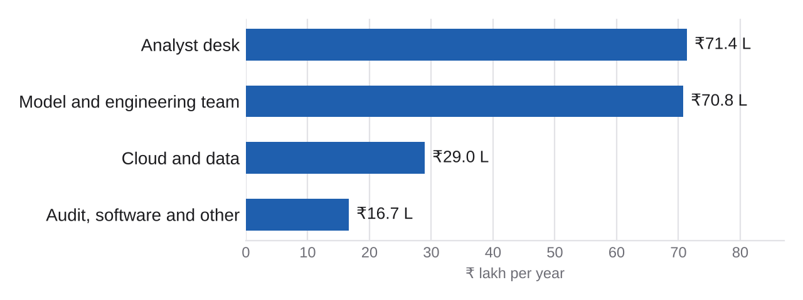
Annual running cost by component, mid-size PA
Component | ₹ lakh a year | Share
Cloud and data | 29.0 | 15%
Model and engineering team | 70.8 | 38%
Analyst desk | 71.4 | 38%
Audit, software and other | 16.7 | 9%
Total running cost | 187.9 | 100%

5.2 Cloud and data
Item | Basis | US$ a year | ₹ lakh
Weekly signals and scoring | 5 x m6i.2xlarge, 4 h a day | 2,949 | 2.7
Network graph and learning loop | 2 x r6i.4xlarge, 3 h a day | 2,190 | 2.0
Dashboard, case management, APIs | 3 x m6i.xlarge, always on | 5,309 | 4.8
Streaming payment feed (Kafka) | 3 managed brokers, always on | 6,570 | 5.9
Cases and results database | Managed PostgreSQL, two zones | 8,760 | 7.9
Payment history storage | 1,752 GB kept 5 years, plus a backup copy | 1,051 | 0.9
Monitoring, logs, backups, data transfer | 20% on top | 5,366 | 4.8
Cloud total |  | 32,195 | 29.0

On-demand prices. Committing to one-year reserved capacity typically cuts compute cost by about 30% (section 10). Trace needs no GPUs: its models are statistics, graph algorithms and a logistic regression.

5.3 Model and engineering team
A small permanent team keeps the data flowing, retrains the learning loop, tunes thresholds with compliance and maintains the dashboard.
Role | Full-time equivalent | ₹ lakh a year
Senior data scientist | 1.00 | 28.8
ML / data engineer | 1.00 | 26.4
Backend engineer | 0.50 | 10.8
DevOps / QA engineer | 0.25 | 4.8
Team total |  | 70.8

5.4 Analyst desk
With 1.0% of 20,00,000 merchants reaching a case, analysts handle about 20,000 cases a year, at an average of 25.8 minutes each.
Work | A year | Minutes each | Hours
Ask: neutral question, merchant replies | 12,000 | 10 | 2,000
Friction: lower limits, slower settlement | 5,000 | 25 | 2,083
Review: reserve, investigation, STR draft | 3,000 | 90 | 4,500
Appeals, decided by a second analyst | 400 | 60 | 400
Random audits of unflagged merchants | 5,000 | 20 | 1,667
Total |  |  | 10,650

10,650 hours ÷ 1,700 productive hours = 7 analysts, plus 1 team lead, costing ₹71.4 lakh a year with overhead.
Most cases are light. Six in ten are a neutral question that the merchant answers; only the 15% that reach Review need a full investigation. That is the action ladder working as a cost control as well as a fairness one.

5.5 Audit, software and other
Fixed yearly items, plus GST lookups at about ₹3 each for every flagged merchant and again for Review cases.
Item | ₹ lakh a year
Annual security test and compliance audit | 6.0
Monitoring, ticketing and other software | 5.0
Policy reviews and analyst training | 3.0
Consortium token sharing (legal and hosting) | 2.0
GST lookups for flagged merchants | 0.7
Total | 16.7

6 Costs at different scales
Fixed costs (the team, the always-on systems, the build) are spread over more merchants as a PA grows, so the cost per merchant falls sharply. Analyst cost grows roughly in line with merchants.
Measure | Small PA | Mid-size PA | Large PA
Active merchants | 5,00,000 | 20,00,000 | 1,00,00,000
Implementation (₹ crore) | 2.14 | 2.15 | 2.29
Running cost (₹ crore a year) | 1.41 | 1.88 | 5.24
Running cost per merchant (₹ a year) | 28.1 | 9.4 | 5.2
Cases a year | 5,000 | 20,000 | 1,00,000
Analysts and leads | 2 + 1 | 7 + 1 | 32 + 4
All-in annual cost, build over 5 years (₹ crore) | 1.83 | 2.31 | 5.70
Years between avoided FIU-scale penalties to break even | 3.0 | 2.4 | 1.0

The mid-size column is the base case. A large PA also gets a second database, more app servers and one more engineer.

7 Sensitivity
How the base case's annual running cost (₹1.88 crore) changes when one assumption moves and the rest stay put.
Driver | Low case | ₹ crore a year | High case | ₹ crore a year
Share of merchants reaching a case | 0.5% | 1.64 | 2% | 2.44
Analyst minutes per case | -30% | 1.72 | +30% | 2.20
Salaries | -20% | 1.59 | +20% | 2.16
Cloud prices | -30% (reserved) | 1.79 | +30% | 1.97

The share of merchants reaching a case matters most: at 2% the running cost rises to ₹2.44 crore, at 0.5% it falls to ₹1.64 crore. This is why the shadow pilot comes first: it measures the real rate before analysts are hired. Cloud prices matter least, because Trace needs little computing.

8 Five-year cost of ownership
Building Trace and running it for five years costs about ₹13.99 crore for the base case, assuming merchants grow 10% and salaries 8% a year.
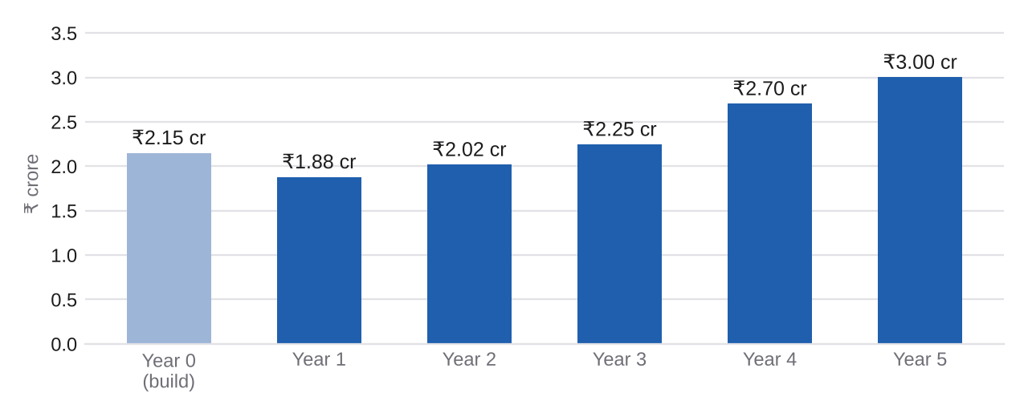
Cost per year, mid-size PA. Year 0 is the build; years 1 to 5 are running costs
Year | Merchants | Analysts | Implementation (₹ lakh) | Running (₹ lakh) | Total (₹ lakh)
Year 0 (build) |  |  | 214.9 |  | 214.9
Year 1 | 20,00,000 | 7 |  | 187.9 | 187.9
Year 2 | 22,00,000 | 7 |  | 201.7 | 201.7
Year 3 | 24,20,000 | 8 |  | 224.5 | 224.5
Year 4 | 26,62,000 | 9 |  | 270.3 | 270.3
Year 5 | 29,28,200 | 10 |  | 300.1 | 300.1
Five-year total |  |  |  |  | 1,399.5

Steps in the curve come from hiring whole people: a ninth analyst also brings a second team lead.

9 Value and break-even
Trace's value to a PA is mostly risk avoided, which is hard to price exactly. The three parts below are shown separately so that each can be judged on its own.

9.1 Regulatory exposure
In March 2024, FIU-IND fined Paytm Payments Bank ₹5.49 crore under the PMLA after law enforcement found that proceeds of online gambling had been routed through accounts at the bank. The RBI can also fine payment system operators up to ₹10 lakh or twice the amount involved, whichever is higher, and can restrict or withdraw a PA's authorisation, a far larger cost that is not priced here.

9.2 Analyst time
In the simulation, 79% of the merchants Trace acts on are really fronts or rented accounts, against 43% for a typical detector that compares a merchant only with its own history. Finding the same 15,800 bad merchants with the typical detector would mean reviewing about 36,744 alerts instead of 20,000: 16,744 fewer reviews, 7,186 hours, or about 4.2 analysts (₹33.0 lakh a year).
This saving is generous to the typical detector: in the simulation it found only 20% of the bad merchants, so in practice it could not find the same number at any price. The figures come from synthetic data and show the method working as designed, not real-world accuracy.

9.3 Honest merchants protected
A common 'sales spike' rule flagged 62% of honest sweet and electronics shops in Diwali week; comparing each shop with similar shops in the same week cut that to 1%. No ordinary honest shop of 920 was penalised. Each wrongly frozen shop is a complaint, a lost customer and a story in the press; this value is real but not priced here.

9.4 Break-even
Measure | Small PA | Mid-size PA | Large PA
All-in annual cost (₹ crore) | 1.83 | 2.31 | 5.70
FIU-scale penalties to avoid per year | 0.33 | 0.42 | 1.04
Break-even: one avoided penalty every | 3.0 years | 2.4 years | 1.0 years

For the base case, Trace breaks even if it prevents one penalty the size of FIU-IND's ₹5.49 crore every 2.4 years, before counting analyst time saved or honest merchants protected.

10 Ways to lower the cost
- Reserved cloud capacity. A one-year commitment cuts compute by about 30%, around ₹8.7 lakh a year for the base case.
- Measure before hiring. Use the shadow pilot's real case rate to size the analyst desk instead of hiring for the base-case estimate.
- Automate the Ask step. Most cases are a neutral question; sending it and reading simple replies automatically shrinks the largest group of cases.
- Start with the riskiest categories. Roll out first to categories and cities where fronts cluster, then widen.
- Share the build. Several smaller PAs could share one Trace service, with consortium tokens keeping their merchant data separate. A small PA would then pay a share of the build instead of the full cost.
- Keep the stack open-source. Trace runs on Python, pandas, scikit-learn and networkx, so there are no model licence fees.

11 Limitations
- These are planning estimates, not quotes. Salaries vary by city and seniority, and cloud prices change; most cloud prices here are approximate.
- The real share of merchants that reach a case is unknown until the pilot runs. Section 7 shows its effect.
- Value figures from the simulation (precision, Diwali false alarms) come from synthetic data calibrated to real NPCI category statistics. They show the method working as designed, not real-world accuracy.
- UPI pricing is changing. Reports in 2026 describe a 0.4% merchant discount rate on payments above ₹2,000; this appendix does not depend on it.
- Regulatory penalties are uncertain events. The break-even figure is a yardstick, not a forecast.

12 Sources
- Salaries: Scaler, Data Scientist Salary in India 2025 (scaler.com/blog/data-scientist-salary-in-india); Hero Vired (herovired.com/learning-hub/blogs/data-scientist-salary); Payscale, Anti-Money Laundering Analyst salary in India (payscale.com); Salary.com, KYC AML Analyst salary in India; AmbitionBox, AML Compliance Analyst salary
- Cloud: DoIT, AWS EC2 m6i.2xlarge pricing in ap-south-1 (doit.com/compute/spot/ap-south-1/m6i.2xlarge)
- Exchange rate: ValutaFX daily USD/INR history, November 2025; VT Markets, USD/INR near 88.85 (14 November 2025)
- FIU-IND penalty: Tribune India and Moneylife, Financial Intelligence Unit imposes ₹5.49 crore fine on Paytm Payments Bank (1 March 2024); PIB release via TaxGuru
- RBI penalty framework: RBI press releases on monetary penalties on payment system operators; Upstox, RBI tightens rules: ₹10 lakh fine and daily penalties for payment system violations
- UPI pricing: Inc42, MDR on UPI is here, but who foots the bill? (2026); PIB, incentive scheme for low-value BHIM-UPI transactions (2025)
- Trace results: reports/results.md in this repository (synthetic world of 1,000 merchants, 37 weeks)

