System Architecture Diagram
Cloud deployment design for Dockerized microservices

The diagram below shows the final target architecture for the microservices application, including containerized services, API gateway/load balancer, managed database, CI/CD pipeline, container registry, and observability components.
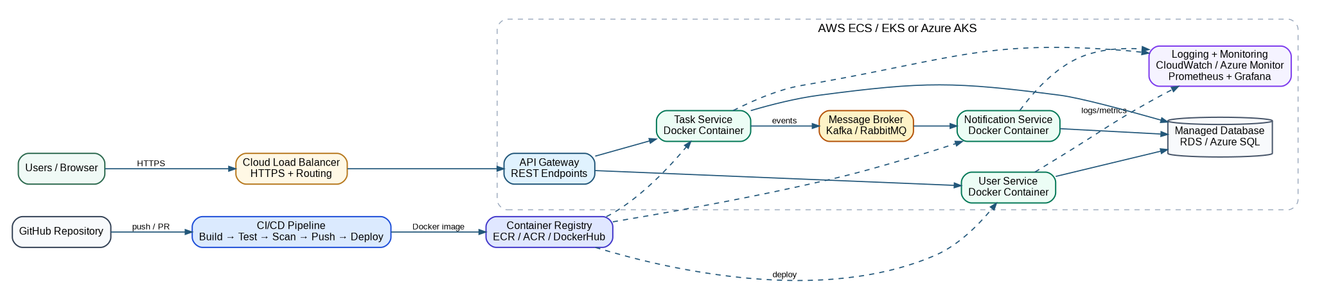

Architecture Explanation
- Users access the application through HTTPS using a cloud load balancer or application gateway.
- API Gateway routes requests to independent microservices such as User Service, Task Service, and Notification Service.
- The CI/CD pipeline builds Docker images and pushes them to a container registry before deployment.
- Logs, metrics, traces, and alerts are collected through CloudWatch/Azure Monitor and optionally Prometheus/Grafana.

