Part 3:

* What is GitHub?

[GitHub](https://github.com/) is a Git repository hosting service, but it adds many of its own features. GitHub provides a Web-based graphical interface. It also provides access control and several collaboration features, such as a wikis and basic task management tools for every project. GitHub will host your source code projects in a variety of different programming languages and keep track of the various changes made to every iteration. It is able to do this by using [git](http://learntocodewith.me/getting-started/" \l "git" \t "_blank), a revision control system that runs in the [command line interface](http://learntocodewith.me/getting-started/topics/command-line/).

* When was it created?

Github was created in 2008

* Github was created by who?

Tom Preston-Werner, Chris Wanstrath, PJ Hyett

* What similar platforms exist?

Bitbucket, Kiln, SCM- Manager and Rhodecode, GitLab, SourceForge, LaunchPad

* Why would you use such a platform?

The platform is used to collaborate with the developers worldwide, to save work and share code and remotely be part of a team with whom we can create different projects and also allow others to learn and reuse it to upgrade or enhance the performance of the software to be built.

**Part 4:**

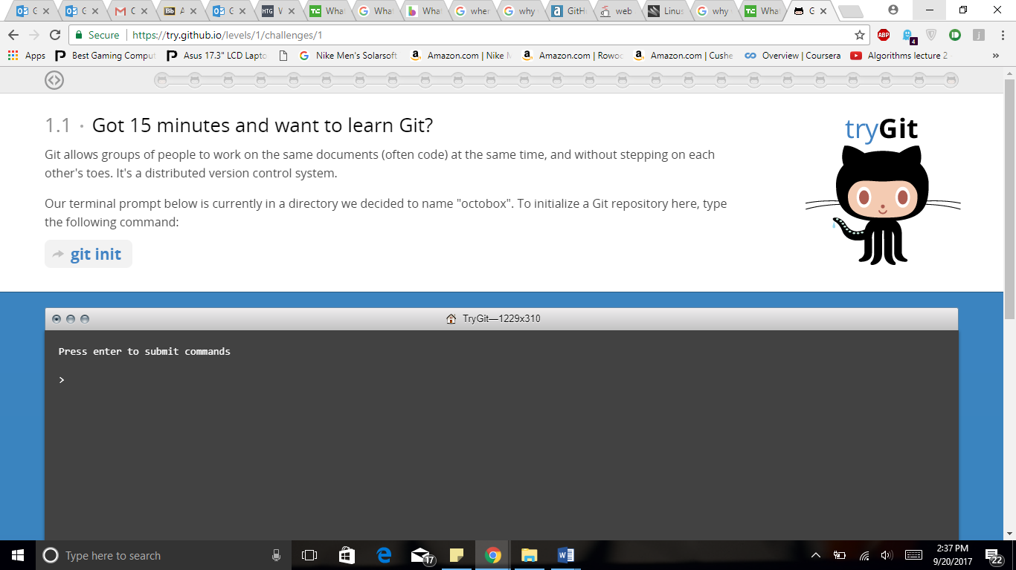

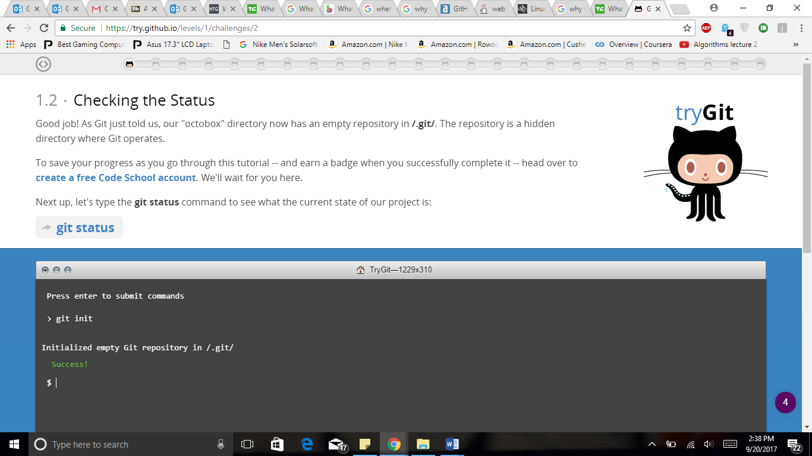

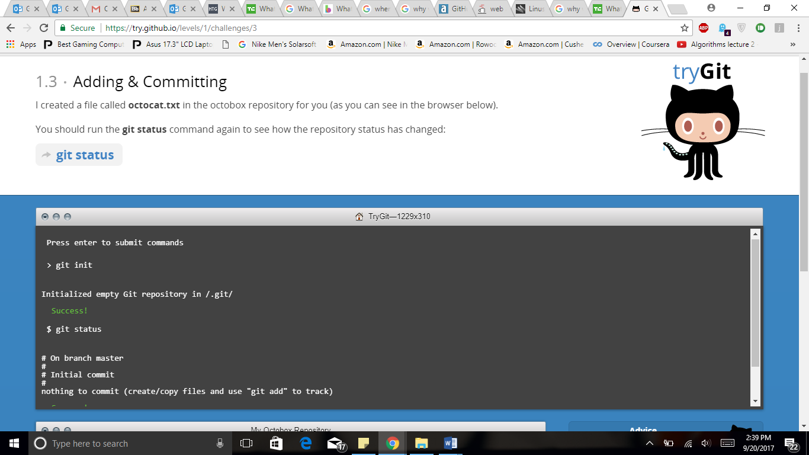

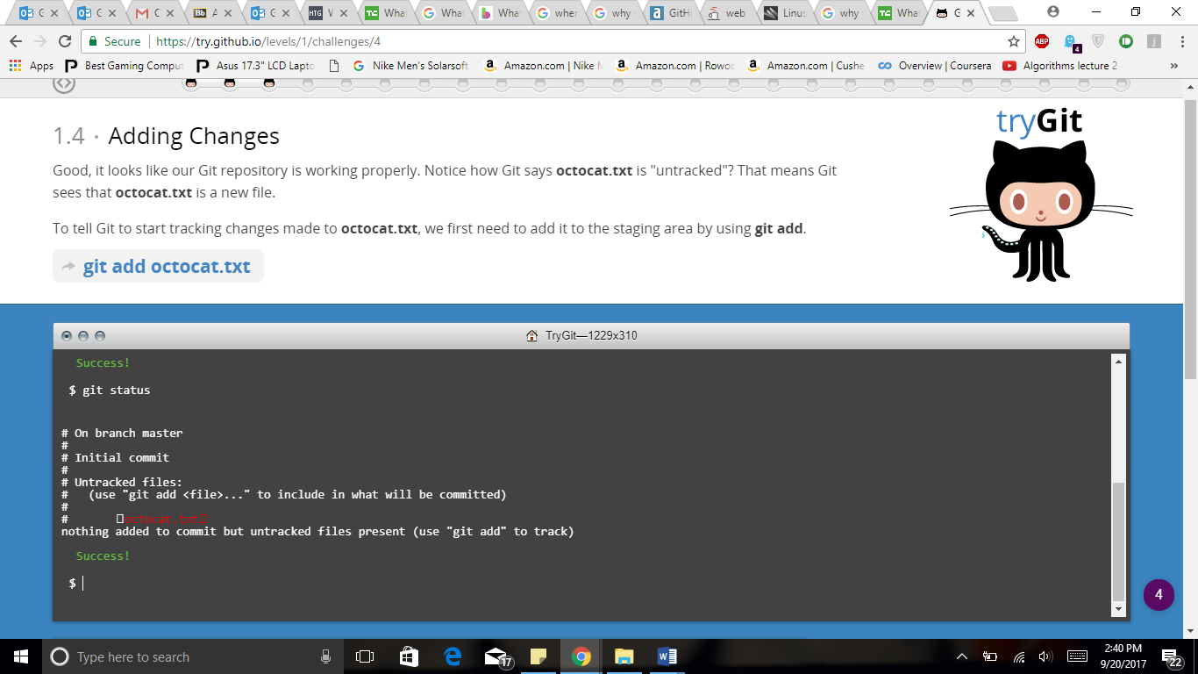

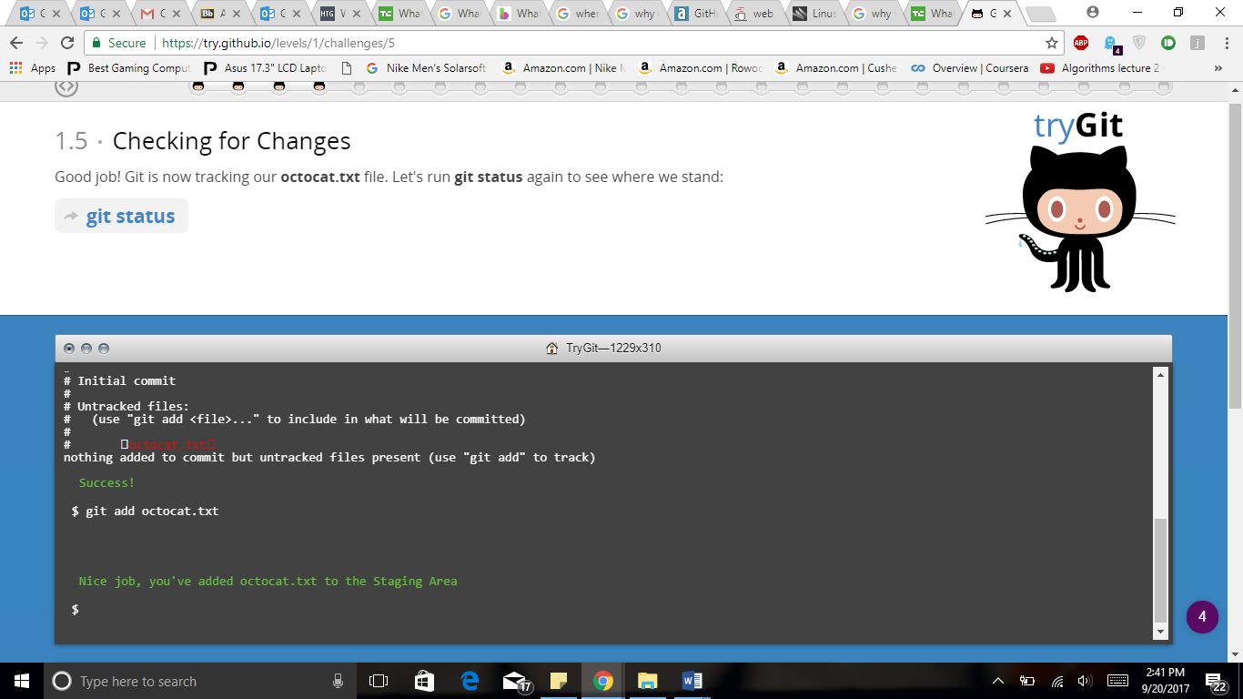

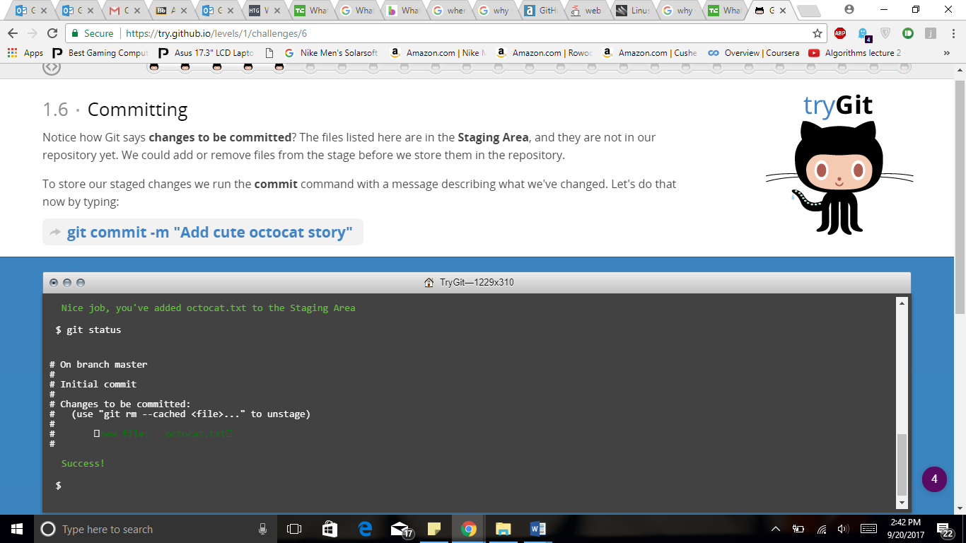

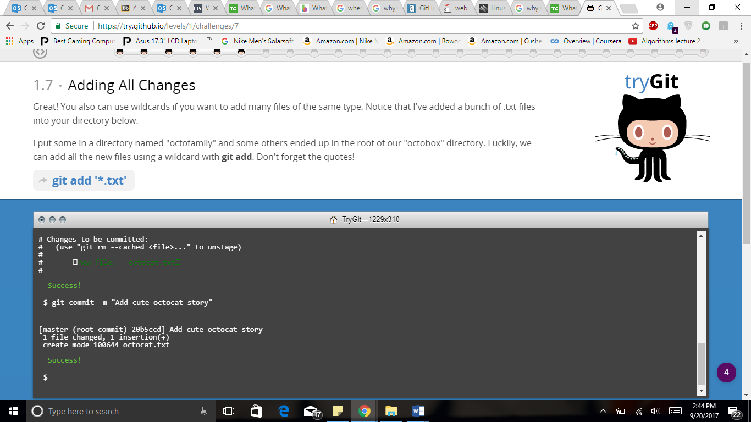

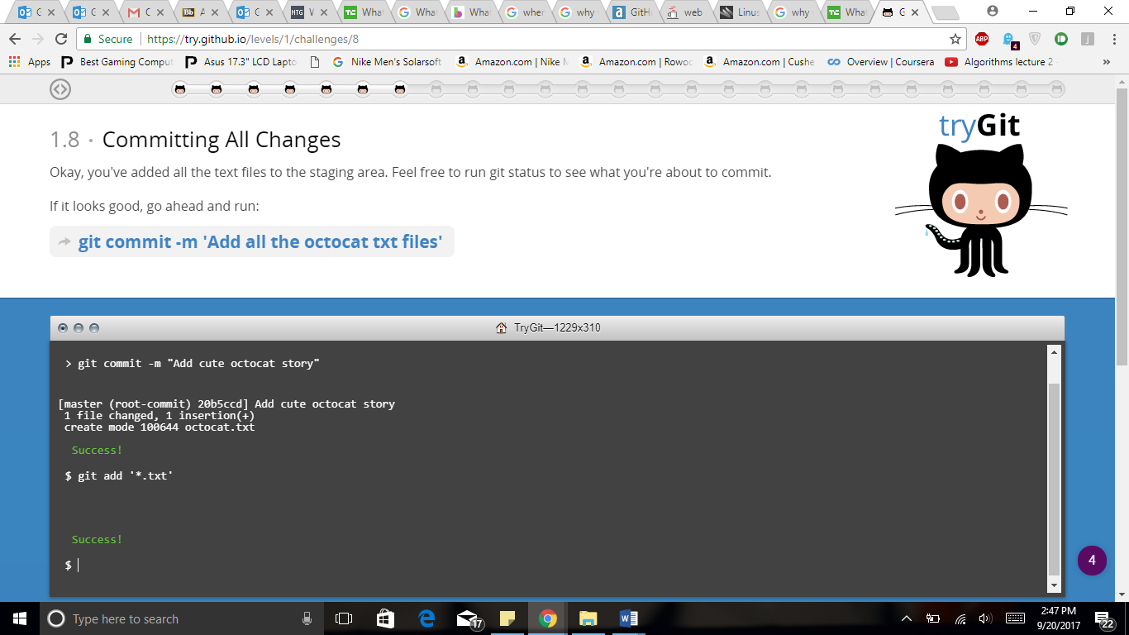

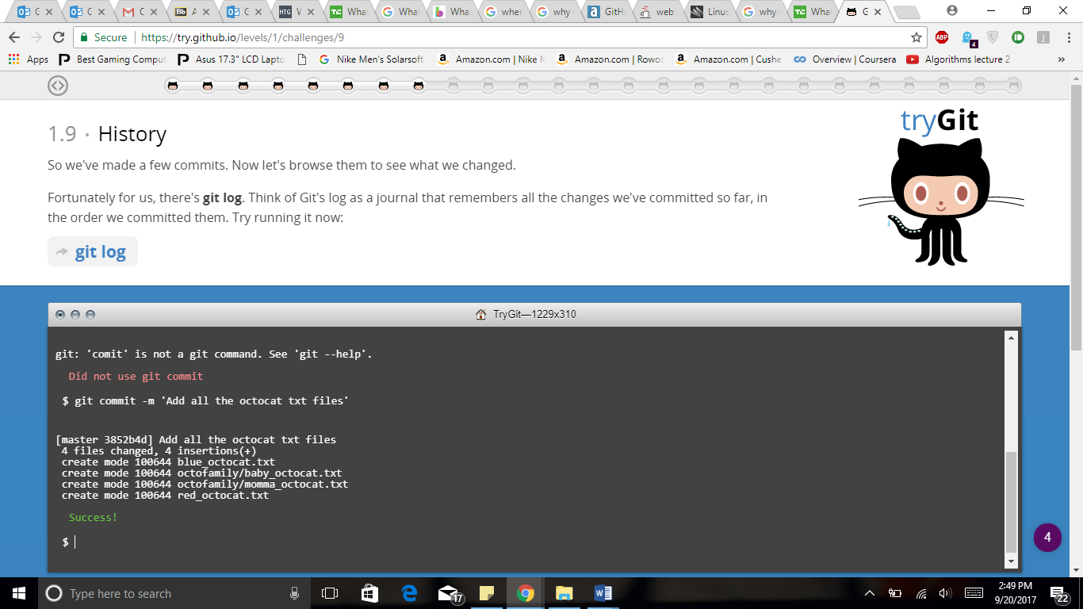

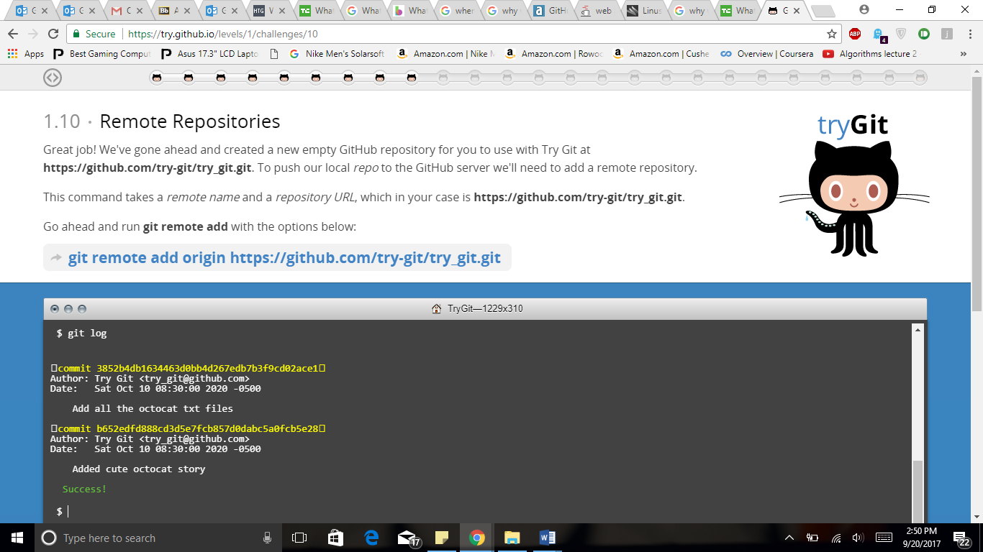

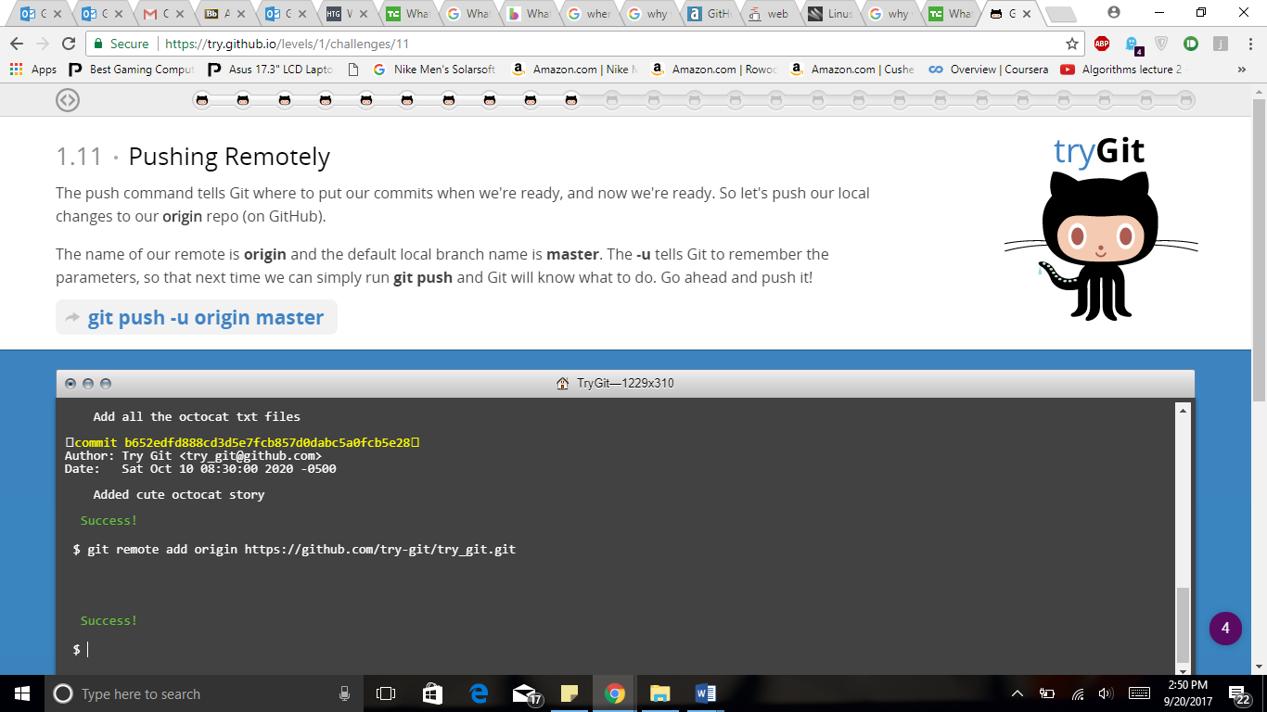

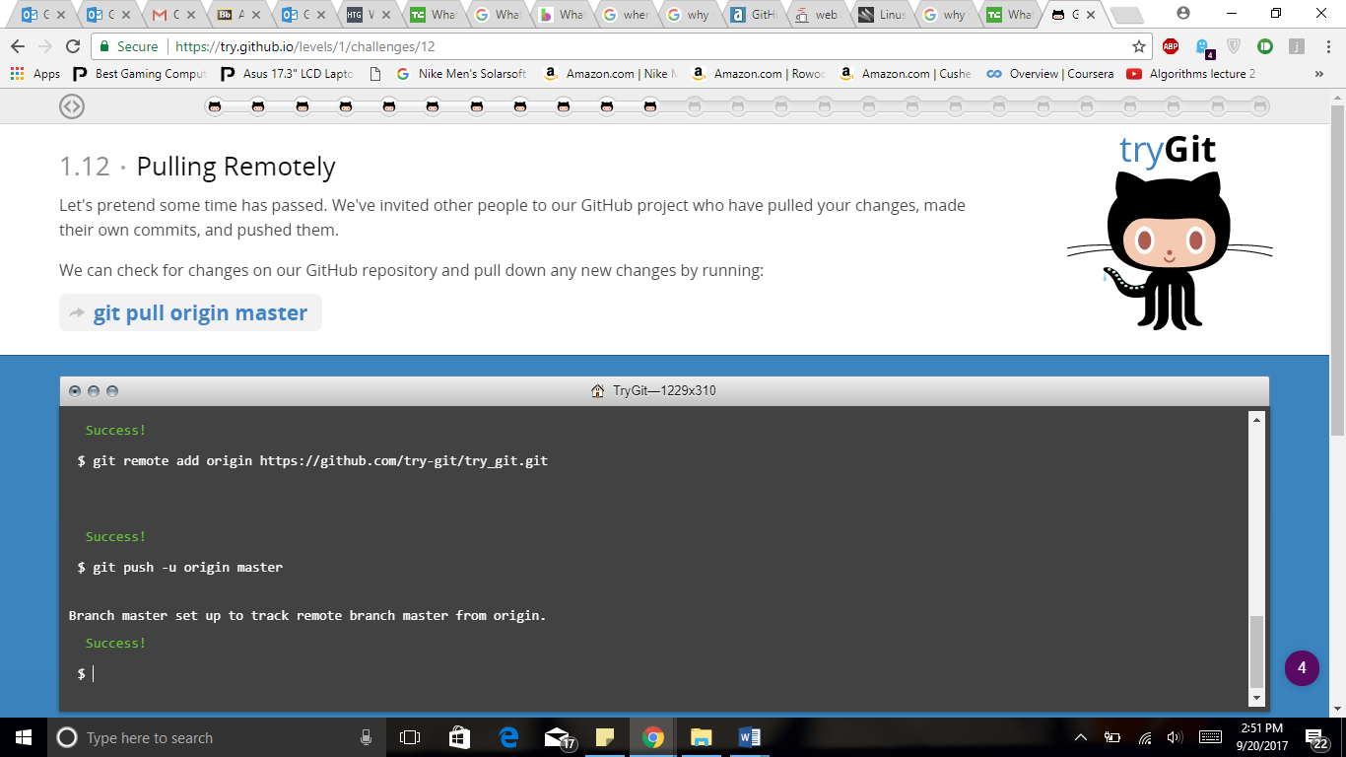

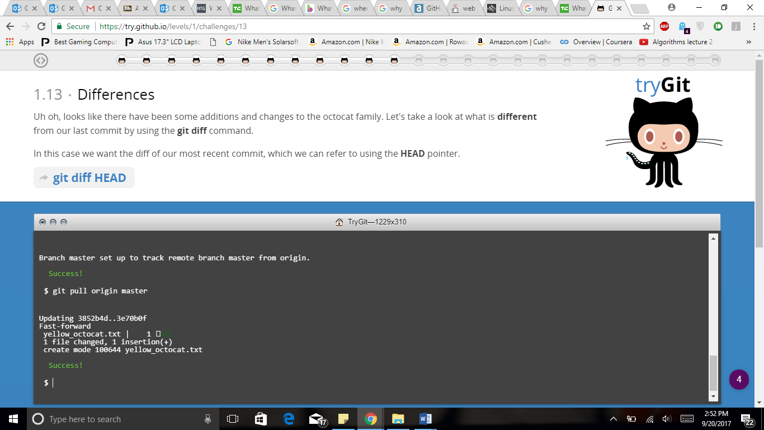

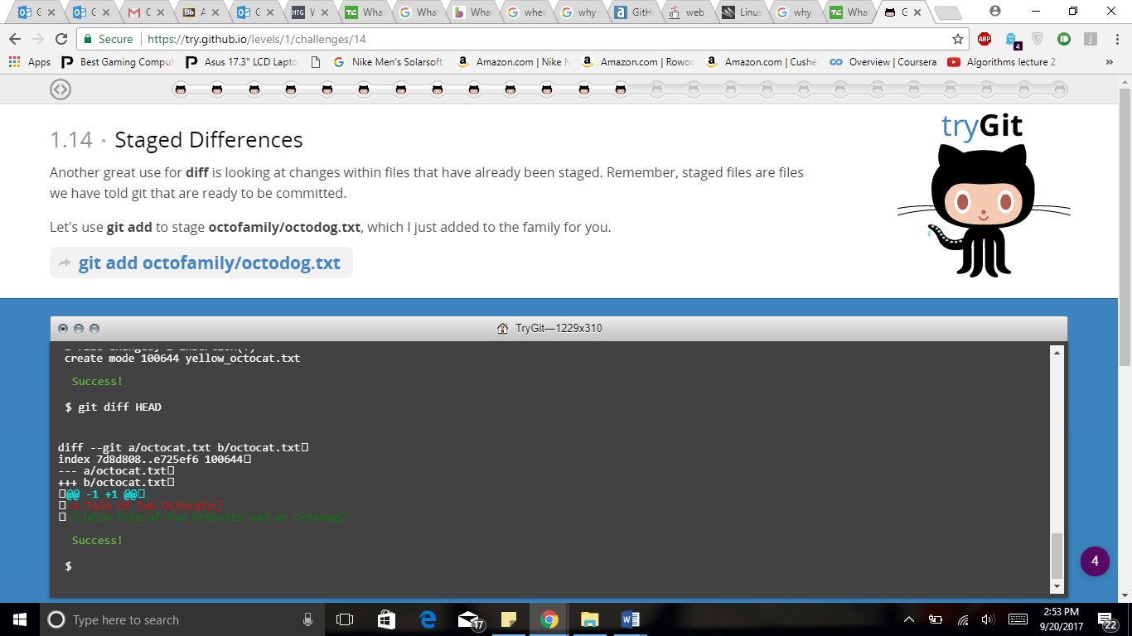

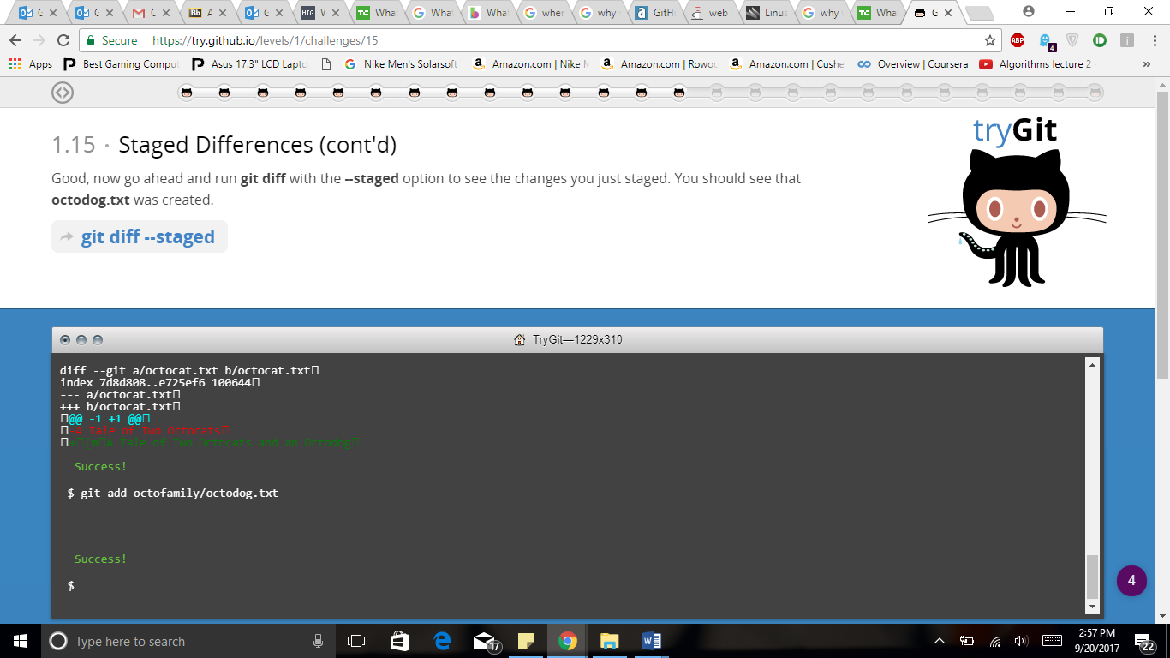

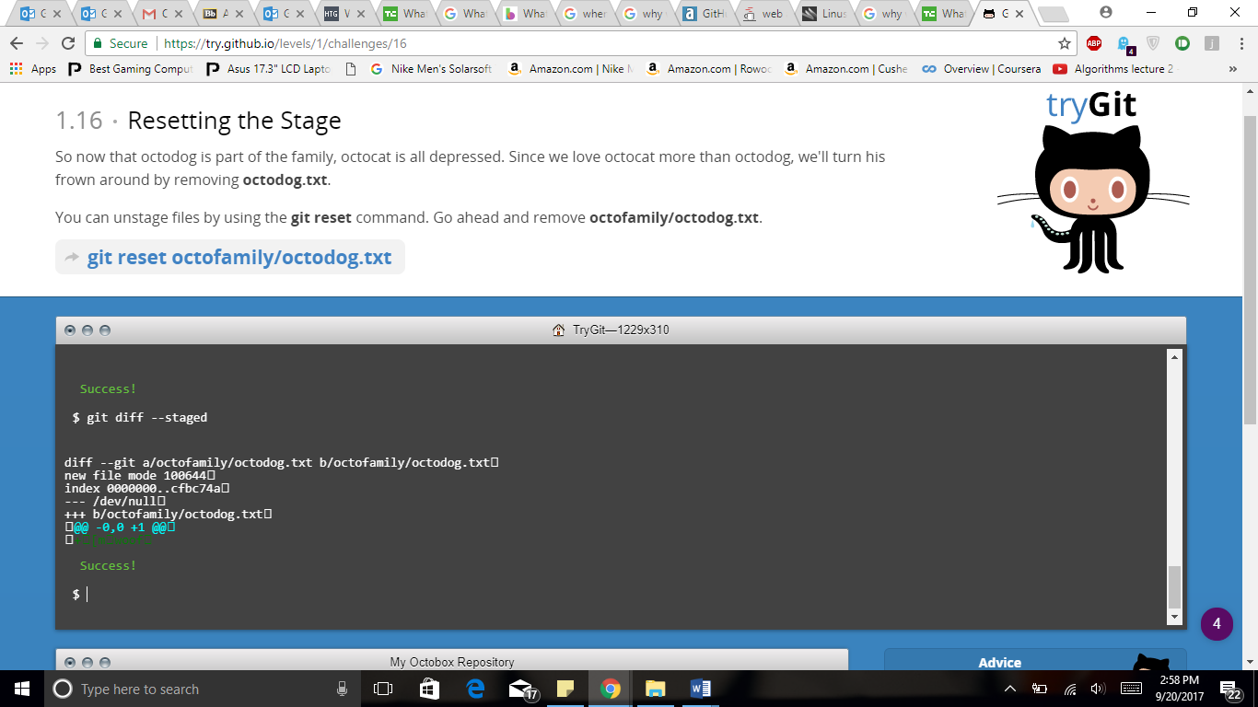

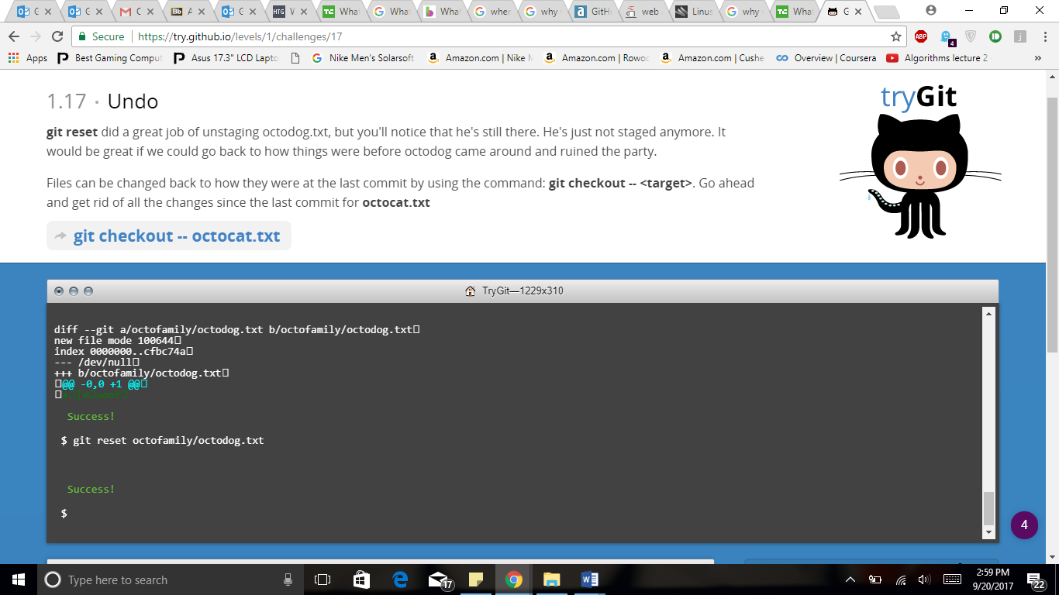

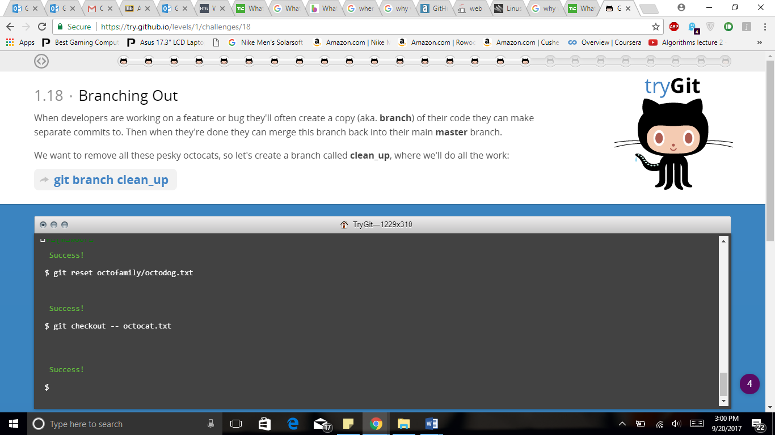

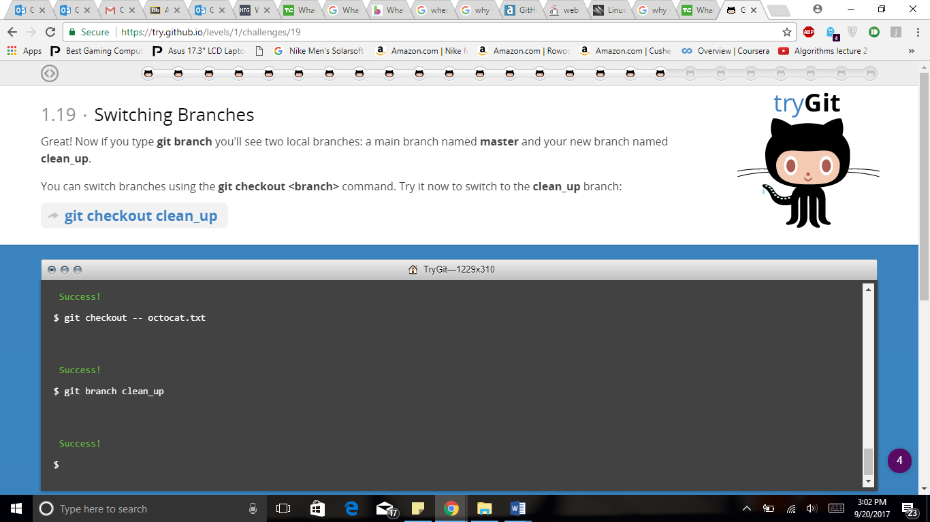

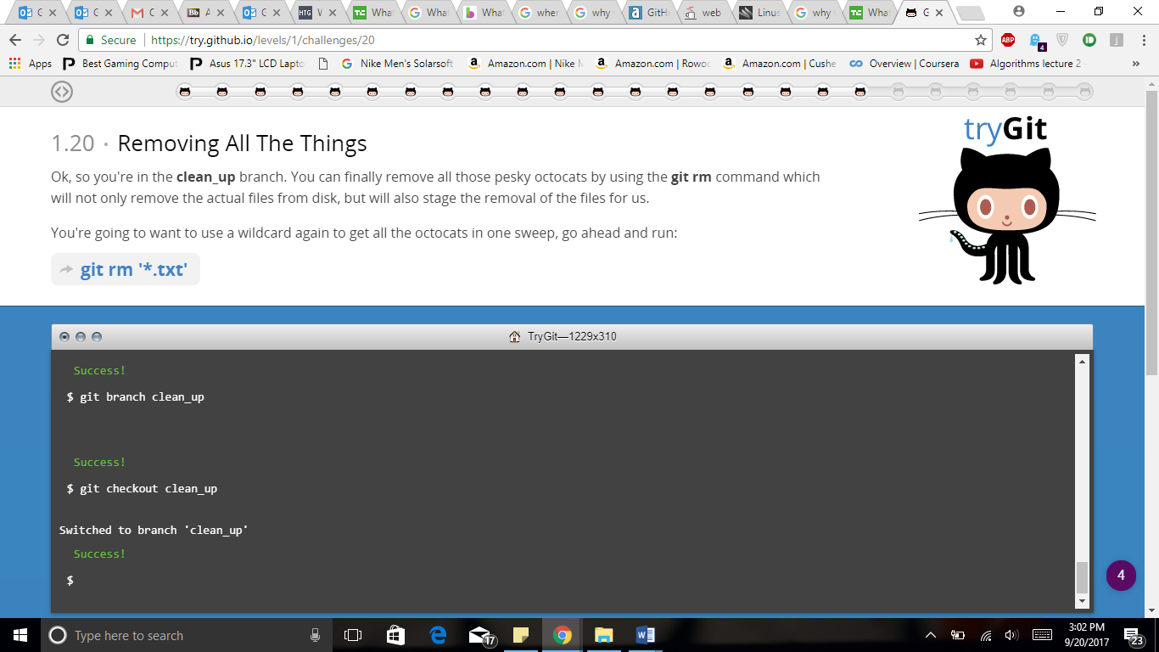

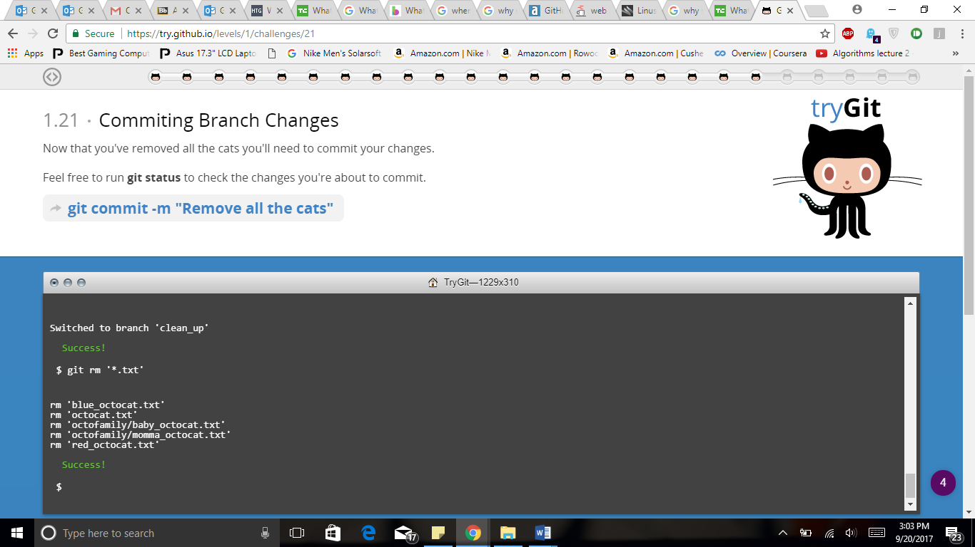

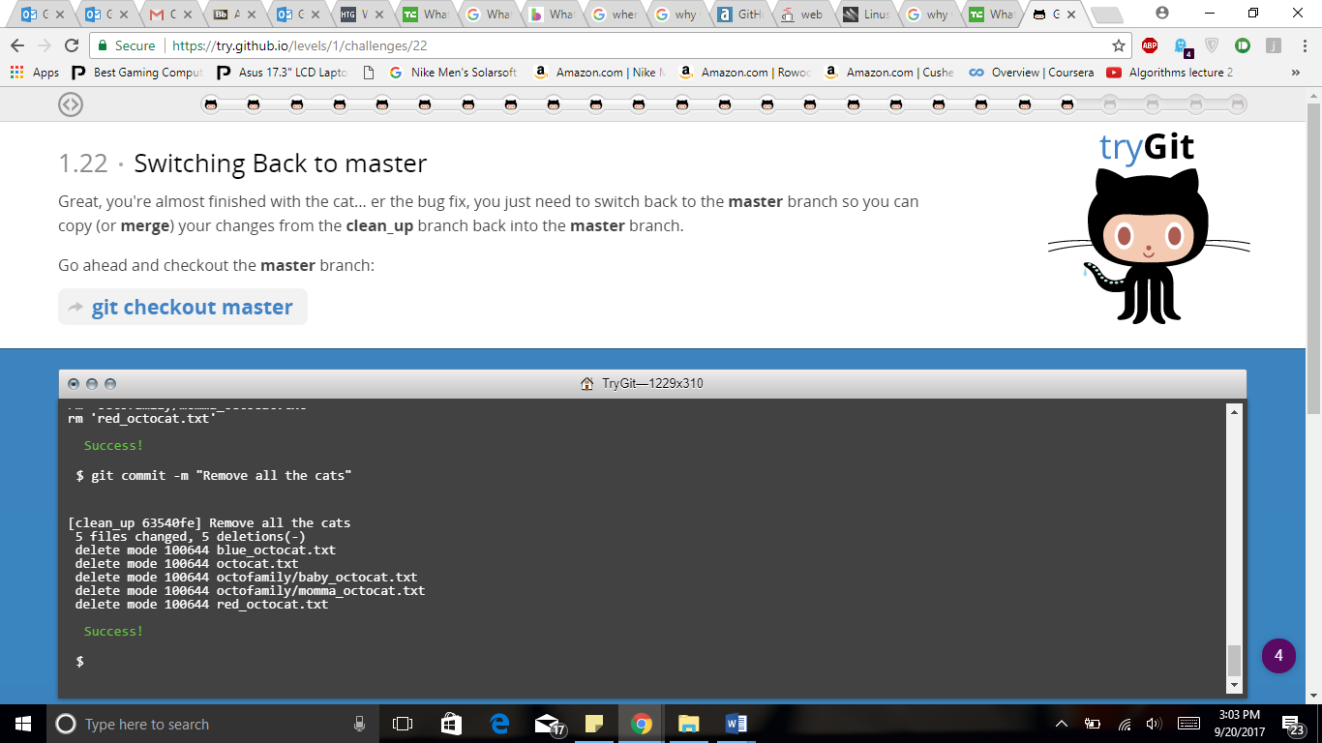

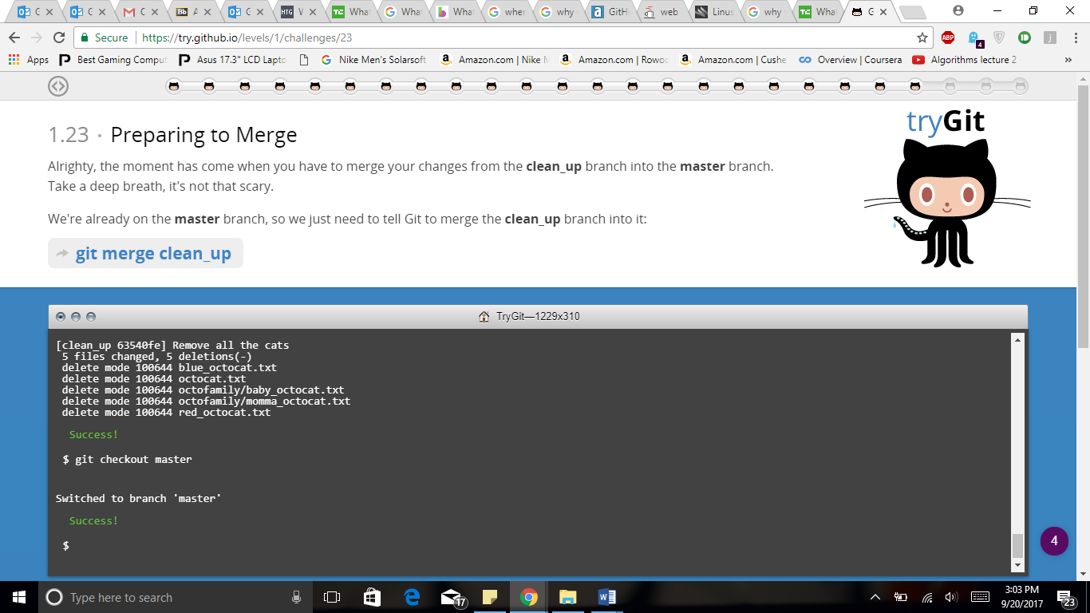

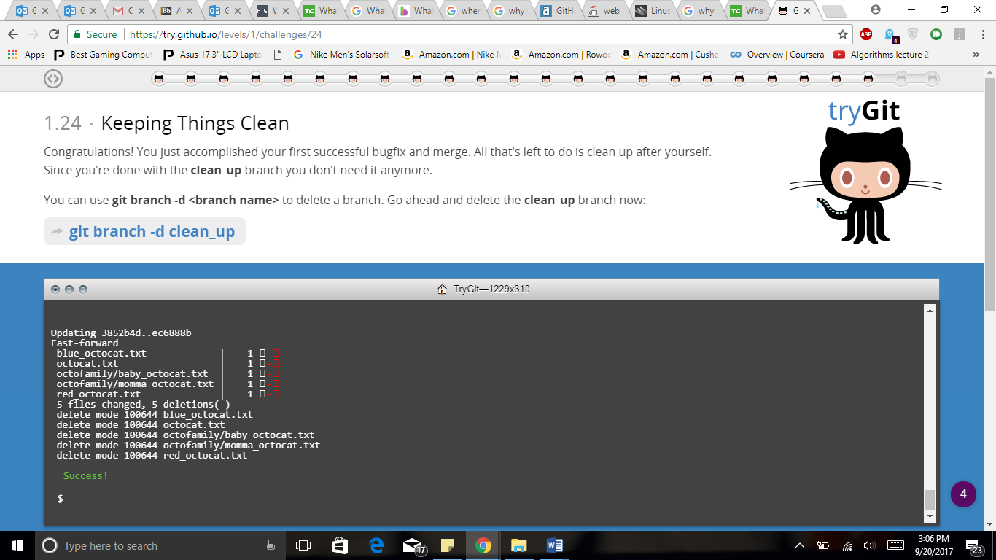

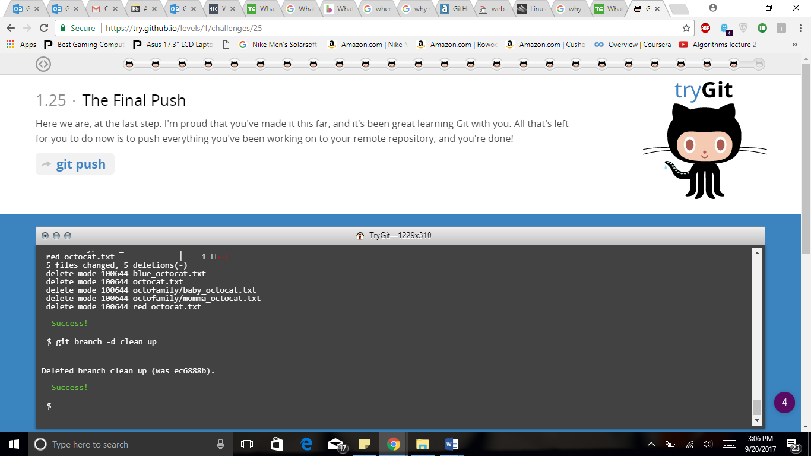

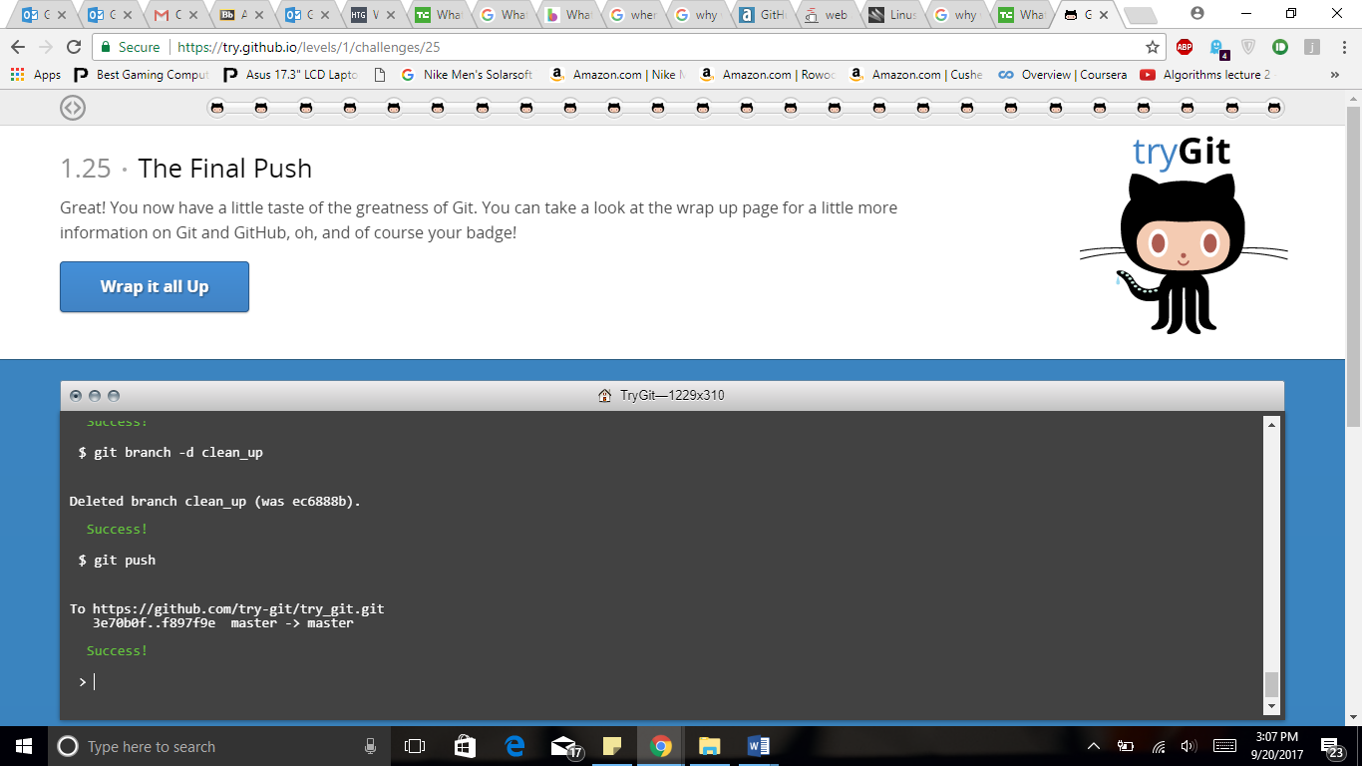

**Part 5:**

Define the following terms in the context of Git :

* Repository

A repository is a simply data structure where we store set of files or manage a project that can be change over time A Repository contains the a set of commit objects and set of references to commit objects called heads

* Commit

It stores the current contents of the index in a new commit along with a log message from the user describing the changes.

* Push

It is used to push the commits on your local branch to a remote repository. The push command takes two arguments, one is remote name and another is branch name.

* Branch

A branch is simply a lightweight pointer to one of these commits. The default branch name in git is master. As you start making commits you are given a master branch that points to the last commit you made.

* Fork:

It is basically copy of a repository. Forking repository allows you to freely experiment with changes without affecting original project.

* Merge

It incorporates changes from the named commits into the current branch. This command is used by git pull to incorporate changes from another repository and can be used by hand to merge changes from one branch into another

* Clone

The clone command copies an existing git repository. It clones a repository into newly created directory, creates remote-tracking branches for each branch in cloned repository.

* Pull

Incorporates changes from remote repository into the current branch. In default mode git pull is shorthand for git fetch followed by git merge FETCH\_HEAD

* Pull request

It provide a user friendly web interface for discussing proposed changes before integrating them into the official project. It makes easier for developers to collaborate using bitbucket.