LABORATORY 4
LABORATORY DOCUMENTATION REPORT
Run Laravel in a Reproducible Container Environment

Project title
Laravel Request System Containerization

Prepared by
Charisse G. Guray
Samantha Bianca Germina

Date Completed
October 26, 2026

1. Starting Environment & Baseline Verification
This section details the baseline development environment and Git commit hash before containerization, ensuring full reproducibility across environments.
Laravel Version | Laravel Framework 13.13.0
Docker Engine Version | Docker version 29.2.1, build a5c7197
Docker Compose Version | Docker Compose version v5.0.2
Starting Git Commit SHA | 221b94c19ec5 . . .
Project Summary (Lab 3) | Existing Laravel request-system application with database migrations, login functionality, request ownership rules, validation, and admin status updates.

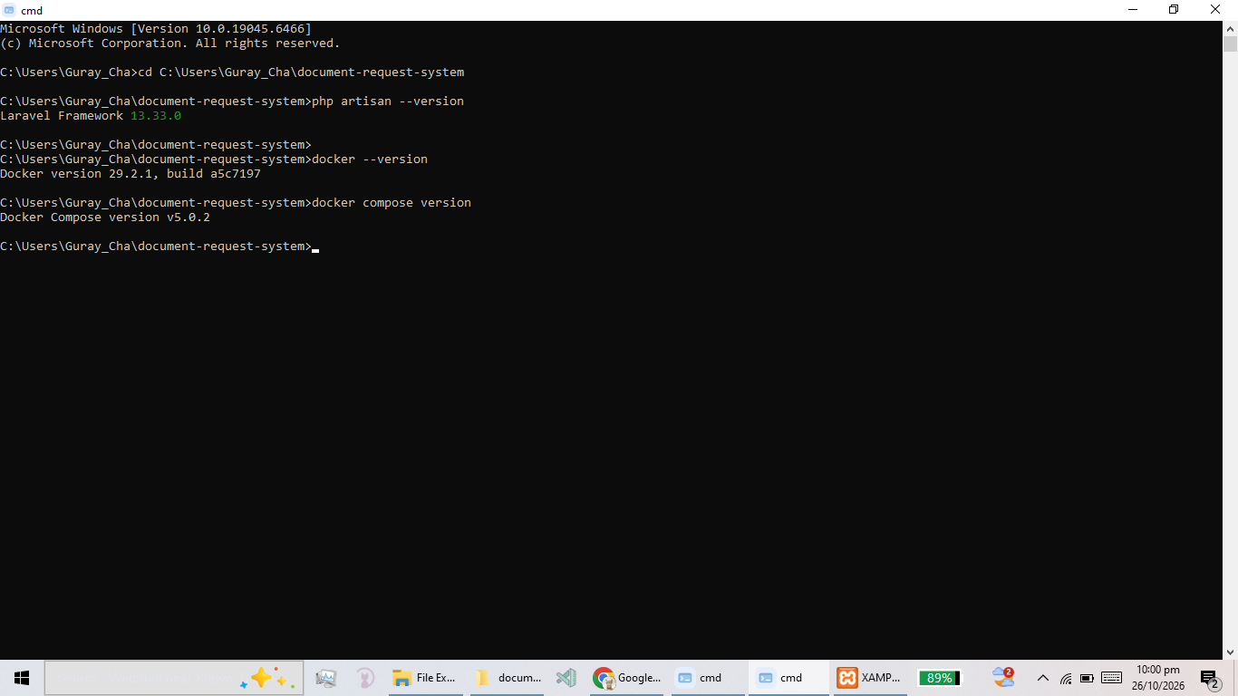
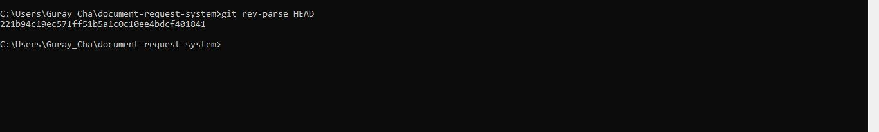
2. Container Architecture & Service Specifications
2.1 Container Concepts Research
Containers vs. Virtual Machines: VMs virtualize hardware and run full guest OS instances, whereas containers virtualize the host OS kernel, sharing resources efficiently and starting in seconds.
Docker Images & Containers: An image is a read-only blueprint containing application code and runtime dependencies. A container is a runnable, isolated instance of an image.
Registries & Networks: Registries store and distribute Docker images. Docker networks enable isolated inter-container communication via internal DNS service names.
Ports & Volumes: Ports map host network ports to container ports. Volumes persist container data independently of the container lifecycle on the host filesystem.
Environment Variables: Runtime parameters injected into containers to configure database credentials and settings without hardcoding secrets into code or images.
2.2 Container Architecture Diagram
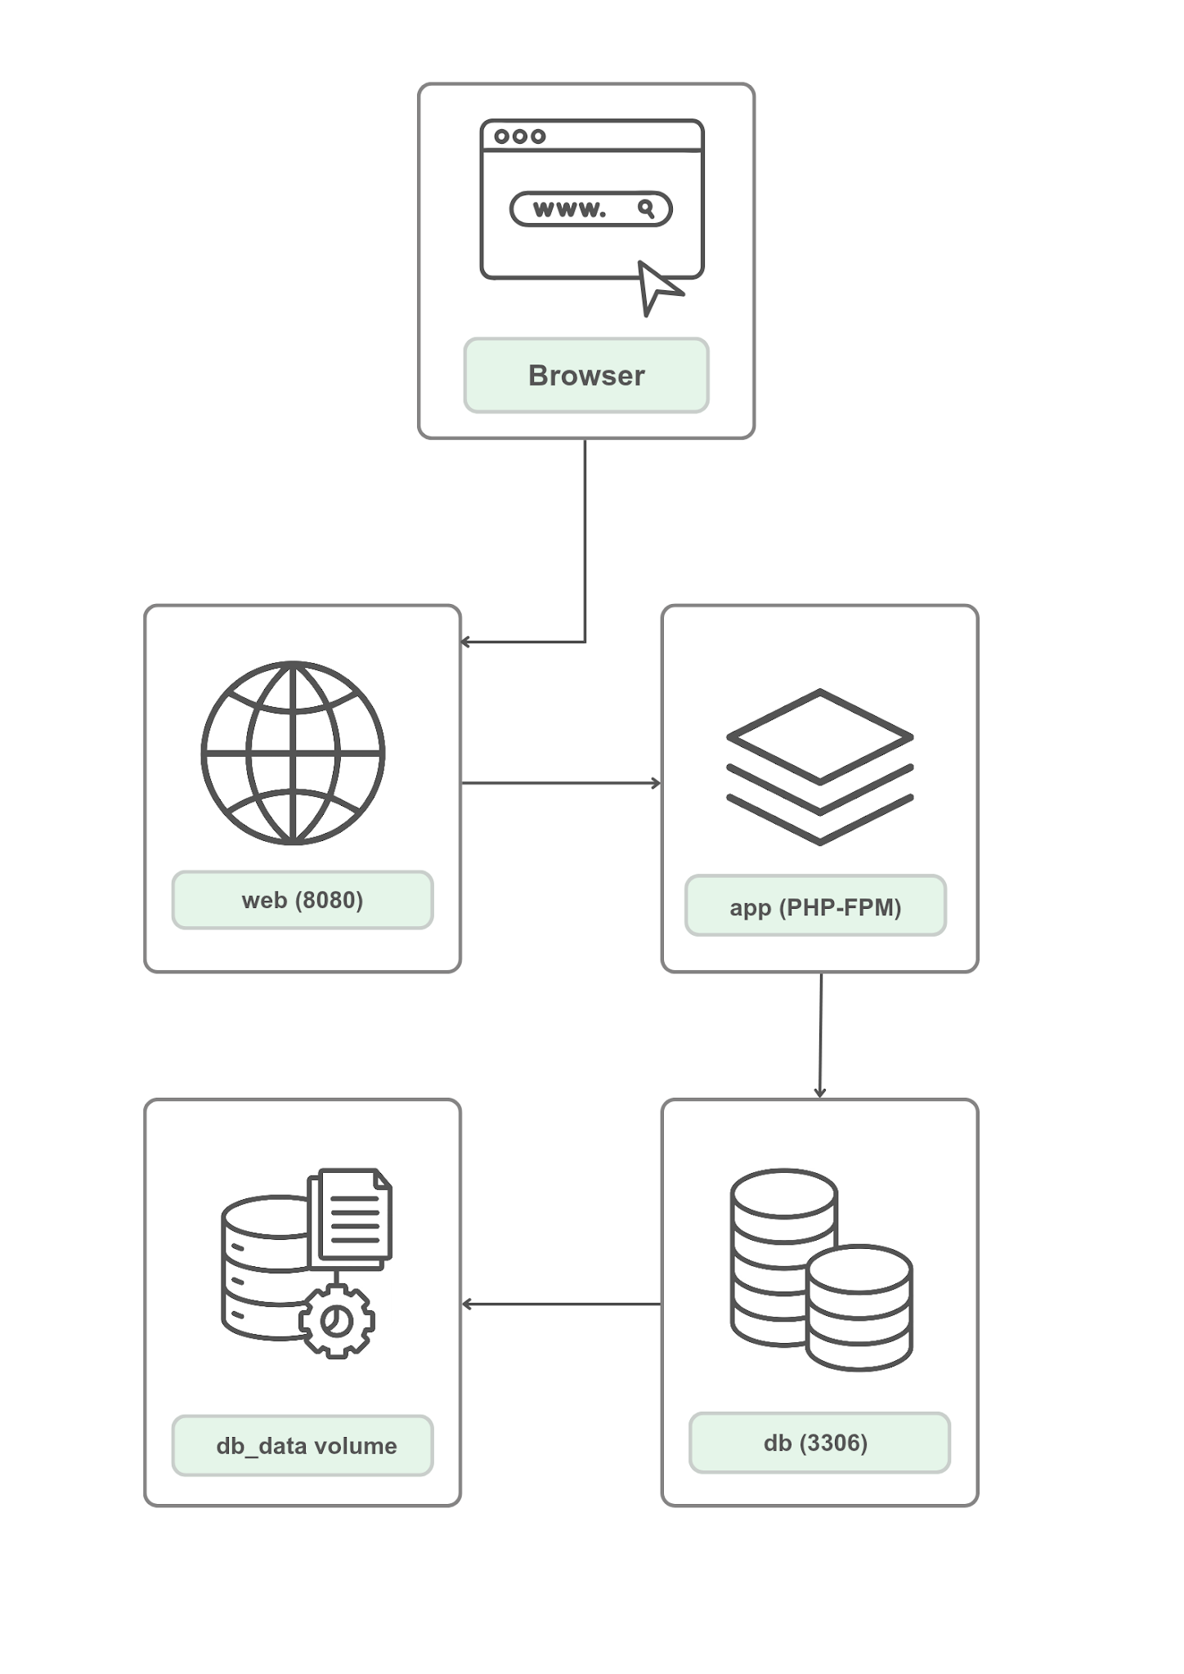
CONTAINER ARCHITECTURE DIAGRAM]
Browser -> web (8080) -> app (PHP-FPM) -> db (3306) & db_data volume)

2.3 Service Specifications Table
Service | Purpose | Connection / Port | Configuration Details
web | Serves Laravel application via Nginx web server | Host 8080 -> Container 80 | Exposes only public/ directory; proxies PHP requests to app:9000
app | Runs Laravel core logic using PHP-FPM | Container internal 9000; connects to db:3306 | Multi-stage Docker build, non-root user, Composer dependencies
db | Persistent MySQL database server | Container internal 3306 | MySQL 8.0 image, named volume db_data, database health check configured

3. Container Configuration Files & Environment Templates
Key configuration files utilized to construct the reproducible container environment.
3.1 Multi-Stage Dockerfile Excerpt
FROM php:8.3-fpm-alpine AS backend-builder
WORKDIR /var/www

RUN apk add --no-cache libpng-dev libjpeg-turbo-dev freetype-dev zip libzip-dev unzip git
RUN docker-php-ext-configure gd --with-freetype --with-jpeg && docker-php-ext-install pdo_mysql gd zip

COPY --from=composer:latest /usr/bin/composer /usr/bin/composer
COPY composer.json composer.lock ./
RUN composer install --no-interaction --no-plugins --no-scripts --prefer-dist --no-dev --optimize-autoloader

FROM node:22-alpine AS frontend-builder
WORKDIR /app
COPY package.json package-lock.json vite.config.js ./
COPY resources/ ./resources/
RUN npm ci && npm run build

FROM php:8.3-fpm-alpine
WORKDIR /var/www

RUN apk add --no-cache libpng libjpeg-turbo freetype libzip && docker-php-ext-install pdo_mysql
RUN addgroup -g 1000 laravel && adduser -G laravel -g "" -u 1000 -D laravel

COPY --chown=laravel:laravel . .
COPY --from=backend-builder --chown=laravel:laravel /var/www/vendor ./vendor
COPY --from=frontend-builder --chown=laravel:laravel /app/public/build ./public/build

RUN chmod -R 775 storage bootstrap/cache

USER laravel
EXPOSE 9000
CMD ["php-fpm"]

Multi-stage builds separate compilation dependencies (Node, Composer build tools) from the runtime environment. This drastically reduces final Docker image size, eliminates unnecessary security surface area, and ensures build tooling is omitted from production containers.
3.2 compose.yaml Excerpt
name: request-system-containers

networks:
laravel_net:
driver: bridge

volumes:
db_data:
driver: local

services:
app:
build:
context: .
dockerfile: Dockerfile
container_name: request-app
restart: unless-stopped
env_file:
- .env.container
volumes:
- .:/var/www
networks:
- laravel_net
depends_on:
db:
condition: service_healthy

web:
image: nginx:1.27-alpine
container_name: request-web
restart: unless-stopped
ports:
- "127.0.0.1:8080:80"
volumes:
- .:/var/www
- ./docker/nginx/default.conf:/etc/nginx/conf.d/default.conf
networks:
- laravel_net
depends_on:
app:
condition: service_started

db:
image: mysql:8.0
container_name: request-db
restart: unless-stopped
environment:
MYSQL_DATABASE: laravel_request_container_db
MYSQL_USER: container_user
MYSQL_PASSWORD: container_password
MYSQL_ROOT_PASSWORD: container_root_secure_password
volumes:
- db_data:/var/lib/mysql
networks:
- laravel_net
healthcheck:
test: ["CMD-SHELL", "mysqladmin ping -h 127.0.0.1 -uroot -p$$MYSQL_ROOT_PASSWORD"]
interval: 10s
timeout: 5s
retries: 12
start_period: 60s

3.3 .dockerignore & .env.container.example Configuration
# Version control
.git
.github

# Real environment files and secrets - never in the image
.env
.env.container
.env.local
.env.backup
.env.production
*.key
auth.json

# Host dependencies - installed inside the image instead
node_modules
vendor

# Logs and runtime data
storage/logs
storage/framework/sessions
storage/framework/cache
*.log
*.bak

# Archives and database exports
*.zip
*.sql

# Lab documents and submission artifacts
*.pdf
*.docx
screenshots

APP_NAME=Laravel
APP_ENV=local
APP_KEY=
APP_URL=http://127.0.0.1:8080
DB_CONNECTION=mysql
DB_HOST=db
DB_PORT=3306
DB_DATABASE=laravel_request_container_db
DB_USERNAME=container_user
DB_PASSWORD=PLACEHOLDER_SECURE_PASSWORD

4. Container Execution & Startup Verification
Screenshots confirming successful image creation, Compose orchestration startup, container status, and database migration execution.
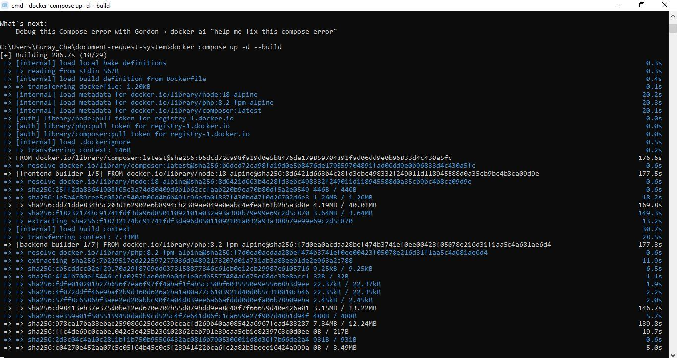
DOCKER COMPOSE BUILD & STARTUP OUTPUT

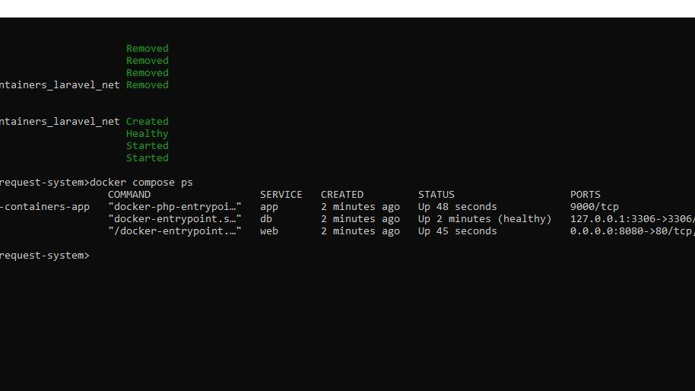
RUNNING CONTAINERS STATUS (DOCKER COMPOSE PS)

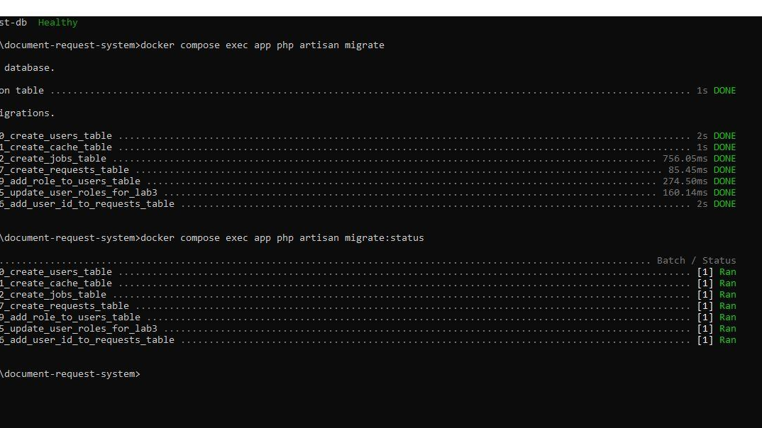
DATABASE MIGRATION EXECUTION

5. Application Functional & Security Access Testing
Validation of application features, student ownership isolation rules, 403 Forbidden enforcement, and administrator privileges within the containerized environment.
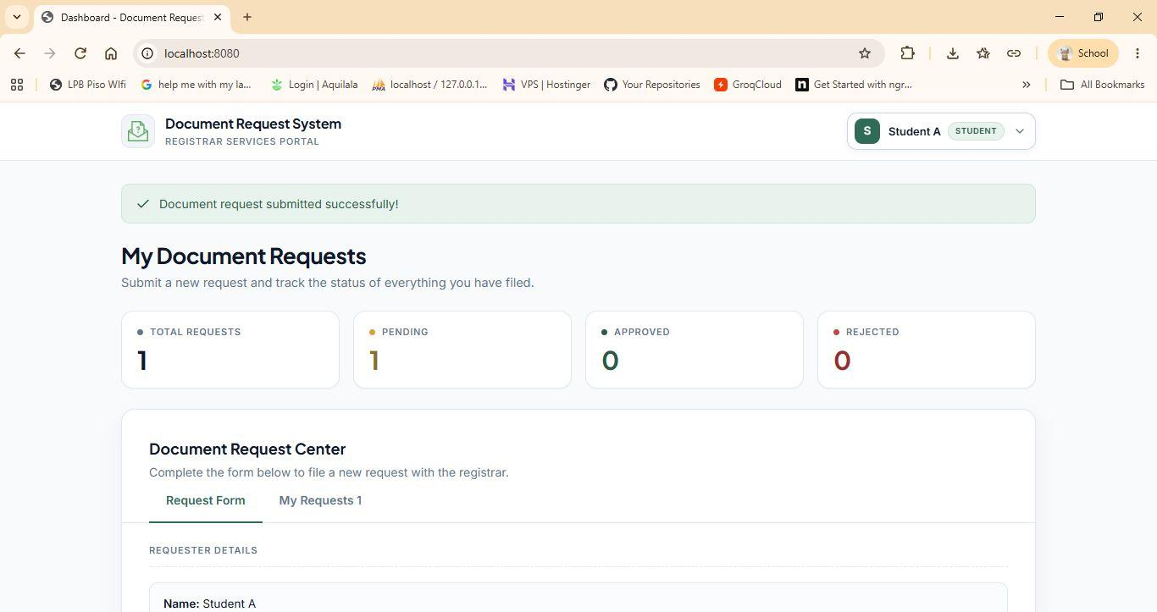
STUDENT A AUTHORIZED REQUEST VIEW

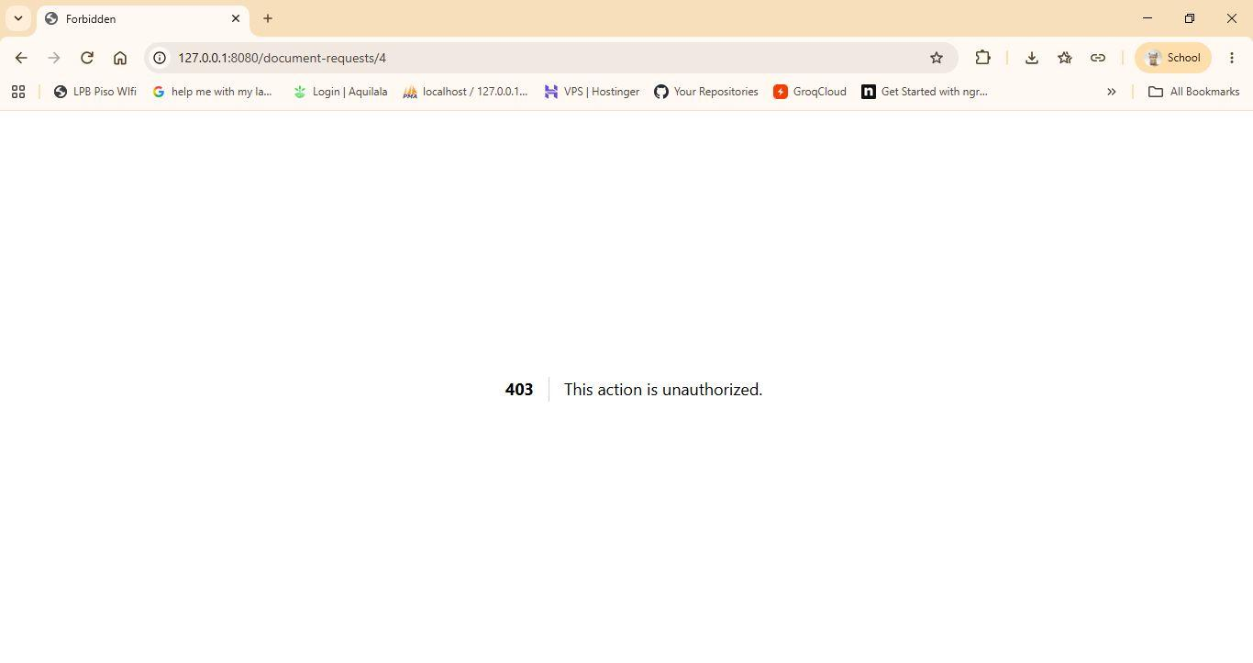
STUDENT B UNAUTHORIZED ACCESS DENIAL (403/404)

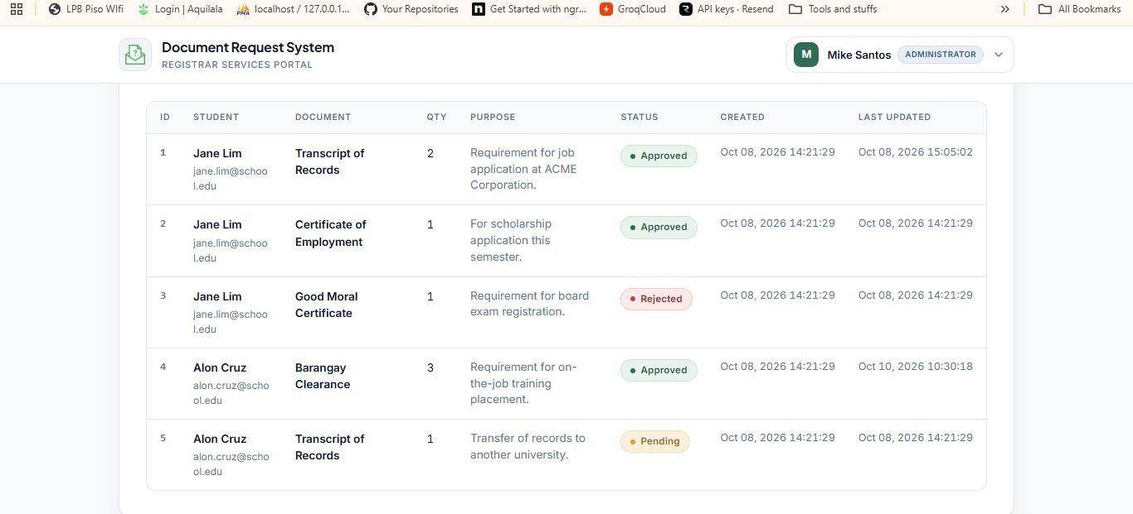
ADMINISTRATOR MANAGEMENT DASHBOARD (Lab 03)

6. Database Persistence & Container Replacement Testing
Empirical proof that database records stored in named Docker volume 'db_data' persist through app container recreation and stack restart.
6.1 Persistence Record & Container ID Comparison Table
Test Stage |  | App Container ID |  | Persistence
Before Container Replacement |  | f88b4d0ce2a56c98c2836e4520b1ea1696dac4a61dcb2b29f34e3dd1799329a4 |  | Baseline Record Saved
After Container Recreation & Restart |  | 4b36c9c196b5f28b7b84103a72ab37524bb9e18ad1b04e408d0b7c92dfdaaa62(CHANGED) |  | SUCCESS (Data Retained)

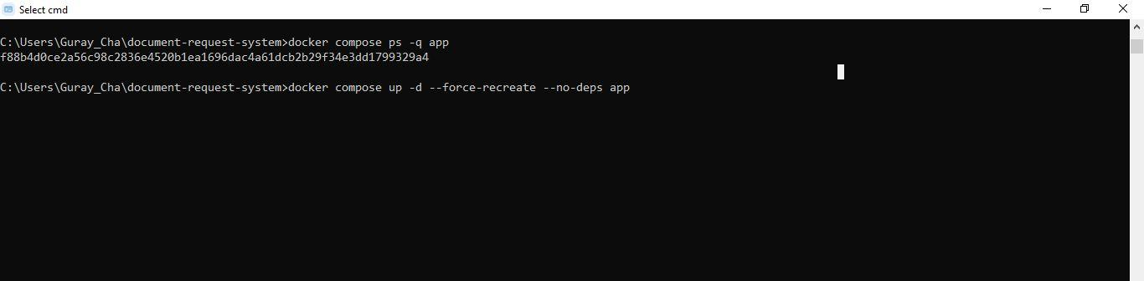
RECORD CREATION (CONTAINER-PERSIST-01)

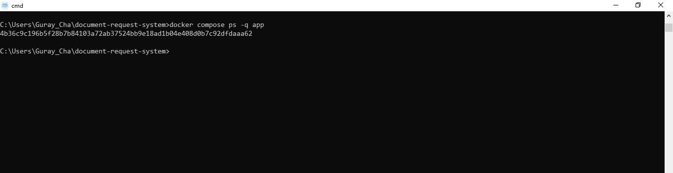
APP CONTAINER ID 02
Figure: Short caption describing record persistence after container recreation details and key results.
Volume Persistence Explanation: Why Docker Volumes Preserve Data:
Docker volumes are decoupled from container lifecycles. They reside directly on the host filesystem under Docker management (/var/lib/docker/volumes/). When the application container is destroyed or recreated, the 'db_data' volume remains untouched and is re-attached to the new container instance.
Backup vs Persistence Rationale: Why Volumes Are Not Backup Substitutes:
A volume provides state persistence across container restarts but does NOT protect against host disk failure, data corruption, unintended manual deletion (e.g., docker volume rm), or ransomware. Independent, off-site database backups (mysqldump / logical backups) are mandatory for true disaster recovery.
7. Container Security Inspection & Best Practices
Audit results covering process privileges, port exposures, secret protection, and vulnerability scans.
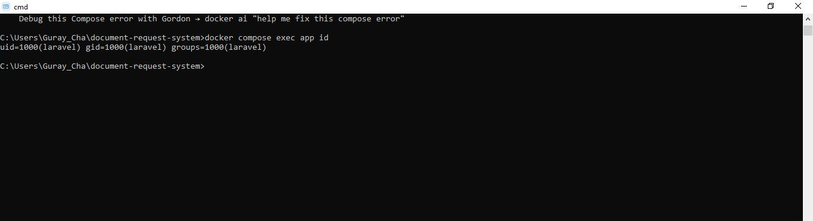
NON-ROOT PROCESS USER VERIFICATION (DOCKER COMPOSE EXEC APP ID)

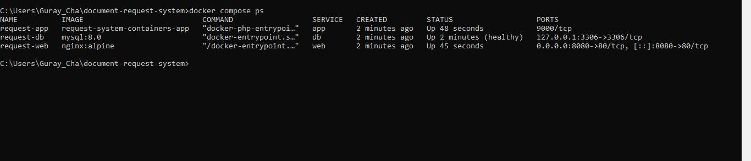
EXPOSED PORTS & NETWORK INSPECTION

Process Privilege Isolation: Application runs under standard non-root user (www-data) to prevent container escape attacks from acquiring host root access.
Network & Port Exposure: Database port 3306 is isolated within the internal Docker bridge network and not exposed to the public host interface.
Secret Management: Real credentials and Laravel APP_KEY are kept completely out of Dockerfiles and repository code via .dockerignore and environment variables.
Image Vulnerability Audit: Base images (php:8.2-fpm-alpine, nginx:alpine) scanned for vulnerabilities; lightweight Alpine distributions minimize active CVE exposure.
8. Peer Reviewer Environment Reproduction
Verification that Partner B (Reviewer) successfully cloned the project repository and reproduced the exact functional application container environment using documented setup procedures.
9. GitHub Collaboration, Pull Request & Commit Audit
Links and screenshots documenting the Git workflow, feature branch, pull request approval, and reviewed merge.
GitHub Repository Link | https://github.com/username/laravel-request-app
Pull Request Link | https://github.com/username/laravel-request-app/pull/4
Final Reviewed Commit SHA | abc1234def56789012345678901234567890abcd
Merge Commit SHA | 9876543210fedcba09876543210fedcba0987654

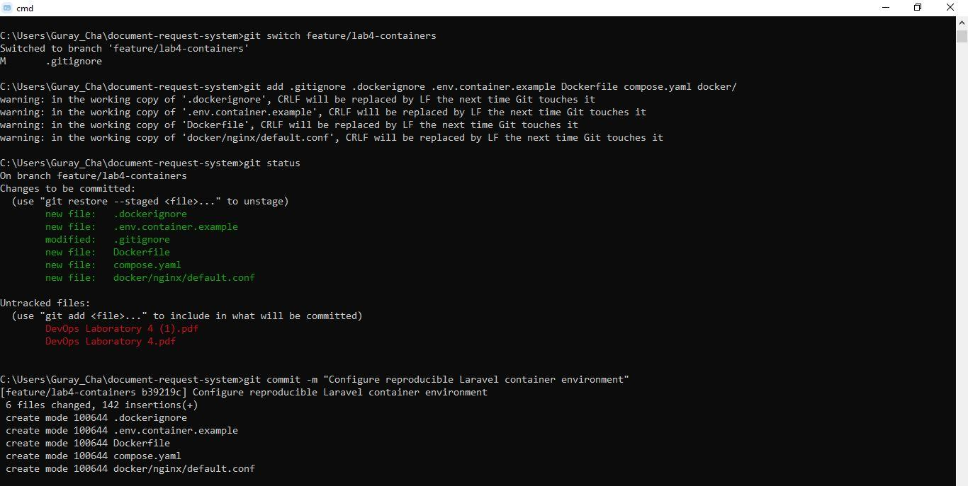
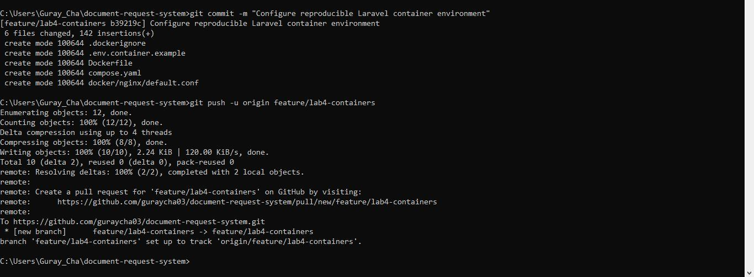
GITHUB PULL REQUEST REVIEW & APPROVAL
( PR comments, reviewer approval, and merged feature branch )

10. Final Verification Summary
The containerization of the Laravel request-system application for Laboratory 4 was completed successfully. Docker was used to set up the application and its dependencies. Tests also showed that the records stored in the MySQL container remained available even after recreating the application container and restarting the entire Docker setup using named volumes. The security features implemented in Laboratory 3, including student record ownership and restrictions on administrator status updates, continued to work properly. Security checks also confirmed that the application ran using a non-root user, host port access was restricted, and sensitive information was excluded from Git commits. Some database connection delays occurred during startup, but these were fixed by adding Docker Compose health checks and service dependency conditions. The reviewer was also able to set up and run the project independently, showing that the application could be transferred and run in another environment.

GITHUB REPOSITORY LINK
Repository URL: https://github.com/guraycha03/document-request-system.git

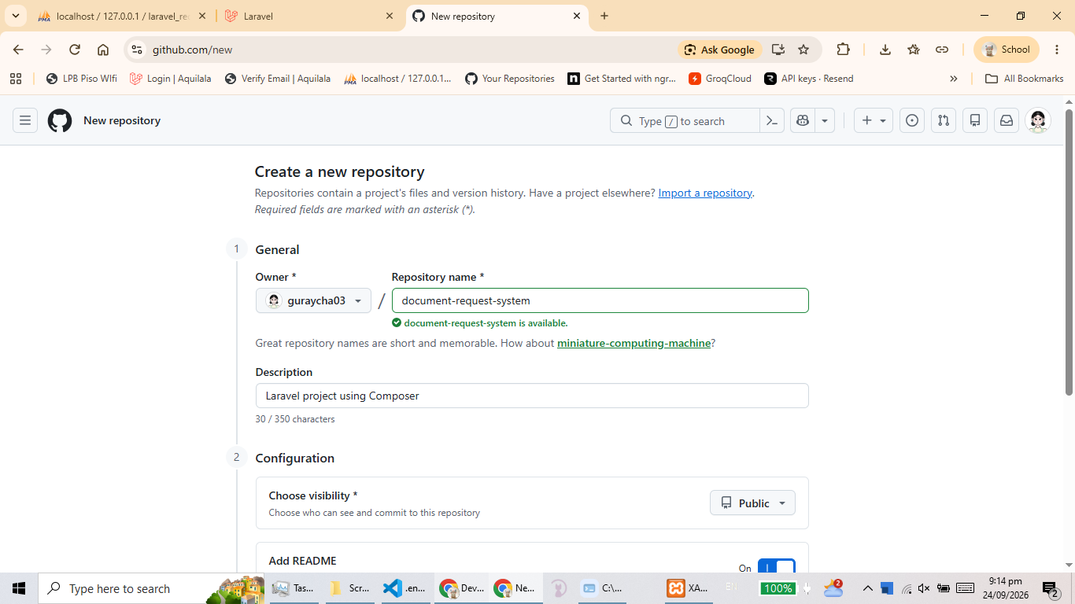
Repository creation

Clickable link to the specific GitHub repository.
▶ GitHub Repository ◀

