LABORATORY 3
SECURE REQUEST ACCESS THROUGH REVIEWED CHANGES
Manage reviewed code changes, resolve a merge conflict, and implement and test server-side access and input controls in the request system from Laboratory 2.

Project title
Document Request and Generation System

Prepared by
Charisse G. Guray
Samantha Bianca Germina

Date Completed
October 10, 2026

Driver and Reviewer Responsibilities

Role | Student | Responsibilities
Driver | Charisse G. Guray (GitHub – guraycha03) | Creates the feature branch; writes the policy, controller, routes, model and views; writes and runs the automated tests; commits and pushes; opens the pull request; changes the README verification instruction on the feature branch; triggers and resolves the merge conflict; performs the post-resolution retest; builds this report.
Reviewer | Samantha Bianca Germina (GitHub – SamBianca) | Uses her own GitHub account and never shares credentials; inspects the diff for authentication, policy enforcement, list scoping, trusted field assignment, validation, escaping, CSRF and secret exclusion; leaves a substantive review comment; approves the pull request; changes the README verification instruction on main; re-checks and re-approves the final revision after the conflict resolution.

Keyboard and testing duties were exchanged during the session as required by instruction 4. No account, password or access token was shared at any point (instruction 6).

5. 1. Starting Checkpoint (Instructions 2 and 3)
Checkpoint item | Recorded value
MySQL database name | laravel_request_system_db
Framework and version | Laravel 13.33.0
PHP version | PHP 8.3.16
Preparation commit | 8aa992a7f35d9a4678801fa827b8b526253f5945 ("Updated migration and model for Lab 03")
Default branch / feature branch | main / feature/lab3-secure-requests
Model mapped to the requests table | App\Models\DocumentRequest (table name: requests)
Real .env file present in the repository | No - .env is untracked; only .env.example is committed

1.1 Fictional account labels and owned request IDs
Labels only. Passwords, tokens and .env contents are deliberately not reproduced anywhere in this report, as required by instruction 3.
Label | Account label | Role | Request IDs
Student A | Jane Lim | Student | 1, 2, 3, 6, 7
Student B | Alon Cruz | Student | 4, 5
Administrator | Mike Santos | Administrator | none (sees all 1-7)

1.2 Checkpoint evidence

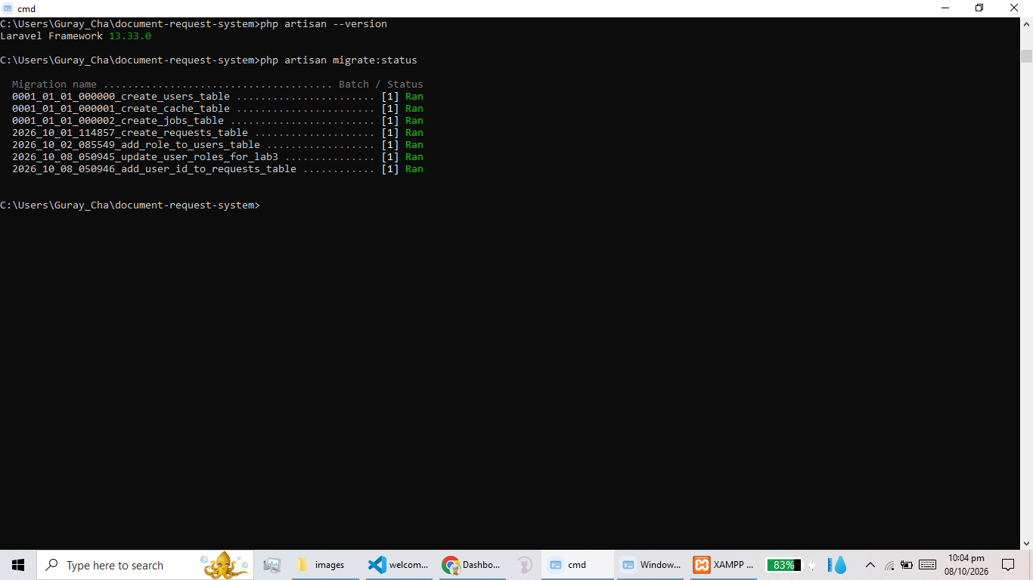
Evidence CP1 - the output of "php artisan --version" showing the Laravel version
Evidence CP2 - the output of "php artisan migrate:status" showing all migrations run for laravel_request_system_db

2. Issue, Feature Branch, CODEOWNERS and Branch Protection (Instructions 5 to 7)

2.1 GitHub issue
Issue #1 - "Secure request ownership and status access" - opened on the repository with the four access rules and measurable acceptance checks, and linked to the pull request.
Issue link
https://github.com/guraycha03/document-request-system/issues/1

2.2 Who maintains what (README section)

Area | Maintained by
Policy (app/Policies/DocumentRequestPolicy.php) | Driver, reviewed by Reviewer
Controller (app/Http/Controllers/DocumentRequestController.php) | Driver, reviewed by Reviewer
Routes (routes/web.php) | Driver, reviewed by Reviewer
Views (resources/views) | Driver, reviewed by Reviewer
Tests (tests/Feature) | Driver, reviewed by Reviewer

2.3 CODEOWNERS
.github/CODEOWNERS
* @guraycha03 @SamBianca

2.4 Repository settings
- Branch protection on main: 1 required approving review, code-owner review required, changes must be made through a pull request.
- Effect observed: a direct push to main was reported as "Bypassed rule violations ... Changes must be made through a pull request", and the pull request itself displayed "Merging is blocked - At least 1 approving review is required by reviewers with write access".
- Access: the Reviewer was added as a collaborator with Write access using her own GitHub account. No credentials were shared.

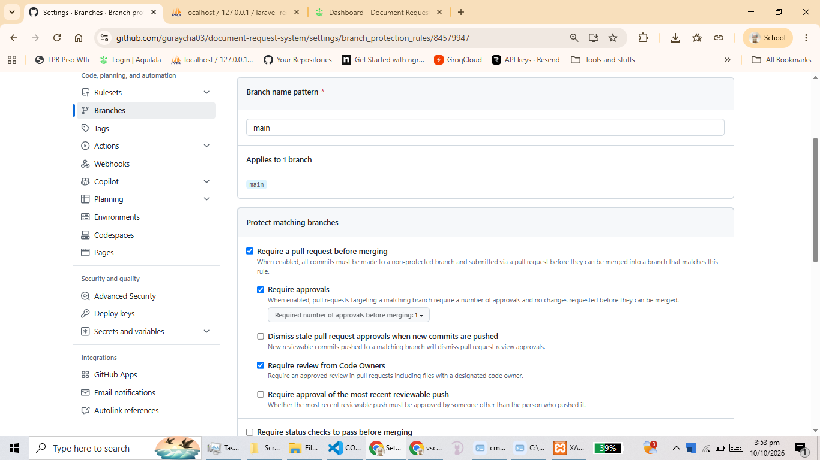
Evidence BP1 - the branch protection rules for main showing the required approving review

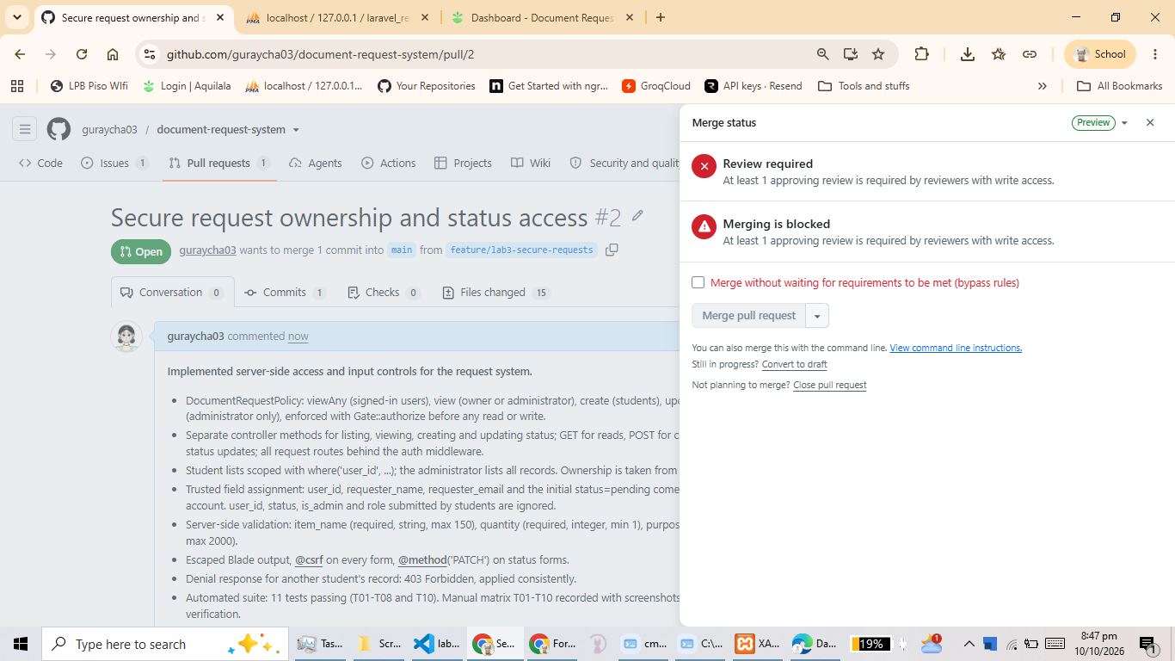
Evidence BP2 - the pull request page showing "Merging is blocked" until the reviewer approved

3. Server-Side Implementation (Instructions 8 to 16)

3.1 Protected routes and HTTP verbs (instruction 8)
All request routes sit behind the auth middleware; login routes stay available to guests. GET is used for reads, POST for creation and PATCH for status updates.
routes/web.php
<?php

use App\Http\Controllers\Auth\AuthController;
use App\Http\Controllers\DocumentRequestController;
use Illuminate\Support\Facades\Route;

// Guest Routes (Only unauthenticated users can access)
Route::middleware('guest')->group(function () {
Route::get('/login', [AuthController::class, 'showLoginForm'])->name('login');
Route::post('/login', [AuthController::class, 'login']);
});

// Authenticated Routes (Only logged-in users can access)
// GET = read, POST = create, PATCH = change status
Route::middleware('auth')->group(function () {
Route::post('/logout', [AuthController::class, 'logout'])->name('logout');

Route::get('/', [DocumentRequestController::class, 'index'])->name('dashboard');
Route::get('/document-requests/{documentRequest}',
[DocumentRequestController::class, 'show'])->name('document-requests.show');
Route::post('/document-requests',
[DocumentRequestController::class, 'store'])->name('document-requests.store');
Route::patch('/document-requests/{documentRequest}',
[DocumentRequestController::class, 'updateStatus'])->name('document-requests.update-status');
});

3.2 Policy (instruction 9)
Named DocumentRequestPolicy to match the Laboratory 2 model DocumentRequest that is mapped to the requests table. Laravel discovers it automatically; no explicit registration was needed.
app/Policies/DocumentRequestPolicy.php
<?php

namespace App\Policies;

use App\Models\DocumentRequest;
use App\Models\User;

class DocumentRequestPolicy
{
// Any signed-in user may open the request list page.
// The list contents are scoped by ownership in the controller.
public function viewAny(User $user): bool
{
return true;
}

// Only the owner of a request or an administrator may view it.
// Anyone else receives 403 Forbidden.
public function view(User $user, DocumentRequest $documentRequest): bool
{
if ($user->isAdministrator()) {
return true;
}

return $documentRequest->user_id === $user->id;
}

// Only authenticated students may create requests.
public function create(User $user): bool
{
return $user->isStudent();
}

// Only an administrator may change the status of a request.
public function updateStatus(User $user, DocumentRequest $documentRequest): bool
{
return $user->isAdministrator();
}
}

3.3 Enforcement before every read and write (instruction 10)
The Gate facade authorises each operation on the server. The Blade @can directive is used only to hide controls that the signed-in user is not allowed to use; it is never the security check.
app/Http/Controllers/DocumentRequestController.php (enforcement points)
Gate::authorize('viewAny', DocumentRequest::class); // index - list page
Gate::authorize('view', $documentRequest); // show - record detail
Gate::authorize('create', DocumentRequest::class); // store - new request
Gate::authorize('updateStatus', $documentRequest); // updateStatus - status change

3.4 Denial response chosen: 403 Forbidden
A 403 is returned for another student's record on both the read path (show) and the write path (updateStatus), applied consistently as required by instruction 10. The choice and its reasoning are documented in README.md: the record demonstrably exists and was listed on a page the student is already authorised to open, so hiding it behind a 404 would be misleading and would also be indistinguishable from a mistyped URL. 403 states exactly what happened - the request exists but belongs to another account.

3.5 List scoping (instruction 11)
app/Http/Controllers/DocumentRequestController.php :: index()
$user = $request->user();

$requests = $user->isAdministrator()
? DocumentRequest::orderBy('created_at', 'desc')->get()
: DocumentRequest::where('user_id', $user->id)
->orderBy('created_at', 'desc')
->get();

return view('welcome', compact('requests'));

A student therefore only ever receives rows whose user_id equals their own primary key. Ownership is taken from user_id only, never from a submitted field.

3.6 Validation and trusted field assignment (instructions 13 to 14)
app/Models/DocumentRequest.php (mass-assignment allowlist)
protected $fillable = [
'item_name',
'quantity',
'purpose',
];

user_id, requester_name, requester_email and status are deliberately absent from $fillable, so they cannot be mass-assigned from any student-submitted input.
app/Http/Controllers/DocumentRequestController.php :: store()
Gate::authorize('create', DocumentRequest::class);

$validated = $request->validate([
'item_name' => ['required', 'string', 'max:150'],
'quantity' => ['required', 'integer', 'min:1'],
'purpose' => ['required', 'string', 'max:2000'],
]);

$documentRequest = new DocumentRequest();
$documentRequest->item_name = $validated['item_name'];
$documentRequest->quantity = $validated['quantity'];
$documentRequest->purpose = $validated['purpose'];
$documentRequest->user_id = $request->user()->id; // signed-in account
$documentRequest->requester_name = $request->user()->name; // signed-in account
$documentRequest->requester_email = $request->user()->email; // signed-in account
$documentRequest->status = 'pending'; // fixed initial state
$documentRequest->save();

Field | Rule | Source of the stored value
item_name | required, string, max:150 | validated user input
quantity | required, integer, min:1 | validated user input
purpose | required, string, max:2000 | validated user input
user_id | rejected from input | $request->user()->id
requester_name | rejected from input | $request->user()->name
requester_email | rejected from input | $request->user()->email
status | rejected from input on create; in:pending,approved,rejected on update | fixed 'pending', then administrator update only

app/Http/Controllers/DocumentRequestController.php :: updateStatus()
Gate::authorize('updateStatus', $documentRequest);

$validated = $request->validate([
'status' => ['required', 'string', 'in:pending,approved,rejected'],
]);

$documentRequest->status = $validated['status'];
$documentRequest->save();

3.7 Escaped output (instruction 15)
Every dynamic value is rendered with the {{ }} Blade escape, so markup submitted inside the purpose field is shown as literal text instead of being executed.
resources/views/document-requests/show.blade.php
<h2 class="card-title">{{ $documentRequest->item_name }}</h2>
<span class="detail-value">{{ $documentRequest->requester_name }}</span>
<span class="detail-value">{{ $documentRequest->requester_email }}</span>
<span class="detail-value">{{ $documentRequest->quantity }}</span>
<span class="status {{ $documentRequest->status }}">{{ $documentRequest->status }}</span>
<p>{{ $documentRequest->purpose }}</p>

3.8 CSRF protection (instruction 16)
Every state-changing form carries @csrf, and the status form additionally declares PATCH with @method, because HTML forms cannot send a PATCH verb natively.
resources/views/document-requests/show.blade.php
<form action="{{ route('document-requests.update-status', $documentRequest) }}"
method="POST" class="status-form detail-form">
@csrf
@method('PATCH')
<select name="status" class="status-select">
<option value="pending" @selected($documentRequest->status === 'pending')>Pending</option>
<option value="approved" @selected($documentRequest->status === 'approved')>Approved</option>
<option value="rejected" @selected($documentRequest->status === 'rejected')>Rejected</option>
</select>
<button type="submit" class="button action-btn">Update Status</button>
</form>

3.9 Implementation evidence screenshots

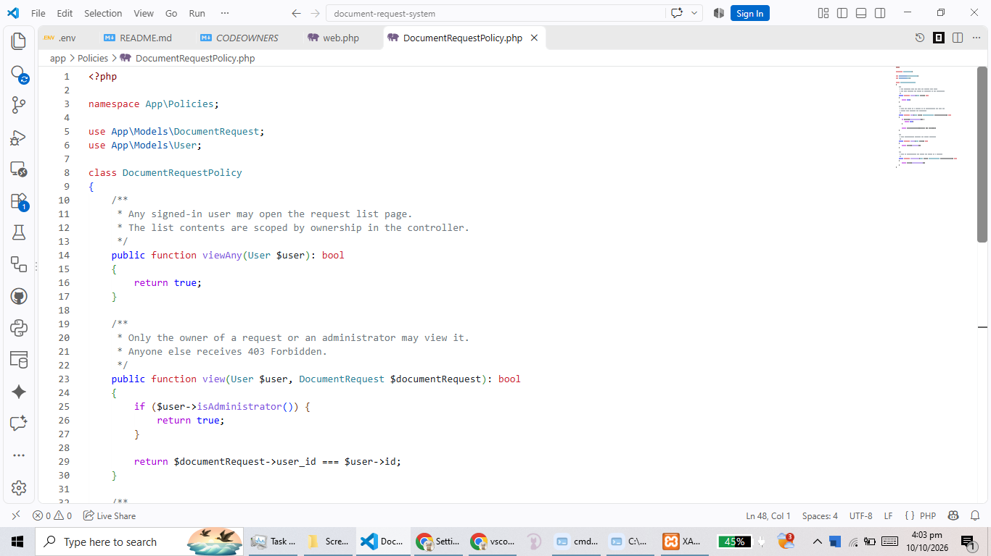
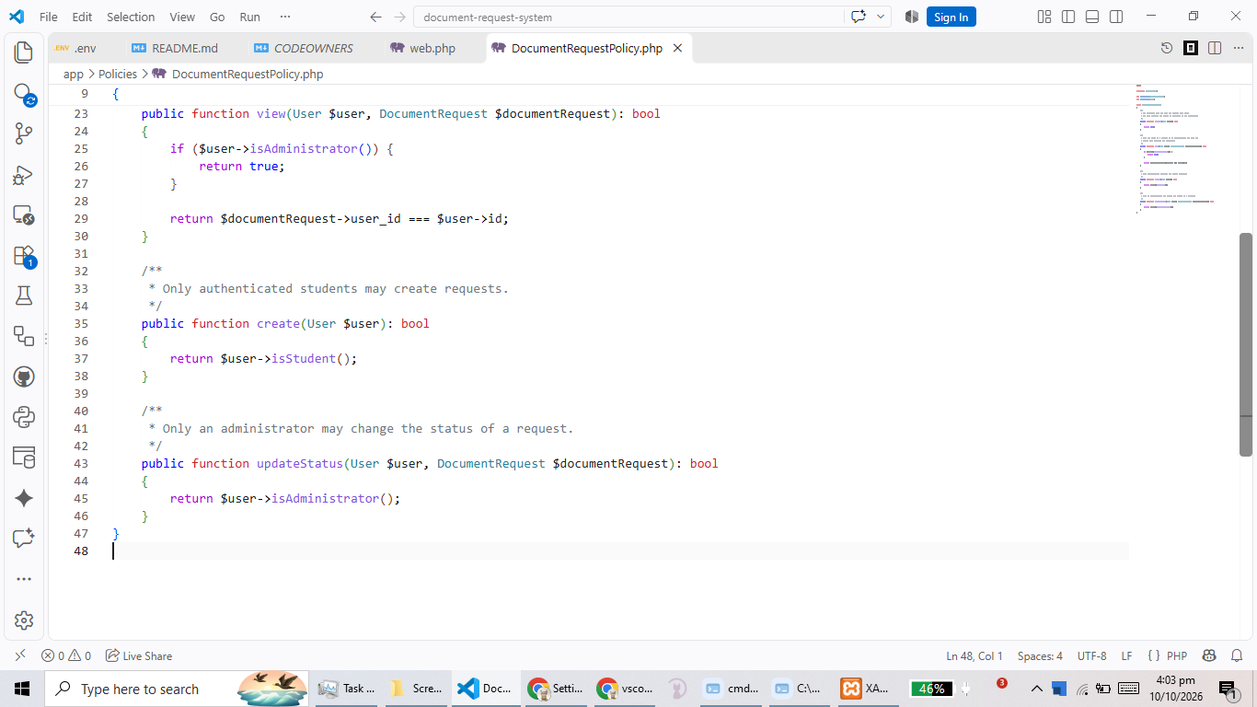
Evidence CD1 - the policy file open in the editor showing the four methods

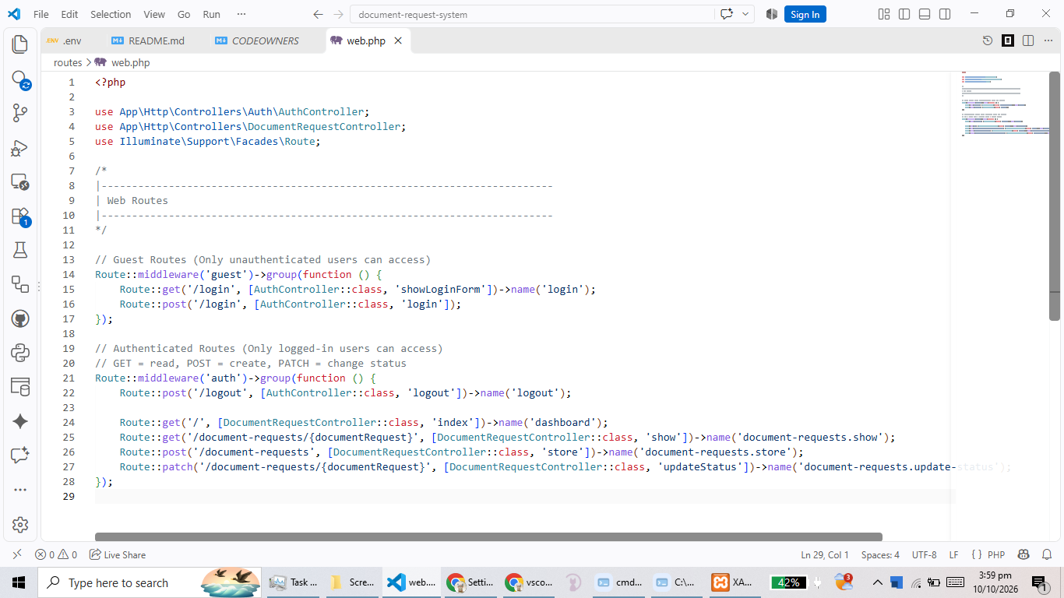
Evidence CD2 - routes/web.php showing the auth middleware group and the GET/POST/PATCH verbs
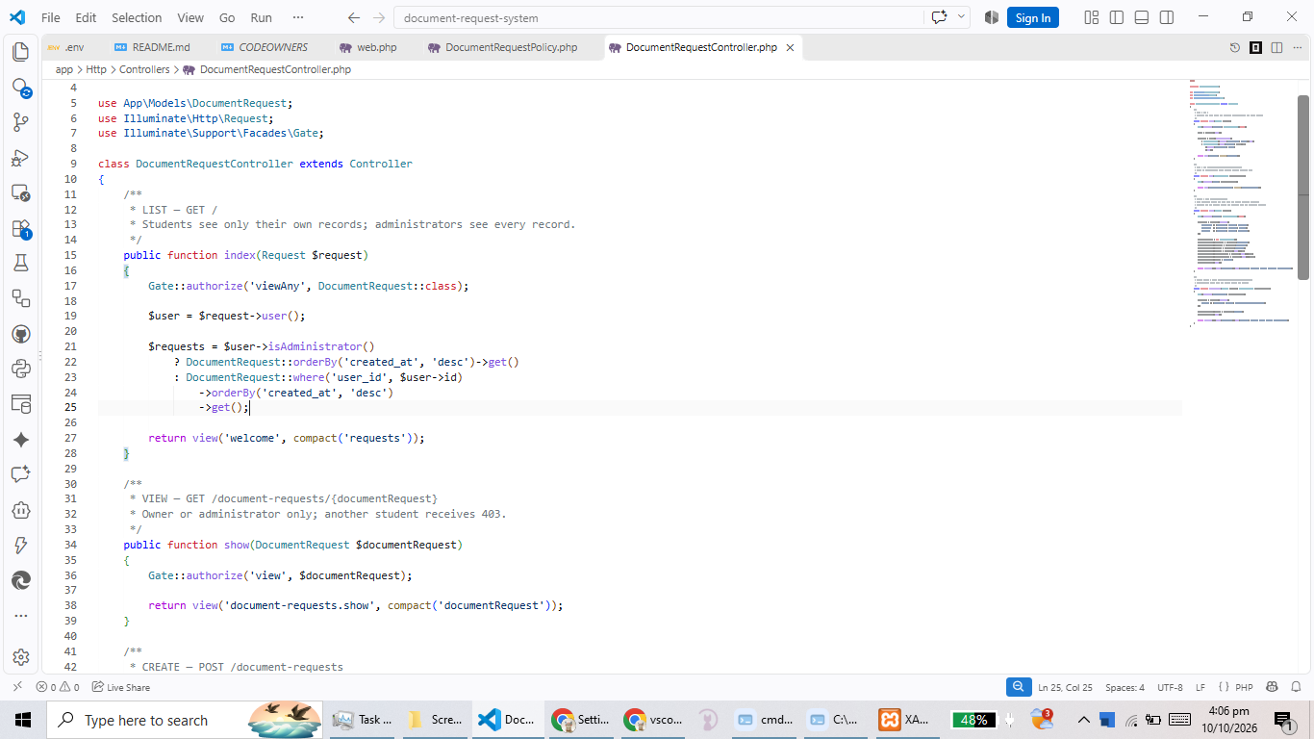
Evidence CD3 - the list-scoping code in index()
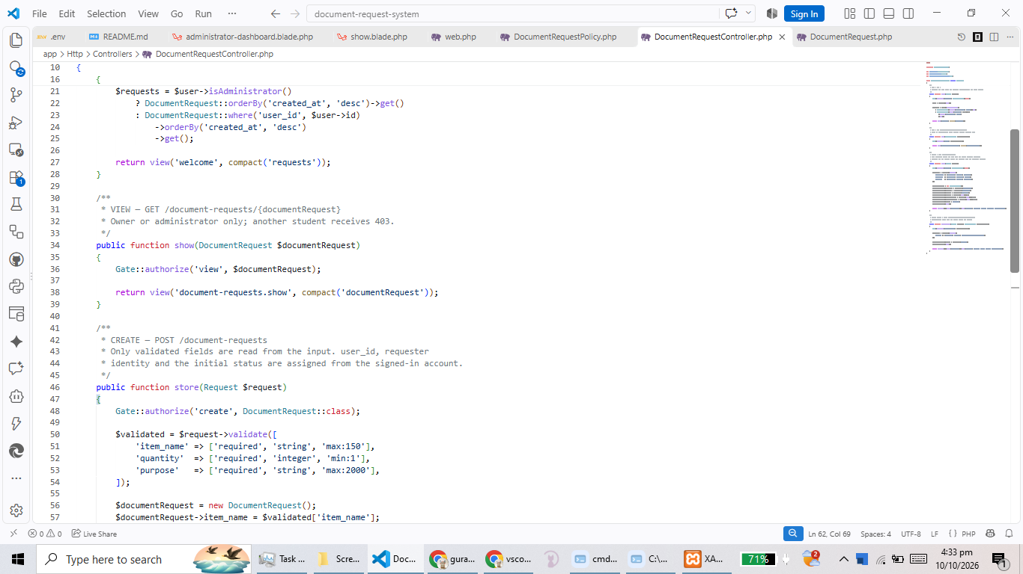
Evidence CD4 - the validation rules in store()
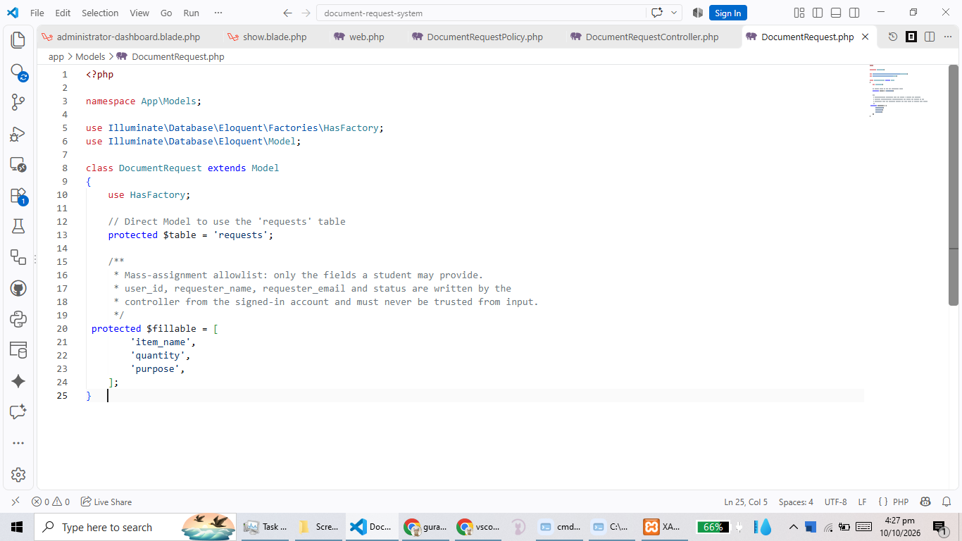
Evidence CD5 - the $fillable allowlist in the DocumentRequest model
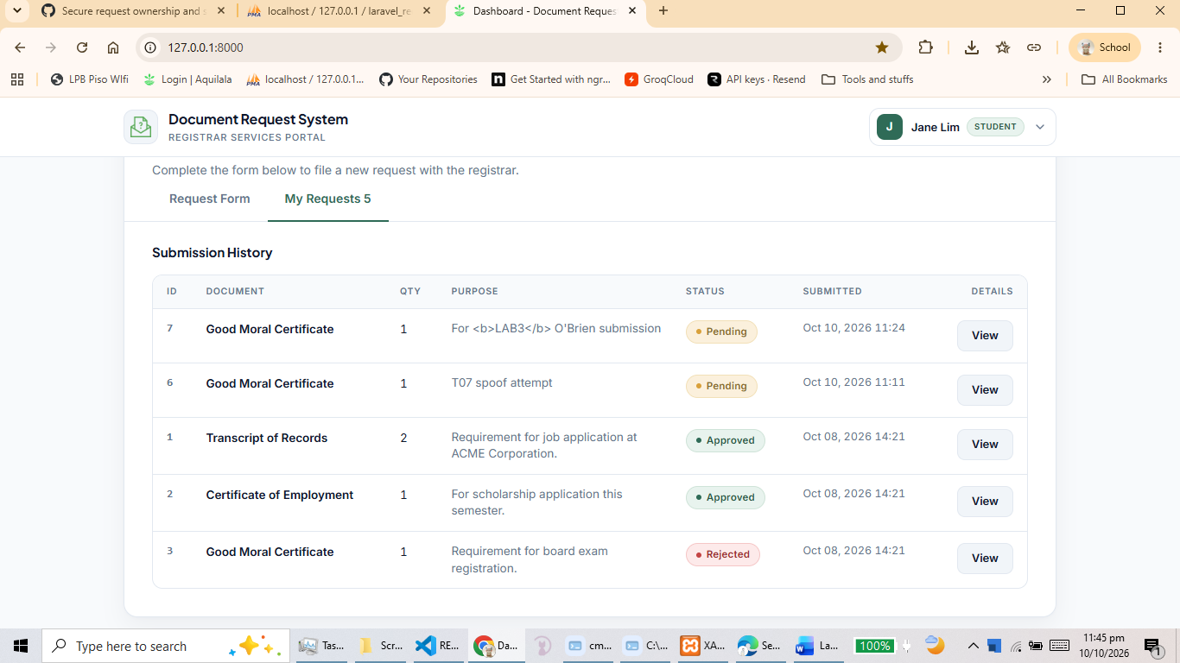
Evidence CD6 - a rendered detail page showing escaped output (markup displayed literally)

4. Completed Access and Input Test Matrix (Instruction 18)
Denial response chosen: 403 Forbidden. Every row was executed against the running application and verified in the database where indicated. Evidence numbers refer to the screenshots in Section 5 and Section 6.
ID | Test | Expected result | Actual result | Pass/Fail | Evidence
T01 | Guest opens / and /document-requests/1 | Redirect to the login page; no request data disclosed | Both URLs redirected to /login. No request rows, requester names or statuses rendered for the guest. | PASS | E1, E2
T02 | Student A and Student B open the list and their own detail pages | Each sees only their own records and can open their own details | Jane Lim saw requests 1, 2, 3, 6, 7. Alon Cruz saw requests 4, 5. Each opened only their own detail page. | PASS | E3, E4
T03 | Jane opens Alon's record ID directly, then Alon opens Jane's | 403 Forbidden; no other-student details disclosed | GET /document-requests/4 as Jane and /document-requests/1 as Alon both returned HTTP 403 Forbidden. No item name, purpose or requester details were returned. | PASS | E5, E6
T04 | Jane sends PATCH /document-requests/{Alon's ID} with status=approved, valid session and CSRF token | Denied (403); database status still pending | Server returned HTTP 403 before any write. Row 4 status remained pending; verified in phpMyAdmin before and after. | PASS | E7, E8, E9
T05 | Administrator lists, views and updates a request | All records visible; status change saved (pending to approved) | Mike Santos saw all seven rows, opened a detail page and changed a status; the new value and updated_at were persisted. | PASS | E10, E11
T06 | Create with quantity 0, -1, abc, and with a blank item name | Server rejects each; validation errors shown; no invalid row saved | Each submission was rejected server-side (quantity must be an integer of at least 1; item_name is required). The error box listed the messages and the row count in requests did not change. | PASS | E12, E13
T07 | Create while also submitting user_id, status, is_admin and role | Request saved for the signed-in student with status = pending | The spoofed values were ignored. The new row carried the signed-in student's user_id, name and email with status pending; no row was created for another user. | PASS | E14, E15
T08 | Purpose contains <b>LAB3</b> and an apostrophe (O'Brien) | Markup and apostrophe shown literally on the detail page | The detail page rendered the literal characters <b>LAB3</b> and O'Brien as text; no HTML element was created. | PASS | E16
T09 | POST or PATCH with a missing/invalid CSRF token | HTTP 419; database unchanged | The request carrying an invalid _token was rejected with HTTP 419 Page Expired. No new row was inserted and no existing row changed. | PASS | E17, E18
T10 | Administrator sends status=banana | Validation rejects; existing status unchanged | Validation rejected the value with "The selected status is invalid." and the stored status of the request was unchanged. | PASS | E19, E20

Automated suite (supporting evidence, run on main after the merge):
php artisan test
Tests\Unit\ExampleTest - that true is true
Tests\Feature\DocumentRequestAccessTest
t01 guest is redirected and sees no request data
t02 student sees only own records
t03 student cannot open other students record
t04 student status patch is denied and status unchanged
t05 administrator lists views and updates all requests
t06 invalid quantity and blank item name are rejected
t07 spoofed trusted fields are ignored
t08 markup in purpose is escaped on the detail page
t10 administrator invalid status is rejected
Tests\Feature\ExampleTest - the application returns a successful response

Tests: 11 passed (61 assertions)

T09 is exercised as a live HTTP request because Laravel disables the CSRF middleware inside feature tests, so the token check cannot be reproduced by the test suite alone.

5. Required Behaviour Screenshots (Submission item 5)
These four behaviours are explicitly required by the submission instructions: guest behaviour, owner access, direct other-student denial, and administrator access and status updates.

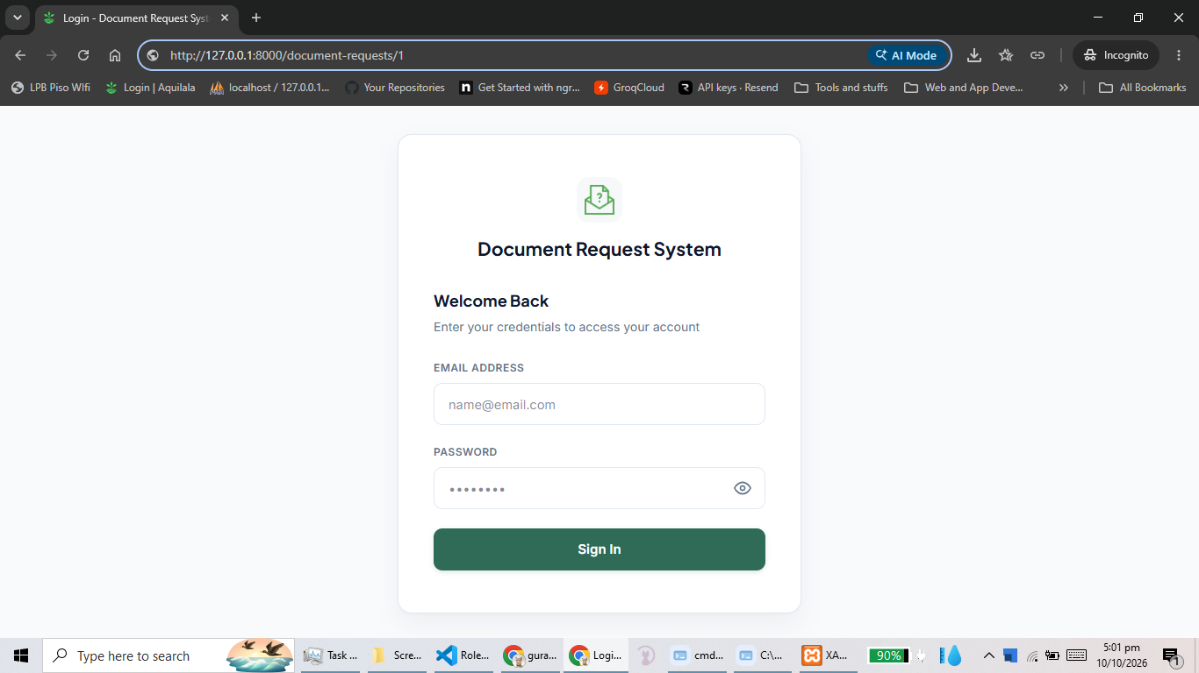
Evidence E1 - guest behaviour: a private request URL opened in a logged-out browser redirects to the login page
Evidence E2 - owner access: Jane Lim's dashboard listing only her own requests (IDs 1, 2, 3, 6, 7)
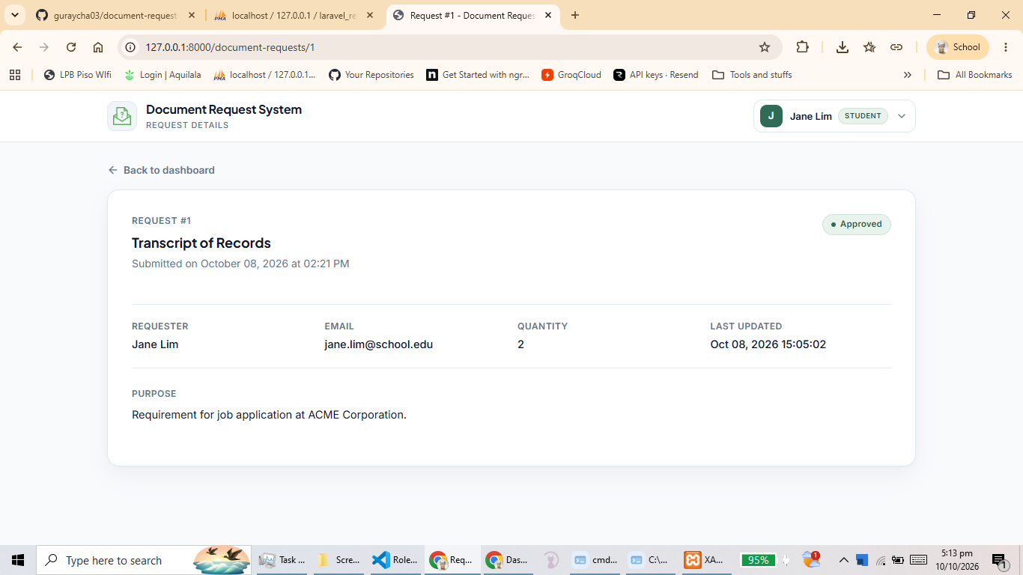
Evidence E3 - owner access: Jane Lim opening her own request detail page successfully
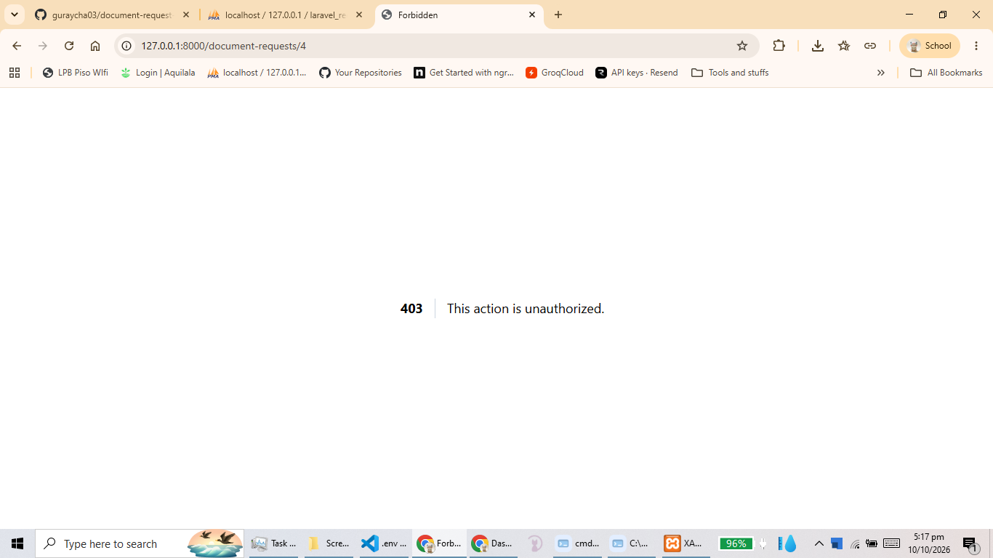
Evidence E5 - direct other-student denial: Alon Cruz requesting Jane's request ID 1 returns 403 Forbidden
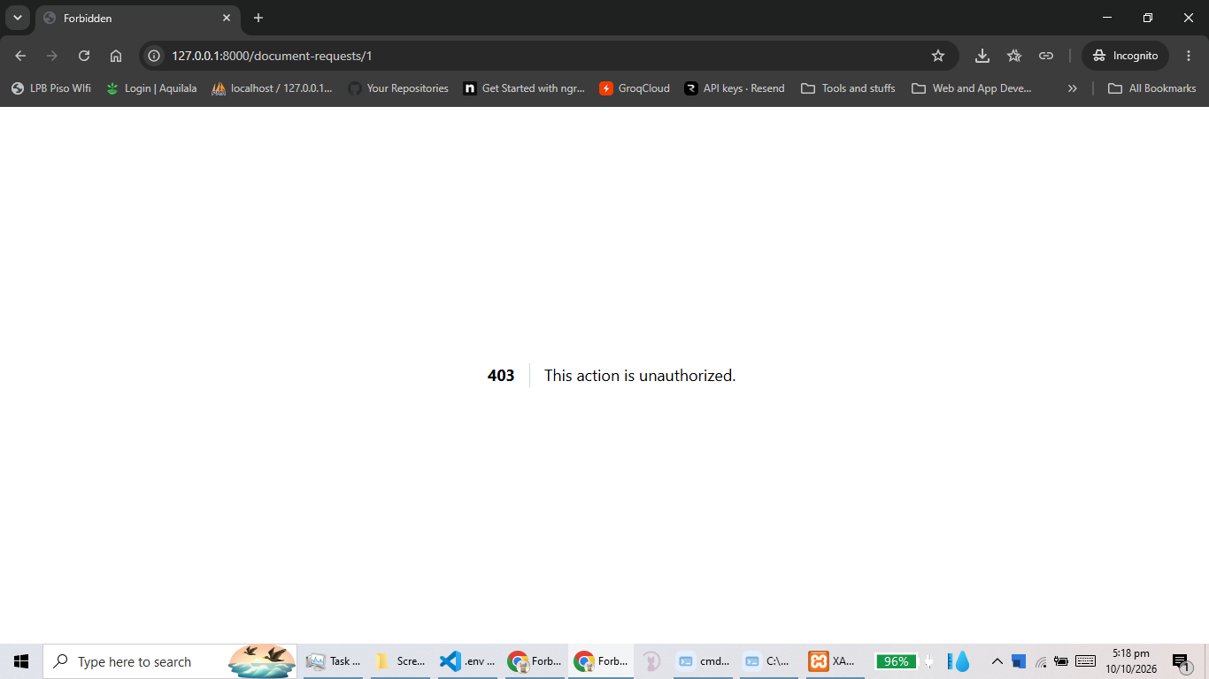
Evidence E6 - direct other-student denial: Jane Lim requesting Alon's request ID 4 returns 403 Forbidden
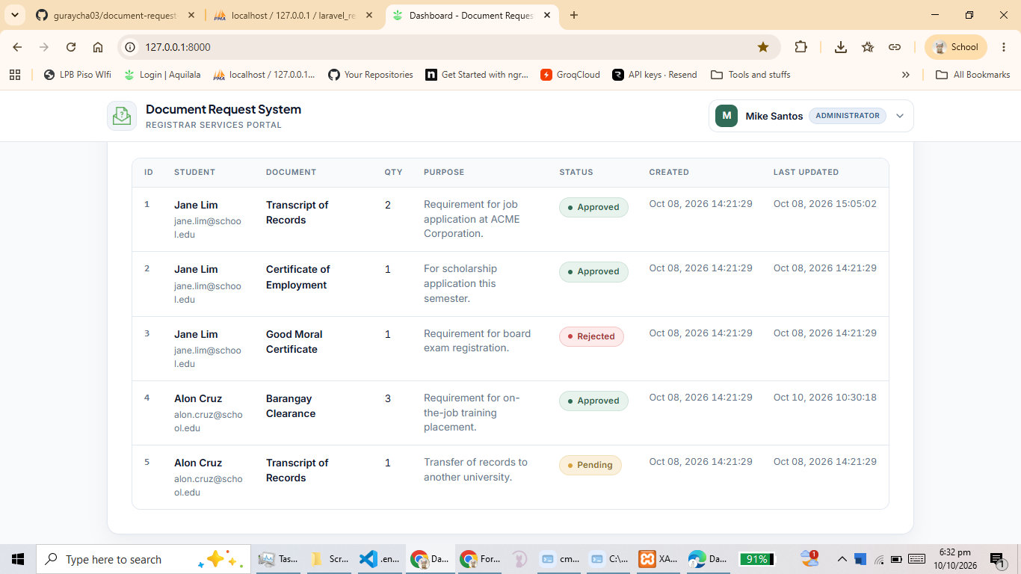
Evidence E10 - administrator access: Mike Santos viewing all requests from both students
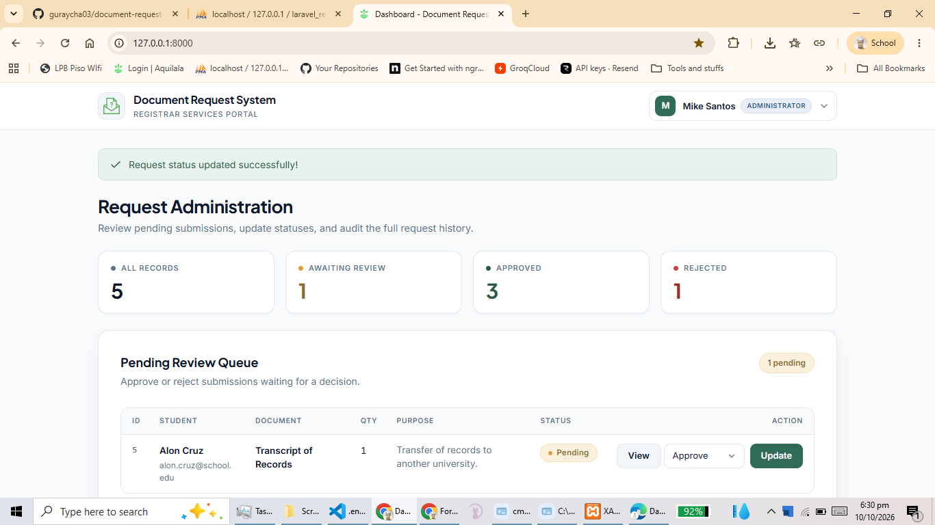
Evidence E11 - administrator status update: the success message after a status change

5.1 Database verification evidence (Submission item 6)
The query used for every before/after capture:
SQL executed in phpMyAdmin
SELECT id, user_id, requester_name, requester_email, item_name, quantity, status, updated_at
FROM requests ORDER BY id;

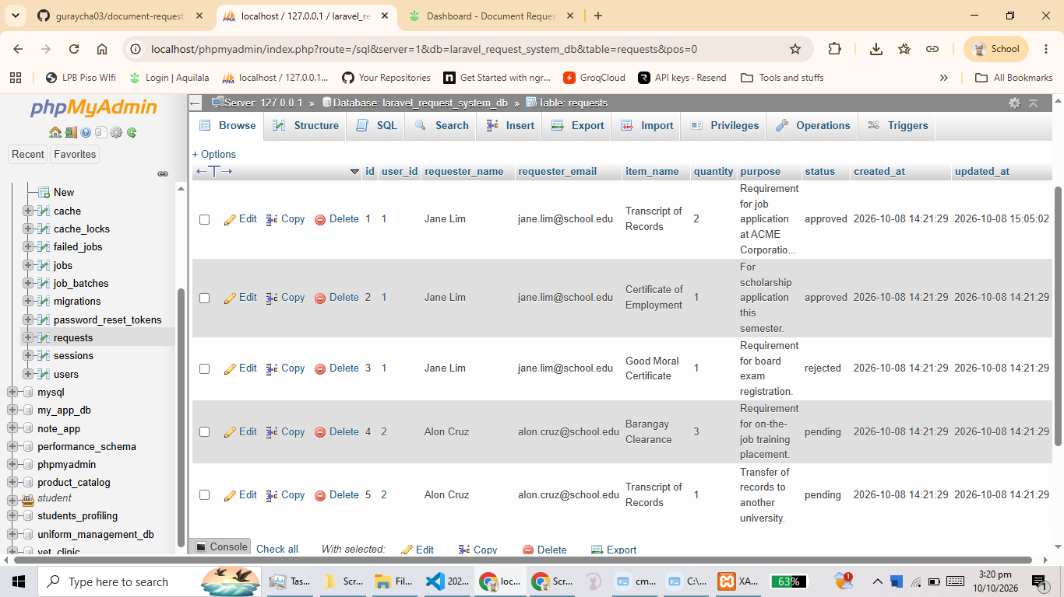
Evidence E8 - database BEFORE the denied write: row for Student B showing its original status
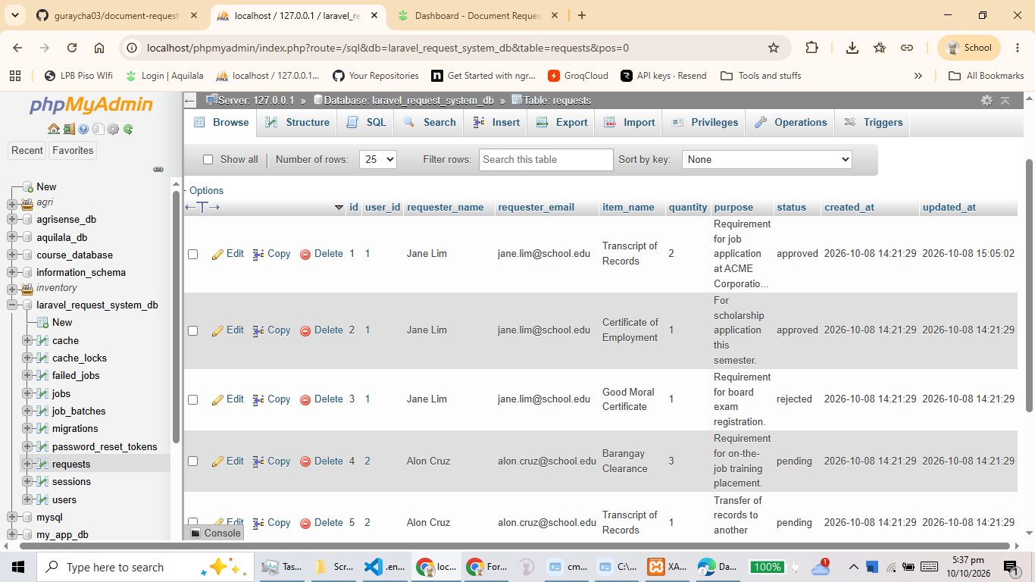
Evidence E9 - database AFTER the denied write: row 4 unchanged, and no new rows created
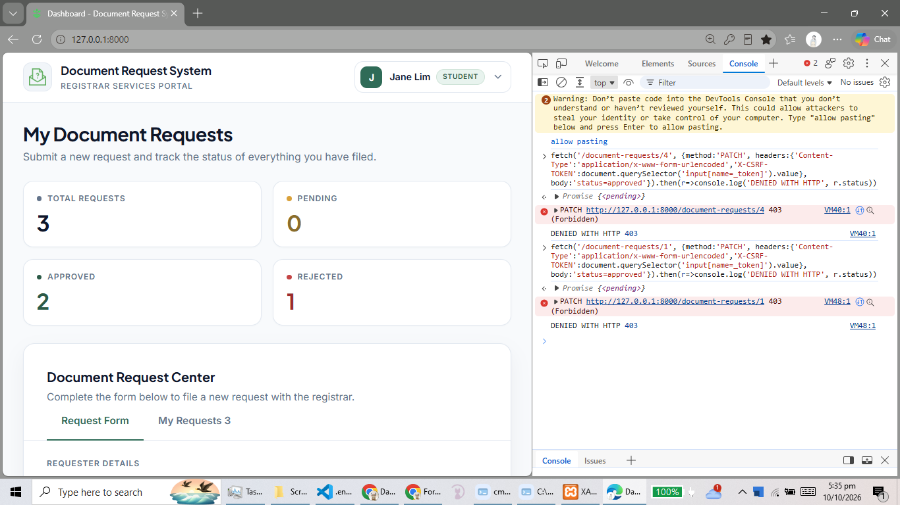
Evidence E7 - the denied write itself: HTTP 403 returned when Student A patches Student B's request
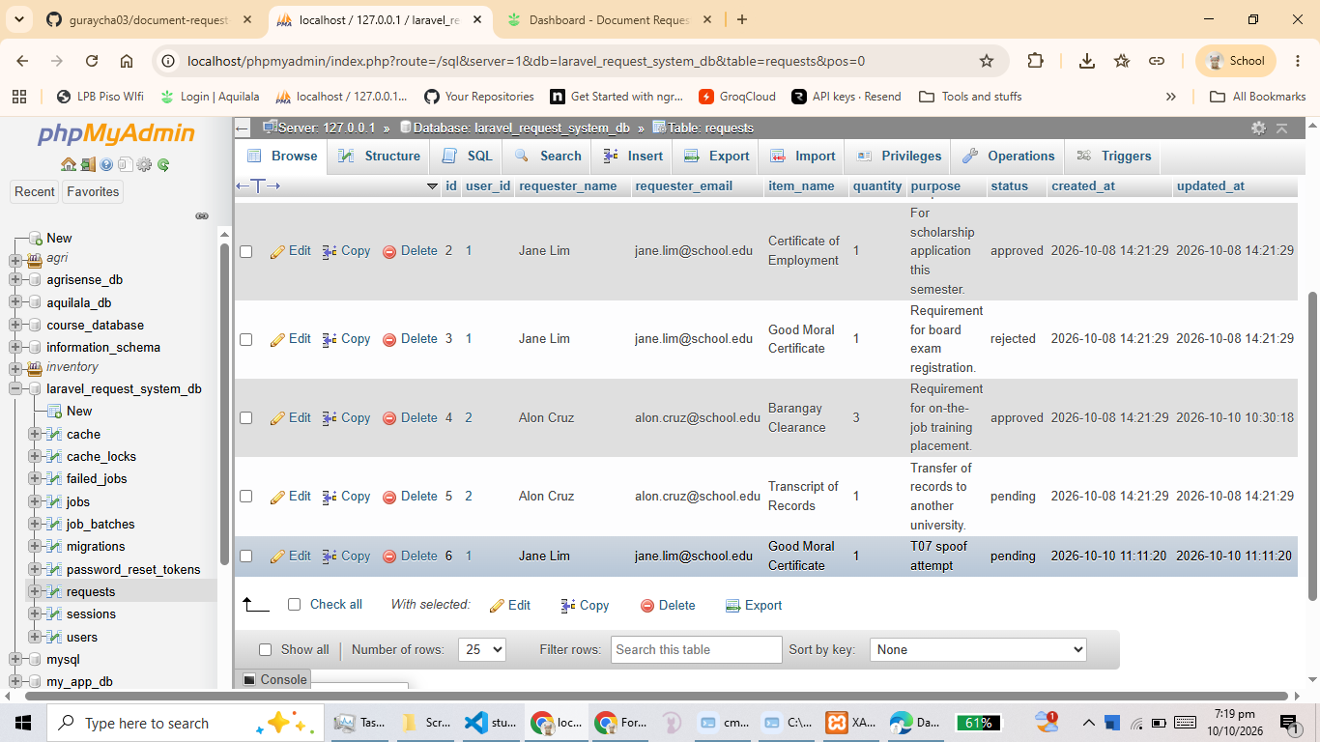
Evidence E15 - database AFTER an allowed write: the new request row created by the signed-in student with status pending and their own user_id
Evidence E13 - database after invalid input: row count unchanged, no row created for the rejected submissions
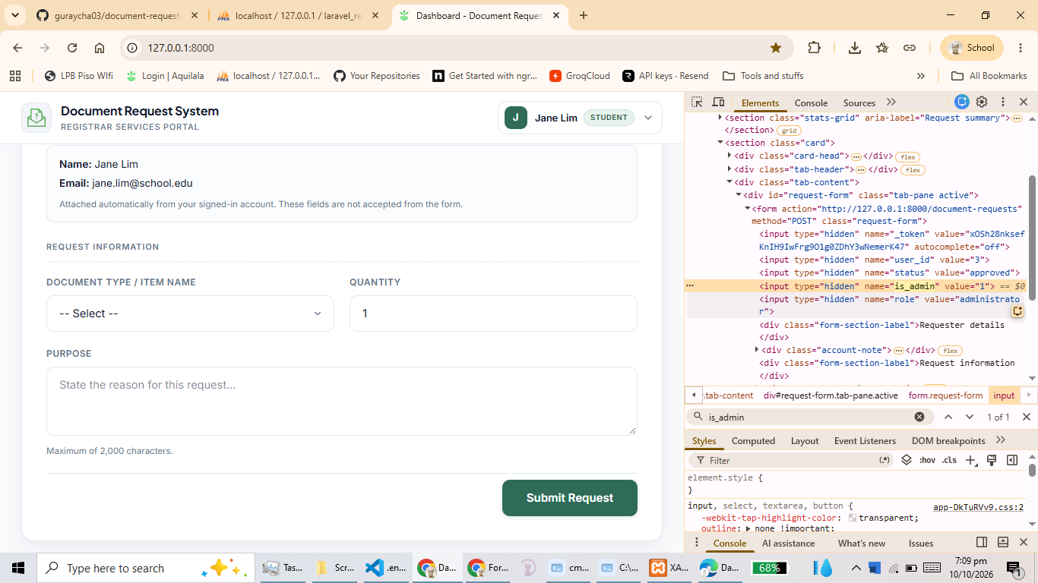
Evidence E14 - spoofed trusted fields: the creation request carrying user_id, status, is_admin and role
[ PASTE SCREENSHOT HERE ]
File name: E17
Must clearly show: the CSRF rejection: HTTP 419 Page Expired returned for the request with an invalid token
The 419 response for the POST/PATCH carrying a bad _token

Evidence E17 - the CSRF rejection: HTTP 419 Page Expired returned for the request with an invalid token
[ PASTE SCREENSHOT HERE ]
File name: E18
Must clearly show: database after the CSRF rejection: no new row and no modified rows
requests table unchanged

Evidence E18 - database after the CSRF rejection: no new row and no modified rows

5.2 Validation, trusted fields and escaping evidence

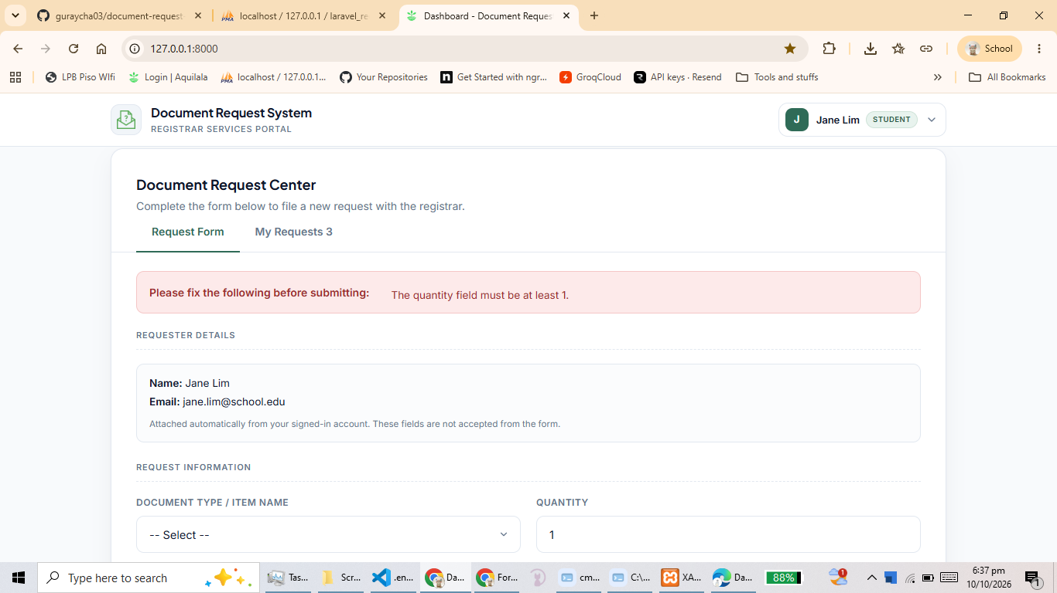
Evidence E12 - server-side validation: the error box listing the quantity and item name messages
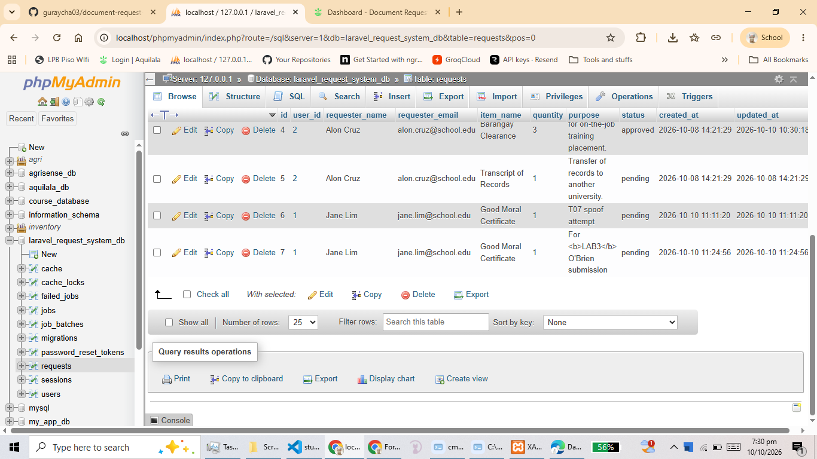
Evidence E16 - escaped output: purpose containing <b>LAB3</b> and O'Brien rendered as literal text
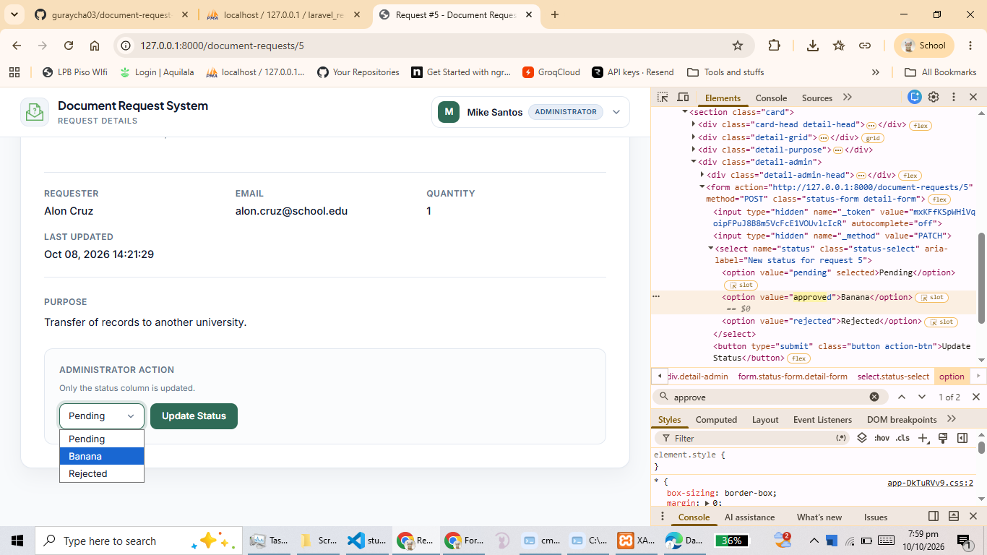
Evidence E19 - administrator invalid status: the validation error "The selected status is invalid."
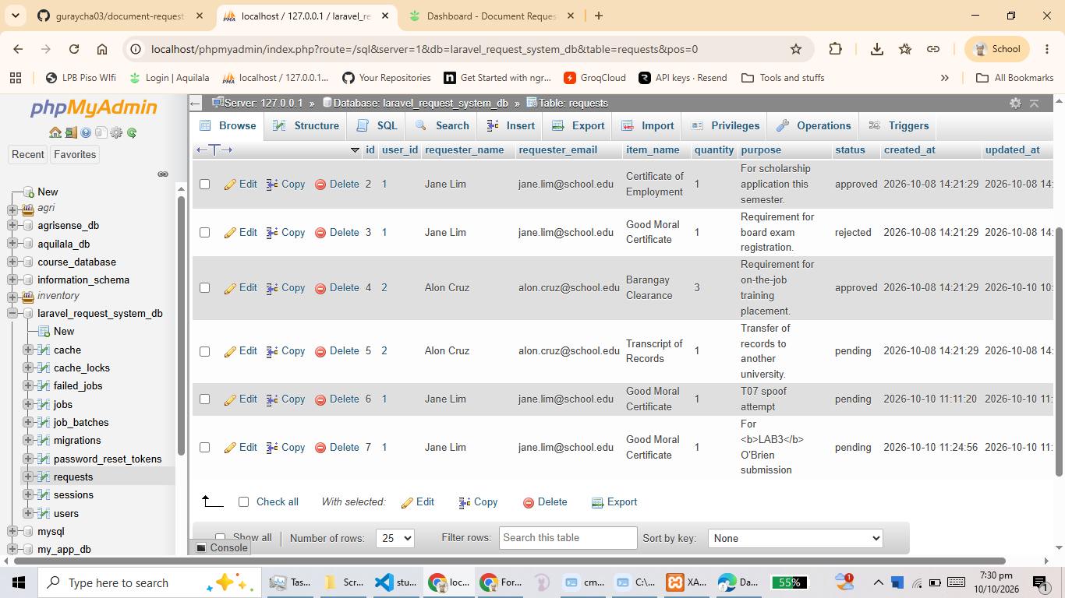
Evidence E20 - database after the invalid status attempt: the request's status unchanged

6. README Merge Conflict and Resolution (Instructions 11, 12 and Laboratory 3 step 24)

6.1 How the conflict was prepared
Step | Who | Action | Result
1 | Driver | Added "## Laboratory 3 Verification" with the shared instruction to README.md on main and pushed | Commit 480a2d6
2 | Driver | Merged origin/main into feature/lab3-secure-requests so both branches shared a common base | Commit 20e618f
3 | Driver | Replaced the shared instruction on the feature branch with the student-ownership instruction | Commit 1ecd7f1
4 | Reviewer | Replaced the same line on main with the administrator-access instruction through a reviewed pull request (branch SamBianca-patch-2) | Pull request #3, merged as ae9e287
5 | Driver | Fetched and merged origin/main while the feature branch was checked out, producing the planned conflict | CONFLICT (content) in README.md
6 | Driver | Captured the conflict message and markers before editing, then preserved both instructions and removed only the three marker lines | Commit b429b1b

6.2 Conflicting versions

The two branches held different versions of the same line
<<<<<<< HEAD
Verification instruction: Test student ownership and deny access to another student's request.
=======
Verification instruction: Test administrator access and administrator-only status updates.
>>>>>>> origin/main

6.3 Resolution
Both intended instructions were preserved and only the three marker lines were removed, so neither branch's text was discarded. The resolved README ends with:
README.md (final state)
## Laboratory 3 Verification

Verification instruction: Test student ownership and deny access to another student's request.
Verification instruction: Test administrator access and administrator-only status updates.

6.4 Conflict evidence

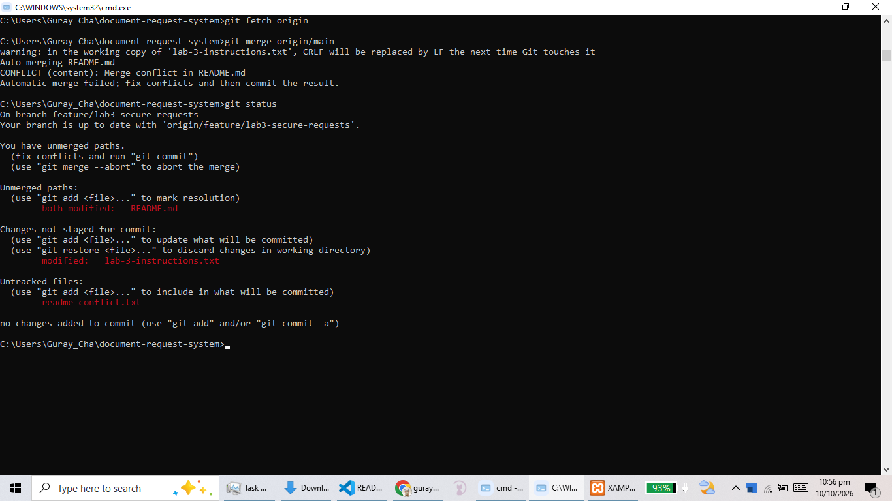
Evidence C1 - the terminal showing "CONFLICT (content): Merge conflict in README.md" and "Automatic merge failed", plus git status listing "both modified: README.md"

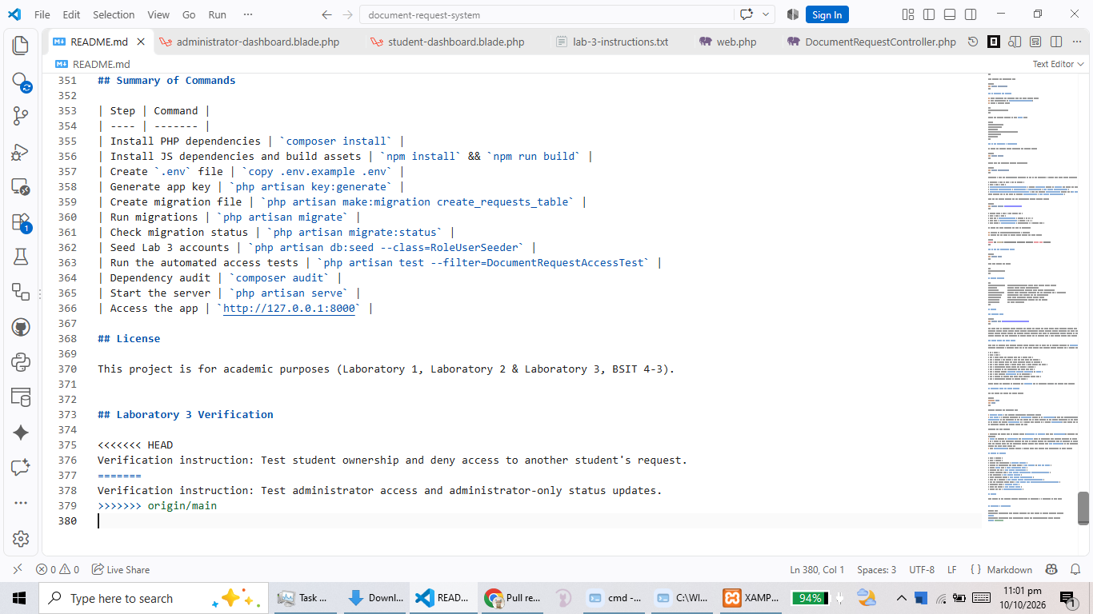
Evidence C2 - README.md in the editor showing the <<<<<<<, ======= and >>>>>>> markers with both instructions

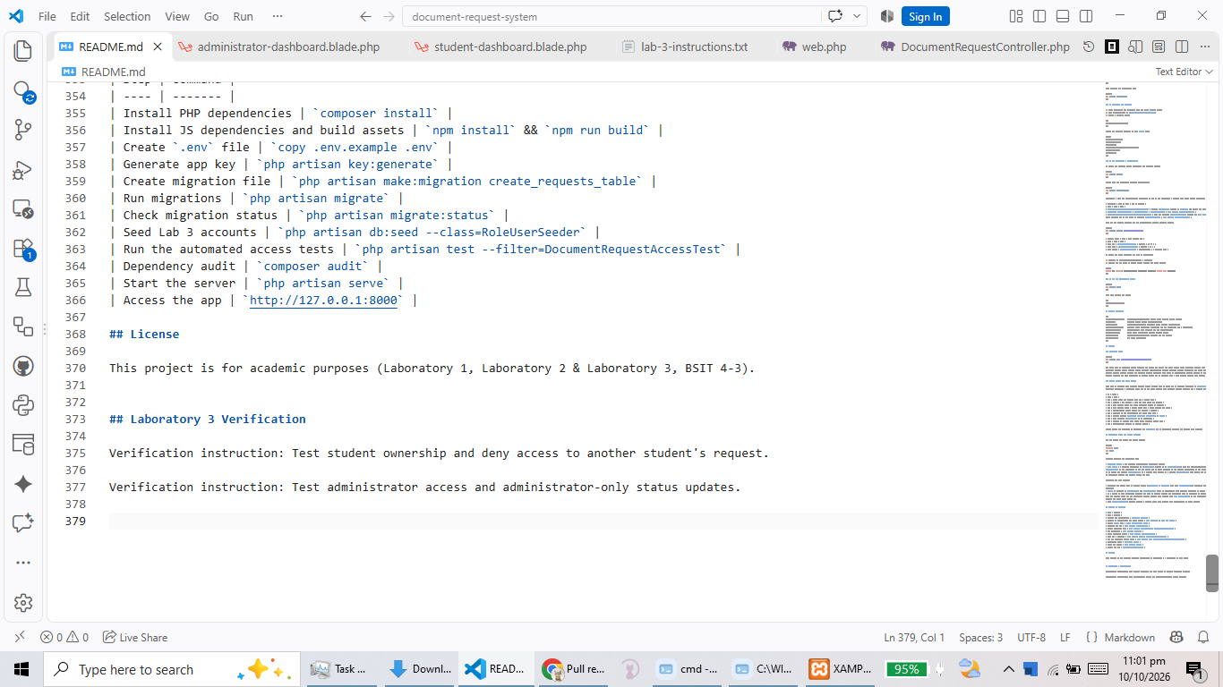
Evidence C3 - the resolved README.md with no conflict markers and both instructions still present

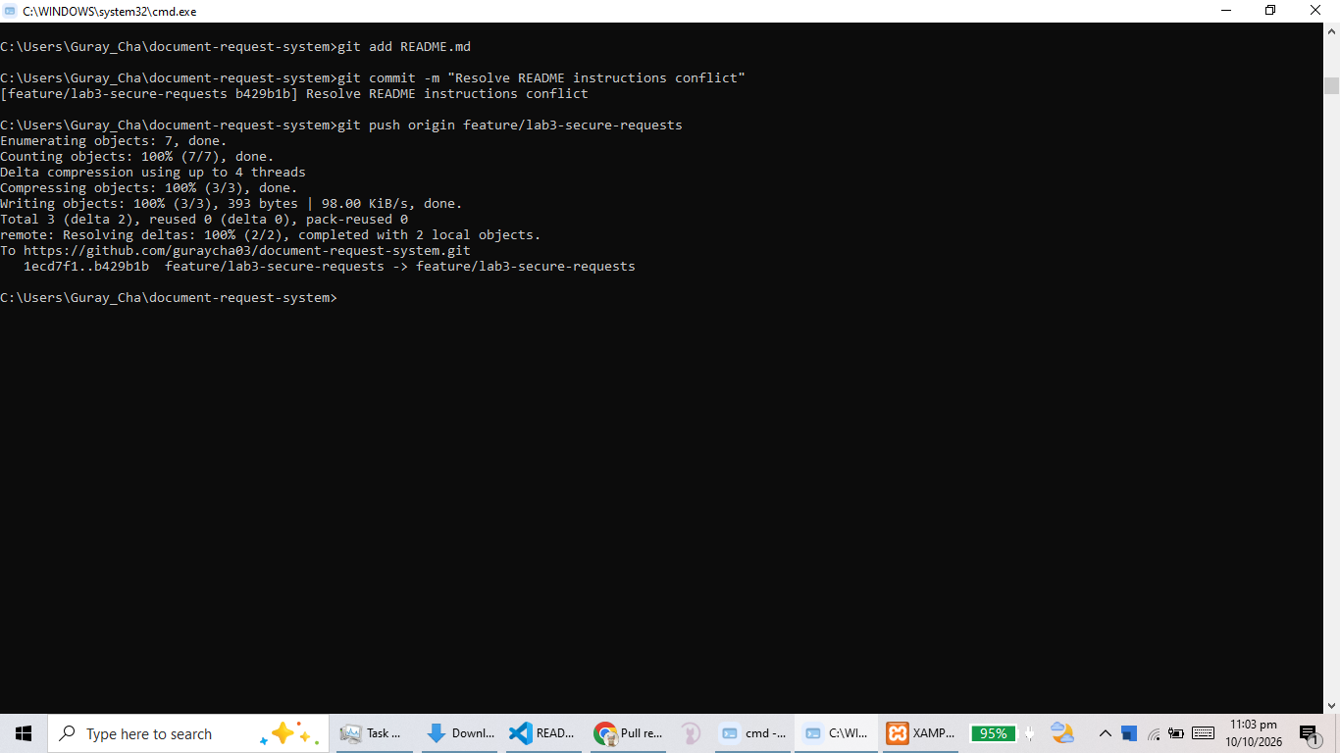
Evidence C4 - the terminal showing the successful commit and push of the resolution

7. Peer Review and Merge (Instructions 17, 23, 25 and 26)

7.1 Review activity
- Pull request: Secure request ownership and status access, base main, compare feature/lab3-secure-requests.
- Substantive review comment: The Reviewer commented on the status assignment in updateStatus(), questioning why the value is assigned directly to the property instead of being passed to update(), given that status is excluded from the mass-assignment allowlist. The Driver answered that status, user_id, requester_name and requester_email are deliberately absent from $fillable, so update() would silently discard them; the validated value is therefore assigned directly and persisted with save().
- Approvals: The Reviewer approved the pull request from her own account, and re-checked the final revision after the conflict resolution at commit b429b1b before the merge.
- Self-approval: the Driver did not approve her own change.

7.2 Review evidence

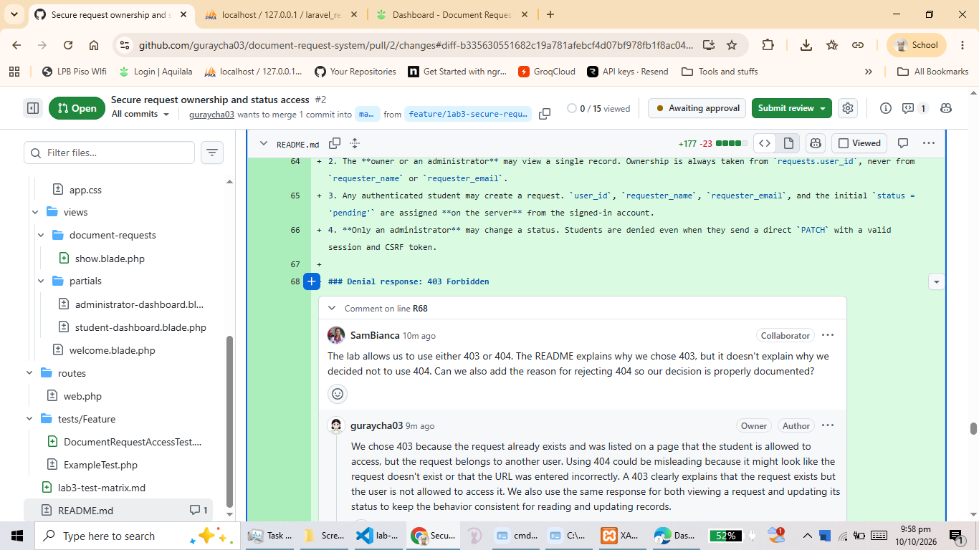
Evidence RV1 - the pull request conversation showing the substantive review comment and the Driver's reply
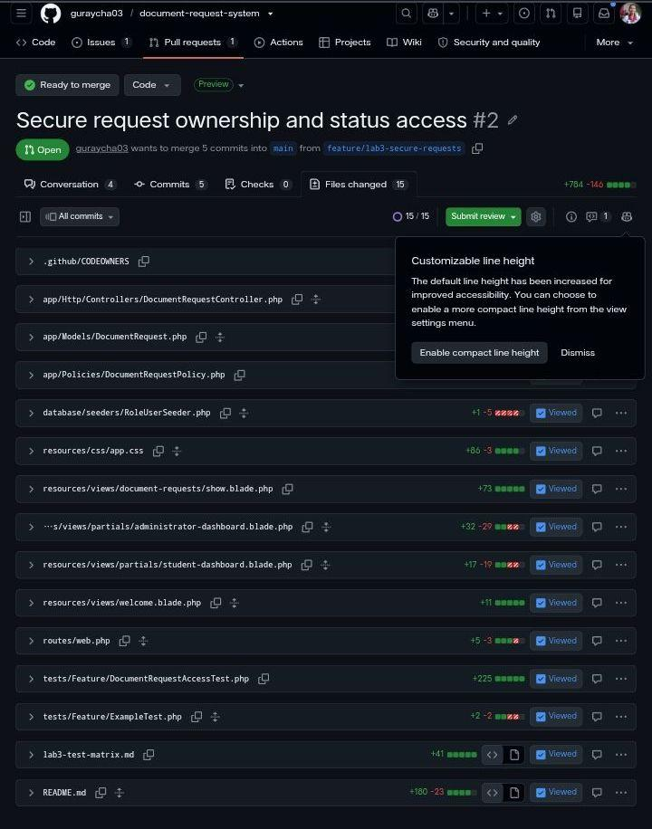
Evidence RV2 - the approval from SamBianca on the pull request

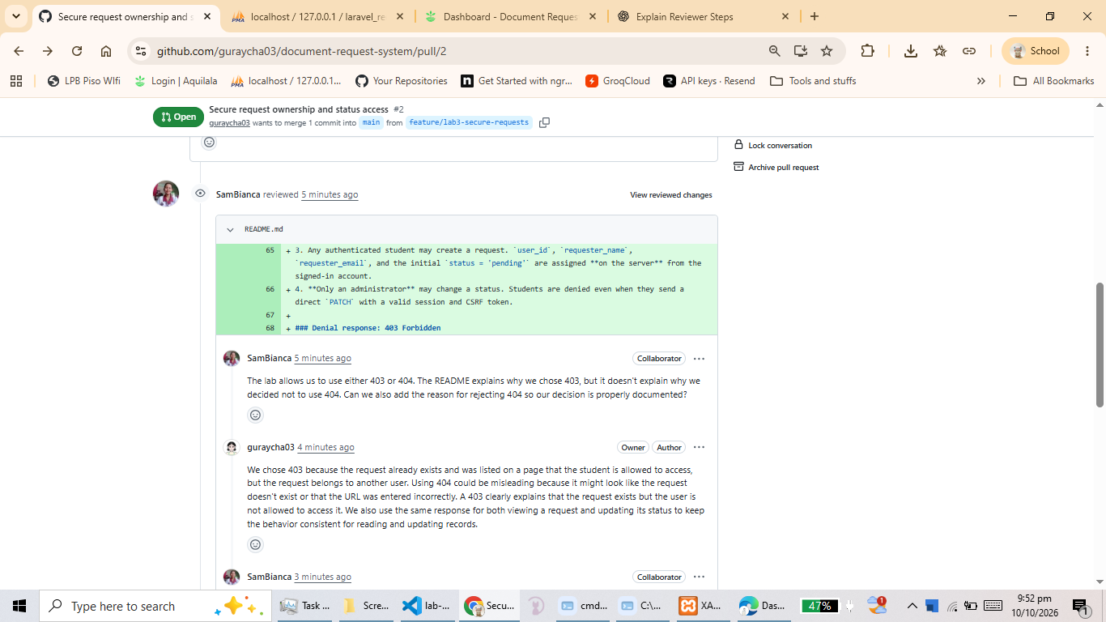
Evidence RV3 - the final reviewer confirmation after the conflict resolution

7.3 Merge
Item | Value
Pull request | https://github.com/guraycha03/document-request-system/pull/2
Issue closed by the change | https://github.com/guraycha03/document-request-system/issues/1
Final reviewed commit SHA | b429b1b767c93aac309c0a748e7d2896a7c6fe1c
Merge commit SHA | 7862c41b20c191dc53c855eeba57d4cded36815d
Merged at | 2026-10-10T15:14:16Z
Result after "git switch main && git pull --ff-only origin main" | main fast-forwarded to the merge commit; 11 tests pass

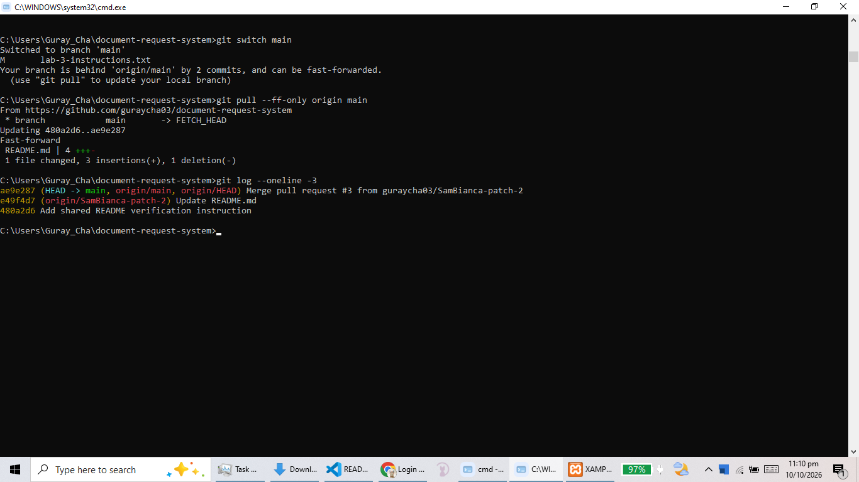
Evidence M1 - the merged pull request showing the merged badge, the approving review and the merge commit
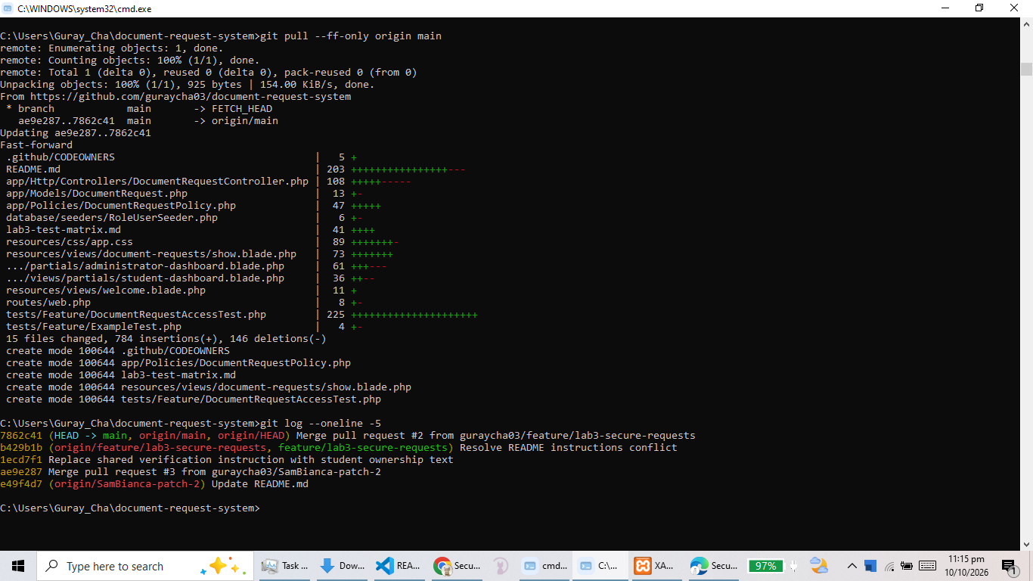
Evidence M2 - the terminal showing "git switch main", "git pull --ff-only origin main" and git log with the merge commit 7862c41
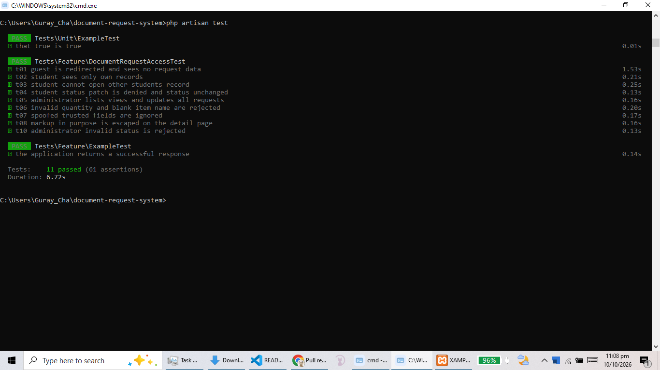
Evidence M3 - the test suite output on main showing 11 passed, 61 assertions

7.4 Post-resolution retest (step 25)
- Owner access: Student A still sees only her own records after the conflict resolution.
- Another student's denial: Student B requesting Student A's record still returns 403.
- Administrator access: status update still saves and reports success.
- Automated suite: 11 tests and 61 assertions pass on main.

8. README, Dependency Audit and Secret Handling (Instructions 18 and 21, submission item 7)

8.1 README content
- Driver and reviewer responsibilities and who maintains the policy, controller, routes, views and tests.
- Laboratory 3 user roles (Student, Administrator) and the four ownership rules.
- The chosen denial response (403 Forbidden) and the reasoning behind it.
- Route summary table with verbs, middleware and authorization.
- Policy enforcement points, validation rules and trusted field assignment.
- Escaping, CSRF and safe error handling.
- Laboratory 1 installation and setup steps and the database name (retained as instructed).
- Laboratory 2 data schema for the requests table (retained as instructed).
- Testing steps, the manual matrix, the dependency audit and the summary of commands.

8.2 Dependency audit
Command | Result
composer audit | No known vulnerabilities reported - clean.
npm audit | 2 critical advisories, both in development-only tooling reached concurrently via shell-quote. They do not affect the production bundle served to users.
Action taken | No dependency was upgraded or removed without review before the submission deadline. The advisories are documented here rather than silently ignored, and the recommendation is to upgrade the development toolchain in a follow-up change with its own review.

8.3 Exposed secret response
- .env is not tracked: git ls-files returns no .env entry, so the live configuration file has never been committed.
- .env.example is committed: it documents the required keys without any real value.
- No credentials in this report: account labels and request IDs are recorded without passwords, tokens or .env contents, as required by instruction 3.
- No access token shared: the reviewer used her own GitHub account with collaborator access (instruction 6).

9. Links and Commit SHAs (Submission item 8)
Item | Link or value
Repository | https://github.com/guraycha03/document-request-system
Issue | https://github.com/guraycha03/document-request-system/issues/1
Pull request | https://github.com/guraycha03/document-request-system/pull/2
Preparation commit | 8aa992a7f35d9a4678801fa827b8b526253f5945
Final reviewed commit | b429b1b767c93aac309c0a748e7d2896a7c6fe1c
Merge commit | 7862c41b20c191dc53c855eeba57d4cded36815d
Reproducibility check | git clone, composer install, npm install && npm run build, .env setup, php artisan migrate, php artisan test - 11 tests pass

10. Step-by-Step Record of Laboratory 3
Each numbered instruction from the laboratory sheet and what was actually done to satisfy it.
Step | Instruction | What was done
1 | Work with the same partner from Laboratory 1 on the existing Laravel request-system project, MySQL database and GitHub repository. | Charisse G. Guray (driver) and Samantha Bianca Germina (reviewer) continued on the existing repository and database laravel_request_system_db.
2 | Verify the starting checkpoint: working login, two fictional student accounts, one administrator account, a model mapped to the requests table, records linked through user_id, administrator role assigned through trusted setup, and record the preparation commit. | Checkpoint verified. Preparation commit 8aa992a7f35d9a4678801fa827b8b526253f5945. The Laboratory 2 records were preserved; the changes were made with reversible migrations.
3 | Record the database name, Laravel version, fictional account labels and owned request IDs; do not show passwords, tokens or .env contents. | Recorded in Section 1. No password, token or .env content appears anywhere in this report or in the README.
4 | Assign one partner as driver and the other as reviewer; record names, responsibilities and exchange duties. | Recorded on the cover page. Duties were exchanged during the session.
5 | Open a GitHub issue titled "Secure request ownership and status access"; identify in README.md who maintains the policy, controller, routes, views and tests; add CODEOWNERS if appropriate. | Issue #1 opened. README "Who maintains what" table added. .github/CODEOWNERS created for both partners.
6 | Enable required pull-request review and branch protection; do not share accounts or access tokens. | Branch protection enabled on main with a required approving review and code-owner review. The reviewer was added as a collaborator with her own account; no credentials were shared.
7 | Start from a clean, up-to-date default branch and create a feature branch. | git switch main; git pull --ff-only origin main; git switch -c feature/lab3-secure-requests.
8 | Protect request routes with auth middleware, keep login routes for guests, use separate controller methods with GET for reads, POST for creation and PATCH for status updates, and apply the four access rules. | Implemented in routes/web.php and DocumentRequestController (index, show, store, updateStatus). See Section 3.1.
9 | Create or complete the policy with viewAny, view, create and updateStatus, and confirm policy discovery. | app/Policies/DocumentRequestPolicy.php defines all four methods. Laravel discovers it automatically from the model name; no manual registration was required.
10 | Enforce the policy on the server before returning data or writing to the database; choose 403 or 404 for another student's record and document the choice. | Gate::authorize is called in all four controller methods. 403 Forbidden was chosen and applied consistently on read and write paths; the reasoning is documented in README.md.
11 | Scope the student list to the signed-in account and trust only authenticated identity fields. | index() filters with where("user_id", $user->id) for students and returns all rows for administrators.
12 | Display only the current account's identity and hide controls the user cannot use. | The account panel renders name and email from the session user, and the status form is wrapped in @can so it is only visible to administrators.
13 | Reduce mass assignment to allowed fields. | DocumentRequest::$fillable contains only item_name, quantity and purpose.
14 | Validate item name, quantity and purpose server-side. | item_name required|string|max:150, quantity required|integer|min:1, purpose required|string|max:2000, enforced with $request->validate() in store().
15 | Escape all rendered content. | Every dynamic value on the detail page and dashboards is printed with the {{ }} Blade escape.
16 | Protect forms against cross-site request forgery. | @csrf on every form; @method("PATCH") on the status form. Verified with the T09 419 test.
17 | Write automated tests for the access and input rules. | tests/Feature/DocumentRequestAccessTest.php covers T01 to T08 and T10; ExampleTest updated for the guest redirect. 11 tests, 61 assertions.
18 | Run the test suite, audit dependencies, and record secret-exclusion checks. | php artisan test: 11 passed. composer audit: clean. npm audit: 2 critical development-only advisories documented in Section 8.2. .env untracked.
19 | Prepare the application for review with a clean working tree. | Only the temporary test scaffolding was removed before committing; git status was clean apart from line-ending normalization on the instruction file.
20 | Complete the access and input matrix with actual results. | Completed in Section 4 with expected result, actual result, pass/fail and numbered evidence references.
21 | Update the README with ownership rules, the chosen 403 response, route summary, setup and migration steps, file responsibilities and testing steps; retain the Laboratory 1 setup and database name and the Laboratory 2 data-model documentation; check git status and secret exclusion before staging. | README.md rewritten for Laboratory 3. The Laboratory 1 installation steps and database name and the Laboratory 2 requests-table schema were retained; the obsolete Laboratory 2 user stories were archived in lab-02-readme.txt.
22 | Commit, push and open the pull request; do not merge. | Commit "Secure request ownership and status access" pushed to feature/lab3-secure-requests and pull request #2 opened against main with "Closes #1".
23 | The reviewer inspects authentication, policy enforcement, list scoping, trusted field assignment, validation, escaping, CSRF, secret exclusion and test evidence; adds at least one substantive review comment; the author does not approve their own change. | Completed. A substantive comment was left on the status assignment in updateStatus() and answered by the driver. SamBianca approved from her own account; the driver never approved her own change.
24 | Resolve the prepared README conflict: fetch and merge with the feature branch checked out, capture the conflict message and markers first, preserve both instructions, remove the markers, stage, commit and push. | Completed. Conflict captured (C1, C2), both instructions preserved, markers removed (C3), committed as b429b1b and pushed.
25 | Retest owner access, another student's denial and administrator access after the conflict; have the reviewer re-check the final revision and record approval after all fixes. | Retested - see Section 7.4. Automated suite re-run: 11 passed. The reviewer re-checked the final revision and recorded approval.
26 | Merge the approved pull request, pull the updated main branch locally, and record the PR link, final reviewed commit SHA and merge commit SHA. | Merged. main pulled with git pull --ff-only origin main. SHAs recorded in Section 9.
27 | Capture readable screenshots and prepare one Word document per pair; confirm the repository contains the completed code, migrations and README and that the actual .env file is absent. | This document. The repository contains the completed code, migrations, README and tests; git ls-files confirms .env is absent.

10.1 Screenshot index
Rename each file to the evidence number below and insert it into the matching placeholder box.
Evidence number | Screenshot must show
CP1 - CP3 | Checkpoint: Laravel version, migrate:status, preparation commit
BP1 - BP2 | Branch protection and blocked merge before approval
CD1 - CD7 | Code excerpts: policy, routes, scoping, validation, allowlist, escaping, CSRF fields
E1 - E2 | Guest behaviour
E3 - E4 | Owner access
E5 - E6 | Direct other-student denial (403)
E7 - E9 | Denied write: HTTP response, database before, database after
E10 - E11 | Administrator list and status update
E12 - E13 | Invalid input: validation messages and unchanged database
E14 - E15 | Trusted fields spoofing attempt and resulting row
E16 | Escaped output on the detail page
E17 - E18 | CSRF rejection: HTTP 419 and unchanged database
E19 - E20 | Invalid administrator status: error and unchanged database
C1 - C4 | Merge conflict: terminal message, markers, resolution, commit
RV1 - RV3 | Review comment, approval, final reviewer confirmation
M1 - M3 | Merged pull request, main pull and test run on main
DA1 - DA2 | composer audit and npm audit outputs
R1 - R4 | README sections: responsibilities, 403 choice, route summary, data schema

GITHUB REPOSITORY LINK
Repository URL: https://github.com/guraycha03/document-request-system.git

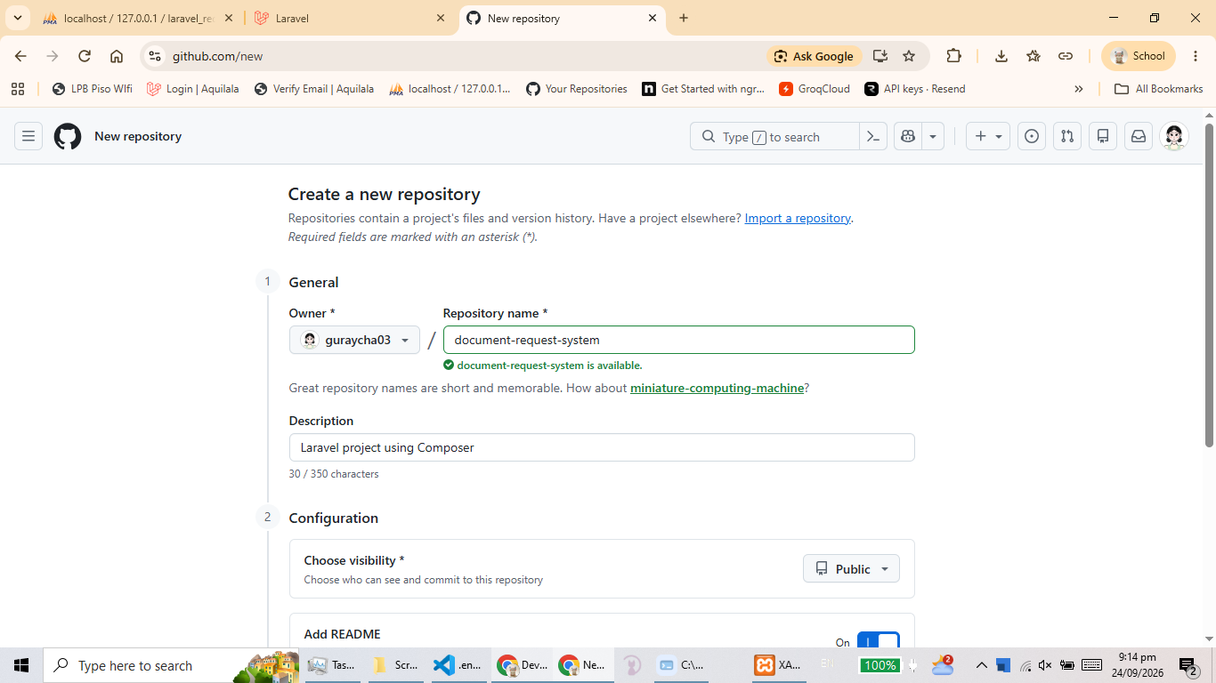
Repository creation

Clickable link to the specific GitHub repository.
▶ GitHub Repository ◀

