**A CSF-centric Image Morphometry Approach via DL-based Segmentation of ICV**

Guray Erus1, Jimit Doshi, Junhao Wen1, Sindhuja Tirumalai Govindarajan1, Dhivya Srinivasan1, Yuhan Cui1, Christos Davatzikos1

1Artificial Intelligence in Biomedical Imaging Laboratory (AIBIL), Center for Biomedical Image Computing and Analytics, Perelman School of Medicine, University of Pennsylvania, Philadelphia, USA

**Introduction**

Neuroimaging pipelines often focus on GM and WM, while overlooking cerebro-spinal fluid (CSF), considering it simply as “background”. Along with other purposes, proper segmentation of cortical CSF is critical for accurate estimation of the intra-cranial volume (ICV), an important measure used for adjusting volumetric imaging measures against variations in head size across individuals. Existing T1-based methods have a tendency to calculate a tight mask around the cerebral cortex, thus potentially under-estimating the ICV [1,2]. We present DLICV, a deep learning method for ICV segmentation from raw T1 images, that combines a convolutional network, an elaborate training strategy with large and carefully curated datasets, and a strategy to transfer label information derived from T2-weighted images with better ICV contrast. Second, we propose atlas-based, as well as data-driven decomposition of CSF, to quantify and analyze regional CSF volumes. We provide an open-source software package with trained models for DLICV segmentation[1].

**Methods**

The main premise of DLICV is that the relatively more explicit, i.e. higher contrast, ICV boundary on T2 images is present on T1 images, but visually less perceivable and more difficult to delineate. To learn this implicit boundary, we extend a UNet architecture for generic segmentation [3-4], and propose a training strategy that uses only the T1 scans as input data, yet reference masks derived from T1+T2 scans as labels. Training stage uses a diverse and large multi-study dataset derived from 22 different datasets that are part of the ISTAGING consortium [5]. Training includes automated and semi-automated steps for selection of the most representative and diverse image subset, specifically by automatically detecting cluster centers of each dataset, quality verification using an in-house visualization tool and iterative refinement of the deep learning model (Fig 1A).

DLICV segmentation is followed by calculation of voxelwise CSF-tissue density maps (CSF-RAVENS) in a common atlas space [6], and CSF feature extraction for quantifying regional CSF. As cortical CSF lacks clear regional boundaries, we propose two alternatives: 1) by adapting a set of pre-defined multi-atlas regions of interest (ROIs) with dense cortical segmentation via image morphology, and 2) using ROIs obtained via NNMF, which identifies data-driven components of CSF covariation across subjects [7] (Fig 2A).

**Results**

Qualitative and quantitative validations on large datasets demonstrate that DLICV provides accurate segmentation of ICV, with significantly reduced failure rates, and importantly, achieving ICV values that are minimally biased by age (Fig 1.B). DLICV consistently obtained age slopes reduced by a factor of 2 in comparison to benchmark methods [8,9] (Fig 1C). Importantly, regional CSF abnormalities, quantified from CSF values normalized by age and gender matched control subjects from the UKBIOBANK study, were able to discriminate various disease effects, including Alzheimer’s disease (AD), fronto-temporal dementia (FTD), and self-reported traumatic brain injury (TBI), with higher significance in comparison to regional GM (Fig. 2B and C). A similar z-scoring approach was applied on voxelwise RAVENS maps to generate individualized CSF atrophy maps for subjects in disease groups (Fig 2D).

**Conclusions**

Accurate estimation of ICV, particularly for subjects with global cortical atrophy due to aging or disease, is critical for downstream data normalization and analyses. DLICV is a user-friendly and fast method to estimate a minimally age-biased ICV, as well as to obtain an accurate brain mask, from a single raw T1 image. Analyses leveraging DLICV and proposed regional CSF quantification methods highlight the potential of CSF-centric analyses for understanding brain changes in disease, as a complementary approach to current volumetric processing and analysis pipelines.

**References**

*[1] Nordenskjöld R, et al. Intracranial volume estimated with commonly used methods could introduce bias in studies including brain volume measurements. Neuroimage. 2013 Dec;83:355-60.*

*[2] Nerland S, et al. A comparison of intracranial volume estimation methods and their cross-sectional and longitudinal associations with age. Hum Brain Mapp. 2022 Jun 16. doi: 10.1002/hbm.25978. Epub ahead of print. PMID: 35708198.*

*[3] Ronneberger, O., et al. U-net: Convolutional networks for biomedical image segmentation. arXiv preprint arXiv:1505.04597.*

*[4]* Doshi, Jimit, et al. "DeepMRSeg: A convolutional deep neural network for anatomy and abnormality segmentation on MR images." *arXiv preprint arXiv:1907.02110*(2019).

[5] Pomponio, Raymond, et al. "Harmonization of large MRI datasets for the analysis of brain imaging patterns throughout the lifespan." *NeuroImage* 208 (2020): 116450.

[6] Davatzikos C, et al. Voxel-based morphometry using the RAVENS maps: methods and validation using simulated longitudinal atrophy. Neuroimage. 2001 Dec;14(6):1361-9.

[7] Junhao, W.E.N., Abdulkadir, A., Satterthwaite, T.D., Robert-Fitzgerald, T., Chen, J., Schnack, H., Zanetti, M., Meisenzahl, E., Busatto, G., Crespo-Facorro, B. and Pantelis, C., 2022. Novel genomic loci and pathways influence patterns of structural covariance in the human brain. MedRxiv. (in review)

[8] *Doshi J, et al. Alzheimer's Neuroimaging Initiative. MUSE: MUlti-atlas region Segmentation utilizing Ensembles of registration algorithms and parameters, and locally optimal atlas selection. Neuroimage. 2016 Feb 15;127:186-195.*

*[9] Isensee F, et al. Automated brain extraction of multisequence MRI using artificial neural networks. Hum Brain Mapp. 2019 Dec 1;40(17):4952-4964. doi: 10.1002/hbm.24750. Epub 2019 Aug 12. PMID: 31403237; PMCID: PMC6865732.*

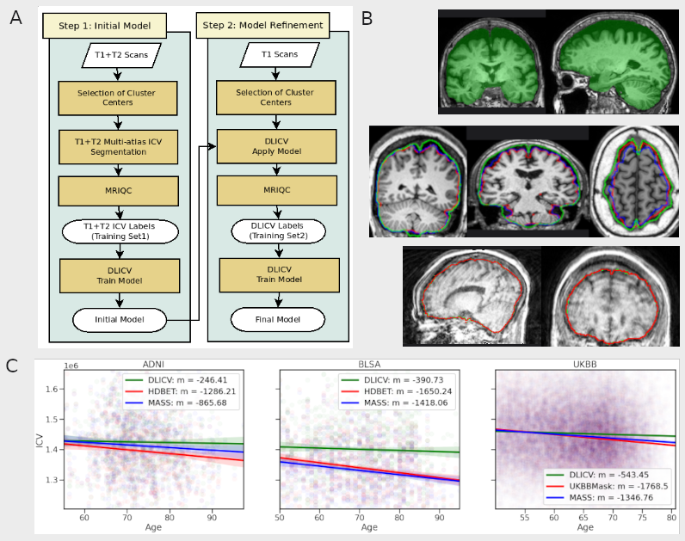**Fig 1.** A. Overview of DLICV model training. B. (top) An example subject with global cortical atrophy, which illustrates the importance of accurate ICV estimation for normalization purposes. The DLICV mask (green) captured cortical CSF due to atrophy, while the multi-atlas “brain mask” (not shown here) had an ICV estimation %6.8 lower than DLICV; B. (middle) Examples of segmentation using DLICV (green), HDBET (red) and MASS (blue); B. (bottom) Example DLICV segmentation (red) for a case with extreme motion showing the robustness of the method. C. Age trends of ICV volumes in ADNI and BLSA (estimated using DLICV, HDBET and MASS), and in UKBIOBANK (estimated using DLICV, MASS and the brain masks computed and distributed by the UKBIOBANK imaging group).

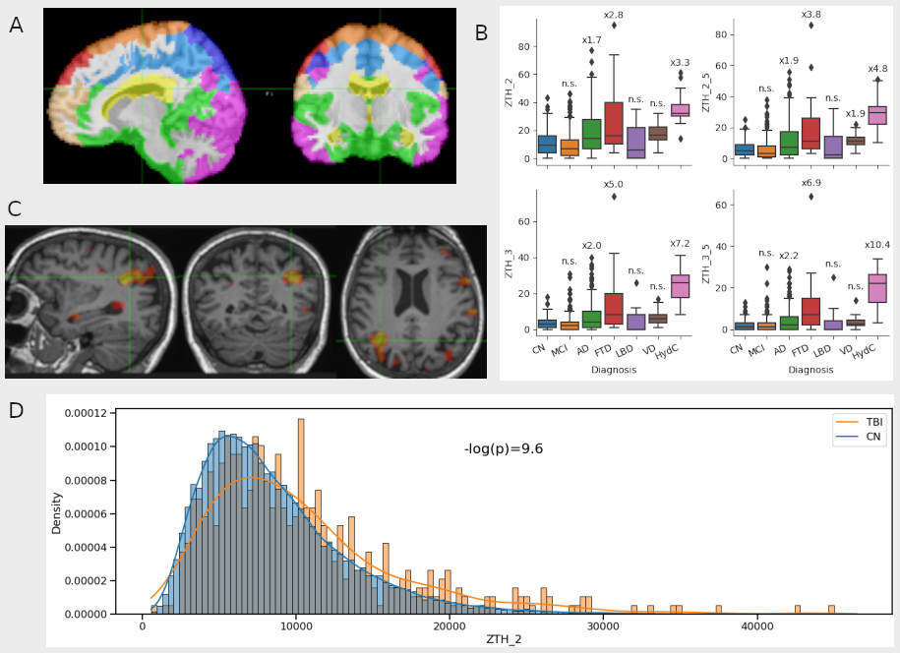**Figure 2.** A. Visualization of CSF regional decomposition using non-negative matrix decomposition. B. Analysis of disease effects using CSF regional volumes normalized by reference control distributions. The y axis shows the count of outlier CSF regions, i.e CSF regions that showed a statistically significant deviation from the distribution of age and gender matched control subjects (for two different z score thresholds). The data shows results for disease groups MCI, AD, fronto-temporal dementia (FTD), Lewy body dementia (LBD), vascular dementia (VD), and hydrocephalus (HydC). The values above each box plot show the incidence rate ratio. C. Individualized CSF atrophy map for a single self-reported TBI subject. Voxelwise z-score map of CSF tissue densities normalized by age and gender matched control subjects were thresholded at z>2.5. D. Comparison of abnormal regional CSF volumes between CN and TBI subjects in UKB. The x axis represents the count of abnormal CSF voxels after normalization of CSF-RAVENS maps by age and gender matched control subjects. TBI subjects had significantly higher CSF abnormality (p<<0.001)

1. https://github.com/gurayerus/DLICV