**A CSF-centric Image Morphometry Approach via DL-based Segmentation of ICV**

Guray Erus1, Jimit Doshi, Junhao Wen1, Sindhuja Tirumalai Govindarajan1, Dhivya Srinivasan1, Yuhan Cui1, Christos Davatzikos1

1Artificial Intelligence in Biomedical Imaging Laboratory (AIBIL), Center for Biomedical Image Computing and Analytics, Perelman School of Medicine, University of Pennsylvania, Philadelphia, USA

[FIXME: Please add if you suggest additional co-authors]

[FIXME: Please add / correct affiliations]

**Introduction**

Neuroimaging pipelines often focus on GM and WM, while overlooking cerebro-spinal fluid (CSF), considering it simply as “background”. Along with other purposes, proper segmentation of cortical CSF is critical for accurate estimation of the intra-cranial volume (ICV), an important measure used for adjusting tissue volumes against variations in head size across individuals. We present DLICV, a deep learning method for ICV segmentation from raw T1 images, that combines a convolutional network, an elaborate training strategy with large and carefully curated datasets, and a strategy to transfer label information derived from T2-weighted images with better ICV contrast. Second, we propose atlas-based, as well as data-driven decomposition of CSF, to quantify regional CSF volumes. Extensive validations convergingly show that DLICV provides robust and accurate brain masks, with computed ICV values that are minimally affected from age bias. We also show that derived CSF variables have discriminative power to capture disease-related regional atrophy patterns comparable to or outperforming commonly used GM volumetric analyses. We provide an open-source software package for DLICV segmentation.

**Methods**

Existing T1-based methods have a tendency to calculate a tight mask around the cerebral cortex, thus under-estimating the ICV [1,2]. The main premise of DLICV is that the relatively more explicit, i.e. higher contrast, ICV boundary on T2 images is present on T1 images, but visually less perceivable and more difficult to delineate. To learn this implicit boundary, we extend a UNet architecture for generic segmentation [3-4], and propose a training strategy that uses only the T1 scans as input data, yet reference masks derived from T1+T2 scans as labels. Training stage uses a diverse and large multi-study dataset [5] and includes automated and semi-automated steps for selection of representative scans, quality verification and iterative refinement of the model.

DLICV segmentation is followed by calculation of voxelwise CSF-tissue density maps (CSF-RAVENS) in a common atlas space [6], and CSF feature extraction for quantifying regional CSF. As cortical CSF lacks clear regional boundaries, we propose two alternatives: 1) by transferring a set of pre-defined multi-atlas regions of interest (ROIs) with dense cortical segmentation into CSF-RAVENS space via image morphology, and 2) using ROIs obtained via NNMF, which identifies data-driven components of CSF covariation across subjects [7]. Validation experiments investigate discrimination power of extracted CSF features in disease and neurodegenerative conditions.

**Results**

Qualitative and quantitative validations on large datasets demonstrate that DLICV provides accurate segmentation of ICV, with significantly reduced failure rates, and importantly, achieving ICV values that are minimally biased by age (Fig 1). DLICV consistently obtained age slopes reduced by a factor of 2 in comparison to benchmark methods [8,9]. Importantly, CSF features were able to discriminate various disease effects, including Alzheimer’s disease (AD), fronto-temporal dementia (FTD), and self-reported traumatic brain injury (TBI), from control subjects with higher significance in comparison to regional GM (Fig. 2)

**Conclusions**

Accurate estimation of ICV, particularly for subjects with global cortical atrophy due to aging or disease, is critical for down-stream data normalization and analyses. DLICV is a user-friendly and fast method to estimate a minimally age-biased ICV from a single raw T1 image, as well as to obtain an accurate brain mask for down-stream processing and analysis steps. Analyses leveraging DLICV and proposed regional CSF quantification methods highlight the potential of CSF-centric analyses for understanding brain changes in disease, as a complementary approach to current volumetric processing and analysis pipelines.

**References**

*[1] Nordenskjöld R, et al. Intracranial volume estimated with commonly used methods could introduce bias in studies including brain volume measurements. Neuroimage. 2013 Dec;83:355-60.*

*[2] Nerland S, et al. A comparison of intracranial volume estimation methods and their cross-sectional and longitudinal associations with age. Hum Brain Mapp. 2022 Jun 16. doi: 10.1002/hbm.25978. Epub ahead of print. PMID: 35708198.*

*[3] Ronneberger, O., et al. U-net: Convolutional networks for biomedical image segmentation. arXiv preprint arXiv:1505.04597.*

*[4]* Doshi, Jimit, et al. "DeepMRSeg: A convolutional deep neural network for anatomy and abnormality segmentation on MR images." *arXiv preprint arXiv:1907.02110*(2019).

[5] Pomponio, Raymond, et al. "Harmonization of large MRI datasets for the analysis of brain imaging patterns throughout the lifespan." *NeuroImage* 208 (2020): 116450.

[6] Davatzikos C, et al. Voxel-based morphometry using the RAVENS maps: methods and validation using simulated longitudinal atrophy. Neuroimage. 2001 Dec;14(6):1361-9.

[7] Junhao, W.E.N., Abdulkadir, A., Satterthwaite, T.D., Robert-Fitzgerald, T., Chen, J., Schnack, H., Zanetti, M., Meisenzahl, E., Busatto, G., Crespo-Facorro, B. and Pantelis, C., 2022. Novel genomic loci and pathways influence patterns of structural covariance in the human brain. MedRxiv. (in review)

[8] *Doshi J, et al. Alzheimer's Neuroimaging Initiative. MUSE: MUlti-atlas region Segmentation utilizing Ensembles of registration algorithms and parameters, and locally optimal atlas selection. Neuroimage. 2016 Feb 15;127:186-195.*

*[9] Isensee F, et al. Automated brain extraction of multisequence MRI using artificial neural networks. Hum Brain Mapp. 2019 Dec 1;40(17):4952-4964. doi: 10.1002/hbm.24750. Epub 2019 Aug 12. PMID: 31403237; PMCID: PMC6865732.*

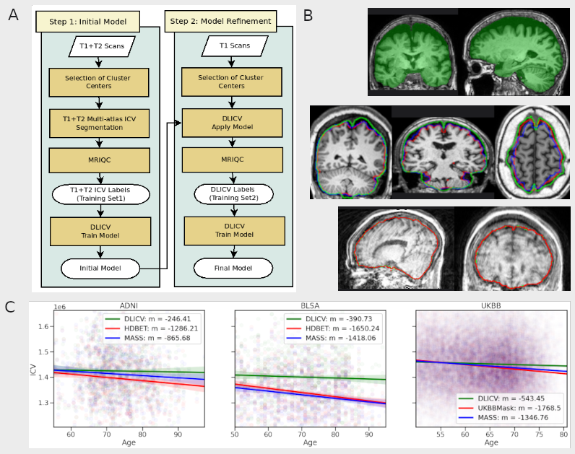**Fig 1.** A. Overview of DLICV model training. The lifespan dataset for training the model was derived from 22 different datasets that are part of the ISTAGING consortium, by automatically detecting cluster centers of each dataset, to select most representative scans. B. (top) An example subject with global cortical atrophy, which illustrates the importance of accurate ICV estimation for normalization purposes. The DLICV mask (green) captured cortical CSF due to atrophy, while the multi-atlas “brain mask” (not shown here) had an ICV estimation %6.8 lower than DLICV; B. (middle) Examples of segmentation using DLICV (green), HDBET (red) and MASS (blue); B. (bottom) Example DLICV segmentation (red) for a case with extreeme motion showing the robustness of the method. C. Age trends of ICV volumes estimated using DLICV, HDBET and MASS in ADNI and BLSA, and using DLICV, MASS and brain masks computed by the UKBB organizers. DLICV reduced the age slope of ICV by a factor of 2 against other methods.

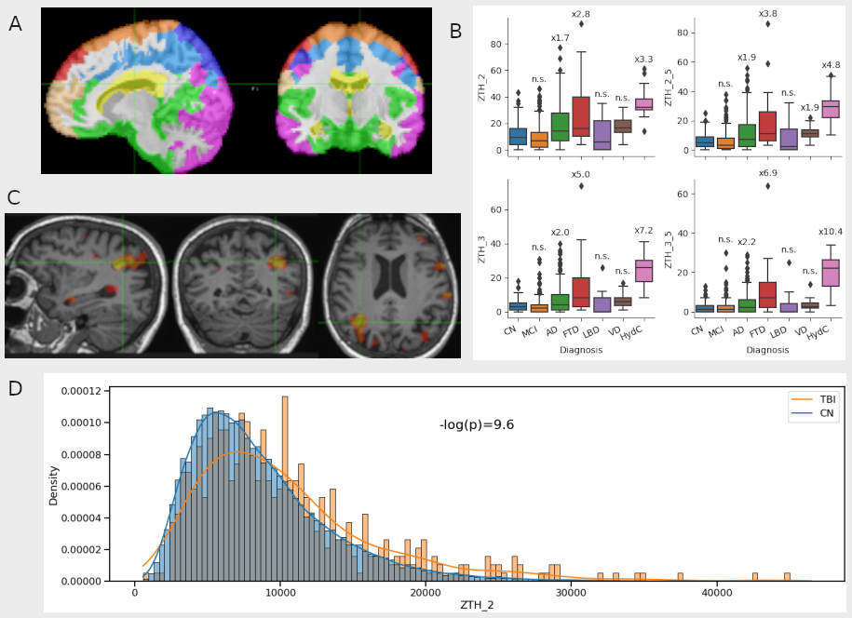**Figure 2.** A. Visualization of CSF regional decomposition using non-negative matrix decomposition. B. Analysis of disease effects using CSF regional volumes normalized by reference control distributions. The y axis shows the count of outlier CSF regions, i.e CSF regions that showed a statistically significant deviation from the distribution of age and gender matched control subjects (for two different z score thresholds), for disease groups MCI, AD, fronto-temporal dementia (FTD), Lewy body dementia (LBD), vascular dementia (VD), hydrocephalus (HydC). The count of outliers were modeled using negative binomial regressions, and significantly higher incidence rate ratios are reported above each boxplot. C. Individualized CSF atrophy map for a single self reported TBI subject. Voxelwise z-score map of CSF tissue densities normalized by age and gender matched control subjects were thresholded at z>2.5. D. Comparison of abnormal regional CSF volumes between CN and TBI subjects in UKB. The x axis represents the count of abnormal CSF voxels after normalization of CSF-RAVENS maps by age and gender matched control subjects. TBI subjects had significantly higher CSF abnormality (p<<0.001)