**Aim:**

Consider a noisy ECG signal. Design a suitable filter to remove the particular artifact/noise using Matlab.

**Theory:**

An ECG or electrocardiogram is used to observe the electrical activity of the heart in order to detect certain irregularities and to even predict onset of certain ailments. ECG is obtained by measuring the potential between different parts of the body.

This is done by attaching electrodes to the skin which can detect the voltage changes. However, certain physiological, instrumentation and environmental factors can introduce noise to the signal which makes it difficult to analyse it. Some examples of sources of noise include: coughing or breathing, thermal noise from heating components and EM waves from fluorescent lightings and even due EMG interference. Thus, it becomes important to use the correct form of filtering so that the original signal can be obtained.

**Types of Noises in ECG**

For this assignment, the data for a noisy ECG sampled at 500Hz has been used. The raw ECG has two noises: a high frequency component of 50Hz, which was introduced due to ‘Powerline Interference’, and a low frequency component which causes a ‘Baseline Wander Noise’ in the ECG, i.e., the signal is wandered from zero line.

Powerline Interference is the most common and disturbing noise in the electrical signals produced by human body. Such noise is characterized by 50 or 60 Hz sinusoidal interference, possibly accompanied by a number of harmonics.

Baseline Wander Noise is the most common noise found in ECG caused due to respiration or movement by the patient.In this type of noise signal is shifted wither upwards or downwards from the zero line of the graph.

**Filtering of Noise in ECG:**

For filtering Power-Line Interference noise the signal is passed from low pass filter and Baseline Wander noise is removed from passing from high pass filter, as the signal has high and low frequency components.

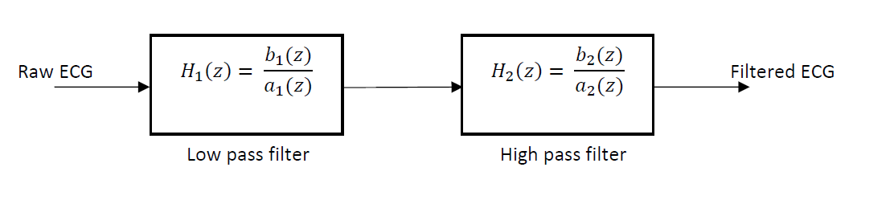

A type-2 Chebyshev filter is used for removing Power-line Interference ( 50/60 Hz frequency),

8th order filter with a stop-band attenuation of 80dB has been implemented and cutoff frequency 60 Hz . The transfer function of the filter is given below:

𝐻1(𝑧)=

0.0001378 z^8 - 0.000727 z^7 + 0.001838 z^6 - 0.002963 z^5 + 0.003432 z^4 - 0.002963 z^3 + 0.001838 z^2 - 0.000727 z + 0.0001378

----------------------------------------------------------------------------------------------------------------- z^8 - 6.902 z^7 + 20.91 z^6 - 36.3 z^5 + 39.5 z^4 - 27.58 z^3 + 12.07 z^2 - 3.025 z + 0.3325

The type 2 Chebyshev filter has a faster roll-off compared to Butterworth filter, while avoiding ripples in the passband. With this filter, the high frequency component of the signal is removed, and only the baseline drift remains, i.e., the low frequency component.

An 8th order Butterworth high pass filter with cut-off frequency of 2Hz is used for removing the

baseline drift. The transfer function for the filter is given below:

𝐻2(𝑧)=

0.8791 z^8 - 7.033 z^7 + 24.62 z^6 - 49.23 z^5 + 61.54 z^4 - 49.23 z^3 + 24.62 z^2 - 7.033 z + 0.8791

-----------------------------------------------------------------------------------------------------

z^8 - 7.742 z^7 + 26.23 z^6 - 50.79 z^5 + 61.46 z^4 - 47.62 z^3 + 23.06 z^2 - 6.382 z + 0.7728

**Code (Matlab):**

val=load('FileName.csv');

Fs=500;

% Ts sampling period

Ts=1/Fs;

% Length of the signal

N=5000;

% Time vector

t=(0:Ts:9.999);

figure(1)

%ploting the signal

subplot(3,1,1)

plot(t,val);

ylabel('Amplitude (mV)')

title('Raw ECG')

grid on;

% Compute fft

ECG=fft(val);

% Take abs and scale it

ECG1=abs(ECG/N);

% Pick the first half

ecg=ECG1(1:N/2+1);

% Multiply by 2 (except the DC part), to compenseate

% the removed side from the spectrum.

ecg(2:end-1) = 2*ecg(2:end-1);

% Frequency range

F = Fs*(0:(N/2))/N;

%plot(F,ecg,'r')

%DTFT Magnitude and Phase Response

n=length(ECG);

k=0:n-1;

w=2*pi*k/n;

subplot(3,1,2)

plot(w/pi,angle(ECG));

xlabel('\omega(rads)');

ylabel('\angleX(\omega)');

title('DTFT Phase Respose');

%Filtering

%Low Pass Power-Line Interference

[b,a]=cheby2(8,80,60/Fs);

x2=filtfilt(b,a,val);

tf(b,a,1/Fs)

plot(t,x2);

grid on;

ylabel('Amplitude (mV)')

title('ECG after 50/60 Hz removed')

%High Pass Baseline Wander Noise filtering

[b1,a1]=butter(8,8/Fs,'high');

x3=filtfilt(b1,a1,x2);

subplot(3,1,3)

tf(b1,a1,1/Fs)

plot(t,x3);

title('ECG Filtered (Baseline Noise Removed)')

xlabel('Time (s)')

ylabel('Amplitude (mV)')

grid on;

**Graph:**

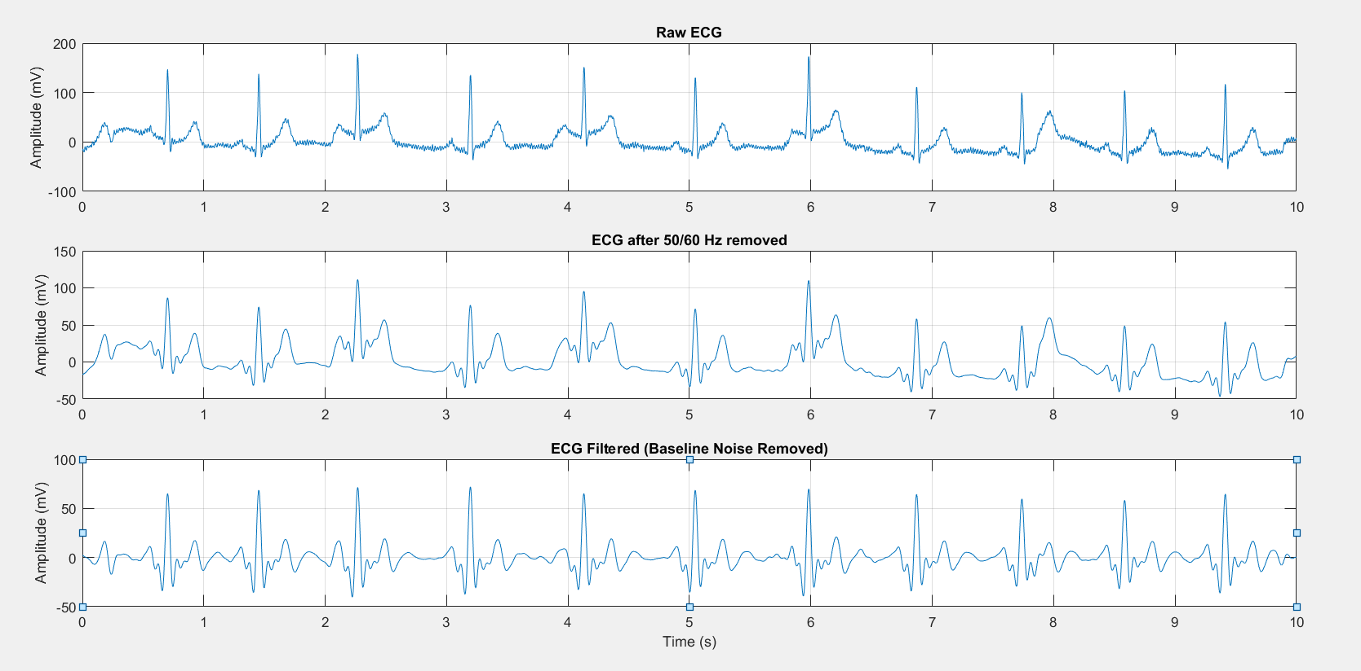

**Conclusion:**

Both the noise artifacts Power-line interference and Baseline Wander , have been successfully filtered out from the original raw ECG signal. All the components in ECG, P wave, QRS complex and the T wave can be clearly identified in the output filtered signal.