BLUE TEAM | WEEK 1
Mini-SOC in a Box
Week 1 Report: Build the lab and deploy Wazuh
Item | Detail
Client scenario | LabShop: one web server, one staff PC, no security monitoring
Role | Security team (builder and analyst)
Date of build | 16 October 2026
Platform | VMware Workstation on a Dell laptop (32 GB RAM, 1 TB disk)
Wazuh version | 4.9.2 single-node, Docker Compose (see section 8, version note)

1. Summary
LabShop had no way to see what its machines were doing. In Week 1 I built the foundation for the whole project: an isolated three-VM lab, a Wazuh SIEM running in Docker, and two monitored endpoints (a Linux web server and a Windows client with Sysmon). I then caused five known events and found each of them in the Wazuh dashboard, which proves that the pipeline from endpoint to alert works.

2. Lab architecture
Wazuh sits at the centre. The two endpoints send their events to the manager on siem-host. Only siem-host has a NAT adapter (to pull Docker images); the endpoints live on the host-only network so the attack lab stays isolated.
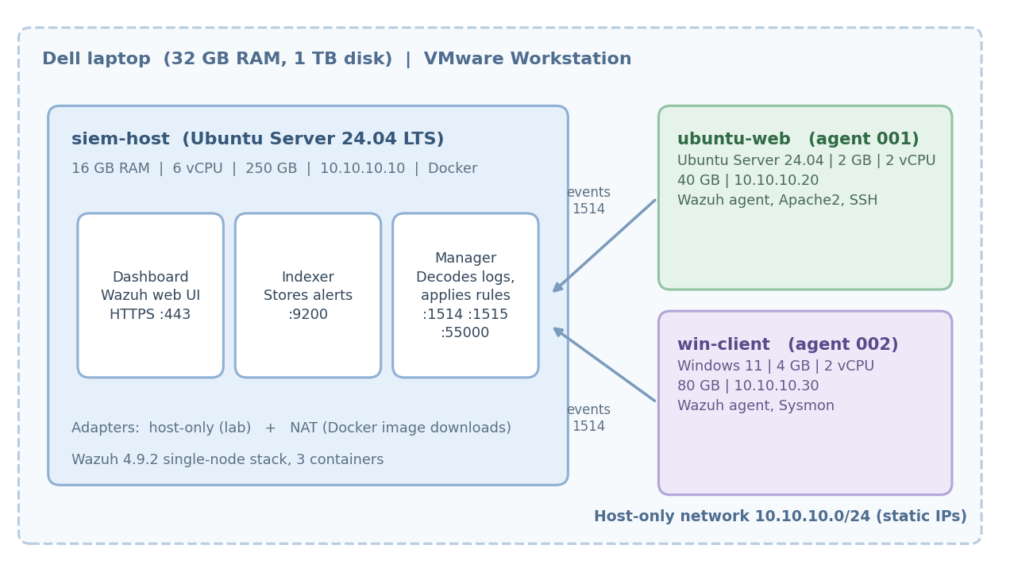
Figure 1. Week 1 architecture as built.
Machine | Role / OS | RAM | vCPU | Disk | IP address | Network
siem-host | Wazuh in Docker / Ubuntu Server 24.04.2 LTS | 16 GB | 6 | 250 GB | 10.10.10.10 | Host-only + NAT
ubuntu-web | Linux endpoint, Apache / Ubuntu Server 24.04 LTS | 2 GB | 2 | 40 GB | 10.10.10.20 | Host-only
win-client | Windows endpoint / Windows 11 | 4 GB | 2 | 80 GB | 10.10.10.30 | Host-only
Windows figures for win-client follow the project brief; confirm them against your VM settings.

3. Build steps

Phase 1. Isolated lab network
In the VMware Virtual Network Editor I used VMnet0 as a Custom host-only network, with subnet 10.10.10.0/24 and the local DHCP service turned off. All lab addresses are static and written in the address table above.
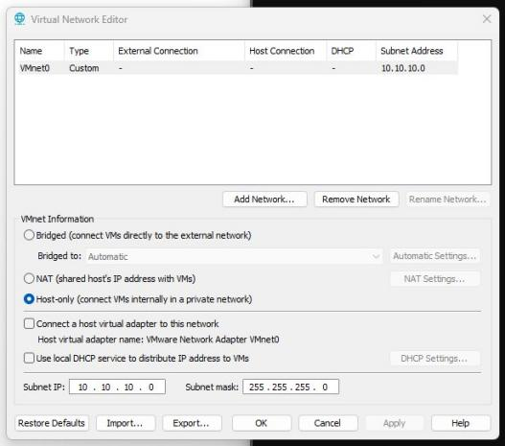
Figure 2. VMnet0: host-only, subnet 10.10.10.0, DHCP off.

Phase 2. Virtual machines
siem-host was built from the Ubuntu Server 24.04.2 LTS ISO with 16 GB RAM, 6 vCPU and a 250 GB single-file disk. ubuntu-web received 2 GB RAM, 2 vCPU and a 40 GB disk on VMnet0. win-client is the Windows 11 endpoint.
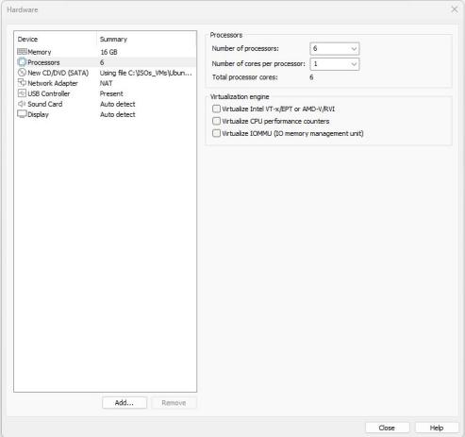  Figure 3. siem-host: 16 GB RAM, 6 vCPU, NAT adapter. | 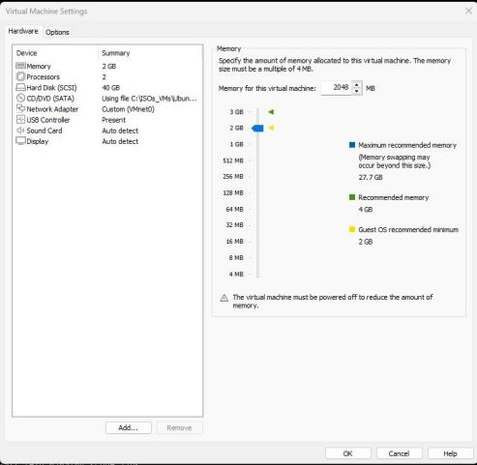  Figure 4. ubuntu-web: 2 GB RAM, 2 vCPU, 40 GB, VMnet0.

Phase 3. Static addressing
Ubuntu endpoints use netplan with DHCP off and a fixed address (ubuntu-web: 10.10.10.20/24). win-client uses a manual IPv4 setting of 10.10.10.30 / 255.255.255.0 with no gateway, so it has no path out of the lab.
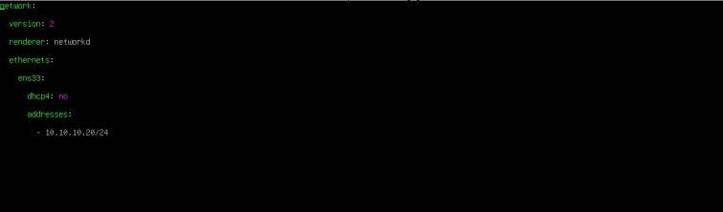  Figure 5. ubuntu-web static address (netplan). | 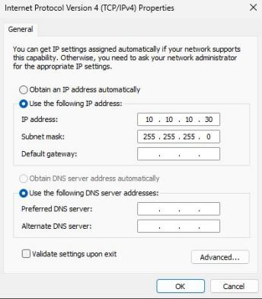  Figure 6. win-client static IPv4.

Phase 4. Docker Engine and Compose
Docker Engine and the Compose plugin were installed on siem-host and verified:
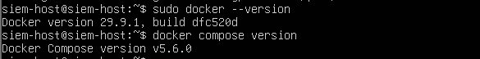
Figure 7. Docker 29.9.1 and Docker Compose v5.6.0.

Phase 5. Deploy the Wazuh stack
I cloned the official wazuh-docker repository, checked out the release tag, moved into the single-node folder and started the stack in the background:
git clone https://github.com/wazuh/wazuh-docker.git
cd wazuh-docker/single-node
sudo docker compose up -d
Compose pulled the manager, indexer and dashboard images, created the network and volumes, and started three containers.
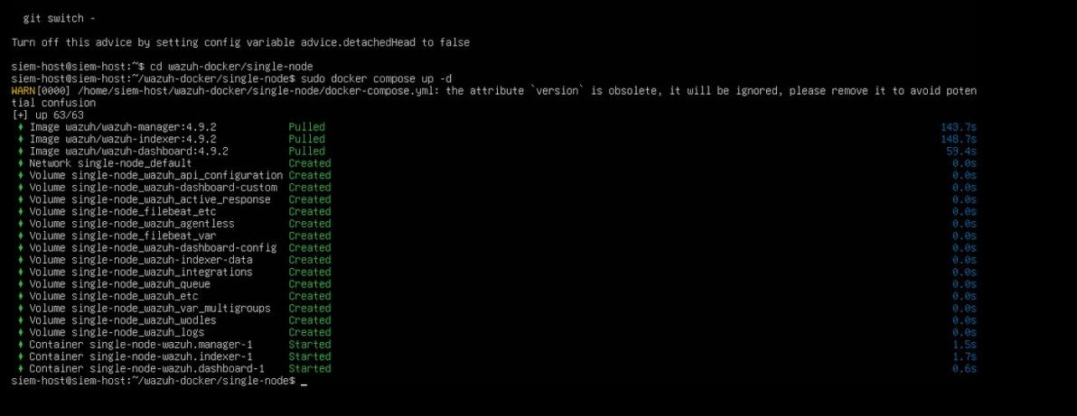
Figure 8. docker compose up -d: images pulled, volumes created, containers started.
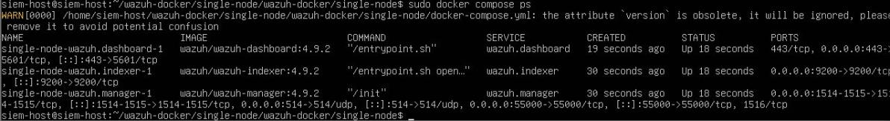
Figure 9. docker compose ps: manager, indexer and dashboard all Up.
Reading the container list: the dashboard publishes 443, the indexer 9200, and the manager 1514/1515 (agents), 514/udp (syslog) and 55000 (API). Compose also warns that the version attribute in the file is obsolete; this is harmless.

Phase 6. Open the dashboard
The dashboard opens at https://10.10.10.10. The browser shows a certificate warning because the stack uses a self-signed certificate created for the lab, not one issued by a public certificate authority. The traffic is still encrypted; the browser simply cannot confirm who signed the certificate. Before any agent was enrolled, the Endpoints page was empty.

Phase 7. Linux agent and web server (ubuntu-web)
The Deploy new agent wizard generated the install command. I selected DEB amd64, entered the manager address 10.10.10.10 and the agent name ubuntu-web, then ran it on the VM and started the service.
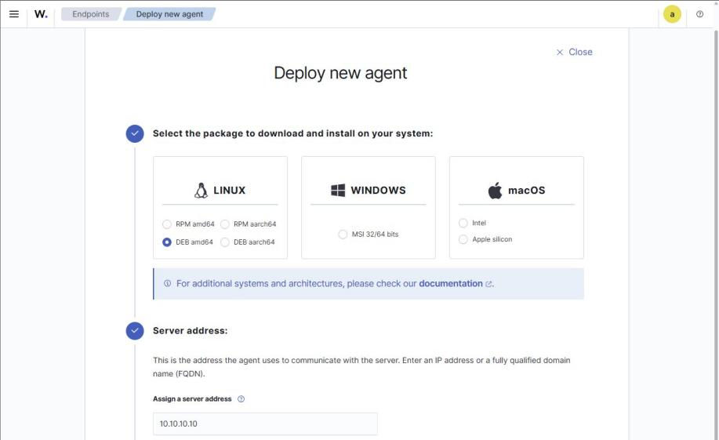
Figure 10. Deploy new agent wizard: package, server address and agent name.
wget https://packages.wazuh.com/4.x/apt/pool/main/w/wazuh-agent/wazuh-agent_4.9.2-1_amd64.deb \
&& sudo WAZUH_MANAGER='10.10.10.10' WAZUH_AGENT_NAME='ubuntu-web' dpkg -i ./wazuh-agent_4.9.2-1_amd64.deb
sudo systemctl daemon-reload
sudo systemctl enable wazuh-agent
sudo systemctl start wazuh-agent
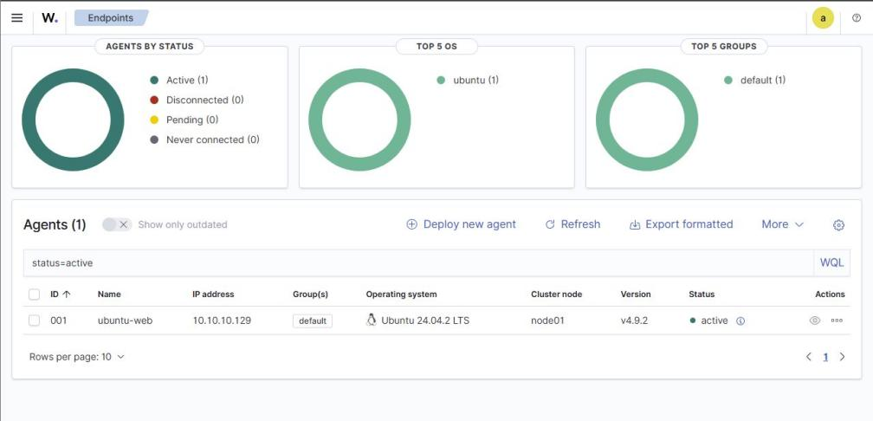
Figure 11. Agent 001 ubuntu-web is Active.
Apache2 was installed on the same VM so there is a web server to attack in Week 3:
sudo apt update && sudo apt install apache2 -y
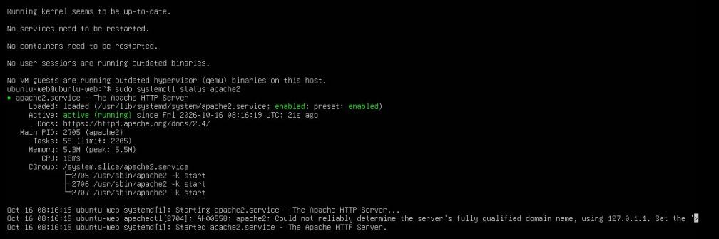
Figure 12. apache2.service active (running) and enabled.

Phase 8. Windows agent (win-client)
The wizard was used again with the Windows MSI package and the agent name win-client. In an administrator PowerShell the agent was downloaded, installed silently and started:
Invoke-WebRequest -Uri https://packages.wazuh.com/4.x/windows/wazuh-agent-4.9.2-1.msi \
-OutFile $env:tmp\wazuh-agent; msiexec.exe /i $env:tmp\wazuh-agent /q \
WAZUH_MANAGER='<manager address>' WAZUH_AGENT_NAME='win-client'
NET START WazuhSvc
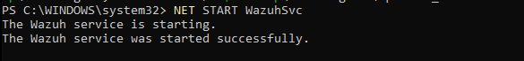
Figure 13. The Wazuh service started successfully on win-client.
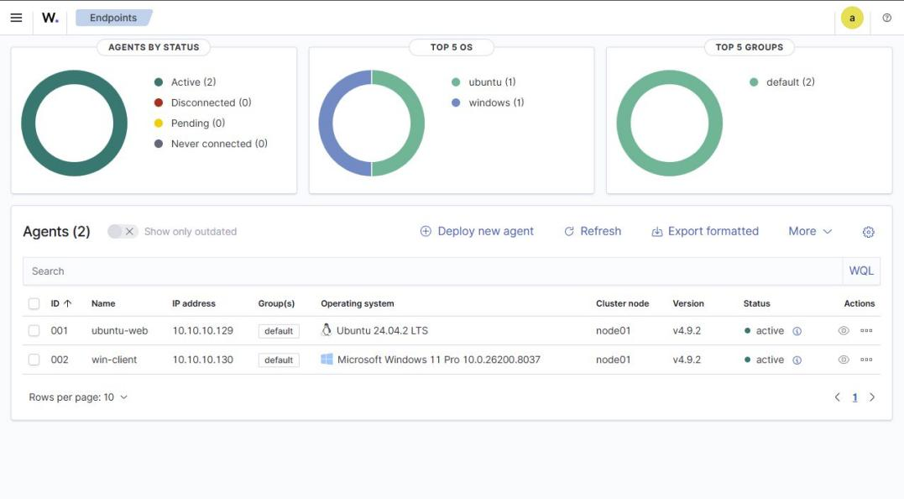
Figure 14. Both agents Active: ubuntu-web (Ubuntu 24.04) and win-client (Windows 11 Pro).

Phase 9. Sysmon on Windows
Sysmon adds detailed endpoint telemetry that the normal Windows Security log does not contain: process creation with full command line, parent process and file hashes, network connections, file creation and more. The Wazuh agent reads the Microsoft-Windows-Sysmon/Operational channel, so these events appear in the dashboard under the agent name win-client.
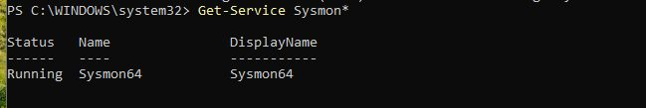
Figure 15. Sysmon64 service is Running.
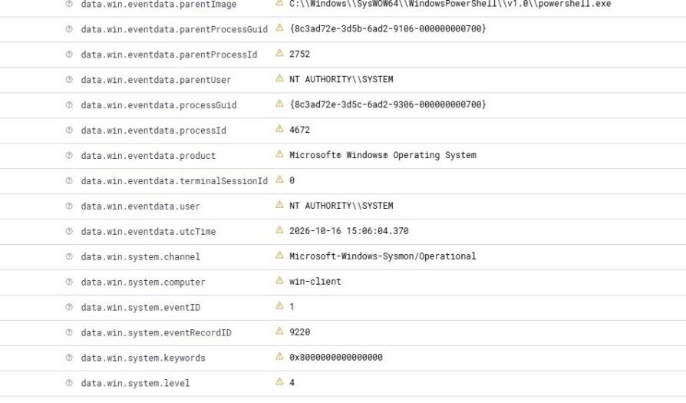
Figure 16. Sysmon Event ID 1 (process creation) in the dashboard: channel Microsoft-Windows-Sysmon/Operational, computer win-client.
Sysmon configuration used: [write here: SwiftOnSecurity or Olaf Hartong config, and the localfile block added to ossec.conf]

5. Verification: five known events
I caused each event on purpose and located it in Discover (index wazuh-alerts-4.x). Every alert shows the agent name, so it is clear which machine produced it.
# | Action performed | Rule description | Level | Rule ID | Evidence (figure)
1 | Failed SSH login as a non-existent user (ssh invaliduser@10.10.10.20) | sshd: Attempt to login using a non-existent user | 5 | 5710 | Figures 17 and 18
2 | sudo with wrong passwords, then sudo whoami | Three failed attempts to run sudo / PAM: Login session closed | 10 / 3 | 5404 / 5502 | Figures 19 to 21
3 | sudo useradd labuser | New user added to the system | 8 | 5902 | Figures 22 and 23
4 | Start-Process notepad.exe (Sysmon Event ID 1) | Sysmon process creation event | see note |  | Figures 24 and 16
5 | Failed Windows logon (Security Event ID 4625, user aisha) | Windows logon failure | see note |  | Figure 25

Event 1. Failed SSH login
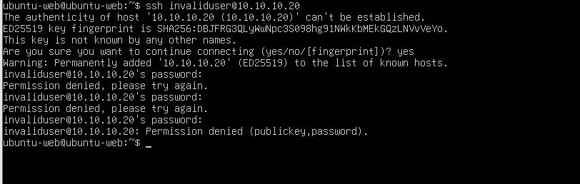
Figure 17. Three password attempts for "invaliduser" are denied.
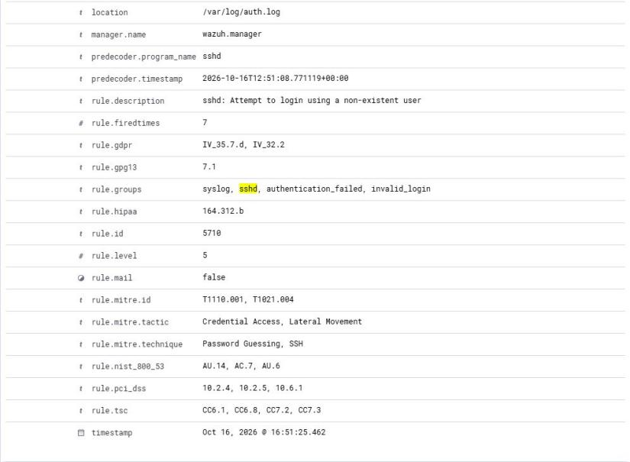
Figure 18. Alert: rule 5710, level 5, agent ubuntu-web, MITRE T1110.001 (password guessing).
Proves: sshd logged the failure, the agent forwarded it, and the manager matched a brute-force related rule.

Event 2. Command run with sudo
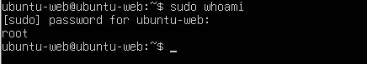
Figure 19. sudo whoami asks for the password and returns root.
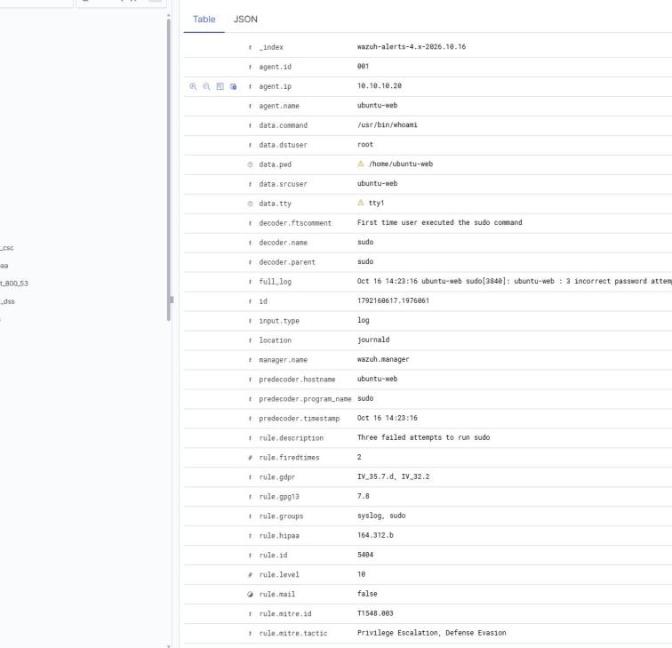
Figure 20. Alert: rule 5404, level 10, "Three failed attempts to run sudo" (MITRE T1548.003).
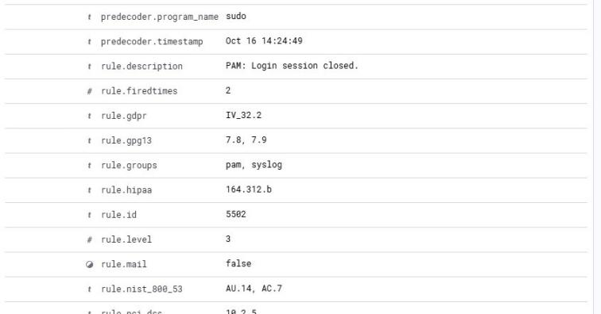
Figure 21. Alert: rule 5502, level 3, PAM login session closed for the sudo session.
Proves: privilege use is visible, and repeated failures are rated much higher than the normal session event.

Event 3. New local user on Linux
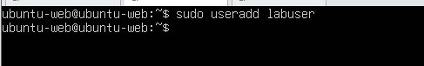
Figure 22. sudo useradd labuser.
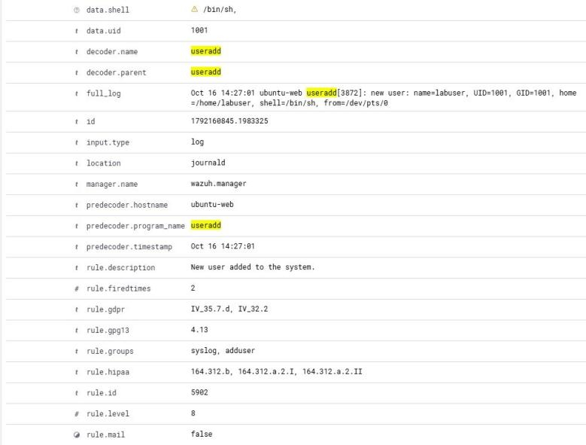
Figure 23. Alert: rule 5902, level 8, "New user added to the system" (MITRE T1136, Persistence).
Proves: account creation, a common persistence step, is detected within seconds.

Event 4. Program started on Windows (Sysmon)
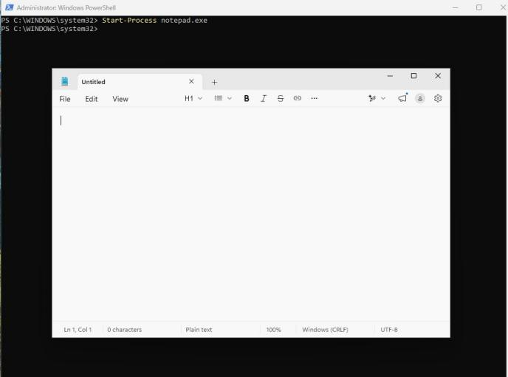
Figure 24. Start-Process notepad.exe on win-client.
The resulting Sysmon Event ID 1 is shown in Figure 16. Proves: Sysmon gives process, parent process, command line and hashes that the Security log alone would not.

Event 5. Failed Windows logon
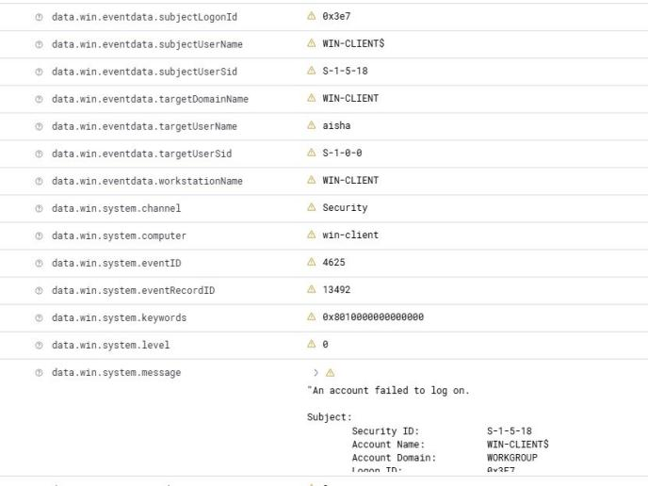
Figure 25. Security Event ID 4625 on win-client: logon failure for user aisha.
Proves: Windows Security log events are collected by the same agent alongside Sysmon.

Dashboard overview
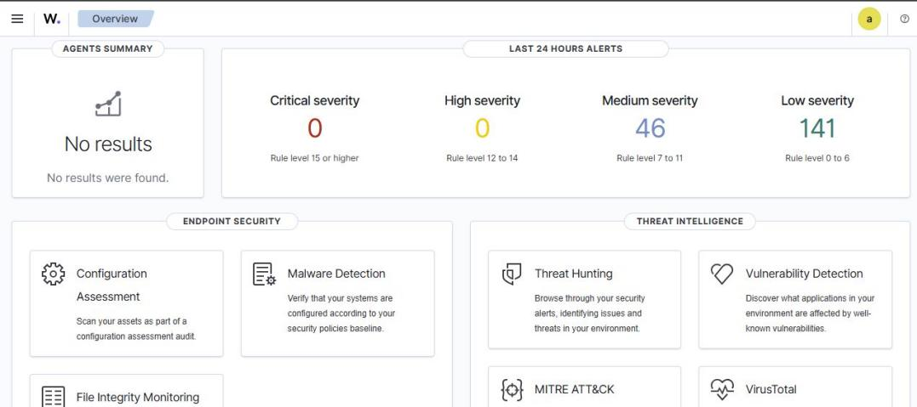
Figure 26. Last 24 hours: 0 critical, 0 high, 46 medium, 141 low alerts.

6. Path of one event: endpoint to dashboard
Example: the failed SSH login from Event 1.
- Event happens. sshd on ubuntu-web writes "Failed password for invalid user" to its log (auth.log / journald).
- Agent collects. The Wazuh agent reads the log line and sends it to the manager on port 1514, encrypted with the key created at enrolment (port 1515).
- Manager decodes. The predecoder and the sshd decoder extract fields such as source IP, user name and program name.
- Rules match. Rule 5710 matches, so the manager creates an alert with level 5 and MITRE mapping T1110.001.
- Alert is indexed. The manager ships the alert to the indexer (port 9200), which stores it in index wazuh-alerts-4.x-2026.10.16.
- Analyst sees it. The dashboard queries the indexer over HTTPS (port 443) and shows the alert in Discover.

7. Start and stop the lab
Order matters because the agents need the manager to be running when they start.

Start
- Power on siem-host and wait for the login prompt.
- Start the stack: cd ~/wazuh-docker/single-node && sudo docker compose up -d
- Check that all three containers are Up: sudo docker compose ps
- Power on ubuntu-web and win-client; confirm both agents are Active in the dashboard.

Stop
- Shut down win-client and ubuntu-web.
- On siem-host stop the stack without deleting data: sudo docker compose stop
- Shut down siem-host: sudo shutdown now

