**Checkout.com .NET Challenge**

**Building a Payment Gateway**

**Solution by Gurdeep Singh**

**Introduction**

The solution to the code challenge is developed in Visual Studio using .Net Core v 3.1

**Documentation**

* All documentation is available in folder - \Documentation

**Assumptions**

* Acquiring Mock Bank API security is omitted
* Address details validations in Credit card are omitted

**Design & Architecture**

Following components and principals are practiced during the development of this solution

* **Diagrams** – Tech Diagram (Checkout_Architecture.pdf) is Documentation folder.
* **Phase 1** – This is how the current code is implemented. The tech diagram is as below. The architecture is monolithic as all of the system components are available in single Repository library.

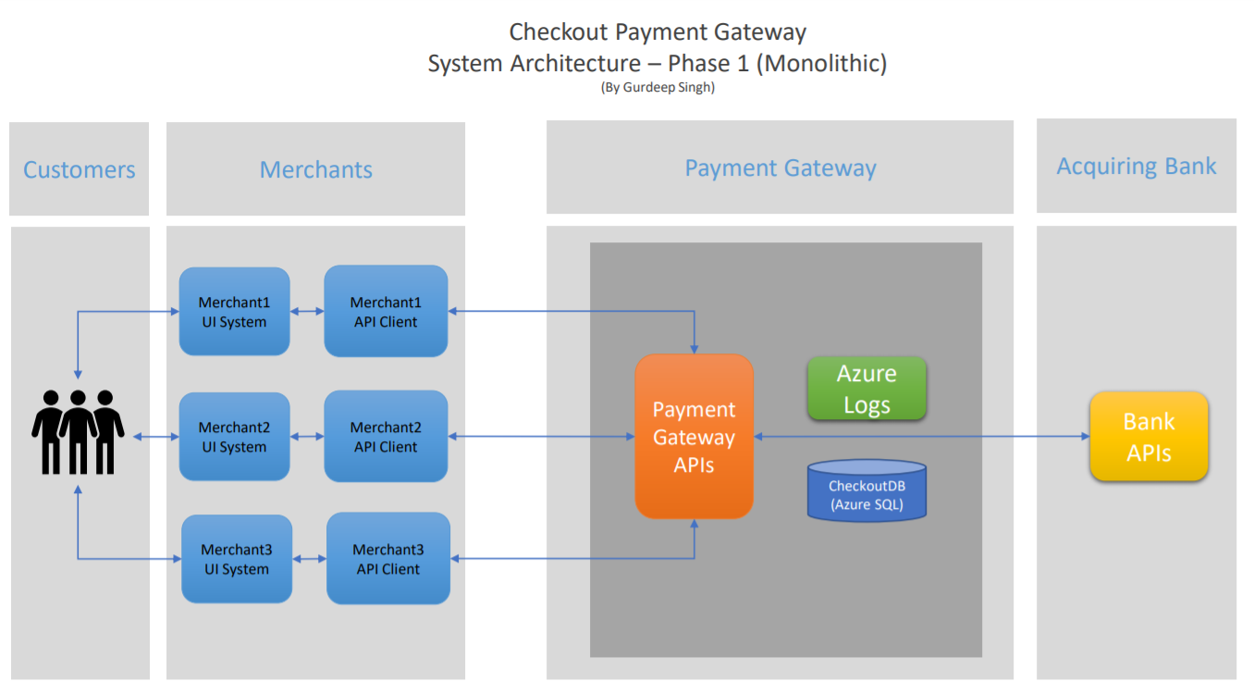

* **Phase 2** – As system grows the better architect may be achieved by migrating into Microservices architecture. The logical breakdown of functions such as Payment service, Bank service, Authentication Service & Merchant Service can be developed. Each logical function can be independent microservices. This can be benefit as maintenance will become easier and can be re-sued by other systems in the organisation.

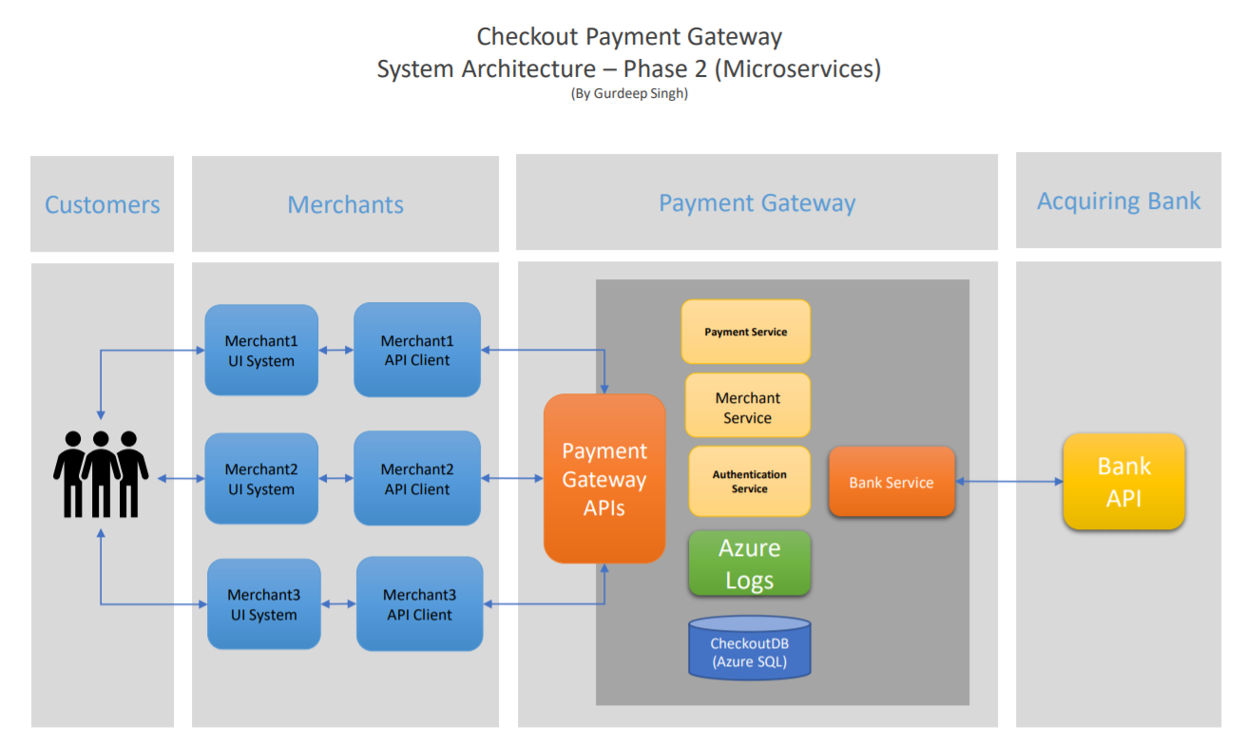

* **Entity Framework .Net core –** For Object relational mapping and Data layer the Entity framework for .Net Core has been used**.**
* **Repository pattern & Unit of Work –** Repository pattern and Unit of work is used. This helps to keep the architecture clean and more maintainable as project grows over the time.
* **Project Structure** – Following are the projects in the solution.

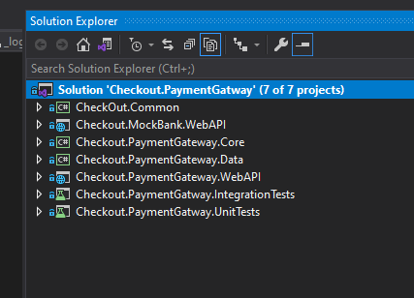

**Database**

* Azure SQL DB is used under local DB Instance.
* Migration scripts are available in **Checkout.PaymentGateway.Data** Project.
* **Data Encryption** – The sensitive data in Credit Card Details table is encrypted using SQL Always Encrypted System and Column keys.

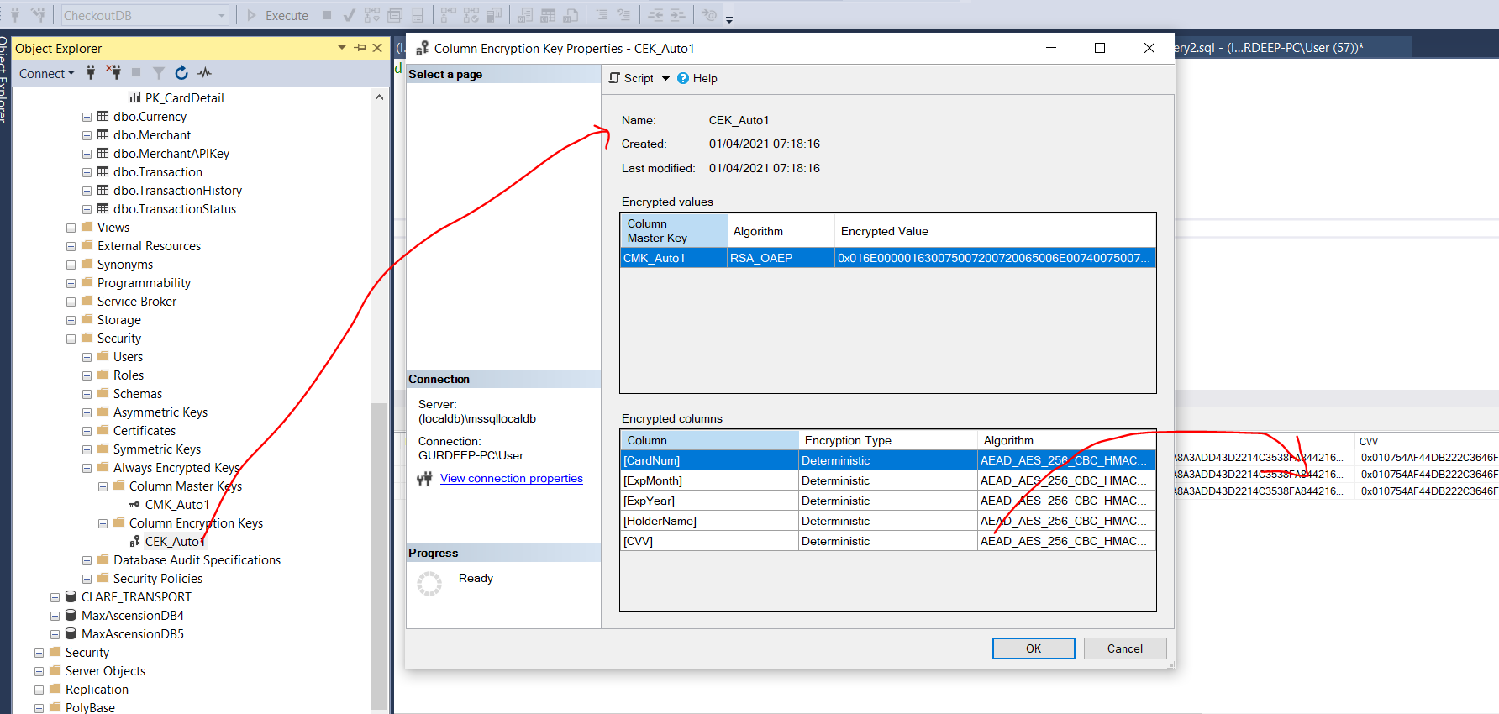

* Data Model

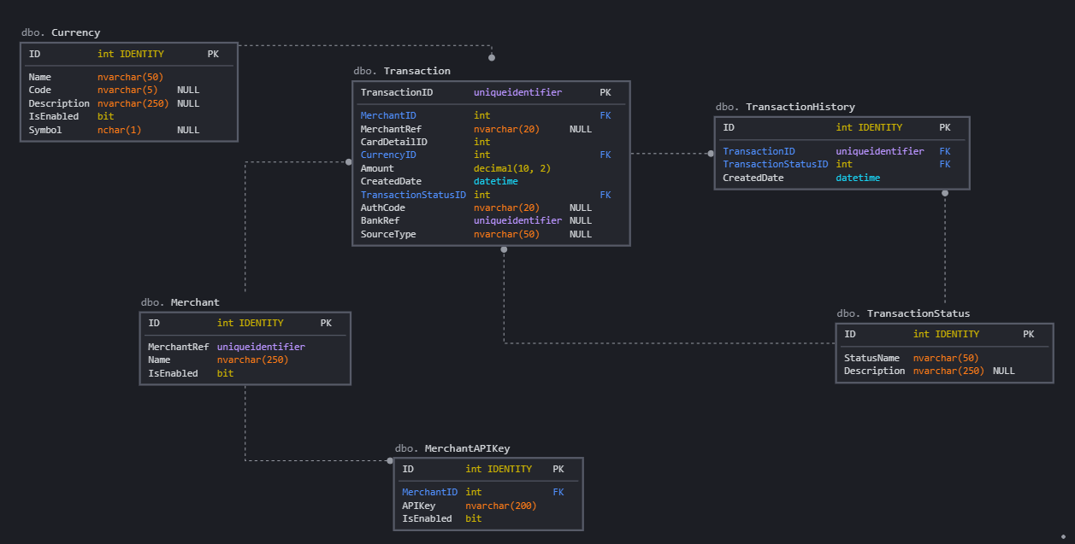

* **Manual DB Creation –** SQL scripts are provided *(\Checkout.PaymentGateway.Data\Scripts*) for generating the DB Objects manually. Please run them in their naming order - 00_Create_Encryption_Keys.sql, 01_Create_DB.sql, 03_DB_Initial_Seed.sql. This should give you the complete DB required for the application.

**Card Validations**

* CardValidator Nuget package is used for Credit Card Validations - <https://www.nuget.org/packages/CreditCardValidator/>

**Application logging & metrics**

* Azure App Insights can be used for logging. The logging is added for any error and for some Payment related information which can be used for audit or error tracking.

**Authentication**

* Basic authentication using API Secret. **X-API-Key** is the header name and the generated string is the Value that is given by Payment gateway. Each Merchant will have API Keys assigned and is stored in **MerchantAPIKeys** table in the Database.
* **AuthenticationHandler** class is used to verify the identity and once validated the Merchant Ref is saved in Claims. This Claim value then is available for the rest of the application to use.

**API client**

* Postman scripts are supplied in PostManScripts folder under Documentation.
* Swagger document is also implemented - <https://localhost:44354/swagger/index.html>. Swagger file (swagger.json) is also located in Documentation folder.

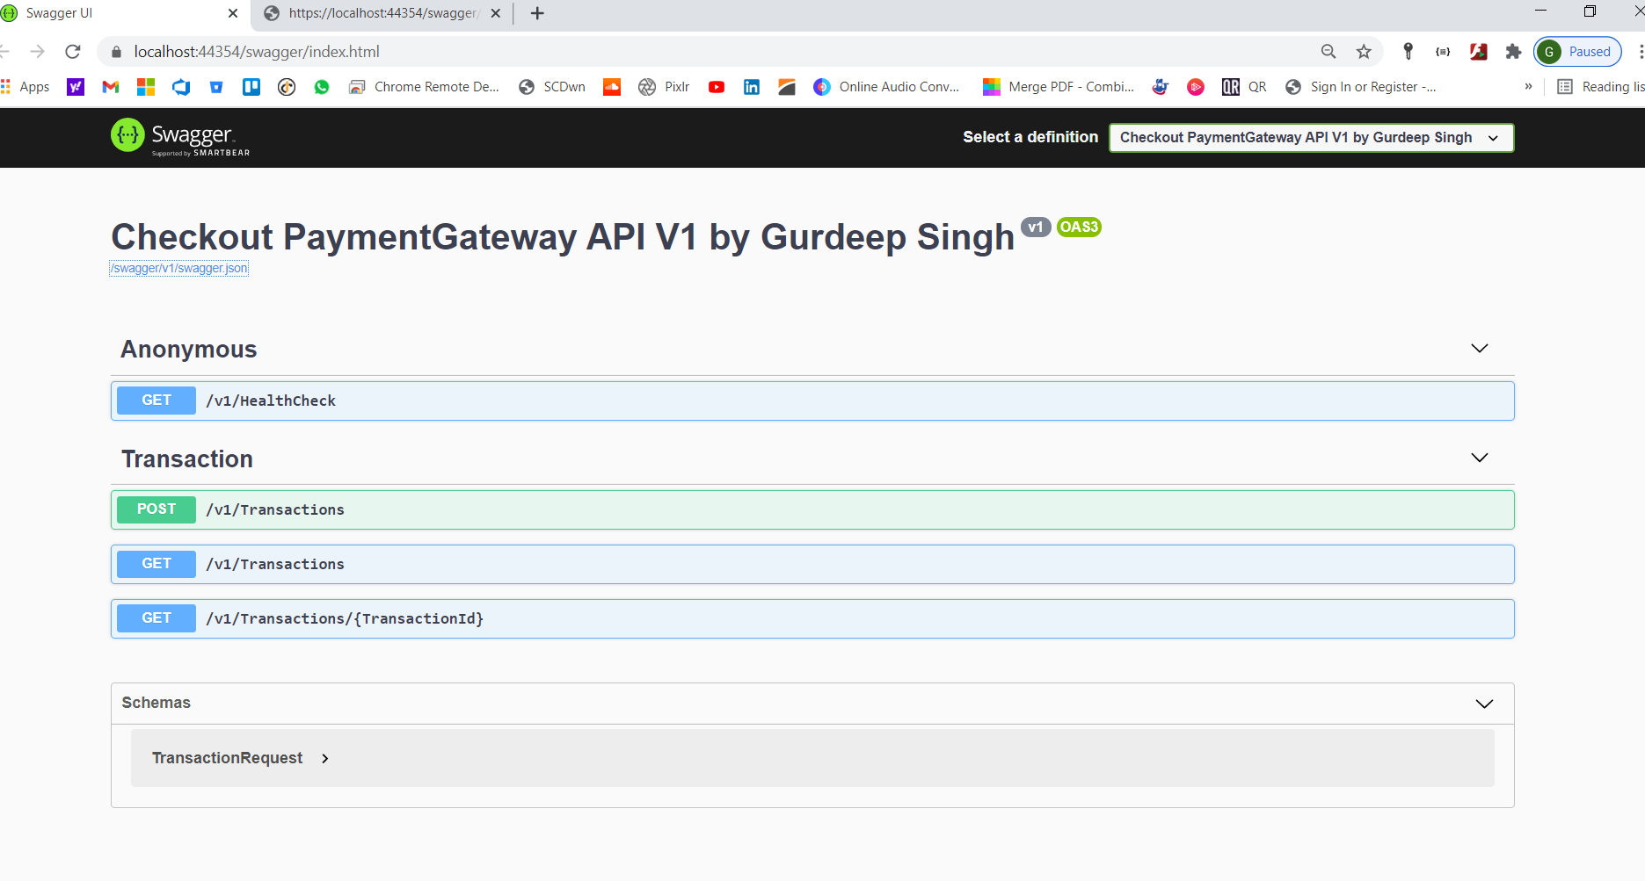

**Testing**

* XUnit & Moq are used for unit testing and several positive and negative scenarios are tested.

**Further development**

In addition to the Micro services architecture the following possible enhancements can be done

* JSON Web Token (JWT) – Jwt tokens can be used to enhance API security. These are better and secure over the API Keys security.
* Caching – For storing static information such as Currency list we can implement the caching to improve the performance. Cloud based caching such as Redis Caching can be used.
* Load balancing – For performance & Load the solution can be deployed to cloud and load balancing can be implemented.
* Segregate the Security Server – The security server to verify the JWT tokens can be physically separated from the Data Layer and other API code. This will enhance the security of the application.