1. There are two navigation bars. But their contents and links are same.

The left one is based on library sidebar.js

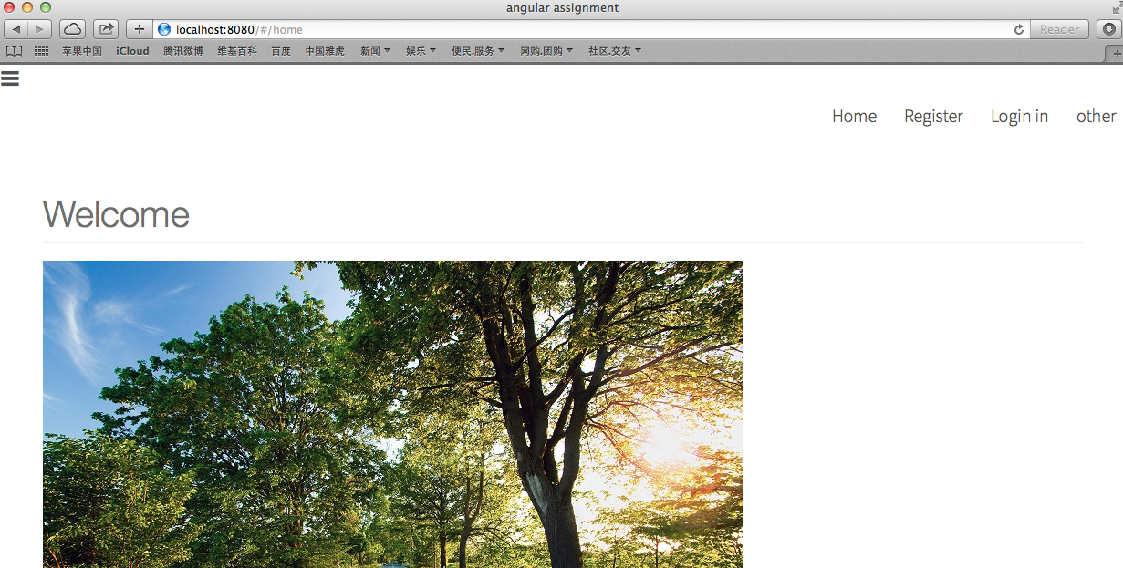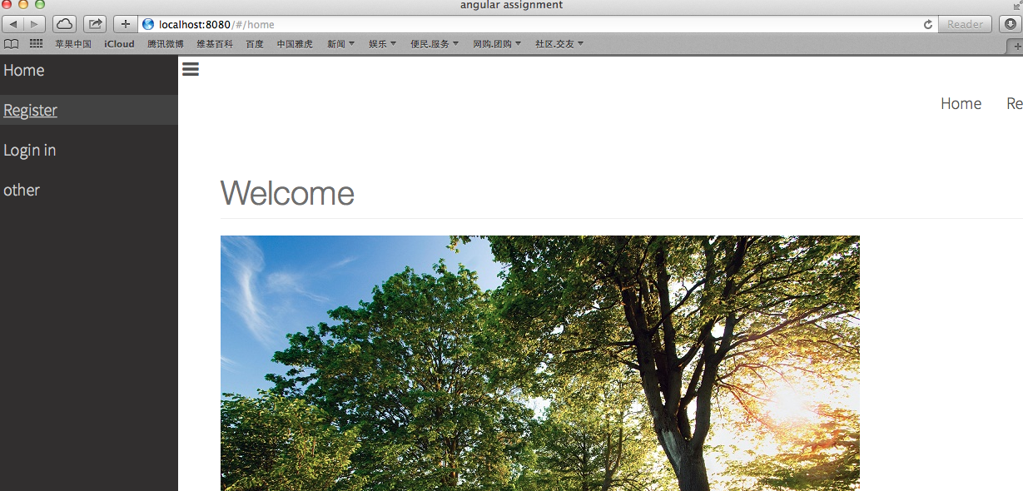

2. In the registration and login page, most of the attributes have authetification.

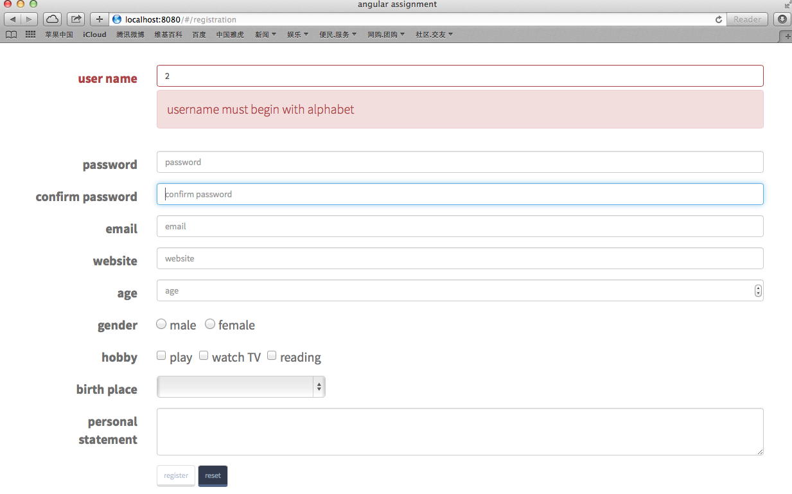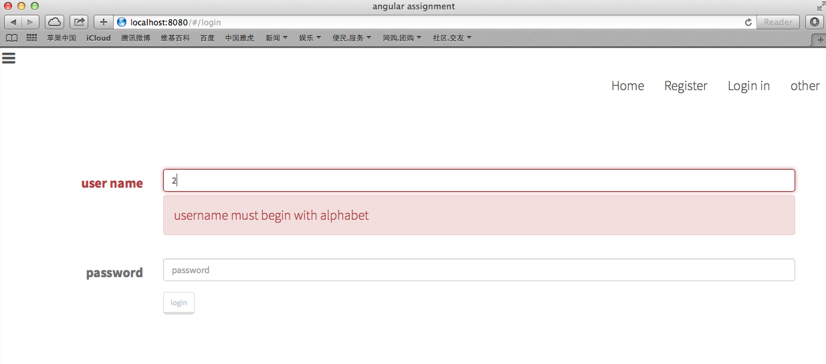

1. After user login in, in navigation bar content button and login out button will appear.

There is a factory provide data, so different controller can share some source of data, despite their $scopes are different.

* + After user login in, the page will change to content page. This is achieved by $locationProvider $location.path('/content');
  + In the content page, user can remove a one line of data, sort table by price or vibration, and search specific data by code.
  + There is a use of ng-table

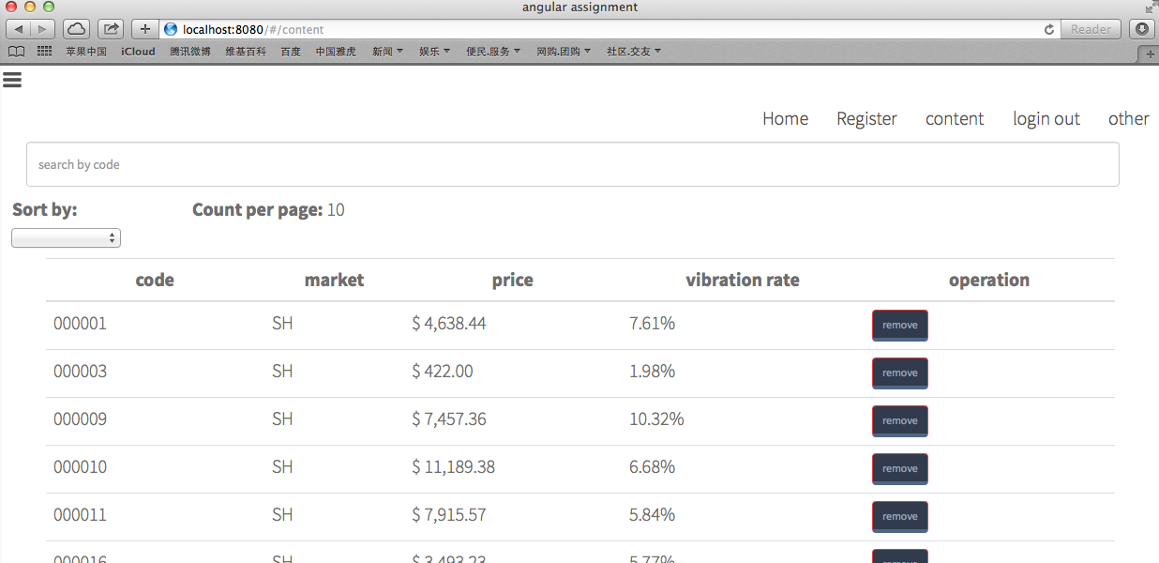

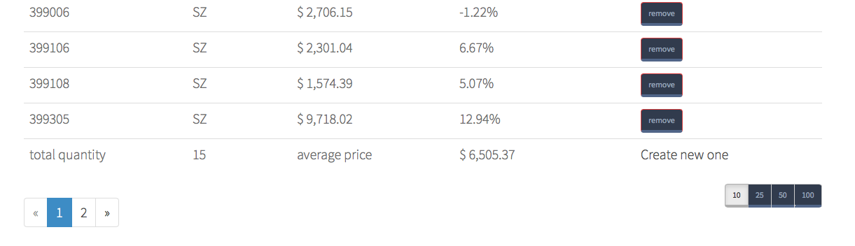

1. User can add a new data. Before the page change there will be a loading bar in the top of the page.

['ngRoute', 'angular-loading-bar','ngTable']

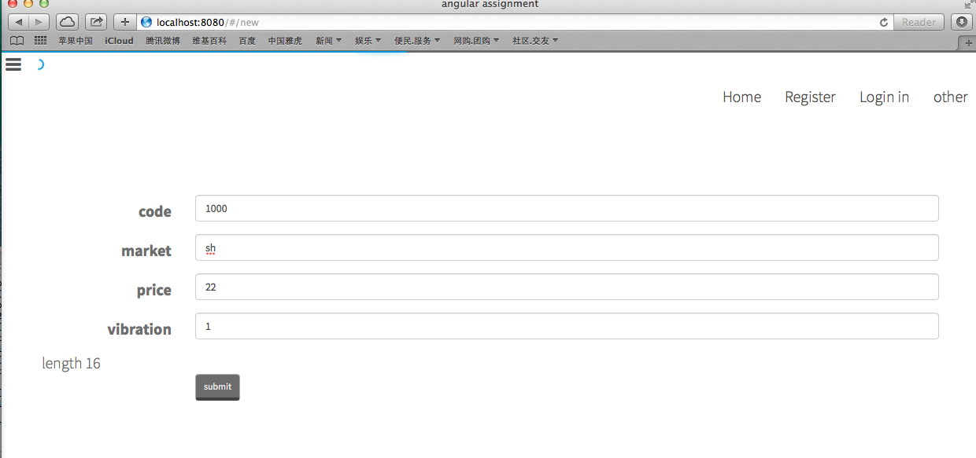

1. there are a customized filter and a customized directive.

*app.filter('cityFilter', function () …..)*

*"c.Country as c.Country for c in cities | cityFilter:'country'"*

*app.directive('myTextArea',function()…..)*

*<my-text-area ng-model="data.introduct">aaa</my-text-area>*