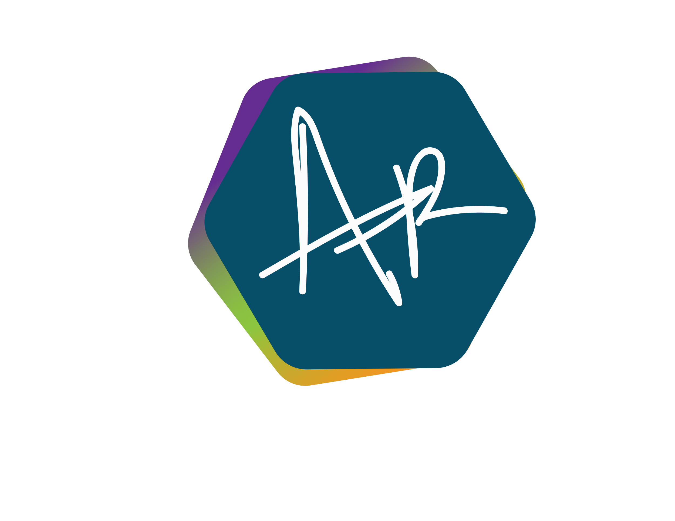 **Adrian Gualberto Rossino Martinez**

Dallas, TX, 75204 | (+1) 469 841 8943

[github.com/gurdoman](http://github.com/gurdoman) **|** [linkedin.com/in/rossino](http://www.linkedin.com/in/rossino) | [arossino@outlook.com](mailto:arossino@outlook.com)

**Software Developer Engineer**

**Amazon**

**01/2022 Dallas, Texas**

**Top Projects**: Tell Amazon, Seller RaV, Noreaster

* Create front end projects using react and other proprietary frameworks using Typescript and JavaScript.
* Participate in code reviews, team discussions and design reviews.
* Participate in on call rotation, owning multiple products across 2 different teams.
* Build workflows using AWS technologies.
* Write CDK app, stacks and constructs

**Stack:** TypeScript, AWS, DynamoDB, JavaScript, HTML, CSS, SCSS, AUI, NPM, Git, Mocha, Jest

**Applications Developer**

**ORACLE**

**07/2020 – 12/2021 Zapopan, Jalisco**

**Top Projects**: HED Student Cloud

* Develop modules for student cloud project.
* Write unit and functional tests for new and legacy modules
* Review and evaluate code quality across our team
* Participate in dev shares to communicate new solutions/ideas to other teams

**Stack:** TypeScript, JavaScript, HTML, CSS, SCSS, Oracle JET, NPM, Git, Sinon, Chai

**Full Stack Developer**

**Match Analysis**

**05/2015 – 12/2019 Remote**

**Top Projects**: Tango, Tango Live, Character creator, Social chart tool.

* Created a tool to customize characters that appear in our sites and social media.
* Developed a way to feed live data fast using feed cache and preloaders.
* Updated the legacy Match Analysis charts to new technologies like HTML 5 and SVG.
* Optimized our proprietary libraries and code.

**Stack:** JavaScript, Java, HTML, CSS, JSP, MySQL, Tomcat, Apache

**Full Stack Developer**

**Medios Alterados**

**11/2014 – 05/2015 Mexico city, Mexico**

**Top Projects**: Arreglalo and Pierre Fabre Intranet, San Rafael Vida en Balance site, Liberatum

**Stack and FW:** JavaScript, Java, HTML, CSS, jQuery, PHP, MySQL, Drupal, Magento, Symfony, Bootstrap, Doctrine, Android Studio

**Java Developer**

**Federación Mexicana de Futbol**

**03/2014 – 09/2014 Mexico city, Mexico**

**Stack and FW:** Javascript, Java, HTML, CSS, JQuery, JSP, Spring, MySql, Drupal, Bootstrap, Node.js, Tomcat, Apache

**Java Developer**

**Prospectiva**

**11/2013 – 03/2014 Mexico city, Mexico**

**Stack and FW:** Java, HTML, CSS, jQuery, JSP, MySQL, Tomcat

**Junior Java Developer**

**CONDUSEF**

**04/2013 – 11/2013 Mexico city, Mexico**

**EDUCATION**

**UPIICSA (Unidad Profesional Interdisciplinaria** **de Ingeniería y Ciencias Sociales y Administrativas.)**

**Instituto Politécnico Nacional**

**2009 – 2013 Mexico city, Mexico**

**Title: Bachelor’s Degree**

Information and Computer Sciences. (Ciencias de la informática)

**FREECODECAMP.ORG**

**Responsive Web Design Certification**

**LANGUAGES**

* English
* Spanish

**TECHNOLOGIES**

**Frontend**

Typescript React HTML

Bootstrap JavaScript jQuery

Oracle JET SCSS CSS

**Backend**

Java Node AWS

Spring JSP

**DB**

MySQL Oracle PLSQL

Stored Procedures DynamoDB

**Other**

Drupal GIT Chai

Photoshop SVN Tomcat

SVG NPM Sinon

**HOBBIES**

* Programmed and animated several Smash Bros characters for Nintendo WII, some still available at kc-mm (3DMAX, BrawlBox (scripting and animation) Photoshop)
* Developed two games using RPG Maker (RGSS2, Photoshop)
* Personal projects to keep myself updated with current technologies (React.js, Angular, Java, Javascript, CSS, HTML, Spring Boot)

**MISC**

* Willing to relocate
* willing to travel
* willing to travel abroad