AFET BİLGİ

Software Architecture

Description

Version 1.1

Gürhan İlhan Adıgüzel

2448025

Anıl İçen

2448488

Group 51

May 31, 2023

Table of Contents

1. Introduction 7

1.1. The Purpose and Objectives of afetbilgi.com 7

1.2. Scope 7

1.3. Stakeholders and their concerns 7

2. References 8

3. Glossary 8

4. Architectural Views 9

4.1. Context View 9

4.1.1. Stakeholders’ uses of this view 9

4.1.2. Context Diagram 9

4.1.3. External Interfaces 10

4.1.4. Interaction Scenarios 12

4.2. Functional Views 14

4.2.1. Stakeholders’ uses of this view 14

4.2.2. Component Diagram 14

4.2.3. Internal Interfaces 15

4.2.4. Interaction Patterns 16

4.3. Information View 17

4.3.1. Stakeholders’ uses of this view 17

4.3.2. Database Class Diagram 18

4.3.3. Operations on Data 19

4.4. Deployment View 21

4.4.1. Stakeholders’ uses of this view 21

4.4.2. Deployment Diagram 21

4.5. Design Rationale 22

5. Architectural Views for Suggestions to Improve the Existing System 22

5.1. Context View 22

5.1.1. Stakeholders’ uses of this view 22

5.1.2. Context Diagram 23

5.1.3. External Interfaces 24

5.1.4. Interaction Scenarios 25

5.2. Functional View 26

5.2.1. Stakeholders’ uses of this view 26

5.2.2. Component Diagram 26

5.2.3. Internal Interfaces 27

5.2.4. Interaction Patterns 28

5.3. Information View 28

5.3.1. Stakeholders’ uses of this view 28

5.3.2. Database Class Diagram 29

5.3.3. Operations on Data 29

5.4. Deployment View 30

5.4.1. Stakeholders’ uses of this view 30

5.4.2. Deployment Diagram 30

5.5. Design Rationale 31

List of Figures

Figure 1: Context Diagram 10

Figure 2: Extenal Interfaces 10

Figure 3: Activity Diagram of PDF Convert and Download 12

Figure 4: Activity Diagram of Filter Map 13

Figure 5: Component Diagram 14

Figure 6: Internal Interface Class Diagram 15

Figure 7: Sequence Diagram of Select City 16

Figure 8: Sequence Diagram of Filter Map 17

Figure 9: Sequence Diagram of Add Information 17

Figure 10: Database Class Diagram 18

Figure 11: Deployment Diagram 21

Figure 12: Improved Context Diagram 23

Figure 13: Improved External Interfaces 24

Figure 14: Activity Diagram of Answer Question 25

Figure 15: Improved Component Diagram 26

Figure 16: Improved Internal Interface Class Diagram 27

Figure 17: Sequence Diagram of Call Aid Units 28

Figure 18: Improved Database Class Diagram 29

Figure 19: Improved Deployment Diagram 30

List of Tables

Table 1: Change History 6

Table 2:Glossary 8

Table 3: External Interface Operation Descriptions 11

Table 4: Internal Interface Operation Descriptions 16

Table 5: CRUD Operations 20

Revision History

|  |  |  |
| --- | --- | --- |
| Version | Date | Explanation |
| 1.0 | 17.05.2023 | All section titles are presented. Introduction, References and Glossary parts are added. Context diagram has been drowned. |
| 1.1 | 31.05.2023 | The whole SAD document has been finished. |

Table 1: Change History

1. Introduction

This document is the Software Architecture Description (SAD) of a website which is afetbilgi.com developed by a group of METU students and METU graduates during the Pazarcik Earthquake on 06/02/2023.

* 1. The Purpose and Objectives of afetbilgi.com

The purpose of this project is to verify crucial information and deliver it to both disaster victims and those who want to help during an earthquake. Also, this site offers help with other needs of survivors. It makes it easier for people to reach their important needs by showing where they can find these needs and emergency phone numbers in a pdf document.

* 1. Scope

Within the scope of this system, it is tried to meet the urgent needs of people who are exposed to earthquakes. The information reaching the admins is confirmed and uploaded to the site's database, so that users need to enter the site and select the appropriate title in order to find what they need. This site provides 4 main titles for what they are looking for.

First, if user selects the topic under the General Needs title, like emergency gathering areas, safe gathering places etc. information in terms of the selected areas is reached from the database and is prepared in a pdf document and presented to the user.

Second, if user selects the topic under the Important Resources title, useful phone numbers, links and articles is provided to the user.

Third, if user selects the topic under the Health Services title, like hospitals’ and pharmacies’ locations are presented in the Google Maps and user can get the directions there and reach it easily.

Last, if user want to help or make donations for people who are suffered from the earthquake, they are forwarded to appropriate sites under the To Help title.

All of this information is recorded in a system’s database service which is provided from Amazon. These databases can be developed by aggregating and verifying more information. In addition, Amazon database service is used for the database requirement system.

* 1. Stakeholders and their concerns

There are three main stakeholders of the Afet Bilgi system which are users, admins and data collector and validators.

Users are people who want to get information about in the earthquake and help people who have been harmed by it. They need any device with an internet connection to connect to this site. They do not need any complicated requirements to enter this website.

Admins are the people who are responsible for the add, update, and delete the information about the earthquakes in the databases. Also, they are responsible for the organizing all interfaces of system. They need to know the system in detail and to have good web site developer skills.

Data-collector and validators are the people who are responsible for the collect the data from other people or social media and then check the reliability of these information. After the check process, they decide to information should be presented or not. They need have good-communication skills, good researcher, and reliable person.

1. References

This document is prepared with respect to IEEE 29148-2011 standard:

29148-2011- ISO/IEC/IEEE International Standard-Systems and software engineering – Life cycle processes – Requirements engineering.

Other Resources:

Afet Bilgi Github (2023). *Afet Bilgi*. URL: https://github.com/alpaylan/afetbilgi.com

1. Glossary

|  |  |
| --- | --- |
| **Term** | **Definition** |
| PDF | PDF is an abbreviation for Portable Document Format. |
| DB Service | Means Database service. It is provided by Amazon Database Service. |
| API | Application Programming Interface |
| RDS | Relational Database Server |

Table 2:Glossary

1. Architectural Views
   1. Context View
      1. Stakeholders’ uses of this view

There are three main stakeholders of the Afet Bilgi system which are users, admins and data collector and validators.

In this particular viewpoint, context of the system is provided, with the actors and other systems related to it in a general manner with detailed explanations. Stakeholders, especially the users of Afet Bilgi, may make use of this view in order to understand different interactions that may occur between the robot and stakeholders, as well as impact of the system on its environment and how external entities and services are used from a context view.

* + 1. Context Diagram

Afet Bilgi is not a part of a larger system. However, it interacts with 5 main external entities such as users, data collectors and validators, Google Maps API, PDF API and Amazon Web Services.

The users want to access information about the earthquake survivors using many entities.

Google Maps API provides locations of necessary places for survivors and people who want to help the survivors.

PDF API provides PDF document for people who wants to access the information they need without internet after downloading the document.

Data collectors and validators collect the information and validate it. Then, they provide it to the database.

Amazon Web Services is used as the database of the system. All the data is collected in the database for the Afet Bilgi. Then, when user requests data, Amazon Web Services provides the data.

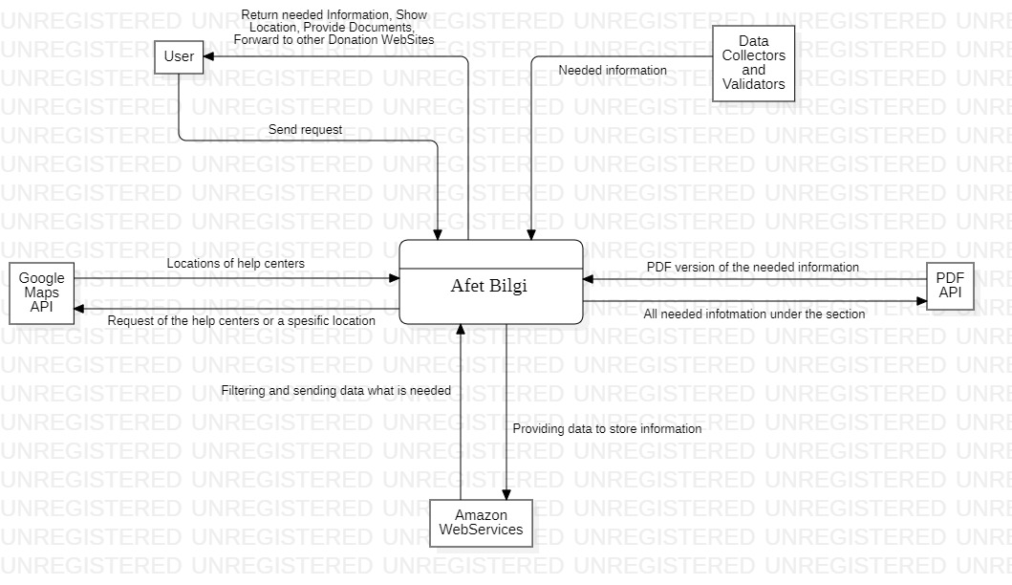

Figure 1: Context Diagram

* + 1. External Interfaces

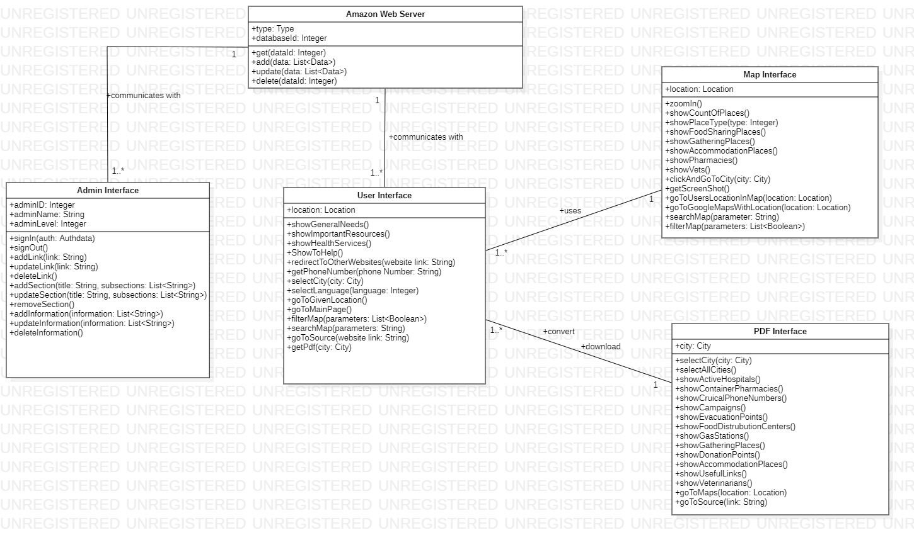

Figure 2: Extenal Interfaces

|  |  |
| --- | --- |
| **Operations** | **Descriptions** |
| signIn | Admins sign into the system with id to construct the server. |
| signOut | Admins sign out from the server. |
| addLink | Admin adds other websites links to website. |
| updateLink | Admin updates other websites links on the website. |
| deleteLink | Admin deletes other websites links from website. |
| addSection | Admin adds section to main page of website. |
| UpdateSection | Admin updates section in the main page of website. |
| removeSection | Admin deletes section from the main page of website. |
| addInformation | Admin adds information to website. |
| updateInformation | Admin updates information on the website. |
| deleteInformation | Admin deletes information from the website. |
| showGeneralNeeds | General Needs section has been shown to user. |
| showImportantResources | Important Resources section has been shown to user. |
| showHealthServices | Health Services section has been shown to user. |
| showToHelp | To Help section has been shown to user. |
| redirectToOtherWebsites | User has been redirected to the requested helpful website. |
| getPhoneNumber | User requested to phone number of aid services. |
| selectCity | Required documents is prepared according to city. |
| select Language | Website is shown in terms of selected language. |
| goToGivenLocation | Google Maps shows the way of going location. |
| goToMainPage | User has redirected to Main page of site. |
| filterMap | Google Map is filtered according to the filters. |
| searchInTheMap | User do search in the Google Maps in terms of key value. |
| goToSource | User has redirected to source of information. |
| getPdf | Pdf document of information is prepared. |
| zoomIn | Zoom in to the Maps. |
| showCountOfPlaces | Shows the place counts. |
| showPlaceType | Shows the place types. |
| clickAndGoToCity | Select and redirected to the city information. |
| getScreenShot | Get screen shot to the website. |
| selectCity | Document is prepared according to the only selected city. |
| selectAllCities | Document is prepared for all cities. |
| get | Get required data from database. |
| add | Add data to database. |
| update | Update data in the database. |
| delete | Delete data from the database. |

Table 3: External Interface Operation Descriptions

* + 1. Interaction Scenarios

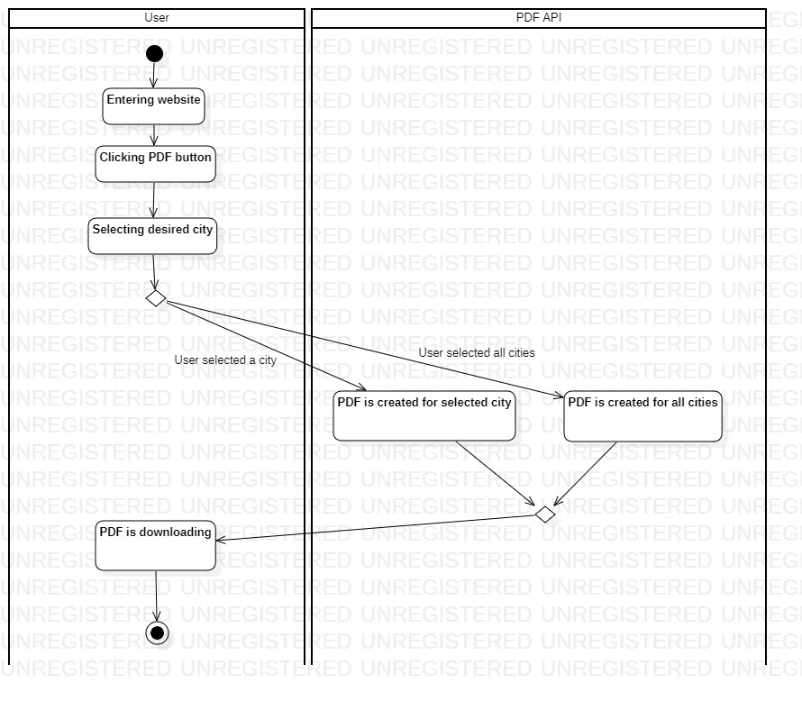

Figure 3: Activity Diagram of PDF Convert and Download

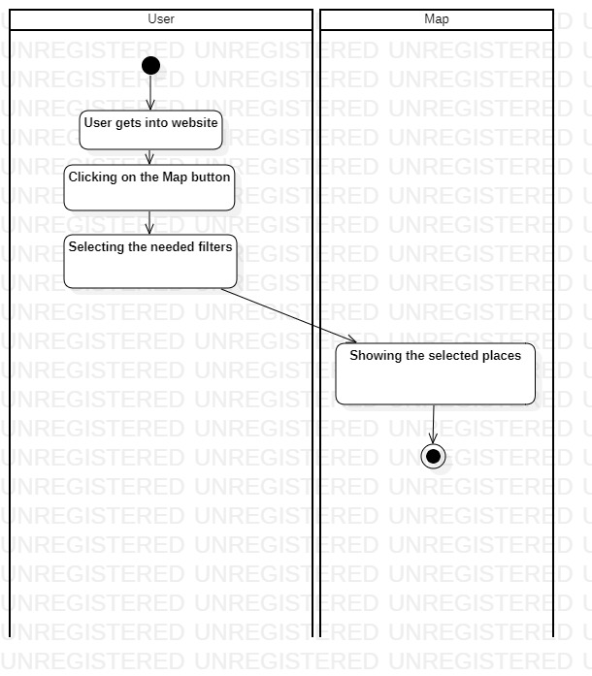

Figure 4: Activity Diagram of Filter Map

* 1. Functional Views
     1. Stakeholders’ uses of this view

There are three main stakeholders of the Afet Bilgi system which are users, admins and data collector and validators.

In this viewpoint, the users use this view to learn more about the earthquake and also user can get help there by filtering map, searching map and convert PDF features. Admins use it for adding, updating, and deleting information about earthquakes from databases and managing all system interfaces. Data-collectors and validators use it to gather data from other people or social media and then validating its accuracy.

* + 1. Component Diagram

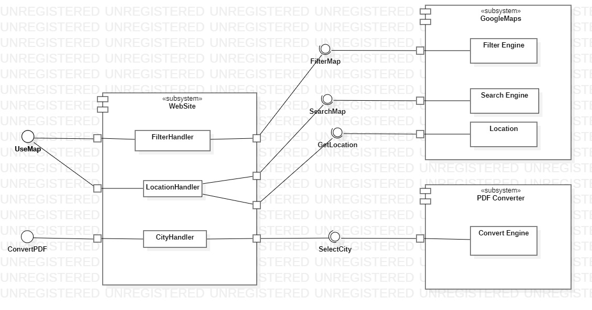

Figure 5: Component Diagram

Our system is divided into 3 main subsytems i.e., Website, GoogleMaps and PDF Converter.

* Website consists of three parts, FilterHandler, LocationHandler, CityHandler.
* FilterHandler and LocationHandler provide an interface to users, namely UseMap. It is responsible for the showing required locations into the map.
* CityHandler provides an interface to users, namely ConvertPDF. It provides selecting city for the creating PDF which consists of all the required information for the city.
* There are three assembly interfaces between Website and GoogleMaps which are FilterMap, SearchMap and GetLocation.
* GoogleMaps consists of three parts, FilterEngine, SearchEngine and Location requires interfaces which are FilterMap, SearchMap and GetLocation.
* FilterEngine provide an interface to users, namely FilterMap. It provides filtering feature in terms of the key values like active hospitals, gathering areas vs.
* SearchEngine provide an interface to users, namely SearchMap. It provides searching into the GoogleMaps in terms of key values like city name, street name vs.
* Location provide an interface to users, namely GetLocation. It provides showing current user location into the GoogleMaps.
* There is one assembly interface between Website and PDF Converter which is SelectCity.
* PDFConverter has only one subsystem, ConvertPDF and requires an interface which is SelectCity.
* ConvertPDF provides an interface to users, namely SelectCity. It provides selecting city feature for creating PDF in terms of selected city.
  + 1. Internal Interfaces

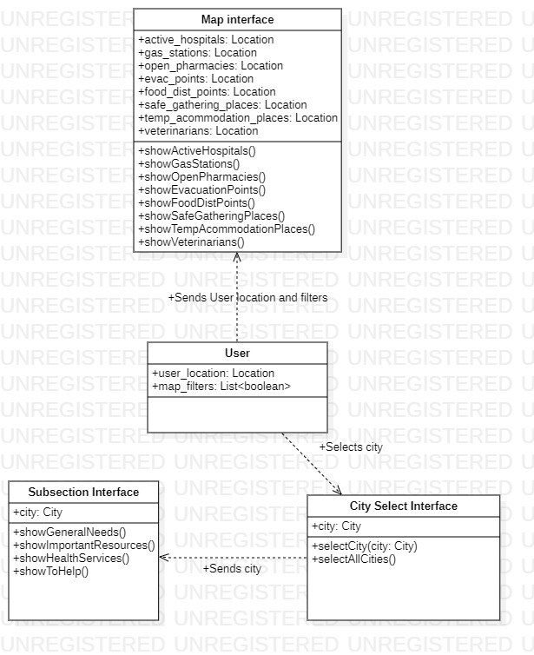

Figure 6: Internal Interface Class Diagram

|  |  |
| --- | --- |
| **Operation** | **Description** |
| showActiveHospitals | It shows Active Hospitals for selected city to the user. |
| showGasStations | It shows Gas Stations for selected city to the user. |
| showOpenPharmacies | It shows Open Pharmacies for selected city to the user. |
| showEvacuationPoints | It shows Evacuation Points for selected city to the user. |
| showFoodDistPoints | It shows Food Distribution Points for selected city to the user. |
| showSafeGatheringPlaces | It shows Safe Gathering Places for selected city to the user. |
| showTempAccomodationPlaces | It shows Temporary Accommodation Places for selected city to the user. |
| showVeterinarians | It shows Veterinarians for selected city to the user. |
| showGeneralNeeds | It shows General Needs section to the user. |
| showImportantResources | It shows Important Resources section to the user. |
| showHealthResources | It shows Health Resources section to the user. |
| showToHelp | It shows To Help section to the user. |
| selectCity | It selects the city for preparing information. |
| selectAllCities | Information is prepared for all cities. |

Table 4: Internal Interface Operation Descriptions

* + 1. Interaction Patterns

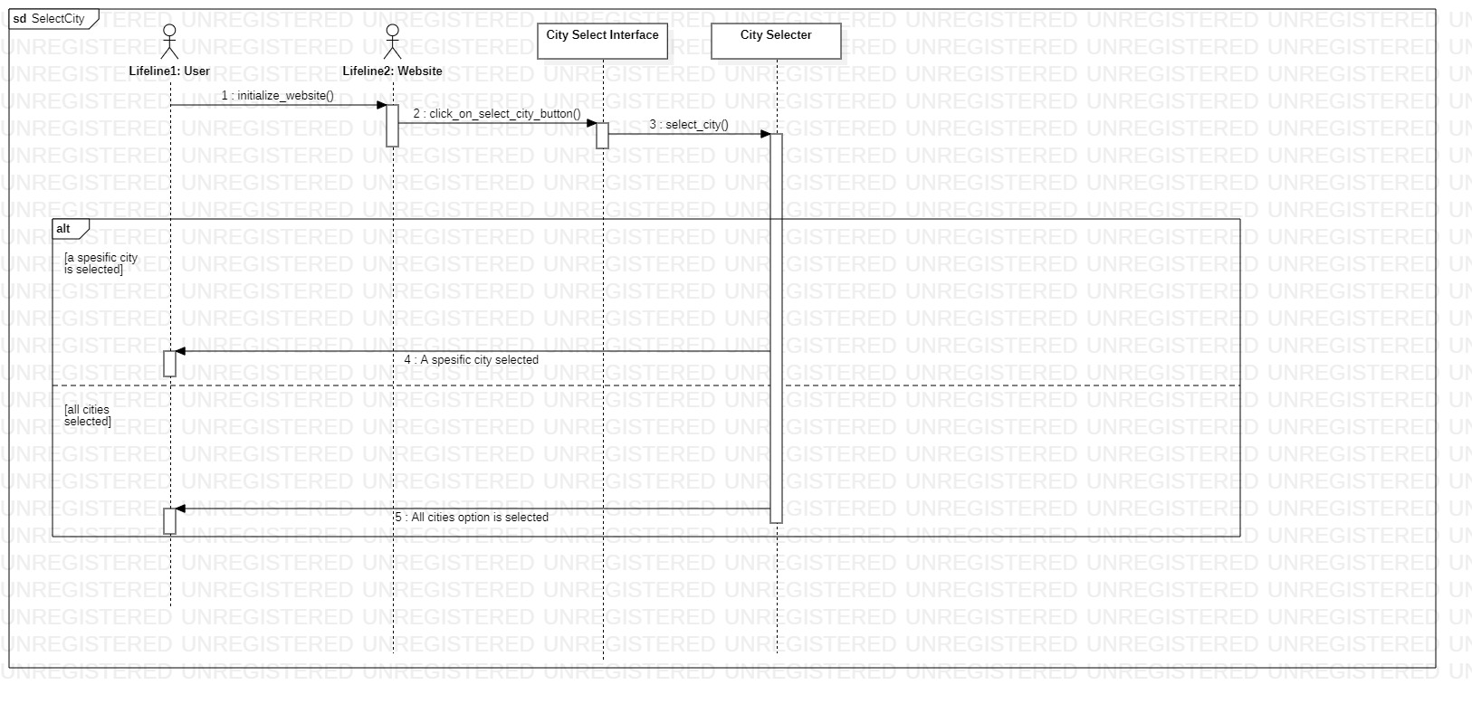

Figure 7: Sequence Diagram of Select City

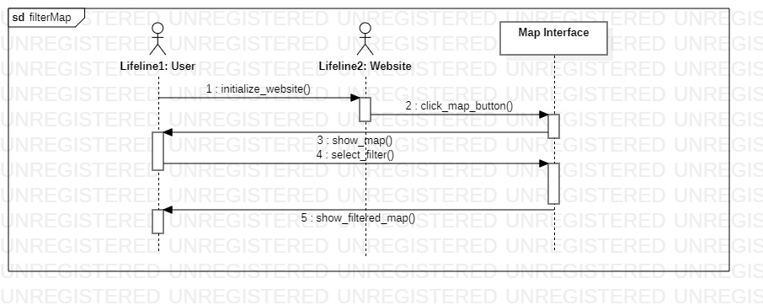

Figure 8: Sequence Diagram of Filter Map

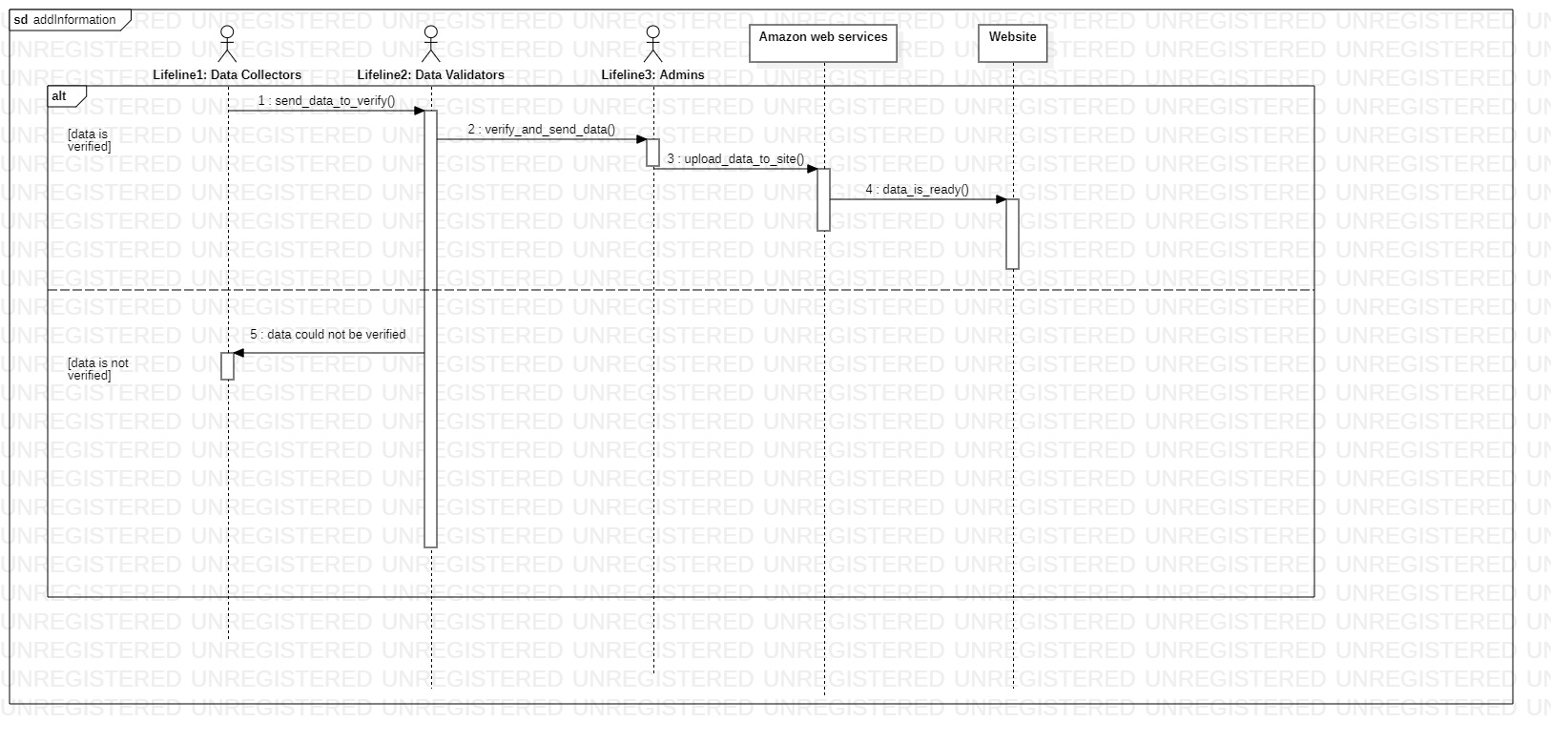

Figure 9: Sequence Diagram of Add Information

* 1. Information View
     1. Stakeholders’ uses of this view

There are three main stakeholders of the Afet Bilgi system which are users, admins and data collector and validators.

In this viewpoint, the users use this view to understand how the website help the people. Admins use this view to how to do add, update, and delete functions about earthquakes and which data store in which databases. Data-collectors and validators use it to gather data and storing these data in the appropriate position.

* + 1. Database Class Diagram

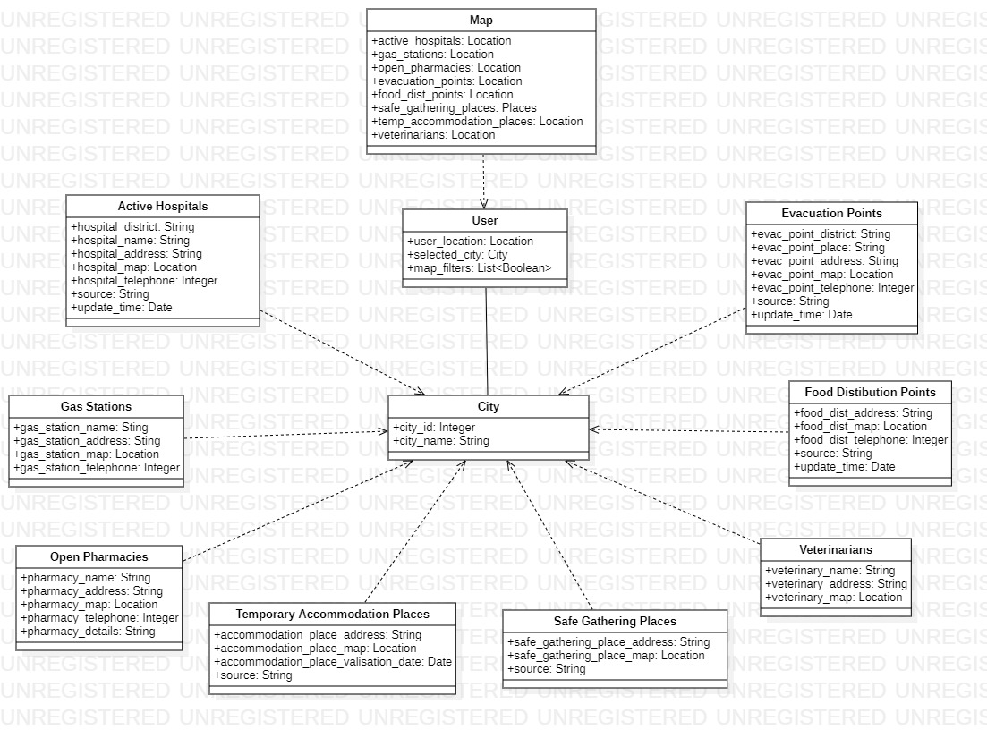

Figure 10: Database Class Diagram

* When user enters the site, it has location.
* When admin creates the city, it is created with the unique id and name.
* When user selects the city or use his/her current location, all other information created in terms of city id.
* ActiveHospitals, GasStations, OpenPharmacies, TemporaryAccommodationPlaces, SafeGatheringPlacs, Veterinarians, FoodDistrubitonPoints, EvacuationPoints all are weak entites. They are created depending on the creation of the city.
* All these place behaviors and information is reached by city id.
* Map entity use user location information or selected city also. It also includes the other places information.
  + 1. Operations on Data

|  |  |
| --- | --- |
| Operation | CRUD (Create/Read/Update/Delete) |
| addActiveHospital() | Create: Active hospital  Read: -  Update: -  Delete: - |
| addGasStation() | Create: Gas station  Read: -  Update: -  Delete: - |
| addOpenPharmacy() | Create: Pharmacy  Read: -  Update: -  Delete - |
| addAcommodationPlace() | Create: Accommodation place  Read: -  Update: -  Delete: - |
| addGatheringPlace() | Create: Gathering place  Read: -  Update: -  Delete: - |
| addVeterinarian() | Create: Veterinarian location  Read: -  Update: -  Delete: - |
| addFoodDistributionPoint() | Create: Food Distribution point  Read: -  Update: -  Delete: - |
| addEvacuationPoint() | Create: Evacuation point  Read: -  Update: -  Delete - |
| updateActiveHospital() | Create: -  Read: -  Update: Active Hospital  Delete: - |
| updateGasStation() | Create: -  Read: -  Update: Gas station  Delete: - |
| updateOpenPharmacy() | Create: -  Read: -  Update: Pharmacy  Delete: - |
| updateAcommodationPlace() | Create: -  Read: -  Update: Accommodation place  Delete: - |
| updateGatheringPlace() | Create: -  Read: -  Update: Gathering place  Delete: - |
| updateVeterinarian() | Create: -  Read: -  Update: Veterinarian place  Delete: - |
| updateFoodDistributionPoint() | Create: -  Read: -  Update: Food distribution point  Delete: - |
| updateEvacuationPoint() | Create: -  Read: -  Update: Evacuation point  Delete: - |
| addLocation() | Create: Location  Read: -  Update: -  Delete: - |
| updateLocation() | Create: -  Read: -  Update: Location  Delete: - |

Table 5: CRUD Operations

* 1. Deployment View
     1. Stakeholders’ uses of this view

There are three main stakeholders of the Afet Bilgi system which are users, admins and data collector and validators.

In this viewpoint, the users use this view to understand how they can reach the useful information and how they can help people who are affected from earthquake. Admins use it how they can do add, delete, and update operations in the databases and how they can manage system interfaces. Data-collectors and validators use it to understand how they can store and gather the information in terms of the city.

* + 1. Deployment Diagram

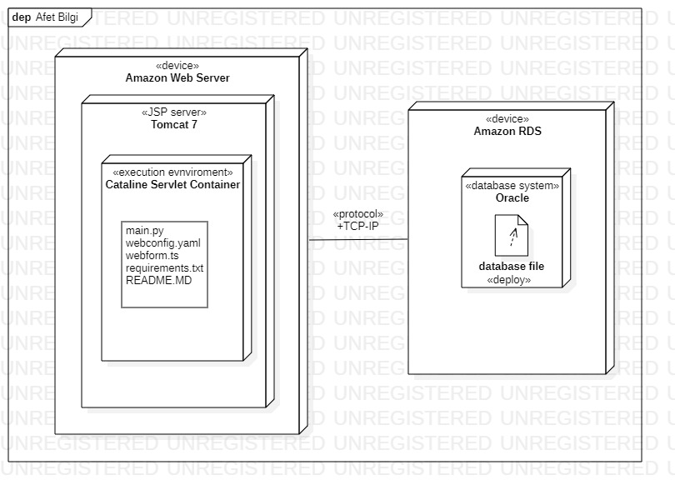

Figure 11: Deployment Diagram

* 1. Design Rationale
     1. Context View

The purpose of the context view is keeping the system self-sufficient. Although, it uses different APIs such as PDF API and Google Maps API, those are integrated into the website. The concern of the context view is the interaction between user and the system.

* + 1. Functional View

The purpose of the functional view is to handle major operations in a way that divides the operations into parts that do not depend on each other. Moreover, those parts must be consistent. For example, searchMap and filterMap are functions that uses Google Maps API, but they are independent from each other.

* + 1. Information View

The purpose of the information view is that storing minimal –close to none- personal data while having a complete functionality. AfetBilgi.com does not collect any personal information about the user at all.

* + 1. Deployment View

The purpose of the deployment view is keeping the structure -as software and hardware- interchangeable and easy to understand. Each component is simple enough to be supported by the other components. Inputs -information- are put into site with excel documents because it is the easiest and integrable way.

1. Architectural Views for Suggestions to Improve the Existing System
   1. Context View
      1. Stakeholders’ uses of this view

There are three main stakeholders of the Afet Bilgi system which are users, admins and data collector and validators.

In this viewpoint, users are individuals who will need to call different aid units for different disasters. Then, the location of user is provided to the aid units. Also, user can ask questions to AI ChatBot for simplicity and got answered. Admins should also handle with Aid Unit caller and Data-Collectors and Validators are responsible for reliability of call.

* + 1. Context Diagram

diyagram içeren bir resim

Açıklama otomatik olarak oluşturuldu

Figure 12: Improved Context Diagram

* A ChatBot integration may be helpful to users. Many other websites use chatBots to get rid of searching an information on the site. The users can easily find the needed information by asking questions to chatBot.
* Another addition to site that will help users is the calling police, ambulance and firefighters to user’s location without making any phone calls and delaying the arrival of the units.
* Other than that, the UI limits the user experience in the site. The user does not see all sections at once. Therefore, a change in the UI might be helpful.
  + 1. External Interfaces

diyagram içeren bir resim

Açıklama otomatik olarak oluşturuldu

Figure 13: Improved External Interfaces

* After adding an AI ChatBot to website, users need a chatting UI to chat and get information from the ChatBot. The ChatBot shall initialize when a user enters the site. Then, it shall send a greeting message to make users see there is a ChatBot to help them. The message should explain what the bot does.
* The calling aid units button would be very helpful to users. Clicking the right button would call police, ambulance or firefighters. But to protect the system from accidental clicks, it shall pop up a question which is “You are calling the Aid Units. Are you sure about calling the Aid Units.”.
  + 1. Interaction Scenarios

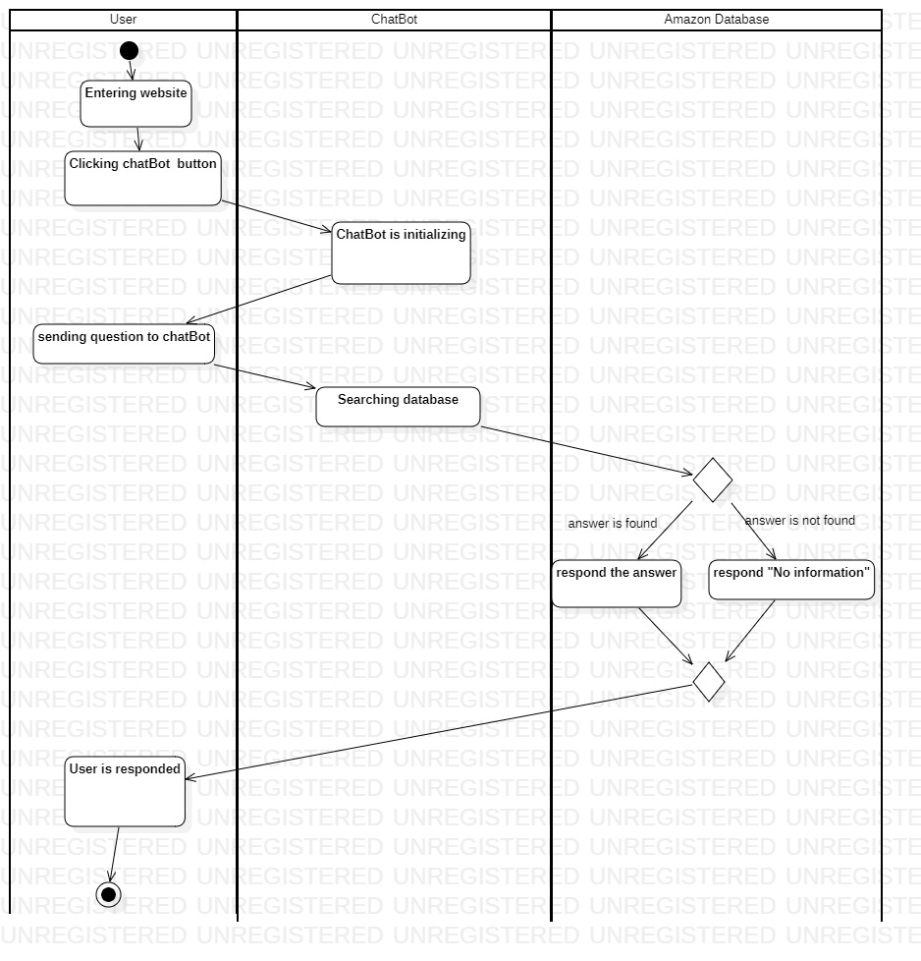

Figure 14: Activity Diagram of Answer Question

* 1. Functional View
     1. Stakeholders’ uses of this view

There are three main stakeholders of the Afet Bilgi system which are users, admins and data collector and validators.

In this viewpoint, different components of the system, internal interfaces within the system, their interactions will be depicted. Functional view is extremely significant to the stakeholders of the Afet Bilgi, since it provides an idea of the quality properties and functionalities of the system and forms the shape of other viewpoints.

* + 1. Component Diagram

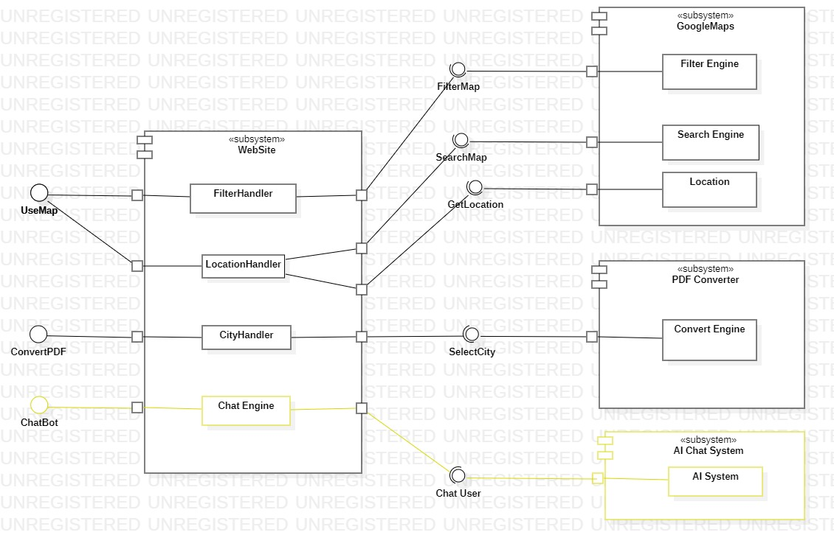

Figure 15: Improved Component Diagram

* Website also includes Chat Engine part.
* Chat Engine provide an interface to users, namely ChatBot. It is responsible for providing information to the user.
* AI Chat System includes only AI System.
* AI System provides an interface to users, namely ChatUser. It is responsible for answering user questions with the help of AI System.
  + 1. Internal Interfaces

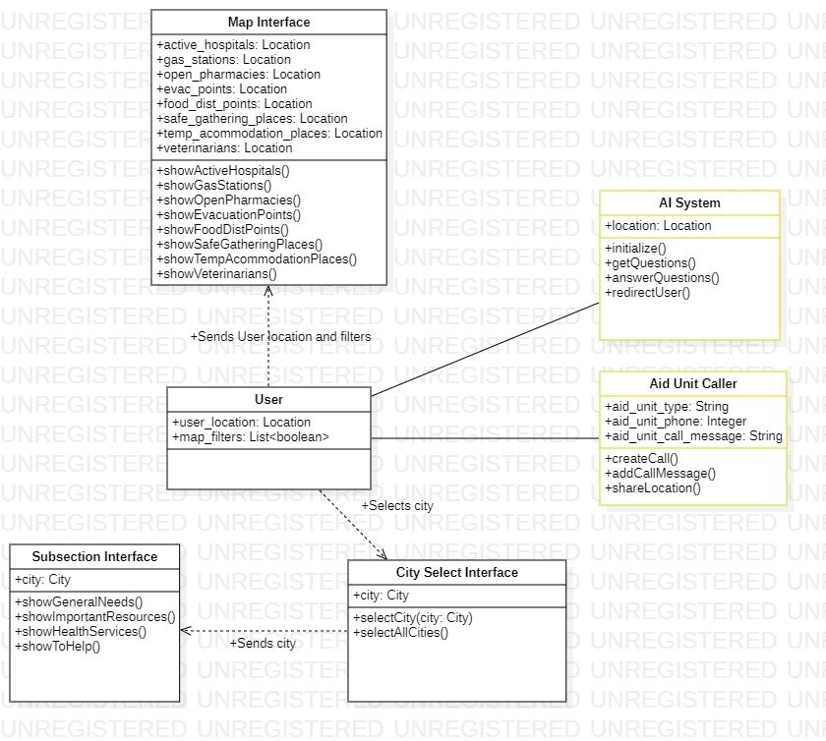

Figure 16: Improved Internal Interface Class Diagram

* + 1. Interaction Patterns

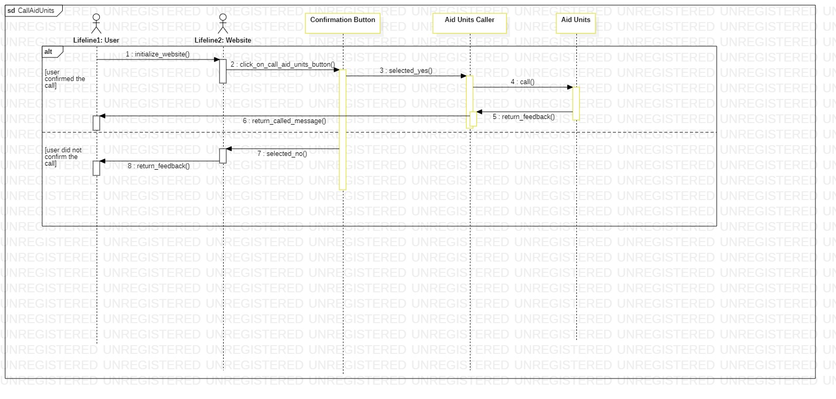

Figure 17: Sequence Diagram of Call Aid Units

* 1. Information View
     1. Stakeholders’ uses of this view

There are three main stakeholders of the Afet Bilgi system which are users, admins and data collector and validators.

In this viewpoint, key database and main memory objects, as well as their associations will be provided. In that sense, it gives an idea of what kind of data flows occur, what kind of memory objects are used and how different data operations are carried out within the system. As a result, they have information about how data is stored, managed, manipulated and distributed in the system, which eases the use of different data objects and data manipulation techniques by the users.

* + 1. Database Class Diagram

metin, diyagram, plan, paralel içeren bir resim

Açıklama otomatik olarak oluşturuldu

Figure 18: Improved Database Class Diagram

* When user needs an aid unit, the user can call the unit easily using this function without entering their location because it is done by the website.
  + 1. Operations on Data

|  |  |
| --- | --- |
| Operation | CRUD (Create/Read/Update/Delete) |
| sendLocation () | Create: Send Location  Read: -  Update: -  Delete: - |
| callAidUnit() | Create: Aid Unit Call  Read: -  Update: -  Delete: - |

* 1. Deployment View
     1. Stakeholders’ uses of this view

There are three main stakeholders of the Afet Bilgi system which are users, admins and data collector and validators.

Although this viewpoint might not be very useful for users, admins, data collector and validators, since it describes the environment into which the system will be deployed, as well as the dependencies. It gives a better idea regarding runtime platforms, third-party software and network requirements, hosting of the software, etc., which are significant aspects after the software is built and is to be validation tested and put into real operation.

* + 1. Deployment Diagram

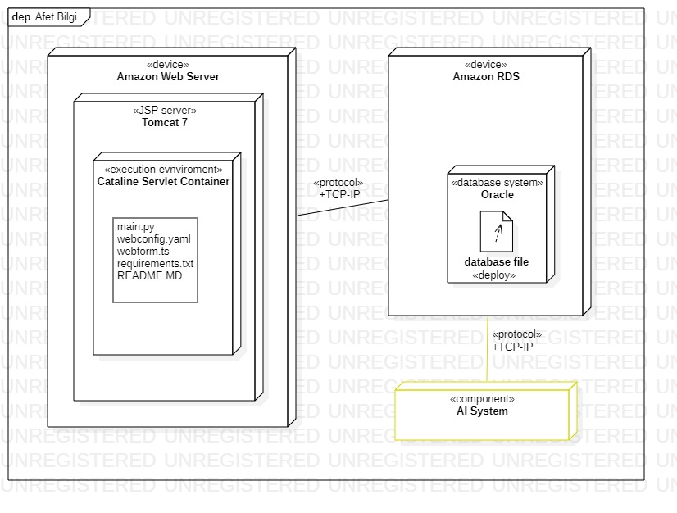

Figure 19: Improved Deployment Diagram

* 1. Design Rationale
     1. Context View

The purpose of the context view is keeping the system self-sufficient. Although, in this new design, it uses AI ChatBot and Aid Unit Caller as subsystems. The concern of the context view is the interaction between user and the system.

* + 1. Functional View

The purpose of the functional view is to handle major operations in a way that divides the operations into parts that do not depend on each other. Moreover, those parts must be consistent. In this new design, chatWithUser and redirectUserToWebsite functions uses AI subsystem, but these new functions are independent from old functions.

* + 1. Information View

The purpose of the information view is that storing minimal –close to none- personal data while having a complete functionality. Only the Aid Unit Caller needs to user location information. It should be encrypted.

* + 1. Deployment View

The purpose of the deployment view is keeping the structure -as software and hardware- interchangeable and easy to understand. Each component is simple enough to be supported by the other components. Inputs -information- are put into site with excel documents because it is the easiest and integrable way and AI System also integrated into database.