AFET BİLGİ

Software Requirements

Specification

Version 1.1

Gürhan İlhan Adıgüzel

2448025

Anıl İçen

2448488

Group 51

April 10, 2023

Table of Contents

1. Introduction 6

1.1. The Purpose of System 6

1.2. Scope 6

1.3. System Overview 6

1.3.1. System Perspective 6

1.3.1.1. System Interfaces 7

1.3.1.2. User Interfaces 8

1.3.1.3. Hardware Interfaces 11

1.3.1.4. Software Interfaces 11

1.3.1.5. Communication Interfaces 12

1.3.1.6. Memory 12

1.3.2. System Functions 12

1.3.3. Stakeholder Characteristics 13

1.3.4. Limitations 13

1.4. Definitions 14

2. References 15

3. Specific Requirements 15

3.1. External Interfaces 15

3.2. Functions 16

**3.3.** Usability Requirements 25

**3.4.** Performance Requirements 25

**3.5.** Logical Database Requirements 26

3.6. Design Constraints 26

3.7. System Attributes 27

3.8. Supporting Information 28

4. Suggestions to improve the existing system 28

4.1. System Perspective 28

4.2. External Interfaces 29

4.3. Functions 30

4.4. Usability Requirements 35

4.5. Performance Requirements 35

4.6. Logical Database Requirements 36

4.7. Design Constraints 36

4.8. System Attributes 37

4.9. Supporting Information 37

List of Figures

Figure 1: Context Diagram 7

Figure 2: Main Page of Afet Bilgi 8

Figure 3: PDF Page of Afet Bilgi 9

Figure 4: PDF Document of Hatay 10

Figure 5: Map Page of Afet Bilgi 11

Figure 6: External Interfaces 15

Figure 7: Use-Case Diagram 16

Figure 8: Activity Table of "Add Information" 18

Figure 9: Sequence Diagram of "Get PDF" 21

Figure 10: State Diagram of "Filter Map" 23

Figure 11: Logical Database Requirements Class Diagram 26

Figure 12: Improved Version of Context Diagram 28

Figure 13: Improved Version of Main Page of Afet Bilgi 29

Figure 14: Improved Version of External Interfaces 29

Figure 15: Improved Use Case Diagram 30

Figure 16: Activity Diagram of "Share User's Location with Aid Units" 32

Figure 17: Sequence Diagram of "Answer Question" 33

Figure 18: State Diagram of "Redirects the Users to Needed Platforms 34

Figure 19: Improved Logical Database Requirements Class Diagram 36

List of Tables

Table 1: Change History 5

Table 2: System Functions 13

Table 3: Definitons 14

Table 4: Get General Needs 17

Table 5: Add Information 17

Table 6: Get Healthcare Services 19

Table 7: Get Helping Campaigns 19

Table 8: Get PDF 20

Table 9: Get Important Resources 21

Table 10: Get Location 22

Table 11: Filter Map 22

Table 12: Search in the Map 24

Table 13: Forwarding Other Websites 24

Table 14: Greets User 31

Table 15: Share User’s Location with Aid Units 31

Table 16: Answers the Questions of Users 33

Table 17: Redirects the Users to Needed Platforms 34

Table 18: Finish the Conversation and Rate the ChatBot 35

Revision History

|  |  |  |
| --- | --- | --- |
| Version | Date | Explanation |
| 1.0 | 12.04.2023 | All section titles have been present. Context diagram has been drawn and Use-cases are determined and Use-case diagram has been drawn and use-case tables are added. |
| 1.1 | 24.04.2023 | Rest of the document is prepared and suggestions part is created. Some of use cases has been fixed. |

Table 1: Change History

1. Introduction

This document is the Software Specification Requirement (SRS) of a website which is afetbilgi.com developed by group of METU students and METU graduates during the PazarcikEarthquake on 06/02/2023.

* 1. The Purpose of System

The purpose of this project is to verify crucial information and deliver it to both disaster victims and those who want to help during an earthquake. Also, this site offers help with other needs of survivors. It makes it easier for people to reach their important needs by showing where they can find these needs and emergency phone numbers in pdf document.

* 1. Scope

Within the scope of this system, it is tried to meet the urgent needs of people who are exposed to earthquakes. The information reaching the admins is confirmed and uploaded to the site's database, so that users need to enter the site and select the appropriate title in order to find what they need. This site provides 4 main title for what they are looking for.

First, if user selects the topic under the General Needs title, like emergency gathering areas, safe gathering places etc. information in terms of the selected areas is reached from the database and is prepared in a pdf document and presented to the user.

Second, if user selects the topic under the Important Resources title, useful phone numbers, links and articles is provided to the user.

Third, if user selects the topic under the Health Services title, like hospitals and pharmacies location are presented in the Google Maps and user can get the directions there and reach it easily.

Last, if user want to help or make donations for people who are suffered from the earthquake, they are forwarded to appropriate sites under the To Help title.

All of these information is recorded in a system’s database service which is provided from Amazon. These databases can be developed by aggregating and verifying more information. In addition, Amazon database service is used for the database requirement system.

* 1. System Overview
     1. System Perspective

Afet Bilgi site was created to both verify and convey important information about the disaster in this area to earthquake survivors, and also deliver these people to those who volunteered to save them.

The whole database is handmade by volunteered people. The purpose of system is providing speed, confirmed, useful information on time which are critical for their life matters. This system interacts with other services such as Google Maps. With the Google Maps entegration people can easily reach the information about what they need in an area and locations.

diyagram içeren bir resim

Açıklama otomatik olarak oluşturuldu

Figure 1: Context Diagram

* + - 1. System Interfaces

**WebSite Interface:** The interface consists of four main titles which are General Needs, Important Resources, Healthcare Services and Donation section. They all work according to selected city. The General Needs section provides information about gathering areas, food distribution center, gas stations etc. The Important Resources Section provides crucial phone numbers, useful links and articles. The Health Services consists active hospitals, veterinarians, and pharmacies. Finally, To Help section provides helping opportunities to people who wants to help survivors.

**Google Maps API:** This system is used for showing all or wanted cities' hospitals, hotels, food places and other needed locations. Thanks to Google Maps API, users can see their locations and how to go to desired locations. (check 1.3.1.2 for details).

**Amazon WebServices:** Amazon database systems is used for storing and parsing information. Also, it provides fast response to users.

**PDF API:** This API is used for creating PDF documents from the information in the website sections. The website sends all the information from the section and this API creates the pdf version of the section.

**Other WebSites:** Afet Bilgi redirects users to some Non-Governmental Organization websites such as Kızılay, Ahbap, AFAD to make donations and to get help.

* + - 1. User Interfaces

Users who wants to use Afet Bilgi does not required to download any applications. They can connect to this website from any device which can connect to internet. They can find information about general needs of a earthquake survivor, resources about education, accommodation, healthcare, phone numbers and useful applications. They can find the locations in Map section. The Map section will provide navigation support to desired place. Users can download PDF documents of the needed section’s information to use without internet because there is limited internet connection in the earthquake site. In addition to the user interface, there is an admin interface to include and remove new or updated information.

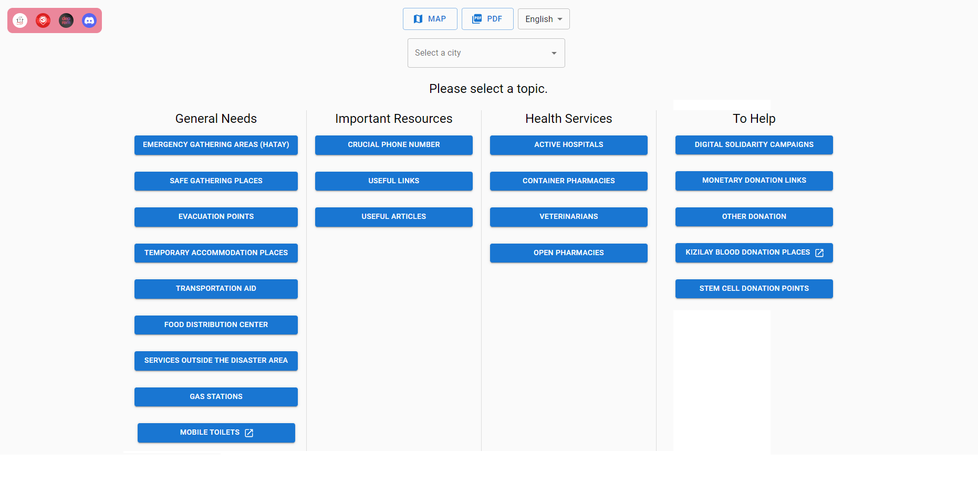

Figure 2: Main Page of Afet Bilgi

**PDF Interface**: For selected city, the required information such as hospitals, pharmacies, gas stations, accommodation places, veterinary and food sharing places will be in the PDFs. If the user has a stable internet connection, they can access to Google Maps or the source directly from the PDF instead of going to website.

metin içeren bir resim

Açıklama otomatik olarak oluşturuldu

Figure 3: PDF Page of Afet Bilgi

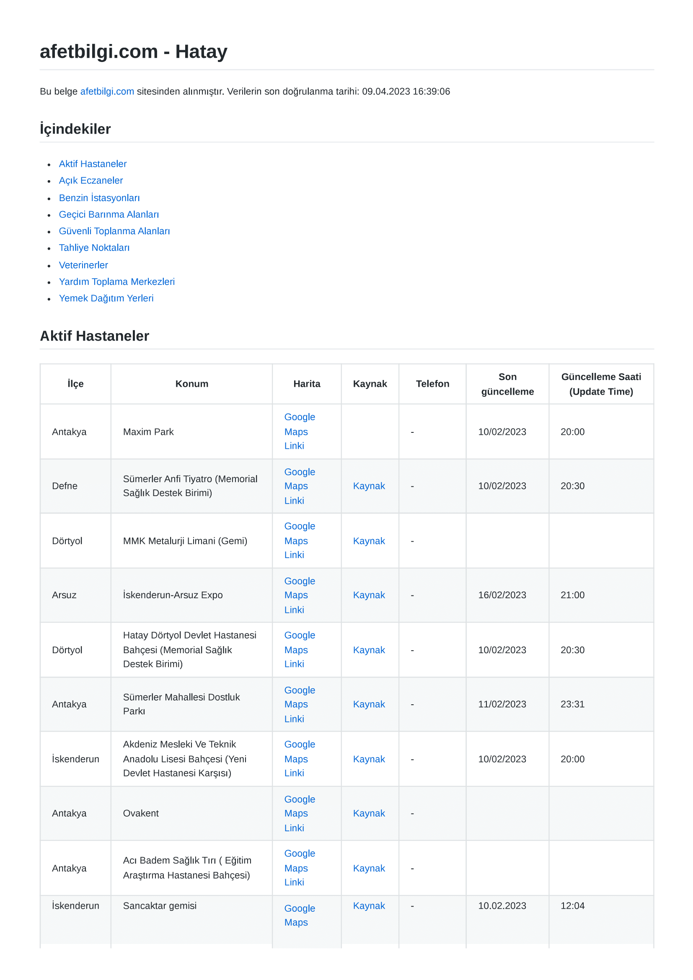

Figure 4: PDF Document of Hatay

**Map Interface:** This system provides temporary accommodation places, food sharing places, hospitals, pharmacies, and helping centers locations and navigation systems. That means the system guides you how to reach desired places. The interface has seach and filter features. The user can search a place and find the available shortest way. If the users need any help, the map will make it easy to find it.

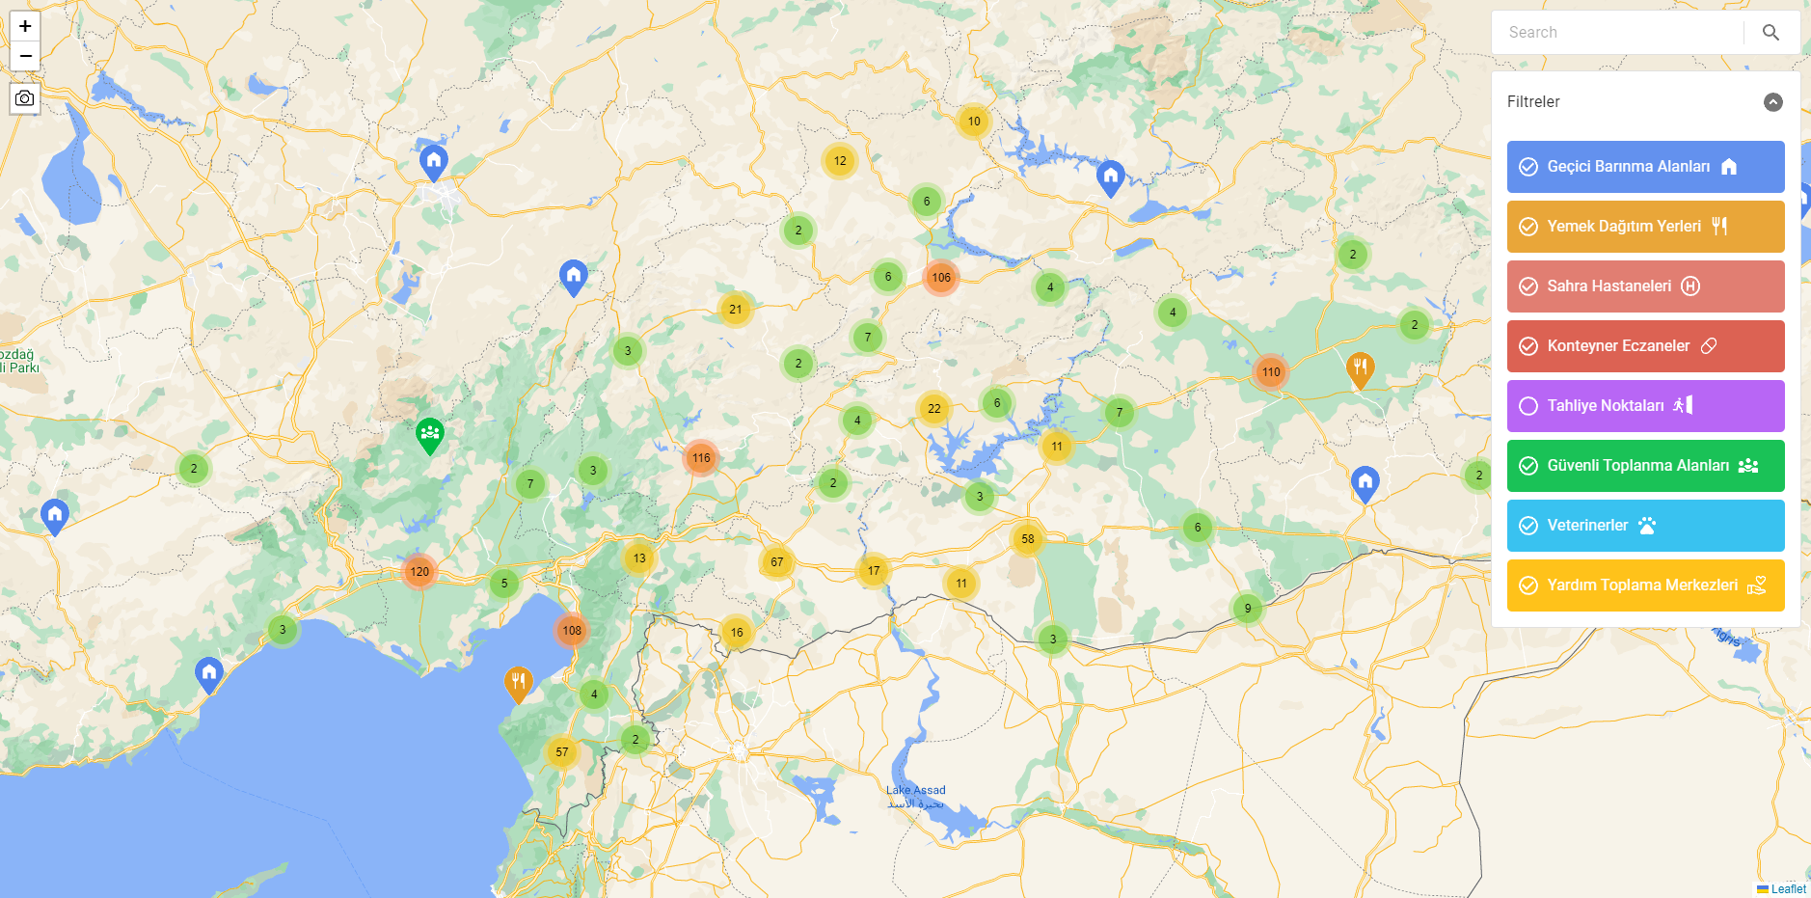

Figure 5: Map Page of Afet Bilgi

* + - 1. Hardware Interfaces

As website-based systems run entirely within a web browser, they do not require any special hardware interface beyond the standard hardware used to access the internet, such as a computer, smartphone, or tablet.

The hardware interface of website-based systems is generally straightforward, as they can be accessed from a wide range of devices with different hardware specifications using a standard web browser. The user interacts with the system through the website's user interface, which is displayed in the web browser. The performance of website-based systems can be affected by factors such as the speed and reliability of the internet connection, the processing power of the device running the web browser, and the amount of memory available on the device.

* + - 1. Software Interfaces

**Database:** Data collectors and validators who works in Afet Bilgi system, firstly take the data and check their accuracy. Then, these validated datas are stored in the storing data sheet. Lastly, these informations are send and hold in Amazon provided database.

**Operating Systems:** These systems can be used by all Operating Systems that can access web services.

**Google Maps:** This system is used for displaying active health services, emergency gathering areas temporary accommodation places which are critical for those people.

* + - 1. Communication Interfaces

Afet Bilgi uses HTTP/HTTPS protocols for communication systems. When you use HTTPS for communication, your data is encrypted before it is sent over the internet. This means that it is much more difficult for anyone to intercept and read the data as it travels across the network. In this way, any data transmitted, such as login credentials, personal information, is protected from malicious actors.

* + - 1. Memory

Memory is not big issue for Afet Bilgi system since this system can do some kind of basic database operations and these operations do not need huge amount of memory. Also, there is no storage needed for this system.

* + 1. System Functions

|  |  |
| --- | --- |
| **Function** | **Summary** |
| Add Information | First, new information reaches managers. After this information is approved, it is added to the databases by the administrators. Than, it becomes available to users. |
| Get General Needs | When user select the city, General Needs which consists the information about safe gathering places, accommodation places, food distribution centers, gas stations and mobile toilets are gathered and shown. |
| Get Important Resources | When user select the city, the critical phone numbers about earthquake and useful links and articles for survivors are gathered and shown for the user. |
| Get Healthcare Services | When user select the city, the Health Services which includes active hospitals, container pharmacies and veterinarians information collected and shown for user. |
| Get Helping Campaigns | When users wants to contribute to organisations which helps to survivors, they are offered many organisation types. After the user selects the organisation type, they will be forwarded to that organisation’s website. |
| Forwarding Other Websites | When user clicks on any source or website section buttons, they are forwarded into appropriate links. |
| Get PDF | When user wants to document of the information about the selected city, these indormation are gathered into the PDF document. After this file converted to the PDF format, this can be easily downloaded and shared. |
| Get Location | There are provided locations in a page under some sections, also pressing the map button will lead to their location on Google Maps. |
| Filter Map | When users have difficulty to find locations, they can filter the locations in terms of useful parameters such as accommodation, food sharing places, hospitals, pharmacies, safe meeting places, evacuation spots, veterinarians and aid collection center. |
| Search in the Map | When users have difficulty while searching in the Google Maps, they can search the locations in terms of the name of the place, or the street name or number. |

Table 2: System Functions

* + 1. Stakeholder Characteristics

There are three main stakeholders of the Afet Bilgi system which are users, admins and data-collector and validators.

Users are people who want to get information about the earthquake and help people who have been harmed by it. They need any device with an internet connection to connect to this site. They do not need any complicated requirements to enter this website.

Admins are the people who are responsible for the add, update and delete the information about the earthquakes in the databases. Also, they are responsible for the organizing the all interfaces of system. They need to know the system in detail and to have good web site developer skills.

Data-collector and validators are the people who are responsible for the collect the data from other people or social media and than check the reliability of these information. After the check process, they decide to information should be presented or not. They need have good-communication skills, good researcher and reliable person.

* + 1. Limitations

1. Regulatory Requirements and Policies:

The system holds critical personal data of user such as location. Therefore, the system must not leak this data and it should be encrypted.

1. Hardware Limitations (e.g., signal timing requirements):

The website uses limited database in servers, so that user density cannot be exceed the limit.

1. Interfaces to Other Applications:

The website system shall be compatible with database web service, all the perating systems that can connect to internet, and smart-phone operating systems for each user.

1. Parallel Operation:

The website may be used by many users at the same time, so parallelization is very important for the system.

1. Audit Functions:

Although there is no payment system in the website, the website redirects users to other websites. In those sides, payment operations are done with online payment services.

1. Control Functions:

All the control functions are avaible for admins of the websites only.

1. Higher-Order Language Requirements:

For the website interface, React Native Programming language is choosen because it is croos-platform supported.

1. Signal Handshake Protocols:

The website uses the HTTPS protocol for sending and receiving information from webserver.

1. Quality Requirements (E.G., Reliability):

Admins update the information in the system and take backups regularly. Network penetration tests are conducted by Amazon and third-party information security consulting firms.

1. Criticality of The Application:

Failures cause poeple to get wrong information and even can cause loss of life.

1. Safety and Security Considerations:

The location information of the user is protected by Amazon Database Servers. The whole system is regularly tested against server attacks.

1. Physical/Mental Considerations:

In the website, there is no special assistan to make it easy to use website for physically / mentally disabled people

* 1. Definitions

|  |  |
| --- | --- |
| Term | Definiton |
| Chatbot | A chatbot is a software application used to conduct an online chat conversation via text or text-to-speech, in lieu of providing direct contact. Also, they are computer programs that are capable of maintaining a conversation with a user in natural language, understanding their intent, and replying based on preset rules and data. |
| DB Service | Means Database service. It is provided by Amazon Database Service. |
| API | Application Programming Interface |

Table 3: Definitons

1. References

This document is prepared with respect to IEEE 29148-2011 standard:

29148-2011 - ISO/IEC/IEEE International Standard - Systems and software engineering – Life cycle processes –Requirements engineering.

Other Resources:

Afet Bilgi Github(2023). *Afet Bilgi*. URL : https://github.com/alpaylan/afetbilgi.com

1. Specific Requirements
   1. External Interfaces

Following class diagram represents the relationship between interfaces and their functionalities.

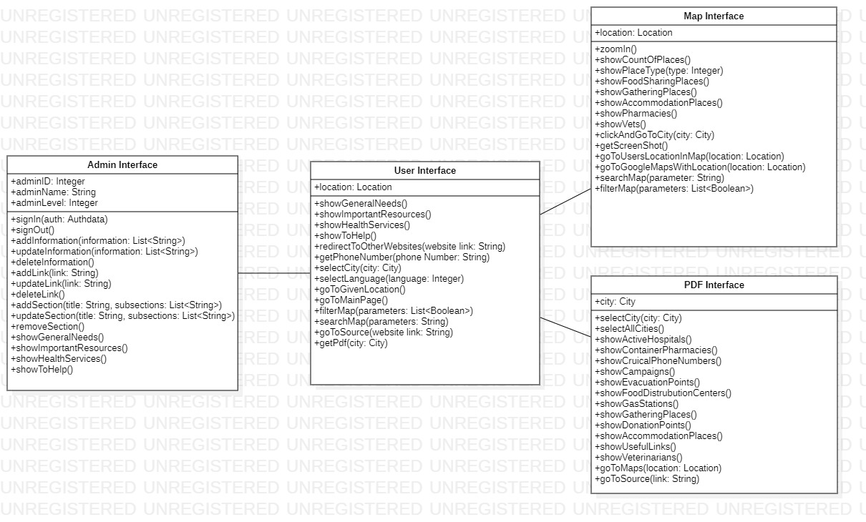

Figure 6: External Interfaces

* 1. Functions

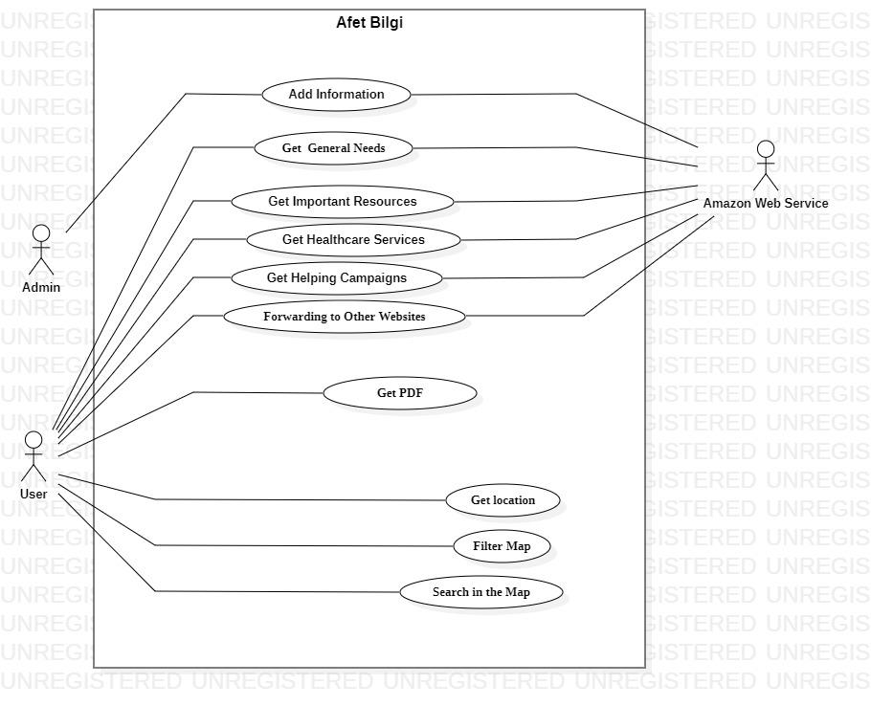

Figure 7: Use-Case Diagram

|  |  |
| --- | --- |
| Usecase name | Get General Needs |
| Actors | Users, Amazon Web Service |
| Description | When user needs to find out about safe gathering places, accommodation places, food distrubution centers, gas stations and mobile toilets, these informations are gathered according to selected city. |
| Data | Information of selected city and General Needs section |
| Preconditions | Desired city must be selected |
| Stimulus | User selects city and clicks on the general needs section. |
| Basic Flow | Step 1: User enters to the website.  Step 2: User selects the city.  Step 3: User selects the title which is under the general needs section.  Step 4: User gets the necessary and verified information. |
| Alternative Flow | - |
| Exception Flow | - |
| Postconditions | The information under the general needs section is provided to the user. |

Table 4: Get General Needs

|  |  |
| --- | --- |
| Usecase name | Add Information |
| Actors | Admin, Amazon Web Service |
| Description | When there is a new data including a needed information, admins will add this information to the database. So that the information will be available for the users in the website. |
| Data | Information of any sections. |
| Preconditions | The information needs to be checked and verified. |
| Stimulus | Admins clicks on the Add button. |
| Basic Flow | Step 1: The information comes from data collectors.  Step 2: The information is checked by validators.  Step 3: The information is verified.  Step 4: The information is added to database.  Step 5: The information is available in the website. |
| Alternative Flow | - |
| Exception Flow | Step 3: If the information cannot be verified, then it will not be added to database until it is confirmed. |
| Postconditions | There is a new information is provided to the users. |

Table 5: Add Information

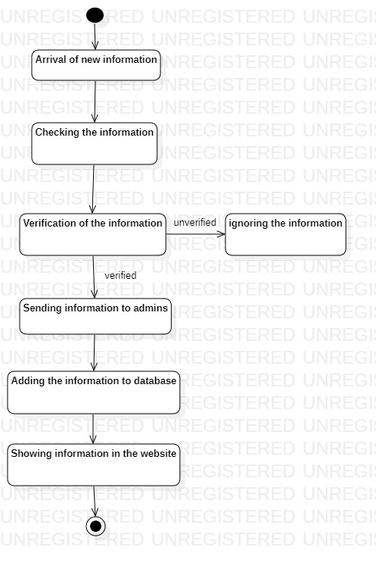

Figure 8: Activity Table of "Add Information"

|  |  |
| --- | --- |
| Usecase name | Get Healthcare Services |
| Actors | Users, Amazon Web Service |
| Description | When user needs to find out hospitals, pharmacies and veterinarians, these informations are gathered according to selected city. |
| Data | Information of selected city and Healthcare Services section |
| Preconditions | Desired city must be selected |
| Stimulus | User selects city and clicks on the general needs section. |
| Basic Flow | Step 1: User enters to the website.  Step 2: User selects the city.  Step 3: User selects the title which is under the healthcare services section.  Step 4: User gets the necessary and verified information. |
| Alternative Flow | - |
| Exception Flow | - |
| Postconditions | The information under the healthcare services section is provided to the user. |

Table 6: Get Healthcare Services

|  |  |
| --- | --- |
| Usecase name | Get Helping Campaigns |
| Actors | Users, Amazon Web Service |
| Description | When user wants to contribute to organisations which helps to survivors, they are offered many organisation types. After the user chooses the organisation type, they can choose the desired organisation. After that, they will be forwarded to that organisation’s website. |
| Data | Selected site’s information |
| Preconditions | Desired organisation must be chosen and clicked |
| Stimulus | User clicks on the organisation’ |
| Basic Flow | Step 1: User enters to the website.  Step 2: User selects the type of organisations.  Step 3: User selects organisation which they prefer to donate or help in any other way.  Step 4: User is forwarded to the preferred organisation’s website. |
| Alternative Flow | - |
| Exception Flow | - |
| Postconditions | The information about organisation’s website is provided to the user. |

Table 7: Get Helping Campaigns

|  |  |
| --- | --- |
| Usecase name | Get PDF |
| Actors | Users |
| Description | When user wants to document of all information about the city which they select, these information are gathered and PDF document is created. This PDF can be easily downloaded and shared. |
| Data | Selected city information |
| Preconditions | Clicks PDF download button and desired city have to be chosen. |
| Stimulus | User clicks to the PDF section and choose the city. |
| Basic Flow | Step 1: User enters to the website.  Step 2: User clicks to the PDF button.  Step 3: User chooses the desired city.  Step 4: The information about the city is converted to PDF by PDF API.  Step 5: The whole information about city is created into the PDF document.  Step 6: The PDF document can be downloaded. |
| Alternative Flow | Step 3: User clicks to the All Cities button.  Step 4: The information about all cities are converted to PDF by PDF API.  Step 5: The whole information about all cities are created into the PDF document.  Step 6: The PDF document can be downloaded. |
| Exception Flow | - |
| Postconditions | The whole information abot the city are showed into the PDF document and ready to downloaded. |

Table 8: Get PDF

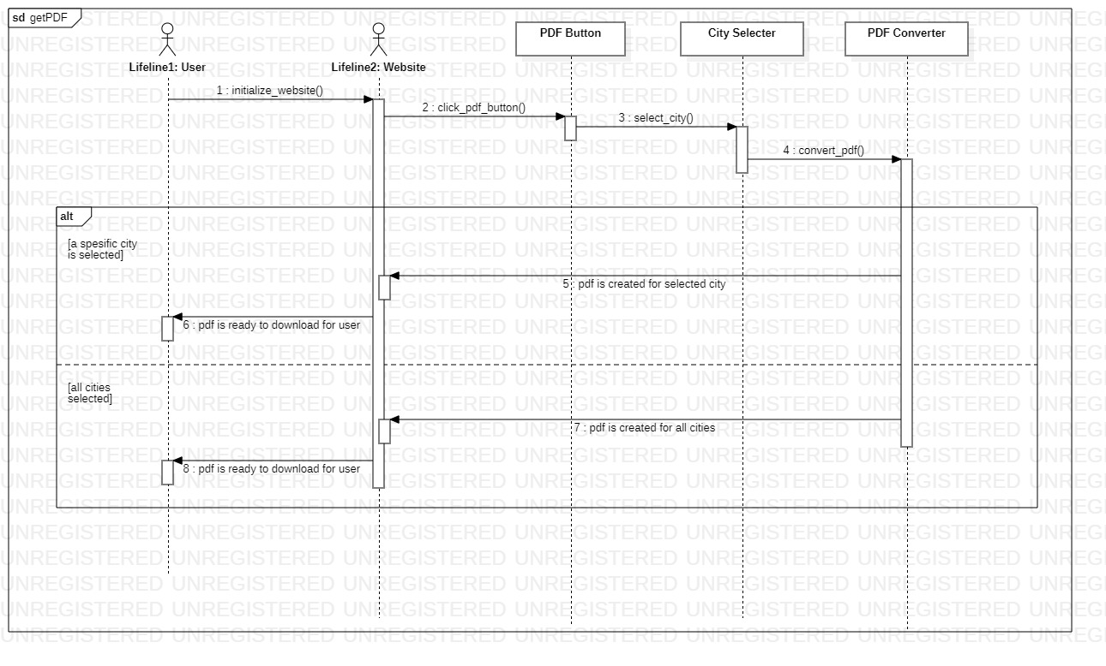

Figure 9: Sequence Diagram of "Get PDF"

|  |  |
| --- | --- |
| Usecase name | Get Important Resources |
| Actors | Users, Amazon Web Service |
| Description | When user needs to find out about the critical information about earthquake and what is useful for the survivors, these informations are gathered for the user. |
| Data | Information of the selected section |
| Preconditions | - |
| Stimulus | User clicks on the buttons under the Important Resources section. |
| Basic Flow | Step 1: User enters to the website.  Step 2: User selects the title which is under the Important Resources section.  Step 3: User gets the necessary and verified information. |
| Alternative Flow | - |
| Exception Flow | - |
| Postconditions | The information under the Important Resources is provided to the user. |

Table 9: Get Important Resources

|  |  |
| --- | --- |
| Usecase name | Get Location |
| Actors | Users |
| Description | When there is a provided location in a page under any section, there is a map button which directs to the Google Maps. In Google Maps this location can be found easily. |
| Data | Location information |
| Preconditions | When there is a provided location under any section, and then user clicks to the Map button. |
| Stimulus | User clicks to the Map button. |
| Basic Flow | Step 1: User enters the section which provides a location.  Step 2: User clicks the Map button under the address section of the site.  Step 3: The address of the location is shown in the Google Maps. |
| Alternative Flow | - |
| Exception Flow | - |
| Postconditions | Google Maps is opened according to the location which is selected by the user. |

Table 10: Get Location

|  |  |
| --- | --- |
| Usecase name | Filter Map |
| Actors | Users |
| Description | In the Google Maps, users can filter the locations in terms of useful parameters such as accommodation, food sharing places, hospitals, pharmacies, safe meeting places, evacuation spots, veterinarians and aid collection center. |
| Data | Location information and filtering parameters |
| Preconditions | User should select to parameter for the location. |
| Stimulus | User clicks filter button in the Google Maps section. |
| Basic Flow | Step 1: User clicks the Map button under the main page and goes to Google Maps.  Step 2: User clicks filter button in the Google Maps.  Step 3: The filtered places are shown in the map. |
| Alternative Flow | - |
| Exception Flow | - |
| Postconditions | The filtered locations are shown. |

Table 11: Filter Map

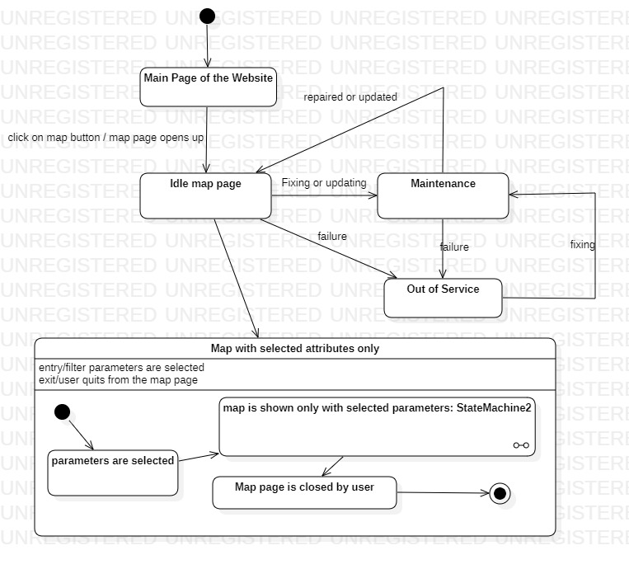

Figure 10: State Diagram of "Filter Map"

|  |  |
| --- | --- |
| Usecase name | Search in the Map |
| Actors | Users |
| Description | In the Google Maps, users can search the locations in terms of the name of the place, or the street name or number. |
| Data | Location information and search parameters. |
| Preconditions | User should enter the parameter for searching location. |
| Stimulus | User clicks the search button after the entering searching parameters. |
| Basic Flow | Step 1: User clicks the Map button under the main page and goes to Google Maps.  Step 2: User enters the required parameters for the search.  Step 3: User clicks the search button.  Step 4: Desired places are shown in the map. |
| Alternative Flow | - |
| Exception Flow | - |
| Postconditions | Google Maps shows the searched locations. |

Table 12: Search in the Map

|  |  |
| --- | --- |
| Usecase name | Forwarding Other Websites |
| Actors | Users, Amazon Web Services |
| Description | When user clicks on any source or website section this buttons forward the user into appropriate links. |
| Data | Other websites links |
| Preconditions | When there is a provided links under source section or website section and user clicks on it. |
| Stimulus | User clicks to link button. |
| Basic Flow | Step 1: User enters the section which provides other websites links.  Step 2: User clicks link or source button in the site.  Step 3: User is forwarded to the desired websites. |
| Alternative Flow | - |
| Exception Flow | Step 3: If the link does not work properly, user cannot be forwarded to other website. |
| Postconditions | User has reached the other useful website. |

Table 13: Forwarding Other Websites

* 1. Usability Requirements
* Users shall be able to find the needed section in the shortest time possible.
* Users shall be able to find the needed city in the city section easily.
* After downloading the PDF of the desired city or all cities, user must be able to use it without internet connection.
* The information that users reach must be correct.
* Adding information to the site must not take longer than an hour.
* Users needs to find the information in 3 steps at most.
  1. Performance Requirements
* The website shall be able to available to thousands users simultaneously.
* Message retrieval latency of both database and user shall not exceed 600 ms.
* Database must be updated instantly for the users who want to access important information.
  1. Logical Database Requirements

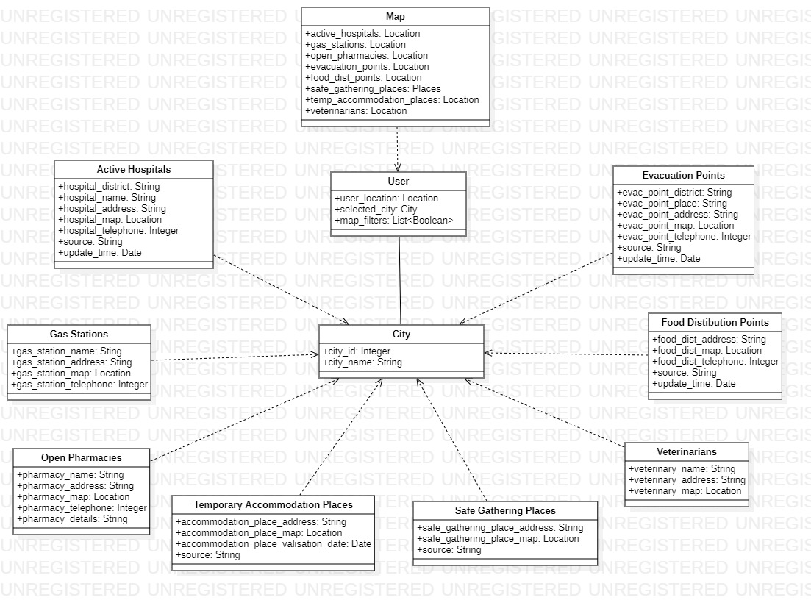

Figure 11: Logical Database Requirements Class Diagram

* 1. Design Constraints
* This system’s first concern is information sharing for earthquake survivors as fast as possible.
* All information in the site are validated and collected by volunteers and uploaded to site by admins.
  1. System Attributes

1. Reliability

* Failure time of system’s database shall be less than 2 hours in a month.
* In case of a shutdown of PDF API, it shall continue its operation in at most 5 minutes.
* Failure of the Map function must be corrected in 5 minutes.

1. Availability

* In case of a system restart, the whole system shall be available in less than 5 minutes.
* In case of a data loss, database must hold the information added in the last 30 days in some other database.
* The system backup must be done at 4 am where the site has the least user count.

1. Security

* The system components shall be tested regularly to avoid zero-day attacks.
* Whenever a new functionality is added, application logic tests shall be performed to avoid broken access controls and insecure direct object reference vulnerabilities.
* HTTPS protocol must be used to avoid the MITM attacks.

1. Maintainability

* Integration of new functions, cities and sections must not cause to an error.
* Documentations of the website must be updated every time after an update. It must help the user and admins to use the system.

1. Portability

* The website must be accessible from any device which has internet connection.
* Programming language which is chosen for the development of the main system shall not be OS dependable.
* Libraries which are used in the main system shall be applicable for different programming languages.
  1. Supporting Information

Afetbilgi is a system that works on volunteers work only. There is no benefit or any advantage for workers. The only goal is to help the earthquake survivors only.

The initialization or release of the website was done only after hours of the earthquake to help the survivors quickly.

1. Suggestions to improve the existing system
   1. System Perspective

diyagram içeren bir resim

Açıklama otomatik olarak oluşturuldu

Figure 12: Improved Version of Context Diagram

A ChatBot integration may be helpful to users. Many other websites use chatBots to get rid of searching an information on the site. The users can easily find the needed information by asking questions to chatBot.

Another addition to site that will help users is the calling police, ambulance and firefighters to user’s location without making any phone calls and delaying the arrival of the units.

Other than that, the UI limits the user experience in the site. The user does not see all sections at once. Therefore, a change in the UI might be helpful. An example is below.

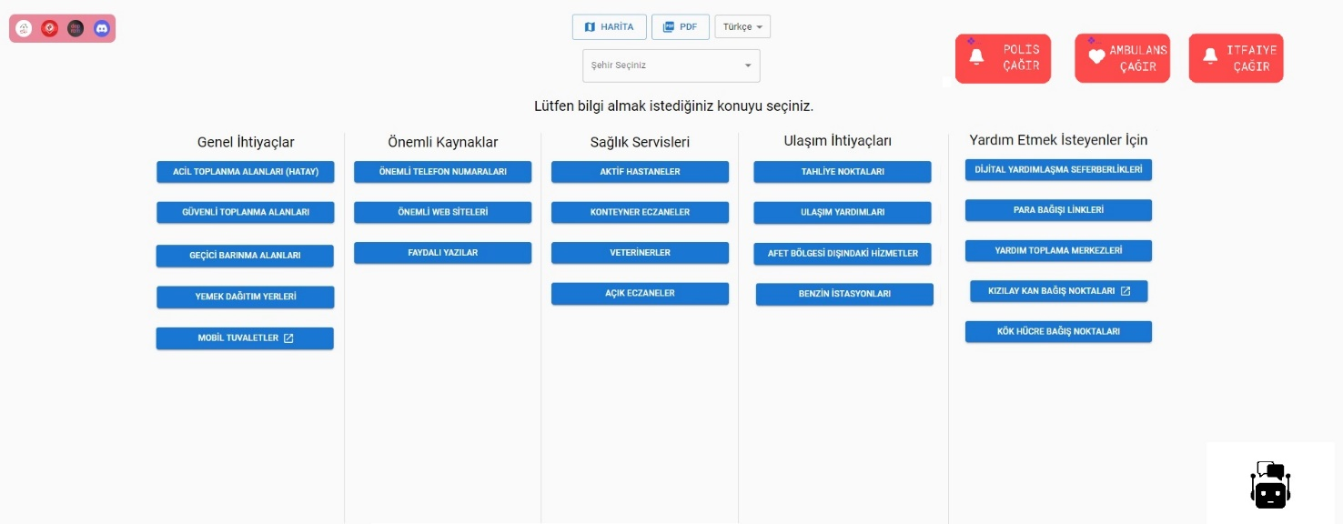

Figure 13: Improved Version of Main Page of Afet Bilgi

* 1. External Interfaces

diyagram içeren bir resim

Açıklama otomatik olarak oluşturuldu

Figure 14: Improved Version of External Interfaces

* After adding an AI ChatBot to website, users need a chatting UI to chat and get information from the ChatBot. The ChatBot shall initialize when a user enters the site. Then, it shall send a greeting message to make users see there is a ChatBot to help them. The message should explain what the bot does.
* The calling aid units button would be very helpful to users. Clicking the right button would call police, ambulance or firefighters. But to protect the system from accidental clicks, it shall pop up a question which is “You are calling the Aid Units. Are you sure about calling the Aid Units.”.
  1. Functions

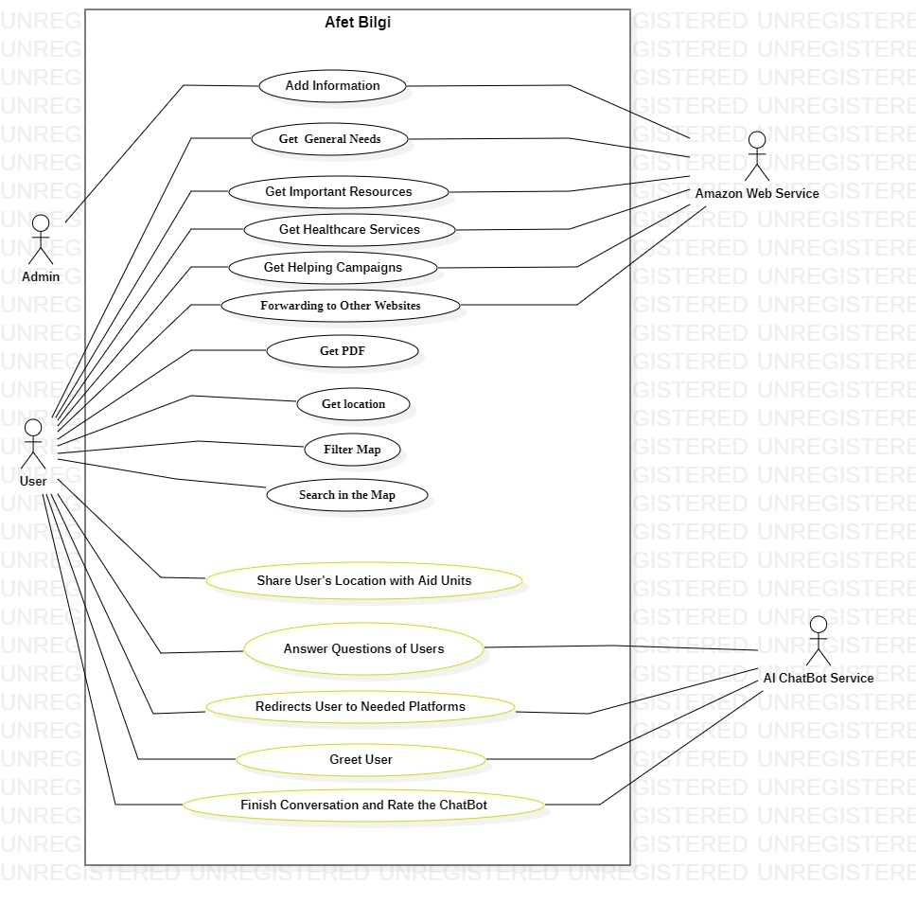

Figure 15: Improved Use Case Diagram

|  |  |
| --- | --- |
| Usecase name | Greets User |
| Actors | Users, AI ChatBot |
| Description | When user enters to the website, ChatBot is initialized and send a greeting messages to the user. |
| Data | Greeting message in the database. |
| Preconditions | User enters the website. |
| Stimulus | The ChatBot is initialized. |
| Basic Flow | Step 1: User enters to the website.  Step 2: ChatBot is initialized.  Step 3: ChatBot sends greeting message. |
| Alternative Flow | - |
| Exception Flow | - |
| Postconditions | The greeting message is visible from user,and user realizes the existence of the chatbot in the website. |

Table 14: Greets User

|  |  |
| --- | --- |
| Usecase name | Share User’s Location with Aid Units |
| Actors | Users |
| Description | When user wants help from Aid units and clicks to the which aid unit button is needed, the current location of the user sent to the needed units immediately. |
| Data | Location information of the user |
| Preconditions | User’s location information should be accesible, and user has to decide the aid unit button which one s/he needs. |
| Stimulus | To click the Aid Unit button which is decided by user. |
| Basic Flow | Step 1: Entering the main page of website.  Step 2:User clicks to the Aid Unit buttons.  Step 3: Site pops up an alert box including an “Are you sure?” message.  Step 4: User clicks “Yes”.  Step 5: The website gets the user’s location. .  Step 6: The Aid Units are not informed. |
| Alternative Flow | - |
| Exception Flow | Step 5: When user’s location cannot be accessed by website, calling Aid Units may fail. |
| Postconditions | The current location of the user is sent to the Aid Units and Aid Units are called to the location. |

Table 15: Share User’s Location with Aid Units

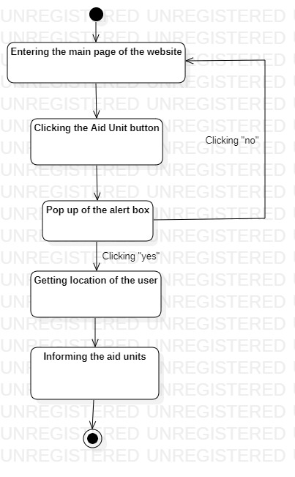

Figure 16: Activity Diagram of "Share User's Location with Aid Units"

|  |  |
| --- | --- |
| Usecase name | Answers the Questions of Users |
| Actors | Users, AI ChatBot |
| Description | When user has a difficulty to find something in the website, ChatBot can help the user for to find it. |
| Data | What the user is looking for. |
| Preconditions | User clicks the ChatBot button at the right-bottom corner and write the questions about what s/he has difficulty with. |
| Stimulus | User should send the question to AI ChatBot. |
| Basic Flow | Step 1: User clicks to the ChatBot button.  Step 2: Writes the question about the needed information.  Step 3: The ChatBot searches in the database with provided keywords in the question.  Step 4: When answer is found, respond is created and presented to the user. |
| Alternative Flow | - |
| Exception Flow | Step 4: When there is no suitable answer for question, ChatBot returns “No information can found about this topic”. |
| Postconditions | When keywords in the question are correlated with the information in the databases, suitable answer is created and sent to the user. |

Table 16: Answers the Questions of Users

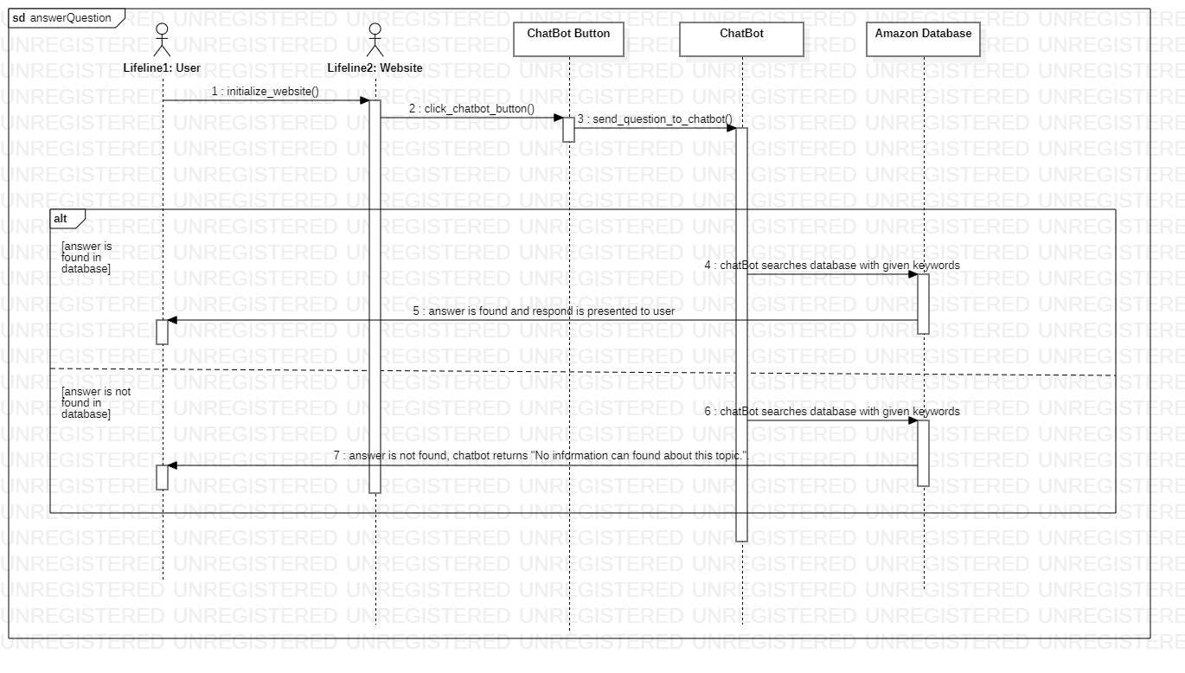

Figure 17: Sequence Diagram of "Answer Question"

|  |  |
| --- | --- |
| Usecase name | Redirects the Users to Needed Platforms |
| Actors | Users, AI ChatBot |
| Description | When user asks about a source of information or donation websites, the ChatBot redirects the user to desired any other website. |
| Data | Any other needed website link. |
| Preconditions | User should provide what kind of platform s/he need. |
| Stimulus | User clicks the provided link from ChatBot. |
| Basic Flow | Step 1: User asks about any other helping source to ChatBot.  Step 2: ChatBot searches the keywords from questions in the database.  Step 3: When suitable information are found, suitable answer is created.  Step 4: ChatBot returns answer to the user. |
| Alternative Flow | - |
| Exception Flow | Step 3: When there is no suitable information in the database, ChatBot returns “No information can found about this topic”. |
| Postconditions | When keywords in the question are correlated with the information in the databases, suitable website link is sent to the user, and the user is ready to redirected. |

Table 17: Redirects the Users to Needed Platforms

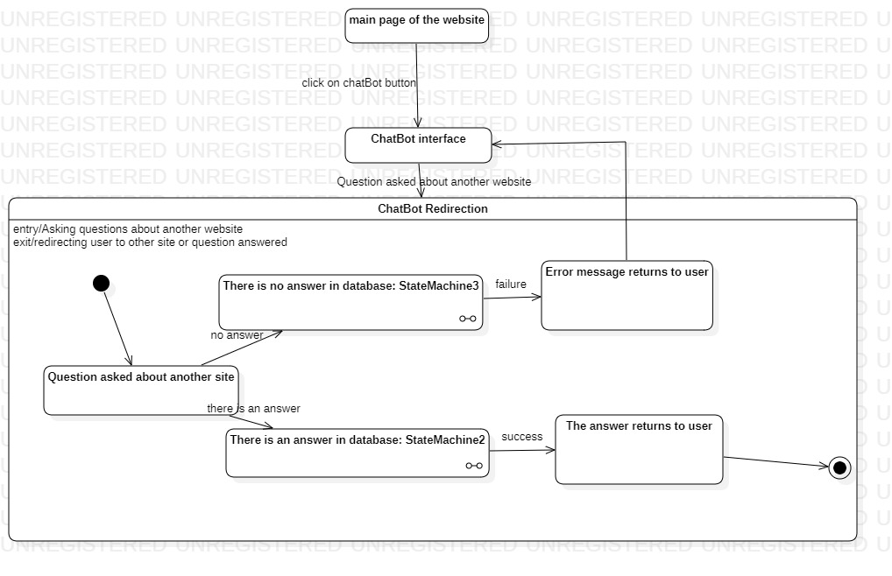

Figure 18: State Diagram of "Redirects the Users to Needed Platforms

|  |  |
| --- | --- |
| Usecase name | Finish the Conversation and Rate the ChatBot |
| Actors | Users, AI ChatBot |
| Description | When the conversation is over between Chatbot and the user, ChatBot sends rating poll to the user before ending conversation. After rating it, the ChatBot window is closes itself. |
| Data | Rating results for ChatBot. |
| Preconditions | User uses the ChatBot. |
| Stimulus | User click to ChatBot’s close button. |
| Basic Flow | Step 1: The conversation between user and ChatBot is over.  Step 2: ChatBot sends rating poll to the user.  Step 3: User wants to rate ChatBot, the rating information is sent to the database. |
| Alternative Flow | - |
| Exception Flow | Stap 3: When user does not want to rate the ChatBot, the rating information is not send to the database. |
| Postconditions | Rating information sent to the database and according to them, ChatBot can be improved. |

Table 18: Finish the Conversation and Rate the ChatBot

* 1. Usability Requirements
* ChatBot must answer to users in seconds at most.
* ChatBot must greet user to show that there is a chatBot in the site.
* Users must get the wanted information from the ChatBot without an error.
* While calling the aid units, the location information of the user cannot be away from the user further than 15 meters.
* Calling the aid units button must call the units when pressed.
  1. Performance Requirements

* The chatBot shall be able to available to thousands users simultaneously.
* Message retrieval latency of the chatBot and user shall not exceed 600 ms.
* The aid unit call must get the location of the user and call the needed units in 5 seconds.
  1. Logical Database Requirements

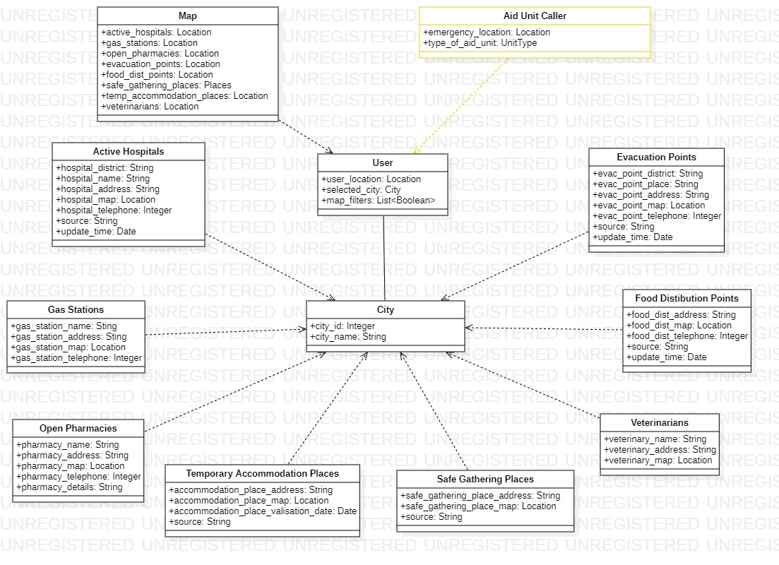

Figure 19: Improved Logical Database Requirements Class Diagram

* 1. Design Constraints
* The chatBot helps the users to get information faster.
* This system’s first concern is information sharing for earthquake survivors as fast as possible.
* In an emergency situation, calling the units function helps the user immediately.
* All information in the site are validated and collected by volunteers and uploaded to site by admins.
  1. System Attributes

1. Reliability

* Failure of the ChatBot must be corrected in 5 minutes.
* In case of a failure of calling aid units, it must be corrected in 1 to 2 minutes.

1. Availability

* In case of a system restart, the whole system shall be available in less than 5 minutes.
* In case of a connection loss and reconnect, chatBot must be connected in 10 seconds.
* The system backup must be done at 4 am where the site has the least user count.

1. Security

* Whenever a new functionality is added to chatBot, application logic tests shall be performed to avoid broken access controls and insecure direct object reference vulnerabilities.
* When calling the aid units, location of the user must not shared with anyone else.

1. Maintability

* Integration of new functions to ChatBot, it must not create any errors.
* ChatBot must be updated by itself every time after an update.
  1. Supporting Information
* Afetbilgi is a system that works on volunteers work only. There is no benefit or any advantage for workers. The only goal is to help the earthquake survivors only.
* The initialization or release of the website was done only after hours of the earthquake to help the survivors quickly.
* It uses chatBot system to help to its users and has an aid unit calling system.