**WSA3**

2448025

1.1. Source Address: 192.168.1.96

1.2. Source Port: 57606

2.1. Destination Address: 128.119.245.12

2.2. Destination Port: 80

3.1. Sequence Number: 346340459

3.2. Flags: 0x002 (SYN). This means that SYN flag is set to 1.

3.3. We can observe that the TCP receiver in this session can employ Selective Acknowledgement

4.1. Sequence Number: 1354301674

4.2. Flags: 0x012 (SYN, ACK). Both are set to one in flags section.

4.3. Acknowledgment Number: 3463400460

4.4. The server adds 1 to the SYN segment from the client computer’s beginning sequence number. The value of the Acknowledgement field in the SYNACK segment is 1 since the beginning sequence number of the SYN segment from the client is 0.

5.1. Sequence Number: 346340460

5.2. TCP payload (633 bytes). No. The alice.txt file is larger, and so multiple TCP segments will be needed.

6.1. The initial segment of the data-transfer portion of the TCP connection was sent at 11.378048.

6.2. The ACK for the first data-data containing segment was received at 11.539276

6.3. For the first data-containing segment, the RTT = 11.539276 - 11.378048 = 0.161228.

6.4. For the second data-containing segment, the estimated RTT = 11.539332 – 11.378357 = 0.160975.

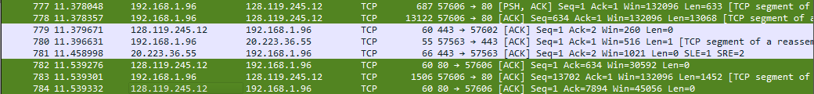

6.5. EstimatedRTT = 0.875 * EstimatedRTT + 0.125 * SampleRTT

= 0.875 * 0.161228 + 0.125 * 0.160975 = 0.161196375 s

7.0. The first TCP segment is 687 bytes long, while the second TCP segment is 13122 bytes, third 1506 bytes, fourth 14574 bytes long.

8.1. 132096 Bytes are the minimum amount of available buffer space among these first four data carrying TCP segments to the clients.

8.2. No, for these initial four data carrying segments, the sender is never throttled due to a lack of receiver buffer space.

9.1. No, there were no some segments retransmitted.

9.2. The trace file's TCP segment sequence numbers can be used to see this. Based on Stevens' methodology, the Time-Sequence Graph shows a steady, monotonic growth in sequence numbers over time. Should a segment be retransmitted, the sequence number linked to it must be less than the sequence numbers of the segments that come before it.

10.1. 2904

10.2. No, among these first ten data-carrying segments, the receiver is not acknowledging each and every other received segment. They are all sequential.

|  |  |  |
| --- | --- | --- |
|  | ACKed Sequence Number | ACKed Data |
| ACK1 | 1 | 633 |
| ACK2 | 634 | 13608 |
| ACK3 | 13702 | 1452 |
| ACK4 | 15154 | 14520 |
| ACK5 | 29674 | 11616 |
| ACK6 | 41290 | 2904 |
| ACK7 | 44194 | 2904 |
| ACK8 | 47098 | 2904 |
| ACK9 | 50002 | 2904 |
| ACK10 | 52906 | 2904 |

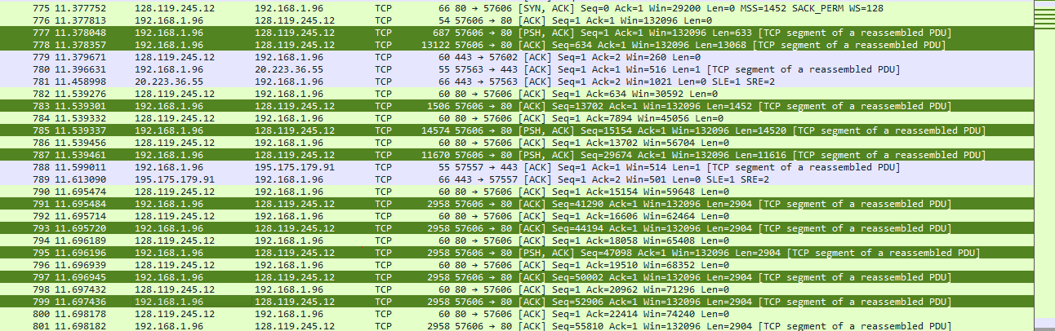

11.1. 315.601161 KBps

11.2. The acknowledgement number of 152952 in the HTTP POST packet, which is compatible with the file size of alice.txt, indicates that 152952 bytes were acknowledged.

Throughput = Amount of data transmitted / time incurred

Amount of data transmitted = 152952 bytes = 152.952 KB

Time incurred = (Last ACK) - (First TCP segment) = 11.862685 - 11.378048 = 0.484637s

Throughput = 152.952 KB / 0.484637s = 315.601161 KBps

12. Since the buffer size is sufficient for our data and the number of packets in the fleets is growing over time, TCP is currently in its slow start phase.

The RTT between the sender and the recipient, which I calculated to be approximately 0.16 seconds earlier, roughly corresponds to the period.

