**WSA4**

2448025

* 1. Packet Number : 8

1.2. The type of application-layer payload or protocol message : DNS.

1.3. The header contains only 4 fields.

1.4. Source Port, Destination Port, Length, Checksum.

2. Each of header fields is 2 bytes. Total UDP header is 8 bytes long.

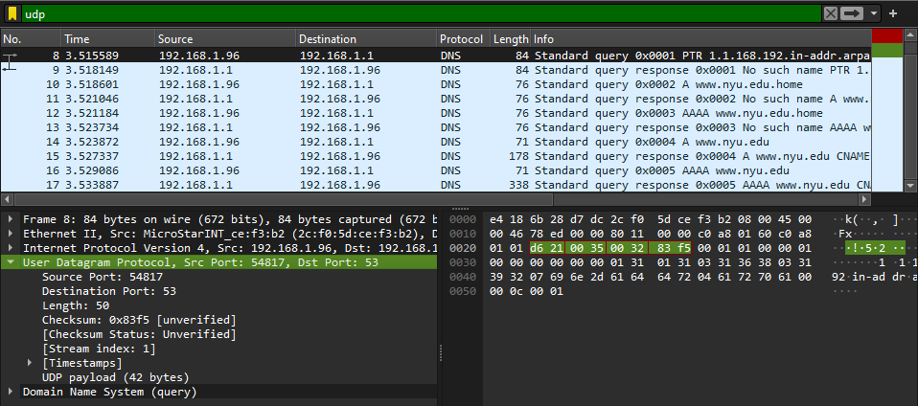

1. (216 – 1) – Header Length = Max Payload Size

65535 - 8 = 65527 bytes.

4. Protocol Number : 17

5.1. First UDP Segment Packet Number : 8

5.2. Second UDP Segment Packet Number : 9  
The source port of a UDP packet sent by the host corresponds to the destination port of a reply packet, and vice versa.

