**WSA7**

2448025

1. Source 48-bit Ethernet address: BelkinIntern_75:b1:52 (c4:41:1e:75:b1:52)
2. Destination 48-bit Ethernet address: 3ComEurope_7e:d9:01 (00:1e:c1:7e:d9:01)

No, the destination address is not the Ethernet address of gaia.cs.umass.edu. It is the address of 3ComEurope router.

1. Hexadecimal Frame Type Value : 0x0800. This corresponds to IP protocol.   
     
   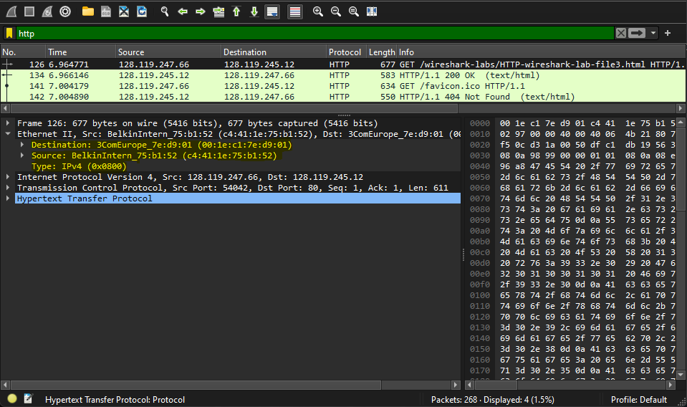
2. “G” appears 67 bytes from the beginning.

1. Source 48-bit Ethernet address of response: 3ComEurope_7e:d9:01 (00:1e:c1:7e:d9:01)   
   No, source address is not the Ethernet address of gaia.cs.umass.edu and sending computer. It is the address of 3ComEurope Router.
2. Destination 48-bit Ethernet address of response: BelkinIntern_75:b1:52 (c4:41:1e:75:b1:52)  
   This is the Ethernet address of sender.
3. The hexadecimal Frame Type Value of response: 0x0800. This corresponds to IP protocol.   
     
   A screenshot of a computer

   Description automatically generated
4. “o” appears 52 bytes from the beginning.  
     
   A screenshot of a computer

   Description automatically generated
5. 4 Ethernet Frames carry the data for “OK” reply message.  
     
   A screenshot of a computer program

   Description automatically generated
6. Source Address Hexadecimal Value: Apple_ac:ad:e1 (78:7b:8a:ac:ad:e1)
7. Destination Address Hexadecimal Value: Broadcast(ff:ff:ff:ff:ff:ff)
8. The hexadecimal Frame Type Value: 0x0806, for ARP.  
     
   A screenshot of a computer

   Description automatically generated
9. The ARP opcode field begins 21 bytes from the beginning.  
     
   A screenshot of a computer

   Description automatically generated
10. Yes, the sender IP address is : 128.119.247.79
11. The destination IP address is :169.254.1.0  
      
    A screenshot of a computer

    Description automatically generated
12. The ARP opcode value of the reply is : reply (2)
13. The ARP request message by computer has   
    Sender Ethernet Address: 3ComEurope_7e:d9:01 (00:1e:c1:7e:d9:01)  
      
    A screenshot of a computer

    Description automatically generated
14. Since we are not at the machine that sent the request, there is no response in this trace. While the ARP reply is sent directly to the sender's Ethernet address, the ARP request is broadcast.