4.2 Application Design

This section will show the design and interface of the application. The application follows a very simple and easy to use interface which allow every person to use the application without prior knowledge.

This is the main page of the application. This page shows the data of the selected file in the TextView as you can see the in diagram below the TextView(red) shows the data of file 07052017.txt which was chosen by the user using spinner. This page will also allow user to turn on Bluetooth and off from the application. The three lines in the top left side will be used to open navigation drawer and to close it. User can also open and close the door by swiping his hand on the screen from left corner toward right.

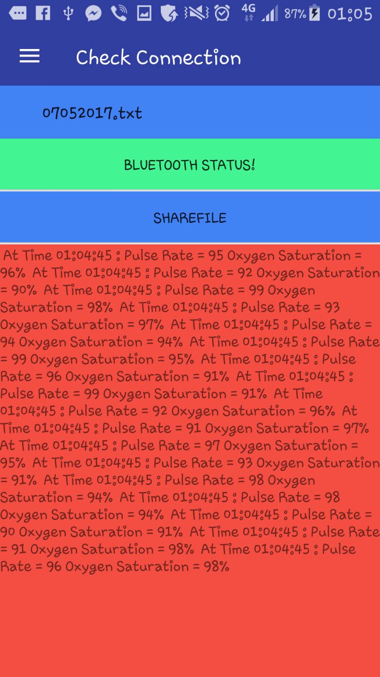

FIG: 4.7 Check Connection Fragment

The below Screenshot shows the side navigation drawer which you can see has few options. This navigation drawer is used for transaction between two devices. If a user clicks and select a option then the main activity will transact to the given and chosen item.

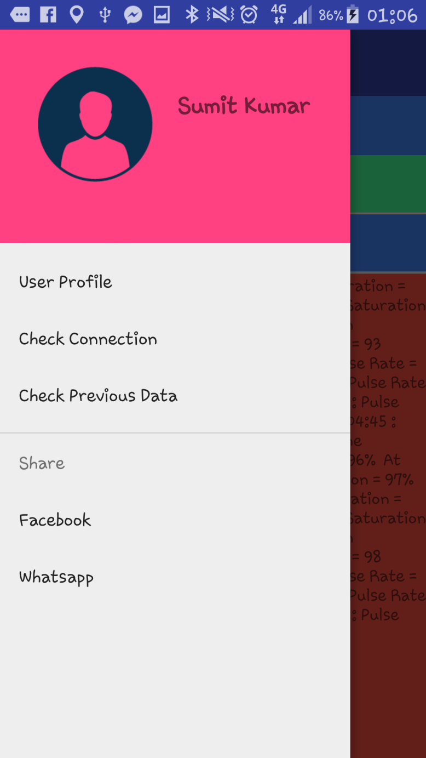

FIG: 4.8 Side navigation drawer

In the check connection fragment when a user try to choose a file to open the file and check it's data the user need to choose the file from the spinner. When user clicks on the spinner the spinner shows the list of the files that are present in the local directories of the application.

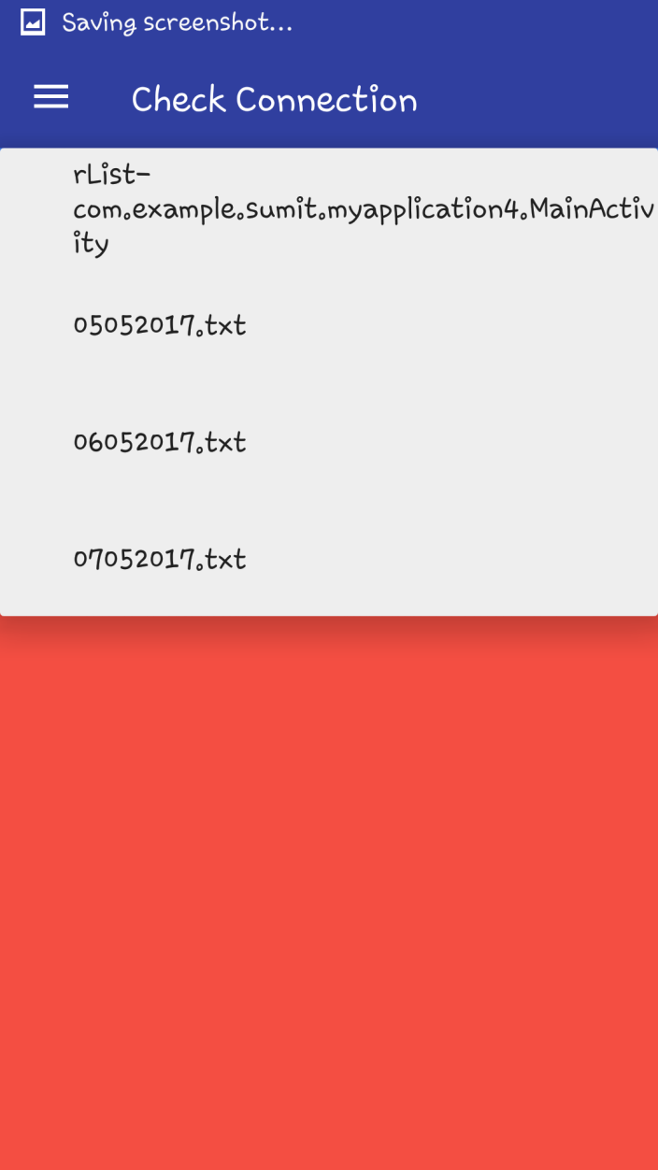

FIG: 4.9 Spinner From Check Connection Fragment

When a user tries to turn on the Bluetooth from the application they need to take permission from user. The permission dialog will look like the picture below.

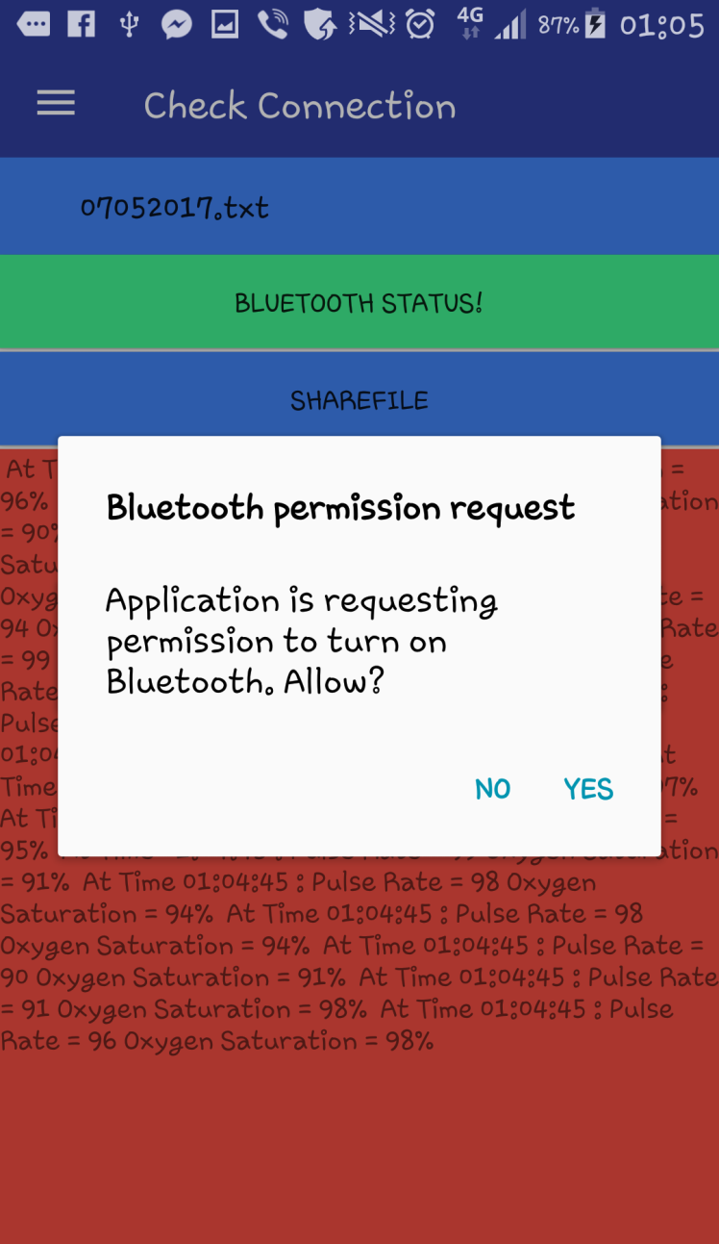

FIG: 4.10 Bluetooth Permission Request

When the permissions are given to the application the Bluetooth is turned on successfully and user gets a message about it which looks the picture below

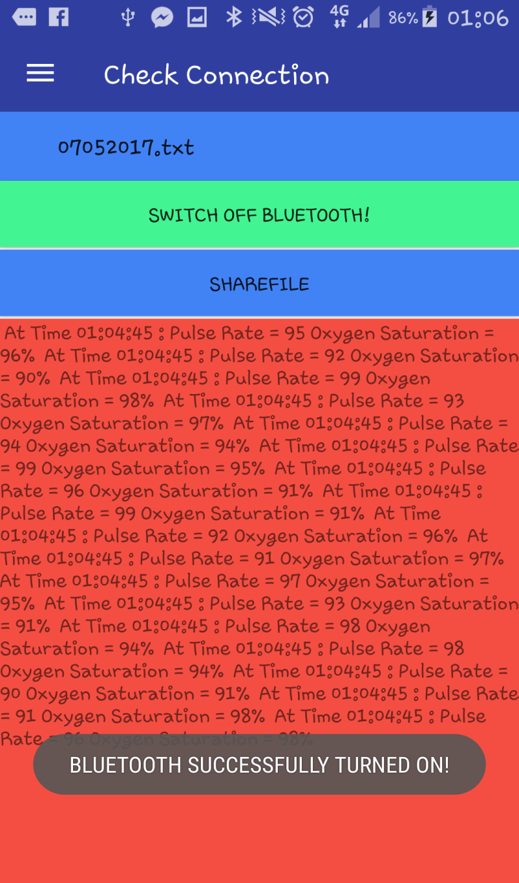

FIG: 4.11 Check Connection Fragment

When permission from the user is denied then application gives out a message stating that Bluetooth turn on failed which looks like the picture below.

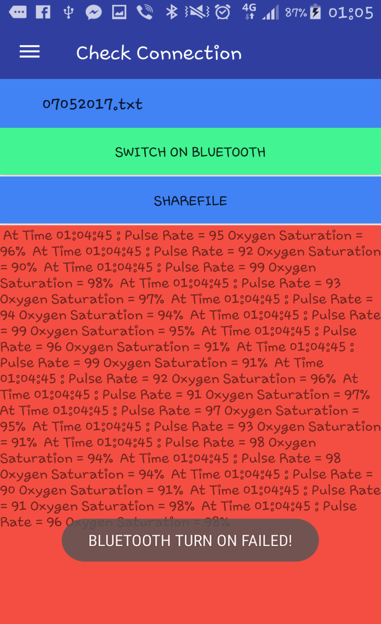

The below picture shows how interface changes when share file button is clicked. The user will be prompted with different application to share file.

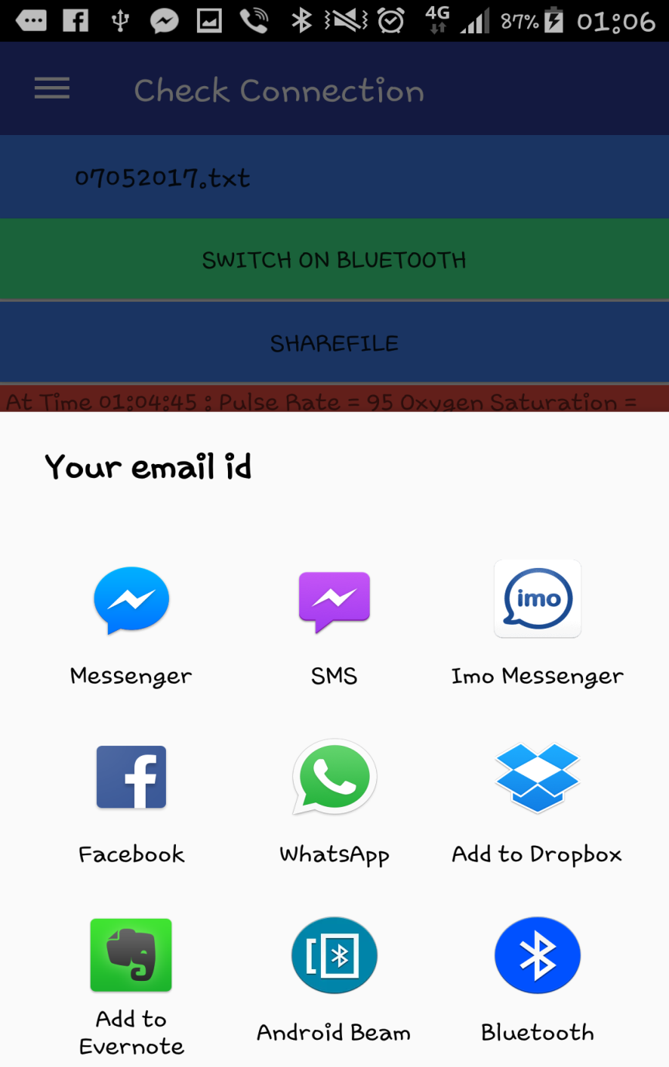

FIG: 4.12 Sharing Data

The below picture show the previous data page which receives the data from a method and them adds that data into the graph . As you can see the method also start displaying the values in the TextView to inform user about data receiving. The method also saves that data into a text file which will be named with the current date.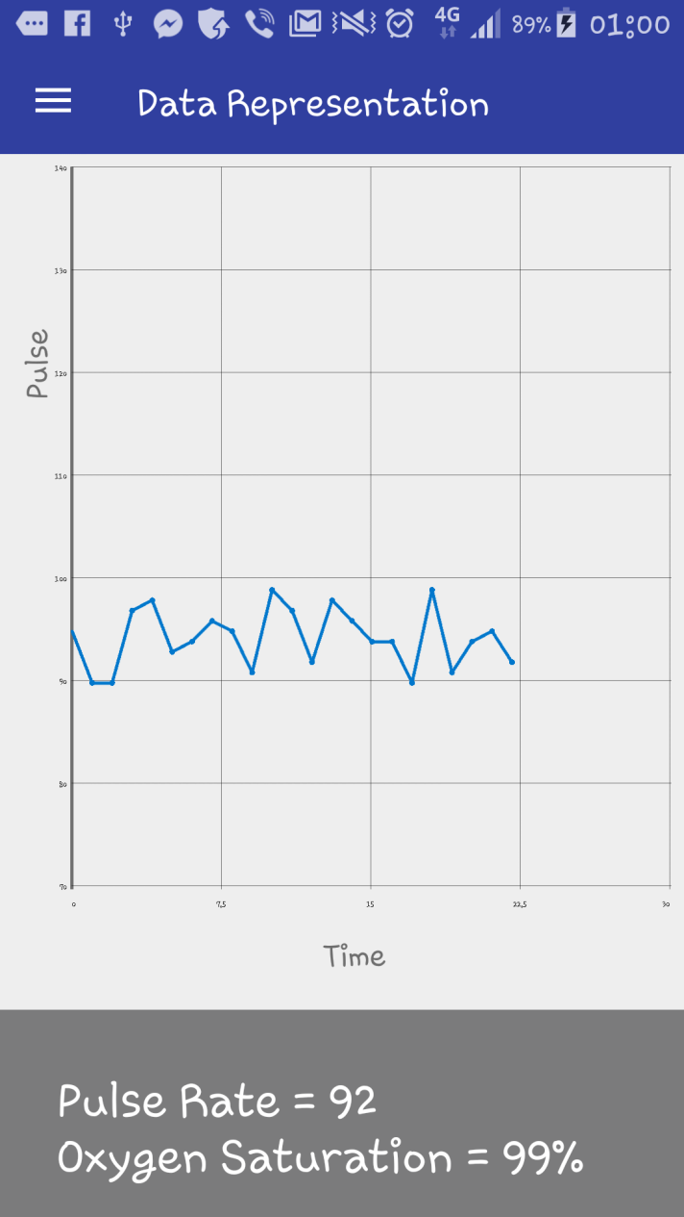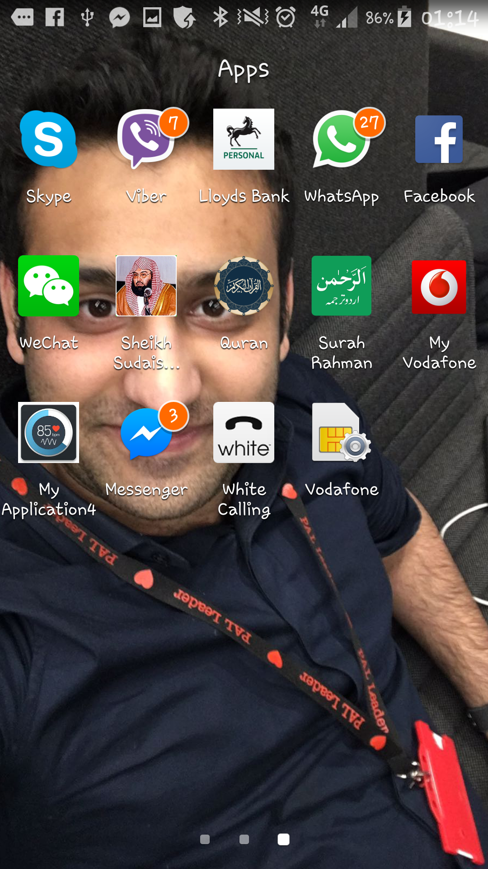

FIG: 4.13 Previous Data Fragment application Icon

The below picture is a user profile page. This picture asks for input from user and then saves them in shared preferences when Submit button is clicked. These user details are accessible to the user using the phone.

The picture on the right is of the application.

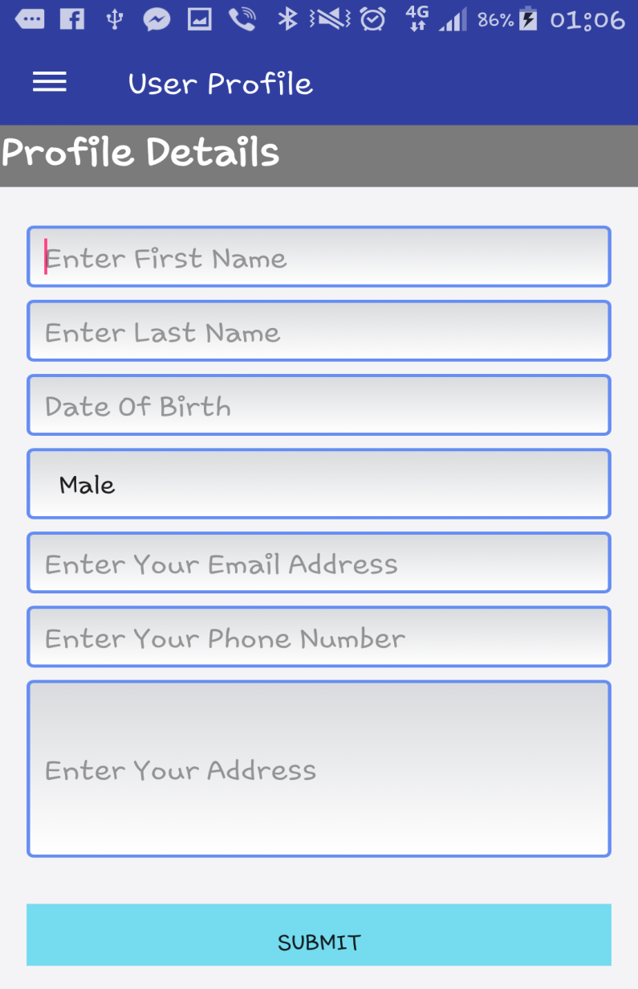

FIG: 4.14 User Profile Fragment