System Architecture Diagrams
These diagrams visually represent the architecture and security flows described in Sections 3 of the full documentation.

System Architecture — Component & Data Flow
The React frontend communicates exclusively via Axios HTTP calls to the Spring Boot backend, which routes requests through a JWT filter before reaching business logic. External services (PostgreSQL, Cloudinary, SendGrid, Gemini AI, Razorpay) are called only from the Service layer.
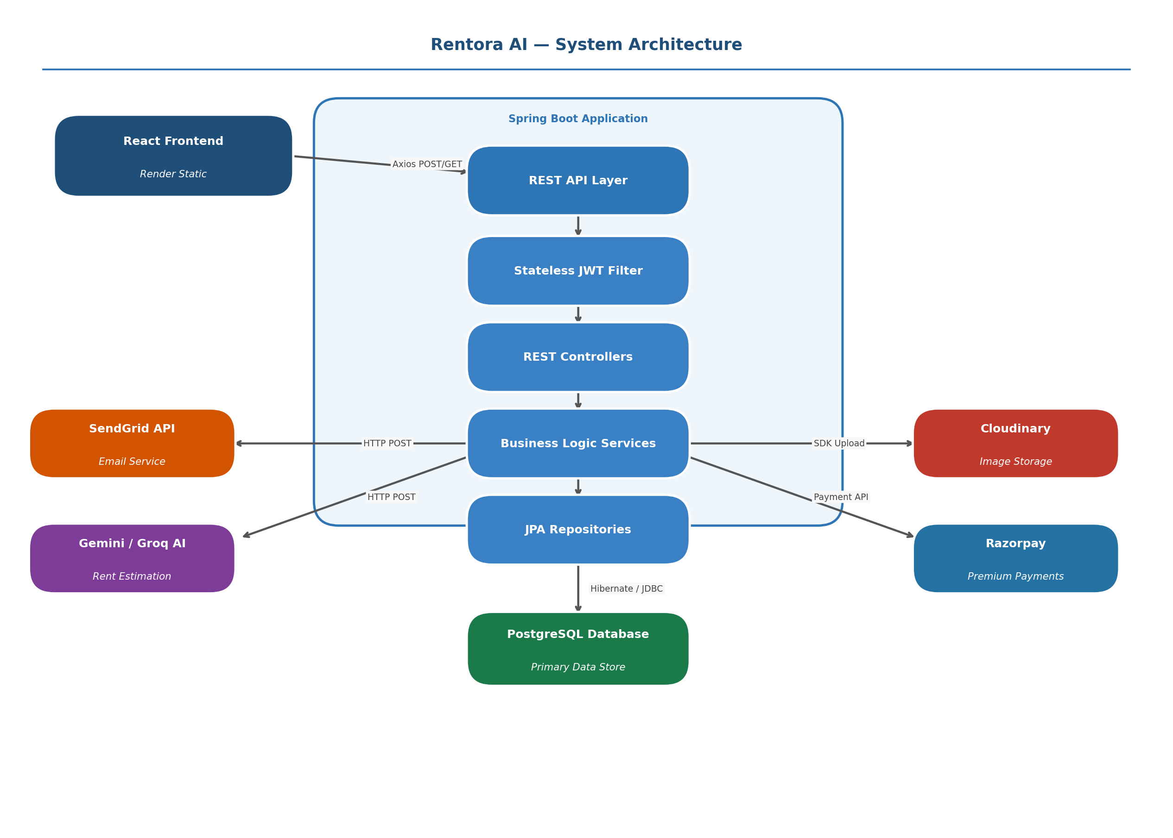
Figure 1: Rentora AI — Full System Architecture & Data Flow

JWT Authentication Flow — Step by Step
On login, the server validates the BCrypt-hashed password and issues a signed JWT. All subsequent requests from the React client carry this token via Axios interceptors. The Spring Security JwtFilter validates the signature and expiry on every request, then sets the authenticated user in SecurityContextHolder — enabling stateless, scalable authentication.
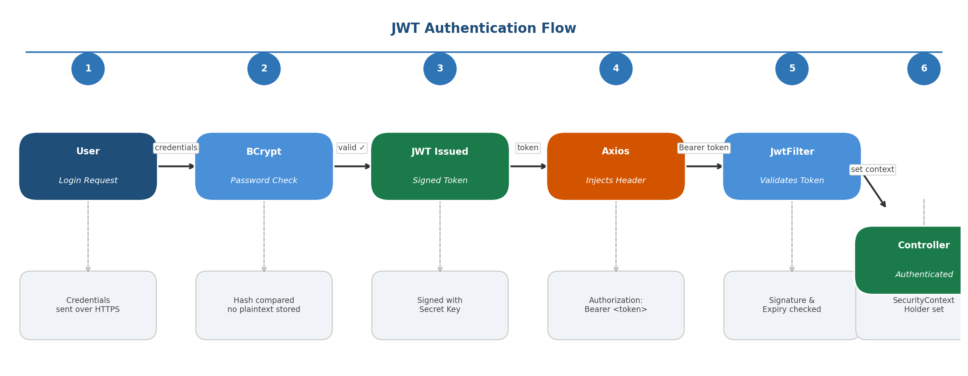
Figure 2: JWT Authentication Flow — 6-Step Lifecycle

# | Step | What Happens
1 | User Login Request | User submits credentials (email + password) over HTTPS to the /auth/login endpoint.
2 | BCrypt Password Check | Spring Security loads the user from DB and compares the submitted password against the BCrypt hash. No plaintext ever stored.
3 | JWT Issued | On successful validation, a signed JWT (HS256) is generated containing user ID, role, and expiry. Returned to frontend.
4 | Axios Injects Header | Every subsequent request is intercepted by Axios and the Authorization: Bearer <token> header is injected automatically.
5 | JwtFilter Validates Token | Spring Security's JwtFilter parses the token, validates signature and checks expiry. Rejects expired/tampered tokens with 401.
6 | Controller Authenticated | Valid token → user context set in SecurityContextHolder. Request proceeds to Controller → Service → Repository.

