Gurjus Singh

September 27th, 2020

MSDS 460 – Decision Analytics

HOMEWORK #1

**Problem #1**

For the first problem let X1 be Italian Cabinet Style, let X2 be French Country, and let X3 be Caribbean

To Maximize his daily profits, **the objective function** is:

72X1 + 65X2 + 78X3

The **constraints** are for Carpentry, Painting, and Finishing are:

3X1 + 2.25X2 +2.50X3 <= 1,360

1.50X1 + X2 +1.25X3 <= 700

0.75X1 + 0.75X2 + 0.85X3 <= 430

Where

X1, X2,X3 >= 60

There seems to be no other constraints, so we are now done setting up this problem.

**Problem # 2**

Let the Decisions variables be for in house

A- Gear A

B- Gear B

C- Gear C

D-Gear D

Let A’ B’ C’ D’ be for outsourcing Gears A-D

To Figure out objective function to maximize we first have to figure out profits which can be determined by

(Revenue - Hours Per Gear*Cost Per Hour – (Outsourcing ))

This is the same as the profit function which is

P(x) = R(x) – C(x)

The Inhouse Cost was subtracted from Revenue:

Revenue Cost of Processes

(12.50A + 15.6B + 17.4C + 19.3D) – (6.55A + 7.89B + 7.956C. + 8.565D)

To get the function below which is in the form

(In house – Outsource Cost) which is the function you are trying to maximize for profits

With this in mind our objective function to maximize is:

Inhouse Revenue – Cost Combined - Outsource Cost

5.95A + 7.71B + 9.435C + 10.735D – (7.10A’ + 8.10B’ + 8.40C’ + 9.00D’)

The constraints for this problem are:

A <= 400

B <= 500

C <= 450

D <= 600

(Represents constraint for demand for each gear)

0.30A + 0.36B +0.38C + 0.45C <= 500 (represents 500 hrs available for forming)

0.20A + 0.30B +0.24C + 0.33C <= 300 (represents 300 hrs available for hardening)

0.30A + 0.30B +0.35C + 0.25C <= 310 (represents 310 hrs available for deburring)

A, B, C, D >= 0

The constraints for outsourcing are:

A’ <= 300

B’ <= 300

C’ <= 300

D’ <= 300

A’, B’, C’, D’ >= 0

**Problem # 3**

We first want to write out the distances between each machine and the new machine which can represent the objective function:

Z = |X1 -3| + |X2| + |X1 | + |X2 + 3| + |X1 -2| + |X2-1| + |X1-1| + |X2-4|

Once we know our objective function the next thing to do is create decision variables which can be substituted into the function:

So our decision variables can be:

X1 -3+ , X1 -3-

X2+, X2-

X1+, X1-

X2 +3+ , X2 +3-

X1 -2+ , X1 -2-

X2 -1+ , X2 -1-

X1 -1+ , X1-1-

X2 -4+ , X2-4-

With this information we can define the set of absolute values above to:

|X1 -3| = X1 -3+  + X1 -3-

|X2| = X2+ + X2-

|X1| = X1+ + X1-

|X2 + 3| = X2 +3+  + X2 +3-

|X1 -2| = X1 -2+  + X1 -2-

|X2-1| = X2 -1+  + X2 -1-

|X1-1| = X1 -1+ + X1-1-

|X2-4| = X2 -4+ + X2-4-

After defining the set above, we can then reconstruct the objective function:

Z = X1 -3+  + X1 -3- + X2+ + X2-+ X1+ + X1-+ X2 +3+  + X2 +3-+ X1 -2+  + X1 -2- + X2 -1+  + X2 -1- + X1 -1+ + X1-1- + X2 -4+ + X2-4-

The only constraint is that the variables all have to be greater than >= 0

X1 -3+ , X1 -3-

X2+, X2-

X1+, X1-

X2 +3+ , X2 +3-

X1 -2+ , X1 -2-

X2 -1+ , X2 -1-

X1 -1+ , X1-1-

X2 -4+ , X2-4-

>= 0

**Problem # 4**

Let the Decision Variables be

B – City of Miami Municipal Bonds

C – American Smart Cars

E– GreenEarth Energy

P – Rosslyn Pharmaceuticals

R – Real Co Real Estate

The objective function to maximize is:

0.053B +0.088C + 0.049E + 0.084P + 0.104R

The constraints are:

We know the brokerage is obligated to invest a total of 500,000 so:

B + C + E + P + R <= 500,000

The other constraints are:

B >= 0.25(B + C + E + P + R) signifies at least 25% in municipal bonds

R + P >= 0.10(B + C + E + P + R) signifies at least 10% in Real estate and Pharmaceuticals

E + C >= 0.40( B + C + E + P + R) signifies at least 40% in Energy and automobile stocks

E >= 0.15(B + C + E + P + R) signifies at least 15% in Energy

C >= 0.15(B + C + E + P + R) signifies at least 15% in Automobile

(R + P) =< 0.50(E + C) Signifies no more than 50% of the total amount invested in energy and automobile stocks in a combination of real estate and pharmaceutical company stock

B, C, E, P, R >= 0

There seems to be no other constraints, so we are now done setting up this problem.

**Problem # 5**

We have:

Objective Function 5X1 +4X2

Subject to X1+2X2 <= 6

-2X1+x2 <= 4

5X1+3X2 <= 15

X1, X2

To solve using the graphical method:

1. We first want to figure out a corresponding equation:

Corresponding equations are:

X1+2X2 = 6

-2X1+x2 = 4

5X1+3X2 = 15

2. Next we want to be able to find X and Y Intercept coordinates to graph:

To find x-intercept simply plug in 0 for X2

This gives us three y-intercept coordinates for the corresponding equations above:

(6,0)

(-2, 0)

(3, 0)

Next find all the y-intercepts by plugging in 0 for X1 in the equation in Step 1, and the corresponding coordinates are:

(0, 3)

(0, 4)

(0, 5)

3. We can then find the correct graph depicted below

Feasible region is in yellow

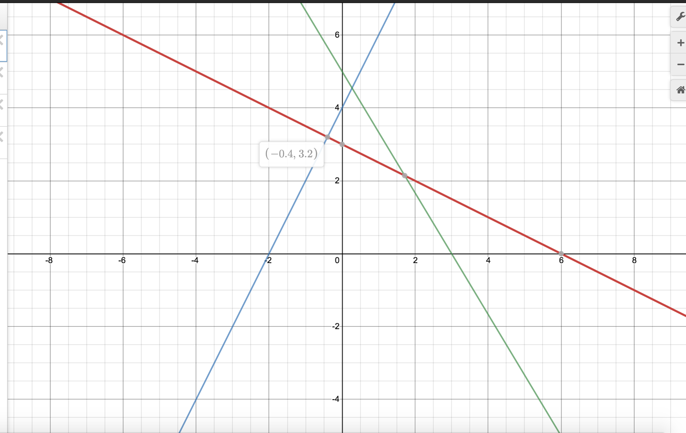

Maximum solution is at (1.714, 2.143) which evaluates to

A solution of 17.142.



**Extra Credit:**

To reform we instead the objective function to say

We introduce new variables to substitute in

Z1 …Zn, where n = 3

This makes our objective function

W = 2Z1 + Z2 + 3Z3  which we want to minimize

We then have to define what Z1…ZN stand for which is

Z1 >= Y1+ + Y1-

Z2 >= Y2+ + Y2-

Z3 >= Y3+ + Y3-

We then reconstruct the constraints:

Subject to

x1 +2x2 + x3 + Y1+ - Y1- =5,

-x1+8x2 -2x3 + Y2+ - Y2- =2,

-2x1 + x2 +4x3 + Y3+ -Y3-=8,

x1+3x2+ x3 =10,

x1, x2, x3 , Y1+ , Y1- , Y2+ , Y2- , Y3+ , Y3-≥ 0.