Supplementary Materials

Integrative Transcriptomic Analysis of Breast-derived (BsMC) vs. Foreskin-derived (FsMC) Mast Cells Across FANTOM5 and FANTOM6 CAGE-seq Platforms

Supplementary Tables

Table S1. Complete Sample Metadata (N=21 Biological Samples)
Complete metadata for all 21 biological samples included in the integrative analysis across FANTOM5 and FANTOM6 datasets. Technical replicates from FANTOM6 (2–3 per biological sample) were summed at the raw count level prior to normalization.
Sample ID | Donor | Tissue | State | Dataset | Original Tech Reps
BR1_aso_NC | BR1 | Foreskin | Native | FANTOM6 | 3
BR2_aso_NC | BR2 | Foreskin | Native | FANTOM6 | 3
BR5_aso_NC | BR5 | Breast | Native | FANTOM6 | 3
BR5_AER_aso_NC | BR5 | Breast | Stimulated | FANTOM6 | 3
BR6_aso_NC | BR6 | Foreskin | Native | FANTOM6 | 2
BR6_AER_aso_NC | BR6 | Foreskin | Stimulated | FANTOM6 | 2
BR7_aso_NC | BR7 | Foreskin | Native | FANTOM6 | 2
BR7_AER_aso_NC | BR7 | Foreskin | Stimulated | FANTOM6 | 2
BR8_aso_NC | BR8 | Breast | Native | FANTOM6 | 3
BR8_AER_aso_NC | BR8 | Breast | Stimulated | FANTOM6 | 3
BR9_aso_NC | BR9 | Foreskin | Native | FANTOM6 | 2
BR9_AER_aso_NC | BR9 | Foreskin | Stimulated | FANTOM6 | 2
Mast cell, donor 1 | F5_D1 | Breast | Native | FANTOM5 | 1
Mast cell – stimulated, donor 1 | F5_D1 | Breast | Stimulated | FANTOM5 | 1
Mast cell, donor 2 | F5_D2 | Breast | Native | FANTOM5 | 1
Mast cell, donor 3 | F5_D3 | Breast | Native | FANTOM5 | 1
Mast cell, donor 4 | F5_D4 | Breast | Native | FANTOM5 | 1
Mast cell, expanded, donor 5 | F5_D5 | Breast | Native | FANTOM5 | 1
Mast cell, expanded and stimulated, donor 5 | F5_D5 | Breast | Stimulated | FANTOM5 | 1
Mast cell, expanded, donor 8 | F5_D8 | Breast | Native | FANTOM5 | 1
Mast cell, expanded and stimulated, donor 8 | F5_D8 | Breast | Stimulated | FANTOM5 | 1

Table S2. Differentially Expressed Genes — Tissue Contrast (BsMC vs FsMC)
All 11 significant genes (Benjamini–Hochberg adjusted P < 0.05) from the tissue contrast (Breast vs Foreskin) using limma-voom with model ~ Tissue + State + Dataset and duplicateCorrelation(block=Donor). Positive log2FC indicates higher expression in Breast MCs; negative log2FC indicates higher expression in Foreskin MCs.
Rank | Gene Symbol | log2FC (BsMC / FsMC) | AveExpr | t-statistic | P-value | adj. P-value | Genomic Origin / Category
1 | RPS4Y1 | -9.61 | 1.61 | -16.03 | 1.07e-12 | 1.07e-08 | Y-chromosome
2 | EIF1AY | -8.22 | 0.85 | -13.53 | 2.65e-11 | 1.33e-07 | Y-chromosome
3 | TXLNGY | -7.42 | 0.57 | -13.06 | 4.88e-11 | 1.63e-07 | Y-chromosome
4 | DDX3Y | -7.72 | 0.91 | -11.66 | 3.32e-10 | 8.33e-07 | Y-chromosome
5 | KDM5D | -7.11 | 0.46 | -10.66 | 1.48e-09 | 2.97e-06 | Y-chromosome
6 | UTY | -5.94 | -0.03 | -10.32 | 2.50e-09 | 4.19e-06 | Y-chromosome
7 | TTTY14 | -5.28 | -0.17 | -10.16 | 3.24e-09 | 4.65e-06 | Y-chromosome
8 | ZFY | -5.24 | -0.05 | -8.76 | 3.88e-08 | 4.87e-05 | Y-chromosome
9 | PPIAP29 | -5.02 | -0.13 | -8.66 | 4.70e-08 | 5.25e-05 | Y-chromosome
10 | TPSD1 | -3.86 | 11.57 | -6.21 | 3.93e-06 | 3.95e-03 | Tissue-specific (Delta-tryptase)
11 | XIST | +4.41 | 3.30 | 5.56 | 1.83e-05 | 1.67e-02 | X-inactivation

Table S3. Canonical Mast Cell Markers — Conserved Across Tissues
Expression of canonical mast cell markers showing no significant tissue-dependent differences (adj.P > 0.05), confirming a conserved core mast cell identity.
Gene | Name / Product | Function | log2FC (BsMC / FsMC) | adj. P-value | Status
KIT | KIT Proto-Oncogene | SCF receptor | +0.04 | 1.00 | Conserved
CPA3 | Carboxypeptidase A3 | Secretory granule protease | +0.13 | 1.00 | Conserved
TPSAB1 | Tryptase Alpha/Beta 1 | Major MC tryptase | +0.61 | 1.00 | Conserved
TPSB2 | Tryptase Beta 2 | Major MC tryptase | -0.25 | 1.00 | Conserved
TPSG1 | Tryptase Gamma 1 | Membrane-bound tryptase | +0.63 | 1.00 | Conserved
FCER1A | Fc Epsilon Receptor Ia | High-affinity IgE receptor alpha | +0.48 | 1.00 | Conserved
FCER1G | Fc Epsilon Receptor Ig | High-affinity IgE receptor gamma | +0.51 | 1.00 | Conserved
HDC | Histidine Decarboxylase | Histamine synthesis | -0.24 | 1.00 | Conserved
CMA1 | Chymase 1 | Serine protease | -1.39 | 0.93 | Conserved

Table S4. Top Activation DE Genes (Stimulated vs Native)
Top 10 upregulated and top 10 downregulated genes upon IgE-mediated stimulation across N=21 samples (Total: 3,456 DE genes, adj.P < 0.05).

Top Upregulated Genes
Rank | Gene | log2FC | P-value | adj. P-value | Function
1 | CCL1 | +10.78 | 3.67e-13 | 3.69e-09 | T-cell chemoattractant
2 | AQP2 | +8.26 | 7.34e-13 | 3.69e-09 | Water channel
3 | XIRP1 | +10.06 | 3.64e-11 | 1.22e-07 | Actin-binding
4 | GBP2 | +4.61 | 9.99e-11 | 2.51e-07 | Guanylate-binding protein
5 | GZMB | +8.27 | 2.06e-10 | 4.15e-07 | Cytotoxic serine protease
6 | NRP2 | +2.31 | 2.07e-10 | 4.15e-07 | VEGF co-receptor
7 | IL3 | +8.59 | 4.12e-09 | 5.92e-06 | Interleukin-3
8 | CCL2 | +6.22 | 4.20e-09 | 6.03e-06 | Monocyte chemoattractant
9 | FASLG | +5.80 | 4.20e-09 | 6.03e-06 | Fas ligand
10 | CXCL8 | +5.50 | 5.26e-06 | 5.29e-03 | Neutrophil chemoattractant (IL-8)

Top Downregulated Genes
Rank | Gene | log2FC | P-value | adj. P-value | Function
1 | FLI1 | -1.59 | 2.23e-09 | 3.74e-06 | Transcription factor
2 | STX3 | -1.51 | 2.61e-09 | 3.74e-06 | Vesicle fusion syntaxin
3 | ARRB1 | -1.34 | 1.89e-08 | 2.11e-05 | Beta-arrestin 1
4 | RASSF1 | -1.81 | 2.50e-08 | 2.51e-05 | Tumor suppressor
5 | LAIR1 | -1.60 | 7.62e-08 | 6.38e-05 | Inhibitory immune receptor

Table S5. Tissue x State Interaction Analysis
No significant interaction genes were detected (0 genes with adj.P < 0.05), confirming that the IgE-mediated activation response is tissue-independent.
Gene | Interaction log2FC | adj. P-value | Interpretation
GZMB | -4.94 | 0.99 | Non-significant
TNFRSF4 | +3.53 | 0.99 | Non-significant
CCL1 | -3.58 | 0.99 | Non-significant
FASLG | -3.46 | 0.99 | Non-significant
TPSD1 | +0.32 | 0.99 | Non-significant
CXCL8 | -1.27 | 0.99 | Non-significant

Supplementary Figures

Figure S1. Batch-Corrected PCA Plot
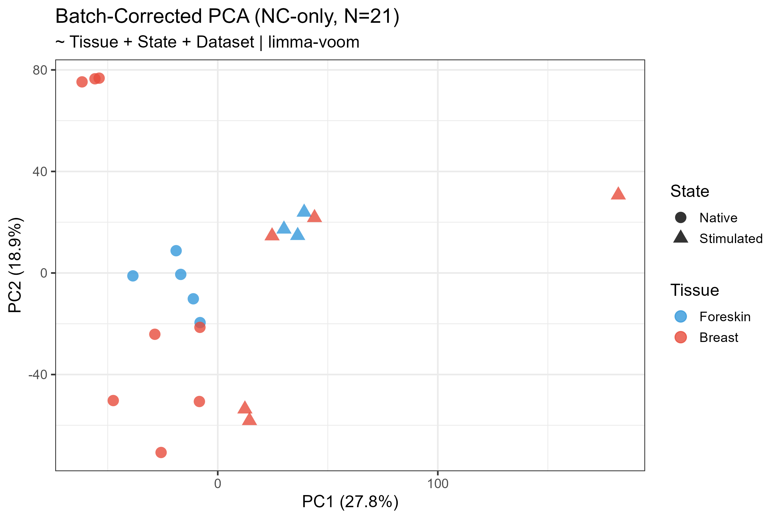
Batch-Corrected PCA

Figure S2. Volcano Plot — Tissue Contrast (BsMC vs FsMC)
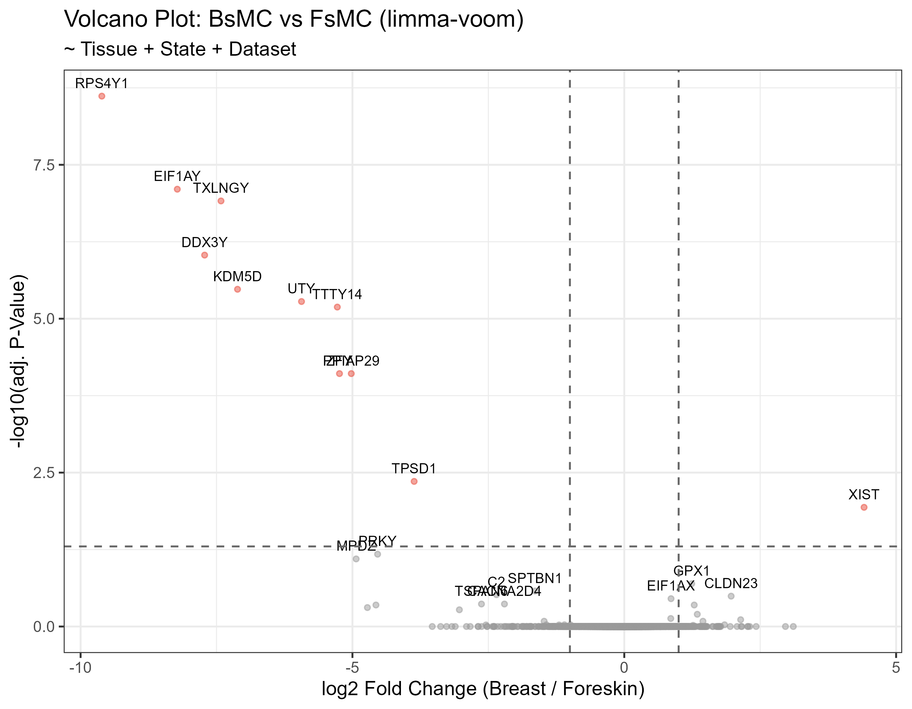
Volcano Plot

Figure S3. Expression of Key Mast Cell & Tissue Genes
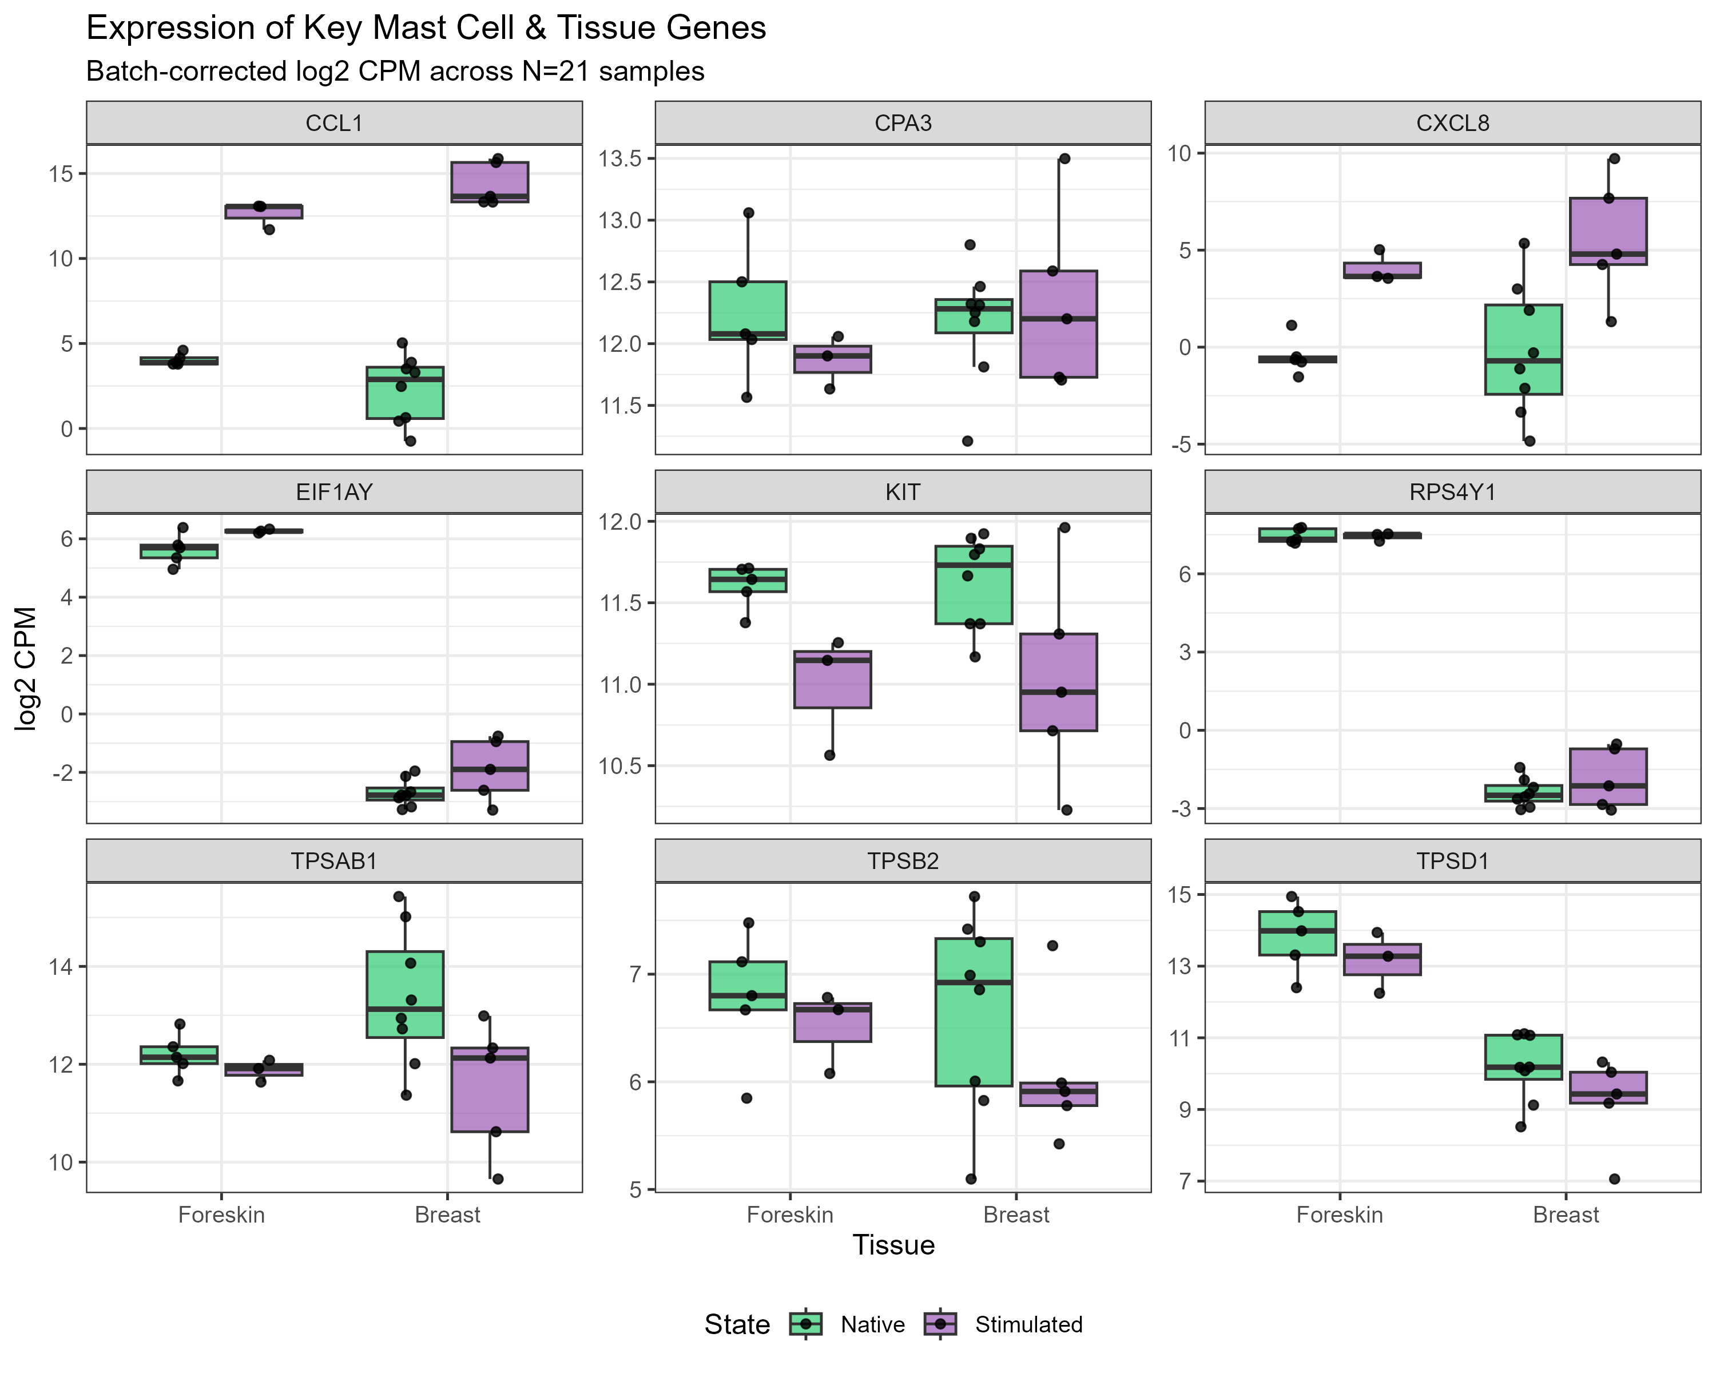
Key Genes Panel

Figure S4. Heatmap — Top 30 Tissue DE Genes
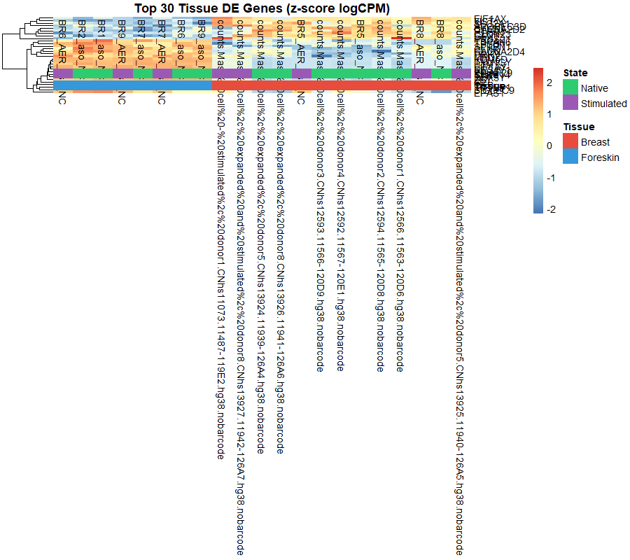
Heatmap Tissue

Figure S5. Heatmap — Top 40 Activation DE Genes
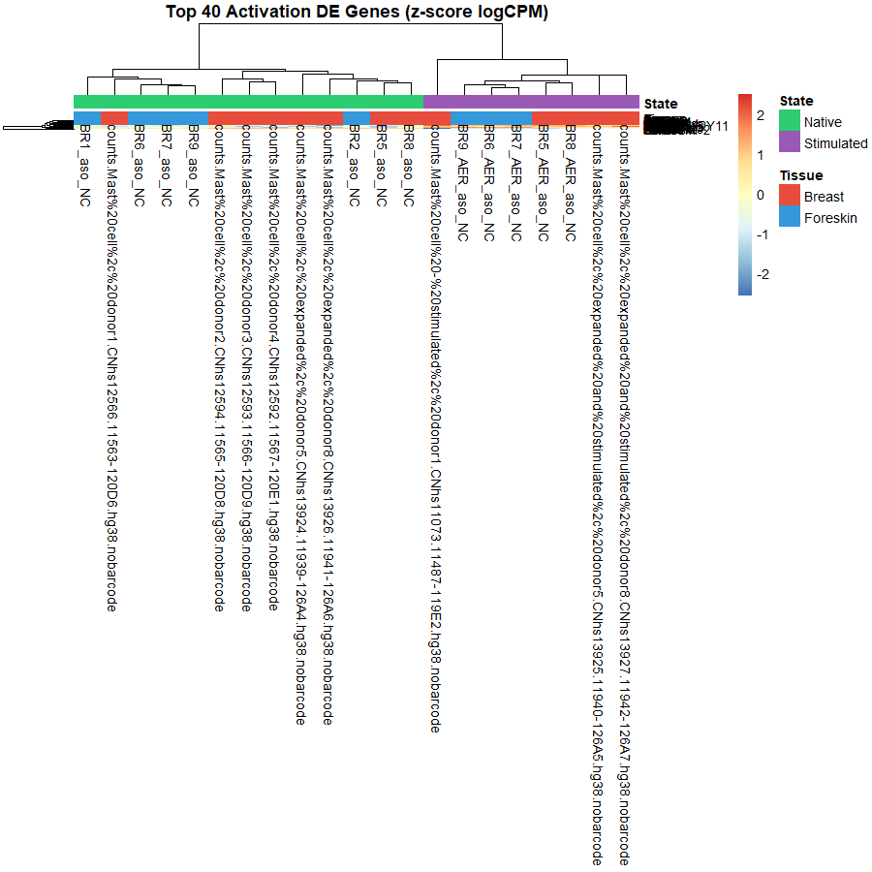
Heatmap Activation

Figure S6. Publication Concordance: Tissue Effect (Breast vs Foreskin)
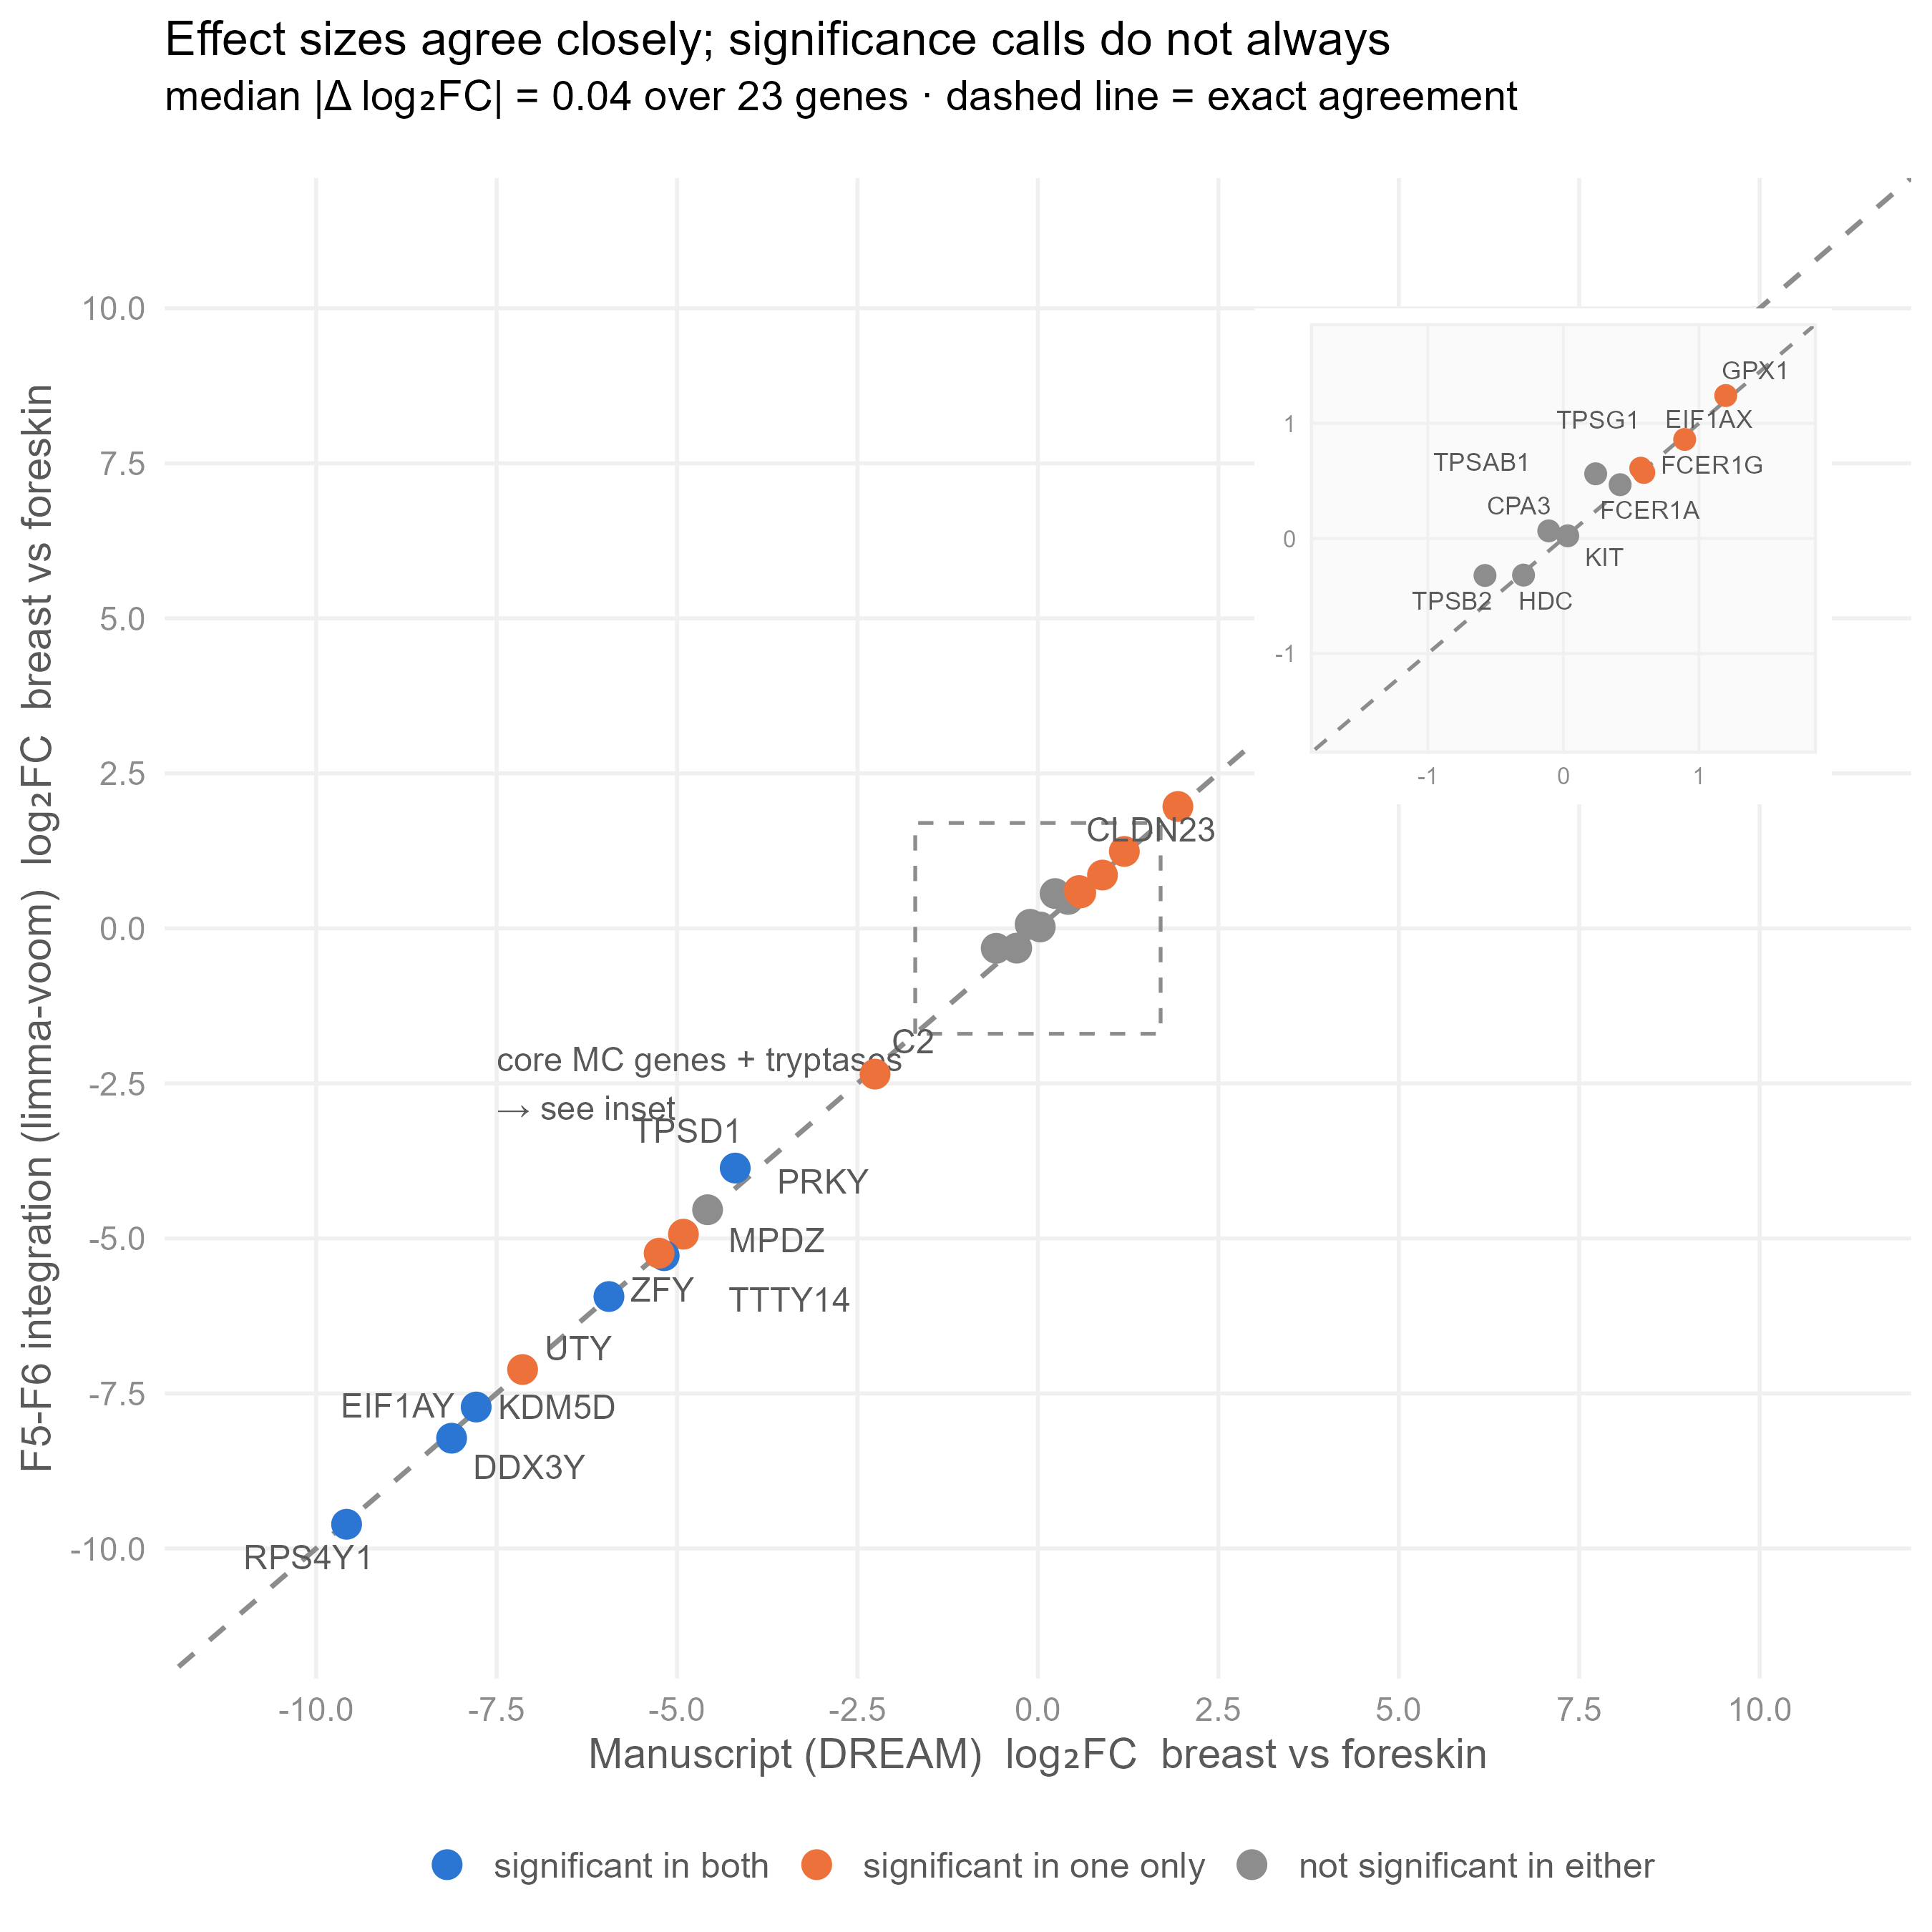
Tissue Concordance

Figure S7. Publication Concordance: State Effect (Stimulated vs Native)
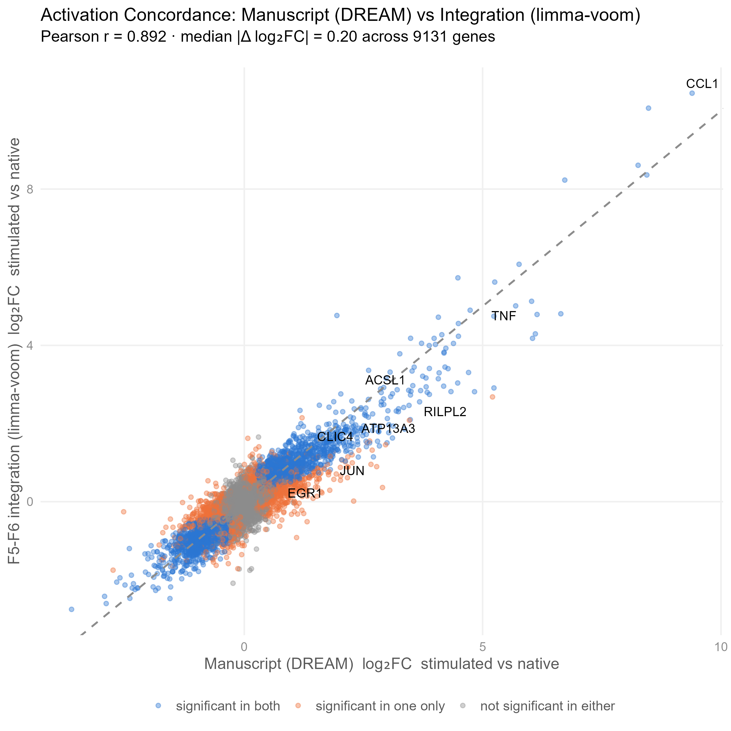
State Concordance

Supplementary Methods

Data Processing Pipeline & Statistical Rationale
- Count Matrix Construction: FANTOM6 CAT gene IDs were mapped to HGNC symbols. FANTOM6 technical replicates (2–3 per sample) were summed at raw count level. FANTOM5 hg38-remapped counts were merged by exact HGNC symbol (10,047 shared genes across N=21 samples).
- Filtering & Normalization: Lowly expressed genes were removed using edgeR::filterByExpr(). Count matrices were normalized via TMM (edgeR::calcNormFactors()) and transformed to logCPM using limma::voom().
- Linear Mixed Modeling: Model formula ~ Tissue + State + Dataset with limma::duplicateCorrelation(block=meta$Donor) to estimate intra-donor consensus correlation (r = 0.433).

