Garcon

Software Requirements

Specification

Ramazan Selim Şahin 2171999

Gürkan Kısaoğlu 2171726

# Table of Contents

**1.Introduction1**

1.1 Purpose of the System2

1.2 Scope2

1.3 System Overview2

1.3.1 System Perspective3

1.3.2 System Functions3

1.3.3 User Characteristics3

1.3.4 Limitations3

1.4 Definitions2

**2. References4**

**3. Specific Requirements4**

3.1 External Interfaces2

3.2 Functions2

3.3 Usability Requirements2

3.4 Performance Requirements2

3.5 Logical Database Requirements2

3.6 Design Constraints2

3.7 Software System Attributes2

3.8 Supporting Information2

# Table of Figures

Figure 1: Context Diagram.....................................................................................7

Figure 2: Use Case Diagram..................................................................................7

# Table of Tables

# Introduction

This document is Software Requirement Specification for Microsoft’s smart campus project, called Garcon.

## Purpose of the System

The purpose of the project is making METU campus smarter than ever. Making the campus an interactive environment for both students and workers. When there is a campus wide security issue, or environment issue students can immediately inform workers of campus with this system. Also, it enables students to get information about campus transportation and food possibilities.

## 1.2 Scope

## 1.3 System Overview

This section will give general information about the system.

### 1.3.1 System Perspective

General purpose of this system is making students life in campus much easier than before. System uses a card reader device for student id cards to authenticate students. Then, waits for the student to talk. When student talks, speech to text service analyses the speech and decides whether student opening an issue or asking for an information. After this stage, Garcon will do whatever students want automatically. If an issue opened , mailing service activated; or if an information asked, then Garcon will get the information to the student from various services.

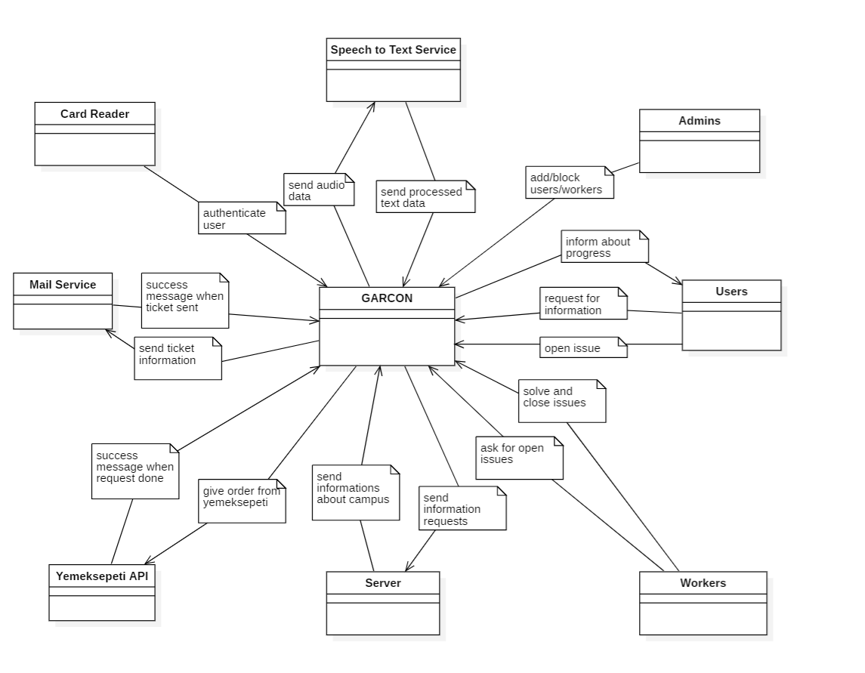

**Figure 1: Context Diagram**

### 1.3.2 System Functions

### 1.3.3 User Characteristics

### 1.3.4 Limitations

## 1.4 Definitions

# References

# Specific Requirements

## 3.1 External Interfaces

## 3.2 Functions

## 3.3 Usability Requirements

## 3.4 Performance Requirements

## 3.5 Logical Database Requirements

## 3.6 Design Constraints

## 3.7 Software System Attributes

## 3.8 Supporting Information