Name-Gurkirat Singh
Section-C
PSCP Assignment-4 (Section-C)
Due Date: 07/02/2021
Q1. A list of numbers 'L' is said to be strictly increasing if L[i] < L[i+1]; L is said to be
strictly decreasing if L[i] > L[i+1]. A list is called perfect if it is first strictly increasing,
then constant and finally strictly decreasing.
Write a C++ function that takes 20 non-negative integer array from the user as parameter
and check whether the list of numbers is perfect or not.

Ans.

#include <iostream>
using namespace std;

int check_perfection(int array[], int n);

int main(void){
int number = 20;
int array[number];
for(int i = 0; i<number; i++){
cin>>array[i];
}
if(check_perfection(array, number)==0){
cout<<"perfect list"<<endl;
}
else{
cout<<"it isn\'t a perfect list"<<endl;
}
}

int check_perfection(int array[], int n){
int check_perfection=0;
int maximum=array[0];
int position_of_maximum = 0;
for(int i=1; i < n; i++){
maximum = max(array[i], maximum);
if(array[i]==maximum){
position_of_maximum=i;
}
}
for(int i = position_of_maximum + 1; i<n-1; i++){
if(array[i]<=array[i+1]){
check_perfection++;
}
}
for(int i = 0; i<position_of_maximum; i++){
if(array[i] != maximum){
if(array[i] >= array[i+1]){
check_perfection++;
}
}
if(array[i] == maximum){
if(array[i] > array[i+1]){
check_perfection++;
}
else if(array[i] < array [i+1]){
check_perfection++;
}
}
}
return check_perfection;
}

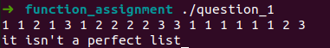

Q2. Write a C++ function which reads a sequence of positive integers till the user types −1. It
counts the lengths of the non-decreasing subsequences, and prints the maximum among
them. For example, for input {6, 7, 2, 29, 17, 5, 5, 11, 6, 7, 8, −1} the non-decreasing
subsequences are: {6, 7}, {2, 29}, {17}, {5, 5, 11} and {6, 7, 8}. Thus the answer should
be 3. Assume that the first integer read is not −1 and a single integer is a sequence of length
1.

Ans.

#include <iostream>
using namespace std;

bool num_1_greater_num_2(int number_1, int number_2);

int main(void){
int number_1 = 0;
int number_2 = 0;
cin>>number_1;
int counter = 0;
int max_counter = 0;
while(number_2 != -1){
cin>>number_2;
if(num_1_greater_num_2(number_1, number_2) == true){
counter++;
}
max_counter = max(counter, max_counter);
if(num_1_greater_num_2(number_1, number_2) == false){
counter = 0;
}
number_1 = number_2;

}
cout<<max_counter<<endl;
return 0;
}

bool num_1_greater_num_2(int number_1, int number_2){
if (number_1 >= number_2){
return true;
}
else{
return false;
}
}

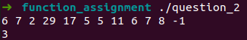

Q3. Write a C++ program to sort a given array of integer numbers and also provide a function
to search for a given element in that sorted array using binary search algorithm.

Ans.

#include <iostream>
using namespace std;

int binary_search(int start, int end, int array[], int num_to_find);

void sort_array(int array[], int length, int element_to_find);

int main(void){
int length;
cout<<"Enter length of array"<<endl;
cin>>length;
int array[length];
for(int i=0; i<length; i++){
cin>>array[i];
}
int element_to_find;
cout<<"which number you wanna find??"<<endl;
cin>>element_to_find;
sort_array(array, length, element_to_find);

}

int binary_search(int start, int end, int array[], int num_to_find){
while(start<=end){
int mid= (start+end)/2;

if(num_to_find==array[mid]){
return mid;
}
else if(num_to_find<array[mid]){
end=mid-1;
}
else if(num_to_find>array[mid]){
start=mid+1;
}
}
return -1;
}

void sort_array(int array[], int length, int element_to_find){
for(int i=0; i<length; i++){
for(int j=0; j<length; j++){
int temp;
if(i>j && array[i]<array[j]){
temp=array[i];
array[i]=array[j];
array[j]=temp;
}
}
}
if(binary_search(0, length-1, array, element_to_find) == -1){
cout<<"Element to find"<<endl;
}
else{
cout<<binary_search(0, length-1, array, element_to_find)<<endl;
}

}

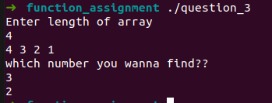

Q4.A way to calculate the value of π is based on the use of a series defines as follows (N-
number of terms). Write a function to find π value (up to n terms and display the result by

correcting it to three decimal places):

Ans.
#include <iostream>
using namespace std;

void pie_calcu(int n);

int main(void){
int n;
cin>>n;
pie_calcu(n);

}

void pie_calcu(int n){
double sum=0;
for(int i=0; i<=n; i++){
int multiplier;
if(i%2==0){
multiplier=1;
}
else{
multiplier=-1;
}
double denominator=2*double(i)+1;
double term=double(multiplier)*double(1)/denominator;

sum+=term;

}
printf("%.3f", 4*sum);

}

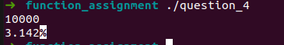

Q5. Given 3-angles as parameters, Write a function to check whether they form a triangle or
not (A+B+C =180). If yes check whether triangle is scalen, equilateral, isoceless or right
angled triangle.

Ans.

#include <iostream>
using namespace std;

void check(float angle_1, float angle_2, float angle_3);

int main(void){
float angle_1;
float angle_2;
float angle_3;
cout<<"Enter the three numbers as space separated integers"<<endl;
cin>>angle_1>>angle_2>>angle_3;
check(angle_1, angle_2, angle_3);

}

void check(float angle_1, float angle_2, float angle_3){
if(angle_1+angle_2+angle_3!=180){
cout<<"The angles given aren't of a triangle"<<endl;
}
else{
if(angle_1==angle_2 && angle_2==angle_3){
cout<<"Equilateral triangle"<<endl;
}
else if((angle_1==angle_2 && angle_2!=angle_3) || (angle_1==angle_3 && angle_3!=angle_2) || (angle_2==angle_3 && angle_3!=angle_1)){
cout<<"Isoceles triangle"<<endl;
}
else{
cout<<"Scalene triangle"<<endl;
}

if(angle_3==90 || angle_2==90 || angle_1==90){
cout<<"Right angled triangle"<<endl;
}

}

}

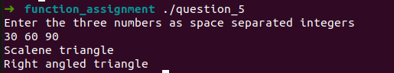

Q6.
A user enters integers until end of input and wants to find the largest number in the list of
integers entered and the number of times it was entered. For example, if the input is 5, 2,
15, 3, 7, 15, 8, 9, 5, 2, 15, 3, and 7, the largest is 15 and is repeated 3 times. Write a
program to compute frequency of the largest of the integers entered without storing them.
Write a function that displays the integers read and returns the largest number and its
frequency.

Ans.

#include <iostream>
using namespace std;

void MaxFinder(int array[], int length);
int MaxCount(int array[],int length);

int main(){
int array[100],length,i;
cout<<"Enter the number of values to be entered - ";
cin>>length;
for(i=0;i<length;i++){
cout<<"Enter Value of Array at position "<<i+1<<" - ";
cin>>array[i];
}
MaxFinder(array,length);
cout<<"Largest number is "<<array[0]<<" and it appears "<<MaxCount(array,length)<<" times.";
return 0;
}

void MaxFinder(int array[],int length){
for(int i=0;i<length-1;i++){
for(int j=0;j<length-i-1;j++){
if(array[j]<array[j+1]){
int temp = array[j];
array[j] = array[j+1];
array[j+1] = temp;
}
}
}
}

int MaxCount(int array[],int length){
int count = 1;
for(int i=1;i<length;i++){
if(array[0] == array[i]){
count++;
}
}
return count;
}
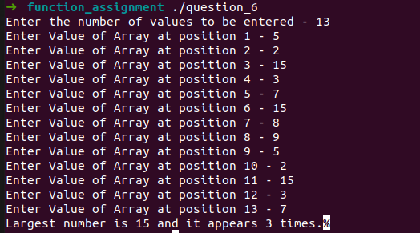

Q7.
Write a C++ function to receive values of latitude(L1,L2) and longitude (G1,G2), in
degrees, of two places on the earth and output the distance(D) between then in nautical
miles.

Ans.
#include <iostream>
#include <cmath>
using namespace std;

float distance(int l1, int l2, int g1, int g2);

int main(void){
int l1, l2, g1, g2;
cout<<"Latitude 1 and Latitude 2"<<endl;
cin>>l1>>l2;
cout<<"Longitude 1 and Longitude 2"<<endl;
cin>>g1>>g2;
cout<<"distance="<<distance(l1, l2, g1, g2)<<" Nautical Miles"<<endl;

}

float distance(int l1, int l2, int g1, int g2){
float dist=3963*acos(sin(l1) * sin(l2) + cos(l1) * cos(l2) * cos(g2 - g1));
return dist;
}

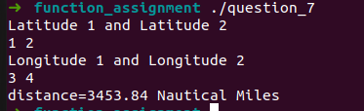

Q8. Write a program that contains function that accepts as argument an array A of integers
together with its size n and a non-negative integer k. The function should return another
array, allocated within the function, which is obtained by cyclically shifting the input
array A by k positions to the right. For example, upon the input of A = {2, 4, 6, 1, 3, 9,
5} of size n = 7 and k = 3, your function should return {3, 9, 5, 2, 4, 6, 1}.

Ans.

#include <iostream>
using namespace std;

void shiftinator(int a[],int n,int k);

int main(){
int a[100],n,k;
cout<<"Enter the Size of the Array - ";
cin>>n;
cout<<"Enter the value to be shifted to right by - ";
cin>>k;
for(int i=0;i<n;i++){
cout<<"Enter Value of Array at position "<<i+1<<" - ";
cin>>a[i];
}
shiftinator(a,n,k);
for(int i=0;i<n;i++){
cout<<"Val of shifted array is - "<<a[i]<<endl;
}
}

void shiftinator(int a[],int n,int k){
for(int i=0;i<k;i++){
int t = a[n-1];
for (int j=n-1;j>=1;j--){
a[j] = a[j-1];
}
a[0] = t ;
}

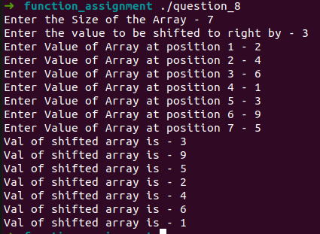

Q9.
Let A and B be two arrays. Write a function to create a new array C that contains elements
alternately from A and B beginning with the first element of A If you run out of elements
in one of the lists (arrays), then append the remaining elements of the other list (array) to
C and display C.

Ans.

#include <iostream>
using namespace std;

int element_picker(int array_1[], int array_2[], int number, int length_1, int length_2);

int main(void){
int length_1;
int length_2;
cout<<"Length of array 1"<<endl;
cin>>length_1;
cout<<"Length of array 2"<<endl;
cin>>length_2;
int array_1[length_1];
int array_2[length_2];
cout<<"Enter elements of array 1 as space separated integers"<<endl;
for(int i=0; i<length_1; i++){
cin>>array_1[i];
}
cout<<"Enter elements of array 2 as space separated integers"<<endl;
for(int i=0; i<length_2; i++){
cin>>array_2[i];
}
int result_array[length_1+length_2];
for(int i=0; i<length_1+length_2; i++){
result_array[i] = element_picker(array_1, array_2, i, length_1, length_2);
}
cout<<"resultant array is"<<endl;
for(int i=0; i<length_1+length_2; i++){
cout<<result_array[i]<<" ";
}
cout<<endl;
return 0;
}

int element_picker(int array_1[], int array_2[], int number, int length_1, int length_2){
if(length_1<=length_2){
if(number < 2*length_1){
if(number%2 == 0){
return array_1[number/2];
}
else{
return array_2[(number-1)/2];
}
}
else{
return array_2[(number-length_1)];
}
}
else{
if(number < 2*length_2){
if(number%2 == 0){
return array_1[number/2];
}
else{
return array_2[(number-1)/2];
}
}
else{
return array_1[(number-length_2)];
}
}
}

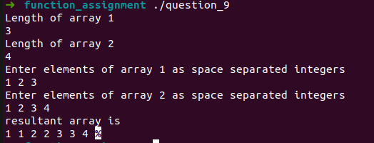

Q10.
Write a program that computes the area of an arbitrary triangle where a, b, and c are the
lengths of the sides. The program should call a function that takes three parameters (such
as, a, b and c) as inputs and returns the area of the triangle to the main () function. Note
that not all the combinations of a, b, and c produce a triangle. Your function (user defined)
should produce correct results for legal data and reasonable results for illegal combinations
of a, b and c.

Ans.

#include <iostream>
#include <cmath>
using namespace std;

float area(float a, float b, float c);

int main(void){
float a=0, b=0, c=0;
cin>>a>>b>>c;

if(area(a, b, c) == -1){
cout<<"Triangle not possible"<<endl;
}
else{
cout<<area(a, b, c)<<endl;
}
return 0;
}

float area(float a, float b, float c){
float s =(a+b+c)/2;
if(s-a<=0 || s-b<=0 || s-c<=0){
return -1;
}
float area = sqrt(s*(s-a)*(s-b)*(s-c));
return area;
}

