Practical Experiment Worksheet-5
SQL Table Management and Conditional Logic

1. Aim of the Experiment
To demonstrate the creation of a database table, insertion of records, and the use of the CASE expression with the modulo function in SQL to perform conditional analysis on salary values and determine whether the salary is even or odd.

2. Objectives of the Experiment
The objectives of this experiment are:
- To understand how to create and manage database tables using SQL.
- To learn how to remove existing tables using the DROP TABLE command.
- To practice inserting records into a table using INSERT statements.
- To understand the use of the MOD() function in SQL to find the remainder.
- To implement conditional logic using the CASE WHEN THEN ELSE expression.
- To retrieve and analyze data using SELECT queries.

3. Software / Tools Required
- Oracle Database / Oracle FreeSQL
- SQL Developer or SQL*Plus
- Computer system with database access

4. Theory
Structured Query Language (SQL) is used to manage and manipulate relational databases. SQL allows users to create database structures, insert records, retrieve information, and perform conditional operations on stored data.
In this experiment, a table named employee is created to store employee details such as employee ID, employee name, and salary.
Table Management
SQL provides Data Definition Language (DDL) commands to define database structures. Examples include:
- CREATE TABLE – Used to create a new table.
- DROP TABLE – Used to remove an existing table.
Data Manipulation
SQL also provides Data Manipulation Language (DML) commands to insert and manage data.
Example:
- INSERT INTO – Used to insert records into a table.
Data Querying
To retrieve data from the table, SQL uses Data Query Language (DQL).
Example:
- SELECT – Used to fetch data from a table.
MOD Function
The MOD() function in SQL calculates the remainder after division.
Syntax:
MOD(number, divisor)
Example:
MOD(10,2) = 0
MOD(15,2) = 1
If the remainder is 0, the number is even.
If the remainder is 1, the number is odd.
CASE Expression
The CASE expression is used to implement conditional logic in SQL queries.
Syntax:
CASE
WHEN condition THEN result
ELSE result
END
In this experiment, the CASE expression is used to classify salaries as:
- Even Salary
- Odd Salary

5. Procedure
Step 1
Start the computer system and open the SQL environment such as Oracle SQL Developer or Oracle FreeSQL.
Step 2
Open a new SQL Query Editor window to write and execute SQL commands.
Step 3
Remove any previously existing employee table using the DROP TABLE command to ensure a clean environment.
Step 4
Create a new table named employee with the following fields:
- emp_id (Primary Key)
- emp_name
- salary
Step 5
Insert records into the table using INSERT statements.
Step 6
Write a SELECT query to retrieve employee details along with the remainder obtained when salary is divided by 2.
Step 7
Use the CASE expression to classify salaries as Even Salary or Odd Salary.
Step 8
Execute the query and verify the output.
Step 9
Record the output and take a screenshot for documentation.

6. SQL Commands Used in the Experiment
Step 1: Drop Existing Table
BEGIN
EXECUTE IMMEDIATE 'DROP TABLE employee';
EXCEPTION
WHEN OTHERS THEN
IF SQLCODE != -942 THEN
RAISE;
END IF;
END;
/

Step 2: Create Employee Table
CREATE TABLE employee (
emp_id NUMBER PRIMARY KEY,
emp_name VARCHAR2(50),
salary NUMBER
);

Step 3: Insert Data into Table
INSERT INTO employee VALUES (101, 'Rahul', 50000);
INSERT INTO employee VALUES (102, 'Anita', 45001);
INSERT INTO employee VALUES (103, 'Vikram', 60000);
INSERT INTO employee VALUES (104, 'Priya', 55003);
INSERT INTO employee VALUES (105, 'Arjun', 70000);
INSERT INTO employee VALUES (106, 'Neha', 48007);
COMMIT;

Step 4: Query with Conditional Logic
SELECT
emp_id,
emp_name,
salary,
MOD(salary,2) AS remainder,
CASE
WHEN MOD(salary,2)=0 THEN 'Even Salary'
ELSE 'Odd Salary'
END AS salary_type
FROM employee;

7. Output
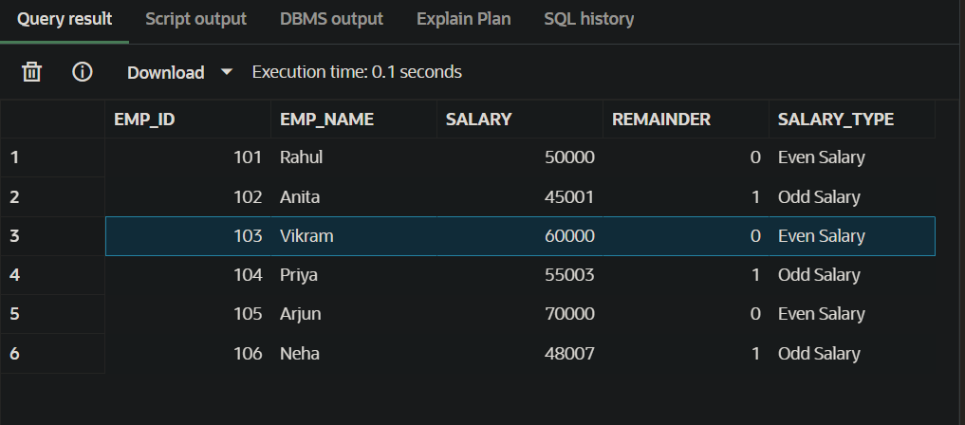

8. Observations
- The table was successfully created using the CREATE TABLE command.
- Six records were inserted into the employee table.
- The MOD function correctly calculated the remainder of salary divided by 2.
- The CASE expression successfully categorized salaries into Even Salary and Odd Salary.
- The SELECT query retrieved the desired output with a new calculated column.

9. Result
The experiment was successfully performed.
The employee table was created, records were inserted, and SQL conditional logic using MOD() and CASE expressions was applied to classify salaries as Even or Odd.

