🧪 PRACTICAL WORKSHEET – EXPERIMENT
Experiment Title
Design and Implementation of Stored Procedures Using IN, OUT, and INOUT Parameters in PL/SQL

1. Aim of the Session
The aim of this practical session is to design, implement, and execute a parameterized stored procedure in PL/SQL that processes employee data using different parameter modes (IN, OUT, and INOUT). The experiment focuses on understanding how business logic can be encapsulated within the database to achieve modular, efficient, and reusable program design.

2. Objective of the Session
After completing this practical, the learner will be able to:
- Understand the concept and importance of stored procedures in database systems
- Differentiate between IN, OUT, and INOUT parameter modes in PL/SQL
- Implement parameterized stored procedures for real-world data processing
- Perform calculations (such as bonus computation) within PL/SQL blocks
- Update and manipulate database records using procedural logic
- Execute stored procedures using anonymous PL/SQL blocks
- Apply exception handling techniques to manage runtime errors
- Develop modular and reusable database programs

3. Practical / Experiment Steps
- Design and create an Employee table with attributes such as EmpID, EmpName, Salary, and DeptID.
- Insert sample employee records into the table for testing purposes.
- Define a stored procedure (ProcessEmployee) with the following parameters:
  - IN parameter for employee ID
  - OUT parameter for bonus
  - INOUT parameter for salary
  - OUT parameter for execution status
- Retrieve the employee’s salary from the database using the input parameter.
- Calculate the bonus as a percentage of the salary.
- Update the salary by adding the calculated bonus.
- Store the updated salary back into the table.
- Return the calculated values and execution status through output parameters.
- Execute the procedure using an anonymous PL/SQL block.
- Display the output using DBMS_OUTPUT.PUT_LINE.

4. Procedure of the Practical
(i) Start the system and log in with valid credentials.
(ii) Open Oracle Live SQL / SQL*Plus / SQL Developer environment.
(iii) Check if the Employee table already exists and drop it if necessary to avoid conflicts.
(iv) Create the Employee table using appropriate SQL DDL commands.
(v) Insert sample data into the table using INSERT statements.
(vi) Write and compile the stored procedure using PL/SQL syntax.
(vii) Ensure correct usage of IN, OUT, and INOUT parameters within the procedure.
(viii) Include exception handling mechanisms such as NO_DATA_FOUND and OTHERS.
(ix) Execute the stored procedure using an anonymous PL/SQL block.
(x) Enable server output to display results using DBMS_OUTPUT.
(xi) Observe and verify the output for correctness.
(xii) Save the code and capture screenshots of execution and results for documentation.

5. I/O Analysis (Input / Output Analysis)
Input
- SQL commands for creating the Employee table
- INSERT statements to populate employee data
- PL/SQL code defining the stored procedure
- Anonymous PL/SQL block for procedure execution
- Input parameter: Employee ID
Output
- Calculated bonus (10% of salary)
- Updated salary after bonus addition
- Execution status message indicating success or failure
- Updated record in the Employee table
(Screenshots showing successful execution and output should be attached.)
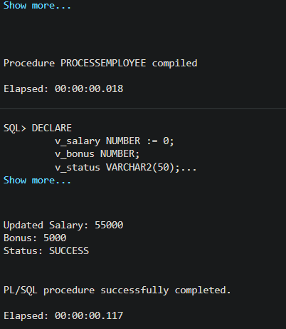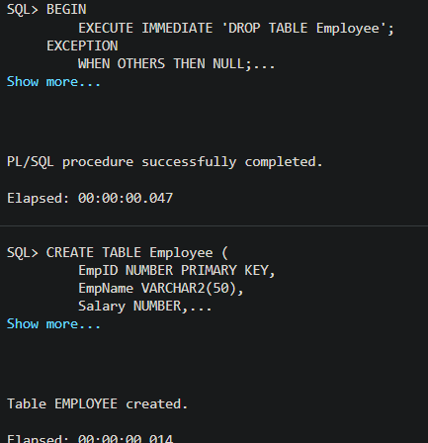

6. Learning Outcome
From this practical session, the student gained:
- A clear understanding of how stored procedures are used in database systems
- Practical knowledge of parameter passing techniques (IN, OUT, INOUT)
- Experience in implementing business logic within the database layer
- Understanding of how to perform data retrieval, computation, and updates using PL/SQL
- Knowledge of exception handling for robust and error-free execution
- Insight into modular programming and code reusability in DBMS
- Hands-on experience with executing PL/SQL blocks and interpreting output

