Practical Experiment Worksheet–6
Understanding and Implementing Cursors in PL/SQL

1. Aim of the Experiment
To understand the concept and working of implicit and explicit cursors in PL/SQL for row-by-row data processing, and to apply business logic using cursor attributes.

2. Objectives of the Experiment
The objectives of this experiment are:
- To understand the concept of cursors in PL/SQL.
- To differentiate between implicit and explicit cursors.
- To learn how to process multiple rows using explicit cursors.
- To use cursor attributes such as %FOUND, %NOTFOUND, %ROWCOUNT, and %ISOPEN.
- To implement business logic on database records using cursors.
- To analyze row-by-row data processing in real-world scenarios.

3. Software / Tools Required
- Oracle Database Express Edition (Oracle XE)
- Oracle SQL Developer / SQL*Plus
- Computer system with database access

4. Theory
🔹 PL/SQL and Cursors
PL/SQL is Oracle’s procedural extension of SQL that allows developers to write programs with loops, conditions, and logic.
When a SQL query returns multiple rows, PL/SQL uses cursors to process each row individually.

🔹 Types of Cursors
1. Implicit Cursor
- Automatically created by Oracle
- Used for single-row operations (INSERT, UPDATE, DELETE)
- No declaration required
Example:
- UPDATE statement

2. Explicit Cursor
- Defined by the programmer
- Used when query returns multiple rows
- Requires:
  - Declaration
  - Opening
  - Fetching
  - Closing

🔹 Cursor Attributes
Attribute | Description
%FOUND | TRUE if row is fetched
%NOTFOUND | TRUE if no row is fetched
%ROWCOUNT | Number of rows processed
%ISOPEN | Checks if cursor is open

🔹 Need of Cursors
- Required when row-by-row processing is needed
- Used in business logic like:
  - Salary updates
  - Bonus calculation
  - Record-wise validation

5. Procedure
Step 1
Start the system and open Oracle SQL Developer.
Step 2
Open a new SQL Worksheet.
Step 3
Drop existing table (if exists).
Step 4
Create Employee table.
Step 5
Insert records into table.
Step 6
Execute implicit cursor program.
Step 7
Execute explicit cursor program.
Step 8
Apply business logic using cursor.
Step 9
Use cursor attributes and observe output.

6. SQL / PL-SQL Commands Used

Step 1: Drop Table
BEGIN
EXECUTE IMMEDIATE 'DROP TABLE Employee';
EXCEPTION
WHEN OTHERS THEN NULL;
END;
/

Step 2: Create Table
CREATE TABLE Employee (
EmpID NUMBER PRIMARY KEY,
EmpName VARCHAR2(50),
Salary NUMBER,
DeptID NUMBER
);

Step 3: Insert Data
INSERT INTO Employee VALUES (1, 'Aman', 30000, 10);
INSERT INTO Employee VALUES (2, 'Riya', 40000, 20);
INSERT INTO Employee VALUES (3, 'Karan', 50000, 10);
INSERT INTO Employee VALUES (4, 'Neha', 35000, 30);
COMMIT;

Step 4: Implicit Cursor Example
BEGIN
UPDATE Employee
SET Salary = Salary * 1.10
WHERE DeptID = 10;
IF SQL%FOUND THEN
DBMS_OUTPUT.PUT_LINE('Rows Updated: ' || SQL%ROWCOUNT);
ELSE
DBMS_OUTPUT.PUT_LINE('No rows updated');
END IF;
END;
/

Step 5: Explicit Cursor Example
DECLARE
CURSOR emp_cursor IS
SELECT EmpID, EmpName, Salary FROM Employee;
v_id Employee.EmpID%TYPE;
v_name Employee.EmpName%TYPE;
v_salary Employee.Salary%TYPE;
BEGIN
OPEN emp_cursor;
LOOP
FETCH emp_cursor INTO v_id, v_name, v_salary;
EXIT WHEN emp_cursor%NOTFOUND;
DBMS_OUTPUT.PUT_LINE('ID: ' || v_id ||
' Name: ' || v_name ||
' Salary: ' || v_salary);
END LOOP;
CLOSE emp_cursor;
END;
/

Step 6: Cursor with Business Logic
DECLARE
CURSOR emp_cursor IS
SELECT EmpID, Salary FROM Employee;
v_id Employee.EmpID%TYPE;
v_salary Employee.Salary%TYPE;
BEGIN
OPEN emp_cursor;
LOOP
FETCH emp_cursor INTO v_id, v_salary;
EXIT WHEN emp_cursor%NOTFOUND;
IF v_salary < 40000 THEN
UPDATE Employee
SET Salary = Salary + 5000
WHERE EmpID = v_id;
DBMS_OUTPUT.PUT_LINE('Bonus added to EmpID: ' || v_id);
END IF;
END LOOP;
CLOSE emp_cursor;
END;
/

Step 7: Cursor Attribute Example
DECLARE
CURSOR emp_cursor IS SELECT * FROM Employee;
BEGIN
OPEN emp_cursor;
IF emp_cursor%ISOPEN THEN
DBMS_OUTPUT.PUT_LINE('Cursor is open');
END IF;
CLOSE emp_cursor;
END;
/

7. Output
Expected output includes:
- Rows Updated: 2
- Employee details displayed row by row
- Bonus added messages
- Cursor open confirmation
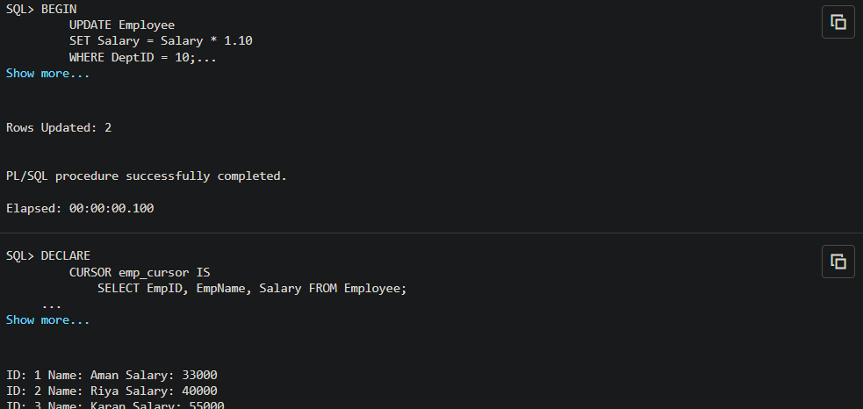
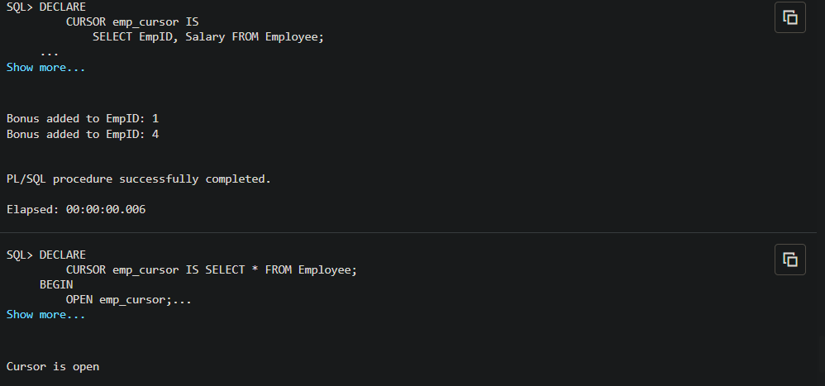

8. Observations
- The Employee table was successfully created.
- Records were inserted correctly.
- Implicit cursor updated multiple rows efficiently.
- Explicit cursor processed rows one by one.
- Cursor attributes controlled execution flow effectively.
- Business logic was applied successfully using cursors.

9. Result
The experiment was successfully performed.
Cursors were implemented to process multiple rows, and PL/SQL programs were used to apply business logic using implicit and explicit cursors.

