🧪 PRACTICAL WORKSHEET – EXPERIMENT
Experiment Title
Design and Implementation of Trigger for Automatic Salary Calculation and Validation in PL/SQL

1. Aim of the Session
The aim of this practical session is to design, implement, and execute a database trigger in Oracle PL/SQL that automatically calculates the total payable amount of an employee based on working hours and per-hour salary. The experiment also focuses on enforcing business rules by restricting the insertion of records where the calculated amount exceeds a predefined limit.

2. Objective of the Session
After completing this practical, the learner will be able to:
- Understand the concept and importance of triggers in database systems
- Differentiate between BEFORE and AFTER triggers
- Implement a BEFORE INSERT trigger in PL/SQL
- Perform automatic calculations using trigger logic
- Enforce constraints at the database level
- Handle exceptions using PL/SQL mechanisms
- Prevent invalid data insertion using business rules
- Develop efficient and automated database solutions

3. Practical / Experiment Steps
- Design and create an Employee table with attributes such as EmpID, EmpName, WorkingHours, PerHourSalary, and TotalPayableAmount.
- Insert sample employee records for testing.
- Define a trigger (cal_payable_amount) that executes before inserting records.
- Calculate the total payable amount using:
  - Working Hours × Per Hour Salary
- Store the calculated value in the column total_payable_amount.
- Apply a condition to check if the amount exceeds 25000.
- Raise an error using RAISE_APPLICATION_ERROR if the condition is violated.
- Execute insert statements using anonymous PL/SQL blocks.
- Handle exceptions using WHEN OTHERS.
- Display output using DBMS_OUTPUT.PUT_LINE.
- Verify results by selecting records from the table.
- Capture screenshots of execution and output for documentation.

4. Procedure of the Practical
(i) Start the system and log in with valid credentials.
(ii) Open Oracle Live SQL / SQL*Plus / SQL Developer.
(iii) Drop the Employee table if it already exists.
(iv) Create the Employee table using SQL commands.
(v) Write and compile the trigger using PL/SQL.
(vi) Ensure correct usage of :NEW keyword in trigger.
(vii) Implement logic for automatic calculation.
(viii) Add validation logic using conditional statements.
(ix) Use RAISE_APPLICATION_ERROR for constraint enforcement.
(x) Enable server output using SET SERVEROUTPUT ON.
(xi) Execute insert statements using anonymous blocks.
(xii) Observe results and verify correctness.
(xiii) Save the code and capture screenshots.

5. I/O Analysis (Input / Output Analysis)
Input
- SQL commands for creating the Employee table
- Trigger definition using PL/SQL
- INSERT statements for employee data
- Anonymous PL/SQL blocks for execution
- Input values: emp_id, emp_name, working_hours, perhour_salary
Output
- Automatically calculated total_payable_amount
- Successful insertion when amount ≤ 25000
- Error message when amount > 25000
- Display of records from Employee table
(Screenshots of execution and results are attached separately.)
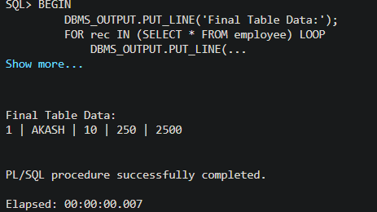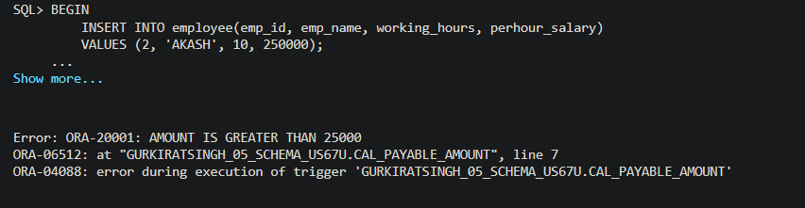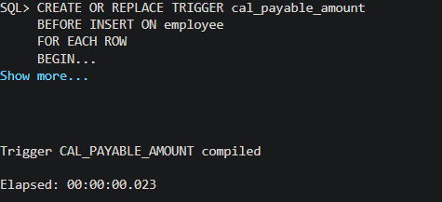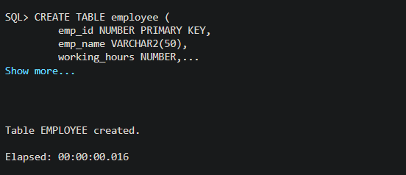

6. Learning Outcome
From this practical session, the student gained:
- Understanding of trigger-based automation in databases
- Knowledge of BEFORE INSERT trigger implementation
- Ability to enforce business rules at the database level
- Experience with PL/SQL programming and syntax
- Understanding of exception handling using RAISE_APPLICATION_ERROR
- Skills in preventing invalid data insertion
- Insight into improving data integrity and consistency
- Hands-on experience with real-time database operations

