Experiment 3: Basic Structure of PL/SQL Block

1. Aim of the Session
The aim of this practical is to design and implement a simple PL/SQL program that demonstrates the basic structure of a PL/SQL block. The program includes a declaration section to define variables and an execution section to perform operations using those variables and display the results.
Purpose of the Practical:
- To understand the structure of a PL/SQL block
- To learn how to declare variables in PL/SQL
- To perform arithmetic operations using PL/SQL
- To display output using built-in PL/SQL output statements

2. Objective of the Session
The specific objectives of this experiment are:
- Understand the components of a PL/SQL block
- Learn the use of DECLARE, BEGIN, and END sections
- Define and use variables in PL/SQL
- Perform simple arithmetic operations
- Display results using DBMS_OUTPUT.PUT_LINE
Upon completion, students will be able to:
- Write basic PL/SQL programs
- Use variables and assignments correctly
- Execute PL/SQL blocks in Oracle environment
- Display output from PL/SQL programs

3. Practical / Experiment Description
This experiment demonstrates the basic structure of a PL/SQL block, which consists of:
- Declaration Section – Used to declare variables
- Execution Section – Used to write executable statements
- Output Statements – Used to display results
The program calculates the sum of two numbers and displays the input values and the result.

4. Procedure of the Practical
Follow the steps given below to execute the experiment:
(i) Start the System and Open DBMS
- Power on the system
- Open Oracle SQL Plus / SQL Developer
- Connect using valid database credentials

(ii) Enable Output Display
SET SERVEROUTPUT ON;
This command enables output display for PL/SQL programs.

(iii) Write the PL/SQL Program
DECLARE
num1 NUMBER := 10;
num2 NUMBER := 20;
sum_result NUMBER;
BEGIN
sum_result := num1 + num2;

DBMS_OUTPUT.PUT_LINE('Number 1: ' || num1);
DBMS_OUTPUT.PUT_LINE('Number 2: ' || num2);
DBMS_OUTPUT.PUT_LINE('Sum: ' || sum_result);
END;
/

(iv) Execute the Program
- Run the program using /
- Observe the output in the output window

(v) Verify the Result
- Ensure that the values of both numbers and their sum are displayed correctly

5. Input / Output Analysis
Inputs Provided:
- num1 = 10
- num2 = 20
Operations Performed:
- Addition of two numbers using PL/SQL
Output Generated:
Number 1: 10
Number 2: 20
Sum: 30

SCREENSHOTS OF THE OUTPUT ARE BELOW:
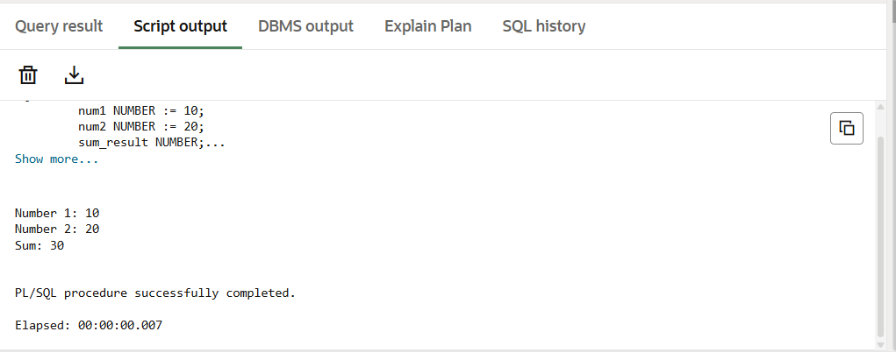

6. Learning Outcomes
Concepts Understood:
- Structure of PL/SQL block
- Variable declaration in PL/SQL
- Execution flow of PL/SQL programs
- Output handling using DBMS_OUTPUT
Skills Developed:
- Writing basic PL/SQL programs
- Performing arithmetic operations in PL/SQL
- Using Oracle built-in packages
- Debugging simple PL/SQL errors
Practical Exposure Gained:
- Hands-on experience with PL/SQL syntax
- Understanding procedural extensions of SQL
- Executing PL/SQL blocks in Oracle environment

7. Result
Thus, a simple PL/SQL program demonstrating the basic structure of a PL/SQL block was successfully designed, executed, and the output was displayed.

