PRACTICAL WORKSHEET - EXPERIMENT
______________________________________
Experiment Title
Database Trigger for Automatic Primary Key Functionality
______________________________________
1. Aim of the Session
The aim of this practical session is to design, implement, and execute a database trigger that automatically generates or enforces primary key values during record insertion, ensuring unique identification of records without manual intervention.
______________________________________
2. Software Requirements
Database Management System:
- Oracle Database Express Edition (Oracle XE) / PostgreSQL
Database Administration Tool:
- Oracle SQL Developer / pgAdmin
______________________________________
3. Objective of the Session
After completing this practical, the learner will be able to:
- Understand the concept and working of database triggers
- Understand how triggers support automated primary key generation
- Design a BEFORE INSERT trigger for enterprise database applications
- Use sequence-based logic to generate unique record identifiers
- Maintain data integrity without manual key assignment
- Apply trigger-based automation in real-world database systems
______________________________________
4. Problem Statement
In enterprise applications, every record must be uniquely identifiable. Manual assignment of primary key values can result in duplication, missing values, and data inconsistency.
Design and implement a database trigger that:
Automatically generates or enforces a primary key value during record insertion
- Uses trigger-based logic similar to a stored procedure
Demonstrates automated primary key functionality for a table
(Industry relevance: Amazon, Flipkart, Oracle)
______________________________________
5. Practical / Experiment Steps
- Create a table requiring automated primary key assignment.
- Create a sequence object for generating unique numeric values.
- Create a BEFORE INSERT trigger for the table.
- Check whether the primary key value is NULL before insertion.
- Assign the next sequence value automatically inside the trigger.
- Insert multiple sample records without manually entering primary key values.
- Commit the transaction.
- Query the table to verify correct key generation.
- Observe whether each record receives a unique identifier.
- Capture output and results for documentation.
______________________________________
6. Procedure of the Practical
(i) Start the system and log in with valid credentials.
(ii) Open Oracle SQL*Plus / SQL Developer or pgAdmin.
(iii) Enable output using SET SERVEROUTPUT ON where applicable.
(iv) Drop existing trigger, sequence, and table if already present.
(v) Create the customers_trigger_demo table using SQL commands.
(vi) Create the seq_customers_pk sequence.
(vii) Write the BEFORE INSERT trigger definition.
(viii) Compile the trigger successfully.
(ix) Insert sample records without providing customer_id manually.
(x) Commit the inserted data.
(xi) Query the table to display generated primary key values.
(xii) Verify that every inserted row has a unique customer_id.
(xiii) Observe output and validate correctness.
(xiv) Save code and capture screenshots.
______________________________________
7. I/O Analysis (Input / Output Analysis)
Input
- SQL commands for creating the customers_trigger_demo table
- Sequence creation statement
- Trigger definition for automatic primary key assignment
- Insert statements for sample customer data
- SELECT query for output verification

Output
- Successful creation of table, sequence, and trigger
- Automatic assignment of customer_id values during insertion
- Display of inserted records with unique primary key values
- Proper execution messages from SQL / PL/SQL
- Validated output showing no duplicate or missing primary key values
(Screenshots of execution and results are attached separately.)
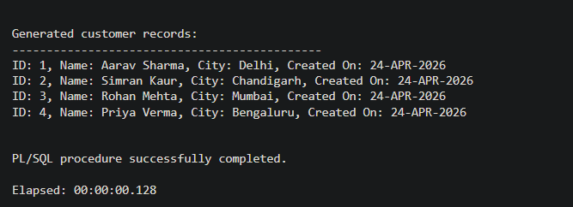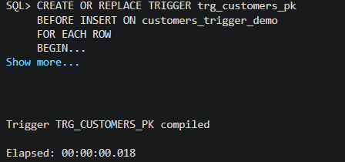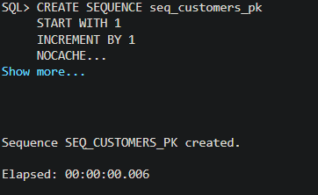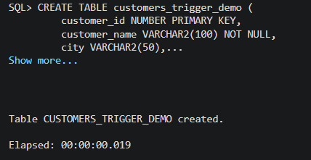

______________________________________
8. Learning Outcome
From this practical session, the student gained:
- Understanding of database trigger structure and execution flow
- Knowledge of automated primary key generation techniques
- Ability to use sequences with triggers for data integrity
- Experience with BEFORE INSERT trigger design
- Skills in reducing manual errors in enterprise databases
- Understanding of how trigger automation supports scalable backend systems
- Hands-on experience with Oracle / PostgreSQL database programming
- Insight into real-world enterprise applications using automated database logic
______________________________________
9. Conclusion
The database trigger was successfully created and executed to automate primary key functionality during record insertion. The experiment demonstrated trigger-based automation, unique key generation, and reliable data integrity, which are essential for enterprise-level database applications.
______________________________________

