Name- Gurkirat Singh Bhangoo
UID-24bai70370
LABMST
Q1
SOL-
CREATE TABLE department (
dept_id INT PRIMARY KEY,
dept_name VARCHAR(30)
);
CREATE TABLE employee (
emp_id INT PRIMARY KEY,
emp_name VARCHAR(50),
salary NUMERIC(10,2),
dept_id INT REFERENCES department(dept_id)
);
INSERT INTO department VALUES
(1, 'IT'),
(2, 'Sales'),
(3, 'HR');
INSERT INTO employee VALUES
(101, 'Aman', 90000, 1),
(102, 'Neha', 70000, 1),
(103, 'Raj', 50000, 1),
(104, 'Priya', 80000, 2),
(105, 'Karan', 60000, 2),
(106, 'Riya', 40000, 2),
(107, 'Mohit', 75000, 3),
(108, 'Simran', 55000, 3);

SELECT d.dept_name, e.emp_name, e.salary
FROM employee e
JOIN department d
ON e.dept_id = d.dept_id
WHERE e.salary > (
SELECT AVG(e2.salary)
FROM employee e2
WHERE e2.dept_id = e.dept_id
)
AND e.dept_id IN (
SELECT dept_id
FROM employee
GROUP BY dept_id
HAVING COUNT(*) >= 3
);
OUTPUT:
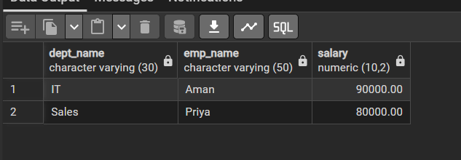

Q2.
CREATE TABLE bank_customer (
customer_id INT PRIMARY KEY,
customer_name VARCHAR(50),
balance NUMERIC(10,2)
);
CREATE TABLE customer_audit (
audit_id SERIAL PRIMARY KEY,
customer_id INT,
customer_name VARCHAR(50),
action VARCHAR(20),
action_time TIMESTAMP
);
INSERT INTO bank_customer VALUES
(1, 'Rahul', 50000),
(2, 'Neha', 75000);
CREATE OR REPLACE FUNCTION customer_audit_function()
RETURNS TRIGGER
LANGUAGE plpgsql
AS $$
BEGIN
IF TG_OP = 'INSERT' THEN
INSERT INTO customer_audit
(customer_id, customer_name, action, action_time)
VALUES
(NEW.customer_id, NEW.customer_name, 'ADDED', CURRENT_TIMESTAMP);
RETURN NEW;
ELSIF TG_OP = 'DELETE' THEN
INSERT INTO customer_audit
(customer_id, customer_name, action, action_time)
VALUES
(OLD.customer_id, OLD.customer_name, 'REMOVED', CURRENT_TIMESTAMP);
RETURN OLD;
END IF;
END;
$$;
CREATE TRIGGER customer_audit_trigger
AFTER INSERT OR DELETE
ON bank_customer
FOR EACH ROW
EXECUTE FUNCTION customer_audit_function();
INSERT INTO bank_customer
VALUES (3, 'Aman', 60000);
DELETE FROM bank_customer
WHERE customer_id = 1;
SELECT * FROM bank_customer;
SELECT * FROM customer_audit;
OUTPUT:
