Airline Passenger Communication — Prompting Strategy Lab
Student name: Gurlal Singh Khangura
Roll number: 2620996570
Programme / Section: BBA Aviation Management
Date: 08/10/2026
AI tool used: Chatgpt

Round 1 — Zero-Shot Prompting
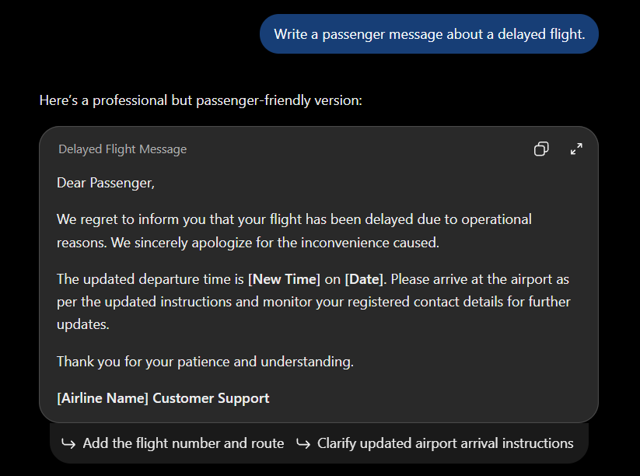
Observation: The initial response was a general passenger delay message. It still needed specific flight information and delay details before it could be used.

Round 2 — Context and Constraints Round
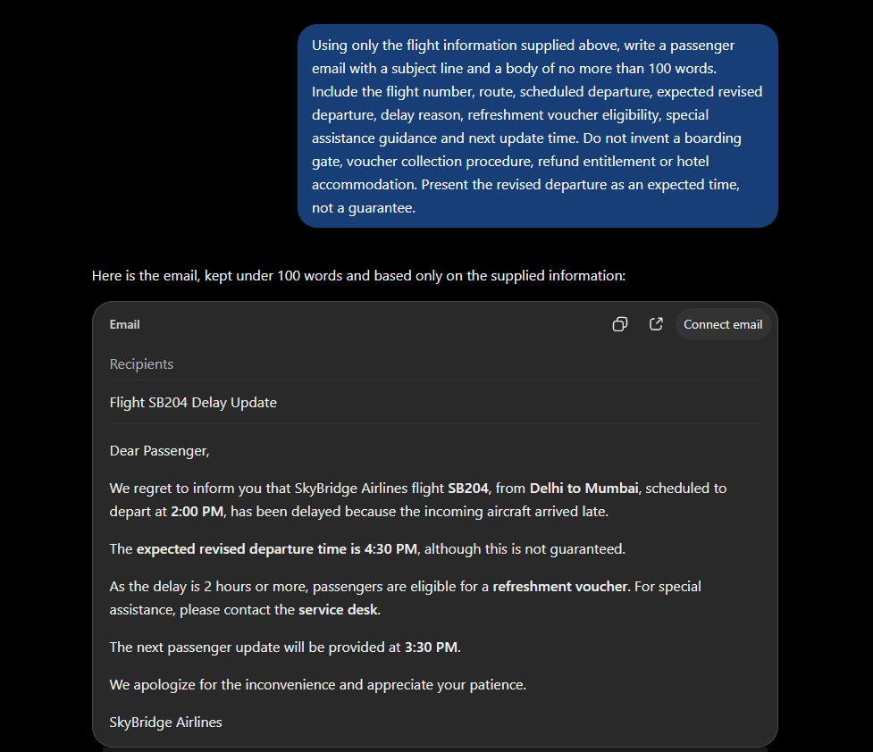

Improvements :-
- The response now contains the actual flight number and route.
- The response uses the supplied timings and avoids inventing hotel, refund or gate information.

Round 3 — Role Prompting
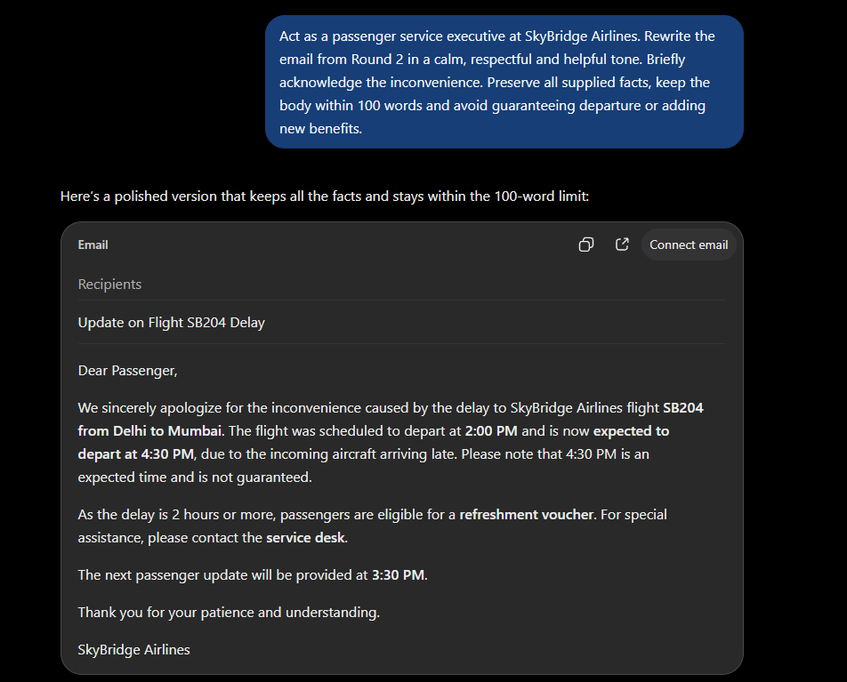
Observation: - The phrase “We sincerely apologize for the inconvenience caused” improves the tone because it acknowledges the passenger’s inconvenience and shows empathy and respect.
Round 4 — Few-Shot Prompting
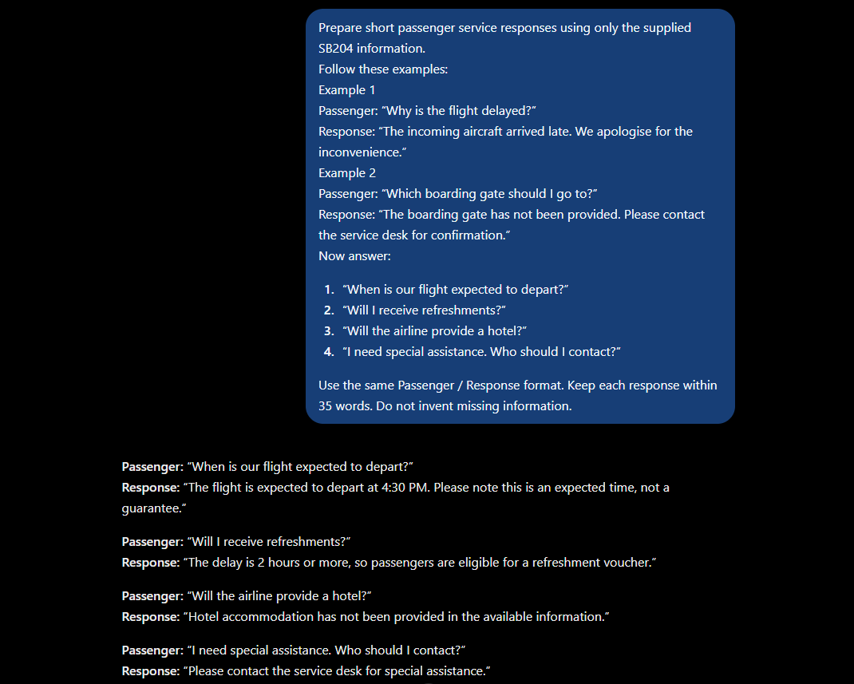
Record: The examples influenced the output by showing the required Passenger / Response format, concise wording, and how to respond politely without inventing missing information.

Round 5 — Structured-Output Prompting
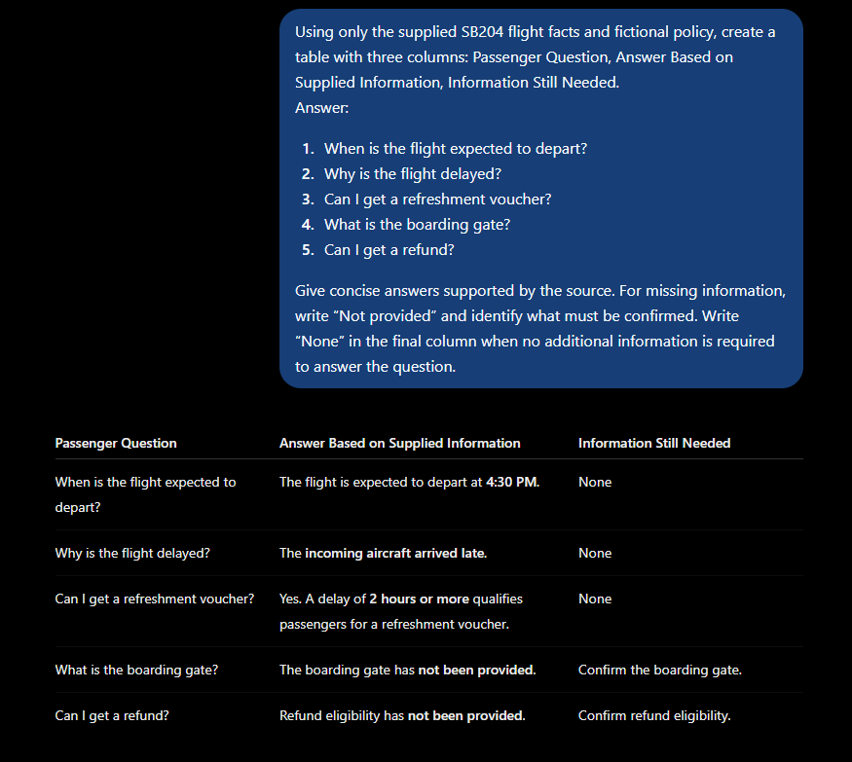

Observation: The table would help a service desk executive because the passenger questions, available answers and missing information are organised clearly in one place.

Round 6 — Audience-Based Prompting
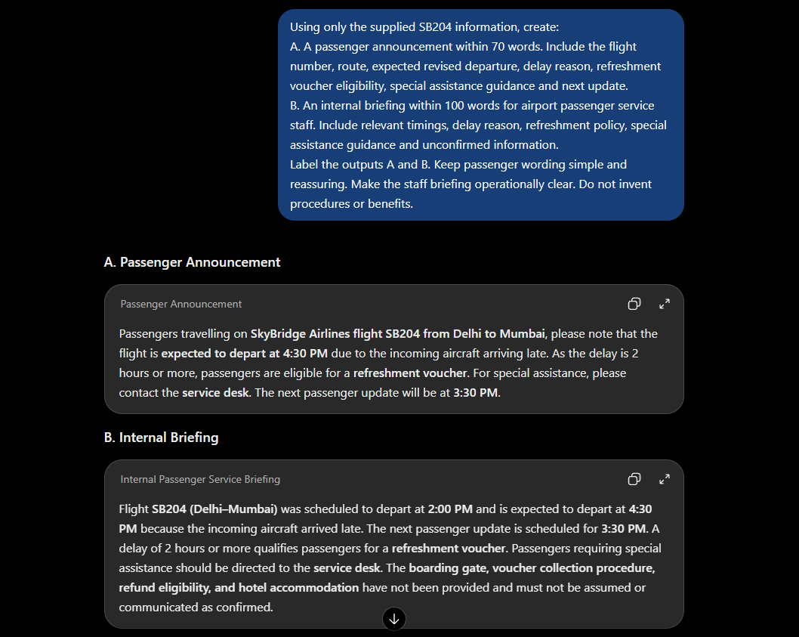

Comparison point | Passenger announcement | Staff briefing
Intended reader | Passengers | Airport passenger service staff
Tone | Simple, calm and reassuring | Clear, operational and professional
Level of detail | Key information passengers need | More detailed information for staff action
Treatment of unconfirmed information | Avoids mentioning unnecessary unconfirmed details | Clearly identifies unconfirmed information so staff do not assume or communicate it as confirmed

Explanation: Passengers need simple and reassuring information about their flight, while staff need more operational detail so they can assist passengers accurately and avoid sharing unconfirmed information.

6-Round Comparison
Round | Strategy | Main change observed | Detail checked/corrected
1 | Zero-shot | Created a general delayed-flight passenger message. | Basic delay communication and apology.
2 | Context & constraints | Added the complete SB204 flight facts and specific requirements. | Flight number, route, timings, delay reason and missing information.
3 | Role prompting | Made the message more calm, respectful and helpful by acting as a passenger service executive. | Tone and expected departure wording.
4 | Few-shot | Examples guided the response format and style for passenger questions. | Kept answers concise and avoided inventing missing information.
5 | Structured output | Organised answers into a three-column table. | Checked which information was supplied and what was still needed.
6 | Audience-based | Created separate passenger and staff messages for different audiences. | Checked tone, detail level and treatment of unconfirmed information.

1. Which prompt produced the most useful output for its intended task, and why?
The Round 6 audience-based prompt produced the most useful output because it created different messages for passengers and staff. Each message had the appropriate tone and level of detail for its intended audience.
2. Which fact did you manually verify or correct?
I manually checked that the expected revised departure was 4:30 PM and that it was presented as an expected time, not a guarantee. I also verified that the incoming aircraft arrived late was the stated delay reason.
3. Why is human review necessary before sending these messages?
Human review is necessary to make sure the information is accurate and that no missing details or invented benefits are communicated. It also helps ensure passengers receive clear and appropriate information.

Final Approved Passenger Email — Classroom Simulation
Dear Passenger,
We sincerely apologize for the inconvenience caused by the delay to SkyBridge Airlines flight SB204 from Delhi to Mumbai. The flight was scheduled to depart at 2:00 PM and is now expected to depart at 4:30 PM due to the incoming aircraft arriving late. Please note that 4:30 PM is an expected time and is not guaranteed.
As the delay is 2 hours or more, passengers are eligible for a refreshment voucher. For special assistance, please contact the service desk.
The next passenger update will be provided at 3:30 PM.
Thank you for your patience and understanding.
SkyBridge Airlines

