Experiment – To design a hand held magical heart that blinks 60 times a minute with red colour if it is held from any one side and 120 times a minute with green colour if held from both sides.

Circuit diagram –

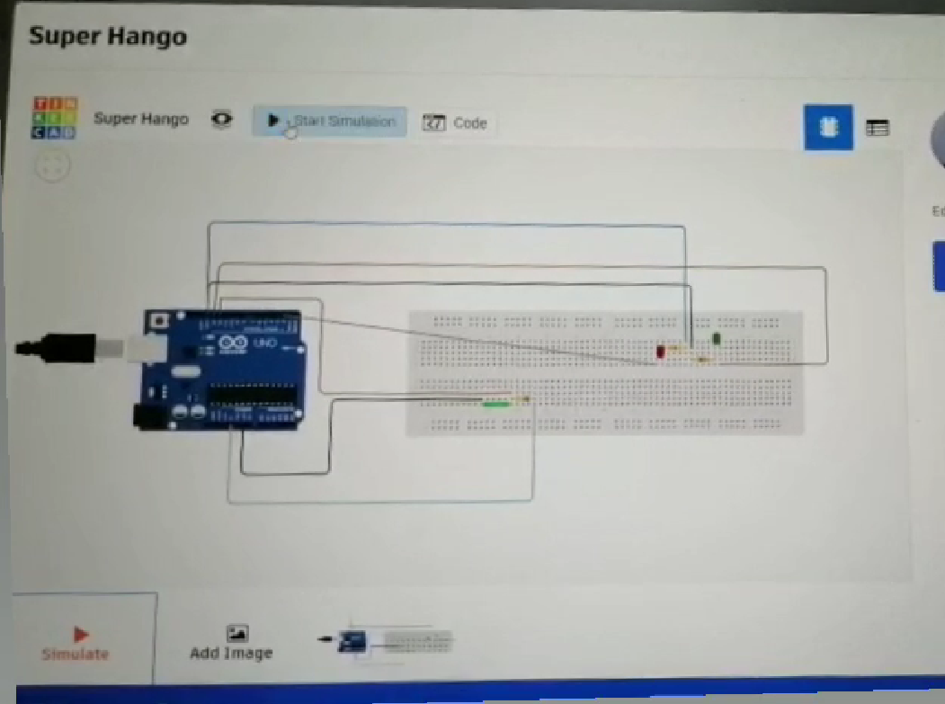

Theory-

Concept used:

A photoresistor is a light –controlled variable resistor. The resistance of a photoresistor decreases with increasing incident light intensity.

Learning and observations:

I designed a hand held magical heart that blinks 60 times a minute with red colour if it is held from any one side and 120 times a minute with green colour if held from both sides

Problems and troubleshooting:

* Arduino should be connected in the correct port .
* Led should be checked beforehand to check whether it is fused or not.
* Connection should not be loose.

PRECAUTIONS:

* Wires should be inserted properly.
* Check whether the circuit is closed or not.

LEARNING OUTCOMES:

I have learned how to use LDR to make light glow differently when it is swipe in the same direction.