|  |
| --- |
| College LaSalle |
| Project – P25 – Introduction to Object Programming - User and Technical Manual |
|  |
| Presented to:….Mihai Maftei |

|  |
| --- |
| Gurleen Singh  7/29/2018 |

A). This is my final project for Programming. I made this form using C# language and windows form application in Microsoft Visual Studio 2017. This program consists of different forms such as lotto, calculator, currency exchange, and Temperature conversion.

B)

. 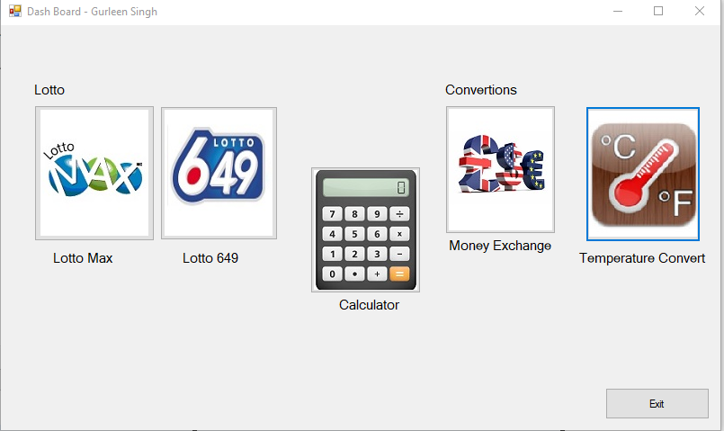

This is the outlet of the main form, which contain different buttons, and by clicking on these buttons; we can get to different forms on new window.

**“LOTTO 649”**

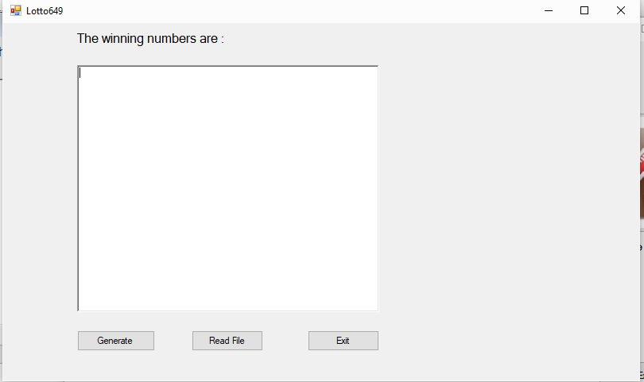

This is the first form “LOTTO 649” which is a form related to lottery system and generate seven different and random numbers.

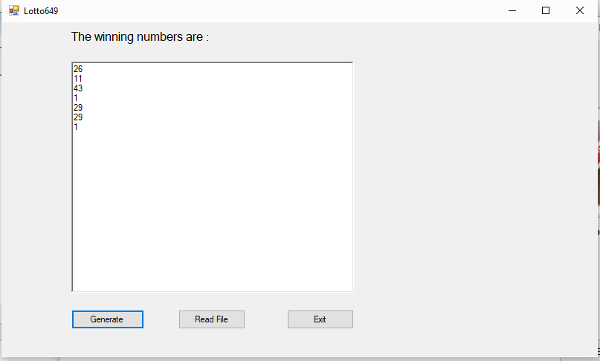

When you click on generate button, it generates seven different random numbers in the text box.

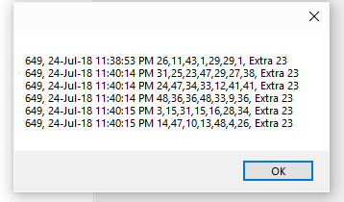

When you click on read files, it will show a message box with the numbers that were generated by the lotto form and shows the date and time at which the codes were generated.

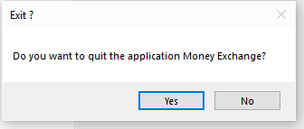

This is a message box, which is being shown when we press exit button so it will ask that you really want to quit the form. By clicking on No button it will return to form again and if we click yes, it will exit the form.

**“LOTTO MAX”**

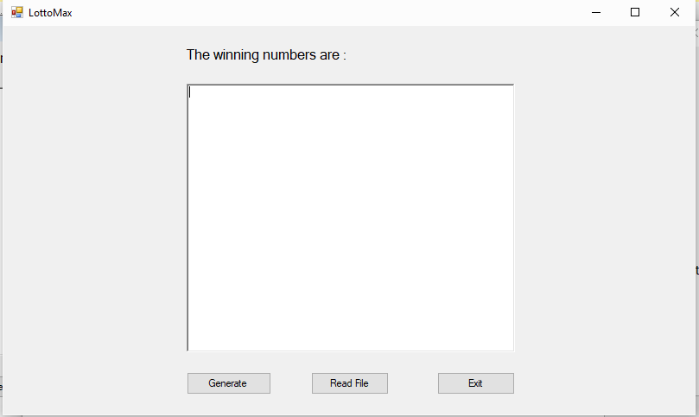

This is the Lotto Max form, which is almost similar to Lotto 649, but in this it generate eight different random numbers.

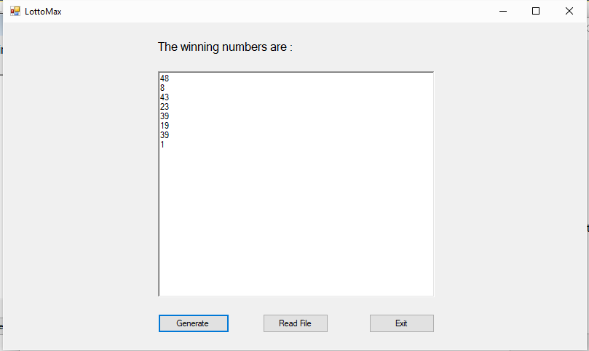

When we click on generate button, it will generate eight different random numbers.

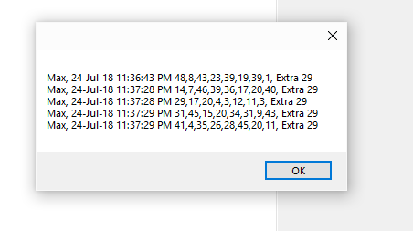

When we click on read file button, it will show a message box with the numbers that were generated by the lotto form with date and time when these numbers were generated.

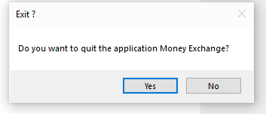

This is the message box which is shown when we click on exit button. If we click on no button it will return to the form but if yes is clicked it will close the form.

**“CALCULATOR”**

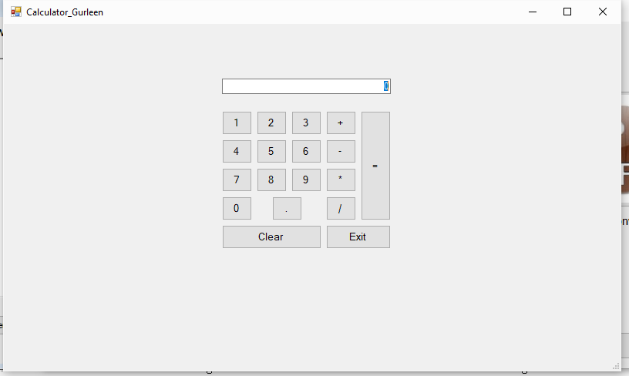

This is the form for the calculator. This form is used to perform simple calculations by using two different numbers.

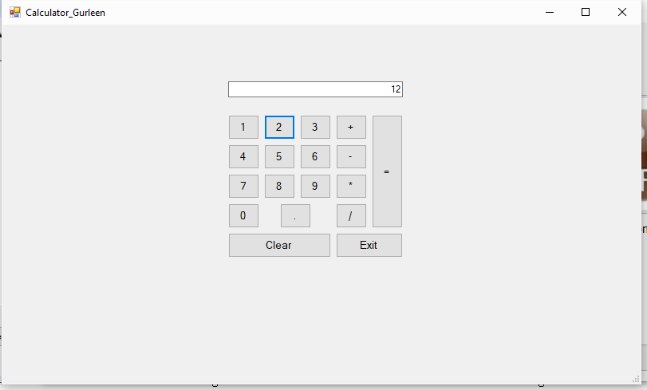

By clicking on different buttons, we can enter a number in the text box, which we want to use.

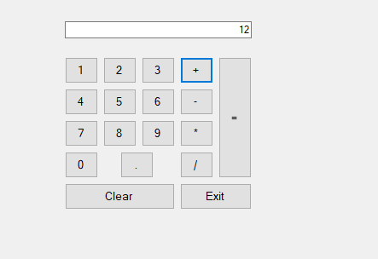

Then we need to click on any button which help to perform different operation which ever we want to use add, subtract, multiply, divide.

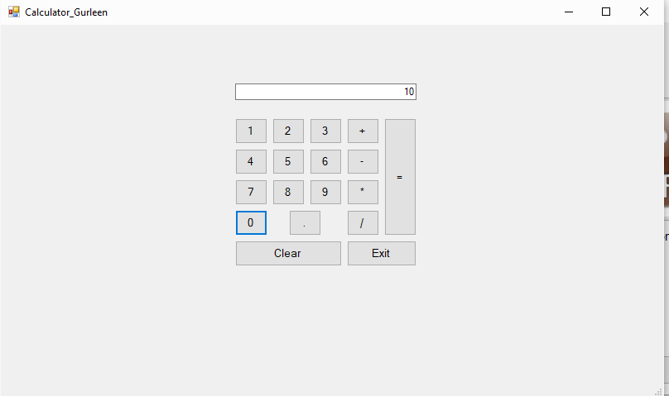

After selecting the operation performed, select another number, which we want to use.

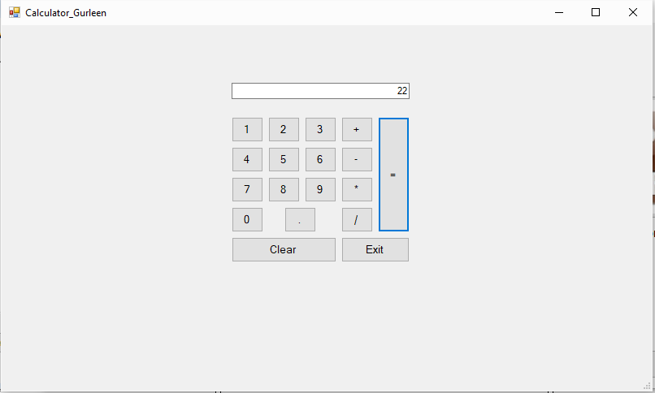

By pressing the “=” button we can get our result for the numbers that we select after applying the operation that we choose.

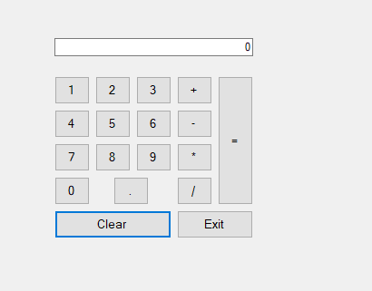

Clear button helps to clear the number in the textbox if written and bring the value back to default zero.

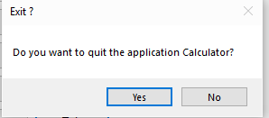

This message box will be shown if exit button is pressed and it will ask that if, you really want to exit.

**“MONEY EXCHANGE”**

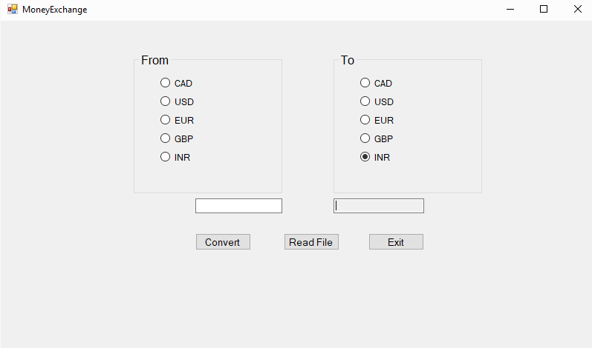

This is the money exchange form, which is used to convert one form of currency to the other.

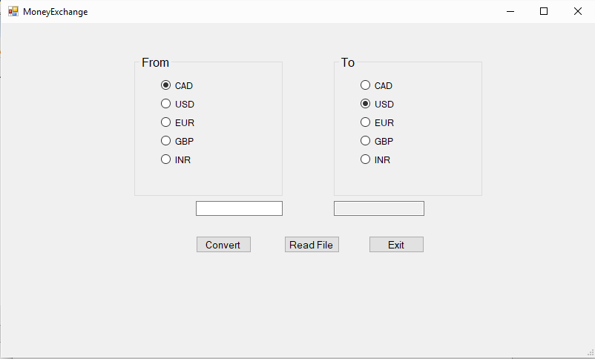

Then select the radio buttons on the both the sides for converting to specific currency.

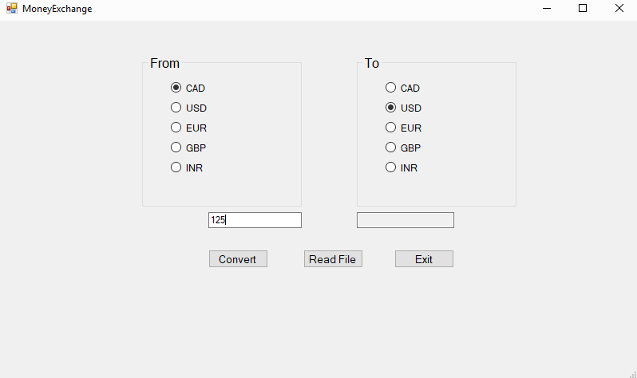

Then enter a value in the left text box, which you want to convert to a specific currency.

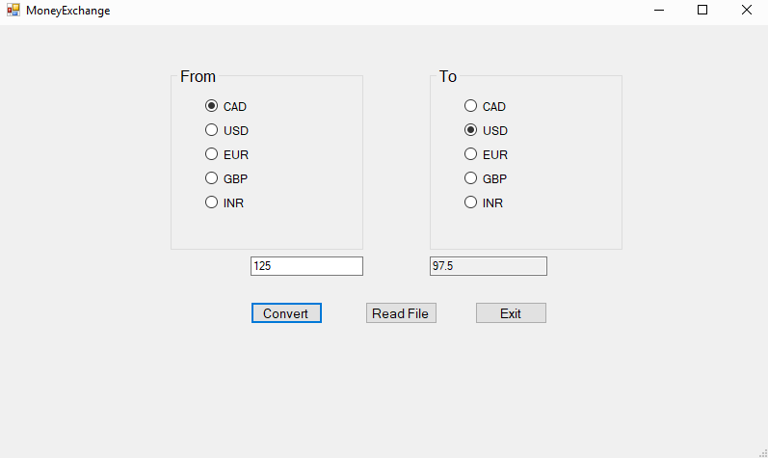

Then by clicking on the convert button helps to convert the entered value to the selected currency and put the value in the right text box.

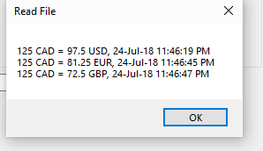

By clicking on the read file button, it will generate a message box to show the conversions that we did along with the date and time when we did these conversions.

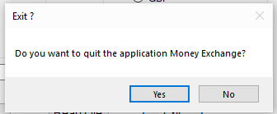

This is the message box, which is shown when we press exit button, and it will ask do you really want to exit.

**“TEMPERATURE CONVERSION”**

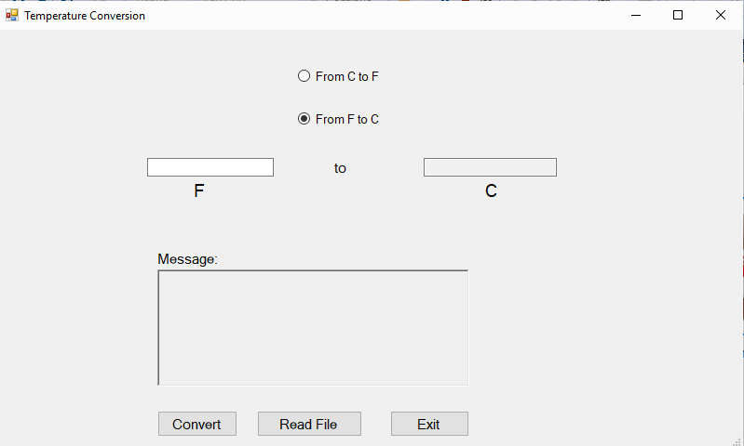

This is the form for the temperature conversion, which is used to convert any given value from Celsius to Fahrenheit or vice a versa.

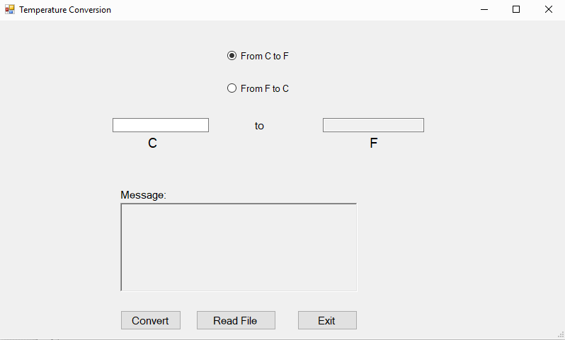

Then choose one of the radio to select which conversion you want to make.

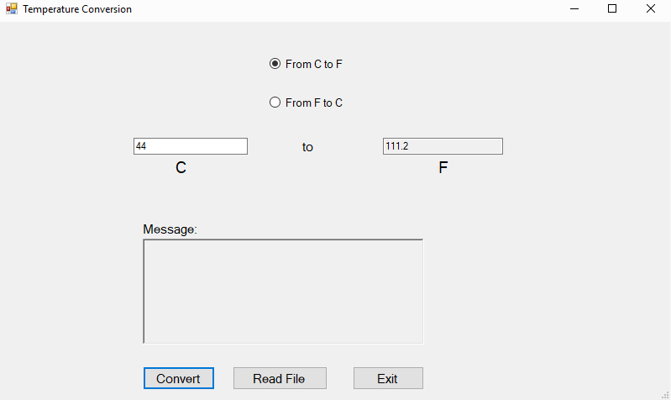

Then enter a value in the left text box and click on convert button hence it will show the specific result after applying the selected conversion.

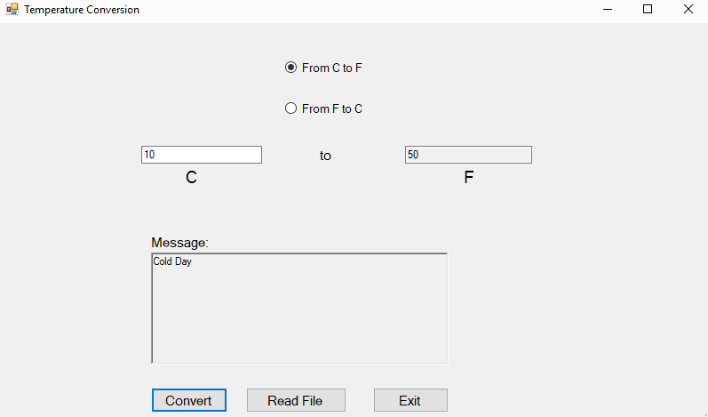

If a specific value is entered in the text box it will also show a message along with result when we press the convert button.

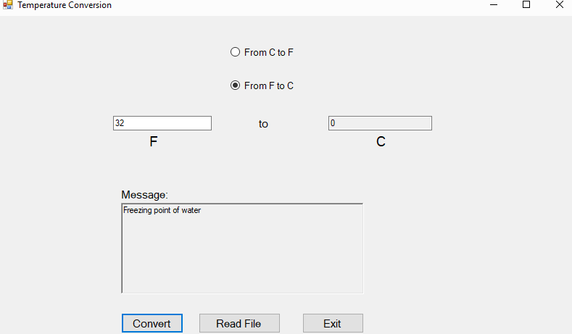

Another example of the message, which is shown when a specific temperature is entered.

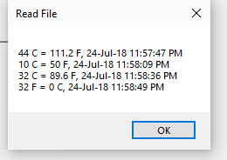

When we click on read file button, it will show all the conversions along with the date and time at which the conversions were made.

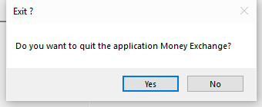

This message is shown when the exit button is pressed then it will ask do you really want to exit.

C). **“LOTTO 649”**

Using System;

using System.Collections.Generic;

using System.ComponentModel;

using System.Data;

using System.Drawing;

using System.Linq;

using System.Text;

using System.Threading.Tasks;

using System.Windows.Forms;

using System.IO;

using System.Text.RegularExpressions;

namespace FinalProject

{

public partial class Lotto649 : Form

{

public Lotto649()

{

InitializeComponent();

}

private void button3_Click(object sender, EventArgs e)

{

byte val1 = 0;

val1 = Convert.ToByte(MessageBox.Show("Do you want to quit the application Money Exchange?", "Exit ?", MessageBoxButtons.YesNo));

if (val1 == 6)

{

this.Close();

}

}

private void button1_Click(object sender, EventArgs e)

{

string texttoPrint = "";

string texttoShow = "";

Random random = new Random();

for (int i = 0; i < 7; i++)

{

int randomNumber = random.Next(1, 49);

texttoPrint += randomNumber.ToString() + ",";

texttoShow += randomNumber.ToString() + "\r\n";

}

richTextBox1.Text = texttoShow ;

string path = dir + "File649.txt";

FileStream fs = new FileStream(path, FileMode.Append, FileAccess.Write);

string d = DateTime.Now.ToString();

StreamWriter textOut = new StreamWriter(fs);

textOut.WriteLine("649, "+ d+" "+ texttoPrint+" "+ "Extra 23");

textOut.Close();

fs.Close();

}

//string dir = @"C:\Users\Gurleen Singh\Desktop\C# Project\FinalProject\FinalProject\bin\Debug\Files\";

string dir = @"./Files/";

private void Lotto649_Load(object sender, EventArgs e)

{

if (!Directory.Exists(dir))

Directory.CreateDirectory(dir);

}

private void button2_Click(object sender, EventArgs e)

{

int linesNbr = 0;

string textToPrint = "";

string path = dir + "File649.txt";

FileStream fs = null;

try

{

fs = new FileStream(path, FileMode.Open, FileAccess.Read);

StreamReader textIn = new StreamReader(fs);

while (textIn.Peek() != -1)

{

textToPrint += textIn.ReadLine() + "\n";

linesNbr += 1;

if (linesNbr == 36)

{

MessageBox.Show(textToPrint);

linesNbr = 0;

textToPrint = "";

}

}

if (linesNbr > 0)

{

MessageBox.Show(textToPrint);

}

textIn.Close();

}

catch (FileNotFoundException)

{

MessageBox.Show(path + " not found.", "File Not Found");

}

catch (DirectoryNotFoundException)

{

MessageBox.Show(path + " not found.", "Directory Not Found");

}

catch (IOException ex)

{ MessageBox.Show(ex.Message, "IOException"); }

finally { if (fs != null) fs.Close(); }

}

}

}

**“LOTTO MAX”**

using System;

using System.Collections.Generic;

using System.ComponentModel;

using System.Data;

using System.Drawing;

using System.Linq;

using System.Text;

using System.Threading.Tasks;

using System.Windows.Forms;

using System.IO;

using System.Text.RegularExpressions;

namespace FinalProject

{

public partial class LottoMax : Form

{

public LottoMax()

{

InitializeComponent();

}

private void button3_Click(object sender, EventArgs e)

{

byte val1 = 0;

val1 = Convert.ToByte(MessageBox.Show("Do you want to quit the application Money Exchange?", "Exit ?", MessageBoxButtons.YesNo));

if (val1 == 6)

{

this.Close();

}

}

private void button1_Click(object sender, EventArgs e)

{

string texttoPrint = "";

string texttoShow = "";

Random random = new Random();

for (int i = 0; i < 8; i++)

{

int randomNumber = random.Next(1, 49);

texttoShow += randomNumber.ToString() + "\r\n";

texttoPrint += randomNumber.ToString() + ",";

}

richTextBox1.Text = texttoShow ;

string path = dir + "FileMax.txt";

FileStream fs = new FileStream(path, FileMode.Append, FileAccess.Write);

string d = DateTime.Now.ToString();

StreamWriter textOut = new StreamWriter(fs);

textOut.WriteLine("Max, " + d + " " + texttoPrint +" "+ "Extra 29");

textOut.Close();

fs.Close();

}

//string dir = @"C:\Users\Gurleen Singh\Desktop\C# Project\FinalProject\FinalProject\bin\Debug\Files\";

string dir = @"./Files/";

private void LottoMax_Load(object sender, EventArgs e)

{

if (!Directory.Exists(dir))

Directory.CreateDirectory(dir);

}

private void button2_Click(object sender, EventArgs e)

{

int linesNbr = 0;

string textToPrint = "";

string path = dir + "FileMax.txt";

FileStream fs = null;

try

{

fs = new FileStream(path, FileMode.Open, FileAccess.Read);

StreamReader textIn = new StreamReader(fs);

while (textIn.Peek() != -1)

{

textToPrint += textIn.ReadLine() + "\n";

linesNbr += 1;

if (linesNbr == 36)

{

MessageBox.Show(textToPrint);

linesNbr = 0;

textToPrint = "";

}

}

if (linesNbr > 0)

{

MessageBox.Show(textToPrint);

}

textIn.Close();

}

catch (FileNotFoundException)

{

MessageBox.Show(path + " not found.", "File Not Found");

}

catch (DirectoryNotFoundException)

{

MessageBox.Show(path + " not found.", "Directory Not Found");

}

catch (IOException ex)

{ MessageBox.Show(ex.Message, "IOException"); }

finally { if (fs != null) fs.Close(); }

}

}

}

**“CALCULATOR”**

using System;

using System.Collections.Generic;

using System.ComponentModel;

using System.Data;

using System.Drawing;

using System.Linq;

using System.Text;

using System.Threading.Tasks;

using System.Windows.Forms;

using System.IO;

using System.Text.RegularExpressions;

using System.Xml;

namespace FinalProject

{

public partial class Calculator : Form

{

Double firstvalue = 0;

string operationperformed = "";

bool val1 = false;

public Calculator()

{

InitializeComponent();

}

string dir = @"./Files/";

private void button18_Click(object sender, EventArgs e)

{

byte val2 = 0;

val2 = Convert.ToByte(MessageBox.Show("Do you want to quit the application Calculator?", "Exit ?", MessageBoxButtons.YesNo));

if (val2 == 6)

{

this.Close();

}

}

private void button1_Click(object sender, EventArgs e)

{

if ((textBox1.Text=="0")|| val1)

{

textBox1.Clear();

}

val1 = false;

Button button = (Button)sender;

textBox1.Text = textBox1.Text + button.Text;

op1.EnteredValue1 = Convert.ToDouble(textBox1.Text);

}

private void button4_Click(object sender, EventArgs e)

{

Button button = (Button)sender;

operationperformed = button.Text;

firstvalue = Double.Parse(textBox1.Text);

op1.EnteredValue = Convert.ToDouble(firstvalue);

val1 = true;

}

private void button17_Click(object sender, EventArgs e)

{

textBox1.Text = "0";

firstvalue = 0;

textBox2.Text = "0";

}

private void button16_Click(object sender, EventArgs e)

{

string path = dir + "Calculator.txt";

FileStream fs = new FileStream(path, FileMode.Append, FileAccess.Write);

switch (operationperformed)

{

case "+":

//textBox2.Text = (firstvalue + Double.Parse(textBox1.Text)).ToString();

textBox2.Text = op1.sum().ToString();

break;

case "-":

//textBox2.Text = (firstvalue - Double.Parse(textBox1.Text)).ToString();

textBox2.Text = op1.substraction().ToString();

break;

case "*":

//textBox2.Text = (firstvalue * Double.Parse(textBox1.Text)).ToString();

textBox2.Text = op1.multiplication().ToString();

break;

case "/":

//textBox2.Text = (firstvalue / Double.Parse(textBox1.Text)).ToString();

textBox2.Text = op1.division().ToString();

break;

default:

break;

}

string d = DateTime.Now.ToString();

StreamWriter textOut = new StreamWriter(fs);

textOut.Write("Calculator, "+d+" "+firstvalue +" "+operationperformed +" "+textBox1.Text+" = " +textBox2.Text + "\r\n");

textOut.Close();

fs.Close();

}

operations op1;

private void Calculator_Load(object sender, EventArgs e)

{

op1 = new operations();

}

private void button19_Click(object sender, EventArgs e)

{

string path = dir + "Calculator.txt";

FileStream fs = null;

try

{

StreamReader sr = new StreamReader(@"C:\Users\Gurleen Singh\Desktop\C# Project\FinalProject\FinalProject\bin\Debug\Files\Calculator.txt");

string text = sr.ReadToEnd();

MessageBox.Show(text, "Read File");

}

catch (FileNotFoundException)

{

MessageBox.Show(path + " not found.", "File Not Found");

}

catch (DirectoryNotFoundException)

{

MessageBox.Show(path + " not found.", "Directory Not Found");

}

catch (IOException ex)

{ MessageBox.Show(ex.Message, "IOException"); }

finally { if (fs != null) fs.Close(); }

}

}

class operations

{

private double enteredValue;

private double enteredValue1;

public double EnteredValue

{

set { enteredValue = value; }

get { return enteredValue; }

}

public double EnteredValue1

{

set { enteredValue1 = value; }

get { return enteredValue1; }

}

public operations() { }

public operations(double num1, double num2)

{

enteredValue = num1;

enteredValue1 = num2;

}

public double sum()

{ return (EnteredValue + EnteredValue1); }

public double substraction()

{ return (EnteredValue - EnteredValue1); }

public double multiplication()

{ return (EnteredValue * EnteredValue1); }

public double division()

{ return (EnteredValue / EnteredValue1); }

}

}

**“MONEY EXCHANGE”**

using System;

using System.Collections.Generic;

using System.ComponentModel;

using System.Data;

using System.Drawing;

using System.Linq;

using System.Text;

using System.Threading.Tasks;

using System.Windows.Forms;

using System.IO;

using System.Text.RegularExpressions;

namespace FinalProject

{

public partial class MoneyExchange : Form

{

public MoneyExchange()

{

InitializeComponent();

}

private void button3_Click(object sender, EventArgs e)

{

byte val1 = 0;

val1 = Convert.ToByte(MessageBox.Show("Do you want to quit the application Money Exchange?","Exit ?",MessageBoxButtons.YesNo));

if (val1==6)

{

this.Close();

}

}

private void button2_Click(object sender, EventArgs e)

{

string path = dir + "FileMoneyExchange.txt";

FileStream fs = null;

try

{

StreamReader sr = new StreamReader(@"C:\Users\Gurleen Singh\Desktop\C# Project\FinalProject\FinalProject\bin\Debug\Files\FileMoneyExchange.txt");

string text = sr.ReadToEnd();

MessageBox.Show(text, "Read File");

}

catch (FileNotFoundException)

{

MessageBox.Show(path + " not found.", "File Not Found");

}

catch (DirectoryNotFoundException)

{

MessageBox.Show(path + " not found.", "Directory Not Found");

}

catch (IOException ex)

{ MessageBox.Show(ex.Message, "IOException"); }

finally { if (fs != null) fs.Close(); }

}

private void button1_Click(object sender, EventArgs e)

{

string path = dir + "FileMoneyExchange.txt";

FileStream fs = new FileStream(path, FileMode.Append, FileAccess.Write);

string d = DateTime.Now.ToString();

string convfrom = "";

string convto = "";

double amount = 0;

double total = 0 ;

try

{

amount = double.Parse(textBox1.Text);

}

catch(FormatException)

{

MessageBox.Show("Please enter the appropriate value !");

}

if (radioButton1.Checked && radioButton11.Checked)

{

total = amount * 1;

textBox2.Text = total.ToString();

convfrom = "CAD";

convto = "CAD";

}

if (radioButton1.Checked && radioButton12.Checked)

{

total = amount * 0.78;

textBox2.Text = total.ToString();

convfrom = "CAD";

convto = "USD";

}

if (radioButton1.Checked && radioButton13.Checked)

{

total = amount * 0.65;

textBox2.Text = total.ToString();

convfrom = "CAD";

convto = "EUR";

}

if (radioButton1.Checked && radioButton14.Checked)

{

total = amount * 0.58;

textBox2.Text = total.ToString();

convfrom = "CAD";

convto = "GBP";

}

if (radioButton1.Checked && radioButton15.Checked)

{

total = amount * 52.44;

textBox2.Text = total.ToString();

convfrom = "CAD";

convto = "INR";

}

if (radioButton2.Checked && radioButton11.Checked)

{

total = amount * 1.31;

textBox2.Text = total.ToString();

convfrom = "USD";

convto = "CAD";

}

if (radioButton2.Checked && radioButton12.Checked)

{

total = amount * 1;

textBox2.Text = total.ToString();

convfrom = "USD";

convto = "USD";

}

if (radioButton2.Checked && radioButton13.Checked)

{

total = amount * 0.86;

textBox2.Text = total.ToString();

convfrom = "USD";

convto = "EUR";

}

if (radioButton2.Checked && radioButton14.Checked)

{

total = amount * 0.76;

textBox2.Text = total.ToString();

convfrom = "USD";

convto = "GBP";

}

if (radioButton2.Checked && radioButton15.Checked)

{

total = amount * 68.93;

textBox2.Text = total.ToString();

convfrom = "USD";

convto = "INR";

}

if (radioButton3.Checked && radioButton11.Checked)

{

total = amount * 1.54;

textBox2.Text = total.ToString();

convfrom = "EUR";

convto = "CAD";

}

if (radioButton3.Checked && radioButton12.Checked)

{

total = amount * 1.17;

textBox2.Text = total.ToString();

convfrom = "EUR";

convto = "USD";

}

if (radioButton3.Checked && radioButton13.Checked)

{

total = amount * 1;

textBox2.Text = total.ToString();

convfrom = "EUR";

convto = "EUR";

}

if (radioButton3.Checked && radioButton14.Checked)

{

total = amount * 0.88;

textBox2.Text = total.ToString();

convfrom = "EUR";

convto = "GBP";

}

if (radioButton3.Checked && radioButton15.Checked)

{

total = amount * 80.60;

textBox2.Text = total.ToString();

convfrom = "EUR";

convto = "INR";

}

if (radioButton4.Checked && radioButton11.Checked)

{

total = amount * 1.74;

textBox2.Text = total.ToString();

convfrom = "GBP";

convto = "CAD";

}

if (radioButton4.Checked && radioButton12.Checked)

{

total = amount * 1.32;

textBox2.Text = total.ToString();

convfrom = "GBP";

convto = "USD";

}

if (radioButton4.Checked && radioButton13.Checked)

{

total = amount * 1.13;

textBox2.Text = total.ToString();

convfrom = "GBP";

convto = "EUR";

}

if (radioButton4.Checked && radioButton14.Checked)

{

total = amount * 1;

textBox2.Text = total.ToString();

convfrom = "GBP";

convto = "GBP";

}

if (radioButton4.Checked && radioButton15.Checked)

{

total = amount * 91.13;

textBox2.Text = total.ToString();

convfrom = "GBP";

convto = "INR";

}

if (radioButton5.Checked && radioButton11.Checked)

{

total = amount * 0.019;

textBox2.Text = total.ToString();

convfrom = "INR";

convto = "CAD";

}

if (radioButton5.Checked && radioButton12.Checked)

{

total = amount * 0.015;

textBox2.Text = total.ToString();

convfrom = "INR";

convto = "USD";

}

if (radioButton5.Checked && radioButton13.Checked)

{

total = amount * 0.012;

textBox2.Text = total.ToString();

convfrom = "INR";

convto = "EUR";

}

if (radioButton5.Checked && radioButton14.Checked)

{

total = amount * 0.011;

textBox2.Text = total.ToString();

convfrom = "INR";

convto = "GBP";

}

if (radioButton5.Checked && radioButton15.Checked)

{

total = amount * 1;

textBox2.Text = total.ToString();

convfrom = "INR";

convto = "INR";

}

StreamWriter textOut = new StreamWriter(fs);

textOut.Write(amount +" "+ convfrom +" "+ "=" +" "+ total+" " + convto+","+" " + d + "\r\n");

textOut.Close();

fs.Close();

}

//string dir = @"C:\Users\Gurleen Singh\Desktop\C# Project\FinalProject\FinalProject\bin\Debug\Files\";

string dir = @"./Files/";

private void MoneyExchange_Load(object sender, EventArgs e)

{

if (!Directory.Exists(dir))

Directory.CreateDirectory(dir);

}

}

}

**“TEMPERATURE CONVERSION”**

using System;

using System.Collections.Generic;

using System.ComponentModel;

using System.Data;

using System.Drawing;

using System.Linq;

using System.Text;

using System.Threading.Tasks;

using System.Windows.Forms;

using System.IO;

using System.Text.RegularExpressions;

namespace FinalProject

{

public partial class TempConvert : Form

{

public TempConvert()

{

InitializeComponent();

}

private void button3_Click(object sender, EventArgs e)

{

byte val2 = 0;

val2 = Convert.ToByte(MessageBox.Show("Do you want to quit the application Money Exchange?", "Exit ?", MessageBoxButtons.YesNo));

if (val2 == 6)

{

this.Close();

}

}

private void button1_Click(object sender, EventArgs e)

{

string path = dir + "FileTempConvert.txt";

FileStream fs = new FileStream(path, FileMode.Append, FileAccess.Write);

string d = DateTime.Now.ToString();

double val1 = 0;

double answer = 0;

string convfrom = "";

string convto = "";

try

{

val1 = double.Parse(textBox1.Text);

}

catch(Exception ex)

{

MessageBox.Show(ex.Message + "Please enter the appropriate value");

return;

}

if (radioButton1.Checked)

{

convfrom = "C";

convto = "F";

answer = (val1 * (1.8) + 32);

textBox2.Text = answer.ToString();

if (textBox1.Text=="100")

{

richTextBox1.Text = "Water Boils";

}

else if (textBox1.Text == "40")

{

richTextBox1.Text = "Hot Bath";

}

else if (textBox1.Text == "37")

{

richTextBox1.Text = "Body Temperature";

}

else if (textBox1.Text == "30")

{

richTextBox1.Text = "Beach Weather";

}

else if (textBox1.Text == "21")

{

richTextBox1.Text = "Room Temperature";

}

else if (textBox1.Text == "10")

{

richTextBox1.Text = "Cold Day";

}

else if (textBox1.Text == "0")

{

richTextBox1.Text = "Freezing point of water";

}

else if (textBox1.Text == "-18")

{

richTextBox1.Text = "Very Cold day";

}

else if (textBox1.Text == "-40")

{

richTextBox1.Text = "Extremely cold day";

}

else

{

richTextBox1.Clear();

}

}

if (radioButton2.Checked)

{

convfrom = "F";

convto = "C";

answer = ((val1 - 32) / 1.8);

textBox2.Text = answer.ToString();

if (textBox1.Text == "212")

{

richTextBox1.Text = "Water Boils";

}

else if (textBox1.Text == "104")

{

richTextBox1.Text = "Hot Bath";

}

else if (textBox1.Text == "98.6")

{

richTextBox1.Text = "Body Temperature";

}

else if (textBox1.Text == "86")

{

richTextBox1.Text = "Beach Weather";

}

else if (textBox1.Text == "70")

{

richTextBox1.Text = "Room Temperature";

}

else if (textBox1.Text == "50")

{

richTextBox1.Text = "Cold Day";

}

else if (textBox1.Text == "32")

{

richTextBox1.Text = "Freezing point of water";

}

else if (textBox1.Text == "0")

{

richTextBox1.Text = "Very Cold day";

}

else if (textBox1.Text == "-40")

{

richTextBox1.Text = "Extremely cold day"+ "\n" + "(and the same number)";

}

else

{

richTextBox1.Clear();

}

}

StreamWriter textOut = new StreamWriter(fs);

textOut.Write(val1 +" "+ convfrom +" "+ "=" +" "+ answer +" "+ convto +","+" " + d + "\r\n");

textOut.Close();

fs.Close();

}

//string dir = @"C:\Users\Gurleen Singh\Desktop\C# Project\FinalProject\FinalProject\bin\Debug\Files\";

string dir = @"./Files/";

private void radioButton2_CheckedChanged(object sender, EventArgs e)

{

label2.Text = "F";

label3.Text = "C";

}

private void radioButton1_CheckedChanged(object sender, EventArgs e)

{

label2.Text = "C";

label3.Text = "F";

}

private void TempConvert_Load(object sender, EventArgs e)

{

if (!Directory.Exists(dir))

Directory.CreateDirectory(dir);

}

private void button2_Click(object sender, EventArgs e)

{

string path = dir + "FileTempConvert.txt";

FileStream fs = null;

try

{

StreamReader sr = new StreamReader(@"C:\Users\Gurleen Singh\Desktop\C# Project\FinalProject\FinalProject\bin\Debug\Files\FileTempConvert.txt");

string text = sr.ReadToEnd();

MessageBox.Show(text, "Read File");

}

catch (FileNotFoundException)

{

MessageBox.Show(path + " not found.", "File Not Found");

}

catch (DirectoryNotFoundException)

{

MessageBox.Show(path + " not found.", "Directory Not Found");

}

catch (IOException ex)

{ MessageBox.Show(ex.Message, "IOException"); }

finally { if (fs != null) fs.Close(); }

}

}

}

C).

|  |  |
| --- | --- |
| **Class/Method Name** | **Description** |
| 1. Class operations | This class contain different functions for the sum, sunstract, multiply, divide. |
| 1. Public opreations () | It is the default constructor. |
| 1. Public operations(double num1, double num2) | This constructor Is use to define the values which were used by the functions. |
| 1. Public double sum() | This function is used for adding two numbers. |
| 1. Public double substraction() | This function is used for substracting two numbers. |
| 1. Public double multiplication() | This function is used for the multiplying two numbers. |
| 1. Public double division() | This function is used for the division of two numbers. |

D). It was a very interesting project as I get to learn a lot of new concepts and develop new skills in programming. Easiest part in this project was to make the design for the program and rest programming was little bit tricky but it was not that much difficult. Overall I enjoyed this project and completed it by my heart.