**Group Members:**

* **Ramanvir Singh Sahota**
* **Gurleen Singh Khaira**
* **Sajagpreet Singh**
* **Nandini Nandini**
* **Malak Singh**

**Page Hierarchy**

**Home Page**

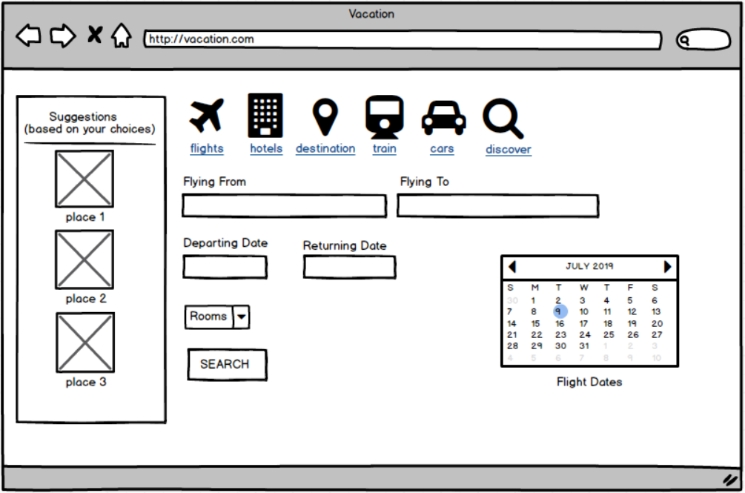

**Sub-Pages**

1.

2.

3.

4.

5.

