Game Design Document

Fill up the Following document

1. Write the title of your project.

5 star restaurant.

1. What is the goal of the game?

Goal is to serve the customers.

1. Write a brief story of your game?

In this game the waiters will be serving food and beverages to the customers and then they will be rewarded for their fast and great serving within a given time. There will be some obstacles which will disturb the waiter and make him lose the game.

1. Which are the playing characters of this game?

* Playing characters are the ones which respond to the user based on the input from the user
* Cars, monkeys, dinos, wizards etc, are the playing characters in the game.

|  |  |  |
| --- | --- | --- |
| Number | Character Name | What can this character do? |
| 1 | Waiter | This character is going the serve the passangers. |
| 2 | Chef | Chef is going to cook for customer |
| 3 | Manager | Manager will do the billing |
| 4 |  |  |
| 5 |  |  |
| 6 |  |  |
| 7 |  |  |
| 8 |  |  |

1. Which are the Non Playing Characters of this game?

* Non Playing characters are the ones which don't have an action or a behaviour when the user interacts with the game.
* Hurdles, stones, bananas, coins, etc are non playing characters in the game.

|  |  |  |
| --- | --- | --- |
| Number | Character Name | What can this character do? |
| 1 | Water | Water is going to destroy the food |
| 2 | Divider | If waiter is going to touch divider then he is going to lose his points. |
| 3 |  |  |
| 4 |  |  |
| 5 |  |  |
| 6 |  |  |
| 7 |  |  |
| 8 |  |  |

Draw your imagination of this game. What does this game look like?

* Draw the game either on your computer or on paper,
* Add images of scenes of the game to show each of the playing and non-playing characters at least once.

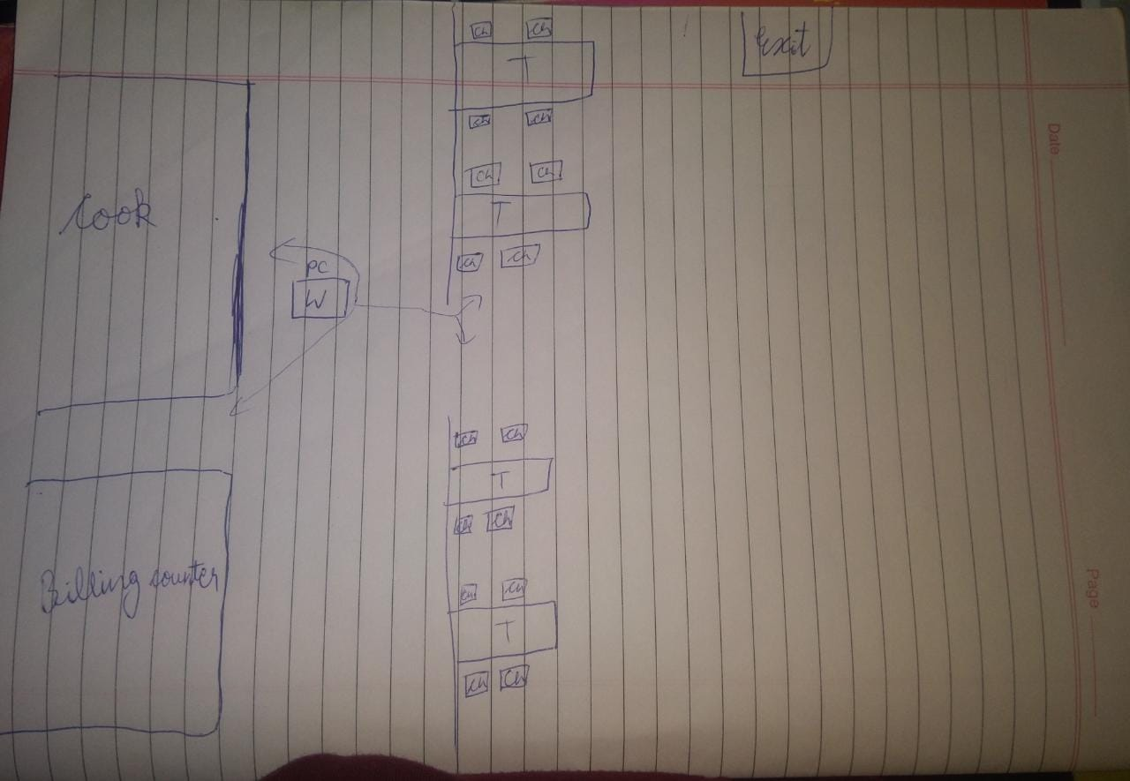

How do you plan to make your game engaging?

In this game the time after every costumer is served then at last a form is going to display which will require the name of costumers and their review or feedback.