CRM | PRODUCT REQUIREMENT DOCUMENT

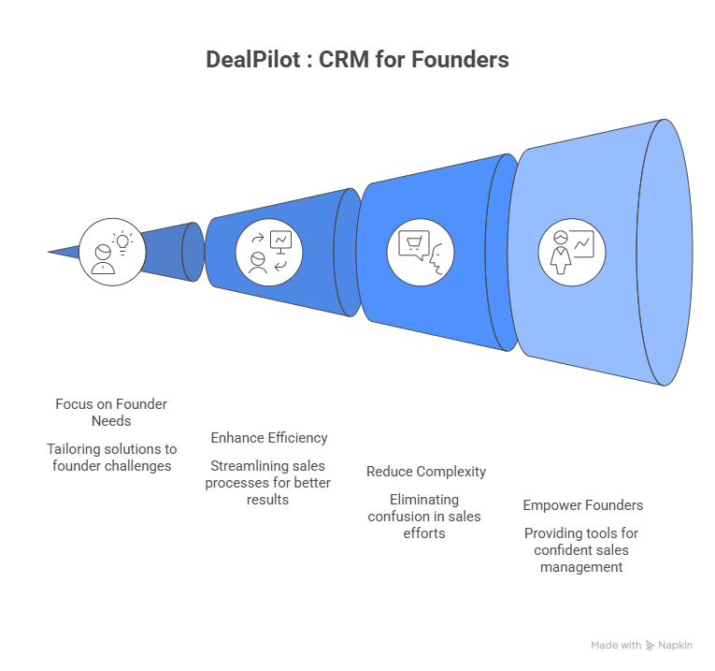

Group Prodigy
Aashik | Ameet | Eshwar | Gurleen | Piyush | Preeti | Soumya | Vijay | Yash

1.Problem Context
Why CRM Matters and Why Founders Are Getting It Wrong

1.1 The Memory of a Business
Every business begins as a conversation between two people.
A founder and an early customer initiate the conversation. On one side, there is a problem, and on the other, there is a solution. At that moment, the relationship is everything, and it is effortless to manage because it lives entirely inside the founder's head. They remember the customer's name, what they needed, how they liked to be contacted, and the little detail that closed the deal. It feels personal. Because it is.
Now fast-forward eighteen months. There are twelve people on the team. Leads are coming in from four different channels. The sales representative who handled a promising prospect last Tuesday is on leave today. The customer who was almost ready to sign two weeks ago has gone quiet, and nobody quite remembers where that conversation was left. The founder, who once knew every customer by name, is now two steps removed from the conversations that actually matter.
Nothing dramatic has happened. The business has made a good decision. It has simply grown, and growth, without a system to hold its memory, starts to feel like slow erosion. Relationships that were once warm become transactional. Opportunities that were once visible start slipping into silence.

1.2 So What Exactly Is CRM?
Strip away the acronym and the software and the sales deck, and CRM is a simple idea: that the relationships a business builds with its customers are its most valuable asset, more valuable than any product, any patent, or any piece of technology, and those relationships deserve to be managed with the same rigour and intentionality that a business brings to its finances, its operations, or its team.
In practice, that means one place where everything lives. Every conversation, every purchase, every complaint, every moment of delight, every signal that a customer might be drifting away. When it works, it means the sales representative who picks up a call already knows the customer's history before they say hello. It means the marketing team knows who to re-engage and when. It means a customer who bought from you three years ago is treated like the relationship, not like a stranger who wandered in off the street.
Without it, customer knowledge stays fragmented. In young companies, it resides in email inboxes, WhatsApp threads, and the memory of whoever took the last call. Larger companies scatter it across departments that rarely communicate with each other. The result is always the same: a business that knows less about its customers than it should and loses more opportunities than it realises.

1.3 The Journey Every Customer Takes
To really understand what CRM does, you have to understand what a customer journey actually looks like, not as a diagram on a whiteboard, but as something that happens to real people, in real time, with real consequences if it is handled well or badly.
It starts with a moment of awareness. Someone sees your brand for the first time, a post, a referral, an ad. They are strangers. Then something shifts, and they reach out. Now they are a prospect. If the experience of that first contact is positive, the customer becomes a lead. If the lead is nurtured, they become a customer. And if the customer is treated well, consistently, personally, attentively, they become something more valuable than any new lead you could ever generate: they become someone who comes back and brings others with them.
CRM is the system that makes each of those transitions intentional rather than accidental. It is the difference between a business that grows through luck and one that grows through design.
Most businesses focus almost all of their energy on the early stages: reach, acquisition, and closing the deal. CRM shifts the lens. The acquisition of a new customer is the most costly activity for any business. Keeping one, deepening a relationship, earning a referral, that is where the real economics of a healthy business actually live. And none of it is possible without the memory to sustain it.
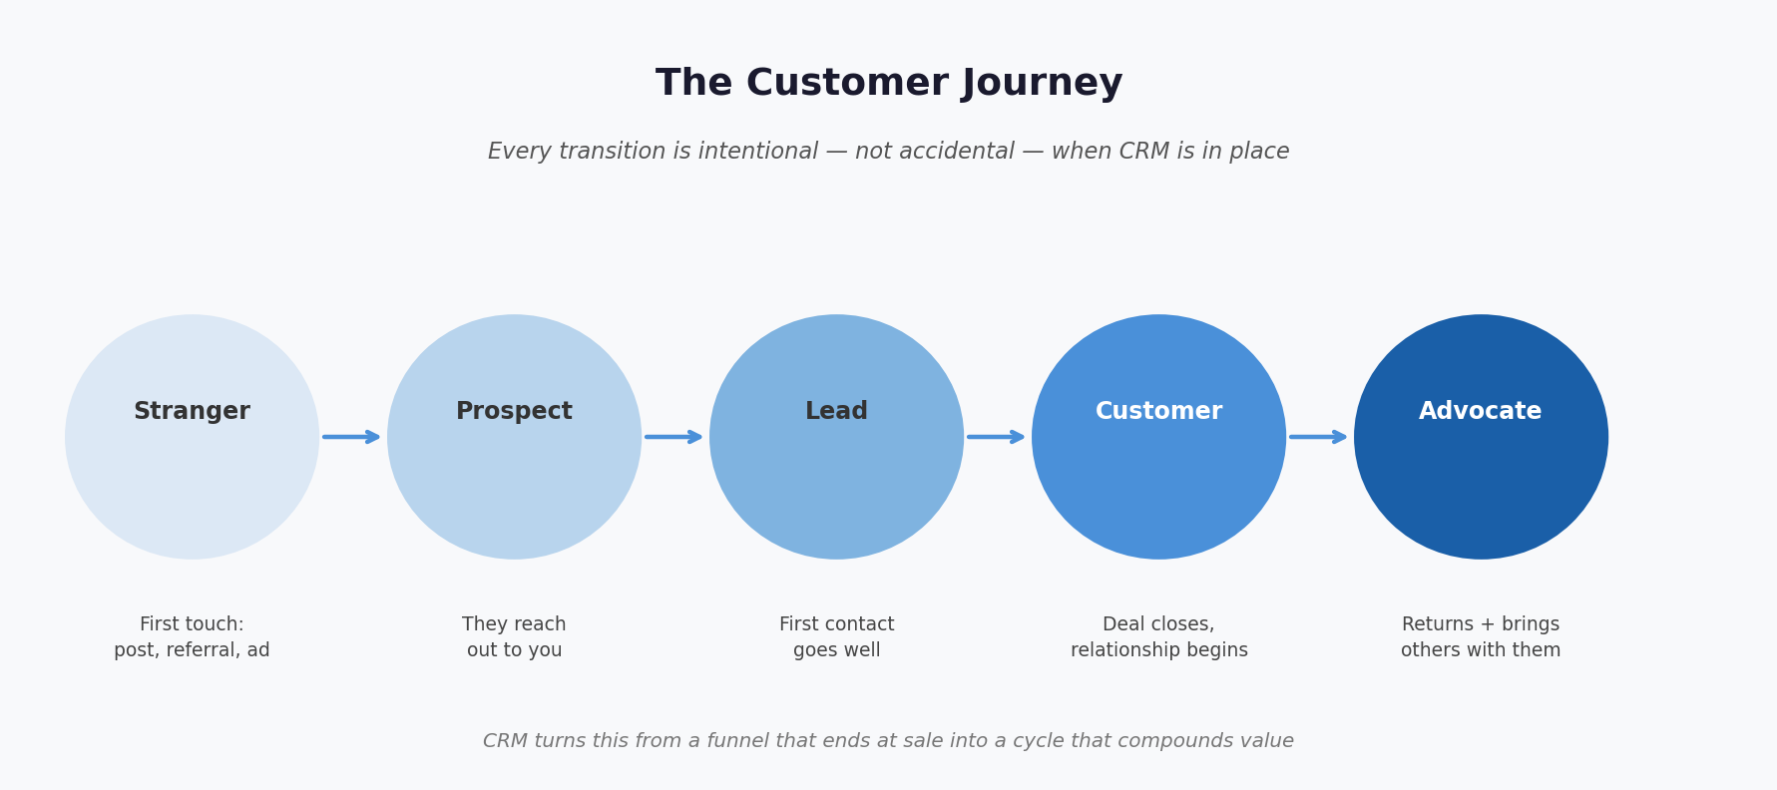

1.4 The Founder, the Tab, and the Spreadsheet That Won
Imagine you have been running your startup for about a year.
You have a product people are actually buying. You are running sales yourself: calls, WhatsApp messages, and follow-ups squeezed between everything else you are doing. Someone tells you that you need a CRM, and they are right. You know they are right, so you sign up for a free trial of one of the well known platforms.
You open it. There are fields for territory management. There is a module for setting up a lead scoring methodology. There are dashboards designed to give your VP of Sales visibility across their team's pipeline. There is a three-step onboarding wizard that assumes you have thirty minutes and a clear sense of what your sales process is.
You close the tab. The spreadsheet stays open.
This is not a story about a founder who does not understand the value of good systems. This is a story about a tool that was built for someone else entirely.

1.5 What founders actually need, and why it is different
Here is the thing that most CRM vendors have never really had to reckon with: the way a founder sells in the early stages of a startup is not a simpler version of how a sales team sells in a mature business. It is a fundamentally different activity.
A mature sales team executes a process that has already been defined. They know the ideal customer. They know the pitch. They know the objections and the answers. They have a playbook. Their job is to run it efficiently and consistently, and a CRM helps them do exactly that.
A founder in the first year is not executing a process. They are trying to discover what the process should be. Every conversation with a prospect is a piece of research, a test of whether the problem they think they are solving is the problem the customer actually feels, whether the language they are using resonates, whether the outcome they are promising is one someone will genuinely pay for. This is not sales. It is a discovery with a commercial edge.
Before you build a sales machine, you have to understand what you are selling, to whom, and why it works. The founder who skips this step does not scale sales, they scale confusion. The tragedy is not that founders skip this work. Most of them do it. They have hundreds of early conversations, learn an enormous amount, and figure out what works. The real tragedy is that almost none of it gets captured. It lives in their heads, and when the time comes to hire the first salesperson or to step back from day-to-day selling, all of that hard-won knowledge has to be reconstructed from memory, or lost entirely.
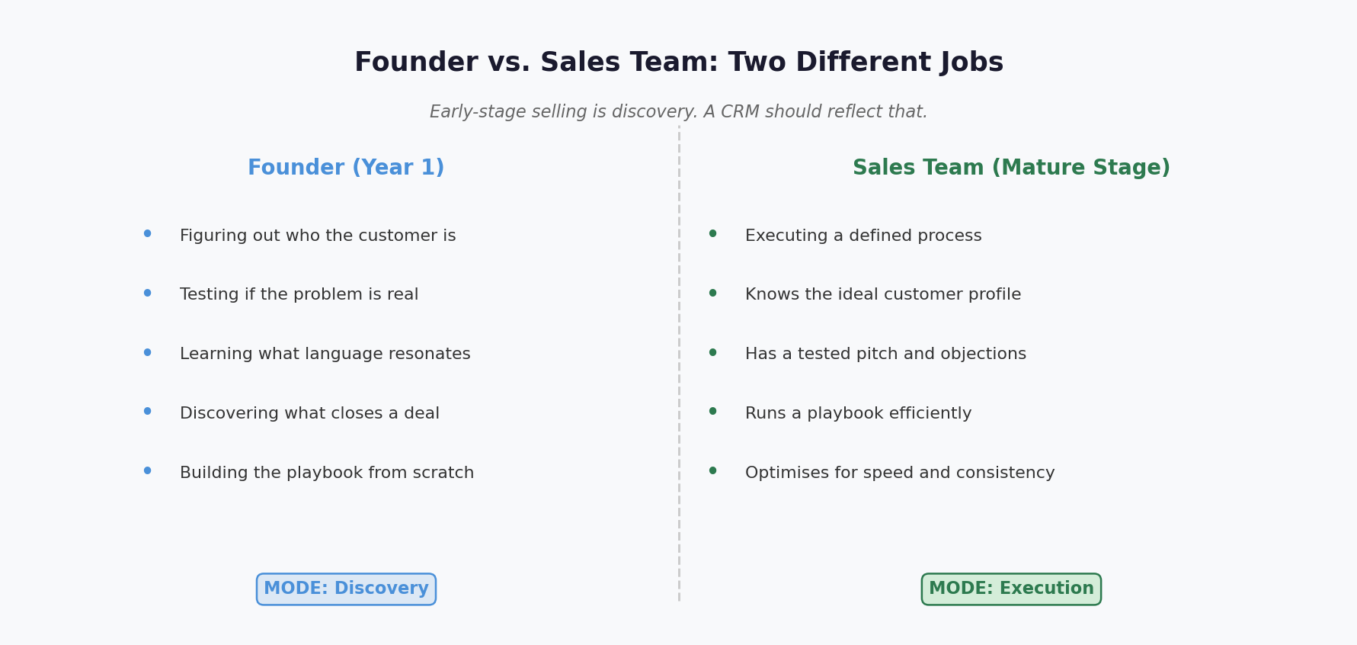

1.6 Why the Big CRMs Are the Wrong Answer
The platforms that dominate the CRM market were not designed for this moment. Salesforce was built for the enterprise. HubSpot for the team that already has a marketing function. They are powerful tools, for the right problem, at the right stage. But they carry enormous assumptions with them: that you have defined pipeline stages, that you have data entry discipline, that you have the time and the patience to configure a system before it will give anything back.
For a founder running at full speed, these tools create more friction than they remove. The onboarding is long. The customisation requires decisions that have not yet been made. The dashboards report on things that do not yet exist. And the price of all this, in time, in money, in mental energy, is too high for a team of three people trying to survive their first year.
So they abandon the CRM. And the spreadsheet wins. Not because the spreadsheet is good, but because it is frictionless. It does not ask for things you do not yet know.
The cost of this choice is invisible at first. Life goes on. Deals still close. But every conversation that goes unlogged is institutional knowledge that evaporates. Every follow-up that slips is a relationship that cools. And when the business eventually grows to the point where the founder can no longer hold it all in their head, when they genuinely need a system, they discover they are starting from scratch, with no history, no playbook, and no foundation to build on.
That is the hidden price of the wrong tool at the wrong moment.
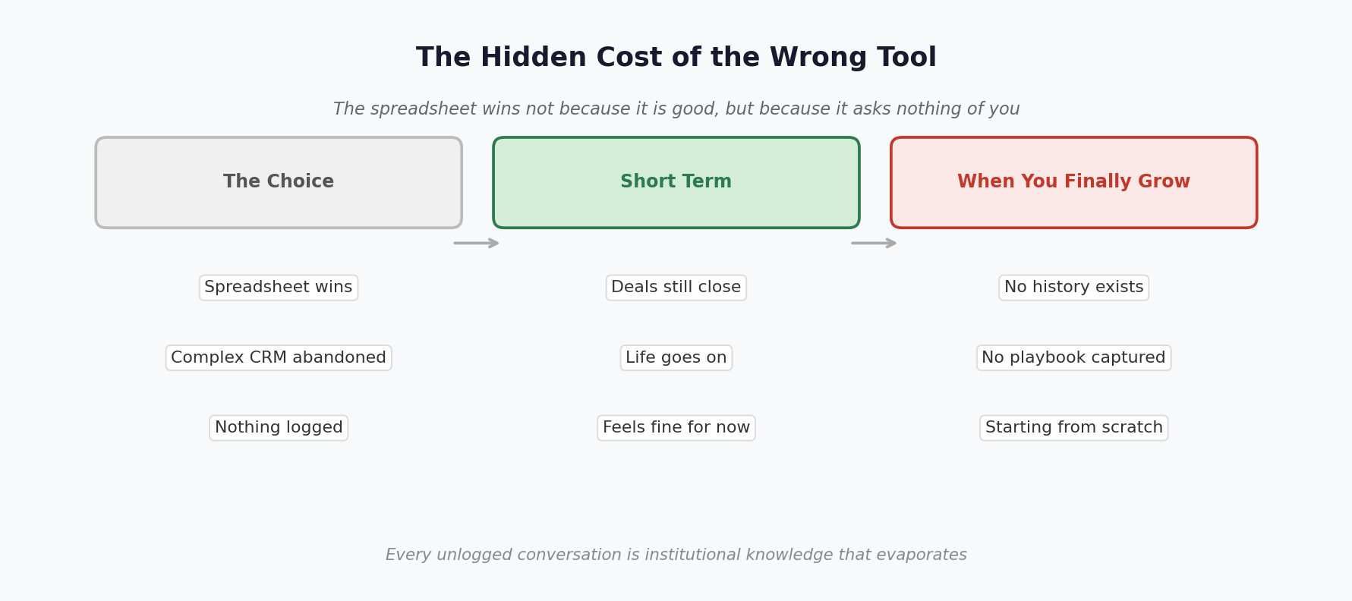

2. Market context
The CRM industry is one of the fastest-growing software markets in the world. The global CRM market was valued at $73.4 billion in 2024 and is projected to reach $163 billion by 2030, growing at a CAGR of 14.6%. As per INVESP study about 3 in 10 businesses said their main objective for using CRM software is increasing marketing productivity.
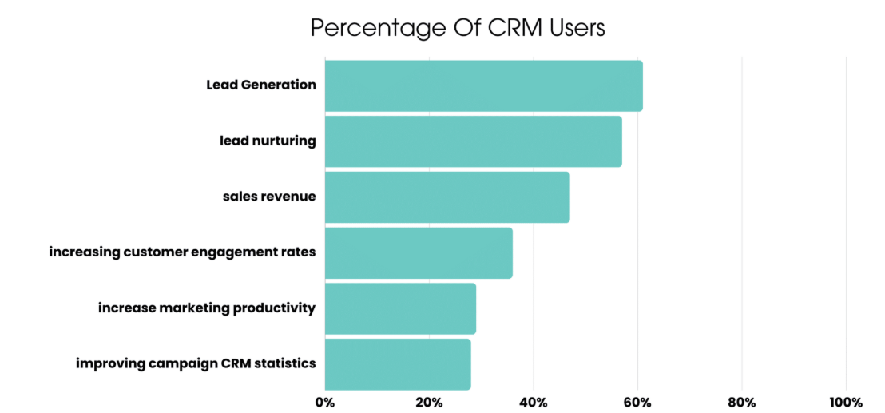Salesforce alone holds 23.9% of this market, more than the combined share of Microsoft, Oracle, SAP, and Adobe. Yet beneath this growth sits a structural blind spot. 91% of companies with 10 or more employees use a CRM, but only 50% of businesses with fewer than 10 employees do.
That gap is not accidental. It is the direct consequence of an industry that has spent two decades building for sales teams, not for the solo founder closing deals over WhatsApp at 11pm.
A typical founder is juggling live conversations at any given time spread across Gmail, WhatsApp, LinkedIn, and back-to-back calendar meetings. And despite all that activity, Salesforce found in a survey of 5,500 sales professionals that only 28% of their time actually goes toward selling. The other 71% disappears into admin work, data entry, and chasing down information that should already be in one place.
Industry research consistently shows that anywhere from 20–70% of CRM projects fail, with poor user adoption cited as the primary cause across every study.
For early-stage founders specifically, this failure is not a product deficiency, it is a category mismatch. Salesforce, HubSpot, and Pipedrive were engineered for coordinated sales teams with dedicated administrators.
A founder who is simultaneously the CEO, the SDR, the AE, and the customer success team has no time to be a CRM manager too. With the current stack early stage founder respond to whoever messages them most recently, follow up on whoever they happen to remember, and discover dead deals only when the lead finally goes cold enough to be unmistakable. They are not failing at sales. They are operating without a dashboard, making critical revenue decisions based on incomplete outdated information.
The founder’s willingness to maintain a parallel administrative system, on top of closing deals, does not exist. That is a product gap.The tools exist. The intelligence does not.
The opportunity this creates is large. The Asia Pacific CRM market is expected to grow at the highest CAGR through 2034, driven by emerging markets including India and Southeast Asia.
India alone has over 115,000 active startups, the vast majority of which are at exactly the 0–20 employee stage where this problem is most acute and where the current CRM market offers nothing that fits.

3. Primary Research
We interacted with a few founders to understand more about sales challenges. We also spent time understanding their early manual process for CRM, which they are currently using.

3.1 User Interviews – Two Founders, One Story
So we sat down with founders who were deep inside the problem, not at a comfortable distance from it. They were not reflecting on a challenge they had already solved. They were dealing with the issue week by week, fixing what they could and learning to live with what they couldn't.
Two conversations. Two completely different businesses. And yet, sitting with both transcripts afterwards, what was striking were not the differences. It was how much the same story kept coming up, told in different words, from different cities, in different industries.

3.1.1 Sanket and the System He Had to Build Himself
Sanket is not the kind of founder who reaches for a tool without understanding it first. He spent years at L&T managing complex engineering projects, then at Uber and Ola Electric learning how to build operational systems at scale. By the time he started Frevolt, a residential solar energy company, he knew better than most what it meant to run something with rigour.
So when his sales pipeline started getting complicated, he did the sensible thing. He looked at what was available. He evaluated HubSpot. He looked at a handful of similar platforms. And then he came to a conclusion that says everything about where the market is right now.

"Off-the-shelf tools ended at customer acquisition. But for us, every closed deal is just the beginning. A solar project has 40 to 45 tasks over two months. At 100 projects a month, that is 8,000 tasks in flight simultaneously. No standard CRM was built to hold that."
Sanket, Founder - Frevolt

So he built his own. It wasn't a choice he made but a necessity. He designed a full data architecture: user profiles, property profiles, and touchpoint logging across every stage of the funnel. He built dashboards that tracked the four conversion ratios he cared about. He ran daily standups with city-specific teams in Pune, Nashik, and Sangli. From the outside, it looked like a sophisticated operation.
But sit with Sanket for long enough, and the picture becomes more complicated, revealing issues such as inconsistent communication and varying levels of team engagement that contribute to the challenges he faces. Despite everything he had built, his CRM note compliance was sitting at around 50%. Half of all customer interactions were going unlogged. When a different rep picked up a lead, they had no context from the conversation that had come before. Duplicate leads were entering the system from Google, Facebook, and referrals simultaneously – inflating his numbers and causing multiple reps to call the same person. There was no automated follow-up. A customer who visited the site and went quiet got inconsistent treatment depending entirely on which rep happened to be paying attention that week.
And then there was the coaching problem. With ten sales reps potentially making a hundred calls a month each, Frevolt had roughly a thousand sales conversations happening every month with no mechanism to review them, no way to identify what was working, and no structured feedback for the reps who were struggling.

"Feedback relies entirely on daily stand-ups. It is too infrequent and too subjective to drive real improvement. I understand that we are not optimising performance, but we lack the necessary infrastructure to address this issue.
Sanket, Founder - Frevolt
https://www.frevolt.co/

What Sanket had built was genuinely impressive. And what it revealed, in being built, was that even a founder with the engineering capability to construct a custom CRM from scratch could not fully solve the underlying problem. The problem was not the tool. The problem was the absence of a tool designed for this kind of business, at this kind of stage, with this kind of complexity, which ultimately hindered the founder's ability to effectively manage customer relationships and scale the business.

3.1.2 Pradip Kuppaswami – The Founder Who Paid More to Sell Less
The second conversation had a different texture. A hospitality-tech founder, Pradip, is building a platform where 80% of the business comes through social media: Instagram, YouTube, and Facebook. Leads arrive quickly, at all hours, across channels that were never designed to feed a sales process. The pace is relentless. The margin for missed follow-up is thin.
He started where most founders start: phone calls, WhatsApp, emails, and a spreadsheet. It worked, up to a point. But as volume grew, the cracks became impossible to ignore. The gaps were causing a significant loss of information. Too many leads were going cold because of slow response or lost context. He knew he needed a system.
So he bought the TeleCRM specifically for the sales process. StayFlexy for hotel management and the social media agency, which was intended to streamline operations and improve efficiency in managing hotel bookings and customer interactions. On paper, everything appeared to be in order.
What happened next was the opposite of what he had expected.

"Operating costs went up after we adopted the CRM. Sales were actually better before. We are spending more, the tools do not talk to each other, and I still cannot tell you how many active deals we have right now without digging through three different places."
Pradip Kuppaswami – Hospitality Founder
https://orchidtree.in/

Every lead still had to be entered manually. TeleCRM didn't get data from Instagram, Facebook, or YouTube, even though most business came from those channels. A prospect who messaged at ten in the evening sat unacknowledged until someone at the office happened to see it the next morning. TeleCRM lacked an after-hours capture feature, an automated queue, and a trigger to ensure lead pickup.
TeleCRM and StayFlexy did not integrate. Sales knew nothing about what was happening on the operations side, and operations had no visibility into the sales pipeline. Every handoff between the two was a manual process - someone re-entering information that already existed, somewhere, in another system. Each integration they tried to build between their tools added to the monthly bill, and despite the costs, none of it measurably improved conversion rates or streamlined the communication between sales and operations. None of it measurably improved conversion.
He had not made a bad decision. He had made the only decision available to him, given the circumstances. And he had ended up in a situation that most founders eventually recognise, even if they cannot always articulate it: the CRM had failed to solve the chaos. It formalised it, added a line item to the budget, and made it slightly harder to change.

3.2 What Both Stories Are Really About
Sanket is a deeply systematic thinker who built his own infrastructure from scratch and still found the gaps. Pradip (hospitality founder) invested in established tools and ended up worse off than before, indicating that reliance on conventional solutions can sometimes lead to unexpected setbacks in business growth, such as decreased efficiency or missed opportunities for innovation, particularly when these tools do not align with the unique needs of the business or fail to adapt to changing market conditions. They come from different industries, different cities, and different moments in their company's life, yet they share a common challenge in that the system they needed did not exist. But they arrived at the same place.
The system they needed did not exist. This was not due to the infeasibility of its construction. But because no one has yet built it for them, for this stage, this kind of team, this particular moment between raw founder-led selling and the first steps toward a scalable revenue operation, they are left without the necessary tools to effectively transition into a more structured sales process.
In their words, during hours of conversation, they both identified a short list of missing elements. There was no automated follow-up; every next step depended on an individual rep's memory. There was no unified view of the customer across channels - the same person could be a lead, a contact, and a referral in three different systems simultaneously. There was no way to learn from sales conversations at scale - no recording, no feedback loop, no coaching infrastructure. The existing tools either assumed too much or offered too little, charging for sophistication that created no value.
Both of them were running their sales well. They were running it with the best tools available for this stage of the company. And those tools were not built for this stage of the company, which means they may not effectively address the specific needs and challenges that arise during this phase of growth.

That is the gap. This is not a feature gap within an existing product. A category gap refers to a stage of a company's sales journey that the market has yet to adequately address. The zero-to-one founder is tasked with simultaneously discovering and managing their sales process. The ten-person team, which has gained early traction, must identify and refine its successful strategies before scaling, particularly focusing on establishing a repeatable sales process that can sustain growth and prevent the need for constant rebuilding. This is the crucial juncture between the founder's instinct and the need for a repeatable process, where a well-designed system could mean the difference between creating a durable product and having to start over every year.

3.3. Problem Statement
Founders Are Losing Deals to a Tool That Was Never Built for Them
Every CRM on the market was designed on the assumption that its users will update it. For early-stage founders, that assumption is fatal.
The early-stage founder is the company's only salesperson. They carry the entire revenue pipeline in their head and across WhatsApp threads, email chains, LinkedIn DMs, and calendar invites simultaneously, alone, at speed. There is no sales ops team, no CRM admin, no RevOps function. There is only the founder, 150 active conversations, and a Notion template that stopped being updated three weeks ago. As a result, 30–40% of warm leads go dark, pipeline health is overestimated, follow-ups are missed, and revenue is lost, not because founders are undisciplined, but because no product has ever been built that captures, organises, and acts on their sales conversations without requiring them to stop selling to do it.

Globally, over 50 million startups are launched each year. The average seed-stage team in 2025 has just 6 employees down from 10 in 2021. In 35% of those startups, the founder is solo. Sales is not a department. It is the founder's entire Tuesday.

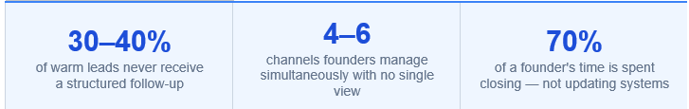

3.3.1 The Failure Modes

The breakdown is not a failure of the founder's work ethic or discipline. It is a structural mismatch between the tool's design contract and the user's reality.
The market offers two options, both wrong.
1) Enterprise CRMs (Salesforce, HubSpot, Zoho) are powerful but demand dedicated setup time, a team to populate them, and a minimum of 3 hours per week of manual upkeep, resources a founder does not have.
2) Lightweight CRMs (Pipedrive, Folk, Notion templates) are easy to set up but offer no intelligence, they are spreadsheets with better design.
Neither category has solved the core problem: zero-friction, automatic capture of multi-channel conversations into a live, intelligent pipeline.

The abandonment pattern is identical across all tools: the founder sets it up during a quiet week, uses it for 2–4 weeks, gets busy closing, stops updating it, and the CRM becomes fiction. Not because the founder failed because the tool demanded a behaviour the founder cannot sustain.

4. Current sales workflow of early stage founders
Most early-stage founders have no formal sales process. Instead, they operate in a reactive, relationship-driven mode where deals surface through personal networks and are tracked informally. The typical ESF sales journey looks like this:
Stage | What Happens | How Founders do It | Tools Used | Goal
Lead Discovery | Finding potential customers via referrals, ads, DMs, cold outreach | Referrals, LinkedIn DMs, cold WhatsApp messages, events | WhatsApp, LinkedIn, Instagram | Identify prospects
Qualification | Check if they actually need the product and can pay | Voice calls, WhatsApp messages, cold email to gauge fit | Phone, WhatsApp, Gmail | Avoid wasting time
First Conversation | Demo, call, or chat to explain value | Demo over call/Zoom or WhatsApp voice note; informal pitch | Zoom, Phone, WhatsApp | Generate interest
Follow-ups | Answer questions, handle objections | Manual reminders, memory, sticky notes; WhatsApp check-ins | Calendar reminders, WhatsApp | Build trust
Proposal | Send formal offer with pricing and scope | Google Docs or PDF sent over WhatsApp or email | Google Docs, Email, WhatsApp | Formalise intent
Negotiation / Decision | Pricing, timing, contract terms | WhatsApp voice notes, calls; informal back-and-forth | WhatsApp, Phone | Convert to paying customer
Closing | Payment / agreement | Verbal agreement, invoice via Razorpay / Stripe | Payment links, Email | Revenue
Post-Sale | Onboarding, retention, upsell | WhatsApp group created; manual check-ins | WhatsApp Groups | Retain & grow

4.1. Secondary research summary (Reddit, Quora, App Store reviews)

We reviewed discussions and reviews across Reddit, Quora, and Google Play store listings to understand (1) what growing small teams expect from a CRM and (2) where current CRMs fail in day-to-day use. A consistent pattern emerged: users are “graduating” from spreadsheets and want lightweight structure and follow-up automation,without paying for complexity, instability, or broken integrations.

4.1.1 What users are trying to achieve:
- Stay on top of relationships as volume grows: users report their “current setup isn’t holding up” and they “can’t rely on spreadsheets anymore.”
- Maintain visibility without admin overhead: they want clear pipeline/progress and next actions, but not spend time configuring or maintaining the tool, especially while mobile.

4.1.2 Features users are actively looking for
- Contact + communication capture
  - All contact info organized in one place, including email + text contacts
  - Auto-register/log phone calls with contacts
  - Convert emails/texts into To-Dos quickly
  - Nudges when they haven’t contacted someone in X days
  - Follow-up reminders when someone hasn’t responded to an email
- Sales execution support
  - Save files per account/contact
  - Email templates with files pre-attached (send info fast without rewriting/reattaching)
  - Send “individual emails to a group” (mass distribution but still personal)
- Product expectations (non-negotiables)
  - Easy for a small team, but strong enough for leads + customer tracking
  - Quick setup and simple daily use
  - Better visibility into prospects/customers without added complexity
  - Reasonable pricing
  - Reliable, complete syncing across tools when on the move (calendar, bookings, notes)

4.1.3 Pain points users raise (Reddit + Play store)
- Outgrowing spreadsheets: a trigger for adopting CRM, but also a point of frustration if the CRM adds overhead.
- Customization is painful and fragile: “every little change takes forever” and can break other workflows.
- Reporting is clunky: basic pipeline data is hard to pull without “jumping through hoops.”
- Integrations are unreliable-even within the same suite: sync “works okay,” but issues keep surfacing, especially for email/calendar.
- Calendar integration gaps break mobile workflows (Play store):
  - Users report they can’t rely on syncing across CRM + Calendar + related apps (e.g., notebook/notes, bookings), which is critical “if you’re on the move.”
  - One-way sync is a major complaint: events created in CRM appear in the calendar, but events created in the calendar do not show in CRM, forcing users to switch between apps to avoid double-booking.
- Mobile performance problems: sluggish basics (e.g., updating a deal stage), dashboards loading slowly-worse with custom fields.
- Time-to-value is too long: setup effort feels higher than daily benefit.

4.1.4 What users like about popular CRMs
- HubSpot: simple pipeline view; automations are “enough” for follow-ups; can scale into marketing automation.
- Pipedrive: beginner-friendly; clean, intuitive, sales-focused; visual pipeline makes deal status obvious; reminders and mail sync valued.
- Zoho CRM: budget-friendly, feature-rich; powerful once configured (but setup burden noted).
- Salesflare: easy to use; connects with Gmail/Outlook/LinkedIn; affordable; reduces manual tracking.
- SeoSamba: interest in AI-driven signals/engagement tracking (site analytics, newsletter opens/clicks, quote views).

4.1.5 Where CRMs disappoint (problems users report)
- Setup/configuration complexity (HubSpot, others): users feel they spend more time setting up than using.
- Getting lost in settings (Zoho): flexibility becomes a usability tax.
- Entry plans feel unusable for teams (HubSpot/Salesforce): strong frustration with forced upgrades and costs exceeding expectations.
- Reliability issues (Zoho/Odoo mentioned): instability harms core workflows (login issues, call log problems), including:
  - App crashes / stability issues
  - Data loss concerns (“my complete data disappeared”)
  - Contact-saving failures (core workflow breaks)
  - Limited customization on mobile → perceived outdated experience
- Critical integration failures (Play store): missing/partial integrations (calendar, bookings, notes) and one-way calendar sync reduce trust and productivity, directly impacting scheduling and follow-up.

4.1.6 Lead sources users mention
- Mostly inbound leads
- Referrals

References of the user requirements and problems faced by the actual users:

Feedback Reference 1
Feedback Reference 2
Feedback Reference 3
Feedback Reference 4
Feedback Reference 5
Feedback Reference 6
Feedback Reference 7

4.2 CRM Adoption Failure Among Early-Stage Founders
Category | Statistic | Insight
Overall CRM Implementation Failure | 30 - 70% of CRM projects fail to meet expectations | Buying a CRM does not guarantee sales process improvement. Early founders often adopt tools before having clear processes.
Failure to Achieve Objectives | 55% of CRM implementations fail to meet planned objectives | Most failures come from poor workflow alignment and low usage rather than technical issues.
Low User Adoption | Only 40% of companies achieve high CRM adoption (>90%) | Founders and sales reps often see CRM updates as extra work rather than a sales tool.
Primary Cause of Failure | 47% of CRM failures are due to poor user adoption | If logging data feels like manual admin work, founders abandon CRM usage quickly.
Manual Data Entry Friction | 23% of users cite manual data entry as the biggest obstacle | Early-stage founders already multitask; manual logging reduces adoption.
Revenue Impact | 37% of CRM users report revenue loss due to poor data quality | When founders stop updating CRM, pipeline visibility breaks and follow-ups are missed.
Feature Underutilization | 40% of companies use less than half of CRM features | Complex tools overwhelm small teams that only need simple deal tracking.
Training and Change Management | 41% report low utilization due to lack of training | Early startups rarely invest time in onboarding or process design.

Insights: Founders see CRM updates as administrative overhead rather than a productivity tool, as it requires constant manual updates (calls, emails, follow-ups) and they stop using them quickly. The biggest opportunity in CRM innovation for early founders is reducing manual data entry and making CRM passive (auto-capturing interactions) rather than expecting founders to maintain it manually.

4.3 Founder Time allocation in Early stages
Time Allocation | Evidence | Insight
Working long hours | 61% of founders work 50+ hours per week | Time-constrained and constantly context switching between tasks
Fundraising (early stage) | 42% of seed-stage founders spend over 50% of their time fundraising | Raising capital becomes a major time sink in the early startup phase
Hiring & team building | 44% of founders spend 30% of their time recruiting and building teams | Hiring the first employees becomes one of the biggest founder responsibilities
Product development & customer understanding | 47% say product work is the most valuable use of their time early on | Founders stay deeply involved in shaping the product and talking to users
Operational firefighting & reactive work | Startups involve constant context switching and “putting out fires” | Founders spend significant time reacting to issues rather than strategic work
Meetings & coordination overhead | 39% of founders say many meetings could have been emails | Communication and coordination consume significant founder time

Early stage founders operate across many roles and work long hours, administrative tasks like manually updating CRM systems become low-priority and are often skipped, even though sales conversations happen continuously across email, WhatsApp, and meetings.

4.4 The Follow up Gap
Lead Follow-Up Gap | Data | What It Indicates
Leads never followed up | 48% of salespeople never follow up with a prospect | Nearly half of potential deals die because no second outreach happens
Leads never contacted | 27% of B2B leads are never contacted at all | Many inbound leads never even receive the first response
Slow response time | Average lead response time is 42 hours | Most teams respond far too late when buyer intent has already dropped
Critical response window missed | Leads contacted within 5 minutes are 21× more likely to convert | Fast follow-up dramatically increases conversion probability
First responder advantage | 35–50% of sales go to the vendor who responds first | Speed often determines which company wins the deal
Lack of structured follow-up | 30% of businesses don’t have a formal follow-up process | Follow-ups are inconsistent and depend on memory

This gap happens because follow-up management is manual and memory-driven (emails, WhatsApp chats, meetings scattered across tools). As a result, founders often forget, delay, or lose track of leads, causing revenue leakage

4.5 Core Gaps:
1) No CRM captures deal activity passively. Every single tool in the market requires the founder to manually log, update, and maintain their pipeline. This assumed behaviour is embedded in every competitor's product design that founders keep updating CRM manually and consistently. Early-stage founders do not.
2) The most important sales channel for 500 million WhatsApp Business users in emerging markets is completely invisible to every CRM in existence. This is not a feature gap, it is a category gap.
3) For a early stage founder who has more active conversations and no time to build a scoring model there is no intelligence layer exists in CRM that could be delivered with minimum integration

4.6 Competitive Analysis

4.6.1 Competitive White Space Map 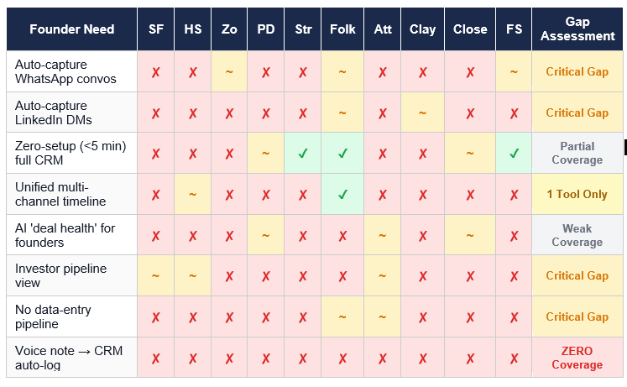
Insight: Only 1 tool (Folk partially) covers 3+ channels in a unified timeline, and even it requires manual steps for WhatsApp. The gap opportunity: An AI-native CRM that passively captures all conversations across WhatsApp, LinkedIn, email, and calls, surfaces next-best actions for the founder, and produces investor-ready pipeline reports automatically with zero data entry.

4.6.2 Unified Competitor Analysis

CRM | WHAT IT DOES WELL | WHERE IT FAILS THE FOUNDER | ABANDONMENT TRIGGER
HubSpot Free CRM (Most Tried, Most Abandoned) | Free forever plan with up to 1M contacts. Email tracking. Deal pipeline. Meeting scheduler. Recognised brand. | Built for marketing-driven SMBs, not sales-driven solo founders. The free plan has no automation; every follow-up is manual. Designed for teams of 5+, not one person. | Week 2–3: Deal stage updates go stale because the founder stopped dragging cards. Pipeline becomes fiction. The founder stops logging.
Pipedrive (Built for Sales Teams, Not Solo Founders) | Visual kanban pipeline. Activity-based selling reminders. 300+ integrations 100,000 companies worldwide. | 100% manual deal stage updates - if the founder misses a week, the pipeline is broken. Pricing $19–89/user. Add-ons (LeadBooster, Campaigns) inflate real cost. | Month 4–6: Manual deal stage updates are essential. Pipedrive's own users admit. Pipeline goes stale after the founder gets busy. Paid plan needed for any useful automation.
Attio (Most Sophisticated Next-Gen CRM) | 5,000 paying customers. Real-time data enrichment. Custom objects. AI-native architecture. Strong automation engine. | Many teams end up spending too much time configuring data models, keeping structure clean, and maintaining the system. Powerful but still requires intent to use. No WhatsApp capture. $29–69/user pricing grows fast. | Configuration overload: Attio is 'Lego bricks' powerful but needs an architect. Excel founder doesn't want to build a system; they want deals captured automatically.
Folk CRM | Simplest CRM onboarding available. Native WhatsApp integration (contact-level, not conversation capture). LinkedIn import. Email sequences. Clean Notion-inspired UI. $24/user/month. | ZERO automation. . 22% of Folk users cite missing automation as criticism. No mobile app. Deals feature are locked behind a paywall ($35/month). Reporting in beta with no customisation. | Month 2: Founder realises there are no automated follow-up triggers. Every reminder is manual. It's a beautiful spreadsheet, not an AI CRM. The 'WhatsApp integration' is contact-level, with no conversation capture.
Notion CRM Templates (Founders here on Upgrade Path) | Free or near-free. Flexible and customisable. 80+ CRM templates available. Founders already live in Notion. Familiar UX. Kanban pipeline view is possible. Integrates with Google Calendar. | No intelligence. Becomes cluttered as leads grow past 30. No email capture. No deal health scoring. Zapier is required for any automation, adding cost and complexity. | When leads hit 30–40, the database becomes a wall of rows with no clear 'what needs action today.' The founder spends 20 min scrolling instead of selling. The template was the destination, not the starting point.
Google Sheets / Excel (Behavioural · The Default State Where 100% of Founders Start) | Free. Zero setup. Universal. The founder already knows it. Works for 0–25 deals. Can add any columns needed. Portable. No vendor risk. | Cannot visualise the pipeline. No email/WhatsApp integration. No intelligence. No reminders. Data decays 2%/month. Siloed from where conversations actually happen. No forecast accuracy. No investor-ready output. | The missed deal moment: the founder gets a reply from a lead saying, 'We went with someone else last month.' They open the sheet and realise there was no system to prevent it, just rows of static text.

4.4.3 Pricing Comparison
Entry-level and tier-by-tier pricing across all 10 tools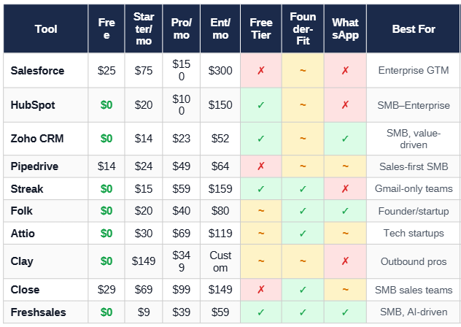
Insights: Effective entry price for a solo founder with full features ranges from $20–$40/month. Below that, critical features like automation and pipeline tracking are gated.
HubSpot's free tier is deceptively feature-poor for founders: workflow automation (their #1 need) requires the $100/user Professional plan.
Folk at $20/month offers the best founder value proposition: LinkedIn + WhatsApp + email + pipeline in one tool at a defensible price point.
Clay's pricing ($149+/month) prices out most pre-revenue founders entirely, it is an outbound power tool, not a relationship CRM.

5. User Persona

5.1 The Founder Who Sells  Role Founder / CEO (sole salesperson)  Company Stage Pre-seed to Series A (0–20 emp)  Age Range 28–45 (median successful: 42)  Background Technical (engg / CS / ops)  Sales Exp. Limited - learns on the job  Work Hours 60–100+ hrs/wk; 8–12 deep work  Active Deals 10–50 at any given time  Channels WhatsApp + Email + Phone + LinkedIn  CRM Budget ₹1,000–3,000/user/month | “I know I’m losing deals because nobody followed up. But I’d rather close the next deal than spend 20 minutes updating a CRM.”  - Composite from founder interviews  Goals  • Never miss a follow-up or forget a promise  • See pipeline health in <30 seconds  • Spend zero time on CRM admin  • Have investor-ready pipeline data on demand  Frustrations  • CRMs feel like a second job, not a tool  • Tools don’t talk to each other (silos)  • Team logging compliance is ~50%  • Can’t confidently answer “will I hit target?”

4–6  sales channels used daily | 70%  of time closing, not logging | 53%  of founders report burnout | 80%  of deals need 5–12 touches | <2 hrs  per day actually selling

5.1.1 Daily Time Allocation (at ~65 hrs/week)

Activity |  | Share | Hrs/Week
Sales & Customers |  | 35% | ~23 hrs
Product / Engineering |  | 25% | ~16 hrs
People & Hiring |  | 15% | ~10 hrs
Ops & Admin |  | 13% | ~8 hrs
Strategy & Fundraising |  | 12% | ~8 hrs
Sales share spikes to 50–60% during fundraising and first-customer acquisition phases.

5.1.2 Sales Channel Usage & Deal Flow

Channel | Primary Use | Frequency | % of Deals Touched
WhatsApp | Warm follow-ups, price negotiation, quick updates | 50–100 msgs/day | 80–90%
Phone / IVR | Discovery calls, objection handling, closing | 10–30 calls/day | 60–70%
Email | Proposals, formal docs, cold outreach | 15–40 emails/day | 40–60%
LinkedIn | Prospecting, warm intros, thought leadership | 3–5 DMs/day | 20–30%
Meta / Google Ads | Inbound lead capture (forms) | Always-on | 40–80% of top-of-funnel
In-Person | Site visits, demos, events | 2–4/week | 10–20%
A single deal spans 3–4 channels on average before close. WhatsApp is the dominant channel for Indian B2B founders - 98%+ open rates vs. 18–25% for email.

5.1.3 Current Tool Stack & CRM History

Tool | Used For | Status | Why It Failed / Stuck
Google Sheets | Pipeline tracker | Workaround | Free & simple, but breaks past ~20 deals. No reminders, no multi-user sync.
TeleCRM | Call logging, lead mgmt | Workaround | No IVR, poor reporting, no integration with ops tools (StayFlexy). Sales didn’t improve.
HubSpot | CRM evaluation | Rejected | Ends at acquisition - doesn’t cover project lifecycle. Too enterprise. Expensive at scale.
Zoho / Freshsales | CRM evaluation | Rejected | Not customizable to specific sales processes. Generic fields don’t fit domain needs.
WhatsApp Business | Customer comms | In Use | Primary channel but no CRM features. Messages stay in phone, no pipeline linkage.
Notion / Notes | Meeting notes | Workaround | Works for 1 person, impossible to search or share. No deal context linkage.
Custom-Built CRM | Full pipeline (Frevolt) | In Use | Built because nothing fit. But 50% logging compliance, no call intelligence, expensive to maintain.

Behavioral Traits  • Optimizes for speed over completeness  • Trusts memory over systems until it fails  • Resistant to tools that feel like “admin”  • Will use voice > typing for any input  • Makes decisions on gut, not data (by default) | When Pain Peaks  • Scaling past ~20 active deals  • Hiring first salesperson  • Investor asks for pipeline data  • Losing a deal due to missed follow-up  • Monthly revenue targets increase | Will Adopt If…  • Setup takes <1 hour  • Daily time cost <5 minutes  • Works inside WhatsApp + Gmail  • Zero manual data entry required  • Priced in INR, <₹3,000/user/mo

Primary: Interview 1 - Sanket, Founder of Frevolt Green Energy (solar, 10+ reps, custom CRM). Interview 2 - Hospitality startup founder (TeleCRM + StayFlexy, 2 sales agents).
Secondary: First Round Review - Founder Time Allocation | Yale SME CEO Time Study | a16z — Founder-Led Sales | SPOTIO Sales Statistics 2026 | Introhive — CRM Data Entry
HubSpot State of Sales 2024 | InsideSales — Lead Response Time | Kracov — Founder-Led Sales | Breakcold — AI CRM for Startups | CRM.org — Startup CRM Guide | Cerevity — Founder Burnout 2025 | AEA — Founder Age Study

6. Current User Journey

Early-stage founders start managing deals with Google Sheets and Notion, tools that work at first but collapse beyond 50+ deals with broken formulas, no pipeline visibility, and unreliable referral tracking. Searching for a CRM only leads to more friction like HubSpot is too complex to set up, Salesforce is overkill, Zoho is unstable, and all force costly upgrades. Even after adopting a CRM, founders spend 15-25% of their day on admin, log only half their touchpoints, have no automated follow-ups, and can't answer "will I hit my target this month?" with any confidence.
The result: decision-making by intuition, rising operational costs, and a sales process that depends entirely on the founder's memory.

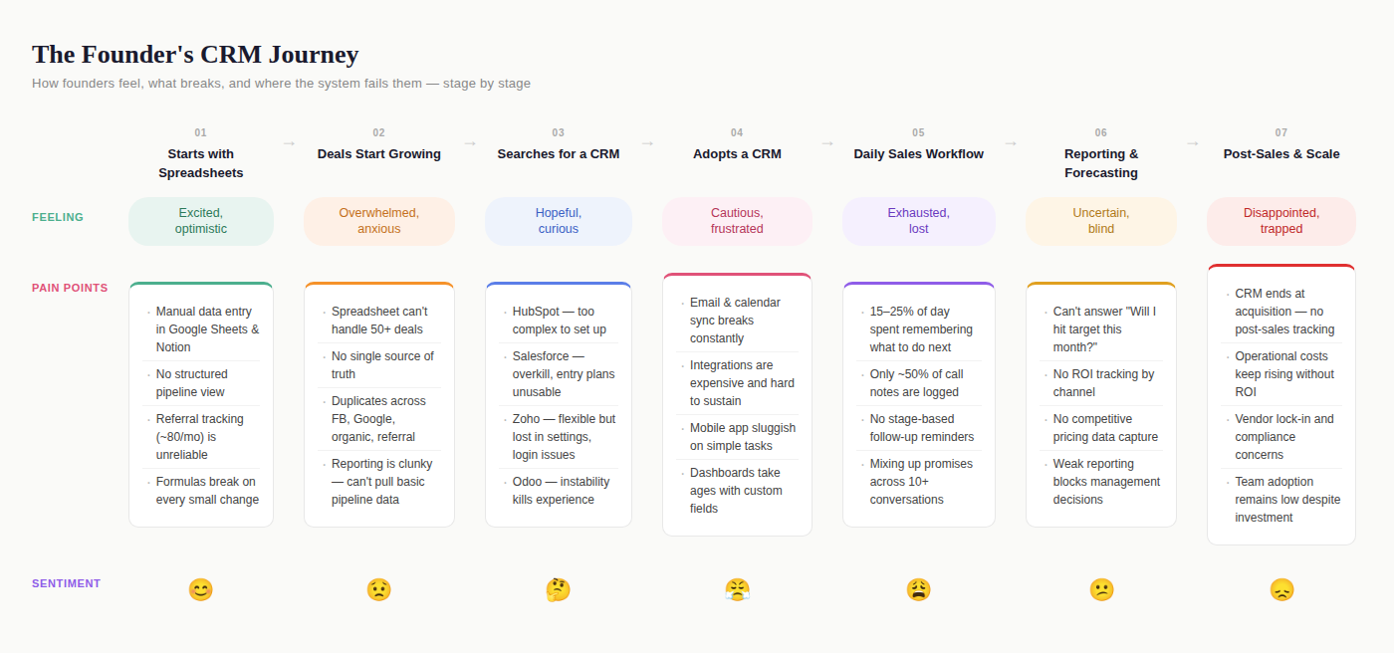

7. Pain Points Prioritization

7.1 Purpose
To focus the MVP on the pain points that most strongly block founders from reliably managing early sales across multiple channels,especially when they have 50–150 active conversations, use 4-6 communication channels, and spend most time selling rather than updating systems .

7.2 Evidence base
Pain points were synthesized from secondary research across User Interviews,Reddit, Quora, and Google Play reviews, reflecting founder/small-team CRM usage patterns and breakdowns in day-to-day workflows (follow-ups, scheduling, logging interactions, and mobile execution). The research aligns with the case’s core problem: traditional CRMs feel heavy, setup-intensive, and time-consuming to maintain, which contributes to missed structured follow-ups and reactive sales management .

7.3 Method used
We prioritized pain points using a simple evidence-weighted score: Priority Score = Impact (1–5) × Frequency (1–5). This highlights what most strongly affects founders’ core job-to-be-done: know what to do next, for whom, across channels, without becoming a full-time CRM admin

Pain point (statement) | Theme | Impact (1–5) | Frequency (1–5) | Priority Score (I×F) | Priority
Follow-up timing is salesperson-driven; no stage-based reminders/nudges | Follow-up / reminders / nudges | 5 | 5 | 25 | P0
Founders spend 15–25% of day remembering what to do next | Priority tasks | 4 | 5 | 20 | P0
Mixing up what was promised across 10+ active conversations | Multiple parallel conversations | 4 | 5 | 20 | P0
Integrations are expensive/complex to sustain across tools/lead sources | Multi-channel integration | 4 | 5 | 20 | P0
Poor visibility/reporting; hard to pull basic pipeline data | Funnel visibility / pipeline / performance | 5 | 4 | 20 | P0
Manual logging expected; ~50% compliance; feels like admin work | Manual data entry effort | 3 | 5 | 15 | P1
Cannot confidently answer “will I hit target this month?” | Sales prediction engine | 3 | 5 | 15 | P1
Mobile app sluggish for basic actions (e.g., update stage) | Mobile app accessibility | 3 | 3 | 9 | P2
CRM not tailored; customization/workarounds add ops burden | Customization / workflow fit | 3 | 3 | 9 | P2
CRMs end at acquisition; no post-sales tracking | Post-sales services | 2 | 2 | 4 | P3
CRM increases operating cost/complexity without clear conversion lift | Operational cost | 3 | 1 | 3 | P3
Duplicate leads across channels create attribution/dedup confusion | Duplicate leads (multi-channel) | 1 | 2 | 2 | P3
Security, compliance, governance | Security & compliance | 1 | 1 | 1 | P3
Referral tracking | Referral tracking | 0 | 0 | 0 | Backlog
Capture competitor quotes / market pricing from field | Competitor insights | 0 | 0 | 0 | Backlog

Overall Problem Space Feedback-
- Lot of rich insights and data that came up, no fault there. The document is well structured, it flows well together, extremely logical as well. Great job team!
- Would have loved to see AI features that are coming up in this market, how people are introducing them and the adoption of those as well.
- Would have loved to see pricing of the tools as well.

8. Solution Space

8.1 Solution Overview
DealPilot is a lightweight CRM designed for B2B founders at early-stage startups (0–20 employees) who personally handle sales. The product operates on a single design principle: the CRM should require less effort than the spreadsheet it replaces.
The solution is structured as a 4-layer architecture, where each successive layer requires incrementally more founder involvement from zero to minimal:
Layer | Name | Founder Effort | What It Does
Layer 1 | Passive Capture | Zero | Auto-syncs Gmail, WhatsApp, Calendar. Creates contacts. Stitches timelines. Moves deal stages.
Layer 2 | Intelligence | Glance (<30 sec) | Scores deal health. Ranks daily priorities. Generates morning brief. Calculates pipeline forecast.
Layer 3 | Suggested Actions | One tap | Drafts follow-up messages from templates. Pushes notifications. Founder approves, edits, or skips.
Layer 4 | Founder Input | 30–60 seconds | Voice-note logging after calls. 2-field post-meeting log. Manual overrides when needed.
This architecture is validated by analogous products that use the same “passive capture → intelligence → suggested action → minimal input” pattern.
Examples-Superhuman (email), Linear (project management), and Reclaim.ai (calendar intelligence).

8.1.1 Design Principles
These principles govern every feature decision in the solution space:
# | Principle | Rationale
1 | Rules first, AI later | Early-stage startups cannot absorb AI inference costs. Every “intelligent” feature in MVP and V1 uses rule-based logic, templates, and event triggers - not ML. AI enters only in V2+ when revenue justifies the cost.
2 | Capture as a side effect | Data should enter the CRM as a byproduct of actions the founder is already taking (sending emails, attending meetings, making calls) - never as a separate logging activity.
3 | Approve, don’t create | The system drafts; the founder approves. Reviewing a pre-written follow-up takes 5 seconds. Writing one from scratch takes 5 minutes. The cognitive load difference is 60×.
4 | WhatsApp is the primary channel | In India, WhatsApp has 98%+ open rates vs. 18–25% for email. Any CRM targeting Indian founders that doesn’t treat WhatsApp as a first-class channel is building for the wrong market.
5 | Three fields maximum | No form in DealPilot requires more than 3 fields to create a record. Every additional required field reduces completion rate by ~15% (Baymard Institute data).
6 | Show, don’t configure | Ship opinionated defaults. The founder should see value on day one without configuring anything. Customization is available but never required.

8.1.2 Pain Point → Solution Mapping

Every feature in DealPilot traces directly to a validated pain point from primary research:

Pain Point | Severity | Primary Feature(s) | Layer
No stage-based follow-up system | Critical | Auto Stage Movement, Follow-Up Drafts, Morning Brief | L1 (Passive Capture), L3 (Suggested Actions), L2 (Intelligence)
Manual data entry / ~50% compliance | Critical | Passive Capture (Gmail + WhatsApp), Voice Logger, Quick Log | L1 (Passive Capture),  L4(Founder Input)
Tool silos (CRM ≠ WhatsApp ≠ ops) | Critical | Unified Deal Timeline, Multi-Channel Sync | L1 (Passive Capture)
No real-time pipeline visibility | High | Auto Stages, Health Scoring, Dashboard Kanban | L1 (Passive Capture), L2 (Intelligence), Core
Mixing up promises across conversations | High | Unified Timeline, Pre-Call Brief, Voice Logger | L1 (Passive Capture), L2 (Intelligence), L4(Founder Input)
Cannot forecast revenue | High | Pipeline Calculator, Weighted Forecast | L2 (Intelligence)
CRM raised costs, didn’t raise sales | High | Template Follow-Ups, Action Center, Priority Ranker | L3 (Suggested Actions), L2 (Intelligence)
Duplicate leads across channels | High | Auto-Create + Dedup, Contact Merge | L1 (Passive Capture)

8.2 Primary Feature: Onboarding Data Integration

8.2.1 Purpose
The cold-start problem kills CRM adoption. A founder evaluating DealPilot has existing deals in Google Sheets, Notion, a previous CRM, or just their email inbox. If the first experience is an empty pipeline, they leave. Onboarding Data Integration ensures DealPilot is useful within the first session by populating the pipeline from where deals already live.
This feature directly addresses two validated pain points: “CRM setup too intensive” (Case Study) and “tool fragmentation across Google Sheets, Notion, and CRM” (Interview 2).

8.2.2 Supported Import Sources

Source | Method | Data Extracted | Priority
Google Sheets | OAuth connect → sheet selector → column mapping | Contact name, email, phone, deal value, stage, notes, dates | MVP
CSV / Excel file | File upload → drag-and-drop → column mapping | Same as above - any tabular data with at least name + email | MVP
Gmail Inbox Scan | OAuth connect → scan last 30 days → suggest contacts with frequent interaction | Contact name, email, company (from signature), last interaction date, thread count | MVP
Notion Database | API connect → database selector → property mapping | Contact name, deal properties, status, dates, notes | V1
HubSpot / Zoho Export | CSV export from source CRM → standard import flow | Full deal records - contacts, stages, values, activity history | V1
WhatsApp Chat Export | Chat export file (.txt) → parser → contact + message extraction | Contact name, phone, message history, last interaction | V2

8.2.3 User Flow
See Section 3: User Flow Diagrams → Flow 1: Onboarding Data Integration for the complete visual flow.
The onboarding import follows a 5-step pipeline: Source Selection → Column Mapping (spreadsheets) or Contact Scan (Gmail) → Validation → Deduplication → Confirmation. Key design decisions:
- All sources are non-exclusive - the founder can import from a spreadsheet AND scan Gmail in the same session.
- Column mapping uses auto-detection with manual override. Headers like “Name,” “Email,” “Amount,” “Stage” are matched via keyword matching (case-insensitive). Unrecognized columns are skipped.
- Stage value mapping converts source values (e.g., “Warm,” “Contacted,” “Pricing Sent”) to DealPilot stages using a keyword vocabulary table. Unrecognized values default to “New” and are flagged for review.
- Gmail scan filters exclude: internal domain emails, newsletters (unsubscribe header), automated/no-reply senders, and threads with fewer than 2 messages. Remaining contacts are ranked by thread count × recency × reply rate.
- Deduplication runs before record creation: exact email/phone → auto-merge; fuzzy name + same company → flag for founder decision; no match → create new record.

8.2.4 Edge Cases
Edge Case | System Behavior
Spreadsheet has no header row | Prompt: “We couldn’t detect column headers. Is the first row data or headers?” with toggle
Spreadsheet has >500 rows | Import in batches of 100. Show progress bar. Background process after first 100.
Gmail scan finds 0 deal-like contacts | Show: “No active deal conversations found in the last 30 days. You can adjust the scan period or import from a spreadsheet instead.”
Deal value in non-INR currency | Auto-detect currency symbol. Convert to INR using current exchange rate with a note: “Converted from USD at ₹83.2”
Google Sheets file has multiple tabs | Show tab selector: “Which sheet contains your deals?” with preview of first 3 rows per tab
Notion database has relation fields | Flatten relations to text values. Nested databases are not supported in V1.

8.3 User Flow Diagrams
This section consolidates the user flows for all four primary features. Each flow is presented as a flowchart diagram showing decision points, system actions, and founder interactions. The accompanying Mermaid source files can be rendered at mermaid.live or any Mermaid-compatible viewer.
Flow 1: Onboarding Data Integration
Scope: From import source selection through deduplication to a populated pipeline.
Key decision points: Source type (spreadsheet vs. Gmail scan vs. skip), column mapping validation, duplicate resolution (auto-merge vs. flag vs. create new).
Flow Diagram- FlowDiagram1.png
Flow 2: Rules-Based Auto Stage Movement
Scope: From activity event detection through rule evaluation to stage transition with undo capability.
Key decision points: Contact found?, Active deals exist?, Manual override active?, Cooldown check, Rule confidence level (High → auto-execute, Medium → ask founder), Founder undo within 1 hour.
Flow Diagram - FlowDiagram2.png
Flow 3: Voice-Note-to-CRM
Scope: From trigger (3 entry points) through recording, transcription, field extraction, review, to CRM update.
Key decision points: Trigger source (FAB / Deal Detail / Post-call prompt), Transcript quality (valid vs. inaudible), Field confidence (all high → clean review, some uncertain → flagged review), Save or discard.
Flow Diagram - FlowDiagram3.png
Flow 4: Unified Deal Timeline Capture
Scope: From multi-channel event ingestion through contact/deal matching, activity record creation, encryption, cross-channel threading, to timeline rendering.
Key decision points: Contact match (found / auto-create / discard), Deal match (single / multiple / none), Cross-channel threading (same contact + <24hr gap → linked cluster vs. standalone entry).
Flow Diagram - FlowDiagram4.png

8.4 Primary Feature:

8.4.1 Rules-Based Auto Stage Movement

Purpose
Founders don’t update deal stages. Interview 1 (Sanket) confirmed: “Follow-up timing is entirely salesperson-driven. No stage-based reminders exist.” Interview 2 confirmed: CRM logging compliance is ~50%. The result is a pipeline that looks frozen even when deals are progressing,destroying forecast accuracy and visibility.
Auto Stage Movement solves this by listening to activity signals (email replies, meetings scheduled, proposals sent) and moving deals through the pipeline automatically. No manual dragging, no data entry, no stage dropdown updates.
Architecture
The system operates as an event-driven rule engine:
[Activity Event] → [Rule Match?] → [Stage Transition] → [Side Effects]
It runs on the application’s existing database infrastructure with zero per-execution cost - no external API calls, no ML inference, no AI spend.
Default Rules
DealPilot ships with 6 default rules. These are pre-configured during onboarding and active immediately. The founder can modify, disable, or add rules in Settings → Pipeline Setup.

Rule # | Trigger Event | Current Stage(s) | New Stage | Confidence | Side Effects
R1 | Email reply received from contact | New | Engaged | High | Update “Last Contacted” timestamp
R2 | WhatsApp reply received from contact | New | Engaged | High | Update “Last Contacted” timestamp
R3 | Calendar meeting scheduled with contact (detected via attendee email match) | New, Engaged | Demo Booked | High | Create pre-call brief reminder; set meeting date on deal
R4 | Email sent with attachment (PDF, DOCX, XLSX) to contact | Engaged, Demo Booked | Proposal Sent | Medium | Log attachment filename; start proposal follow-up timer
R5 | Email containing pricing keywords (“quote,” “pricing,” “proposal,” “contract,” “invoice,” “payment terms”) sent to contact | Engaged, Demo Booked | Proposal Sent | Medium | Same as R4
R6 | Payment received / invoice paid (manual trigger or integration) | Proposal Sent, Negotiation | Won | High | Update deal value to actual; trigger won celebration

Rule Execution Logic
See Section 3: User Flow Diagrams → Flow 2: Auto Stage Movement for the complete event processing pipeline.
The rule engine processes events through a 7-step pipeline: Event Ingestion → Contact Resolution → Deal Lookup → Override Check → Cooldown Check → Rule Evaluation → Stage Transition + Side Effects.
Execution Constraints:
Constraint | Rule | Rationale
Forward-only movement | Deals can only auto-advance forward (New → Engaged, not Engaged → New) | Prevents false regressions. Backward movement requires manual override.
One transition per event | A single event can trigger at most one stage change per deal | Prevents cascade chains (e.g., email with attachment jumping New → Engaged → Proposal Sent)
Cooldown period | 5-minute cooldown between auto-transitions for the same deal | Prevents rapid-fire stage changes from burst activity
Manual override priority | Any manual stage change by the founder overrides auto-movement for 24 hours | Respects founder intent - if they manually moved a deal back, the system shouldn’t fight them
Confidence gating | Medium-confidence rules (keyword detection) show a confirmation prompt instead of auto-executing | Prevents false positives on ambiguous signals

Rule Customization
Founders can create custom rules in Settings → Pipeline Setup → Auto Stage Rules. The rule builder uses a simple sentence structure:
WHEN [trigger dropdown] happens on a deal in [stage dropdown] → MOVE to [stage dropdown]
Available triggers:
Trigger | Detection Method | Confidence
Email reply received | Gmail API history.list() - new message in thread where contact is sender | High
Email sent to contact | Gmail API - new message in thread where contact is recipient | High
Email with attachment sent | Gmail API - sent message + payload.parts[].filename exists | High
WhatsApp message received | WhatsApp Cloud API webhook - messages event | High
WhatsApp message sent | WhatsApp Cloud API webhook - statuses.sent event | High
Calendar meeting scheduled | Calendar API push - new event where contact email is in attendees | High
Calendar meeting completed | Calendar API - event end time has passed | High
Phone call logged | Layer 4 voice note mentioning contact, or manual call log | Medium
Pricing keywords detected | NLP keyword match on email subject/body: “quote,” “pricing,” “proposal,” “contract,” “terms,” “invoice” | Medium
No activity for N days | Daily cron job - NOW() - last_activity_date > N | High

Edge Cases & Failure States

Scenario | System Behavior
Email reply is from a colleague (CC’d), not the deal contact | No stage change - rule only fires when the sender’s email matches the deal contact’s email
A meeting is scheduled but later cancelled | Meeting cancellation event detected → revert to previous stage only if the deal hasn’t progressed further since
Contact has multiple active deals | Rule applies to the deal most recently active (by last_activity_date). If ambiguous, apply to all matching deals and surface a notification: “Stage updated on 2 deals for Priya - verify in pipeline.”
Internal email thread (founder to team member, CC’ing client) | Exclude emails where all participants are internal domain. Only fire rules when at least one external participant matches a deal contact.
Attachment is a signature image, not a proposal | Filter attachments: skip files <10KB (signature images), skip image-only files (PNG, JPG, GIF). Only trigger on PDF, DOCX, XLSX, PPTX, or ZIP.
Founder manually moves deal backward (e.g., Negotiation → Demo Booked) | 24-hour override period - auto-rules are suppressed for this deal. Log: “Auto-movement paused - manual override by [Founder] at [time].”
WhatsApp message is a broadcast, not a personal message | WhatsApp Cloud API provides context.from - only fire rules for direct messages, not broadcast or group messages

Transparency & Trust
Auto-movement is the highest-trust feature in the product. A single false positive (deal moved to the wrong stage) destroys confidence. Trust-building mechanisms:
Mechanism | Description
Stage change notifications | Every auto-transition generates an in-app notification: “DealPilot moved ‘Solar Enterprise Q1’ from Engaged → Demo Booked (meeting detected with Priya at 2:30 PM)”
Timeline annotation | Auto-transitions appear in the deal timeline with a ⚙️ system icon and the trigger event: “⚙️ Stage changed: Engaged → Demo Booked
Undo within 1 hour | Every auto-transition includes an “Undo” link in the notification. Tapping it reverts the deal to the previous stage immediately.
Rule activity log | Settings → Pipeline Setup shows a log of the last 50 auto-transitions: timestamp, deal, from/to stage, trigger, rule ID. Founders can audit what the system is doing.
Confidence indicator | Rules display a confidence level (High / Medium) in the rule list. Medium-confidence rules (keyword detection) show a confirmation prompt to the founder instead of auto-executing.

8.4.2 Voice-Note-to-CRM
Purpose
Interview 1 (Sanket): “Sales consultants are expected to manually log call notes. Observed compliance is around 50%.” Interview 2: “Founders are unwilling to manually enter data after every call - it feels like admin, not selling.”
Voice-Note-to-CRM replaces typing with talking. After a sales call, the founder records a 30-second voice note. The system transcribes it, extracts structured deal fields (stage update, next action, promises, timeline), and presents them for one-tap confirmation. The entire flow takes under 60 seconds.
This feature targets the single largest data quality gap in founder-led CRM: post-call logging.
Technical Architecture
[Voice Recording] → [Speech-to-Text] → [Field Extraction] → [Review UI] → [CRM Update]
(client) (Whisper API) (Rule-based + (client) (server)
$0.006/min keyword matching)
Cost model for 100 calls/month at 30 seconds average (50 minutes total):
Component | Provider | Cost
Speech-to-text | OpenAI Whisper API | ~$0.30/month
Field extraction (rule-based) | Internal logic, no external API | $0
Field extraction (V2: LLM) | GPT-4o-mini for complex notes | ~$2–5/month
Total |  | <$6/month
The Whisper API handles Hindi, Marathi, and Hinglish (Hindi-English code-switching) natively across 50+ languages. For V2, Sarvam AI’s Saaras v3 model offers India-optimized transcription across 22 Indian languages.
User Flow
See Section 3: User Flow Diagrams → Flow 3: Voice-Note-to-CRM for the complete 6-state flow.
The voice logging flow has 6 states: Trigger → Record → Process → Extract → Review → Save. Key design decisions:
Three entry points ensure the feature is always accessible: (1) Floating Action Button on every screen (general), (2) Deal Detail quick-add bar (deal pre-linked), (3) Post-call auto-prompt 2 minutes after a calendar meeting ends (deal + contact pre-linked).
Recording is capped at 2 minutes. Most founder notes are 15–30 seconds. The mic button pulses with a red ring and shows a waveform visualization.
Field extraction uses rule-based keyword matching (no LLM in MVP):
Field | Extraction Method | Example
Deal | Match contact/company names from existing records | “Spoke to Amit from SolarMax” → Deal: SolarMax Enterprise
Stage Update | Keyword → stage vocabulary map | “He wants a pilot” → Negotiation
Next Action | Sentences with action verbs after “need to,” “should,” “will” | “Need to loop in CTO” → Schedule call with CTO
Timeline | Date/time entity extraction | “by January” → January 2027
Promises | Sentences with “I told him,” “we agreed,” “I’ll send” | “10% discount on annual” → Promise logged
Key Notes | Remainder not captured by other fields | “Also evaluating Zoho” → Notes
Review screen shows the transcript (editable) and extracted fields with confidence indicators: ✓ (high confidence) or ? (uncertain, highlighted with yellow border). The founder edits only what’s wrong and taps Save.
Edge Cases
Scenario | System Behavior
Transcript is empty or inaudible | Show: “We couldn’t transcribe this recording. Try again in a quieter environment, or type your notes instead.” Offer text input fallback.
No deal match found in transcript | Show deal dropdown with “Select a deal” placeholder. Auto-suggest top 3 most recent deals. Allow “Create new deal” inline.
Founder speaks in mixed Hindi-English (Hinglish) | Whisper handles Hinglish natively. Field extraction keywords include Hindi equivalents: “bhejenge” (will send), “meeting rakh do” (schedule meeting), “price bataya” (shared pricing).
Recording is >2 minutes | Auto-stop at 2:00 with message: “Recording saved (2:00). For longer notes, you can record multiple clips.” Process the full 2 minutes.
Multiple deals mentioned in one note | Extract the primary deal (most keywords associated). Flag: “This note may relate to multiple deals. Currently linked to [Deal A]. Add to [Deal B] as well?”
Founder says “delete that” or “actually, scratch that” | V1: Ignore - founder edits in review screen. V2: Detect correction language and remove the preceding sentence from transcript.
Field extraction returns zero fields | Show transcript only, with empty field cards and placeholder text: “We couldn’t extract structured fields. You can fill them in manually or just save as a note.”

8.4.3 Unified Deal Timeline
Purpose
Interview 1 (Sanket) described founders “mixing up what was promised to which client - especially with 10+ active conversations.” Interview 2 reported needing to “check three different places - email sent folder, the spreadsheet, and your calendar - to understand the last interaction with a prospect.”
The Unified Deal Timeline collapses every interaction with a deal contact - across every channel - into a single, chronological, auto-populated thread. It is the source of truth for “what happened with this deal?”
Data Model
Every entry in the timeline is an Activity Record with a standard schema:
Field | Type | Description
activity_id | UUID | Unique identifier
deal_id | FK → Deals | Associated deal
contact_id | FK → Contacts | Associated contact
channel | Enum | email, whatsapp, phone, calendar, note, voice_note, system
direction | Enum | inbound, outbound, system
timestamp | DateTime | When the activity occurred (email sent time, meeting start, note creation)
subject | String (nullable) | Email subject line; meeting title; null for WhatsApp/phone
body_preview | String (255 chars) | First 255 characters of message content or note text
body_full | Text (encrypted) | Full content - encrypted at rest, decrypted only for the owning user
attachments | JSON Array | List of attachment filenames and types (no content stored)
metadata | JSON | Channel-specific data: email thread ID, WhatsApp message ID, calendar event ID
stage_at_time | String | The deal stage when this activity occurred - enables historical context
created_by | Enum | auto_capture, manual, voice_note, system

8.4.4 Channel-Specific Capture Logic
See Section 3: User Flow Diagrams → Flow 4: Unified Deal Timeline for the complete capture-to-render pipeline.
Each channel follows the same processing pattern: Ingest → Parse → Contact Match → Deal Match → Create Activity Record → Encrypt → Thread → Render. Channel-specific details:
Channel | Ingestion | Key Data Extracted | Limitations
Gmail | Pub/Sub push → history.list() | Subject, body preview (255 chars), attachments (name + type), thread ID, direction | Full body encrypted at rest. CASA certification needed for production.
WhatsApp | Cloud API webhook (messages + statuses) | Message text, media type, direction, phone number | Forward-only capture - no historical messages before integration date.
Google Calendar | HTTPS push notification | Event title, attendees + RSVP, start/end time, conference link, description | Cannot distinguish meeting type (sales vs. internal) - uses heuristics.
Phone / Voice | Voice note (Layer 4) or manual log | Transcript, duration, extracted fields, audio reference | Requires founder to record. No auto-capture without IVR integration (V2).
Manual Notes | Direct input from Deal Detail | Text content, timestamp | No auto-capture - founder-initiated only.
Contact matching resolves the sender/recipient to an existing Contact record via email or phone. If auto-create is enabled and no match is found, a new Contact + Deal is created automatically.
Deal matching links the activity to the most recently active deal for that contact. If multiple active deals exist, the system links to the most recent and notifies the founder.

8.4.5 Timeline Rendering
Sort order: Reverse chronological (newest first). This matches how founders think: “what happened most recently?”
Grouping: Activities are grouped by day with date headers (“Today,” “Yesterday,” “March 5, 2026”). Within a day, sorted by timestamp.
Visual hierarchy:
Channel | Icon | Color Accent | Typical Entry
Email | 📧 | Blue | “Email sent: Proposal for Q1 deployment - 2 attachments”
WhatsApp | 💬 | Green | “WhatsApp: Discussed pricing, client asked about bulk discount”
Phone/Call | 📞 | Orange | “Call logged: 15 min - outcome: positive, next: send contract”
Calendar | 📅 | Purple | “Meeting: Product demo with Priya + CTO - 30 min - Google Meet”
Voice Note | 🎙️ | Teal | “Voice note: ‘Spoke to Amit, wants pilot in Jan, loop in CTO’” (with playable audio)
Manual Note | 📝 | Grey | “Note added: Client prefers annual billing over monthly”
System | ⚙️ | Light grey | “Stage changed: Engaged → Demo Booked”
Interaction patterns:
Action | Behavior
Tap on email entry | Expands to show full email body (collapsible)
Tap on WhatsApp entry | Expands to show full message text
Tap on voice note | Plays audio inline + shows transcript
Tap on calendar entry | Shows: attendees, conference link, duration, meeting notes (if Quick Log was completed)
Tap on system entry | Shows: rule that triggered the action + “Undo” link (if within 1 hour)

8.4.6 Cross-Channel Threading
The key technical challenge: linking activities across channels to the same conversation thread.
Scenario | Threading Logic
Email → WhatsApp follow-up | Same contact + within 24 hours = likely same thread. Display with visual connector line.
Multiple email threads with same contact | Group by Gmail threadId. Different threads show as separate timeline clusters.
Meeting → Post-meeting email | Calendar event attendee match + email sent within 2 hours of meeting end = linked.
WhatsApp → Phone call → Voice note | Same contact + within 30-minute window = linked cluster.
Threading is informational, not structural - all activities are stored as independent records. Thread linkage is computed at render time using the heuristics above. This avoids the complexity of maintaining thread state across channels.

8.4.7 Privacy & Data Handling
Concern | Implementation
Email body content | Encrypted at rest (AES-256). Decrypted only for the authenticated deal owner. Never used for analytics or ML training.
WhatsApp messages | Same encryption standard. Messages visible only to authenticated users with deal access.
Shared deals (V3: team mode) | Activity content visible to all team members assigned to the deal. Toggle per-deal: “Share activity content with team” (default: on).
Right to erasure | “Delete all data for this contact” removes all activity records, voice notes, transcripts, and deal history. Irreversible.
Data retention | Activity records retained for the lifetime of the account. Voice note audio files retained for 12 months, then auto-deleted (transcript text retained).

8.5. Reference Features
The following features are part of the DealPilot solution space but are not detailed in this PRD iteration. They are documented at summary level with their target phase.

8.5.1 Layer 2 - Intelligence Features
Feature | Phase | Summary
Deal Health Scoring (G/Y/R) | MVP | Rule-based: Green (<3 days since contact), Yellow (4–7 days), Red (7+ days). Displayed as colored dot on every deal card. Configurable thresholds in Settings.
Priority Ranking Formula | MVP | Score = Deal Value × Days Since Touch × Stage Weight. Surfaces top 5 deals in “Today’s Focus” strip on dashboard.
Morning Brief | MVP | Daily digest pushed at 8 AM: top deals needing action, today’s meetings with context, pipeline summary, overnight leads. In-app screen + WhatsApp push (V1).
Pre-Call Context Brief | V1 | 30 minutes before a calendar meeting: push notification with last 3 interactions, promises made, deal stage, and key notes for the contact.
Pipeline Calculator / Weighted Forecast | MVP | Total pipeline × stage probability = weighted forecast. “Will I hit target?” confidence meter on dashboard. Stage probabilities configurable.
Weekly Pipeline Report | V2 | Auto-generated: deals won/lost, avg cycle, stage bottlenecks, channel ROI. Exportable PDF for investor sharing.

8.5.2 Layer 3 - Suggested Actions Features
Feature | Phase | Summary
Template-Based Follow-Up Drafts | MVP | System picks message template based on deal stage + days since last touch. Personalizes with {{contact_name}}, {{deal_value}}, etc. Ships with 5 default templates.
One-Tap Approve / Edit / Skip | MVP | Core interaction pattern for all suggested actions. Approve sends immediately. Edit opens composer. Skip snoozes (2hrs / tomorrow / next week).
Action Center | MVP | Central queue of all pending suggested actions, sorted by priority. Progress bar. Empty state celebration when queue is cleared.
Multi-Channel Notifications | V1 | WhatsApp (urgent + AM brief), Push (real-time), Email (weekly digest). Configurable per event type. BSP cost for WhatsApp notifications.
Smart Follow-Up Sequences | V2 | Rule-based sequences: “If no reply in 3 days → send Nudge 1. If no reply in 5 more days → send Nudge 2. After 3 nudges → flag as at-risk.”
Speed-to-Response Alert | V1 | Urgent push when new lead arrives and no response within 5 minutes. Escalate at 30 min and 2 hours. Based on InsideSales data: 5-min response = 21× qualification rate.

8.5.3 Layer 4 - Additional Input Features
Feature | Phase | Summary
Post-Meeting Quick Log | MVP | Auto-triggered 5 min after calendar meeting ends. 2 fields: Outcome (dropdown: Positive / Follow-up / Info Requested / Lost / On Hold) + Next Step (text or voice). <10 seconds to complete.
Manual Deal Creation | MVP | Minimal form: Contact Name + Deal Value + Stage (required). Company, Source, Notes (optional). Auto-suggest existing contacts. <15 seconds to create.
Call Recording + Summarization | V3 | Record sales calls with consent, auto-generate summary + action items + deal update. Sanket’s #1 wishlist item. Deferred due to high build complexity and consent UX requirements.

8.6 Core Infrastructure Features
Feature | Phase | Summary
Single-Screen Dashboard | MVP | Three zones: Today’s Focus (top), Pipeline Kanban (center), Quick Stats (bottom). The “home” screen - founder assesses pipeline in <30 seconds.
Onboarding Flow | MVP | 3 steps: Connect Channels → Set Up Pipeline → Import Deals. Smart defaults. Every step skippable. <5 minutes total.
Contact List + Merge Duplicates | V1 | Auto-captured contacts with search, filters, source icons. Duplicate detection + merge flow.
Templates Manager | V1 | Create/edit message templates with merge variables. 5 defaults. Usage stats. Powers all Layer 3 actions.
Settings (Channels, Pipeline, Notifications) | V1 | Configure channel connections, deal stages + auto-rules, notification preferences + quiet hours.
Analytics & Reports | V2 | 6 founder-friendly charts: funnel, deal flow, channel performance, follow-up effectiveness. Export PDF.
Mobile PWA | V2 | Lightweight progressive web app. <2 taps to update. Offline queueing.
Team Mode (Multi-User) | V3 | Add sales reps. Assign deals. Shared pipeline. Role-based visibility.
Sales Hire Onboarding Playbook | V3 | Auto-generated playbook from founder’s deal history: stages, patterns, talk tracks.
Investor Dashboard Export | V2 | One-click PDF: ARR forecast, deal velocity, funnel conversion, channel ROI.

8. 7 Technical Decisions & Constraints
Decision | Choice | Rationale
Gmail API access | Middleware (Zapier/Pipedream) for MVP; direct API with CASA certification for V1 | CASA costs $5K–$75K and takes 2–6 months. Middleware avoids this for launch.
WhatsApp integration | BSP (Interakt or Gallabox) for V1 | Direct Cloud API requires FB Business verification. BSP handles compliance. ₹799–5K/month.
Speech-to-text | OpenAI Whisper API | $0.006/min. Handles Hindi, Marathi, Hinglish. Good accuracy. Cheapest production-ready option.
Field extraction (voice notes) | Rule-based keyword matching for MVP; GPT-4o-mini for V2 | Rule-based is free and fast. LLM adds ~$5/month but handles complex/ambiguous notes better.
Database | PostgreSQL (Supabase) | Consistent with the team’s existing stack. Row-level security for multi-user V3. Real-time subscriptions for live timeline updates.
Frontend | FlutterFlow (prototype) → React (production) | FlutterFlow for rapid case study prototype. React + Tailwind for production mobile-responsive web app.
Hosting | Supabase (DB) + Vercel (frontend) + Cloudflare Workers (webhooks) | Low-cost, scalable. Supabase free tier covers MVP. Cloudflare Workers handle webhook processing at edge.
Pricing model | ₹999/user/month (INR pricing) | Based on market research: Indian startup CRM budget is ₹1,000–3,000/user. Below TeleCRM (₹599 but limited), above spreadsheets (free).

8.8 Wireframes - CRM wireframes

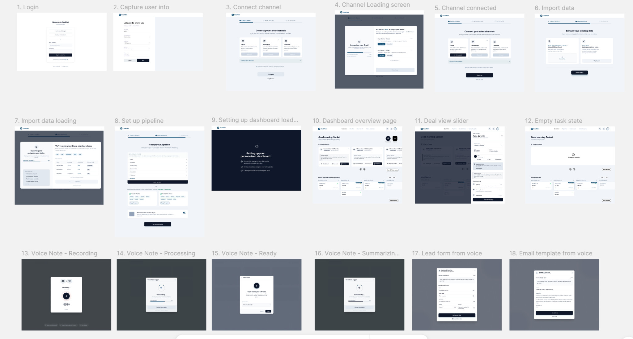

9. Success Metrics
All success metrics for the primary features are consolidated below. These metrics define the acceptance criteria for each feature and should be tracked from day one of launch.

9.1 Onboarding Data Integration

Metric | Target | How We Measure
Import completion rate | >70% of users who start import finish it | Funnel analytics: start → complete
Time to first populated pipeline | <10 minutes from signup | Event timestamp: signup → first deal created
Column mapping accuracy (auto-detect) | >80% columns correctly mapped without manual override | Override rate on auto-detected mappings
Duplicate detection precision | >90% true positives in flagged duplicates | Manual audit of flagged duplicates vs. actual duplicates

9.2 Rules-Based Auto Stage Movement

Metric | Target | How We Measure
Auto-transition accuracy | >90% correct (founder does not undo) | Undo rate per rule: undo events / total transitions
Manual stage updates replaced | >60% of all stage changes are auto-triggered | Event source analysis: auto vs. manual drag
Pipeline staleness reduction | Avg “days since last stage update” decreases by >50% | Before/after comparison at 30-day mark
Rule undo rate | <10% across all active rules | Undo events / total auto-transitions

9.3 Voice-Note-to-CRM

Metric | Target | How We Measure
Voice note adoption rate | >40% of active deals have at least 1 voice note | Deal records with voice_note attachment
Transcription accuracy | >90% word accuracy for Indian English and Hinglish | Founder edit rate on transcript text (edits / total words)
Field extraction accuracy | >70% of extracted fields accepted without edit | Edit rate per field type (stage, next action, timeline)
Post-call logging rate improvement | From ~50% baseline to >80% | Deals with activity logged within 30 min of calendar meeting end
Time to complete full voice log | <60 seconds (record + review + save) | Client-side timing from mic-tap to save-tap

9.4 Unified Deal Timeline

Metric | Target | How We Measure
Timeline completeness | >80% of deal interactions captured automatically | Activities where created_by = auto_capture / total activities
Cross-channel coverage | >50% of active deals have activities from 2+ channels | Distinct channel count per deal
Time to find deal context | <10 seconds to answer “when did I last talk to this person?” | User research task timing (moderated test)
Timeline engagement | Founders view deal timeline >3× per active deal per week | Screen view analytics: deal_detail views / active deals

9.5 North Star Metrics (Product-Level)
These aggregate metrics track whether DealPilot is delivering on its core promise: making the founder a better seller without making them a CRM manager.
Metric | Target | Baseline (Without CRM) | How We Measure
Daily CRM time | <5 minutes/day | 15–25 min (spreadsheet maintenance) | Session duration analytics
Follow-up coverage | >80% of warm leads receive structured follow-up | 27–30% (HBR/InsideSales baseline) | Leads with ≥1 follow-up activity / total leads
Lead response time | <30 minutes average | 42 hours (HBR 2024 baseline) | Time from lead creation to first outbound activity
Pipeline data confidence | Founder answers “pipeline value?” in <10 seconds | 30+ min spreadsheet archaeology | User research timing + survey (1–5 confidence)
Deal stage accuracy | >85% of deals in correct stage at any point | Unknown - most founders don’t track stages | Spot-check audit: actual state vs. CRM state
Founder retention (W4) | >60% weekly active at week 4 | Industry avg: 26% CRM adoption rate (FullEnrich) | WAU at day 28 / total signups

10. Trade-offs and Limitations
Every design decision in DealPilot involves a deliberate trade-off. This section documents what we chose, what we gave up, and why.

10.1 Design Trade-offs
Decision | Chose | Gave Up | Why It’s Worth It
Rules over AI/ML | If-else logic, templates, keyword matching for MVP + V1 | Accuracy on ambiguous inputs (~30% of voice fields, ~10% of auto-stage triggers need manual correction) | AI costs $50–200/mo - prohibitive for pre-revenue startups. A 70% accurate system founders use beats a 95% accurate one they can’t afford. AI enters V2 when revenue justifies it.
Single-user first | Solo founder architecture; no team features in MVP/V1 | Shared pipeline, deal assignment, role-based access | Multi-user = 3–5× schema complexity. 80% of target users sell solo. Risk: founders who hire in month 2–3 hit a wall before V3 team mode.
Opinionated defaults over configurability | 6 stages, 5 templates, fixed thresholds - zero setup required | Flexibility for non-standard sales processes (Frevolt’s 40-task lifecycle, hospitality booking fields) | Interview 2: “CRM raised costs, didn’t raise sales” - setup overhead killed adoption. Defaults work for 90%. Customization opens in V1.
Forward-only auto staging | Deals auto-advance only, never auto-regress | Auto-handling backward movement (cancelled demo, lost champion, frozen budget) | One false regression destroys trust and forecast simultaneously. Backward movement must be deliberate (manual). Stale deals are caught by health scoring (→ red → Action Center).
Template follow-ups over AI generation | Founder-written templates with merge variables; system selects, never generates | AI-drafted emails that adapt tone and reference deal-specific context | AI risks tone mismatch, hallucinated claims, and impersonal feel. Indian B2B sales depend on personal relationships - sounding like the founder matters more than convenience.

10.2. Known Limitations
Area | Limitation | Impact | Resolution Path
WhatsApp | No group chat or voice/video call capture via API | Group deal discussions invisible | Manual voice-note logging. Depends on Meta API roadmap.
WhatsApp | Forward-only capture (no history import) | Pre-integration deals have timeline gaps | Disclosed at setup. Onboarding import fills metadata gap.
Gmail | Middleware adds 1–5 min sync delay; free tier = 100 tasks/mo | Slight lag; power users hit cap | Direct API in V1. Paid middleware ($20/mo) as interim.
STT | Whisper ~85–90% accuracy for Hindi/Hinglish | Transcription errors need correction | Review screen for edits. Sarvam AI (India-optimized) in V2.
Calendar | Cannot classify meeting type (sales vs. internal) | Internal meetings may trigger deal activity | Heuristic: exclude all-internal-domain attendees + title keywords.
Offline | No offline capability in MVP | Spotty connectivity = no access | PWA with offline queue in V2. Voice notes recordable offline.
Scope | Not a Salesforce/HubSpot replacement | Founders with >50 deals or >5 reps outgrow it | Graduation to enterprise CRM is a success metric, not failure.

11. References:

Why Early-Stage Startups Don't Need a Traditional Go-to-Market Strategy
https://blog.salesflare.com/crm-challenges
[https://www.pipedrive.com/en/crm-comparison/pipedrive-vs-salesforce
https://www.pipedrive.com/en/crm-comparison/pipedrive-vs-odoo-crm
https://www.pipedrive.com/en/crm-comparison/pipedrive-vs-freshworks
https://www.pipedrive.com/en/crm-comparison/pipedrive-vs-monday
https://www.pipedrive.com/en/crm-comparison/pipedrive-vs-zoho
https://www.pipedrive.com/en/crm-comparison/pipedrive-vs-zoho]
https://www.hubspot.com/products/crm/startups
https://www.affinity.co/blog/crm-adoption-rates
https://www.demandsage.com/crm-statistics/
https://assets.ctfassets.net/f43wltp2j5se/2gHMpCURXzpMW7PJ3SlWZJ/3cad8d7e8496abbd3c0f99d5c7f16ef4/salesforce-state-of-sales-report-6-ed.pdf
https://www.salesforce.com/news/stories/sales-research-2023/
https://www.digitalsilk.com/digital-trends/crm-statistics/
Overall Feedback on the Solution Space-
- Great job here as well, solutions are detailed, the features make sense, they are written well, scoped out well. Good job here too!
- Loved the fact that you also made wireframes and uploaded them before you moved to the actual building of the prototype.
- Would have loved a little more detailing on the analytics and reporting side. What are you planning to show there and why?
- Predictive actions are also missing. Eg- You just finished a phone call with Preeti. Log that data now to ensure all action items are covered
Overall great job!

Feedback on Prototype-
- The UI of the app could be better. It seems like not a lot of thought went into the text, color scheme and icons on the platform and are default lovable ones.
- The UX can be better, eg- I dont know where to log my voice memos from. Its not obvious to me and I saw this because of a Pro tip.
- This is not an MVP, so some of the features are not working I guess, but great job overall!

