|  |
| --- |
|  |
| **Principles of Programming Language CS-611** |
| Assignment-3 |
|  |
| **Gurleen Kaur Sudan** |
| **02/11/2016** |

|  |
| --- |
|  |

**Github username-**gurleenkaur16

**Part 3:**

**Q1. What is GitHub? When was it created? Why? By who? What similar platforms exist? Why would you use such a platform?**

**Ans***.* Git Hub is a web-based Git repository hosting service.

Git Hub platform is created on 1st October 2007.

It is a platform where users can collaborate on or adopt open source code projects, fork code, share ideas and more.

Linus Torvalds invented GitHub.

**Similar platforms**- ALLURA, CHILIPROJECT, BITBUCKET, KILN, CODEPLANE

This platform is used because when developers are creating an application, for example, they are making constant changes to the code and releasing new versions , upto and after the first official release. It helps in collaboration and also helps new and existing users to make use of the publically uploaded projects.

**Part 4:**

**Screenshots of different commands used in GitHub:**

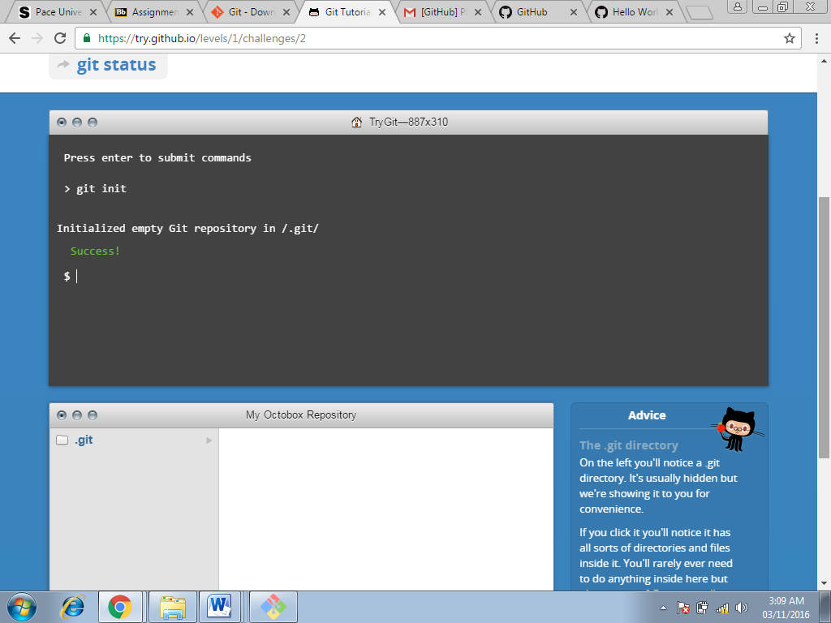`

**Command used at this step:**

**Git init command (Screenshot-1)**

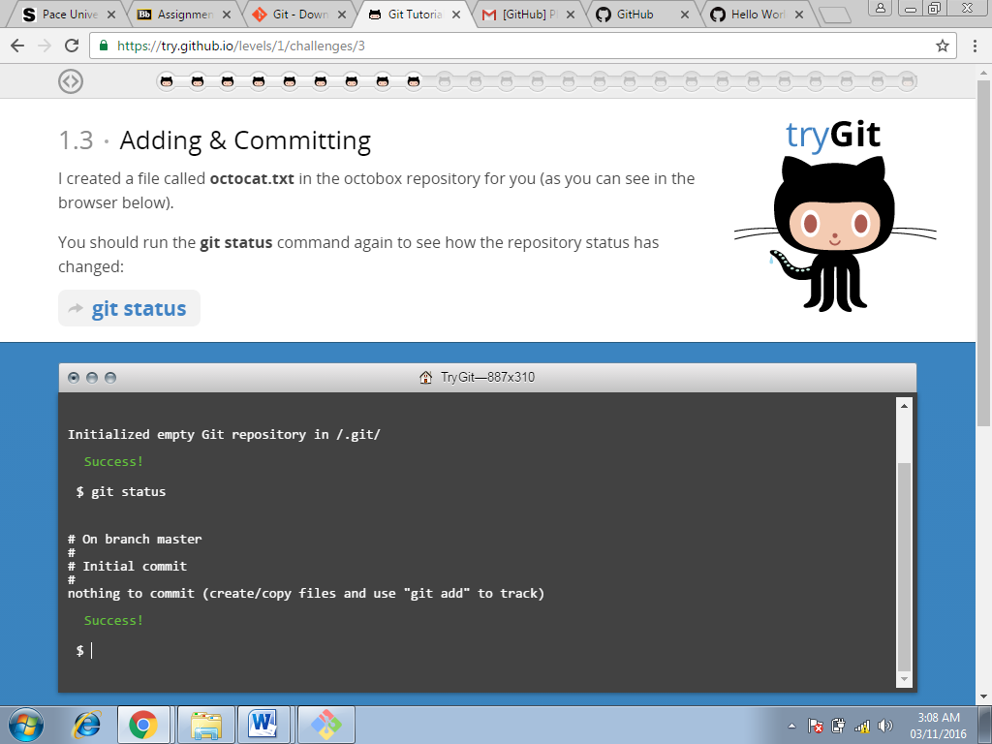

**Command used at this step:**

**Git status (Screenshot-2)**

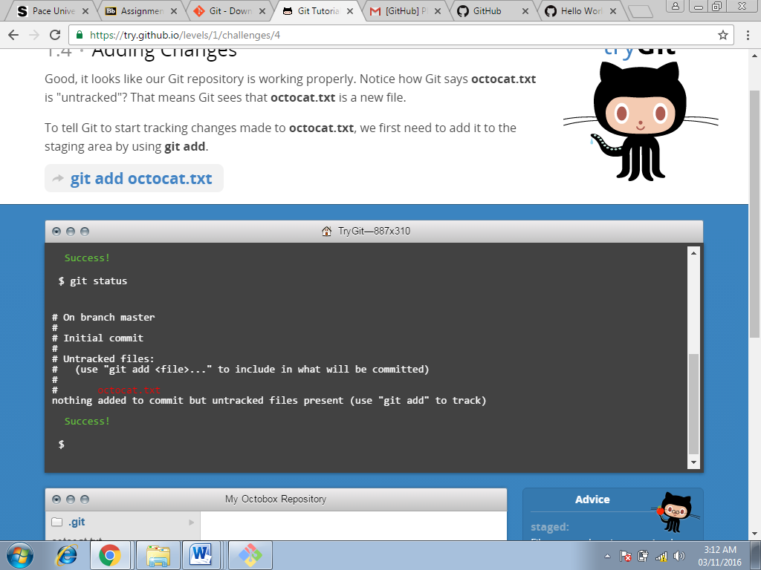

**Command used at this step:**

**Git add octocat.txt command (Screenshot-3)**

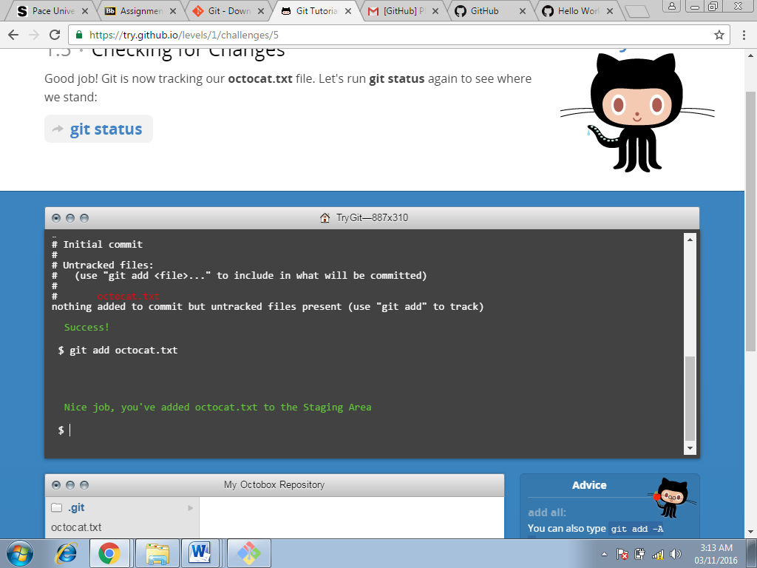

**Command used at this step:**

**Git add command(Screenshot-4)**

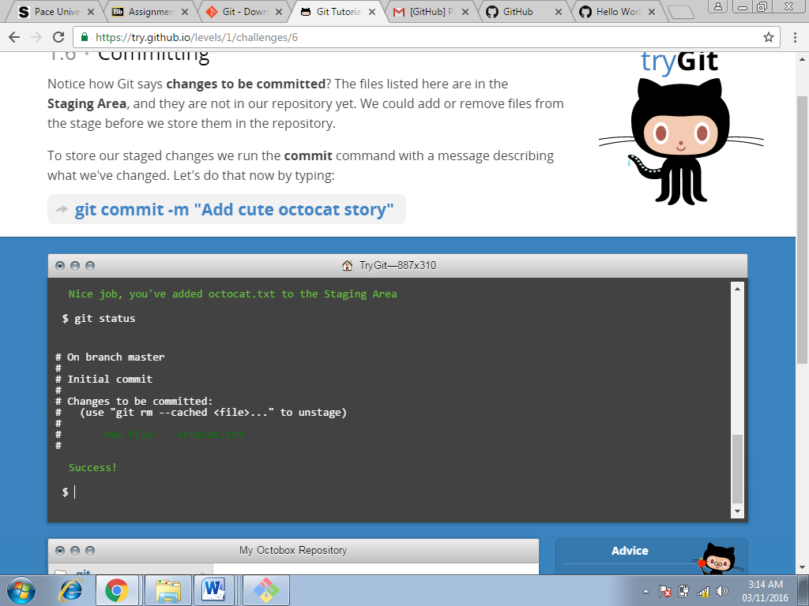

**Command used at this step:**

**Git status command(Screenshot-5)**

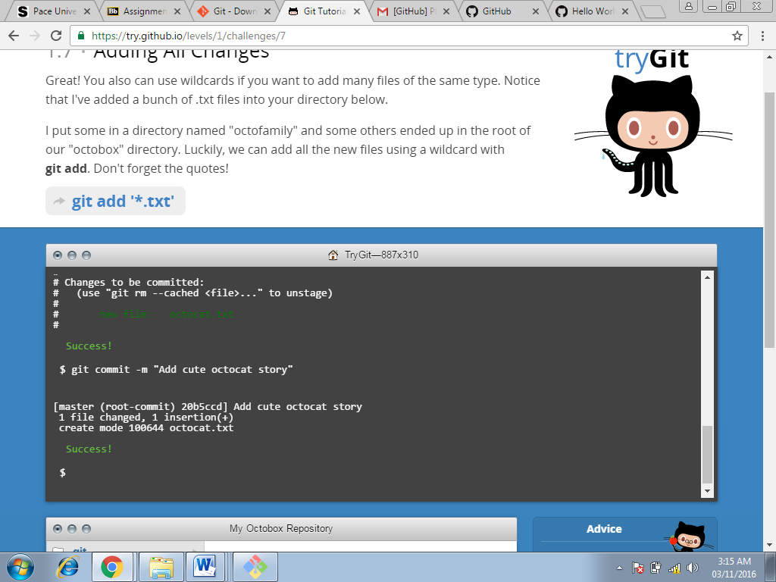

**Command used at this step:**

**Git commit command(Screenshot-6)**

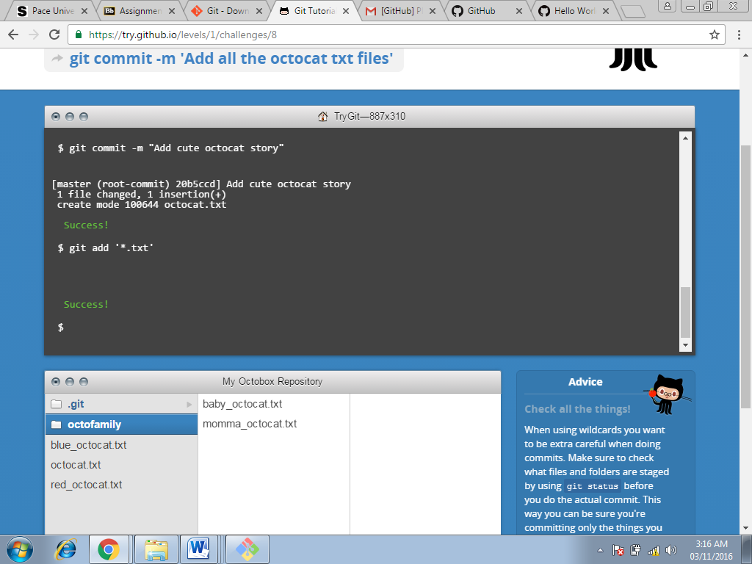

**Command used at this step:**

**Git add command(Screenshot-7)**

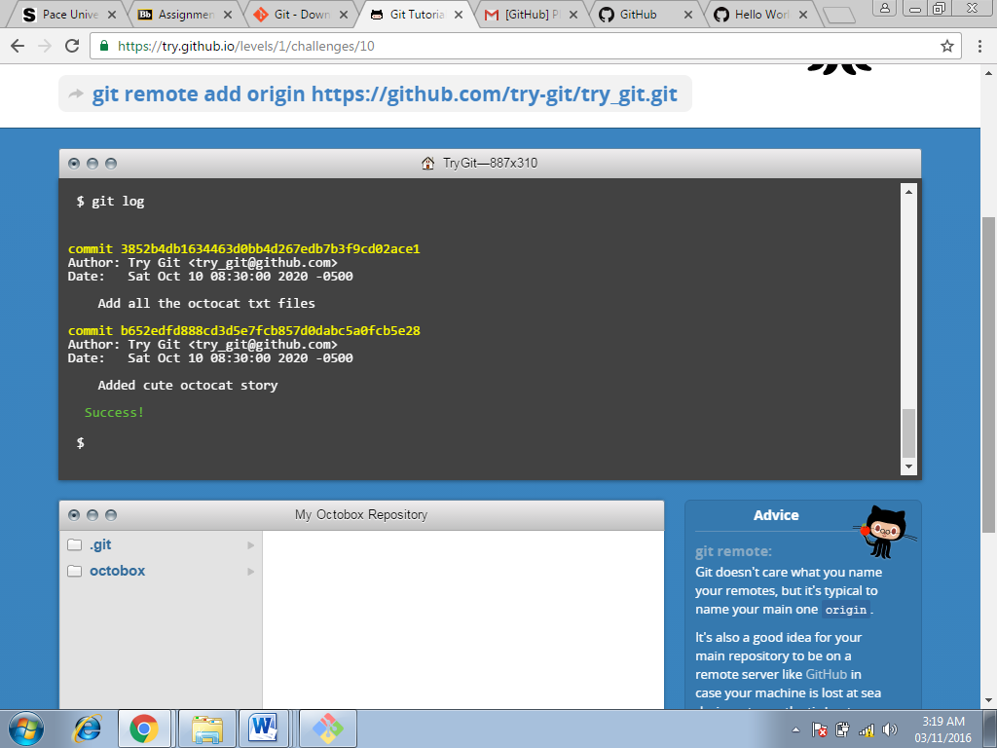

**Command used at this step:**

**Git log(Screenshot-8)**

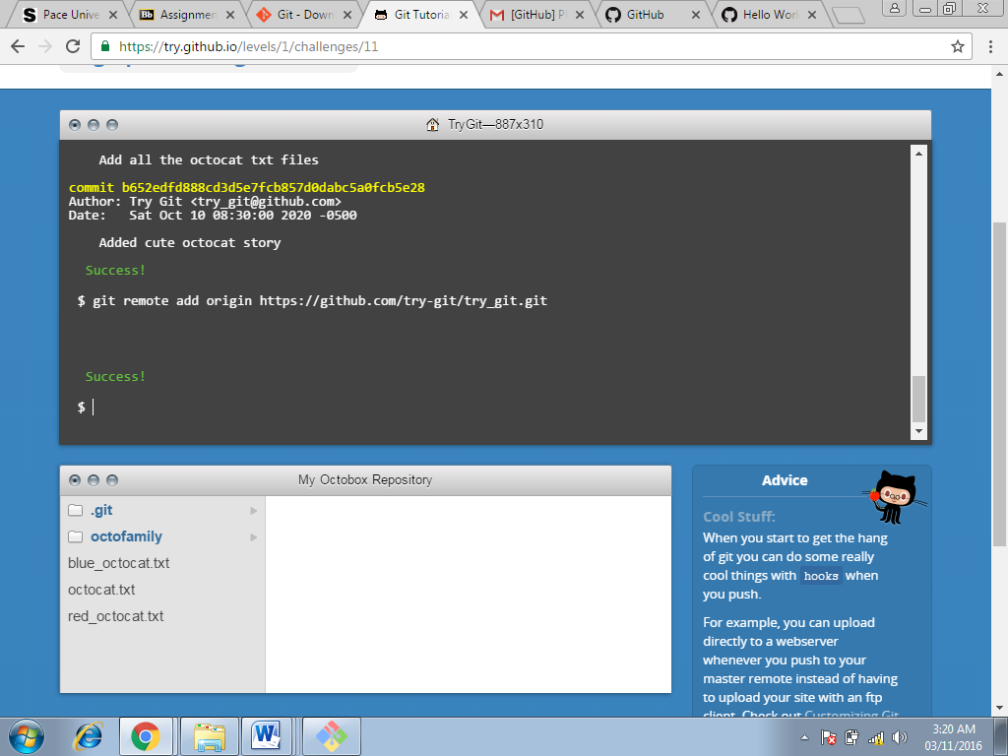

**Command used at this step:**

**Git remote add origin(Screenshot-9)**

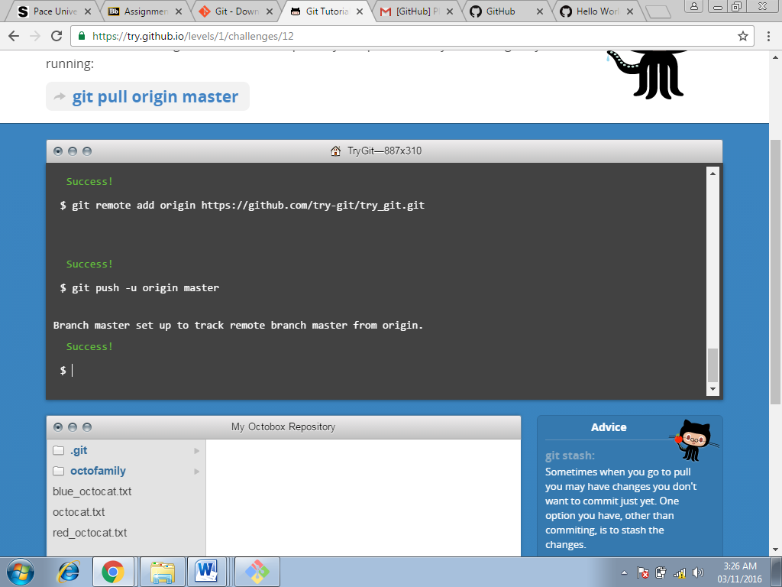

**Command used at this step:**

**Git push command(Screenshot-10)**

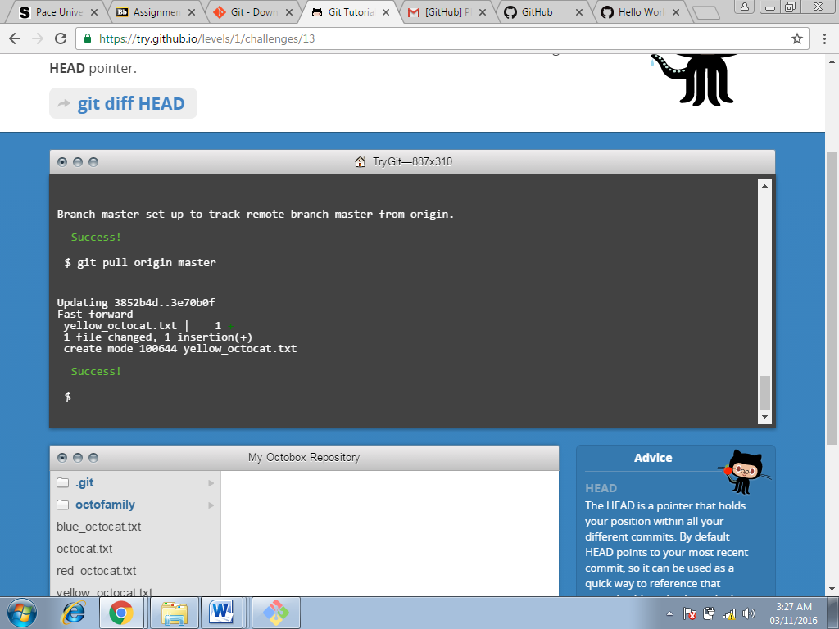

**Command used at this step:**

**Git pull origin(Screenshot-11)**

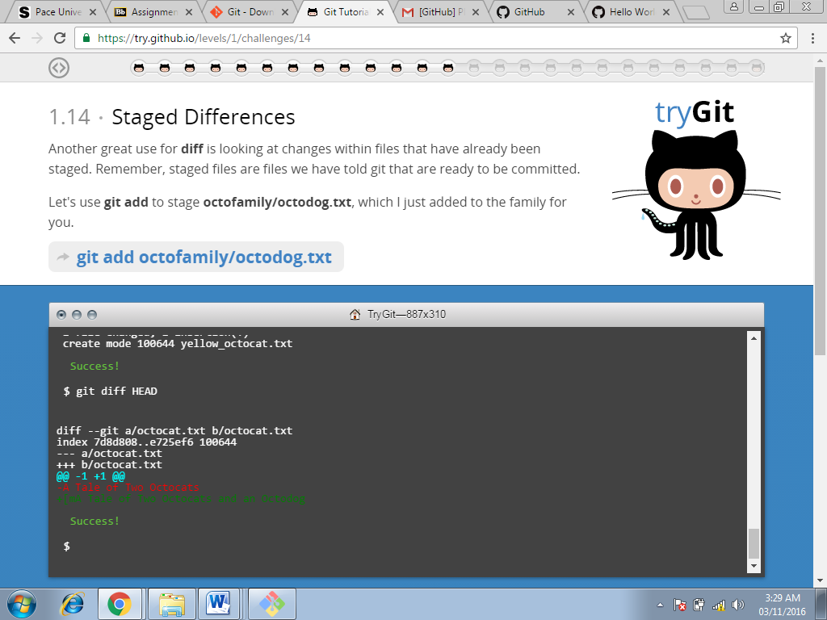

**Command used at this step:**

**Git diff(Screenshot-12)**

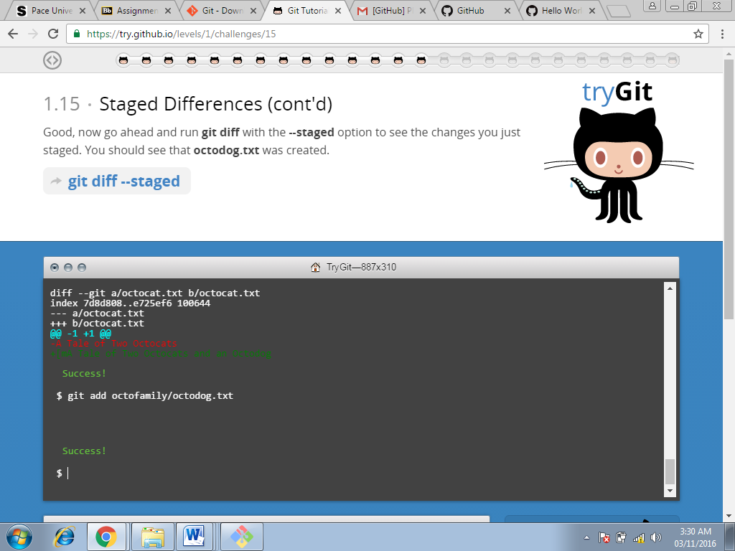

**Command used at this step:**

**Git add (Screenshot-13)**

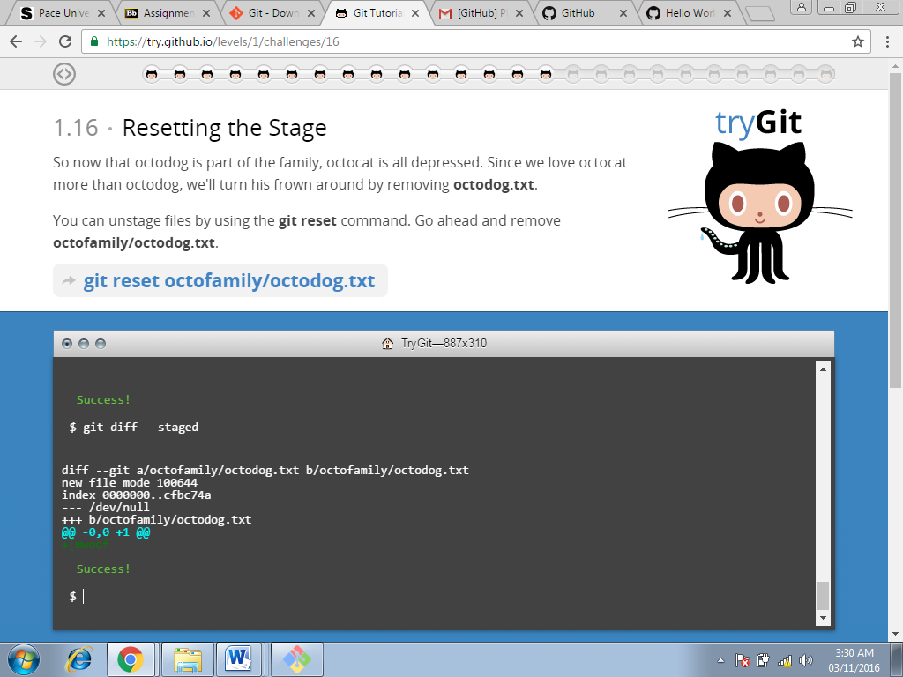

**Command used at this step:**

**Git diff(Screenshot-14)**

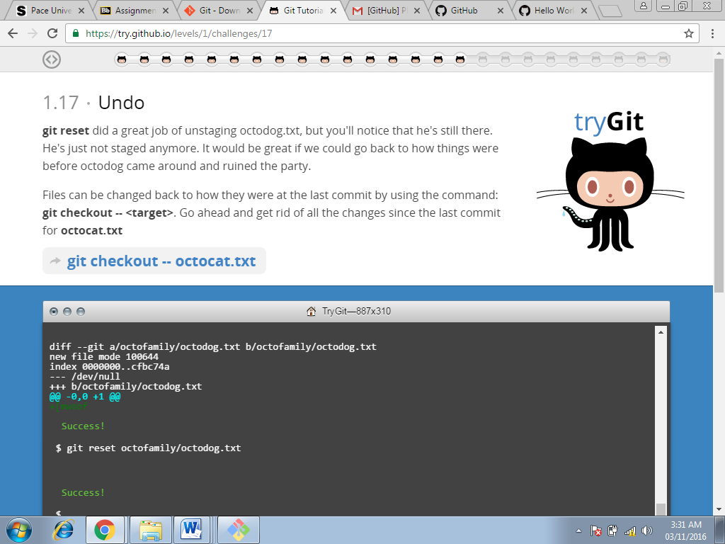

**Command used at this step:**

**Git reset(Screenshot-15)**

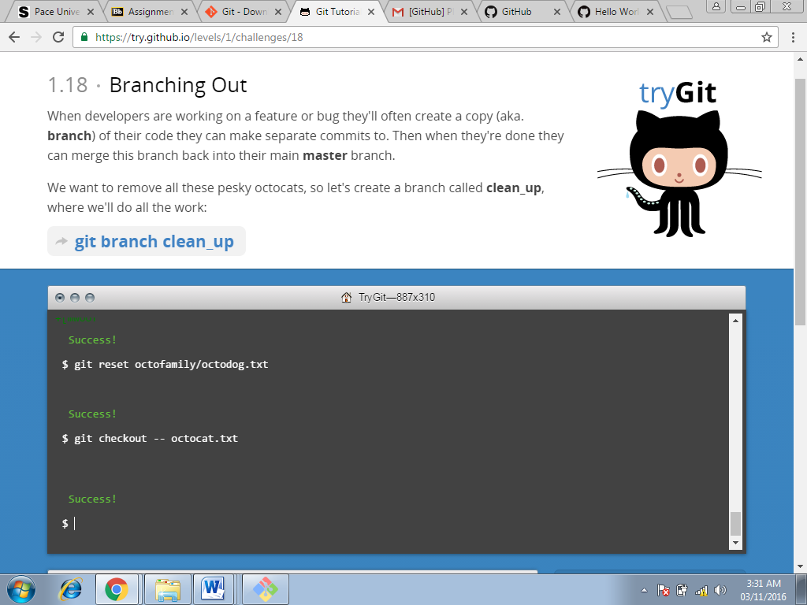

**Command used at this step:**

**Git checkout(Screenshot-16)**

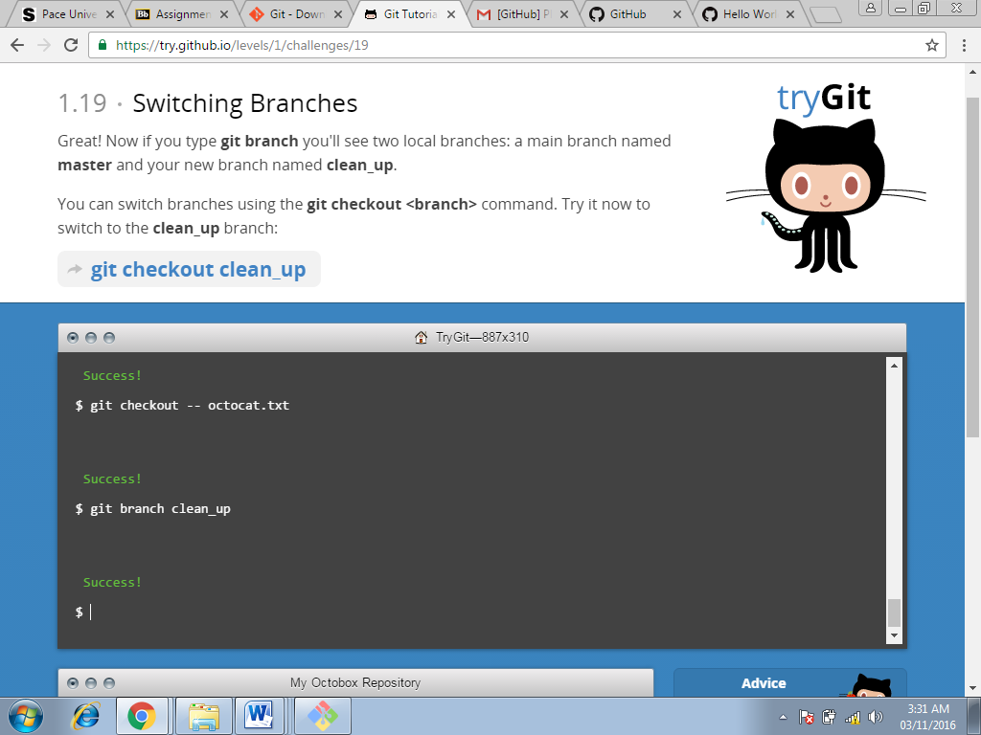

**Command used at this step:**

**Git branch clean_up(Screenshot-17)**

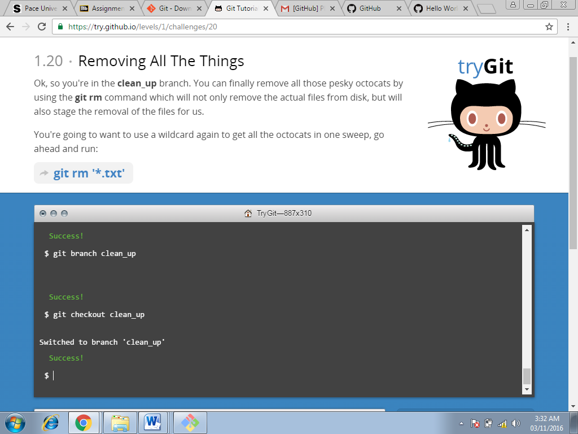

**Command used at this step:**

**Git checkout clean_up(Screenshot-18)**

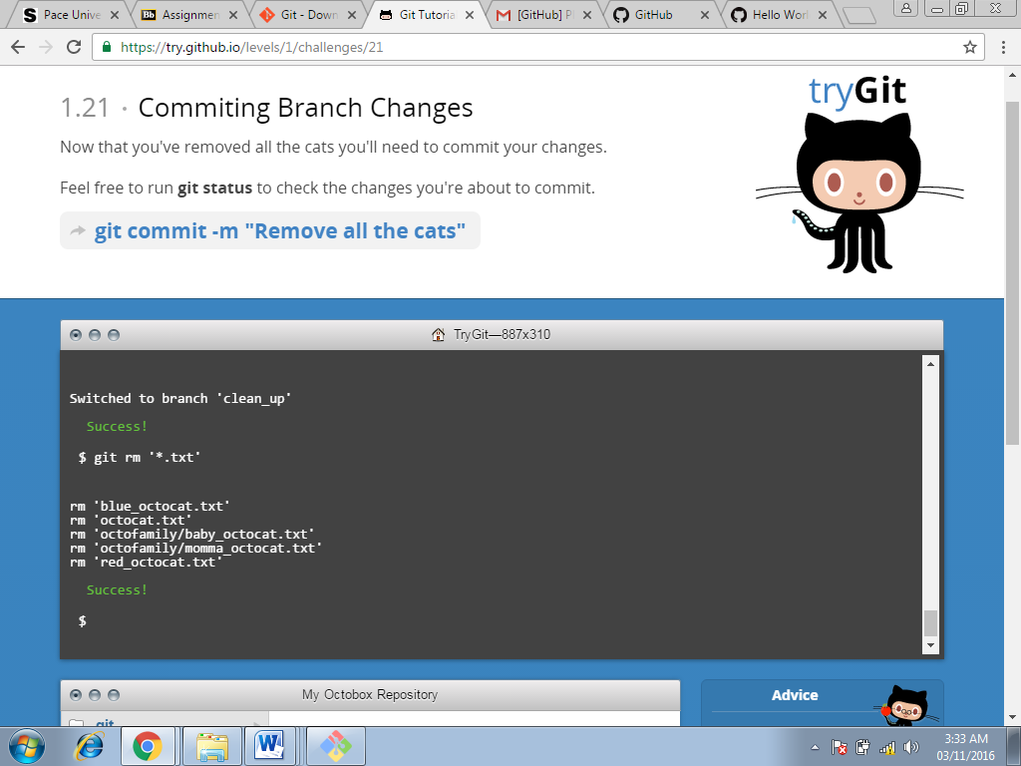

**Command used at this step:**

**Git rm(Screenshot-19)**





**Command used at this step:**

**Git commit(Screenshot-20)**

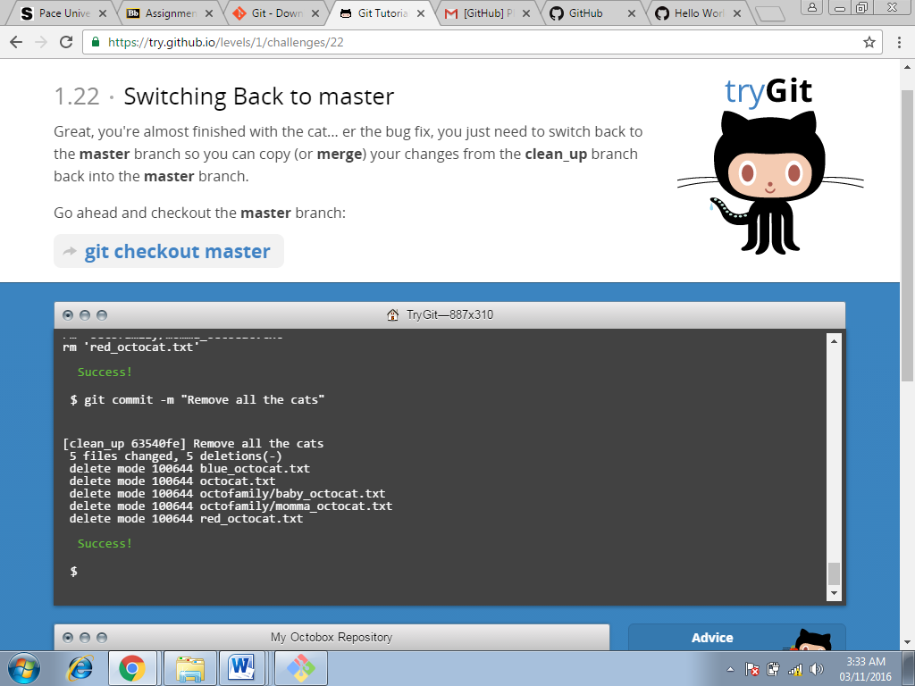

**Command used at this step:**

**Git commit(Screenshot-21)**

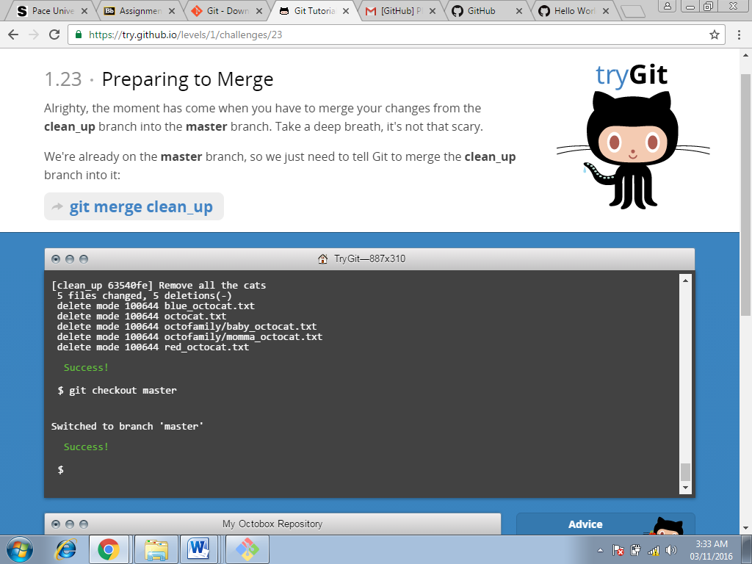

**Command used at this step:**

**Git checkout master(Screenshot-22)**

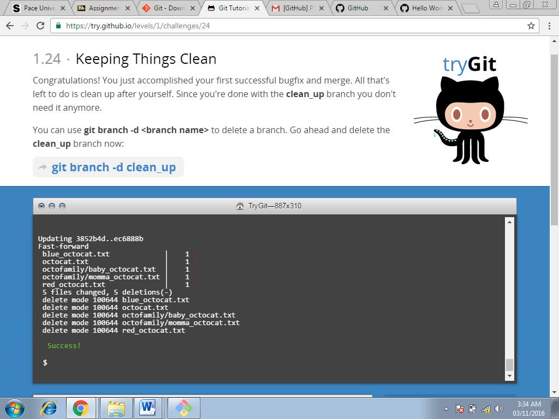

**Command used at this step:**

**Git merge clean_up(Screenshot-23)**

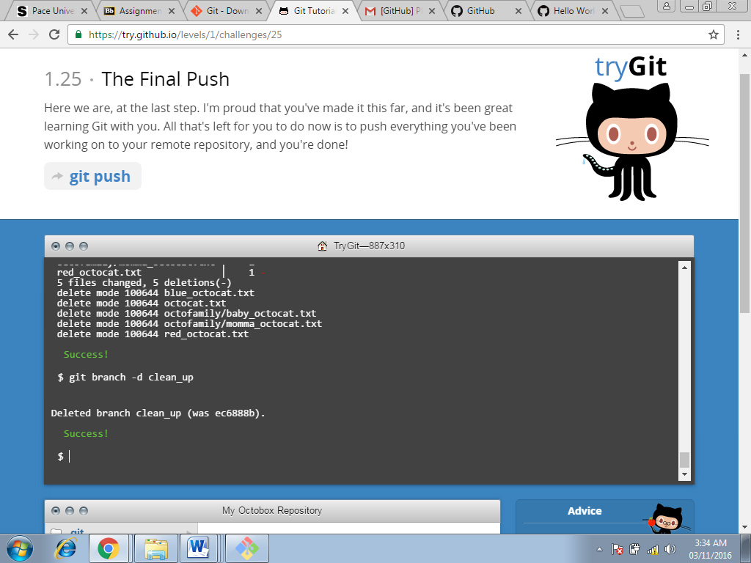

**Command used at this step:**

**Git branch-d clean_up(Screenshot-24)**

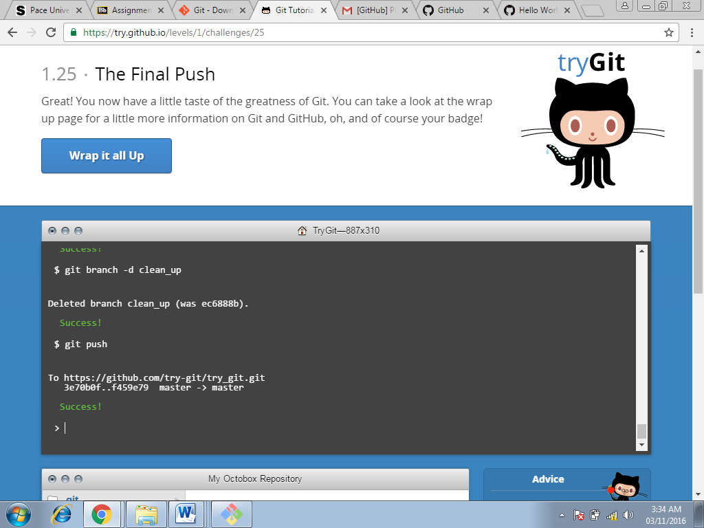

**Command used at this step:**

**Git push(Screenshot-25)**

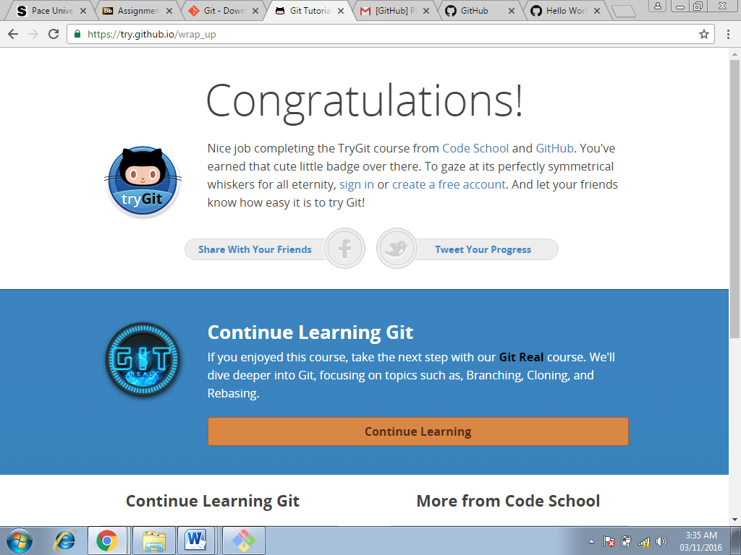

**Badge earned(Screenshot-26)**

**Part 5:**

**Define the following terms in the context of Git (2 lines maximum):**

* **Repository**

Repository is a storage space where the user can access there project, the files and all versions of its files that Git saves.

* **Commit**

Commit command is used to record changes to the repository.

* **Push**

This command is used to transfer the last commits to a remote server.

* **Branch**

While working on a project there are a bunch of different features or ideas in progress at any given time – some of which are ready to go, and others which are not so branching exists to help to manage this workflow.

* **Fork**

Fork is used to create a personal copy of someone else project.

* **Merge**

Merge is used to squash all commits into one commit.

* **Clone**

Clone is used to copy a repository to our local computer.

* **Pull**

Pull is used to pull the changes from the remote repository into ours.

* **Pull request**

Pull request is used to tell others about the changes that we had made and pushed to the repository in github.

**Part 7:**

**Commands and strategies for updating README.MD:**

* First I headed to the pace university courses page and clicked on the ‘README.md’ in the repository.
* I selected the ‘Edit’ option on the upper right side of the repository. A new page opened with the README.md file.
* I updated the file with my last name, first name, time and date. And requested for the update of file.
* I then created a new ‘Pull Request’ and add comment to the pull request. And ‘submit’ the pull request.

The ‘Pull Request’ will be later merged with the main repository, and updated in the ‘README.md’ file.