|  |
| --- |
| Cs-611 |
| Principles of Programming Language |
| Assignment-3 |
|  |
| **Gurleen Kaur Sudan** |
| **02/11/2016** |

|  |
| --- |
|  |

**Part 3:**

**Q1. What is GitHub? When was it created? Why? By who? What similar platforms exist? Why would you use such a platform?**

**Ans***.* Git Hub is a web-based Git repository hosting service.

Git Hub platform began on 1st October 2007.

It is a platform where users can collaborate on or adopt open source code projects, fork code, share ideas and more.

Linus Torvalds invented GitHub

**Similar platforms**- ALLURA, CHILIPROJECT, BITBUCKET, KILN, CODEPLANE

This platform is used because when developers are creating an application, for example, they are making constant changes to the code and releasing new versions , upto and after the first official release. It helps in collaboration and also helps new and existing users to make use of the publically uploaded projects.

**Part 4:**

**Screenshots of different commands used in GitHub:**

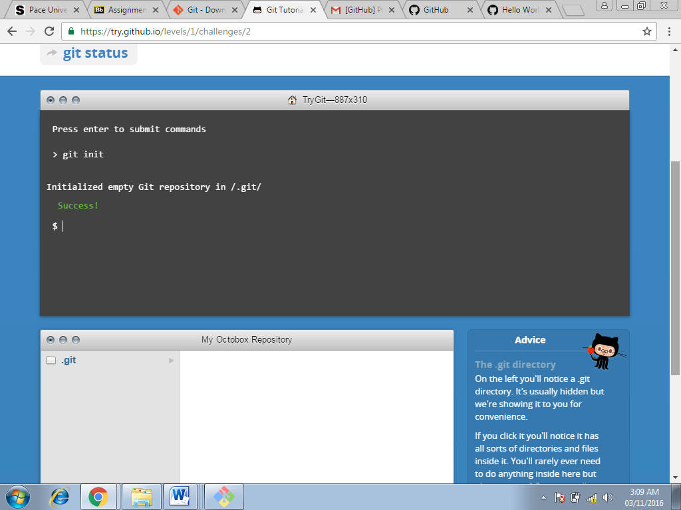

**Command used at this step:**

**Git init command (Screenshot-1)**

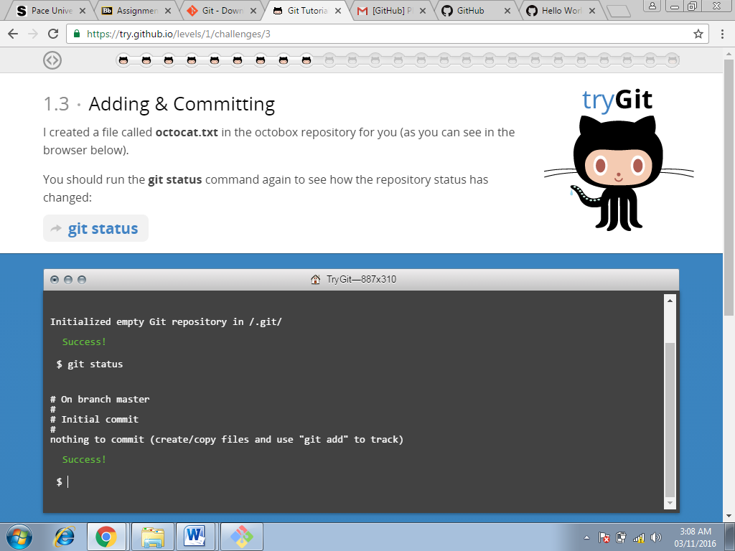

**Command used at this step:**

**Git status (Screenshot-2)**

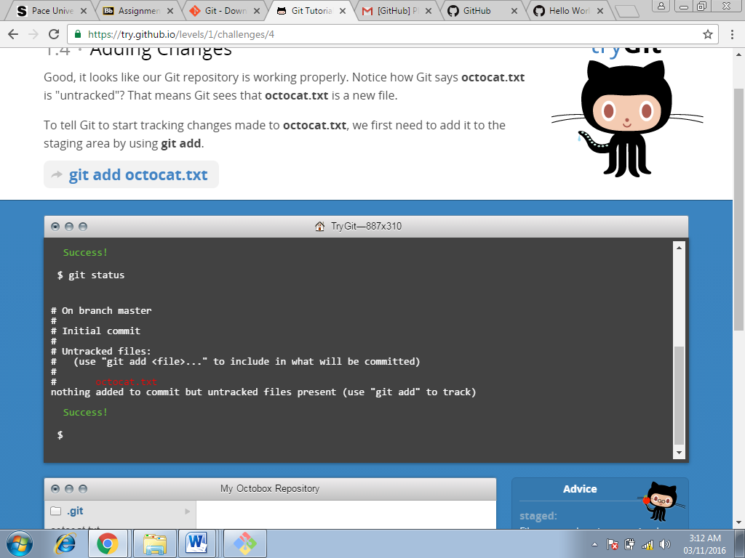

**Command used at this step:**

**Git add octocat.txt command (Screenshot-3)**

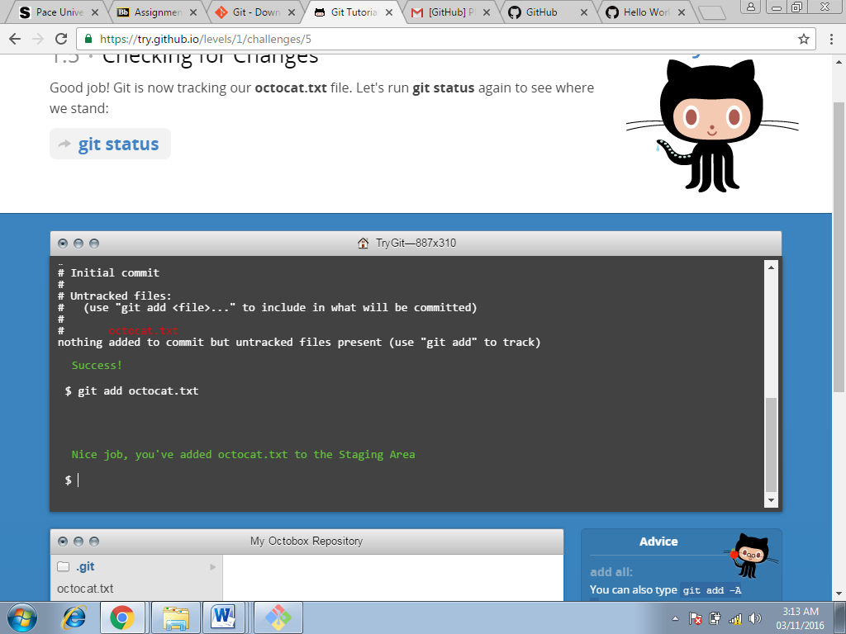

**Command used at this step:**

**Git status command(Screenshot-4)**

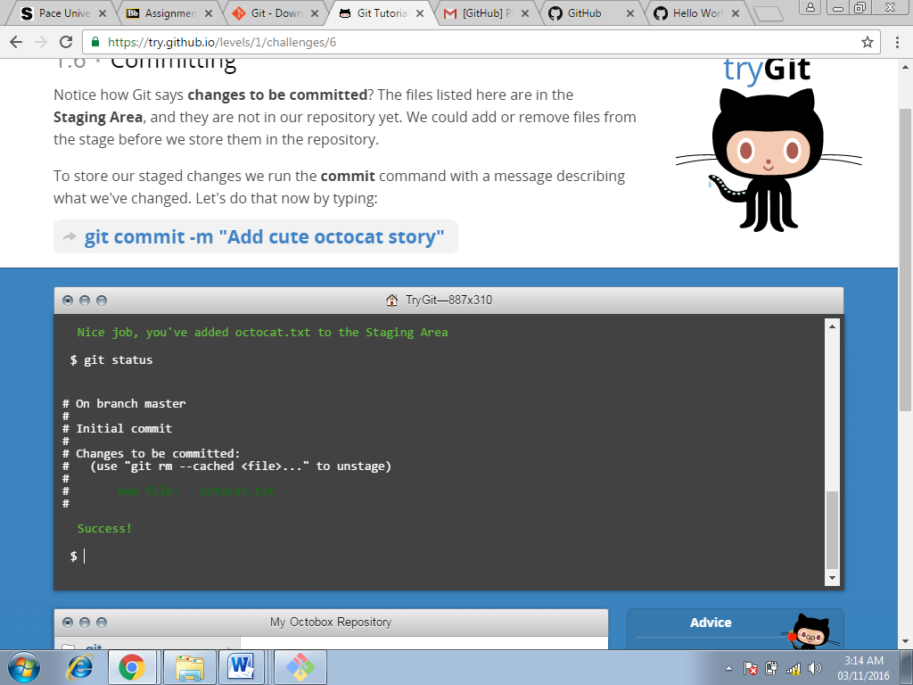

**Command used at this step:**

**Git commit-m command(Screenshot-5)**

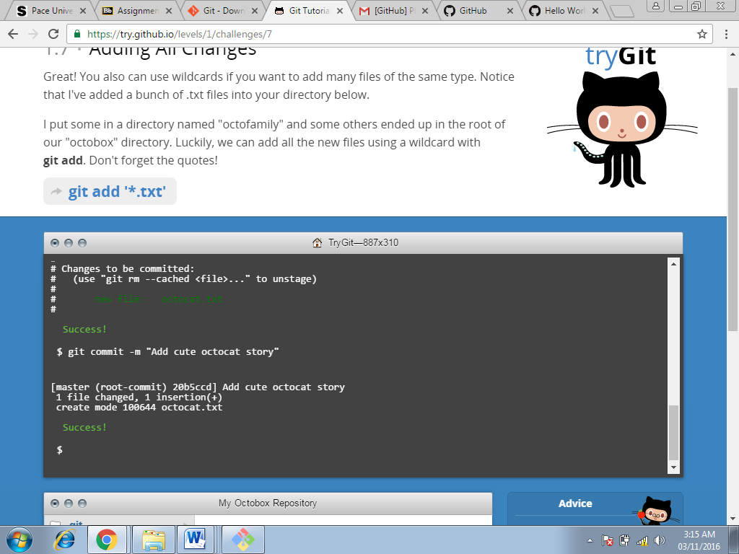

**Command used at this step:**

**Git add’*.txt’ command(Screenshot-6)**

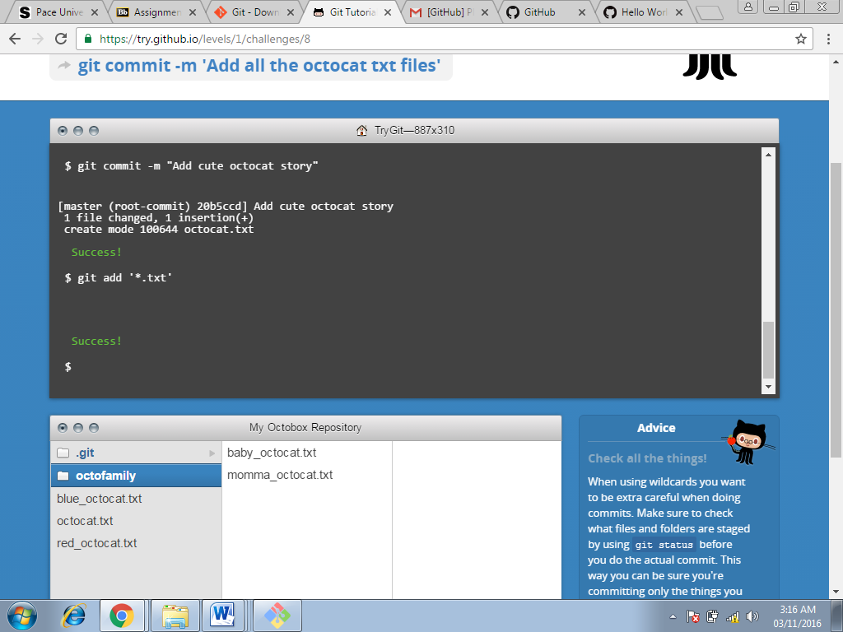

**Command used at this step:**

**Git commit-m command(Screenshot-7)**

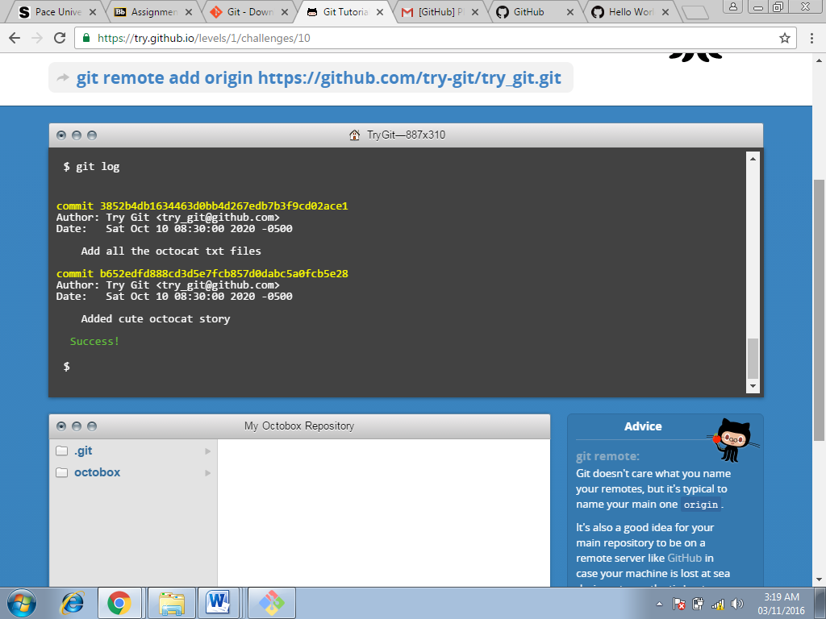

**Command used at this step:**

**Git log(Screenshot-8)**

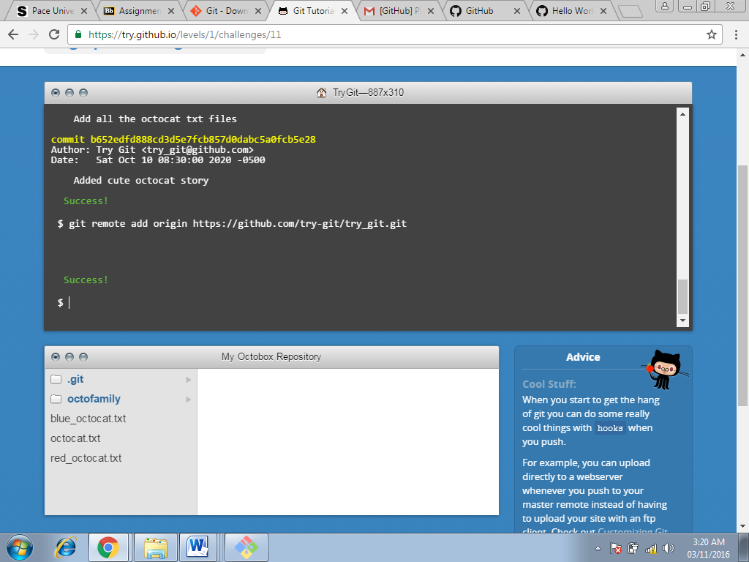

**Command used at this step:**

**Git remote add origin(Screenshot-9)**

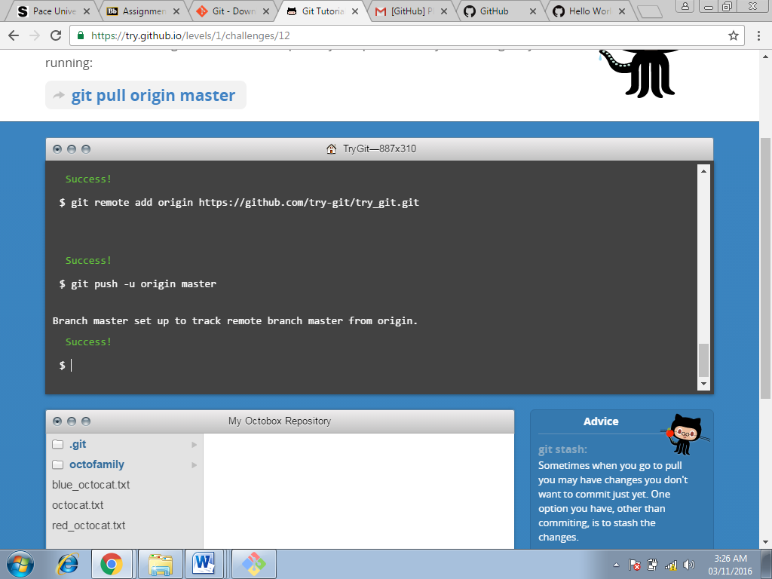

**Command used at this step:**

**Git push command(Screenshot-10)**

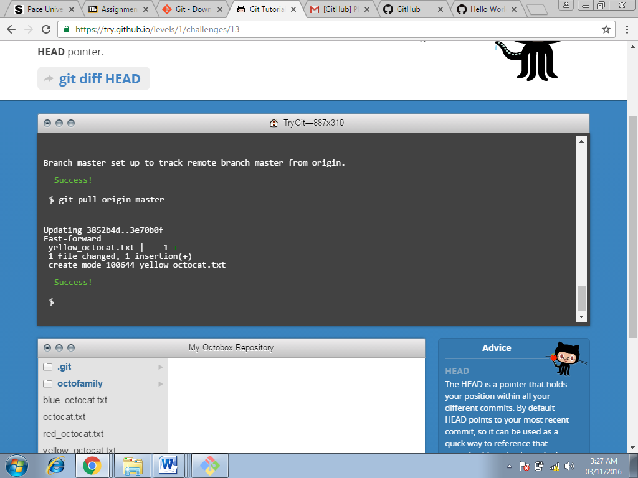

**Command used at this step:**

**Git pull origin(Screenshot-11)**

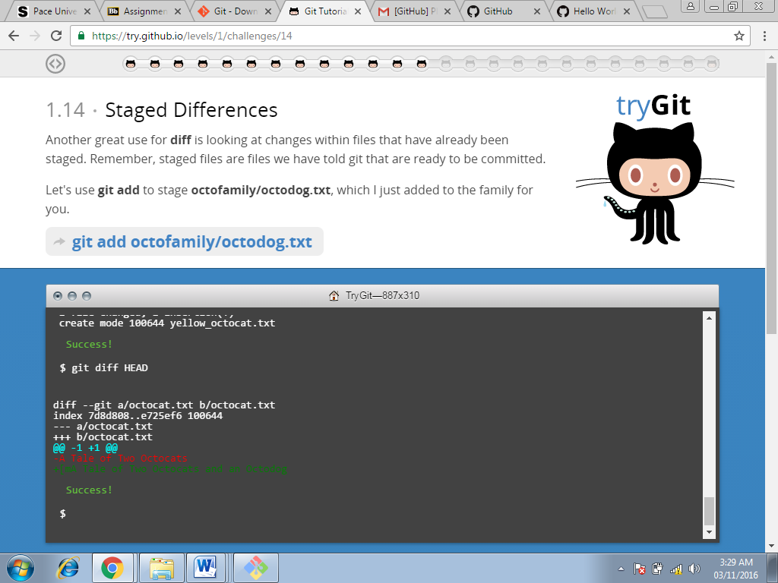

**Command used at this step:**

**Git diff(Screenshot-12)**

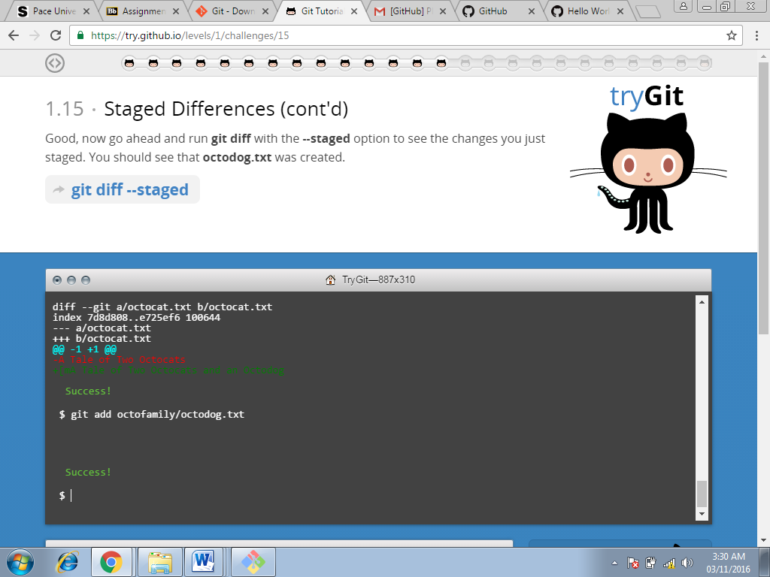

**Command used at this step:**

**Git add (Screenshot-13)**

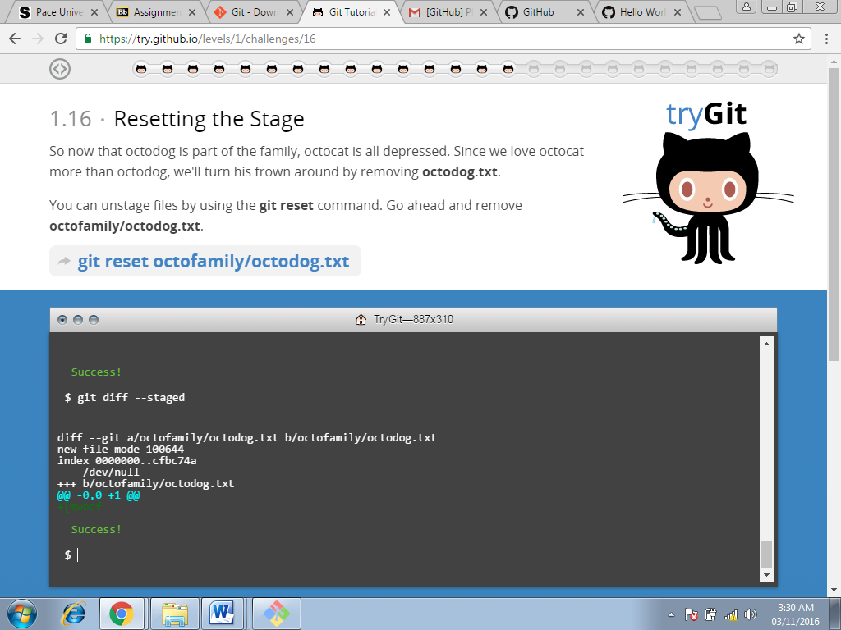

**Command used at this step:**

**Git diff(Screenshot-14)**

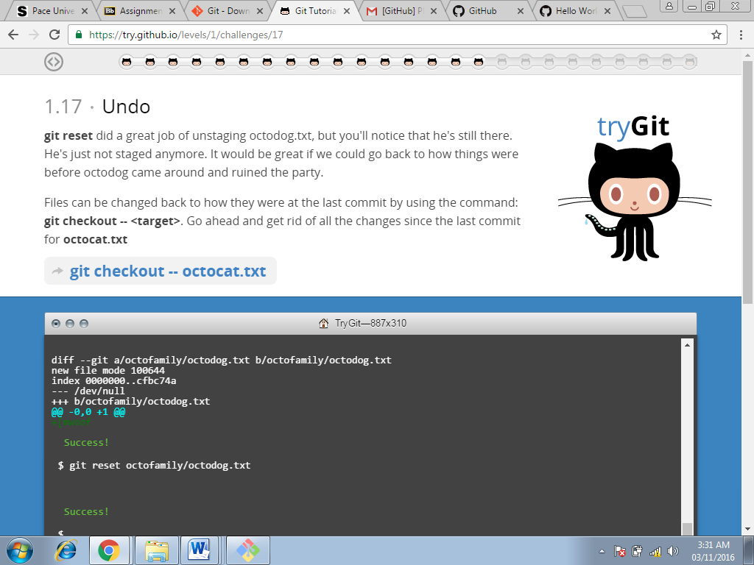

**Command used at this step:**

**Git reset(Screenshot-15)**

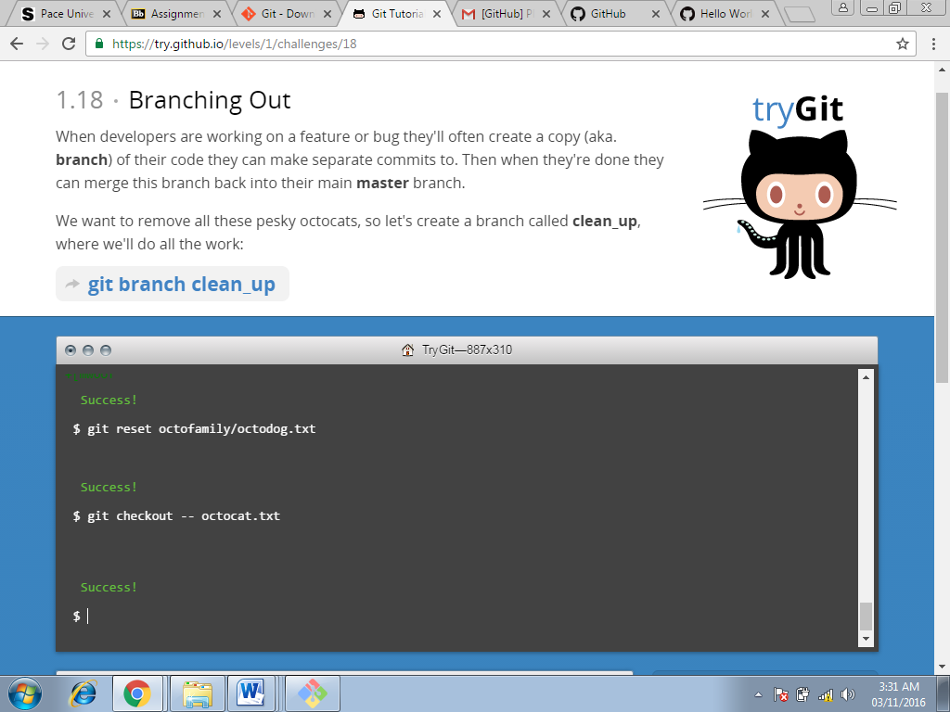

**Command used at this step:**

**Git checkout(Screenshot-16)**

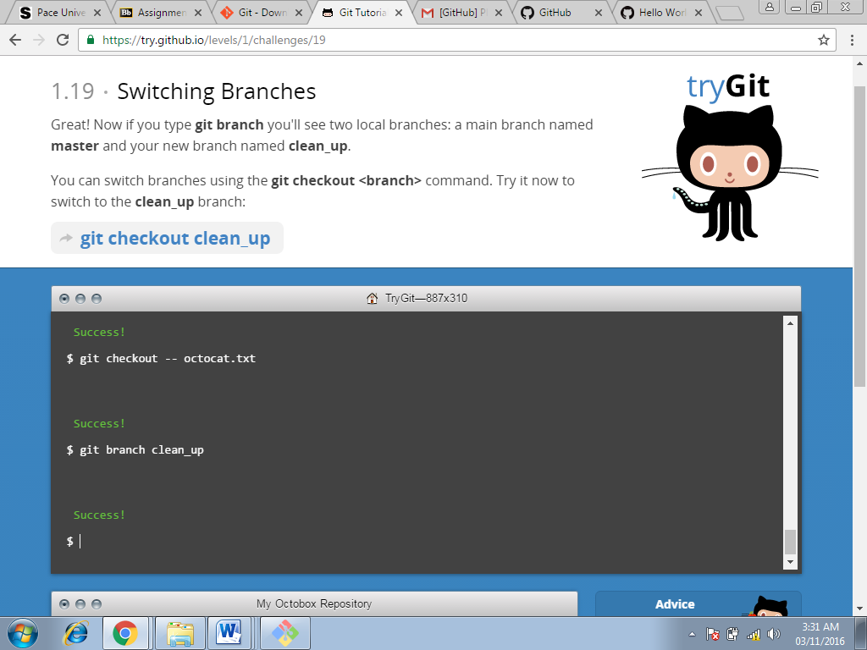

**Command used at this step:**

**Git branch clean_up(Screenshot-17)**

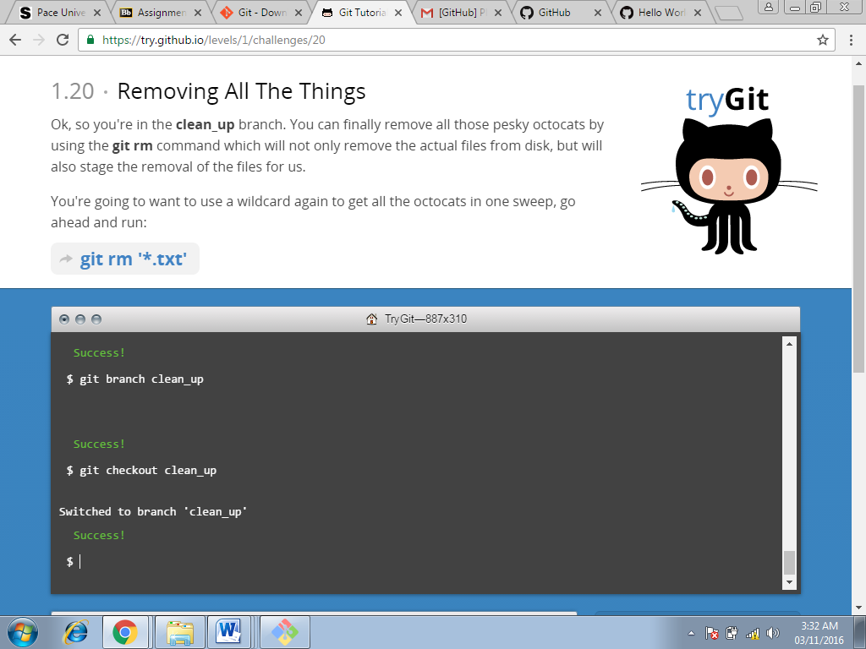

**Command used at this step:**

**Git checkout clean_up(Screenshot-18)**

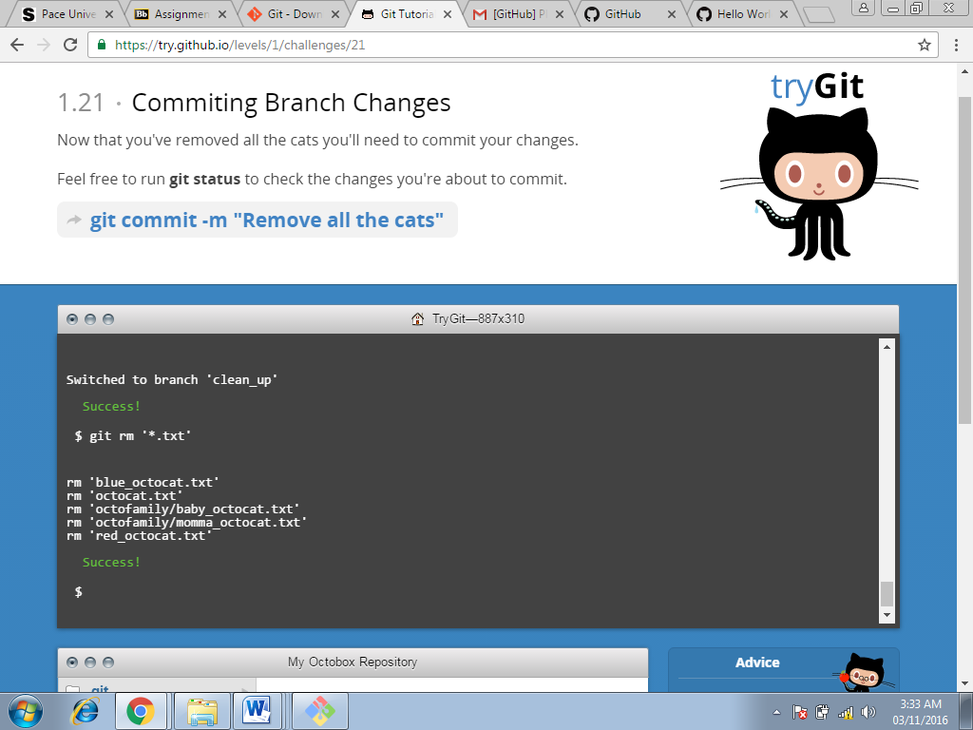

**Command used at this step:**

**Git rm(Screenshot-19)**





**Command used at this step:**

**Git commit(Screenshot-20)**

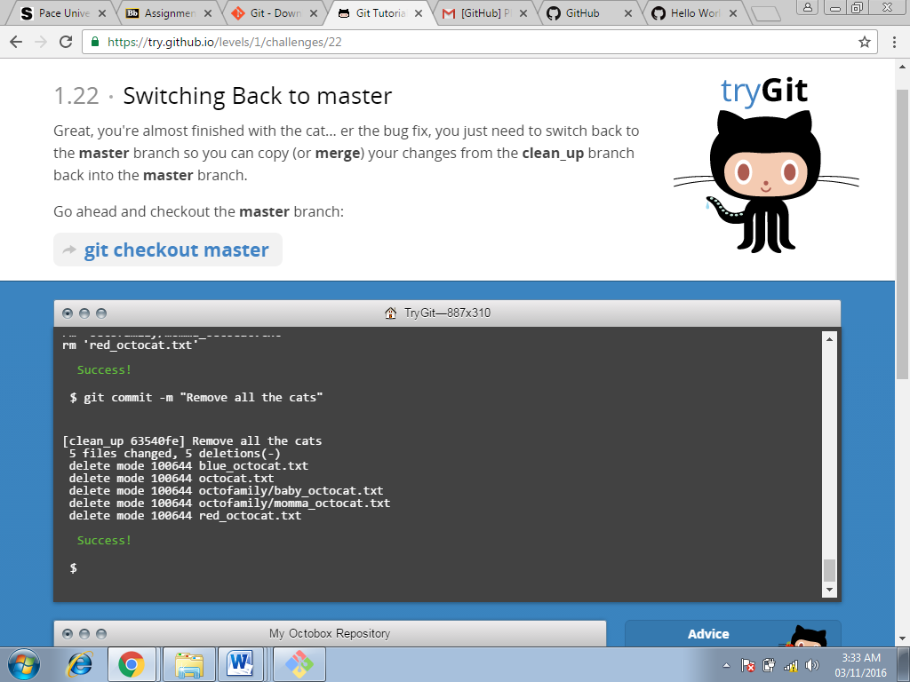

**Command used at this step:**

**Git commit(Screenshot-21)**

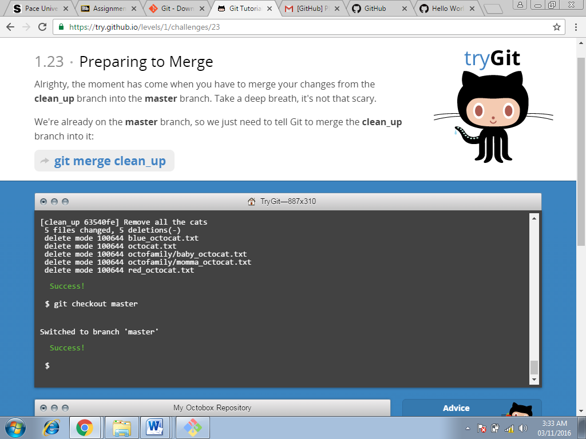

**Command used at this step:**

**Git checkout master(Screenshot-22)**

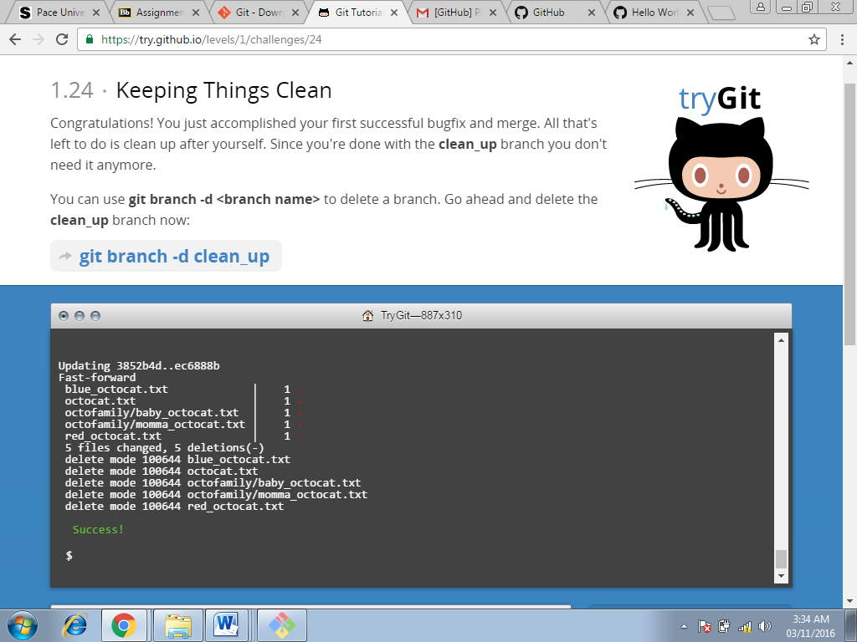

**Command used at this step:**

**Git merge clean_up(Screenshot-23)**

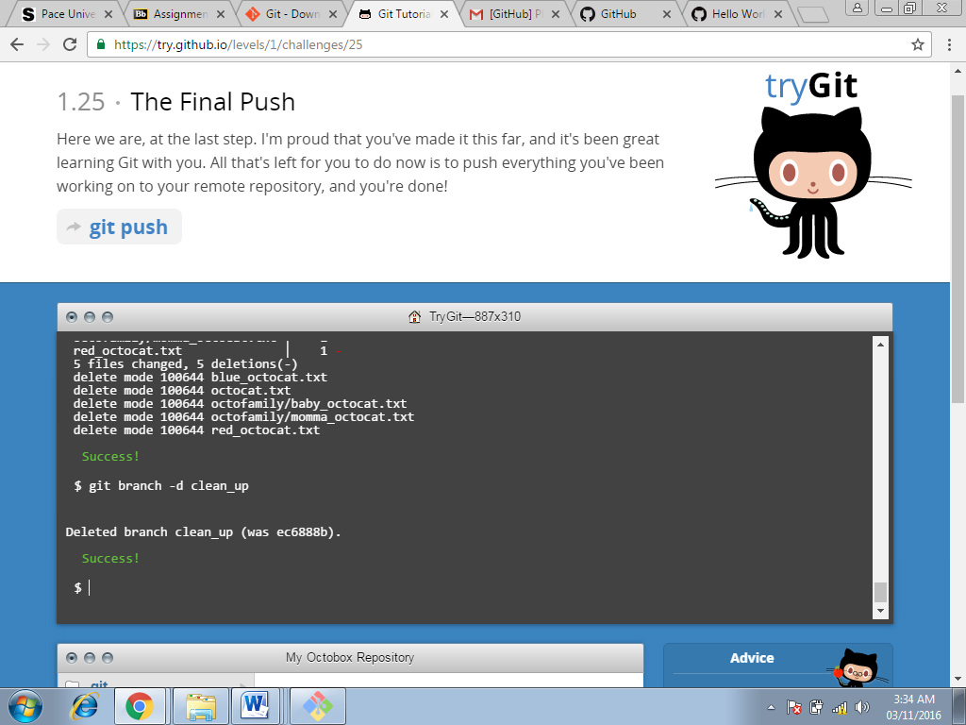

**Command used at this step:**

**Git branch-d clean_up(Screenshot-24)**

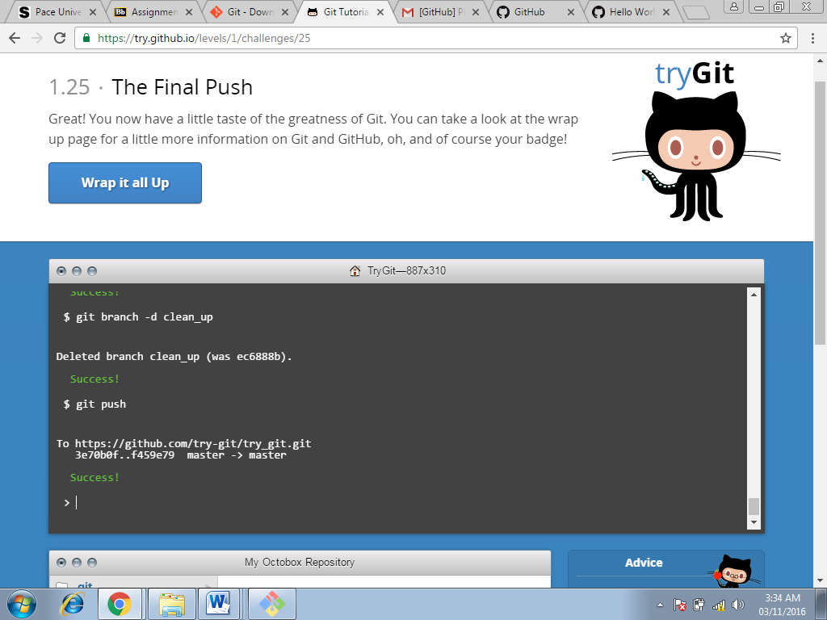

**Command used at this step:**

**Git push(Screenshot-25)**

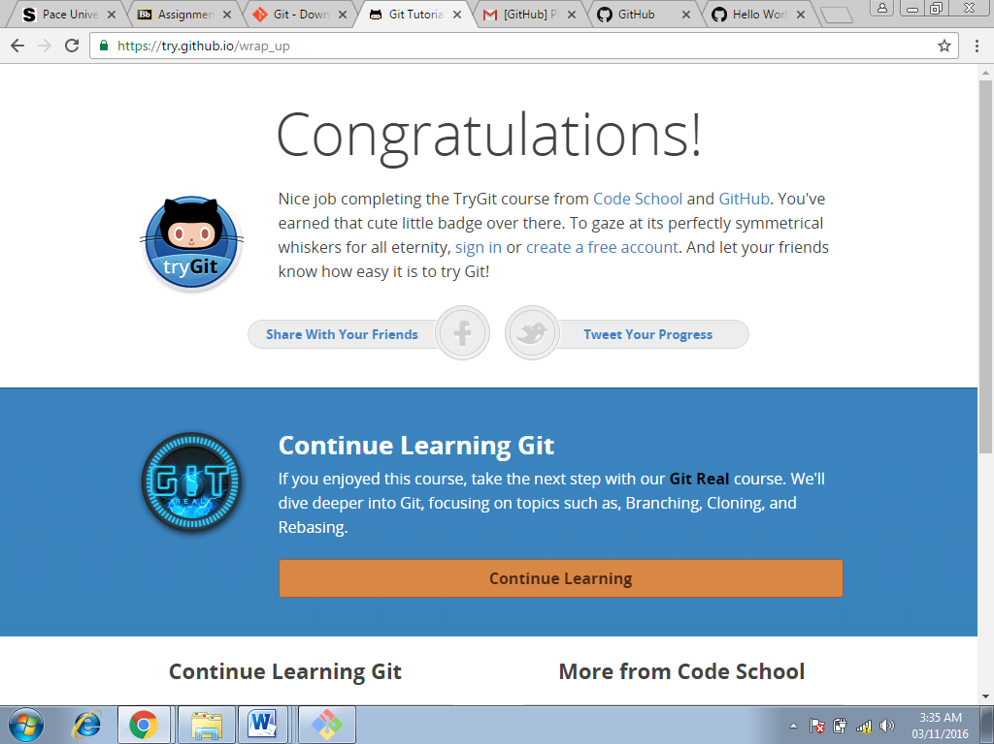

**Badge earned(Screenshot-26)**

**Part 5:**

* **Repository**

Repository is a storage space where the user can access there project, the files and all versions of its files that Git saves.

* **Commit**

Git Commit is used to record changes to the repository.

* **Push**

It is used to transfer the last commits to a remote server.

* **Branch**

While working on a project there are a bunch of different features or ideas in progress at any given time – some of which are ready to go, and others which are not so branching exists to help to manage this workflow.

* **Fork**

Fork is used to create a personal copy of someone else project.

* **Merge**

Merge is used to squash all commits into one commit.

* **Clone**

Clone is used to copy a repository to our local computer.

* **Pull**

Pull is used to pull the changes from the remote repository into ours.

* **Pull request**

Pull request is used to tell others about the changes that we had made and pushed to the repository in github.