1. Download **Cuda Toolkit 10.0** and Install it ---->Can use this link **(**[**https://developer.nvidia.com/cuda-10.0-download-archive**](https://developer.nvidia.com/cuda-10.0-download-archive)**)**

a) After installing cuda toolkit the bin path will be automatically added to the environment variables

2. Download **CuDnn library with 10.0** version , same as your Cuda Toolkit ---->Can use this link **(https://developer.nvidia.com/rdp/cudnn-download)**

3. Set the path of your CuDnn in the Environment Variables under System Variables

a) Place the cuda folder in c drive

b) Open the folder and you will find the 3 folders(bin, include, lib) and a file (NVIDIA_SLA_cuDNN_Support.txt)

It will look something like below-

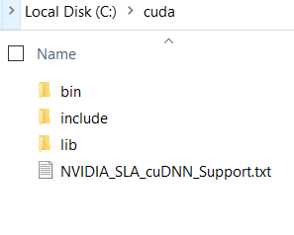

4. Download visual studio 2017 community-----> Can use this link **(**[**https://my.visualstudio.com/Downloads?q=visual%20studio%202017&wt.mc_id=o~msft~vscom~older-downloads**](https://my.visualstudio.com/Downloads?q=visual%20studio%202017&wt.mc_id=o~msft~vscom~older-downloads)**)** and install it

Since cuda is written in c++ therefore, we can copy the c++ required file

5. Create the environment and install tensorflow-gpu

a) Open Anaconda command prompt

b) create the environment **(conda create –n myenv python=3.6)**

c) Activate the environment you created **(conda activate myenv)**

d) After activating install tensorflow-gpu **(pip install tensorflow-gpu==2.0.0)**

6. Now to check that tensorflow-gpu is installed or not

a) type **python**

b) type **import tensorflow (you will get cuda directory .dll file name)**

c) Even you can run the following command to know the tensorflow-gpu

**Import tensorflow as tf**

**print(tf.test.is_gpu_available())**

**print(tf.test.is_built_with_cuda())**

7. Install Keras (**pip install keras**)