Here is a list of students from the ftp directory, with each student getting their own page:

Krishnapriya Sarojam

Chris Dyck

Junseob Noh

Sathish Parthasarathi

Sukanya Chulliparambil Mohanan

MaryPravalika Jaddu

Mostafizur Rahman

Ankita Singh

Prakash Gurung

Mostafizur Rahman

Priyanka Garg

Manpreet Kaur

Pranav Sharma

Kavya Arora

Aditya Pidikiti

BalaPrathima Gade

Prajwal Acharya

Preet Shah

Bruno Simoes

Tugrul Goktas

Prajwal Katuwal

Pavel Sazonov

swarnim sharma

Tugrul Goktas

Jay Kalal

HemaAbhinandu Kotha

AkhilDas PradeepKumar

Swathi Palavalli

KavirajSingh Jon

Althaf Edathara

Nipin Dasani

Avi Saini

Kashish Jhaveri

Robert Routledge

Sahiba Sachdeva

Sofiya Raju

Sony Varghese

Krishnapriya Sarojam

SargunSingh Walia

Nikhil Patel

Gurminder Singh

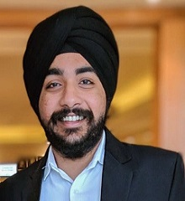

Vrunda Patel

Vrushabh Patel