**Input. Split () returns type of str**

**1 10 11 x,y,z=input ().split**

**X=int(x) to convert into appropriate type**

**If less Input Given if More Input Given it will throw error whitespaces need not to be exactly 1 it may be many. If you press next Line it will again throw an erro**r.

**AttributeError: 'int' object has no attribute 'split'**

**The Python "AttributeError: 'int' object has no attribute 'split'" occurs when we call the split() method on an integer. To solve the error, make sure the value you are calling split on is of type string.**

**Above error can be solved using List compression but we need to type cast in same Line in List compression.**

**x,y,z=[w for w in input('Enter three values').split()]**

**Return x,y,z of type str.**

**x,y,z=[int(w) for w in input('Enter three values').split()]**

**Returns x,y,z of type int as w is typecasted.**

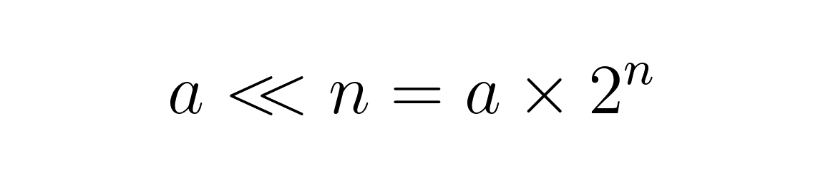Left shift Operation.

Right shift Operators.