Predictive Maintenance for Rotating Equipment

# 1. Introduction

This case study explores the use of Predictive Maintenance (PdM) for rotating equipment in NTPC, India’s largest power utility company. Leveraging AI and IoT technologies, Tata Consultancy Services (TCS) implemented a data-driven maintenance approach to improve equipment reliability, reduce costs, and increase plant uptime.

# 2. Project Overview

Client: NTPC (National Thermal Power Corporation)  
Tech Partner: Tata Consultancy Services (TCS)  
Focus: Turbines, Compressors, Motors, and Boilers  
Tools Used: IoT Sensors, SCADA Logs, Azure Cloud, ML Models  
Objective: Reduce unplanned downtime, enable proactive maintenance, optimize performance

# 3. Impact Analysis

One of the most measurable benefits of predictive maintenance in NTPC was the reduction in equipment downtime. Using sensor-based predictive alerts, breakdowns were significantly reduced.

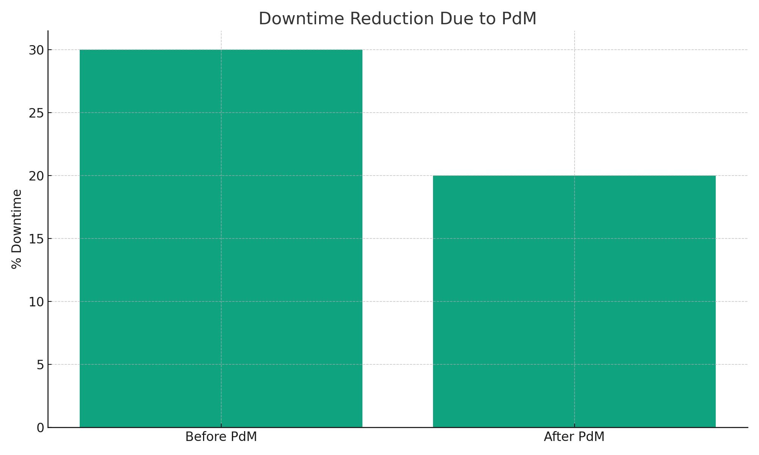

Key Metrics:  
- 25–30% reduction in downtime  
- ₹50+ crores annual savings  
- 60% improvement in maintenance planning  
- 70% reduction in emergency failures

# 4. Future Scope for BHEL

If BHEL adopts similar predictive maintenance systems, it can unlock major operational efficiencies in power plant equipment and manufacturing units. Real-time data ingestion, AI-driven failure prediction, and cloud-based dashboards could transform BHEL’s machinery uptime and reduce unnecessary overhead costs.