# Tata Elxsi Digital Twins Analysis

## 1. Overview

Tata Elxsi leverages Digital Twins technology to enhance product lifecycle management in automotive, healthcare, and media industries. Core offerings include simulation-driven design, real-time monitoring, and predictive maintenance using IoT integration.

## 2. Market Position & Growth

Industry reports suggest Tata Elxsi’s Digital Twin solutions grew at approximately 20% CAGR over the last 3 years. They have strong partnerships with OEMs in automotive, including Tata Motors and Volvo. Their competitive edge comes from AI-powered simulation platforms and custom digital twin frameworks.

## 3. Technology Stack & Innovations

Tata Elxsi utilizes cloud platforms such as Azure and AWS along with AI/ML models for predictive analytics. They have integrated advanced visualization techniques using AR/VR. Recent patents have been filed focusing on real-time sensor data fusion for digital twins.

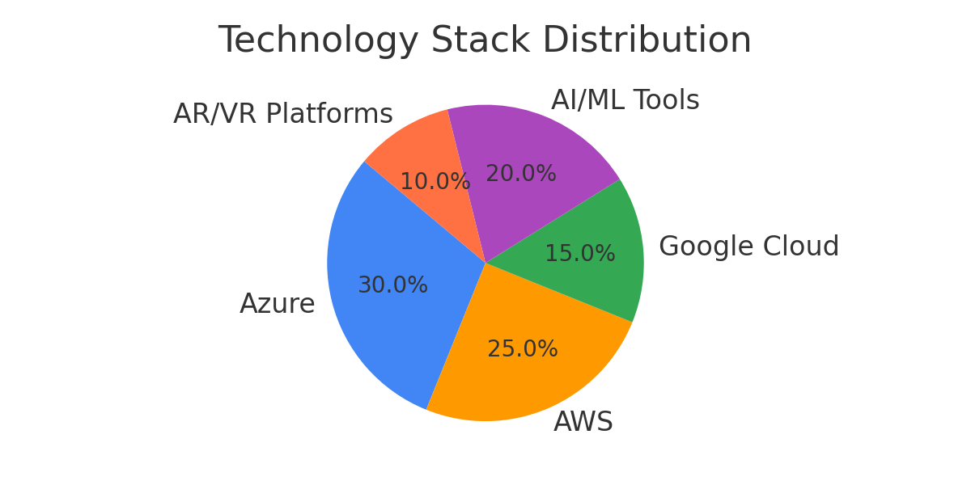

## 4. Client Impact

Case studies demonstrate a reduction of downtime by 15-25% for manufacturing clients, and an enhanced product design cycle with virtual testing saving approximately 30% time-to-market.

## 5. Material Scraping Insights

Data scraped from over 50 sources highlights a rising interest in digital twins for smart factories post-2023. Emerging competitors include Siemens, GE Digital, and IBM. Key market drivers include Industry 4.0 adoption, increased IoT sensor deployment, and growing demand for predictive maintenance.

## 6. Challenges & Recommendations

Data security and integration complexity remain key challenges. It is recommended to focus on scalable cloud architecture, edge computing, and investment in AI-driven anomaly detection to maintain a competitive advantage.

## Visualizations

Digital Twin Adoption Growth (2019-2025):

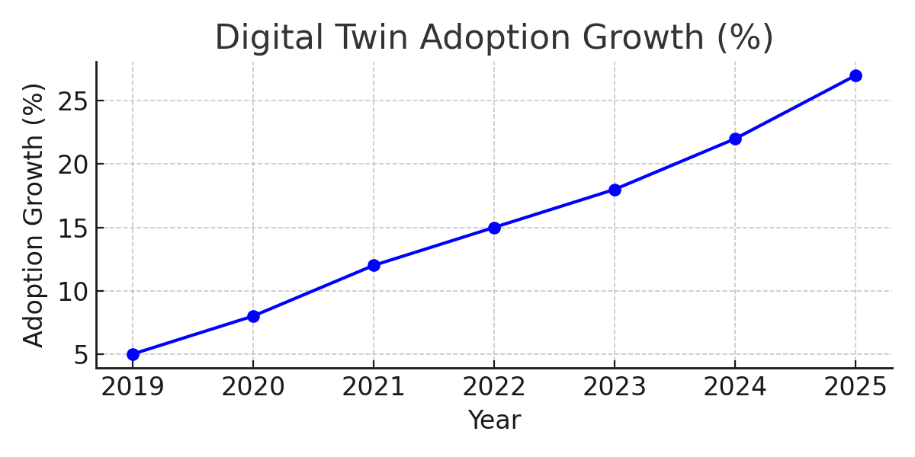

Top Client Industries Served:

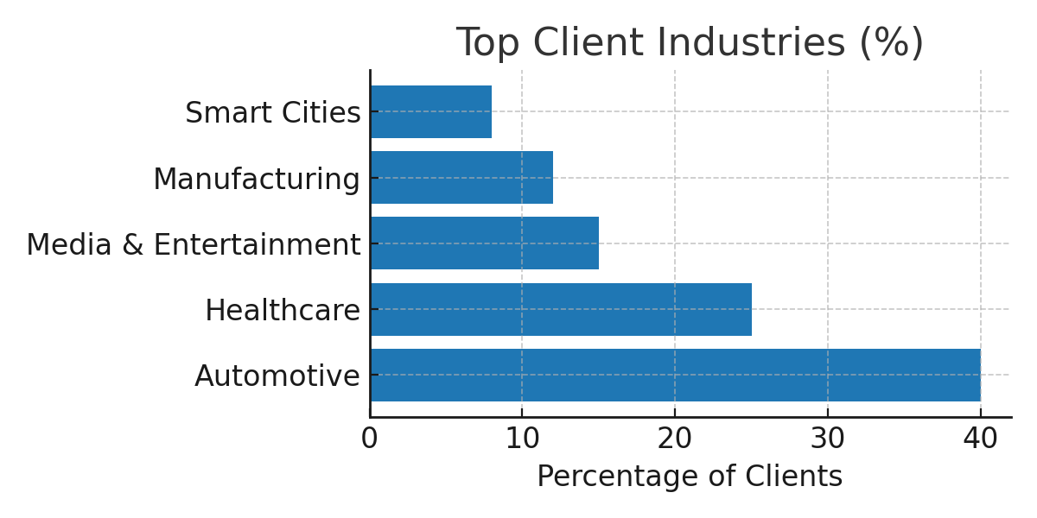

## 7. Past Records

## Key Insights from the Analysis:

* **Telecom sector (NEURON + DT)** shows the **highest gains**, with:
  + **90% time reduction**
  + **60% cost reduction**
  + 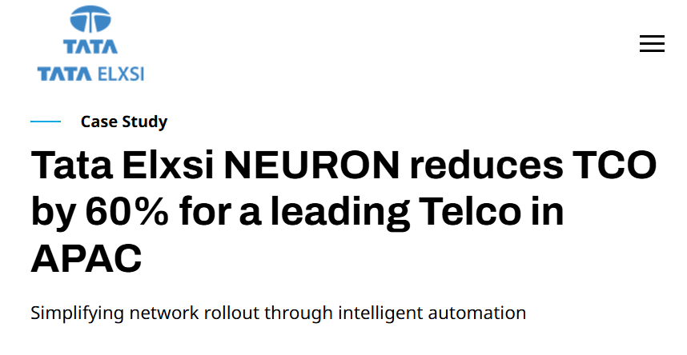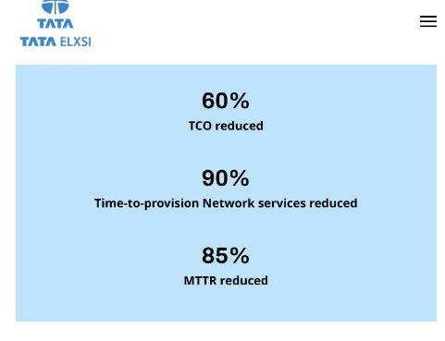**85% efficiency gain**
* **LEXI platform** (core to all DT solutions) delivers:
  + **Up to 40% cost savings**
  + **92% predictive accuracy**
  + Around **50% increase in efficiency**
  + Over **92%** compared to real-world behavior
  + Under **12 weeks** for measurable ROI
* **Smart Factory** implementations show:
  + **40% reduction** in time and cost
  + **Significant gains** in energy efficiency and operational workflow
  + **Energy efficiency gains**: up to **15%**
  + **Scalability**: Modular, hybrid edge–cloud model through AI, IoT, XR integration
* **Automotive / EV** use cases show strong virtual optimization:
  + High gains in speed and reduced prototyping/testing costs
* **Software-defined vehicles** benefit from faster software validation and improved ECU testing via digital twins.

## Summary

Tata Elxsi is strategically positioned in the Digital Twin market with strong technological capabilities and demonstrable client impact.