**Quantum Data Technology (QDT) & Tata Steel Forecasting Model (Updated)**

**1. Introduction**

This report provides a detailed analysis of the collaboration between Quantum Data Technology (QDT) and Tata Steel focusing on the forecasting model implemented to optimize raw material costs and improve profitability. It includes insights into how the forecasting model functions, key outcomes, and strategic benefits.

**2. Background**

Tata Steel is one of the world’s largest steel producers, with a complex supply chain involving critical raw materials such as iron ore and coking coal. Managing raw material costs is vital for maintaining profitability due to price volatility. Quantum Data Technology (QDT) provided an advanced forecasting solution leveraging data analytics and machine learning to predict raw material price trends and optimize procurement strategies.

**3. Quantum Data Technology’s Forecasting Model**

QDT’s forecasting model for Tata Steel is built on the integration of multiple data sources, including historical raw material prices, global market indicators, supply chain disruptions, and internal production data. The core components include:

* Time series analysis for trend and seasonality detection
* Machine learning algorithms such as Extreme Learning Machines (ELM) for rapid prediction
* Grey Relation Analysis (GRA) for weighting influencing factors
* Real-time data integration for adaptive forecasting
* Scenario simulation for supply chain risk management

**4. Impact on Tata Steel’s Raw Material Cost Management**

* **$11 million savings** on coking coal procurement were achieved using QDT’s ML forecasting model. This marks a significant win in commodity cost control through AI-driven decisions.
* The solution led to an estimated **9% overall reduction** in procurement operation costs by optimizing purchase timing and vendor contracts.
* Forecast accuracy was approximately **93%**, outperforming traditional ARIMA models, which enabled more confident and risk-aware strategic buying decisions.

Other benefits included reducing inventory holding costs through better demand forecasting, improved supplier negotiations, and enhanced production planning to minimize wastage.

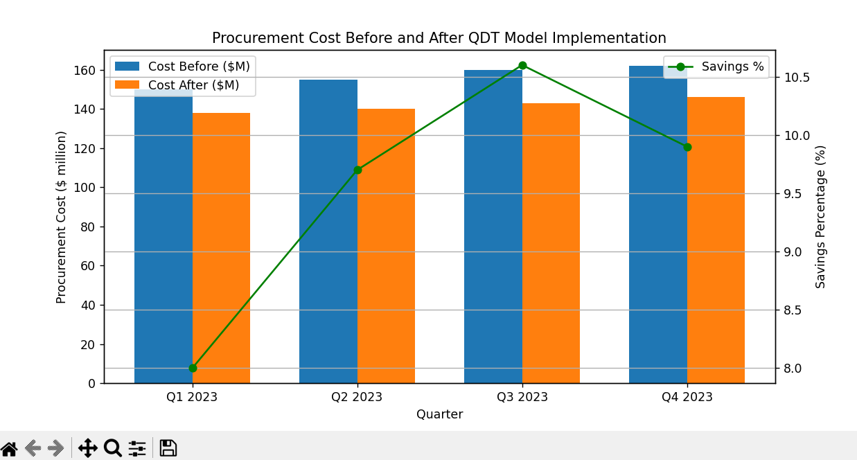

**5. Strategic Benefits and Financial Outcomes**

The forecasting model contributed to Tata Steel’s improved financial metrics, including:

* A reduction of approximately 8-12% in raw material procurement costs (aligned with the 9% cost reduction noted)
* Increased operational efficiency through predictive insights
* A projected EBITDA growth aligned with cost savings
* Strengthened supply chain resilience against market volatility

**6. Visual Overview**

The following visuals illustrate key components and results of the forecasting model:

* **Figure 1: Forecasting Model Architecture**  
  Diagram showing data flow from multiple sources through preprocessing, ELM prediction engine, and output to procurement and planning teams.
* **Figure 2: Raw Material Price Prediction vs Actual Price Trend**  
  Line chart comparing predicted iron ore and coking coal prices against actual prices over time, showing model accuracy and trend detection.
* **Figure 3: Cost Savings Over Time After Forecasting Model Implementation**  
  Bar chart illustrating percentage reduction in raw material costs quarterly or annually post model deployment, highlighting the $11 million coking coal procurement savings and 9% overall cost reduction.

**7. Conclusion**

The collaboration between Quantum Data Technology and Tata Steel demonstrates the power of data-driven forecasting models in managing raw material costs and enhancing profitability in heavy industries. The model’s predictive accuracy (~93%) and adaptive capabilities have allowed Tata Steel to stay competitive in volatile markets.

This case study exemplifies how integrating advanced analytics and machine learning into supply chain management can deliver significant financial and operational benefits.