Setup Instructions
- Backend Setup:
  - Open the backend project in VS Code.
  - Launch the integrated terminal.
  - Initialize the Node.js project: npm init -y
  - Install the required dependencies: npm install express multer xlsx cors
- Frontend Setup:
  - Open VS Code and launch the terminal.
  - Install project dependencies: npm install
  - Install Axios for API communication: npm install axios

Run Instructions
- Running the Backend:
  - Open the backend project in VS Code.
  - Start the server using: node server.js
- Running the Frontend:
  - Open the frontend project in VS Code.
  - Start the development server: npm run dev

Approach:
I implemented a robust validation layer at the very beginning of the workflow to ensure that all uploaded data is accurate and reliable before any processing takes place. This includes validating the presence of required columns, handling missing values, enforcing numeric constraints on fields like sales quantity, and maintaining uniqueness for key identifiers such as Component_ID. By addressing these checks upfront, I ensure data integrity and prevent invalid or inconsistent data from impacting downstream processing and final outputs.
Next, I implemented a linking mechanism using Component_ID as the common key between the Existing and New datasets. To make this efficient, I used hash maps (JavaScript Maps) which allowed me to quickly identify:
- Matched records (present in both files)
- Unmatched records (present in only one file)
Once the components were linked, I moved to the aggregation layer, where sales data is processed. Since sales can have multiple entries for the same Product_SKU, I aggregated the quantities to get total sales per SKU.
Finally, I combined everything to generate the Final Linked Output, which represents the business view of the data — showing how components are connected to products and how those products are performing in terms of sales. The output is also formatted to be clean and readable, such as displaying component IDs as comma-separated values instead of raw objects.

Assumptions:
- Each Component_ID is unique within the Existing and New datasets.
- Product_SKU in the Sales data may appear multiple times and therefore needs aggregation.
- Any unmatched data (in Existing, New, or Sales) is meaningful and should be surfaced.
- Files follow a consistent structure with expected column names, sheet names, workbook names, sheet positioning in a workbook.
- Added some extra data in the files to showcase the different Unmatched scenarios (Refer Screenshots).

Screenshots
Existing Packaging Data file uploaded.
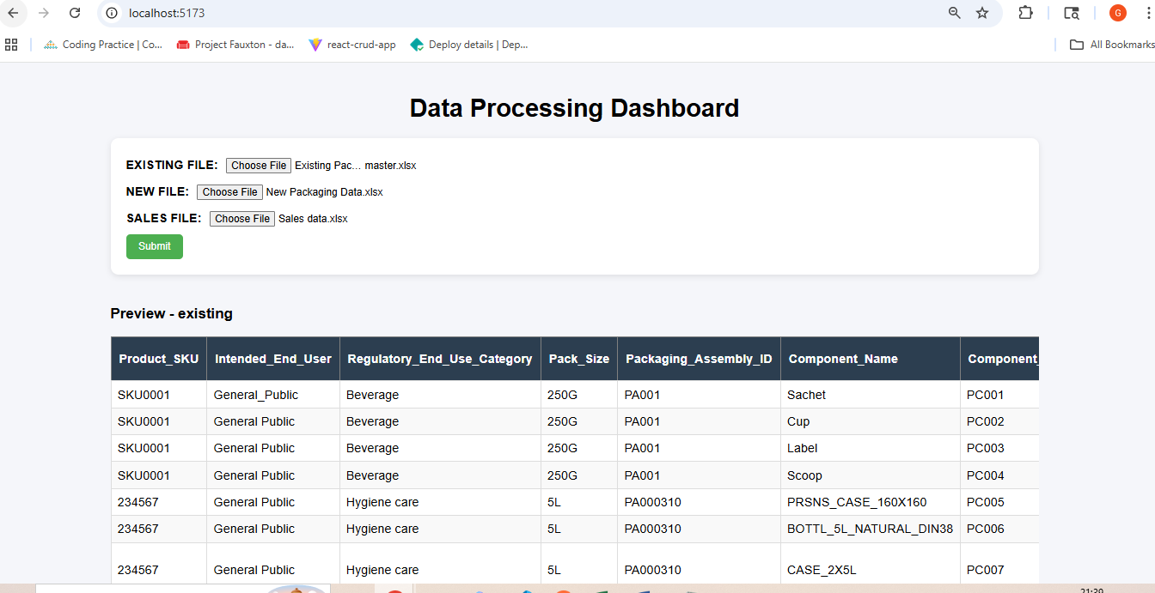

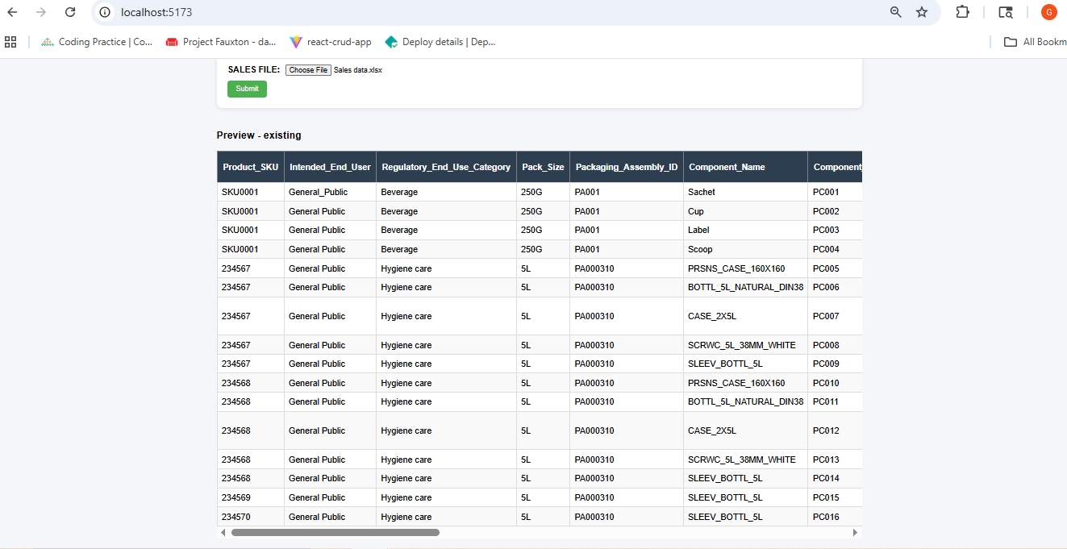

New Packaging Data file uploaded.
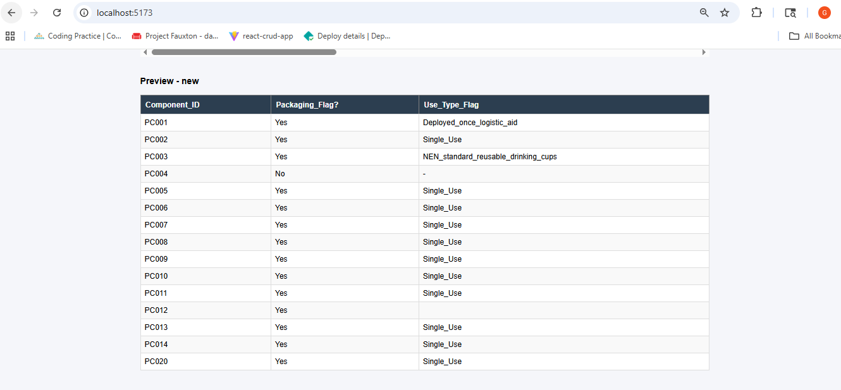

Sales Packaging Data file uploaded.
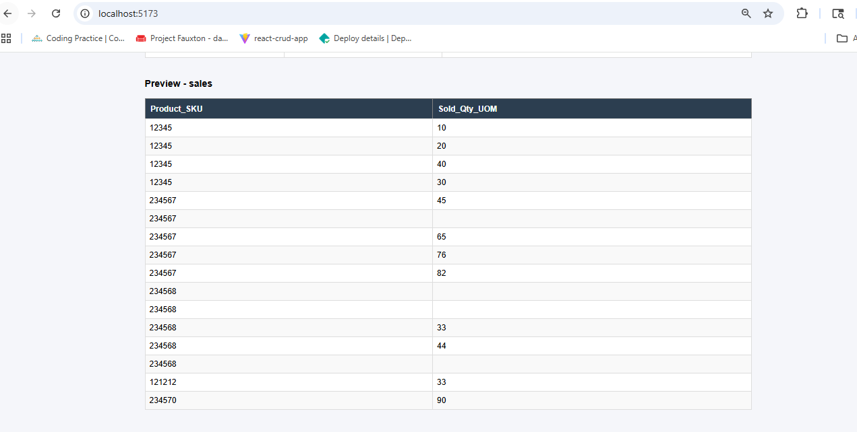

Summary
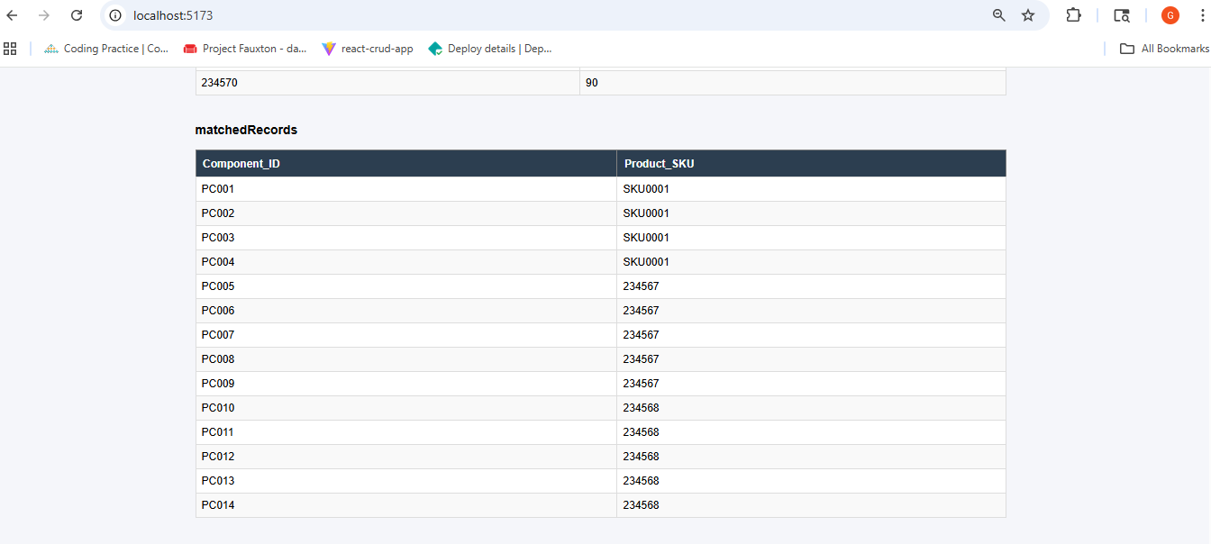

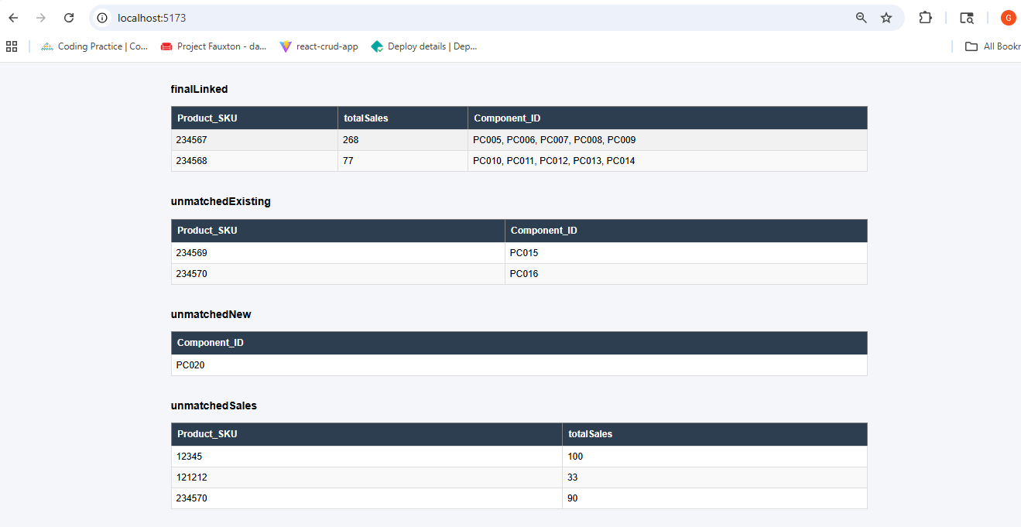

Validations
- Submit without uploading file in existing field

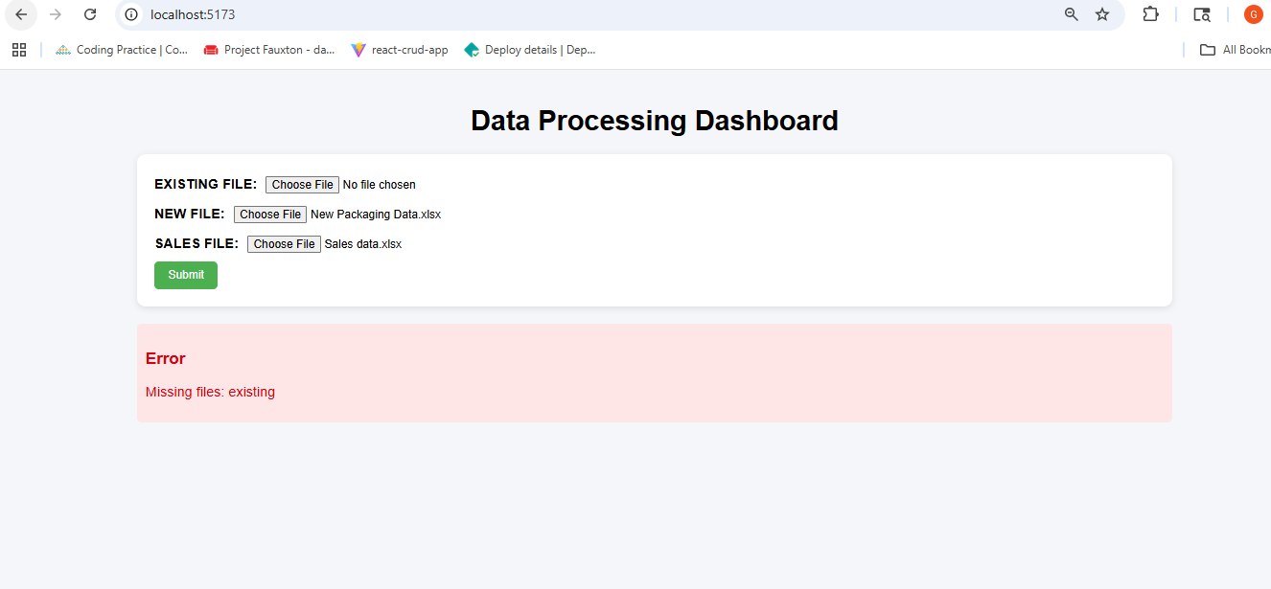

- Clicked on Submit without uploading the files.
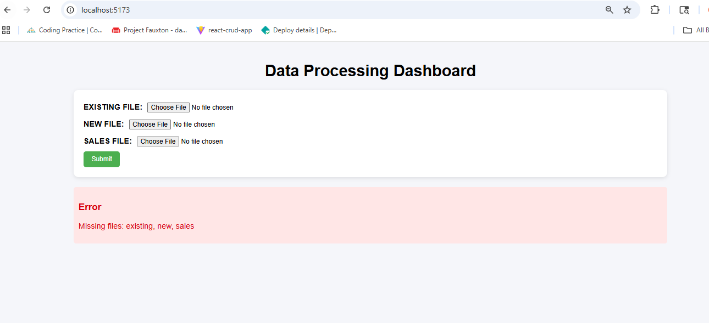

- File is empty or invalid in New File Field
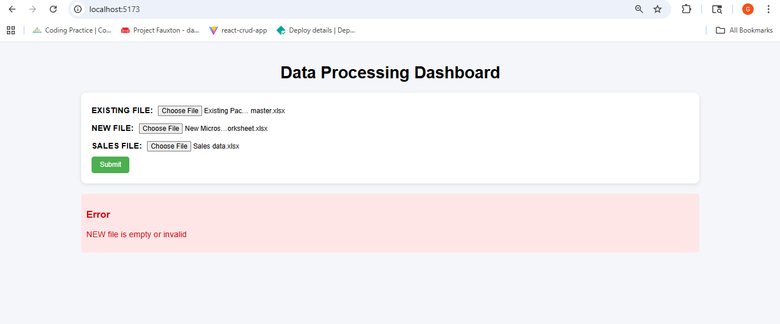

- Wrong uploaded file in existing field
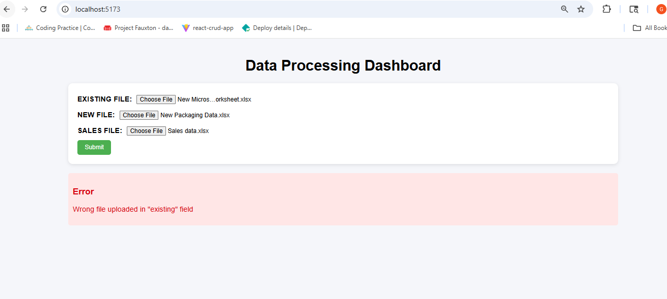

- Component Id value is not present in Existing packaging master file.
Note: existingErrors mean that the error is in Existing packaging master file.
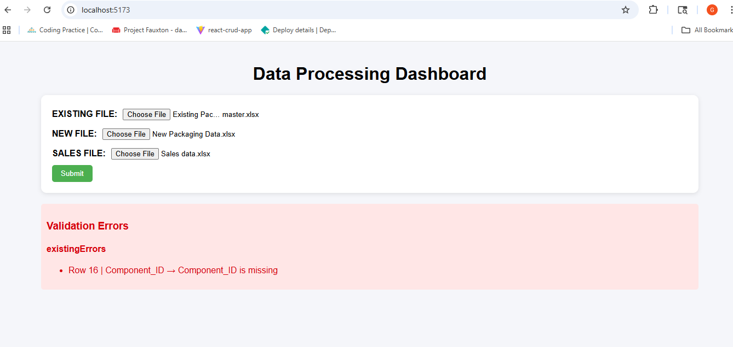

- Product_SKU is not present in Sales data file:
Note: salesErrors mean that the error is in sales data file.

- Duplicate component id is present in Existing Packaging Master file:
Note: existingErrors mean that the error is in Existing packaging master file.

- Duplicate component id is present in New Packaging Master file:
Note: newErrors mean that the error is in New packaging master file.

