

ZURICH UNIVERISTY OF APPLIED SCIENCES SCHOOL OF
LIFE SCIENCES AND FACILITY MANAGEMENT

Track Module 2

Final Report

XXX

Master program: Life sciences, V5_3, SS26

Submission date: 29.06.2026

Supervisor:
Dr. XXX
Dr. XXX

Contents
1. Introduction 3
2. Methodology 3
2.1 Straight Pipe CFD Simulation 3
2.2 Tortuous Vessel CFD 4
2.2.1 Geometry Preparation 4
2.2.2 CFD Model 6
2.2.3 Post-processing 6
2.3 Reduced-Order Modeling and Extraction of CFD Quantities 7
2.4 Model Comparison 9
3. Results 11
3.1 Straight Pipe Validation 11
3.2 Tortuous Vessel CFD 12
3.2.1 Geometry 12
3.2.2 Pressure 12
3.2.3 Velocity 13
3.3 Model Comparison 15
3.4 Calibration 15
4. Conclusion 15
5. Bibliography 15

Introduction
Hemodynamic simulations are widely used to analyse blood flow behaviour in patient-specific vascular geometries and to support the analysis of cerebrovascular diseases. Multiple approaches are available for the required analysis. For example, three-dimensional computational (3D) fluid dynamics (CFD) provides detailed information about velocity and pressure distributions throughout the vascular domain (H. Liu et al., 2020a). Such simulations capture complex behaviour coming from vessel curvature and geometric variations. However, the computational cost of CFD is high when the task is to compute large vascular segments.
Reduced-order models on the other hand reduce the required amount of parameters but simplify spatial parameters. In zero-dimensional (0D) models, each vessel segment is represented by lumped parameters such as resistance, compliance, and inertance, without considering spatial variations along the vessel (Pfaller et al., 2022). One-dimensional (1D) models preserve the vascular topology and resolve pressure and flow in the axial direction (Alastruey et al., 2007). Nevertheless, both approaches neglect detailed three-dimensional flow features, including radial velocity profiles, secondary flow structures, and local recirculation zones that are captured by CFD.

A main challenge in such modelling is determining how accurately simplification is able to reproduce the hemodynamic behaviour in comparison to CFD, because the detailed special information is removed. Velocity profiles, secondary flow structures and local recirculation zones are generally not represented in 0D and 1D simulations. This simplification may reduce the accuracy of predicted pressure and flow distributions, particularly in regions with complex geometry, bifurcations, curvature, or disturbed flow. For example, two vessels with identical radius and length may show different flow resistance and pressure losses when their geometries differ.

The goal of this project is to evaluate how accurately analytical, 0D, and 1D reduced-order models reproduce the haemodynamic behaviour predicted by 3D CFD for a patient-specific tortuous vessel. Using the CFD solution as the reference, the work identifies the limitations of each reduced-order representation and investigates which modelling parameters have the greatest influence to reach reference solution. The resulting parameters is the basis future parameter calibration and model improvement.

Methodology
The analysis begins with a straight cylindrical vessel, where numerical CFD results can be compared with analytical solutions to Poiseuille theory (Westerhof et al., 2019). This step is only used as a verification for a general approach for further validation. After that, a tortuous segment is analysed for differences between models. The final stage of the project focuses on the comparison between CFD, 0D and 1D models.

2.1 Straight Pipe CFD Simulation
The first CFD simulation was done on a straight cylindrical pipe and used as a reference for laminar flow. The geometry was taken from tutorials in OpenFOAM with steady, incompressible flow conditions (OpenFOAM, 2026). Blood was modelled as a Newtonian fluid with constant density and dynamic viscosity corresponding to physiological values (Razavi & Sahebjam, 2014).

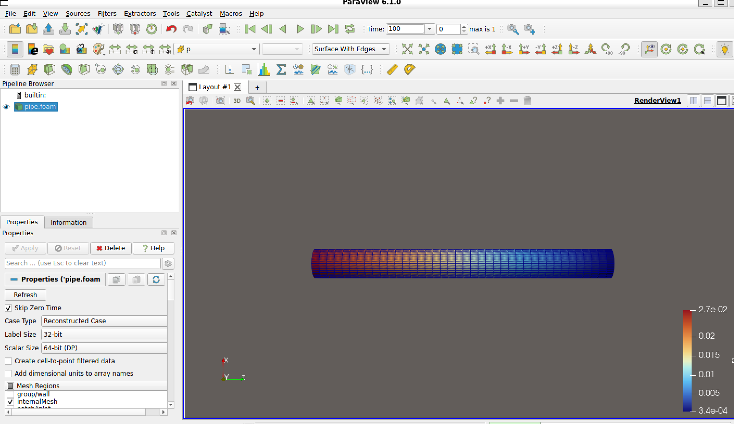
Figure 1: Straight pipe simulation in OpenFoam

A constant velocity was specified at the pipe inlet and the outlet pressure was fixed to provide a pressure reference. No-slip boundary conditions were applied at the pipe wall. The simulation was performed until a steady-state flow field was reached.

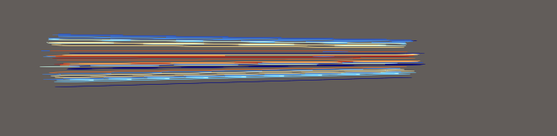
Figure 2: Streamlines of velocity flow

The exact workflow for further validation is shown in the figure below.
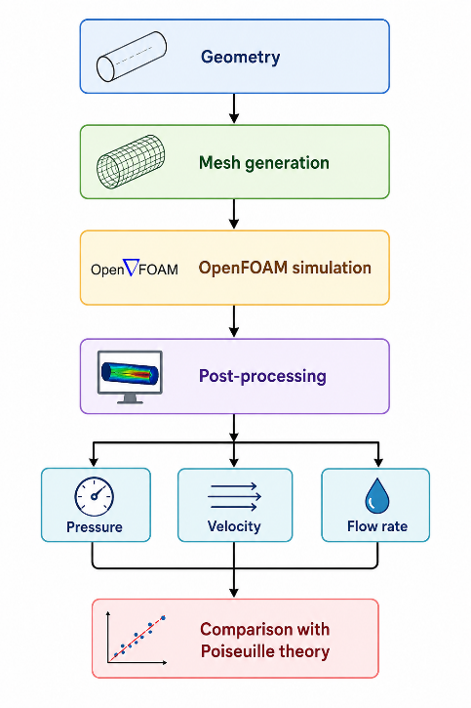
Figure 3: Steps for straight pipe analysis (Image generated with GPT)

The CFD simulation results were compared with the analytical Poiseuille solution for laminar flow in a straight pipe. The analytical solution, derived from the Navier-Stokes equations, was used as the reference for validating the numerical results.

Tortuous Vessel CFD

Geometry Preparation
The tortuous vessel geometry used in this study was obtained from an existing dataset that had been reconstructed from medical imaging(Musio et al., 2025). The dataset contained both the vascular surface mesh and the extracted vessel centrelines (Figure 4). Figure 5 represents the selected segment on the right bottom part where the mesh is overlaid.
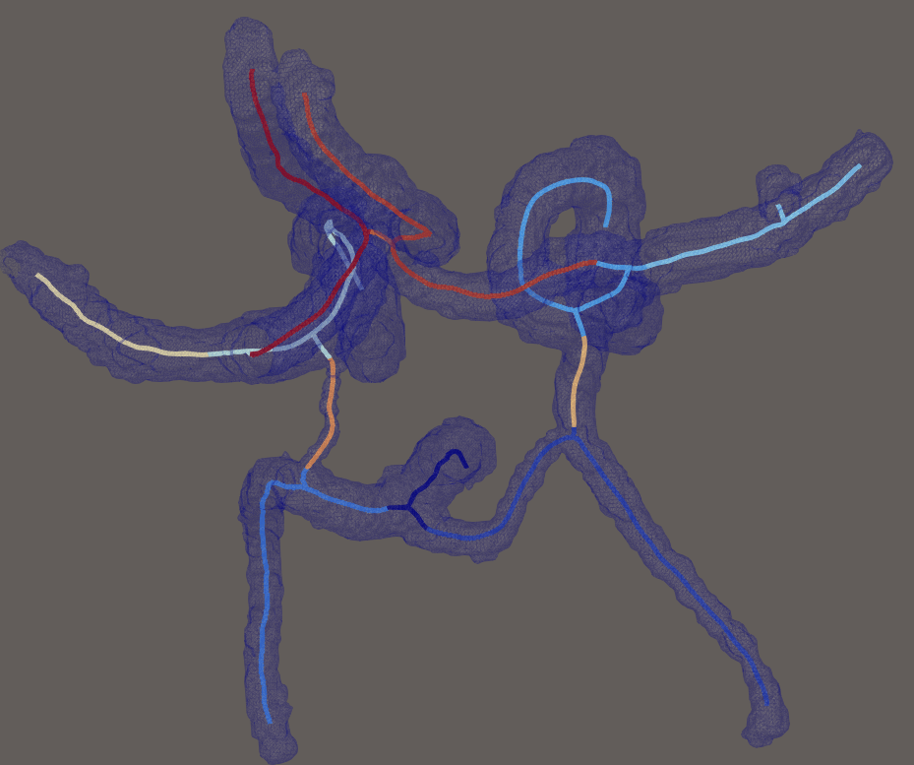  Figure 4: Whole vascular mesh with extracted centrelines | 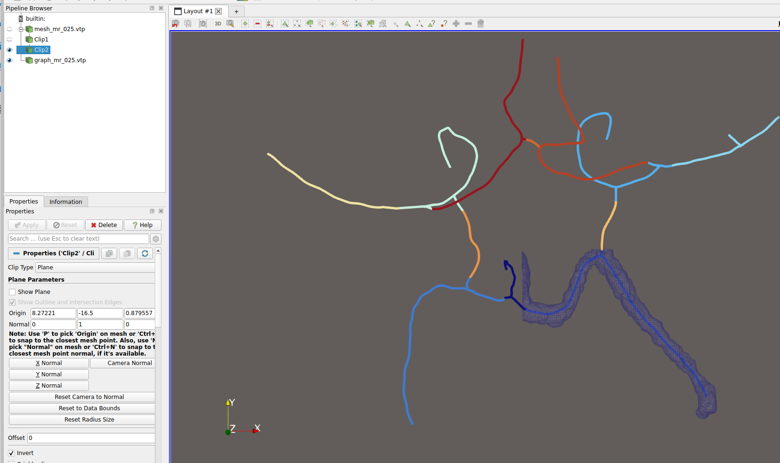  Figure 5: Selected segment
Figure 6 demonstrates the lumen surface (the surface obtained from the segment (Steinman et al., 2002)) defines further computations and represents the inner wall of the vessel. The centreline follows the centre of lumen and serves to provide geometric information for further reduced-order model analysis (Antiga et al., 2008). Local vessel radius, cross-sectional area, segment length, and curvature were computed along this path and used as inputs for the 0D and 1D models.
.
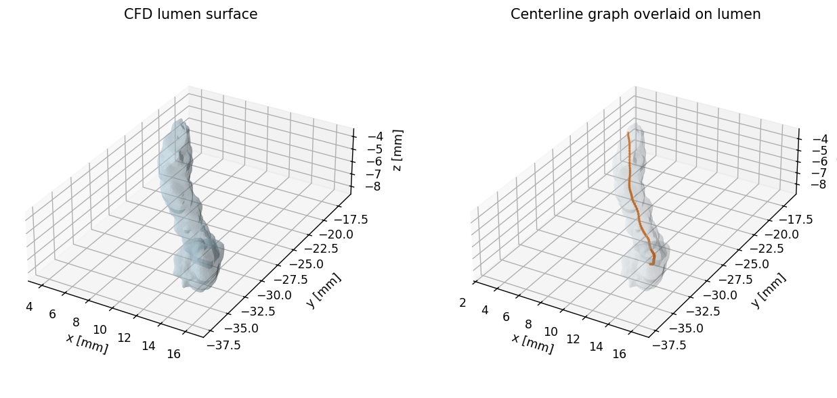
Figure 6: 3D vessel geometry & extracted centreline

Figure 7 illustrates the geometry of the vessel based on the centreline. The x-axis is the distance along the centreline from the inlet to the outlet. At every position, the local vessel radius (top graph) and the local centreline curvature (bottom graph) were calculated. The local radius is one of the most important parameters because it determines the cross-sectional area and strongly influences the hydraulic resistance used in reduced-order models (Pfaller et al., 2022). The curvature profile describes how strongly the vessel bends at each location. Curvature is not used in 0D models, but this information will be used for further calibration.
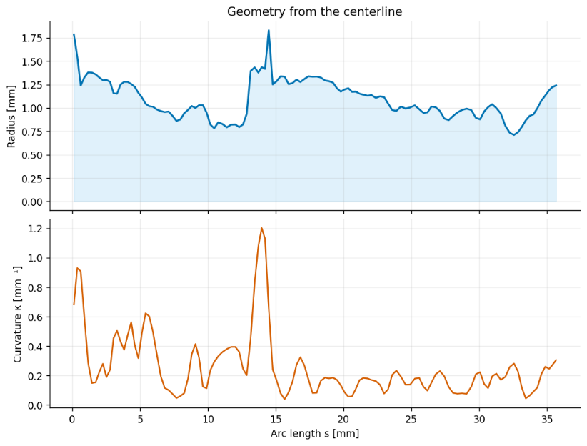
Figure 7: Geometry changes along the centreline

CFD Model
The selected vessel segment was discretised using a volumetric computational mesh in OpenFoam (Figure 8). The same incompressible Newtonian blood model and numerical approach used during the straight-pipe validation were used to ensure consistency. Boundary conditions were prescribed at the inlet and outlet, and the simulation was performed until a stable solution was obtained.

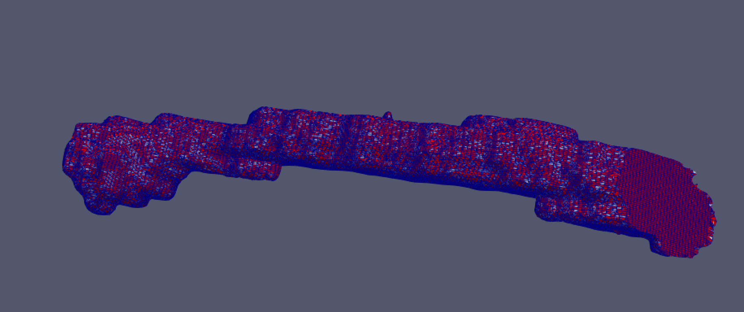
Figure 8: Simulated Mesh

Post-processing
Fist for visual understanding streamlines of the velocity were displayed (Figure 9). Afterwards, three cross-sections were defined at the inlet, middle and outlet of the vessel (Figures 10-12). Area s were extracted from each slice using ParaView (GUI of OpenFoam), including pressure, velocity and volumetric flow rate. These quantities were further used to calculate pressure drop, hydraulic resistance and average flow velocity, providing the reference values for comparison with the reduced-order models.
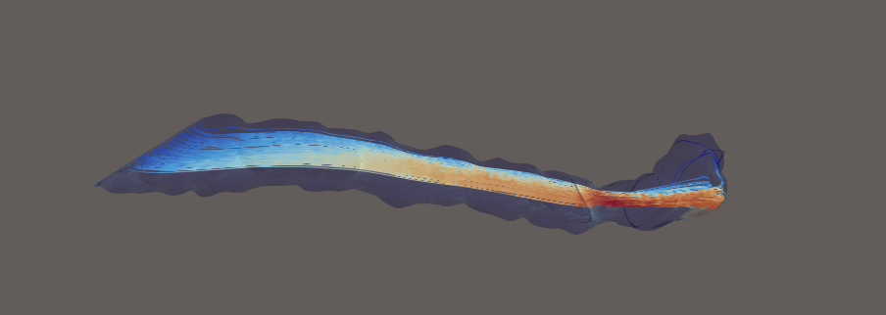
Figure 9: Streamlines used in post-processing
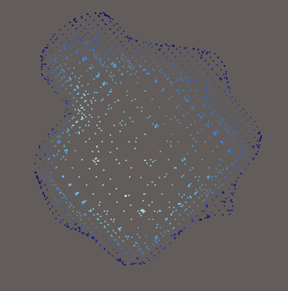  Figure 10: Inlet slice in the segment | 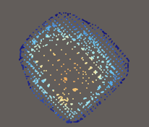  Figure 11: Midslice | 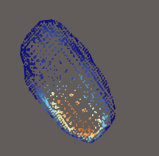  Figure 12: Outlet slice

Reduced-Order Modeling and Extraction of CFD Quantities
    - Reduced-Order Modelling
The extracted centreline geometry was used to construct four reduced-order representations of increasing complexity. Their characteristics are summarized in the table below:
Model | Description | Main Assumptions | Limitations
Poiseuille | Analytical model representing the vessel as a straight tube with a constant radius. Used as a theoretical reference. | • Straight vessel  • Constant circular radius  • Fully developed laminar flow  • No curvature  • Uniform cross-section | • Ignores vessel tortuosity  • Ignores local radius variations  • Cannot represent curvature-induced effects
0D native | Represented as 123 hydraulic resistance elements containing the full centreline discretisation | • Flow described by lumped hydraulic elements  • Local radius and length preserved for each segment | • Does not resolve local velocity profiles  • No secondary or cross-sectional flow structures
0D (N=50) | Reduced 0D model to only 50 resistance elements to invesitigate coarser discretisation. | • Same assumptions as the native 0D model  • Fewer computational segments
1D (FirstBlood) | One-dimensional model representing the isolated vessel by 40 segments extracted from the CFD centreline. | • One-dimensional conservation of mass and momentum  • Pressure and flow vary only along the vessel axis  • Cross-sectional averaged quantities  • Prescribed inlet flow and outlet pressure | • Cross-sectional velocity profiles are not resolved  • Curvature-induced and secondary flow losses are neglected  • Does not reproduce the full 3D pressure and velocity fields

The reduced-order models were constructed directly from the CFD centreline to provide representations of increasing physical complexity. The analytical model assumes a straight vessel with a constant radius, whereas the 0D and FirstBlood models preserve local geometric information extracted from the patient-specific vessel.

- Analytical (Poiseuille) model
The analytical model assumes a straight cylindrical vessel with constant radius and fully developed laminar flow. The vessel is represented by a single hydraulic resistance element computed using the Hagen-Poiseuille equation.

Hydraulic resistance:
$$R=\frac{8μL}{πr^{4}}$$ | where  - L = vessel length  - r = constant radius  - μ = dynamic viscosity

Pressure-flow relationship : ΔP=RQ
- 0D Model
Each vessel segment is represented by a hydraulic resistance calculated from its local geometry. Resistance element is characterised as:
$R_{total}=\sum_{i=1}^{N}{R_{i}}$, where $R_{i}=\frac{8μ L_{i}}{πr_{i}^{4}}$

In this model each segment has its own length and own radius.
For the 0D with 50 segments the same formula is used but with the reduced discretization.

- 1D model
The one-dimensional simulations were performed using the FirstBlood solver. This model solves the one-dimensional conservation equations for mass and momentum along the centreline(Wéber et al., 2023). The isolated tortuous vessel was reconstructed from the CFD centreline and represented by 40 vessel segments with spatially varying geometric properties. A prescribed inlet flow rate and a fixed outlet pressure were applied to reproduce the CFD boundary conditions.

Mass conservation is calculated as:
$\frac{∂A}{∂t} +\frac{∂\left(Au\right)}{∂x}=0$,  $\frac{∂u }{∂t}+\frac{∂\left(Au\right)}{∂x}+\frac{1}{ρ}\frac{∂p}{∂x}+\frac{32ν}{d^{2}}u=0$  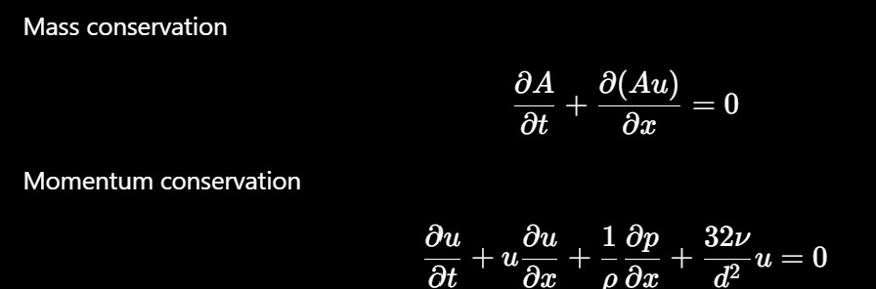 | Where  - A = cross-sectional area  - u = mean velocity  - p = pressure  - ρ = blood density  - ν = kinematic viscosity  - x = axial coordinate

    - Extraction of CFD Reference for Model Validation
For reference quantities taken from the CFD simulation, two groups were defined:
- Geometric information from the centreline
- Haemodynamic information from the numerical flow

The centreline was used for defining vessel length, local radius, cross-sectional area, tortuosity and curvature. These were used to calculate hydraulic resistance and define the geometry of the reduced-order models.
The CFD simulation provided the haemodynamic reference solution. Pressure and velocity were extracted at the inlet, middle and outlet cross-sections of the vessel, while the pressure field was additionally sampled along the centreline to obtain a continuous pressure profile. From these data, pressure drop, volumetric flow rate, average velocity and hydraulic resistance were determined.

Model Comparison
All the models were compared with the main focus on pressure drop across the vessel, volumed flow rate and hydraulic resistance. The resistance was calculated as:
$$R=\frac{∆P}{Q}$$
where
- $∆P$ is the pressure drop between the inlet and outlet
- $Q$ volumetric flow rate

A general comparison of characteristics in all models is presented in Table X, adapted from the comparison of computational models by Liu et al.(2020):
Characteristic | CFD | Poiseuille | 0D | 0D (N=50) | 1D
Geometry Representation | Full 3D lumen | Straight tube | Centreline (123 segments) | Centreline (50 segments) | Continuous centreline
Variable vessel radius | + | - | + | + | +
Vessel curvature | + | - | Represented though segment geometry | Represented though segment geometry | +
Pressure drip | + | + | + | + | +
Pressure distribution | Full 3D field | Analytical | Node pressure | Node pressure | Continuous axial
Flow rate | + | + | + | + | +
Hydraulic resistance | + | + | + | + | +
Velocity distribution | Full 3D profile | Analytical profile | - | - | Cross-sectional mean velocity

Hydraulic resistance was selected as the primary comparison metric because it combines the pressure drop and volumetric flow rate into a single quantity and can be evaluated consistently for all the models. Additionally, the models were compared for their ability to preserve the local radius variations, pressure distributions and flow characteristics.

3. Results

3.1 Straight Pipe Validation
Figure 3.1 shows that both velocity profiles from the CFD and the analytical solution at the outlet are nearly aligned. Both solutions are distributed in the parabolic curve, where maximum velocity is at the pipe centraline and velocity is decreasing to zero at the vessel wall due to the no-slip boundary condition.

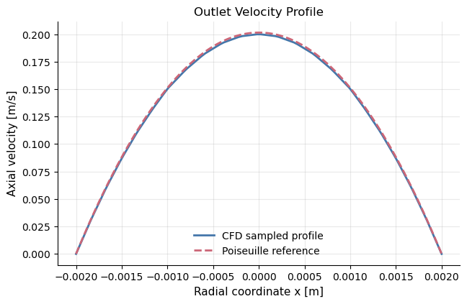
Figure 13: Velocity Profile in the Straight Pipe Outlet
The numerical values from in both cases are aligned along the whole radius and the deviations were of the error below 1%. This suggests that discretisation and mesh are sufficient to reproduce the expected laminar flow behaviour in a straight cylindrical vessel.

Figure X represents the pressure variation along the vessel , where the pressure decreases continuously from the inlet towards the outlet and follows a linear trend.

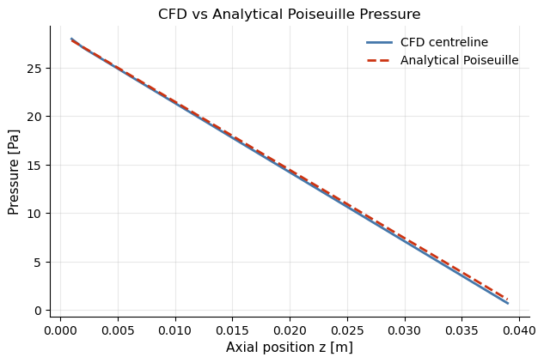
Figure 14: Pressure Distribution along the Pipe Centraline
Small deviations are expected because the flow develops after entering the computational domain and may be influenced by the boundary conditions.
Figure X summarizes the quantitative comparison between the CFD results and the analytical solution. The mean velocity, pressure drop, hydraulic resistance, wall shear stress, and Reynolds number all show relative differences of approximately 1.3-1.4%. These small discrepancies are attributed to numerical discretization, mesh resolution, and interpolation during post-processing. Based on these validation results, the numerical setup is considered sufficiently accurate for further analysis of the tortous vessel segment.
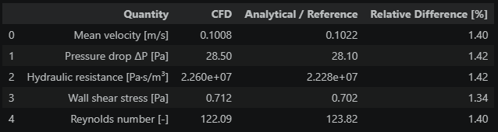
Figure 15: Validation Summary for Straight PIpe

3.2 Tortuous Vessel CFD

3.2.1 Geometry
Figure 16 shows that the segment has variability in radius with wider and narrower regions and not constant. Variations in vessel diameter influence the hydraulic resistance and therefore affect the pressure distribution and local blood velocity. Previous studies shown that in regions with smaller radius larger pressure losses and higher blood velocities is expected (X. Liu et al., 2016).
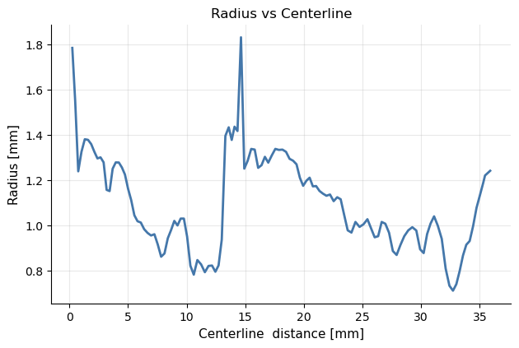
Figure 16: Averaged radius

3.2.2 Pressure
Figure X shows the spatial pressure ditribiution in the vessel. The highest pressure is near inlet and gradually decreases towards the outlet. Numerical solution is stable because the pressure field has no abrupt changes.
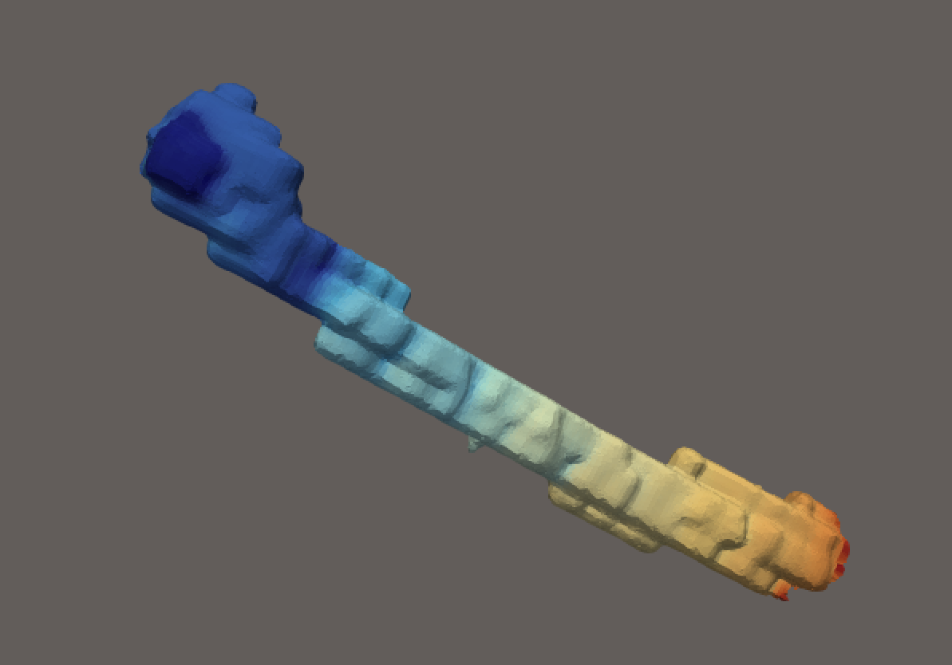
Figure 17: Pressure magnitude in OpenFoam

Figure X shows the pressure distribution along the centreline. The pressure decreases from approximately 505 Pa at the inlet to about 90 Pa at the outlet, giving an overall pressure drop of approximately 415 Pa across the analysed vessel segment.
The pressure decrease indicates energy loss caused by blood viscosity. The rate of pressure decrease is not perfectly linear because the vessel has a varying radius and a tortuous geometry, which produce local changes in flow resistance. A slightly steeper pressure decrease is observed near the outlet. This behaviour is likely related to local geometric changes and the prescribed outlet boundary condition. Overall, the pressure drop is physically correct and steady.
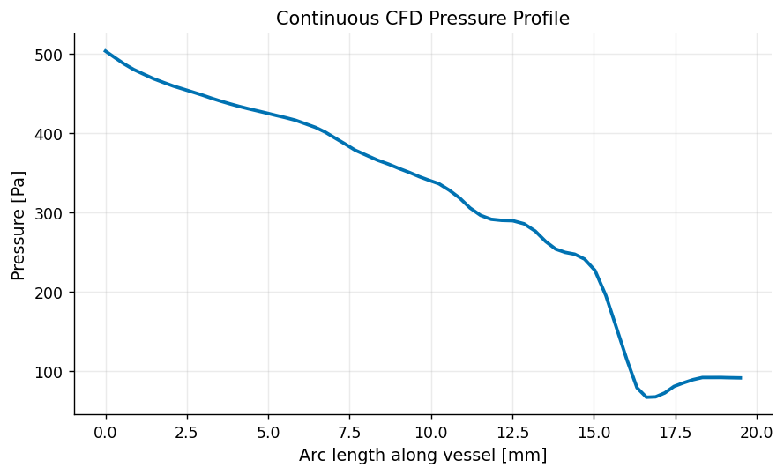
Figure 18: Pressure distribution along the centreline

3.2.3 Velocity
Figure 19 demontrates that the velocity varis along the vessel and increases towards outlet (red color). In the narrower section the higher velocity is present, while lower velocities are present in the wider regions.
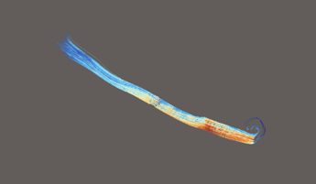
Figure 19: Velocity flow in OpenFoam

Figure X shows the velocity magnitude is not constant along the vessel but varies continuously with the geometry. A gradual increase in velocity is observed from the inlet towards the middle of the vessel, followed by a local maximum before the outlet. This behaviour is consistent with the presence of regions of reduced cross-sectional area, where the flow accelerates to maintain mass conservation. Towards the outlet, the velocity decreases again as the vessel geometry changes.
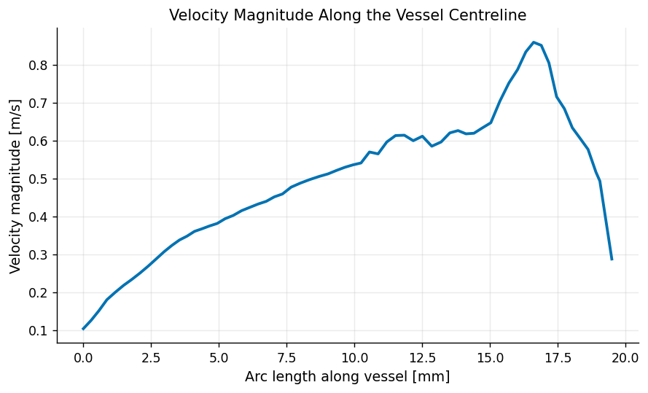
Figure 20: Velocity field
Figure X demonstrates the overview of the parameters in the tortuous vessel:
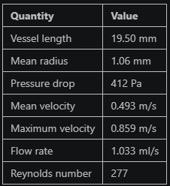
Figure 21: CFD simulation summary

3.3 Model Comparison

3.3.1 Pressure Profile
Figure 22 compares the pressure-loss profiles. The analytical solution shows a linear pressure-loss distribution because it assumes a straight vessel with a constant pressure gradient. Both 0D models predict very similar pressure-loss profiles, suggesting that reducing the discretisation from 123 to 50 segments has only a minor influence on the predicted pressure distribution. The FirstBlood model predicts a continuous pressure profile with a slightly lower total pressure loss than the 0D models. In contrast, the CFD model shows a larger pressure loss, showing in an overall pressure drop of approximately 356 Pa compared with 166-174 Pa for the reduced-order models.

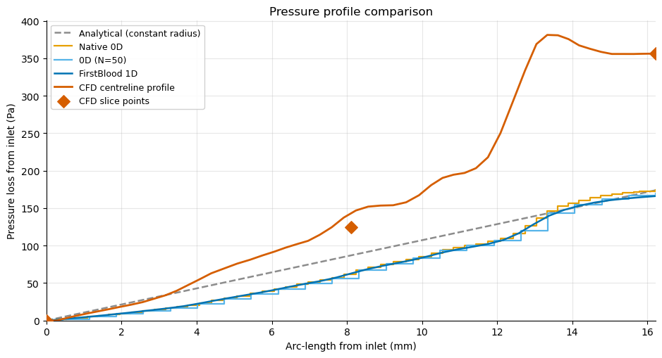
Figure 22: Pressure profile comparison
Figure 23 compares the total pressure drop predicted by all models. The analytical and native 0D models produce almost identical pressure drops of approximately 174 Pa. Reducing the discretisation to 50 segments decreases the predicted pressure drop only slightly to approximately 169 Pa. The FirstBlood model predicts the lowest pressure drop (166 Pa), while the CFD simulation predicts a larger value of 356 Pa. Therefore, all reduced-order models underestimate the pressure losses observed in the CFD simulation.

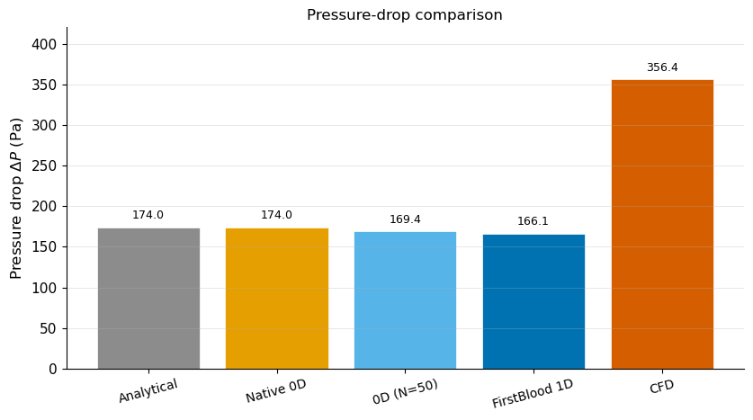
Figure 23: Pressure drop difference

3.3.1 Hydraulic Resistance
Figure 24 compares the hydraulic resistance. The analytical and native 0D models predict almost identical hydraulic resistance, whereas the coarsened 0D model and the FirstBlood model produce slightly lower values. The CFD simulation predicts a hydraulic resistance of 3.476 × 10⁸ Pa·s/m³, which is approximately twice the value predicted by all reduced-order models. None of the reduced-order models reproduces the hydraulic resistance obtained from the three-dimensional CFD simulation.

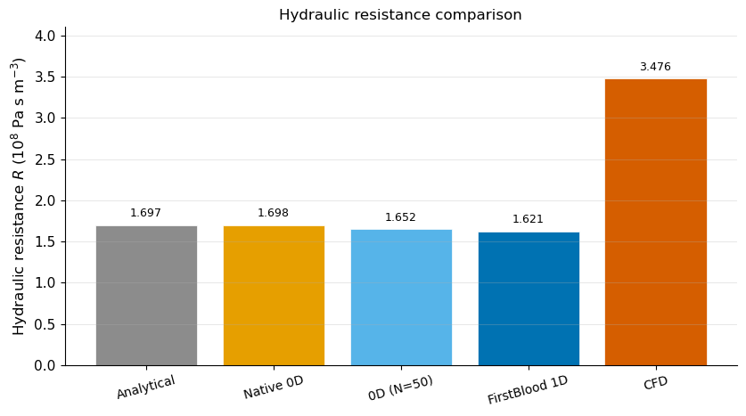
Figure 24: Hydraulic resistance among models

Discussion
Before interpreting the differences between the reduced-order models and the CFD simulation, the complete comparison workflow was verified. Fluid properties, vessel geometry, boundary conditions and post-processing were found to be consistent between OpenFOAM, FirstBlood and the 0D models. Numerical verification confirmed mass conservation, steady-state convergence and negligible numerical errors. Therefore, the differences observed between the reduced-order models and CFD are unlikely to originate from implementation or processing errors.
Suprisingly, FirstBlod model results were not improved in comparison to the 0D modals. Although FirstBlood solves the one-dimensional conservation equations for mass and momentum, it represents only cross-sectional averaged quantities. Therefore such mechanisms as curvature-induced secondary flow, developing velocity profiles, radial pressure gradients and other local three-dimensional flow effects were also not represent in 1D model. This is a possible explanation for inaccurate results in hydraulic losses and much smaller pressure drop in comparison to CFD.
Additionally, the present FirstBlood model was applied to an isolated vessel segment with prescribed inlet flow and outlet pressure. These boundary conditions are consistent with the CFD model, however the isolated segment cannot represent the flow in the other segments in the Circle of Willis. A complete network simulation might produce different pressure distributions and should be investigated in future work.
The comparison demonstrates that increasing model complexity from analytical to 1D modelling only is not sufficient to recreate accurate CFD results. There is a large discrepancy in solutions and additional physical effects should be implemented in the reduced-order models.

Future Work
Future work should investigate parameters that represent hydraulic losses that are not included in the current reduced-order models. Previous studies have shown that neglecting pressure losses at vessel connections can reduce the accuracy of 0D/1D simulations. Using calibrated loss coefficients improves prediction accuracy and provides smoother pressure-loss results. In addition, wall mechanical properties, such as Young's modulus and the pressure-area relationship, are important in 1D models because vessel wall stiffness strongly affects wave propagation and pressure-flow behaviour (Mynard & Valen-Sendstad, 2015).
Based on the present comparison, the following parameters could be calibrated to improve reduced-order models:
- Curvature-dependent friction coefficient: adds extra pressure losses caused by curved vessels and secondary flow (Formaggia et al., 2010).
- Local loss coefficient (K): represents pressure losses caused by bends and other changes in geometry (Colebank & Olufsen, 2021)
- Entrance-loss coefficient: describes the additional pressure loss that occurs while the flow develops near the inlet
- Effective hydraulic radius: corrects uncertainties in the measured radius and its effect on hydraulic resistance
- Local or global resistance scaling factor: adjusts the predicted hydraulic resistance to include 3D effects that are not considered in the current 0d & 1D models
- Wall mechanical properties (Young's modulus and pressure-area relation): should be included in the modelling of elastic vessel walls
Instead of increasing the discretisation steps, future work should focus on calibrating these parameters using validated CFD simulation. This is expected to improve the prediction of pressure distribution and hydraulic resistance and produce results that are closer to CFD simulation and more precise.

Conclusion

The current project focused on implementing the mesh generation, centraline extraction and CFD simulation for analysing hemodynamic properties in the segmented tourtous vessel. The project aimed to compare how accurate reduced-order modelling in comparison to 3D simulation. Reduced models delivered less accurate results as expected due to their limitations.

Bibliography

Declaration of AI
Artificial intelligence (AI) tools, such as ChatGPT and Microsoft Copilot, were used for idea support, inspiration and debugging (ChatGPT, 2026; Microsoft, 2026). In addition, AI tools were used to correct grammar and phrase the report in more scientific language style.

