PROJECT PROPOSAL

ON

SURAJKUND MELA

(EXHIBITION)

**INDEX**

1. Introduction to Project
2. Abstract of the project
3. System Analysis
4. Hardware/ Software Requirements
5. Feasibility Study
6. Software Requirement Specifications
7. Project Planning
8. Project Scheduling (20 Days)
9. Modules
10. Coding
11. Database Tables
12. Output Screens

**Introduction to Project**

**Project Overview:**

The purpose of this project is to provide the services for Crafts Exhibition for Craftsperson and Customers who come for exhibition.

Exhibition System belong to the class of application software intended for storage and management of information of person , food stall coupons. The systems are used to control and manage ID Card, Duplicate ID Card, banner, registration, coupons.

**Project Objectives:**

The basic objectives and tasks of industrial enterprises comprise the maintaining Details of Exhibition of Huts, Stalls. This constitutes complex structures that perform their activities in accordance with requirements.This created automation process. This carry out a functions, including record of huts, stalls, food coupon and many other functions. When considering the structure and functions of system, it becomes obvious that successful implementation of such multifaceted activity requires the use of information measurement and information management systems.

**Abstract of the project**

This system is designed for Any Exhibition to replace their existing manual, paper based system. The new system is to control the following information;User Registration, duplicate ID card, ID Card, Banners.. These services are to be provided in an efficient, cost effective manner, with the goal of reducing the time and resources currently required for such tasks. A significant part of the operation of any exhibition involves the acquisition, management and timely retrieval of great volumes of information. This information typically involves;, staff information, various facilities lists. All of this information must be managed in an efficient and cost wise fashion so that an institution's resources may be effectively utilized Exhibition system will automate the management of the Exhibition making it more efficient and error free. It aims at standardizing data, consolidating data ensuring data integrity and reducing inconsistencies. The basic objectives and tasks of exhibition comprise quality and achieving increased efficiency of the production process with least costs.

**System Analysis**

1. **Existing System :**

Exhibition setup currently uses a manual system for the management and maintenance of critical information. The current system requires numerous paper forms, with data stores spread throughout infrastructure. Often information (on forms) is incomplete, or does not follow management standards. Forms are often lost in transit between departments requiring a comprehensive auditing process to ensure that no vital information is lost. Multiple copies of the same information exist and may lead to inconsistencies in data.

1. **Proposed System:**

The Surajkund Exhibition is designed for any exhibition to replace their existing manual, paper based system. The new system is to control the following information user information, stalls & huts information. These services are to be provided in an efficient, cost effective manner, with the goal of reducing the time and resources currently required for such tasks.

**Hardware/Software Requirements**

**System Specifications Minimum Hardware Requirements:-**

* 4 GB Ram
* Hard disk 500 GB
* Microsoft Compatible 101 or more Key Board Software Requirements: -

**Operating System** :

* Windows 10
* Programming language: .NET
* Web-Technology: ASP.NET 4.5
* Front-End: ASP.NET MVC
* Back-End: SQL SERVER
* Web Server: IIS

If system, which is going to be developed, is complex in nature the goals of the entire system could not be easily comprehended. Hence the need for a more rigorous system analysis phase arose.

**Feasibility Study**

Feasibility study is conducted once the problem is clearly understood. Feasibility study is a high level capsule version of the entire system analysis and design process. The objective is to determine quickly at a minimum expense how to solve a problem. The purpose of feasibility is not to solve the problem but to determine if the problem is worth solving. The system has been tested for feasibility in the following points.

1. Technical Feasibility

2. Economical Feasibility

3. Operational Feasibility.

1. **Technical Feasibility:** The project entitles "Surajkund Exhibition” is technically feasibility because of the below mentioned feature. The project was developed in Asp.net MVC which is depending upon Model View Controller. It provides the high level of reliability, availability and compatibility. All these make Asp.net MVC an appropriate language for this project. Thus the existing software Asp.net MVC is a powerful and secure language.
2. **Economical Feasibility:** The computerized system will help in automate the selection leading the profits and details of the organization. With this software, the machine and manpower utilization are expected to go up by 80-90% approximately. The costs incurred of not creating the system are set to be great, because precious time can be wanted by manually.
3. **Operational Feasibility:** In this project, the management will know the details of each project where he may be presented and the data will be maintained as decentralized and if any inquires for that particular contract can be known as per their requirements and necessaries.

**Software Requirement Specifications**

A **software requirements specification** (SRS) is a detailed description of a software system to be developed with its functional and non-functional requirements. The SRS is developed based the agreement between customer and contractors. It may include the use cases of how user is going to interact with software system. The software requirement specification document consistent of all necessary requirements required for project development. To develop the software system we should have clear understanding of Software system. To achieve this we need to continuous communication with customers to gather all requirements.

**1. INTRODUCTION**

**1.1 PURPOSE**

The Software is for the automation of Exhibition Management. It maintains two levels of users:-

1. Administrator Level
2. Craftsperson Level

**The Software includes:-**

1. Maintaining Customers Details for Registration
2. Providing and maintaining all categories of Craftsperson
3. Generating ID Card, Takhati, Food Coupon for Stalls

**User Classes and Characteristics:** This software is used two types of end user. First is Administrator who has right to control this software. Administrator view complaints and mark the complaint to the person complaint, can also forward the complaint to the concerned person. User classes of system are as follows:

**Administrator:-**

Administrator is responsible for following activities:-

1. User Management
2. Role Management
3. ID Card Management
4. Banner Generation
5. Duplicate ID Card Generation
6. Registration Slip

**Cratsperson:-**

1. Food /Stall Coupon Generation
2. Enter Helper Craftsperson detail

**Project Planning**

Project life cycle has three stages: -

Project Initiation –

I prepare the project plans and finalize the outcome of each phase. In this stage I also prepare the comprehensive list of tasks involved in each phase, and the project.

Project Execution – In this stage, I develop the product. This Stage consists of following phase:

• Requirement Analysis

• High Level Design

• Low Level Design

• Construction

• Testing

• Acceptance

Project Completion – In this stage, I have to update the site regularly. Each new item has to add by the administrator as according to the needs and demands. This stage is very important the freshness of the site. When any updating or up gradation is required for the website, I make the website up to date. There are lots of requirements after the completion of the Project. As this website is dynamic website in which lots of changes are required.

**Project Scheduling (20 Days)**

|  |  |
| --- | --- |
| **1-4 July 2019** | **Feasibility Study** |
| **5th-11th July 2019** | **Requirement Gathering** |
| **12-14th July 2019** | **Designing** |
| **15th -21 July 2019** | **Coding** |
| **22nd July 2019** | **Testing and Implementation** |

**MODULES**

1. **User Management**
2. **Roles Management**
3. **Stall & Huts Categories**
4. **ID Card Management**
5. **Food Coupon**
6. **Generate Takhti**

**Coding Part**

**Controllers :-s**

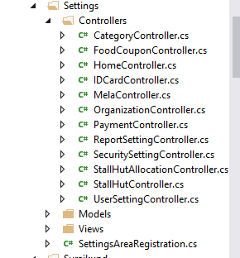

**Controller Coding**

1. **ID CARD Controller:-**

In this controller I have added the index, details, Create, Edit and Delete Methods ID CARD Generation

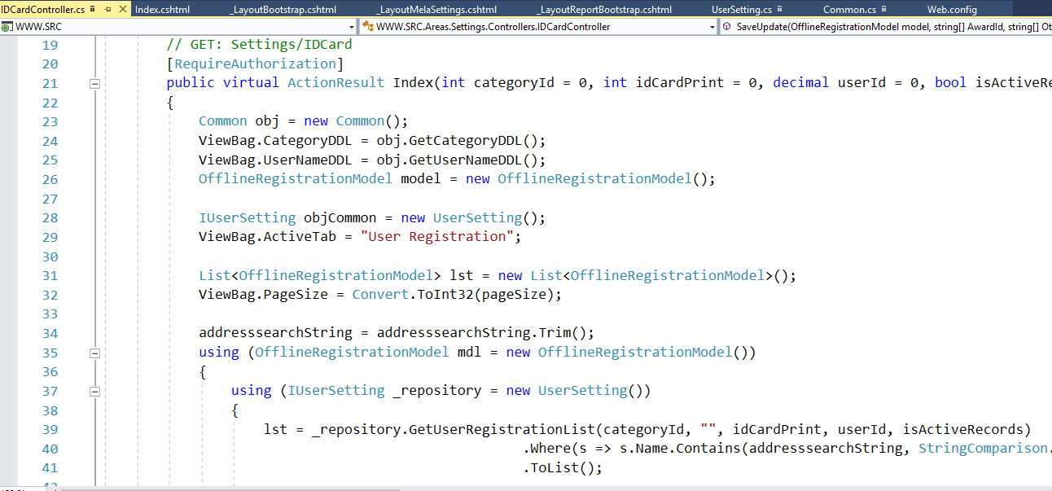

1. **Sub Test Masters Controller:-**

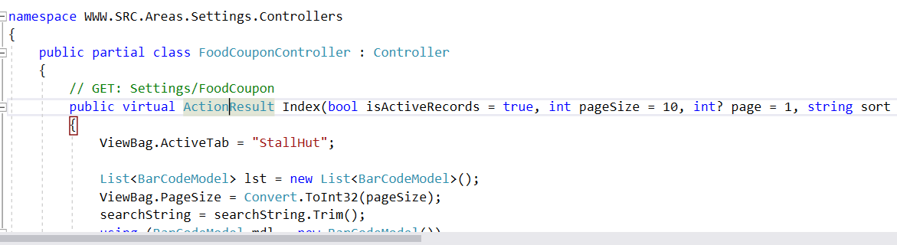

1. **Stall Hut Controller**

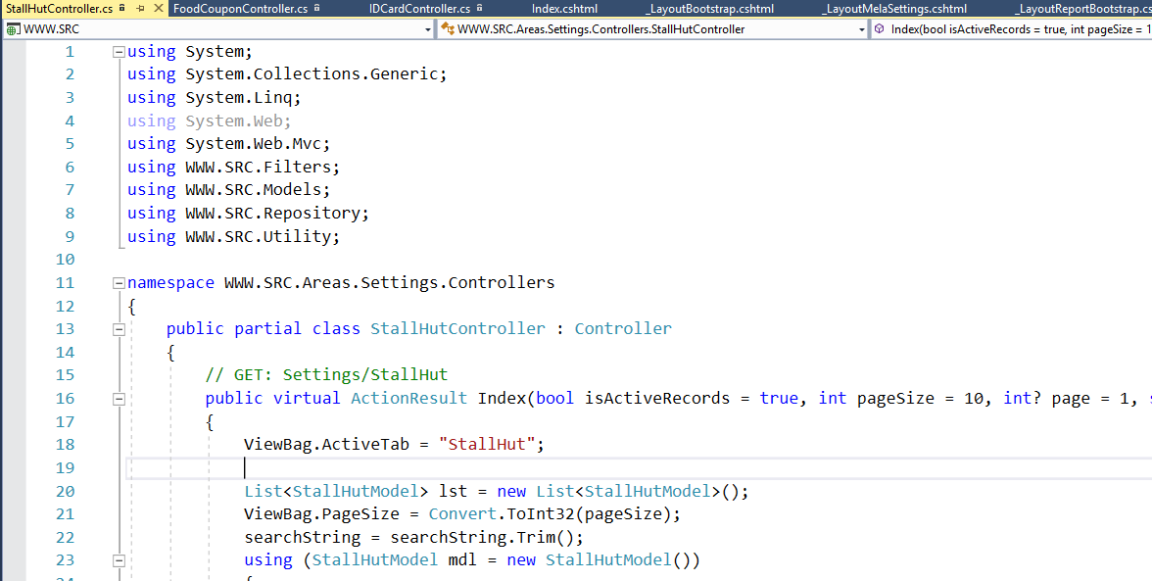

1. **Stall Hut Allocation Controller:-**

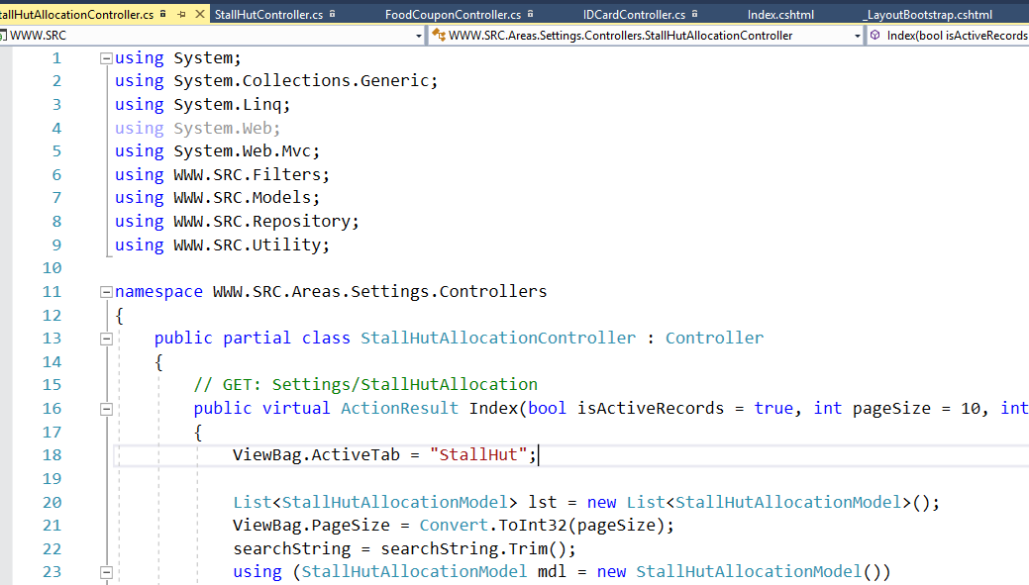

1. **User Registration Controller:-**

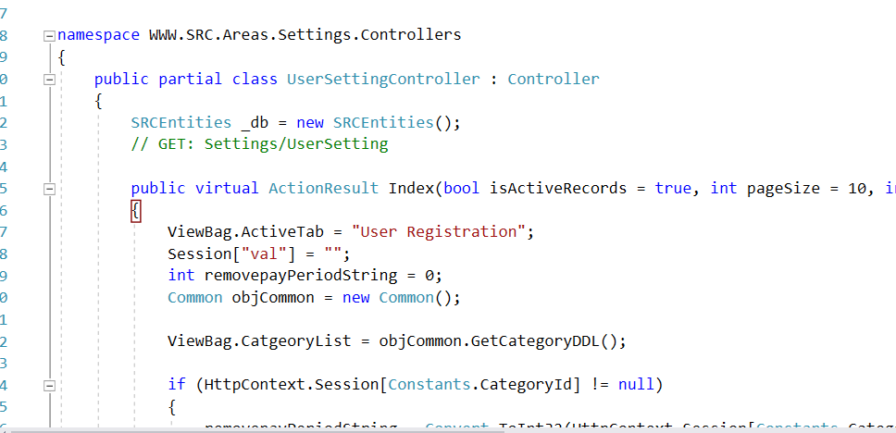

1. **Category Controller:**

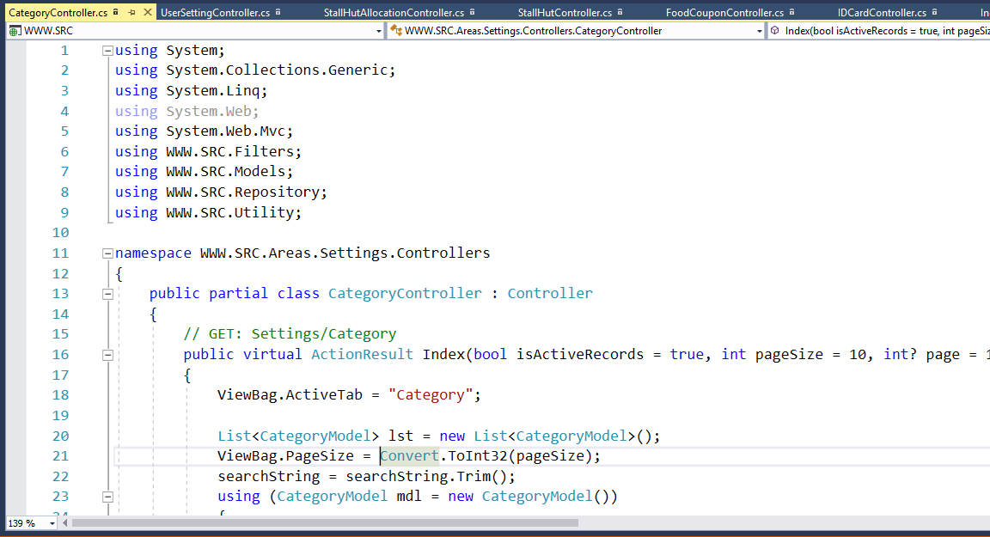

1. **Reports:**

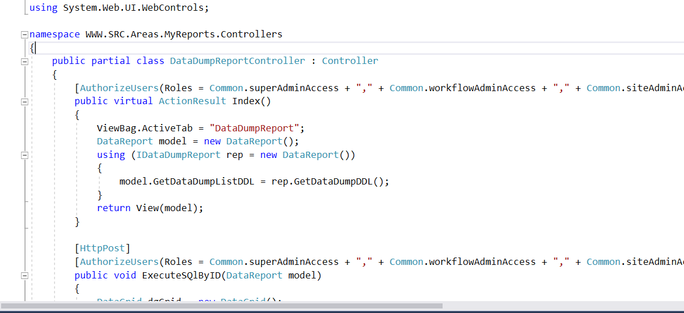

**Models**

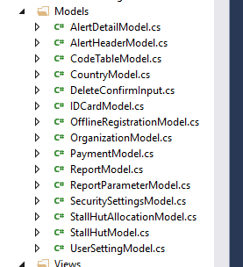

**Views**

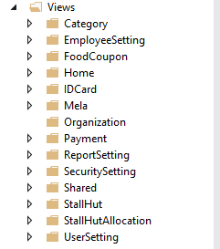

**Output Screens**

**Login Page**

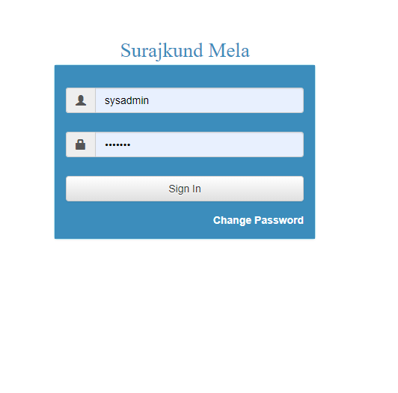

**Dashboard:**

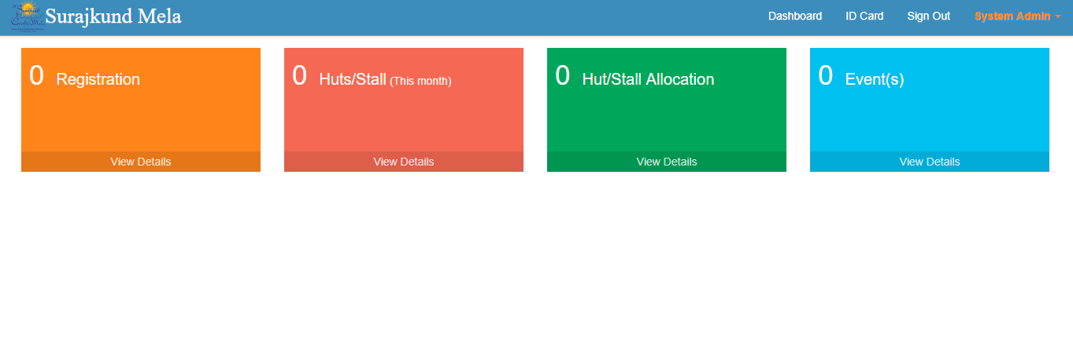

**Role Management**

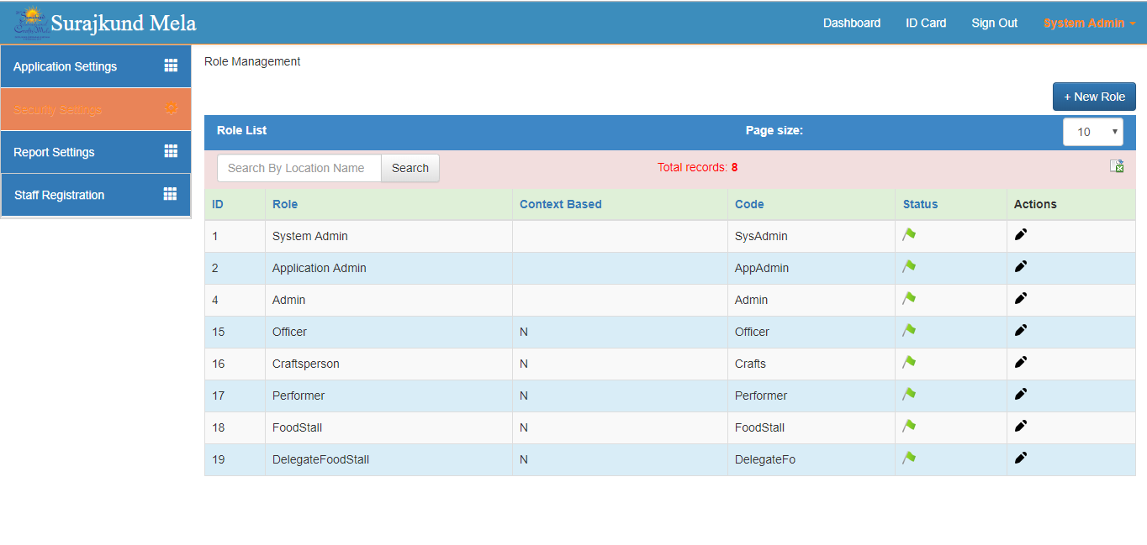

**User Role Mangement**

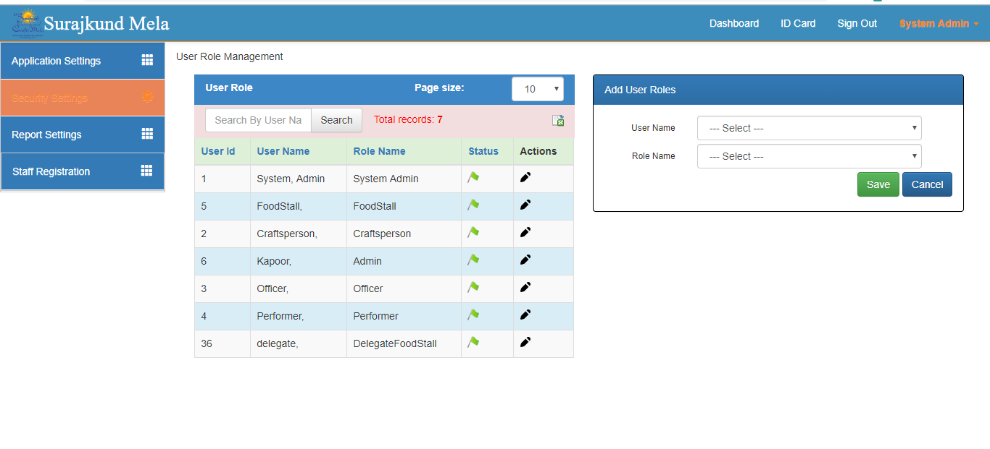

**Category Screen**

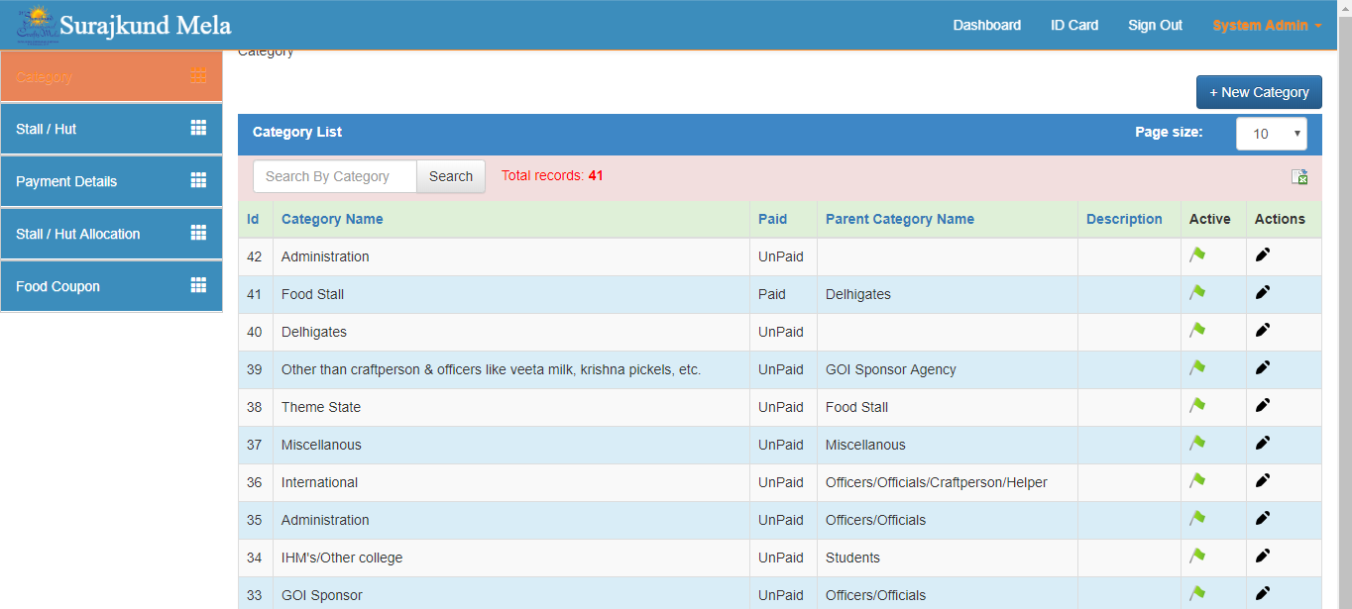

**Stall Hut Screen**

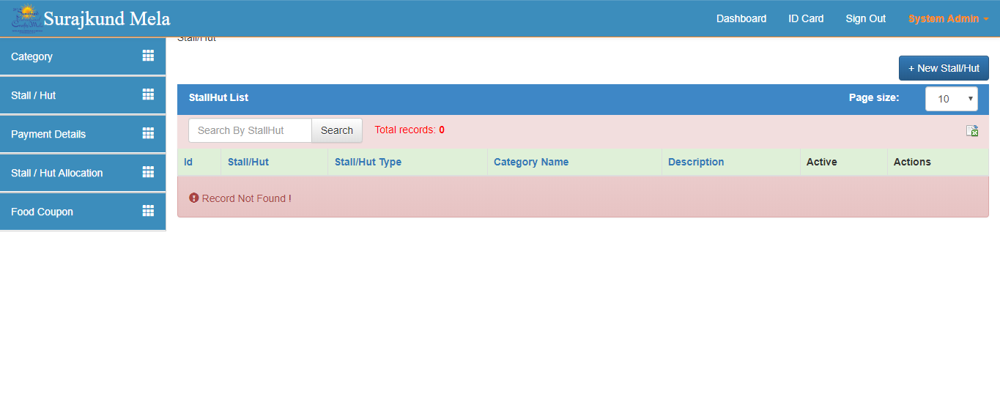

**Payment Amount**

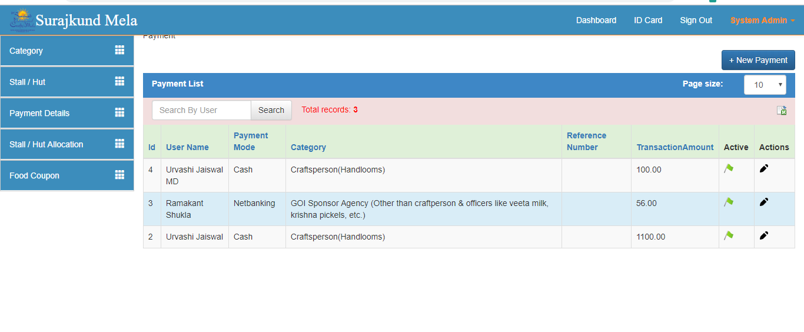

**Stall Hut Allocation**

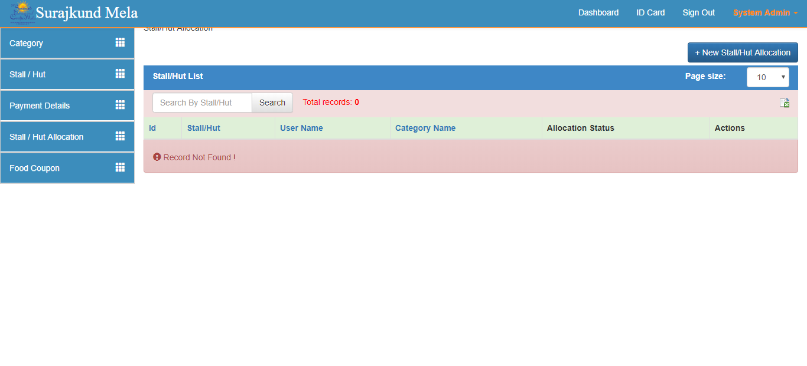

**Food Coupon**

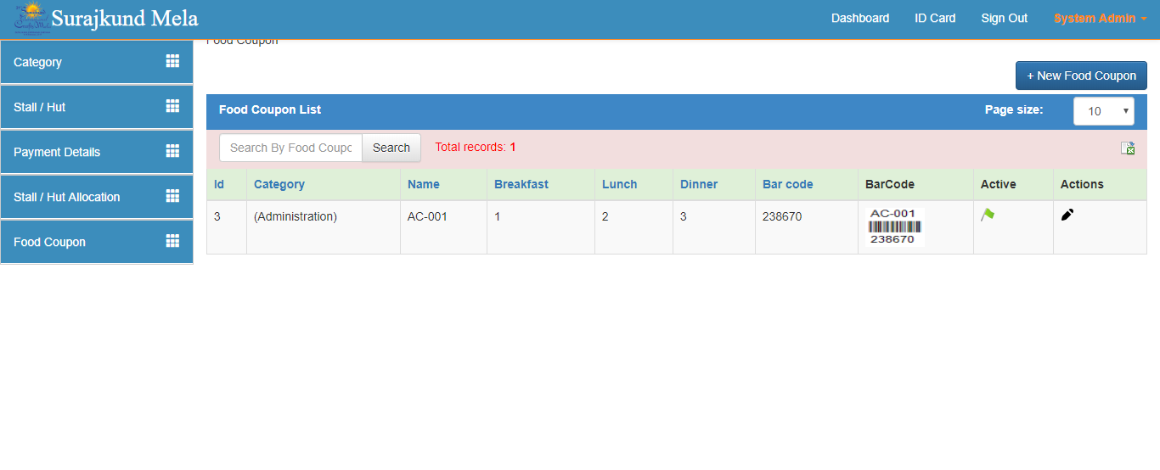

**User Registration**

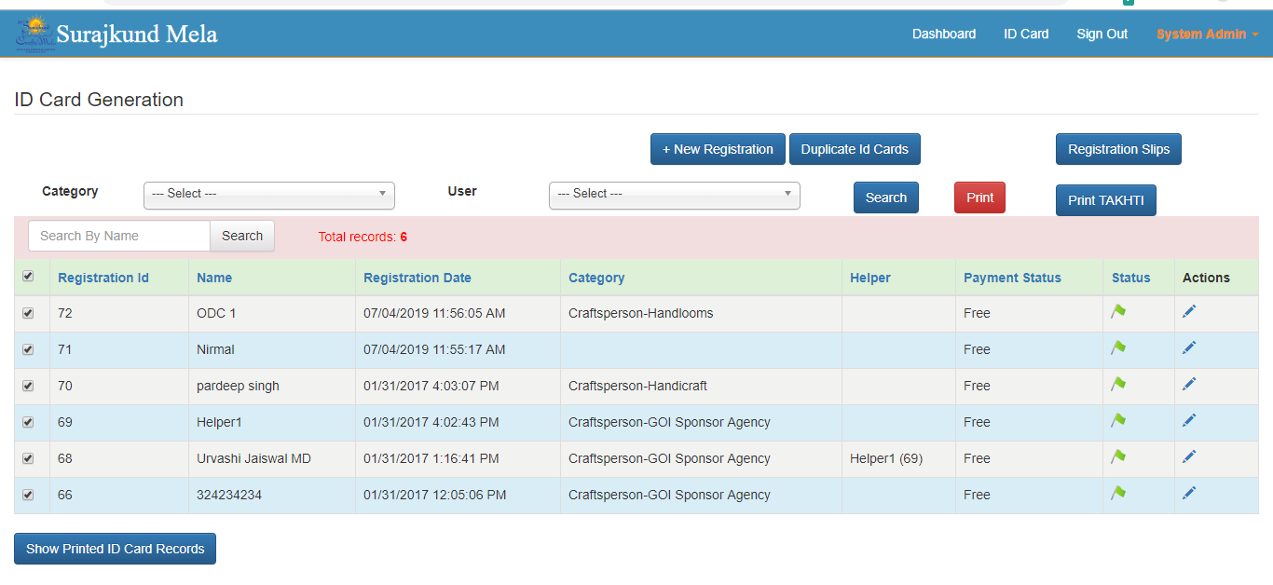

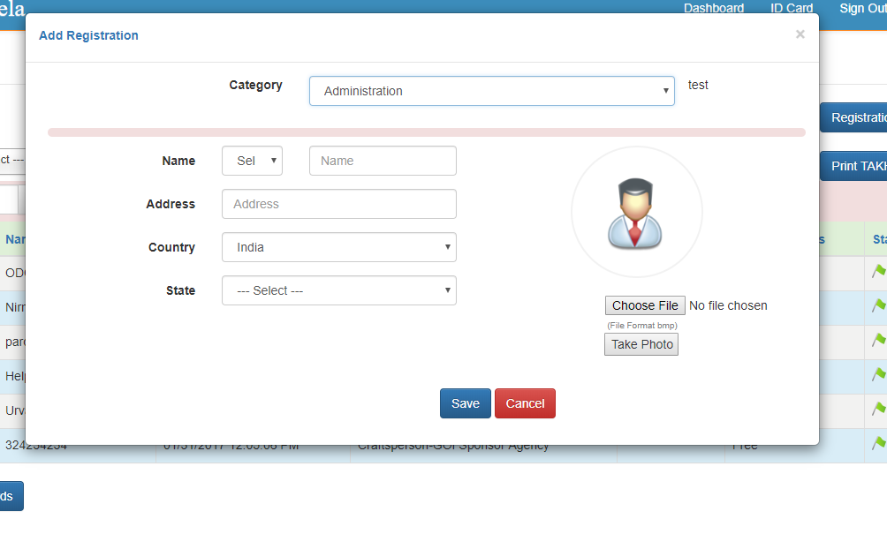

**ID CARD**

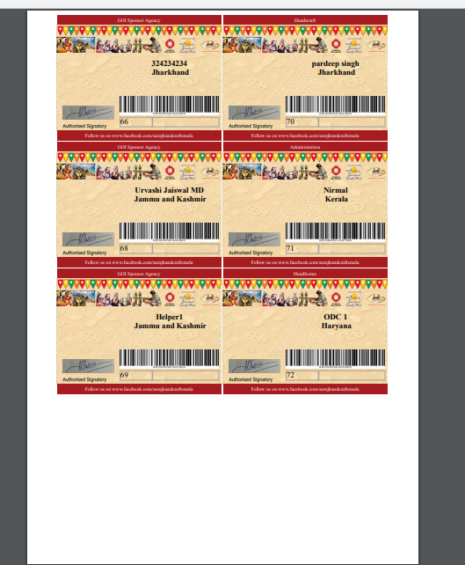

**Banner :**

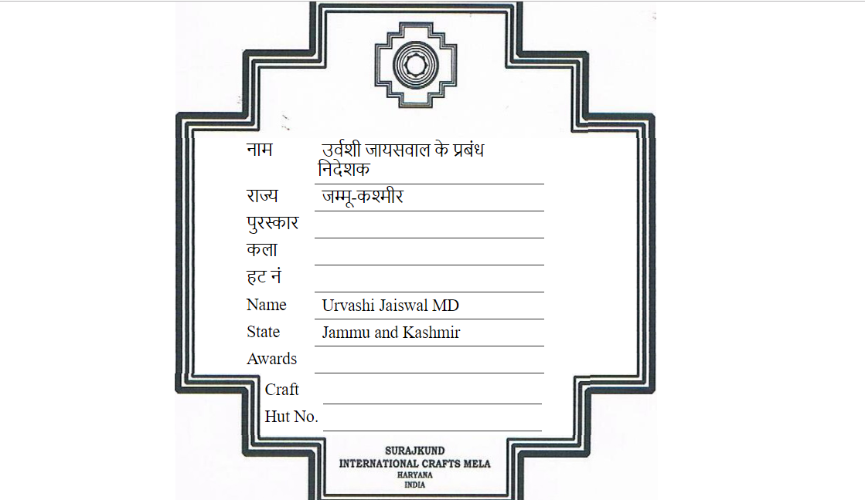

**Registration Slip**