6/22/2026
Gurpreet Singh
NaGARRO
Multi-Tier Architecture Application Using Kubernetes, DevOps & FinOps
Home Assignment

Table of Contents
1 Requirement Understanding 3
1.1 Objective 3
1.1.1 Service API Tier 3
1.1.2 Database Tier 3
1.2 Functional Requirements Addressed 3
2 Assumptions 3
3 High Level Architecture 4
4 Solution Overview 5
4.1 Service API Tier 5
4.2 Database Tier 5
5 Kubernetes Resource Design 5
5.1 Namespace 5
5.2 Deployment 6
5.3 StatefulSet 6
5.4 Service API Tier Design 6
5.5 Database Tier Design 6
5.6 Networking Design 6
5.6.1 Service Api Service 6
5.6.2 PostgreSQL Headless Service 7
5.7 ConfigMap 7
5.8 Secret 7
5.9 Secret And Configuration Injection Strategy 7
5.10 Storage and Persistence Design 8
5.11 External Access using NGINX Ingress Controller 8
5.11.1 Why Ingress Was used 8
5.12 Rolling Update Implementation 9
5.13 Self-Healing Implementation 9
5.14 Horizontal Pod Autoscaling 9
5.15 FinOps Considerations and Cost Optimization 10
5.15.1 Current Resource Allocation 10
5.15.2 FinOps Optimizations Implemented 10
5.15.3 Additional Cost Optimization Opportunities Identified (Not Implemented) 12
5.15.4 Cost Optimization Summary 13

Requirement Understanding

Objective
The objective of this assignment is to design, containerize, and deploy a multi-tier application on Kubernetes that consists of:

Service API Tier
- Exposes API endpoints.
- Retrieves data from the database tier.
- Supports rolling updates.
- Supports self-healing.
- Supports horizontal scaling.
- Externally accessible through Ingress.

Database Tier
- Stores Data.
- Uses persistent storage.
- Accessible only within the Kubernetes cluster.
- Supports automatic recovery after pod deletion.
- Retains data during pod recreation.

Functional Requirements Addressed
Requirement | Implementation
API Tier | Node.js + Express
Database Tier | PostgreSQL 15
API Replicas | 4
Database Replicas | 1
Rolling Updates | Deployment Strategy
Self-Healing | Kubernetes Controllers
Persistent Storage | Persistent Volume Claim + StorageClass
Configurable Database Settings | ConfigMap
Secure Credentials | Kubernetes Secret
External Access | NGINX Ingress
Auto Scaling | Horizontal Pod Autoscaler
Cloud Platform | Google Kubernetes Engine (GKE Standard)

Assumptions
The following assumptions were made during implementation:
- Google Kubernetes Engine (GKE Standard) is used as the Kubernetes platform.
- Docker Hub is used as the image repository.
- Node.js and Express are used for implementing the Service API tier.
- PostgreSQL is selected as the database platform.
- The application workload is moderate and suitable for a single PostgreSQL instance.
- NGINX Ingress Controller is installed within the cluster.
- Google Cloud Load Balancer is provisioned automatically to expose the Ingress endpoint.
- The deployment is intended for demonstration purposes rather than production workloads.
- DB records are initialized automatically during database startup.
- Persistent storage is backed by Google Persistent Disk.

High Level Architecture
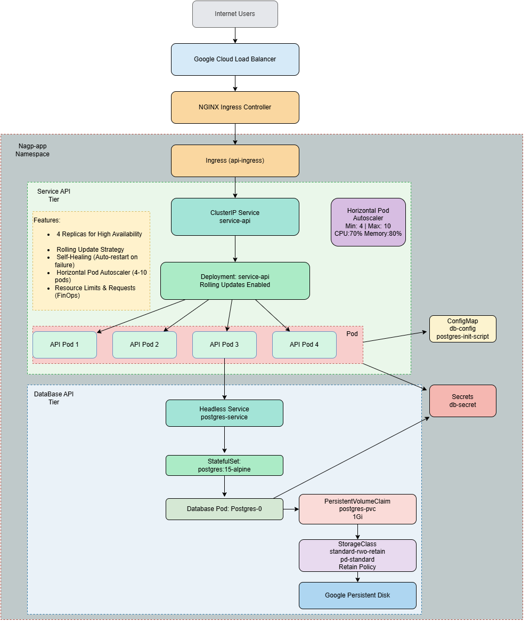

Solution Overview
The solution consists of a two-tier application deployed on Kubernetes.

Service API Tier
The Service API tier is implemented using Node.js and Express. It exposes REST endpoints that allow users to retrieve employee records stored in PostgreSQL.
The API deployment runs with four replicas and improve availability.

Database Tier
The database tier is implemented using PostgreSQL running as a StatefulSet.
A Persistent Volume Claim is attached to the StatefulSet to ensure data remains available even when the database pod is deleted and recreated.
Kubernetes Objects Utilized For The Solution:
- Namespace
- Deployment
- StatefulSet
- ConfigMap
- Secret
- ClusterIP Service
- Headless Service
- Persistent Volume Claim
- StorageClass
- Ingress
- Horizontal Pod Autoscaler
- Liveness Probes
- Readiness Probes

Kubernetes Resource Design

Namespace
A dedicated namespace is created to logically isolate all application resources.
Benefits:
- Better organization
- Resource isolation
- Easier administration
- Improved operational visibility

Deployment
The Service API tier is deployed using a Kubernetes Deployment.
Benefits:
- Replica management
- Self-healing
- Rolling updates
- Easy scaling

StatefulSet
PostgreSQL is deployed using a StatefulSet.
Benefits:
- Stable pod identity
- Persistent storage association
- Predictable DNS names
- Database-friendly deployment model

Service API Tier Design
The Service API tier is built on Node.js and Express, exposing endpoints that retrieve data from the database. It incorporates two distinct health endpoints configured for Kubernetes Liveness and Readiness Probes. These probes automatically detect application failures, trigger restarts of unhealthy containers, and guarantee that network traffic is only routed to healthy pods.

Database Tier Design
PostgreSQL is deployed as a StatefulSet using the official PostgreSQL 15 Alpine image. Database initialization is handled via a ConfigMap containing an SQL script, which is mounted to /docker-entrypoint-initdb.d. Upon pod startup, this script automatically runs to create the necessary tables and insert 10 initial records. The script includes logic “IF NOT EXISTS” to ensure that tables are not recreated and data is not duplicated during pod restarts.

Networking Design

Service Api Service
A ClusterIP service exposes the API pods internally.
Benefits:
- Internal load balancing
- Service discovery
- Decoupling from pod Ips

PostgreSQL Headless Service
A headless service is created with clusterIP: None configured. This configuration enables direct DNS resolution for individual StatefulSet pods rather than routing traffic through a single cluster IP. As a result, the database can be reliably reached via the stable endpoint {pod-name}.{service-name}.{namespace}.svc.cluster.local.
Benefits:
- Stable hostname
- No dependency on pod IPs
- StatefulSet compatibility

ConfigMap
ConfigMap is created to externalizes database configuration.
Benefits:
- Configuration externalization
- Easier updates
- Separation of concerns

Secret
Sensitive data, such as database credentials, is decoupled from the application source code and is securely managed using Kubernetes Secrets. These secrets are injected into the containers at runtime using volume mounts, ensuring that confidential information is never exposed in plaintext configuration files or version control systems.
Benefits:
- Restricts access to sensitive data using Kubernetes Role-Based Access Control (RBAC) and encrypts data at rest within the cluster data store (etcd).
- Allows the same application image to be safely deployed across multiple environments (Dev, QA, Prod) simply by swapping the underlying Secret
- Prevents accidental leaks by keeping credentials out of container images, application logs, and Git repositories.

Secret And Configuration Injection Strategy
While both environment variables and volume mounts are valid methods for injecting configuration data and secrets into containers, this solution explicitly utilizes volume mounts. This decision is made to optimize security posture, support dynamic updates, and adhere to cloud-native best practices.
Benefits of Volume Mounts Over Environment Variables:
- When a Kubernetes ConfigMap or Secret is updated, the changes are automatically reflected inside the mounted volume file system without requiring a pod restart. Conversely, updating environment variables requires a full rolling restart of the application pods to take effect.
- Environment variables are visible to any process running within the container and can be easily inspected via standard debugging tools. Volume Mounts restrict data access to the file system.

Storage and Persistence Design
To Ensure data persistence for stateful workloads, like PostgreSql database tier, the storage requirement is decoupled from the pod lifecycle. Persistent Volume Claims(PVC) paired with a dedicated Storage Class(dynamic volume provisioning) is used for the same. In the solution we have used reclaimPolicy as Retain so that even if Kubernetes resource is deleted, the actual physical disk containing the database state remains compelety intact and untouched.
Benefits:
- Dynamically provision the exact underlying storage hardware the moment a PVC created, eliminating the manual ticketing and delays.
- Instead of wasting capital by pre-allocating large pools of unused storage, the StorageClass ensures that volumes are created on-demand and sized exactly to the gigabyte requested by the PVC.
- Containers are ephemeral by design; if a container crashes or a pod is rescheduled onto a different node, its internal data is permanently lost. A PVC ensures that data survives pod restarts, updates, and node failures, making it essential for stateful applications like databases.

External Access using NGINX Ingress Controller
To expose the Service API tier externally while ensuring that the database tier remained accessible only within the Kubernetes cluster.
To achieve this, an NGINX Ingress Controller was deployed within the GKE cluster. The Ingress Controller acts as a reverse proxy and entry point for external traffic entering the Kubernetes environment.

Why Ingress Was used
Using an Ingress Controller provides several advantages compared to exposing individual services using LoadBalancer services:
- Centralized traffic management.
- Single external entry point for multiple services.
- URL-based and host-based routing support.
- Improved scalability and maintainability.
- Reduced public exposure of internal services.
- Lower Operational Overhead.
- Reduction in cloud load balancer costs as for individual service using load balancer service we need load balancer for each service.

Rolling Update Implementation
The Service API deployment uses the RollingUpdate strategy.
Deployment Process:
- New pod is created.
- Readiness probe validates the pod.
- Traffic shifts to the new pod.
- Old pod is terminated.
- Process repeats until all pods are updated.
Benefits:
- Zero downtime deployment
- Controlled rollout
- Improved availability

Self-Healing Implementation
Both the Service Api Tier and the Database Tier are self healing i.e even if one of the pod crashes the respective controller i.e deployment controller for Service Api and StatefulSet controller for Database Tier creates a replacement pod automatically. As a persistent storage is attached to the database pod, database remain intact and data remains available.

Horizontal Pod Autoscaling
A Horizontal Pod Autoscaler (HPA) is configured to automatically scale the number of application pod replicas up or down based on real-time resource utilization. By continuously monitoring metrics CPU and memory thresholds, the HPA ensures the application dynamically scales out to handle sudden traffic spikes and scales in during low-demand periods to optimize cluster resource utilization and cloud costs.
Benefits:
- Automated Elasticity
- High Availability
- Cost Efficiency

FinOps Considerations and Cost Optimization
The solution was designed using FinOps principles to ensure efficient utilization of cloud resources while maintaining scalability, reliability, and operational resilience. Resource allocation, autoscaling, storage provisioning, and monitoring capabilities were incorporated to optimize infrastructure costs.

Current Resource Allocation
API Tier (4 Pods)
Resouce | Request | Limit
CPU | 400m | 800m
Memory | 512Mi | 1024Mi

DataBase Tier (1 pod)
Resouce | Request | Limit
CPU | 200m | 500m
Memory | 256Mi | 512Mi

Resource requests and limits were explicitly configured for both application and database tiers to prevent over-provisioning and improve node utilization efficiency.

FinOps Optimizations Implemented

Resource Right-Sizing (Implemented)
During load testing, HPA metrics indicated CPU utilization values ranging from approximately 1% during idle periods to around 32% under generated load. These observations confirmed that the application could handle expected traffic while remaining within the configured resource requests and limits. This validation process ensured that resource allocation was appropriately sized and aligned with FinOps best practices.
Estimated Cost Savings: 30–40%
Benefits:
- Prevents over-allocation of compute resources.
- Improves node utilization.
- Reduces infrastructure waste.
- Enables more accurate autoscaling decisions.

Horizontal Pod Autoscaler (Implemented)
The Service API tier uses a Horizontal Pod Autoscaler configured with:
- minReplicas: 4
- maxReplicas: 10
- cpu: 70%
- memory: 80%
The HPA automatically increases or decreases the number of application pods based on resource consumption.
Benefits:
- Resources are consumed only when demand increases.
- Prevents over-provisioning during low traffic periods.
- Improves cost efficiency without impacting performance.
Estimated Cost Savings: 40–60% during off-peak workloads.

Storage Optimization (Implemented)
The PostgreSQL StatefulSet uses a custom StorageClass backed by Google Persistent Disk Standard (pd-standard):
parameters:
type: pd-standard
The database workload does not require SSD-level performance, therefore standard persistent disks were selected to minimize storage costs.
Additionally, storage allocation was limited to: storage: 1Gi, which is sufficient for the assignment workload.
Dynamic Volume Provisioning: Storage was provisioned only when needed through the Storage class.
Benefits:
- Lower monthly storage costs.
- Reduced infrastructure waste.
- Persistent storage retained across pod recreation.
Estimated Cost Savings: 20–30% compared to higher-cost SSD storage classes.

Shared Ingress Architecture (Implemented)
The solution uses an NGINX Ingress Controller and Ingress resource instead of exposing application services directly through individual LoadBalancer services.
Benefits:
- A single external Cloud Load Balancer serves as the entry point for the cluster.
- Multiple services can be exposed through the same load balancer using routing rules.
- Reduces public IP usage.
- Simplifies network management.
- Supports future service expansion without provisioning additional load balancers.
Estimated Cost Savings:
- Currently only one API Service is exposed, But this avoids provisioning additional cloud load balancers for future services.
- Can reduce external networking costs in the future if more services are exposed by approximately 20–40% compared to architectures that expose each service independently through dedicated LoadBalancer services.

Additional Cost Optimization Opportunities Identified (Not Implemented)

Spot / Preemptible Nodes for API Tier
The Node.js API tier is stateless and therefore suitable for deployment on Google Cloud Spot VMs.
Benefits:
- Up to 60–80% lower compute cost compared to on-demand nodes.
- Kubernetes self-healing capabilities mitigate node interruptions.
- Particularly suitable for horizontally scalable microservices.
Potential Cost Savings: 60–80%

GKE Cluster Autoscaler
Cluster Autoscaler automatically adds or removes worker nodes based on workload demand.
Benefits:
- Reduces idle node costs.
- Scales cluster capacity only when required.
- Improves overall resource utilization.
Potential Cost Savings: 40–60%

Resource Quotas and Limit Ranges
Namespace-level ResourceQuota and LimitRange objects can be configured to prevent uncontrolled resource consumption.
Benefits:
- Prevents accidental over-allocation.
- Improves governance and budget control.
- Eliminates unexpected infrastructure growth.
Potential Cost Savings: Prevents cost overruns and resource waste.

Idle Resource Detection and Cleanup
Regular review of unused Persistent Volume Claims, ConfigMaps, Secrets, and idle workloads can reduce unnecessary resource consumption.
Benefits:
- Removes orphaned resources.
- Reduces storage costs.
- Improves operational visibility.
Potential Cost Savings: 10–20%

Cost Optimization Summary
Optimization Strategy | Status | Estimated Savings
Resource Right-Sizing | Implemented | 30-40%
HPA | Implemented | 40-60%
Storage Optimization | Implemented | 20-30%
Shared Ingress Architecture | Implemented | 20-40% (In future when more services are exposed)
Spot / Preemptible Nodes | Future Opportunity | 60-80%
Cluster Autoscaler | Future Opportunity | 40-60%
Resource Quotas | Future Opportunity | Prevents Overruns
Idle Resource Cleanup | Future Opportunity | 10-20%

The implemented solution incorporates multiple cost optimization mechanisms including resource right-sizing, autoscaling, and storage optimization. Based on industry FinOps benchmarks, the current implementation is expected to achieve approximately 30–50% infrastructure cost reduction compared to an equivalent non-optimized deployment.

