9/20/2026
Gurpreet Singh
NagARRO
AI Travel Planning Assistant
Context-Aware Travel Assistant Combining Retrieval-Augmented Generation with Model Context Protocol (MCP) Tools, Powered by Google Gemini

Table of Contents
Table of Contents 1
1. Problem Statement 3
2. Architecture Overview 3
2.1 High-Level Components 4
2.2 Request Lifecycle 4
2.3 Technology Stack 5
3. RAG Workflow 6
3.1 Knowledge Base Sources 6
3.2 Ingestion Pipeline 6
3.3 Retrieval & Grounded Generation 7
4. RAG Exposed as an Agent Tool - Design Rationale 7
4.1 What the Tool Does 7
4.2 Why This Design, Specifically 7
5. MCP Tools 8
5.1 Weather Tool 8
5.2 Currency Conversion Tool 8
5.3 Failure Handling — No Fabrication 8
6. Prompt and Context Strategy 9
6.1 System Prompt Design 9
6.2 Multi-Turn Context 9
6.3 Distinguishing Fact from Recommendation 9
7. Agent Evaluator — Thought Process and Design 10
7.1 What It Runs Against 10
7.2 What Gets Checked, Per Test Case 10
7.3 Why an LLM Judge, and Why Four Separate Dimensions 11
8. Other Notable Technical Decisions 11
8.1 FAISS Over a Chroma Server 11
8.2 Zero-Fabrication Policy, Enforced and Tested 11
8.3 Markdown-Aware Chat Rendering 11
9. Model version sensitivity 12
9.1 Why a model swap can change behaviour here, technically 12

1. Problem Statement
Travel planning requires two distinct types of information: destination knowledge, such as attractions, neighbourhoods, transportation options, cultural guidance, and suggested itineraries; and current information, such as weather forecasts and currency exchange rates. Destination knowledge can be collected in advance and searched using Retrieval-Augmented Generation. Current information should be requested from external services when the user asks a time-sensitive question.
Build an AI Travel Planning Assistant that helps users plan a trip to a selected destination. The assistant must use a travel knowledge base to provide destination recommendations and use MCP tools to retrieve current information. It should combine both sources when a question requires destination knowledge as well as current information. Example: “Plan a three-day trip to Singapore and adjust the activities based on the weather forecast.” For this request, the application should retrieve attractions and itinerary recommendations from the knowledge base, invoke an MCP weather tool, generate a weather-aware itinerary, and identify the sources and tool results used.

2. Architecture Overview
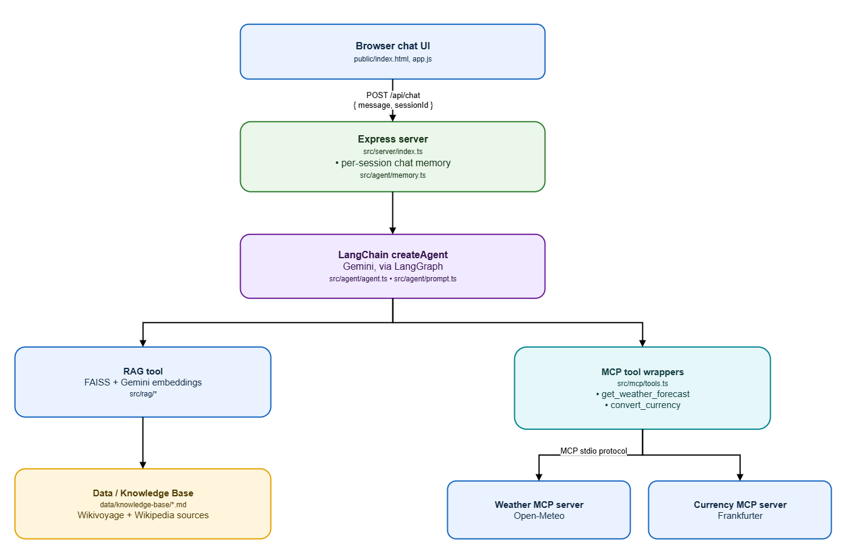

2.1 High-Level Components
The application is a single Node.js/TypeScript process (plus two small MCP server child-processes) with five main layers:
Component | Responsibility | Key Location
Browser chat UI | Minimal HTML/CSS/JS chat interface; renders the assistant's Markdown-structured replies and shows which tools were used for each answer. | public/index.html, app.js
Express web server | Exposes /api/chat and /api/session/reset; owns per-session conversation memory. | src/server/index.ts
LangChain agent | A tool-calling agent (built with createAgent, backed by @langchain/langgraph) that decides which tool(s) to call for a given user message and produces the final grounded answer. | src/agent/agent.ts, prompt.ts
RAG tool | Wraps a FAISS similarity search over the Singapore knowledge base as a callable tool with citation metadata. | src/rag/ragTool.ts, vectorStore.ts
MCP tools + servers | Two independent MCP servers (weather, currency) connected over the stdio MCP transport, wrapped as LangChain tools. | src/mcp/servers/*.ts, client.ts, tools.ts
Knowledge base | Five curated Markdown documents (Wikivoyage + Wikipedia + a compiled itinerary guide) with source metadata. | data/knowledge-base/*.md
Agent Evaluator | An offline test harness that runs the same agent against a fixed dataset and scores it (see Section 7). | src/eval/*, eval/dataset.json

2.2 Request Lifecycle
- User sends a message. The browser posts { message, sessionId } to POST /api/chat.
- Session history is loaded. The server looks up the prior turns for that sessionId (if any) from an in-memory conversation store.
- The agent is invoked. The full message list (history + new human message) is passed to the LangChain agent, which was created once at startup with the chat model, the system prompt, and all three tools bound to it.
- The model decides which tool(s) to call. Based on the system prompt's tool-selection rules, the model calls the knowledge-base tool, one or both MCP tools, both, or neither, depending on what the question actually needs.
- Tools execute and return results. The RAG tool returns retrieved passages with citations; the MCP tools return live data (or a clearly-flagged failure).
- The model produces a final, structured answer. It is instructed to separate knowledge-base facts, MCP-sourced current information, and its own recommendation, and to cite sources.
- The server records and responds. The final answer text and a toolUsage list (which tools ran, with what arguments, and what they returned) are appended to session memory and returned to the browser, which renders the answer and small tool-usage badges.

2.3 Technology Stack
Concern | Choice | Why
Language / runtime | TypeScript, Node.js 22 | Type safety across the RAG/MCP/agent boundary; native fetch and ESM support.
Orchestration | LangChain (createAgent, @langchain/core, @langchain/langgraph) | Required by the assignment brief; createAgent is LangChain's current tool-calling agent API.
LLM | Google Gemini (gemini-2.5-flash) | Candidate's choice of LLM provider, as permitted by the brief.
Embeddings | Google Gemini gemini-embedding-001 | Keeps a single provider/API key for both generation and embeddings.
Vector store | FAISS (@langchain/community FaissStore + faiss-node) | Self-contained flat-file index; no extra server process to run for a single-user demo.
MCP | @modelcontextprotocol/sdk, stdio transport | MCP client/server implementation
Weather data | Open-Meteo API | Free, keyless, reliable — no extra credential setup for a grader to reproduce.
Currency data | Frankfurter API (ECB reference rates) | Free, keyless; covers both INR and SGD.
Web / UI | Express + vanilla HTML/CSS/JS | The brief explicitly de-prioritises UI sophistication.

**Model Pinning Note: All captured transcripts (SAMPLE_QA.md) and evaluator reports (eval/reports/) in this submission were generated with GEMINI_CHAT_MODEL=gemini-2.5-flash (the default in .env.example). Tool selection in this app is an LLM decision, not hardcoded routing — running with a different Gemini model version can legitimately change which tools get called and how the answer is worded.

3. RAG Workflow

3.1 Knowledge Base Sources
At least three public resources were required; five documents were curated, four of them fetched directly from live public sources, each retaining its original title and URL as metadata so the assistant can cite a meaningful source for every answer:
File | Source | Covers
01-wikivoyage-singapore.md | Wikivoyage — Singapore | Districts, transport, culture, food, safety, practical tips
02-wikipedia-tourism-in-singapore.md | Wikipedia — Tourism in Singapore | Attractions, family/nature/culture categories
03-wikipedia-public-transport-in-singapore.md | Wikipedia — Public transport in Singapore | MRT, buses, taxis, fares
04-wikipedia-culture-of-singapore.md | Wikipedia — Culture of Singapore | Ethnic groups, festivals, etiquette, food culture
05-compiled-sample-itineraries.md | Compiled from the four sources above | 3-day itinerary, family/cultural itineraries, indoor vs. outdoor activity lists

**The fifth file is explicitly labelled in its own metadata as a derived compilation rather than an independent source: every fact in it is already present in one of the four sources above, simply reorganised into itinerary and indoor/outdoor structures so the assistant can answer itinerary-style questions directly without over-claiming provenance.

3.2 Ingestion Pipeline
- Load. Every Markdown file in data/knowledge-base/ is read, and its YAML frontmatter (title, source_url, publisher, retrieved date, topics) is kept as document metadata.
- Chunk. Each document is split with a markdown-aware RecursiveCharacterTextSplitter into 900-character chunks with 150 characters of overlap, so a fact near a chunk boundary is not silently lost.
- Embed. Each chunk is embedded with Gemini's gemini-embedding-001 model.
- Store. Embeddings are written to a FAISS index on disk (vector-store/), rebuilt on demand with npm run ingest whenever the knowledge base changes.

3.3 Retrieval & Grounded Generation
- Retrieve. For each relevant query, a similarity search returns the top 5 chunks, each carrying its original source title and URL.
- Generate, grounded. The system prompt instructs the model to answer only from the retrieved passages for destination facts, and to say so explicitly if the retrieved context is insufficient, rather than inventing an answer.
- Cite. Every knowledge-base-grounded answer lists the source titles/URLs actually used; the chat UI also renders a small badge sourced from the same citation data, independent of the text.

4. RAG Exposed as an Agent Tool - Design Rationale
A common, simpler RAG implementation always retrieves from the knowledge base before every model call, then stuffs the retrieved text into the prompt regardless of whether the question actually needs it. This project deliberately does not do that. Instead, the FAISS retriever is wrapped as a named, independently callable LangChain tool search_singapore_knowledge_base with its own description and input schema, and handed to the same tool-calling agent that also holds the two MCP tools. The model decides, per question, whether to call it at all.

4.1 What the Tool Does
Given a natural-language query, the tool runs a FAISS similarity search over the ingested knowledge base and returns a JSON payload containing:
- formattedContext — the retrieved passages, each labelled with its source title and URL, ready to be quoted or grounded against.
- citations — a de-duplicated list of {title, sourceUrl, publisher} for every source that contributed a passage, used both by the model (to cite sources in respone text) and by the server (to show a knowledge-base badge in the UI, independent of the model's own citation text).
- matchCount — how many chunks were found, which is what allows the model (and the evaluator) to detect a genuinely empty result and say so honestly.

4.2 Why This Design, Specifically
- Intent-based invocation. The agent only searches the knowledge base when a question actually needs destination knowledge. A pure weather or currency question never triggers a retrieval call, and a pure destination question never triggers an MCP call — directly satisfying the requirement that MCP must not be used to answer questions the knowledge base already covers, and vice versa.
- Unified orchestration for combined questions. Because RAG and the two MCP tools are just three tools available to one agent, a combined question such as “create a 3-day itinerary and adjust it for the weather” is handled by the model naturally calling both the knowledge-base tool and the weather tool in the same turn. No separate, hand-written branch of application logic is needed to detect “this looks like a combined query” — the agent's normal tool-selection behaviour already produces that outcome.
- Transparency, independent of the prose answer. Because retrieval is a discrete, named tool call rather than invisible prompt construction, its input (the exact search query the model chose) and output (which chunks and sources came back) are recorded as structured data on every request, not just embedded inside the answer text.
- Extensibility. Swapping the vector store, adding a second knowledge base, or changing the embedding model only means changing what is inside this one tool; the agent's orchestration logic and the other two tools are unaffected.

5. MCP Tools
This project implements two genuine, independent MCP servers, each using the official @modelcontextprotocol/sdk, connected to the application over the standard stdio MCP transport.

5.1 Weather Tool
get_weather_forecast (src/mcp/servers/weatherServer.ts) geocodes a place name and calls the free Open-Meteo API for current conditions and up to a 7-day forecast, mapping Open-Meteo's numeric WMO weather codes to short human-readable descriptions (e.g. “Light drizzle”).

5.2 Currency Conversion Tool
convert_currency (src/mcp/servers/currencyServer.ts) converts an amount between two ISO 4217 currency codes using the free Frankfurter API, which publishes European Central Bank reference rates - including both INR and SGD.

5.3 Failure Handling — No Fabrication
Both tools return a normalised { ok, data | error } shape rather than throwing an unhandled exception. A bad location, an unsupported currency code, or a network/HTTP failure produces ok: false with a human-readable error, which the system prompt instructs the model to surface honestly instead of inventing a plausible-looking number. This was verified directly: requesting a BTC conversion (not supported by Frankfurter) produces a clear failure message with no fabricated rate.

6. Prompt and Context Strategy

6.1 System Prompt Design
The full system prompt lives in src/agent/prompt.ts. It is organised into four explicit rule sets rather than a single free-form instruction, so each requirement from the brief maps to a distinct, checkable rule:
- Tool-selection rules - spell out exactly when to call the knowledge-base tool versus the weather/currency tools, and require calling both for a combined question, so the model does not default to answering from its own training data.
- Grounding rules - forbid stating a destination fact not present in the retrieved context, forbid stating a weather/rate fact not returned by a successful tool call, and require saying so plainly when information is insufficient or a tool failed.
- Response-structure rules - require separating “From the knowledge base” (with citations), “Current information (via MCP)” (labelled with the tool used), and “Recommendation” (explicitly flagged as the assistant's own synthesis).
- Conversation-memory rules - instruct the model to preserve previously stated preferences (budget, dates, party composition, interests) across turns without asking the user to repeat them, unless a later statement contradicts an earlier one.

6.2 Multi-Turn Context
A lightweight, in-memory, per-session store (src/agent/memory.ts) keeps the last 12 turns of conversation as LangChain message objects and passes them back to the agent on every request.

6.3 Distinguishing Fact from Recommendation
Because the tool-selection and grounding rules are enforced at the prompt level rather than left implicit, every non-trivial answer produced by the assistant visibly separates three categories of content: knowledge-base facts (with source citation), MCP-provided current data (with the tool name and retrieval time), and the assistant's own itinerary/recommendation logic.

7. Agent Evaluator — Thought Process and Design
This component is developed beyond the minimum requirements. It was added because manually typing sample questions proves the happy path works once, by hand — it says nothing about whether a later prompt tweak, a knowledge-base edit, or a model swap quietly breaks tool selection, starts hallucinating a number, or stops citing sources. The evaluator turns that manual, one-off confidence into a reproducible, versioned, numeric report.

7.1 What It Runs Against
The evaluator (src/eval/*, driven by npm run eval) boots the exact same runtime the web server uses - the same vector store, the same MCP server connections, the same agent instance is shared by both - and drives it through a version-controlled dataset of test cases (eval/dataset.json), each specifying one or more conversational turns, the tool call(s) expected, the arguments expected, and (for RAG-relevant cases) the source titles expected to be retrieved.

7.2 What Gets Checked, Per Test Case
Check | Type | What It Catches
Tool-call count | Deterministic | The model called too many or too few tools (e.g. calling MCP for a pure knowledge-base question).
Tool selection match | Deterministic | The model called the wrong tool for the intent (e.g. currency conversion instead of weather).
Tool argument match | Deterministic | The model called the right tool but with the wrong arguments (e.g. wrong currency codes or wrong location).
Retrieval precision / recall | Deterministic, set comparison | The knowledge-base search returned sources that don't match what the test case expects, or missed an expected one.
Retrieval relevance | LLM-judged, 1-5 | The retrieved chunks are on-topic for the query, beyond simple keyword/source overlap.
Correctness | LLM-judged, 1-5 | The final answer states something factually wrong relative to the retrieved context and tool outputs.
Relevance | LLM-judged, 1-5 | The final answer wanders off-topic from what was actually asked.
Completeness | LLM-judged, 1-5 | The final answer omits something the test case expects to see.
Faithfulness | LLM-judged, 1-5 | The final answer states something not actually supported by the retrieved context or tool output (i.e. a hallucination), even if it happens to sound plausible.

A test case passes only if every deterministic check passes and every judged dimension scores at least 3 out of 5. A technically correct answer that fails to cite sources, or that calls the right tool with subtly wrong arguments, is still reported as a failure.

7.3 Why an LLM Judge, and Why Four Separate Dimensions
Free-text answers cannot be checked with a simple string match - the same correct fact can be phrased many ways. A second Gemini call is used as a judge, given the user's question, the retrieved context, the tool outputs, and the assistant's final answer, and asked to score each dimension independently with a short justification. Four separate dimensions were used instead of one overall score because they catch different failure modes that a single score would blur together: an answer can be relevant and complete but unfaithful (a confident hallucination), or correct and faithful but incomplete (it answered part of a multi-part question), and only a graded breakdown makes that distinction visible in the report.

8. Other Notable Technical Decisions

8.1 FAISS Over a Chroma Server
FAISS was chosen over Chroma specifically because it needs no separate server process: the index is a flat file under vector-store/, which keeps the deployment footprint to a single Node.js process (plus the two MCP child-processes) for a single-user grading context.

8.2 Zero-Fabrication Policy, Enforced and Tested
“Don't invent an answer” is stated in the brief as a requirement, not a suggestion. This project treats it as a testable property in both directions: a knowledge-base gap (a fictional neighbourhood was used as a probe question) and an MCP tool failure (an unsupported currency code) both correctly produce an explicit “I don't have this information” style answer rather than a fabricated one.

8.3 Markdown-Aware Chat Rendering
The system prompt asks the model to produce clearly structured, sectioned answers, which means the model naturally produces Markdown (headings, bold labels, bullet lists)- the convention any modern LLM uses for “structured text”. A small Markdown-to-HTML renderer was added to the chat UI so that structure is actually rendered- headings, bold, italics, bullet/numbered lists, and section dividers - instead of showing the raw Markdown characters to the user.

9. Model version sensitivity
Pinned versions used for every artifact in this submission: GEMINI_CHAT_MODEL=gemini-2.5-flash (chat / tool-calling) and GEMINI_EMBEDDING_MODEL=gemini-embedding-001 (RAG embeddings), as set in .env.example / .env and read by src/config.ts. Both SAMPLE_QA.md and every report in eval/reports/ are captured, not hand-written, output from this exact configuration.

9.1 Why a model swap can change behaviour here, technically
This app has no hardcoded "if question mentions weather → call weather tool" branching. Tool selection is delegated entirely to the LLM's own function-calling decision, driven by the natural-language rules in src/agent/prompt.ts (createAgent from langchain, backed by @langchain/langgraph). That is by design — "RAG Exposed as an Agent Tool - Design Rationale" — so that adding/changing tools never requires new application-side routing logic. The direct consequence is that the same prompt and the same question can be interpreted differently by different model generations, because each generation has its own reasoning depth and instruction- following strictness. A newer/stronger model may reasonably decide a question needs an additional tool call that an older model didn't make, or phrase/structure the answer differently, while still producing a factually correct, grounded response.
- eval/dataset.json's expectedToolCalls were authored and validated against gemini-2.5-flash's actual behaviour on each question. Running npm run eval with a different GEMINI_CHAT_MODEL may therefore show a different pass/fail count on one or more cases.
- SAMPLE_QA.md is live-captured output; a different model will produce different exact wording, forecast/exchange-rate numbers (also because those come from live external APIs), and potentially a different tool-call pattern for borderline questions like the one above.
- To reproduce this submission's exact results: keep GEMINI_CHAT_MODEL=gemini-2.5-flash (already the default in .env.example) when running npm run dev, npm run eval.
- Changing GEMINI_EMBEDDING_MODEL additionally requires re-running npm run ingest, since the FAISS index in vector-store/ stores vectors from one specific embedding model and is not interchangeable across embedding model.

