

**Program: ESE 4009_2**

**INSTRUCTOR:** Prof**.** Mike Aleshams

**Group# 2**

|  |  |  |
| --- | --- | --- |
| Student Name | Student ID | Signature* |
| SIMRAN | C0765503 | S |
| AMANDEEP SINGH | C0761298 | AS |
| KIRANPRREET KAUR GILL | C0761396 | KG |
| GURPREET SINGH | C0761753 | GS |
| JASMEET SINGH | C0751797 | JS |

*\*By signing above you attest that you have contributed to this submission and confirm that all work you have contributed to this submission is your own work.  Any suspicion of copying or plagiarism in this work will result in an investigation of Academic Misconduct and may result in a “0” on the work, an “F” in the course, or possibly more severe penalties.*

**Project Proposal**

**Project Title:** GSM and GPS Based Ambulance Tracking with Health Monitoring System  
**Description of the latest similar system:** Basic idea of the project is to track an ambulance and health details to the hospital. Project is mainly divided into three parts first is collecting the health details of the patient, second one is tracking down the ambulance that is carrying the patient and last one is the sending details over to the hospital. Parameters of health are heartbeat, temperature. So, the values of the sensors are recorded and sent to the hospital number by the help of GSM. It is very helpful as hospital staff get details about the patient in advance so that they can be prepared in advance. GPS is used to record the values of latitude and longitudes of the vehicle and by this means the vehicle can be easily traced and approximate time that is needed to reach to the hospital can be known.

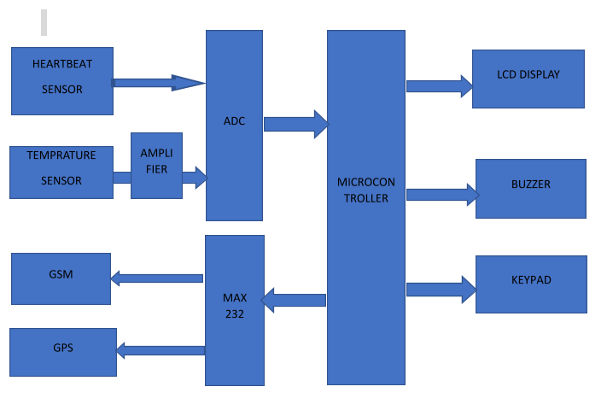

Figure 1: Block Diagram

**Hardware Components:**

The listed hardware components are used in this system and are explained below:

**GSM modem:** GSM stands for Global System for Mobile Communication. It is a hardware device that uses the GSM mobile telephone technology to provide a data link to a remote network. It accepts a SIM card and mainly works as mobile phone. Now, the GSM in this project is used to send all the patient’s information that is temperature and heart beat, to the doctor with the help of text message. The microcontroller used in the project is connected with GSM modem to perform serial communication, so as the text message will be sent.

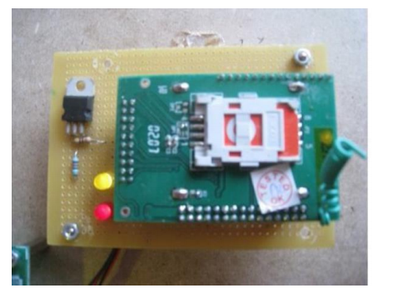

Figure 2: GSM modem

**GPS modem:** GPS stands for Global Positioning System. Here, it is used to provide longitude and latitude of the ambulance. It received data from the satellite and transmitted it to the serial port of the microcontroller. The patient’s location is tracked, and variations are given to the microcontroller.

**Microcontroller:** 89S51 is used which is from 8051 microcontroller family. Microcontroller is the heart of the system as it communicates with the all input and output devices and the whole system is under its control. It is a low-power, high-performance 8-bit microcontroller having a 4K bytes of inbuilt flash memory which results in highly-flexible and cost-effective solution to many embedded system projects. For this project, 8-bit microcontroller with 40 pins is used. There are numerous functions that the microcontroller performed and those are explained below:

For latitude and longitude reading from GPS modem.

For heartbeat reading.

For displaying the reading.

For sending the SMS from GSM modem.

For turning on the buzzer if any reading exceeds the threshold values.

**Heart beat Sensor:** Heart beat sensor is used in this project to determine the heart beat of the patient. The sensor works on the principle that blood in the human body pumps with every heartbeat. As the heartbeat sensor consists of two devices Red LED and LDR. LDR is a light dependent resistor that is a passive electronics component, basically a resistor which has a resistance that varies depending of the light intensity. So, the patient needs to place his finger in between these two components and the red light will be reflected from patient’s finger to LDR. The blood will pump with every heart beat. And this results in the fluctuations in the light intensity.

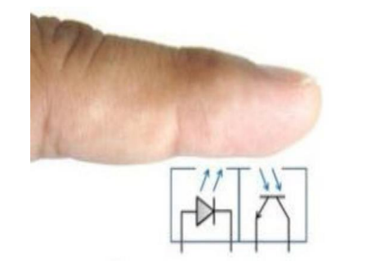

Figure 3 Heart Beat Sensor Principle

**Temperature Sensor:** In this project we have used the temperature sensor to measure the temperature of the patient. It is an analog type of sensor that will always monitor the variations on the temperature of the patient. It gives variable output voltage as per the variations in the temperature received as per the temperature sensed.

**Buzzer:** In theproject,we are setting a threshold value to give indication. As the parameter, temperature or heart beat crossing a threshold value the buzzer will be activated or will be turned ON. This is quite helpful as the doctors will be alert before the patient arrived to the hospital, and the doctors will be well prepared to handle the situation.

**Analog to Digital Converter:** 89C51 is a microcontroller used in this project, which belongs to 8051 family. As, the microcontroller is not capable to read an analog signal or an analog voltage. So, I am external ADC device is used in this project in between the sensors and the microcontroller as per given in the block diagram. Main functionality of ADC is to give digital output data at output as per corresponding to the input voltage received. Thus, it converts an analog input voltage into respective digital data. The value for the data varies from 00-FF as in hexadecimal code. So, ADC is compatible to this microcontroller.

**Amplifier:** Amplifier is used to increase the magnitude of an output signal as per applied to its input. Here, amplifier is used to amplify the voltage of the temperature sensor, as the output voltage of the temperature sensor is in millivolts. So, the output of the amplifier will act as an input to the ADC converter.

**MAX 232:** The MAX 232 is an integrated circuit that perform dual transmission and receiving. It is used to perform the serial communication. Basically, it supports analog device that is used to convert the signals from TIA-232 serial port to signals suitable for use in TTL- compatible digital logic circuit. The signals like RX, TX, CTS, RTS are mainly converted by MAX 232 due to its dual transmitter and receiver capability.

**Flowchart:**

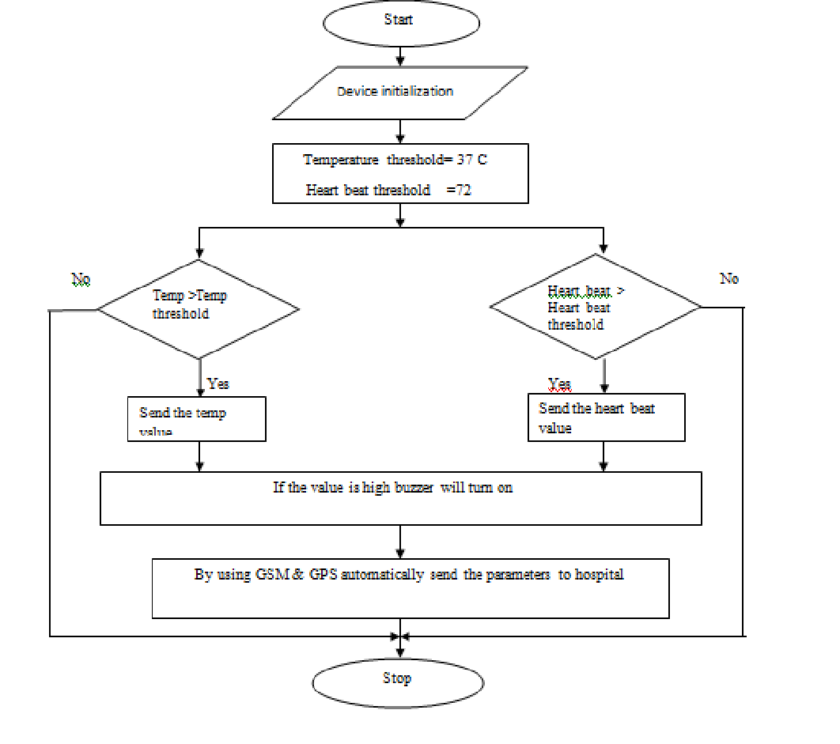

**Advantages:**

1. With help of this project, the live location of the ambulance is easily tracked because GPS system is included in the Circuitry.
2. Doctor will be well aware about the patient’s health before the patient arrival, as the temperature and heart beat will be measured by the respective sensors used in the project and will be immediately send to the doctor.
3. With the help of this project, patient life can be saved.

**Limitations:**

1. Nowadays we are using IOT and cloud in the embedded field, and this system lacks it.
2. Microcontroller, which is known as the heart of any project, As the controller listed above is easy to use but still lacks in processing speed as compared to the latest microcontrollers available in the market.
3. The message we are sending message using GSM is not stored anywhere, as there is no data storage component in the project.
4. There is no alternatives way to send the message.

**References:**

<https://www.ijert.org/research/design-gps-and-gsm-based-ambulance-tracking-with-health-monitoring-system-IJERTCONV4IS11009.pdf>